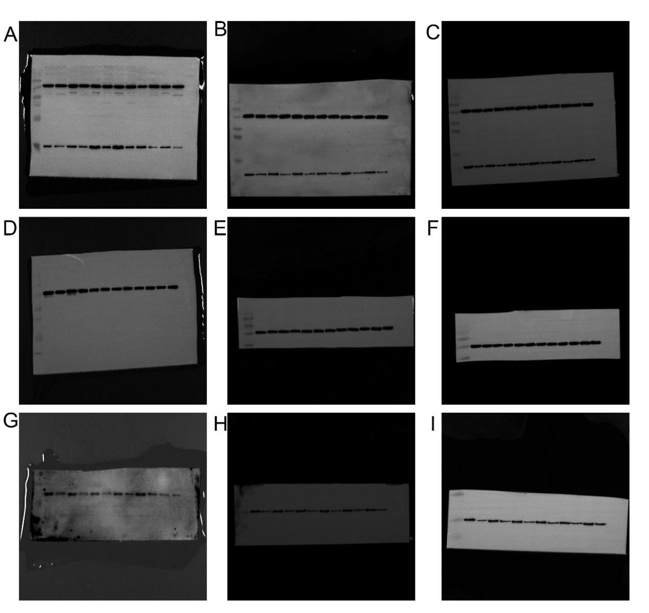
Original WB gels
A-I Original blots of CXCL12 and β-actin (A-C), β-actin (D-F), IGF1 (G-I)

