Graphical Abstract:
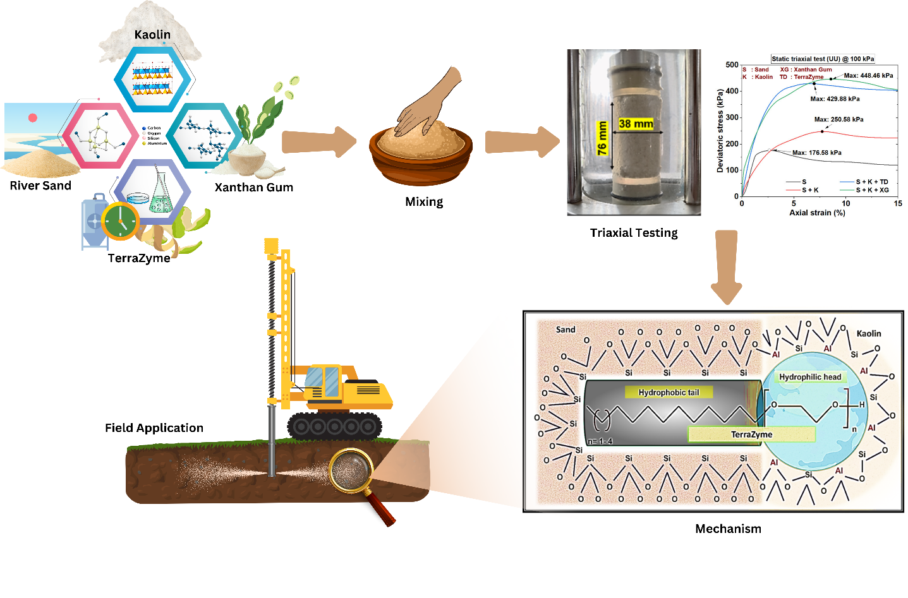
Synopsis:
The study highlights the prospects of bio-stabilization methods for sustainable ground improvement and recommends the use of natural additives like TerraZyme and Xanthan gum in place of conventional materials like cement and lime for environmentally responsible development.

