Supporting information

Unveiling the Mechanisms of Biopolymer and Bioenzyme Sand Stabilization: A Chemical and Microstructural Approach

Geethu Thomas^{1,*}, Ripsa Rani Nayak², Navneet Kumar Gupta^{2,*}, Gali Madhavi Latha^{1,2}

¹Department of Civil Engineering, Indian Institute of Science, Bengaluru, India - 560012
²Centre for Sustainable Technologies, Indian Institute of Science, Bengaluru, India- 560012

E-mail: GT: toms88geethu@gmail.com (ORCID: 0000-0002-4039-2606), NKG: nkgupta@iisc.ac.in (ORCID: 0000-0002-4204-4680)

Number of pages: 20
Number of figures: 12
Number of tables: 5
Table of content
Figure S1. BET analysis of untreated sand.……………………………………………….….. | S4
Figure S2. BET analysis of Sand with 15% Kaolin………………………………………….. | S5
Figure S3. BET analysis of Sand + 15% Kaolin treated with TerraZyme…………………… | S6
Figure S4. BET analysis of Sand + 15% Kaolin treated with Xanthan gum………………... | S7
Figure S5. EDS data of sand and treated soils………………………………………………. | S8
Figure S6. XPS survey of TerraZyme and Xanthan gum treated soils………………………. | S9
Figure S7. C 1s narrow scan XPS spectra of soil-additive combinations…………………… | S10
Figure S8. Si 2p narrow scan XPS spectra of soil-additive combinations…………………... | S11
Figure S9. O 1s narrow scan XPS spectra of soil-additive combinations…………………… | S12
Table S1. Chemical composition of soil-additive combinations obtained from XPS………... | S13
Table S2. XPS analysis of O 1s binding states of different soil-additives combinations…….. | S14
Table S3. XPS analysis of C 1s binding states of different soil-additives combinations…….. | S15
Table S4. XPS analysis of Al 2p binding states of different soil-additives combinations…… | S16
Table S5. XPS analysis of Si 2p binding states of different soil-additives combinations……. | S17
Figure S10. Functionalities groups (Si 2p) versus peak deviatoric stress for treated soils…... | S18
Figure S11. Functionalities groups (O 1s) versus peak deviatoric stress for treated soils…… | S19
Figure S12. Functionalities groups (C 1s) versus peak deviatoric stress for treated soils…… | S20

Figure S1. BET analysis of untreated sand.
Figure S2. BET analysis of Sand with 15% Kaolin.
Figure S3. BET analysis of Sand + 15% Kaolin treated with TerraZyme.
Figure S4. BET analysis of Sand + 15% Kaolin treated with Xanthan gum
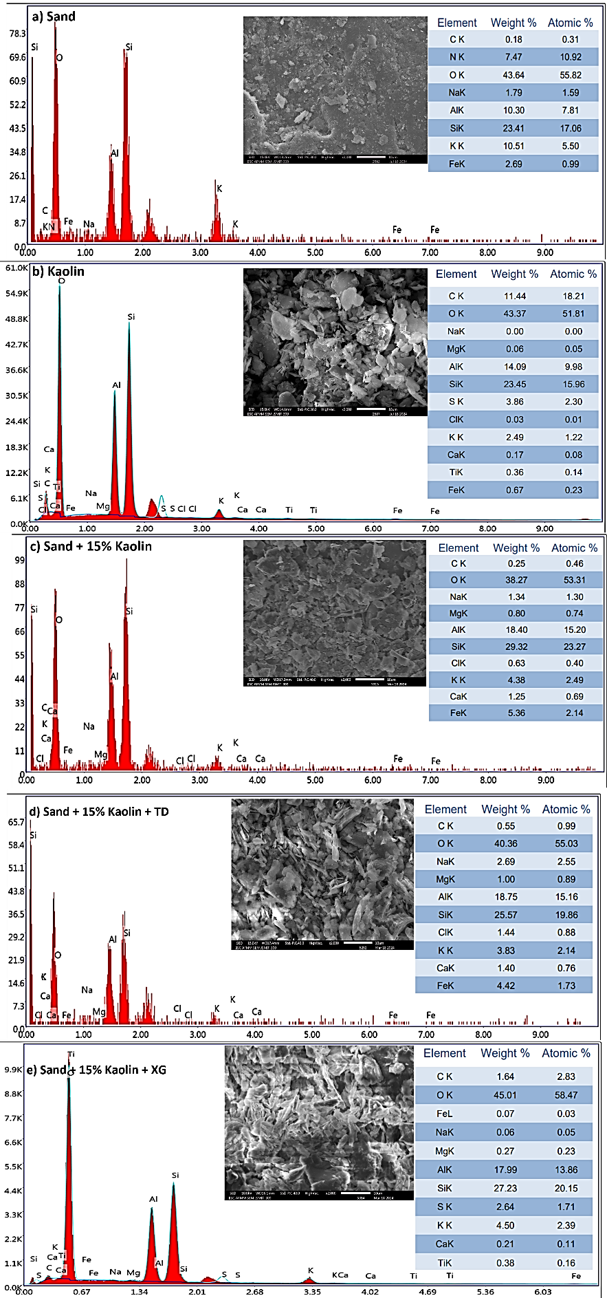
Figure S5. EDS data of sand and treated soils.
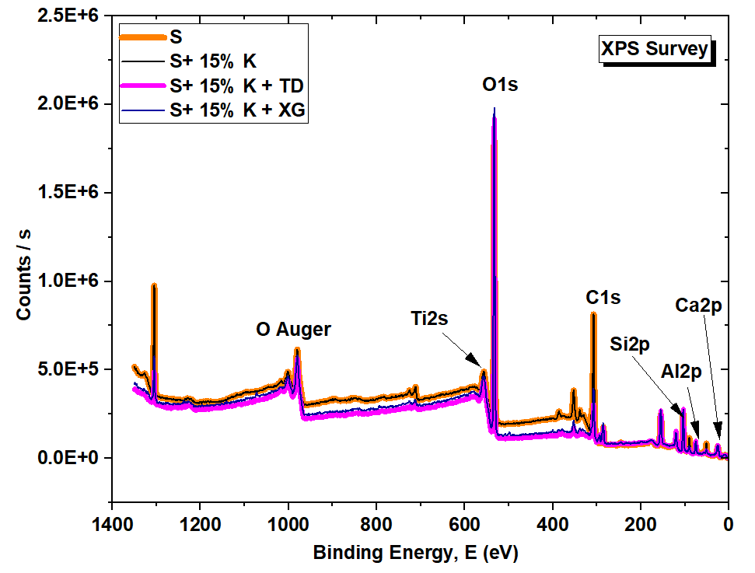
Figure S6. XPS survey of TerraZyme and Xanthan gum treated soils.
Figure S7. C 1s narrow scan XPS spectra of soil-additive combinations
Figure S8. Si 2p narrow scan XPS spectra of soil-additive combinations
Figure S9. O 1s narrow scan XPS spectra of soil-additive combinations
Table S1. Chemical composition of soil-additive combinations obtained from XPS.
Soil-additive combinations | Atom (%)
Soil-additive combinations | Al | Si | O | C
Sand | 5.12 | 25.49 | 10.78 | 58.62
Sand + 15% Kaolin | 12.46 | 25.6 | 13.44 | 48.5
Sand + 15% Kaolin + TD | 11.97 | 25.98 | 6.18 | 55.87
Sand + 15% Kaolin + XG | 10.93 | 24.4 | 8.52 | 56.15

Table S2. XPS analysis of O 1s binding states of different soil-additives combinations.
 |  | O 1s binding states (atom %)
Soil-additive combinations | Al₂O₃ |  | SiO₂ | C=O | C-O
Soil-additive combinations | 531.1 eV |  | 532.8 eV | 532 eV | 533 eV
Sand | 1.83254 |  | 18.46613 | 12.9697 | 25.55037
Sand + 15% Kaolin | 4.41277 |  | 21.10364 | 9.16345 | 13.83785
Sand + 15% Kaolin + TD | 1.20732 |  | 42.05443 | 6.15924 | 6.6448
Sand + 15% Kaolin + XG | 2.90256 |  | 32.42175 | 11.50793 | 9.43299

Table S3. XPS analysis of C 1s binding states of different soil-additives combinations.
 |  | C 1s binding states (atom %)
Soil-additive combinations | C-C |  | C-O-C | O-C=O
Soil-additive combinations | 284.8eV |  | 286 eV | 288.5 eV
Sand | 6.56601 |  | 2.71629 | 2.03979
Sand + 15% Kaolin | 7.60381 |  | 5.219 | 0.87956
Sand + 15% Kaolin + TD | 3.58599 |  | 2.14 | 0.52561
Sand + 15% Kaolin + XG | 3.77398 |  | 3.76893 | 1.00401

Table S4. XPS analysis of Al 2p binding states of different soil-additives combinations.
 | Al 2p binding states (atom %)
Soil-additive combinations | Aluminosilicate | Al (OH)₃ | Al oxide
Soil-additive combinations | 74.282 eV | 74.403 eV | 75.61 eV
Sand | 1.22033 | 2.2566 | 0.20199
Sand + 15% Kaolin | 1.74407 | 2.72015 | 7.99582
Sand + 15% Kaolin + TD | 1.29504 | 3.50757 | 7.9504
Sand + 15% Kaolin + XG | 1.75294 | 2.95579 | 6.24506

Table S5. XPS analysis of Si 2p binding states of different soil-additives combinations.
Soil-additive combinations | Si 2p binding states (atom %)
Soil-additive combinations | Aluminosilicate | SiO₂
Soil-additive combinations | 102.7 eV | 103.5 eV
Sand | 3.74817 | 22.0925
Sand + 15% Kaolin | 6.13578 | 19.86433
Sand + 15% Kaolin + TD | 6.34802 | 20.0701
Sand + 15% Kaolin + XG | 4.89075 | 19.64925

Figure S10. Functionalities groups (Si 2p) versus peak deviatoric stress for treated soils.
Figure S11. Functionalities groups (O 1s) versus peak deviatoric stress for treated soils.
Figure S12. Functionalities groups (C 1s) versus peak deviatoric stress for treated soils.

