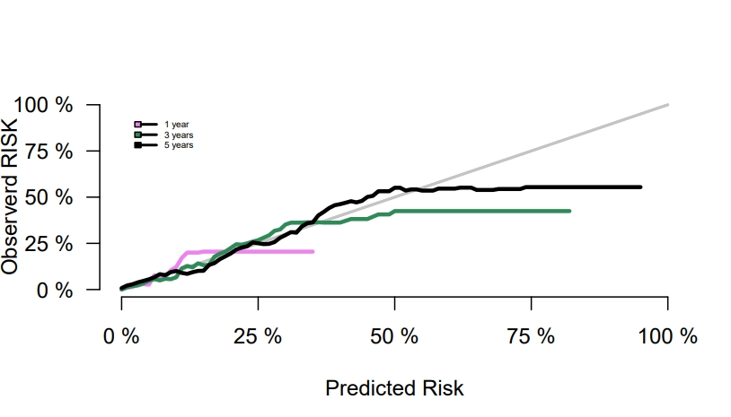
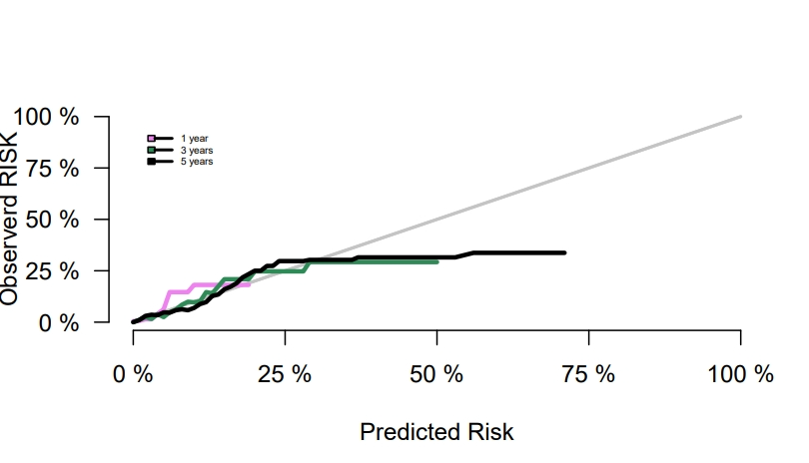
Supplementary Figure 2. NLR-free model calibration curves for predicting mortality in pan-vascular disease populations, a:All-cause mortality b:Cardiovascular mortality
a All-cause mortality
b Cardiovascular mortality

