a All-cause mortality
b Cardiovascular mortality
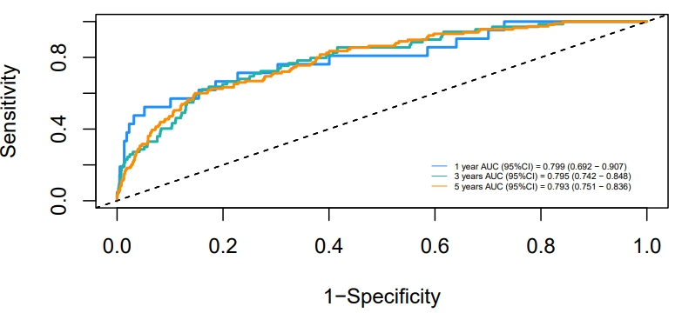
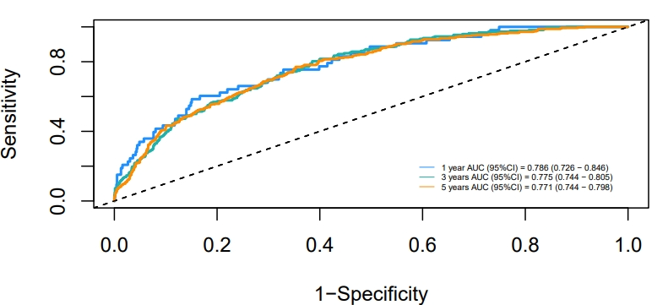
Supplementary Figure 1. An NLR-free ROC model for predicting mortality over time in pan-vascular disease populations, a:All-cause mortality b:Cardiovascular mortality

