Supplementary Figure 1. Pathways for the Pricing and Reimbursement Evaluation of New Orphan Drugs in the South Korean National Health Insurance System
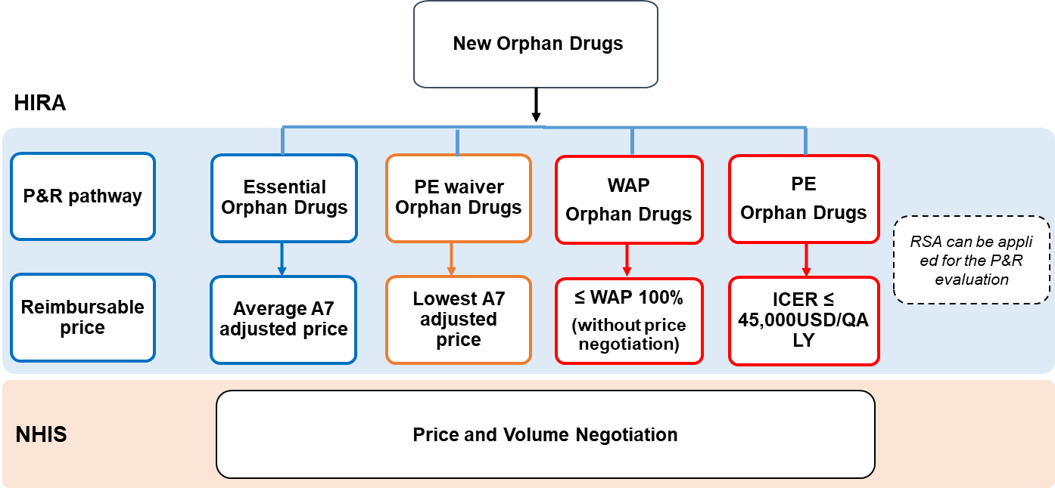
Notes: HIRA: Health Insurance Review and Assessment Service; PE: Pharmaco-economic Evaluation; WAP: Weighted Average Price; A7: US, UK, Italy, Germany, Japan, Switzerland, and France; P&R: Pricing & Reimbursement; RSA: Risk-Sharing Agreement; ICER: Incremental Cost-Effectiveness Ratio; QALY: Quality-Adjusted Life Year; NHIS: National Health Insurance System
Supplementary Figure 2. Histogram for Annual Treatment Cost per Patient and Average of A7 Adjusted Prices
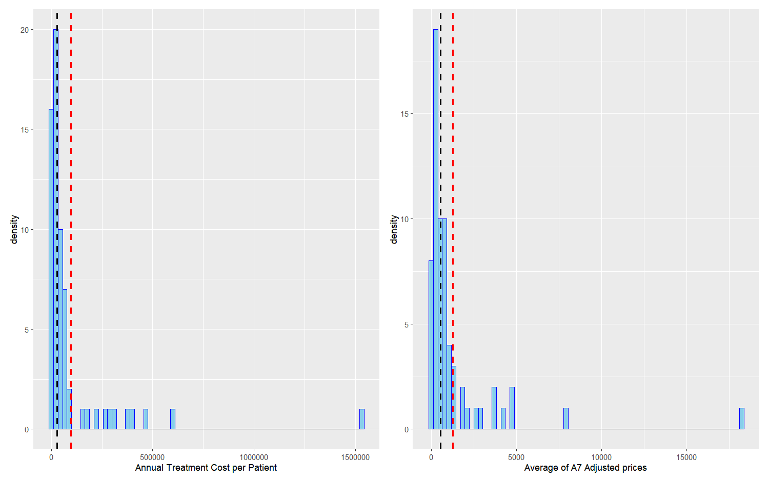
Note: The black line corresponds to the median value and the red line, to the average of 66 observations used in this analysis. Both treatment costs display heavily skewed distributions, with each mass concentrated around the left tail. The unit is in USD (exchange = KRW 1,294/USD).

Supplementary Figure 3. Log-transformed Scatterplots of Annual Treatment Cost per Patient against Major Variables (1. Number of Patients, 2. Average of A7 Adjusted Prices, and 3. Budget Impact)
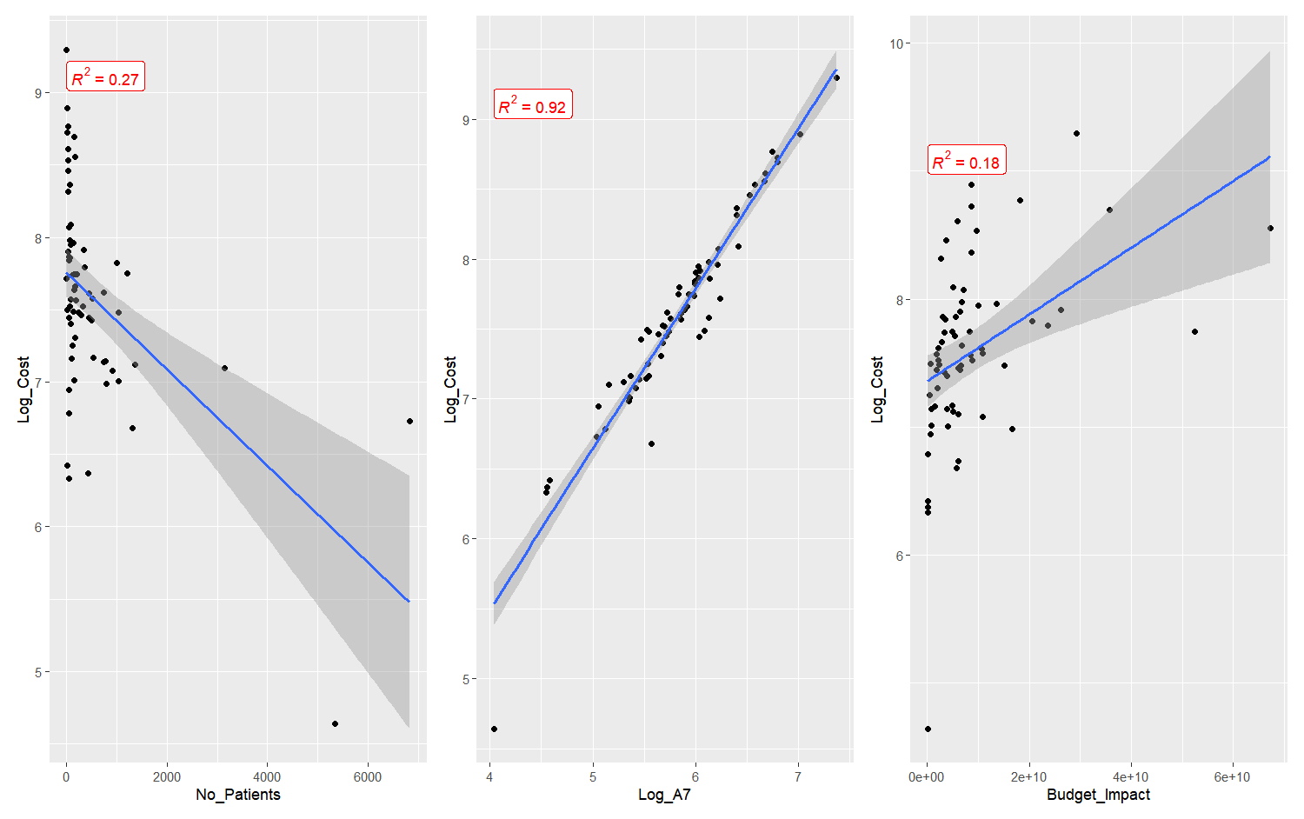

Supplementary Table 1. Criteria for the Major Review Pathways of New Orphan Drugs in South Korea
Pathway | Criteria
Designation as essential drugs | Meet all the following criteria  - No alternatives  - Treating serious life-threatening conditions  - For small patient groups (e.g., rare diseases)  - Significant improvement in clinical efficacy or survival rate
PE waiver | Meet all the following criteria  - Drugs for anticancer or rare disease treatments in case of i) no alternatives or ii) no clinical equivalent drugs or treatments, and for treating serious life-threatening conditions  - Drugs approved with single arm clinical trial, or only based on a Phase 2 clinical trial, or difficult to generate evidence owing to small number of patients  - Listed in at least three A7 countries
A7 countries: Seven advanced reference countries (US, UK, Italy, Germany, Japan, Switzerland, and France); PE: pharmacoeconomic evaluation

