Systematic Development of Hybrid PPY/GO/ZnO Composite Modified Electrode for Efficient Electrochemical Detection of Pb²⁺ in Aqueous Solution
Supplementary Data
Morphological Studies: The morphological study of the prepared ternary composite (PGT 2) was examined using scanning electron microscopy (SEM) as represented in Fig S1. The presence of rolled and folded sheets generates the fibrous morphology due to GO sheets in the composite material. The folding of the GO sheets is due to the presence of oxygen functionalities and the accumulation of its sheets. PPY gets adsorbed on the surface of the GO sheets through electrostatic and ᴨ-ᴨ stacking resulting in non-granular morphology with porous on its surface thus representing flakes-like structures. The presence of ZnO as granules covers the whole surface of the PPY/GO resulting in different shapes in repeated manners thus, providing the porous structure as well as increasing the surface area of the ternary composite material. [1-3]
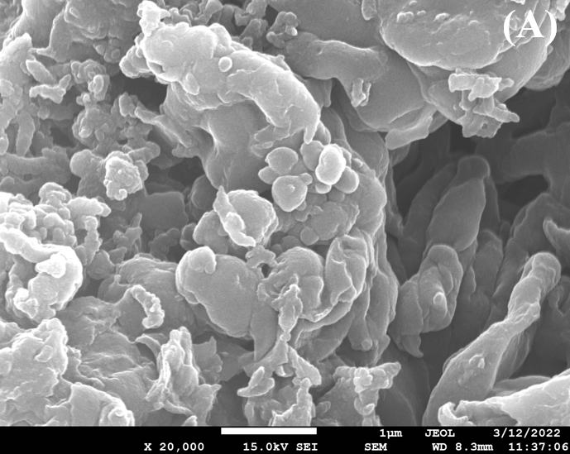 | 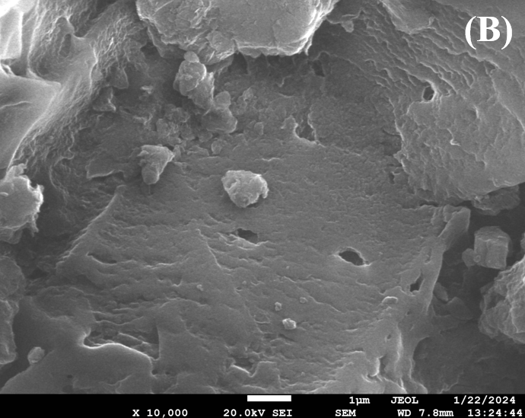
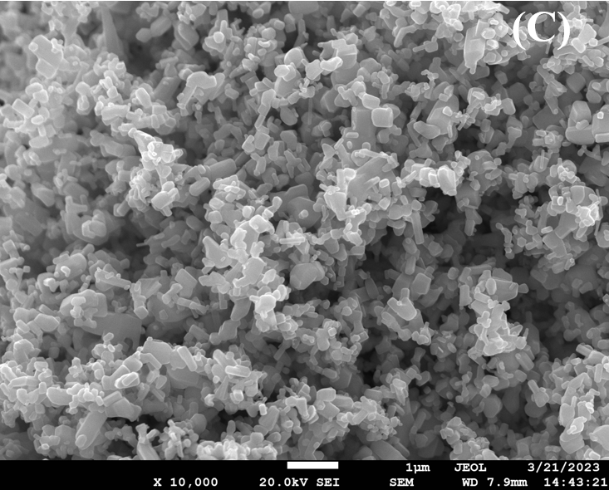 | 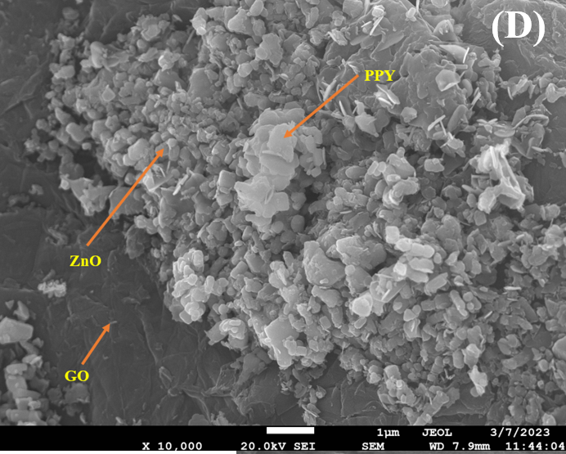

Figure S1: SEM micrograph of PPY (A), GO (B), ZnO (C), and PGT 2 (D)
CV studies for Pb²⁺ detection: CV studies were carried out for PG 1 and PGT 2 in the absence and presence of 0.1 M Pb²⁺ ion at a scan rate of 0.05 V/s within the potential window of -1.5 to 1.5 in an acetate buffer solution as a supporting electrolyte. As shown in the Figs. S2 (A) and S2 (B) the pattern of the CV curves for both PG 1 and PGT 2 shows a different behavior in the presence of 0.1 M Pb²⁺ ion. A broadened peak within the potential range of -0.25 to 0.5 V was observed for both composite materials. The intensity of the peak current for Pb²⁺ sensing is higher for the PGT 2 composite compared to the PG 1 which shows that the ternary composite has a high affinity for the lead chelation on its surface which is further supported by the DPASV studies [4-5].
Figure S2: CV curve of PG 1 (A) PGT 2 (B) in the presence and absence of Pb²⁺ ion

References:
1. Ali, Z.R., and Dawood, A. F., (2022). Structural and Electrical characterizations of new synthesized PVA/ PoPDA-rGO-ZnO Nanocomposite. Egypt. J. Chem. 65(4) 761 – 770. DOI: 10.21608/EJCHEM.2021.91060.4331
2. Ding, C., Qian, X., Yu, G., and An, X. (2010). Dopant effect and characterization of polypyrrole-cellulose composites prepared by in situ polymerization process. Cellulose, 17(6), 1067–1077. doi:10.1007/s10570-010-9442-6
3. Arumugam, C., Kandasamy, S. K., and Subramaniam, T. K. (2023). Enhancing supercapacitor performance using ZnO embedded on GO/PPy composite as versatile electrodes. High Energy Chemistry, 57(1), 69-76.
4. Kausar, H., Khan, Y., Ahmad, A., Ahmad, S. I., & Nami, S. A. (2021). Synthesis and characterization of zirconium (IV) molybdosulphosalicylate, multi-walled carbon nanotubes and polypyrrole based ternary nanocomposites: Adsorption and lead sensing studies. Synthetic Metals, 274, 116730.
5. Oularbi, L., Turmine, M., & El Rhazi, M. (2017). Electrochemical determination of traces lead ions using a new nanocomposite of polypyrrole/carbon nanofibers. Journal of Solid State Electrochemistry, 21, 3289-3300.

