Supplementary materials：Table 1 : q-PCR Primer：
Sequence | Name | Length（bp）
AACAGGCACCTTGGATTA | FTO(M)-F | 75
CCATCGTCTGAGTCATTG | FTO(M)-R | 75
GATCCGTCGTTGAAGG | LeAlkB(M)-F | 78
GTAATTCGCCTGGGTC | LeAlkB(M)-R | 78
TGTTGTAAGTGGTATTATTC | HIF-1α(M)-F | 132
CTTGTATCCTCTGATTCA | HIF-1α(M)-R | 132
GCTTGATGACTCTAAACC | RUNX2(M)-F | 84
ACACCTACTCTCATACTG | RUNX2(M)-R | 84
CTGGTGAACTCTGTGAAT | BMP2(M)-F | 82
CTAGGTACAACATGGAGATT | BMP2(M)-R | 82
AAGGACATCGCATATCAG | ALP(M)-F | 108
TTCGTATTCCACATCAGTT | ALP(M)-R | 108
TATGGAATCCTGTGGCATC | β-actin(M)-F | 87
GTGTTGGCATAGAGGTCTT | β-actin(M)-R | 87
Pig 1: LeAlkB successfully purified electrophoresis image
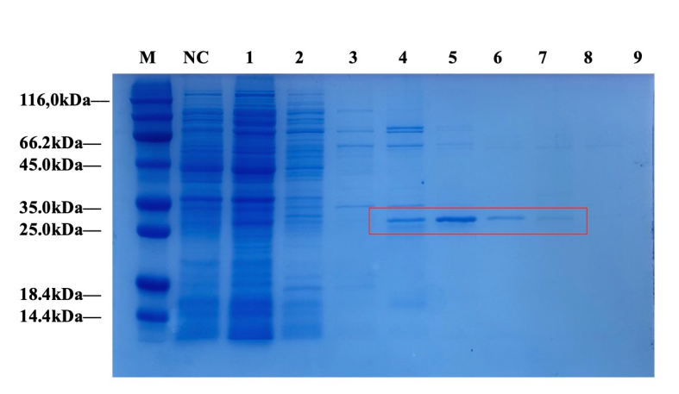
Pig 2 :Plasmid map（pCDNA3.1 and pCDNA3.1-eGFP-MSC）
