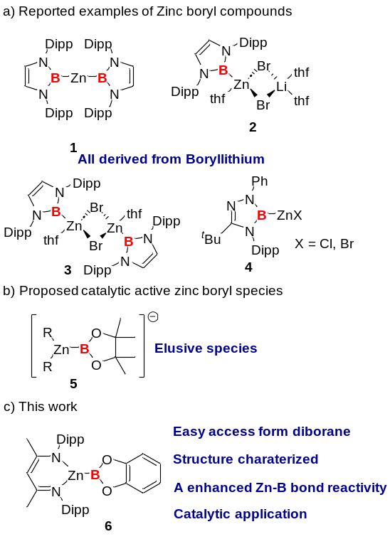
Scheme 1. Examples of Zinc-boryl compounds
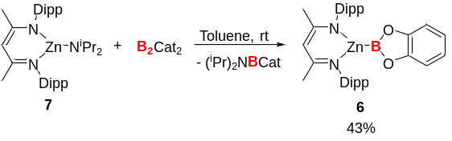Scheme 2. Synthesis of Zinc-boryl compound 6.

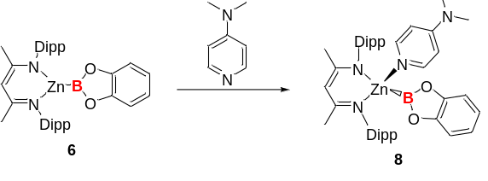
Scheme 3. Reaction of compound 6 with DMAP.
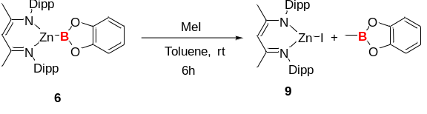
Scheme 4. Reaction of compound 6 with MeI.
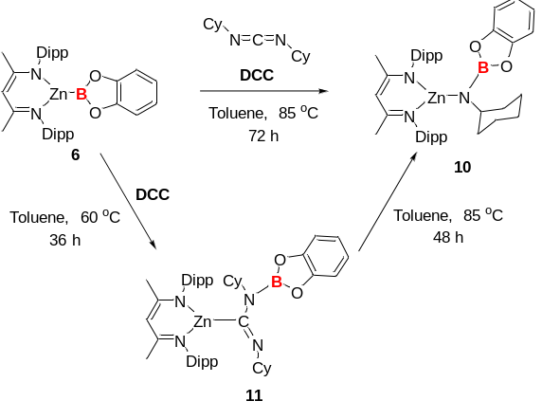Scheme 5. Reaction of compound 6 with N,N’-dicyclohexylcarbodiimide
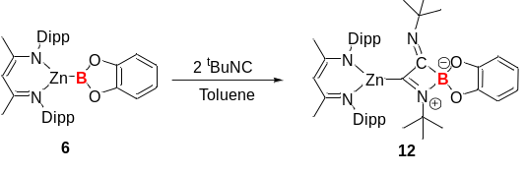
Scheme 6. Reaction of compound 6 with isocyanide
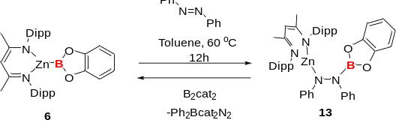
Scheme 7. Reaction of compound 6 with azobenzene
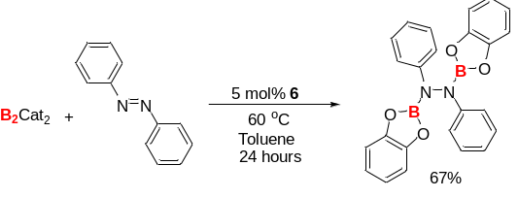
Scheme 8. Catalytic diborylation of azobenzene enabled by compound 6

