Supporting Information
A Zinc-Bcat Compound: Unlocking New and Diverse Reactivity Pathways Beyond Nucleophilic Borylation
Gan Xu,^{1,4} Hok Tsun Chan,^{2,4} Shuchang Li,¹ Tsz Ying Wong,¹ Lei Zhang,³ Qichun Zhang,³ Zhenyang Lin*² and Zhenpin Lu*¹
1. Department of Chemistry, City University of Hong Kong, Kowloon Tong, Hong Kong SAR, P. R. China. 2. Department of Chemistry, The Hong Kong University of Science and Technology, Clear Water Bay, Kowloon, Hong Kong SAR, P. R. China. 3. Department of Materials Science and Engineering City University of Hong Kong, Kowloon Tong, Hong Kong SAR, P. R. China. 4. These authors contributed equally: Gan Xu, Hok Tsun Chan. E-mail: zhenpinlu@cityu.edu.hk, chzlin@ust.hk

Contents
General Methods 2
Experimental Section 3
NMR Spectrum 15
X-Ray Single-Crystal Diffraction 32
Computational Details 36
Cartesian Coordiantes of Optimized Structure 38
References 58

General Methods
All manipulations were conducted under a dry argon atmosphere using either a Vigor glove box or a standard Schlenk line. Ether, hexane, pentane, and toluene were refluxed over sodium metal and benzophenone until dry, followed by distillation under a nitrogen atmosphere. Tetrahydrofuran (THF) was similarly refluxed over potassium metal and benzophenone until dry and subsequently distilled under a nitrogen atmosphere. All the solvents were degassed prior to use and stored over activated 3Å molecular sieves in the glove box. NacNac(Dipp)ZnN^{i}Pr₂ was synthesized by reported literature¹, while all the other chemicals were purchased from commercial companies. Deuterated benzene (C₆D₆) was degassed via three freeze-pump-thaw cycles and then dried over a Na/K alloy in the glove box. NMR spectroscopy was performed on Bruker Avance spectrometers at 300, 400, and 600 MHz. Chemical shifts (δ) are given in ppm relative to the residual proton (¹H) signal or carbon nuclei (¹³C{¹H}) of the respective solvent's residual. The ¹¹B NMR spectra were referenced to external BF₃·OEt₂ standards. High-resolution mass spectra were conducted via a Sciex X500R Q-TOF mass spectrometer and Bruker autoflex maX MALDI-TOF/TOF under an inert atmosphere.

Experimental Section
Synthesis of 6:
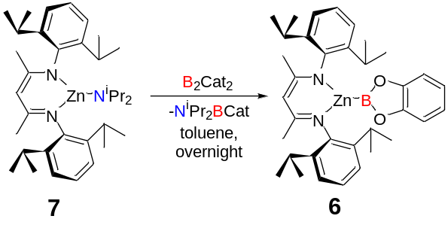
Compound 7 (58.3 mg, 0.1 mmol) was dissolved in 2 mL of toluene in a 4 mL vial. One equivalent of bis(catecholato)diboron (B₂cat₂, 23.7 mg, 0.1 mmol) was then added as a solid. The solution was stirred overnight, during which the color changed from pale yellow to chartreuse. The solvent was removed under vacuum, and the residue was extracted with hexane (2 mL, three times) and filtered through Celite. The pure product was isolated as single crystals from a frozen concentrated hexane solution (31.9 mg, 53%).
¹H NMR (400 MHz, C₆D₆) δ (ppm) = 7.09 (m, 6H, Ar-H), 6.82 (dd, J = 5.9, 3.3 Hz, 4H, cat-Ph), 6.55(dd, J = 5.9, 3.3 Hz, 4H, cat-Ph), 5.09 (s, 1H, NC(CH₃)CH), 3.34 (hept, 4H, CH(CH₃)₂), 1.73 (s, 6H, NC(CH₃)CH), 1.44(d, J = 6.8 Hz , 12H, CH(CH₃)₂), 1.20(d, J = 6.9 Hz, 12H, CH(CH₃)₂).
¹³C NMR (101 MHz, C₆D₆) δ (ppm) = 167.64, 148.37, 144.70, 141.61, 126.15, 123.79, 121.77, 112.14, 96.24, 28.48, 24.63, 23.38, 23.35.
¹¹B NMR (96 MHz, C₆D₆) δ (ppm) = 39.7
HRMS: simulated (M+H)⁺ = 601.2944, found = 601.2972

Synthesis of 8:
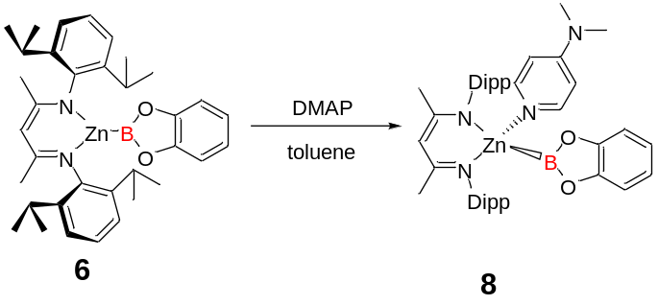
Compound 6 (20.0 mg, 0.033 mmol) was dissolved in toluene (2 mL), and DMAP (4.1 mg, 0.033 mmol) was added as a solid. The reaction was stirred for ten minutes, after which all solvent was removed under vacuum. The residue was then extracted with 1 mL of a 1:1 mixture of toluene and hexane and kept at -30 °C to yield products as single crystals (19.5 mg, 81%).
¹H NMR (400 MHz, C₆D₆) δ (ppm) = 8.69 (d, J = 5.9 Hz, 2H, DMAP), 7.15 (m, 6H, Ar-H) , 6.98(dd, J = 5.8, 3.3 Hz, 4H, cat-Ph), 6.67(dd, J =5.8, 3.3 Hz, 4H, cat-Ph), 5.91 (d, J = 6.0 Hz, 2H, DMAP), 5.03(s, 1H, NC(CH₃)CH) 3.55(hept, 4H, CH(CH₃)₂) 2.10( s, 6H, N(CH₃)₂, DMAP), 1.84 (s, 6H, NC(CH3)CH), 1.29 (d, J = 6.9 Hz , 12H, CH(CH₃)₂), 1.23(d, J = 6.8 Hz , 12H, CH(CH₃)₂).
¹³C NMR (101 MHz, C₆D₆) δ (ppm) = 166.88, 154.83, 148.94, 146.56, 142.36, 125.42, 123.73, 121.51, 112.00, 106.36, 94.73, 38.25, 28.65, 24.90, 24.19, 23.94.
¹¹B NMR (96 MHz, C₆D₆) δ (ppm) = 42.16
HRMS: simulated (M+H)⁺ = 723.3790, found = 723.3528

Synthesis of 9:
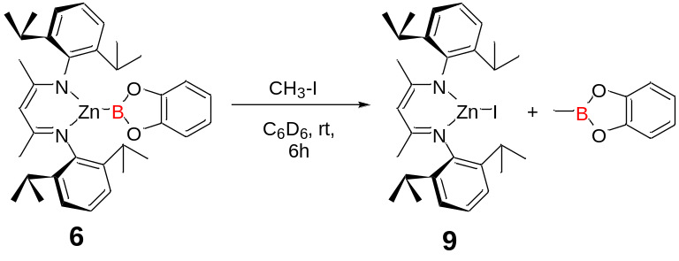
Compound 6 (20.0mg, 0.033 mmol) was dissolved in C₆D₆ (0.55 mL) in a J-Young NMR tube, to which iodomethane (1.9 μL, 0.033 mmol) was added. After 6 hours, the ¹H NMR monitor indicated total conversion, showing the signal of CH₃Bcat and a clear set signal of compound 9, all of which were consistent with the reported data (Figure S31, 32).^{2, 3} HRMS for 9 : simulated (M+H)⁺= 609.1679, found = 609.1639
Synthesis of 10:
Route A
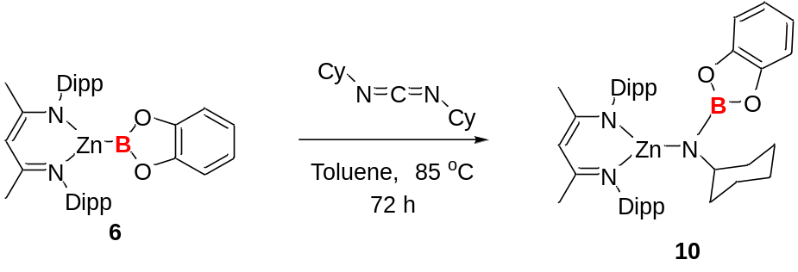
Compound 6 (30.0 mg, 0.05 mmol) was dissolved in 0.5 mL of toluene in a J-Young NMR tube, to which one equivalent of N,N’-dicyclohexylcarbodiimide (10.3mg, 0.05 mmol) was added. The tube was then heated at 85 ⁰C over 72 hours, during which the color of the solution turned from colorless to light green. The solution was extracted and dissolved in 2 mL of hexane, resulting in the precipitation of a small amount of white solid. The solution was then filtered and concentrated to 0.5 mL. Pure products were obtained as colorless single crystals by cooling the concentrated solution at -30 ⁰C with a yield of 52% (36.3 mg).
¹H NMR (600 MHz, C₆D₆) δ (ppm) =7.16 (m, 6H, Ar-Nacnac), 6.97 (dd, J = 5.7, 3.4 Hz, 2H, cat-Ph), 6.79 (dd, J = 5.7, 3.4 Hz, 2H, cat-Ph), 4.90(s, 1H, NC(CH₃)CH), 3.41(hept, J = 6.9 Hz, 4H, CH(CH₃)₂), 3.09 (tt, J = 11.0, 4.0 Hz, 1H, CHN(Bcat)(CH₂)₂, 1.69 (s, 6H, NC(CH₃)CH), 1.53(m, 2H, CH₂-Cy), 1.43(m, 2H, CH₂-Cy), 1.37 (m, 2H, CH₂-Cy), 1.23 (d, J = 6.9 Hz, 12H, CH(CH₃)₂), 1.19 (d, J = 6.8 Hz, 12H, CH(CH₃)₂), 1.02(m, 2H, CH₂-Cy), 0.58(m, 2H, CH₂-Cy).
¹³C NMR (151 MHz, C₆D₆) δ (ppm) =169.13, 150.12, 143.47, 142.06, , 126.04, 123.73, 120.76, 110.66, 95.66, 53.59, 40.00, 28.23, 25.72, 25.44, 24.19, 23.97, 23.41.
¹¹B NMR (193 MHz, C₆D₆) = 26.74.
HRMS: simulated (M+Na)⁺ = 720.3656, found = 720.3984

Route B
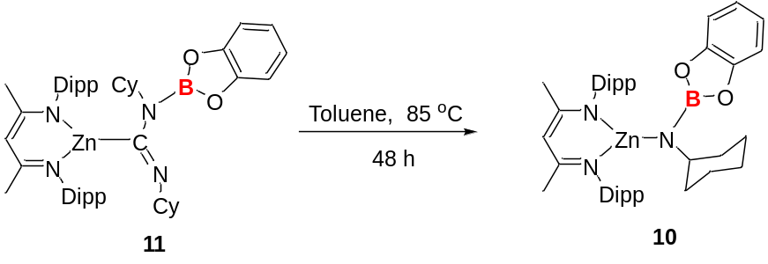
Compound 11 (20 mg, 0.025 mmol) was dissolved in 0.5 mL of toluene in a J-Young NMR tube and then heated at 85 ⁰C over 72 hours; no obvious color change was observed. All the solution was then removed under vacuum and extracted with hexane. Pure products were obtained by cooling the concentrated solution at -30 ⁰C with a yield of 80% (14.0 mg).
Synthesis of 11
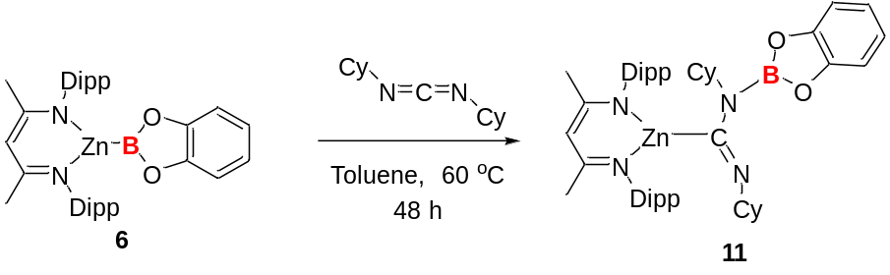
Compound 6 (30.0 mg, 0.05 mmol) was dissolved in 0.5 mL toluene in a J-Young NMR tube, to which one equivalent of N,N’-dicyclohexylcarbodiimide (10.3 mg, 0.05 mmol) was added. The tube was heated at 60 ⁰C for 48 hours until total conversion of compound 6 was monitored. All the solvent was removed under vacuum, the residue was extracted with hexane and filtered to remove insoluble impurities. The pure product was isolated as single crystals by cooling the concentrated solution at -30 ⁰C with a yield of 53% (21.4 mg).
¹H NMR (400 MHz, C₆D₆) δ (ppm) = 7.50 (dd, J = 7.9, 1.3 Hz, 1H, cat- Ph), 7.11 (m, 6H, Ar-Nacnac), 7.01 (m,1H, cat-Ph), 6.94 (td, J = 7.8, 1.3 Hz, 1H, cat-Ph), 6.81 (td, J = 7.9, 1.3 Hz, 1H, cat- Ph), 5.02 (s, 1H, NC(CH₃)CH), 4.95 (ddt, J = 12.0, 7.7, 3.9 Hz, 1H, C=NCH(CH₂)₂), 3.40 (hept, J = 6.9 Hz, 2H, CH(CH₃)₂ ), 3.21 (hept, J = 6.9 Hz, 2H, CH(CH₃)₂), 2.74 (C-NCH(CH₂)₂), 2.11 (m, 2H, CH₂-Cy), 1.93 (m, 2H, CH₂-Cy), 1.81, 1.80 (m, 2H, CH₂-Cy), 1.74 (m, 2H, CH₂-Cy), 1.64 (s, 6H, NC(CH₃)CH), 1.58 (m, 2H, CH₂-Cy), 1.41 (d, J = 6.9 Hz, 6H, CH(CH₃)₂), 1.38 (m, 8H, CH₂-Cy), 1.21 (d, J = 6.8 Hz, 6H, CH(CH₃)₂), 1.17 (m, 2H, CH₂-Cy), 1.06 (d, J = 6.8 Hz, 6H, CH(CH₃)₂), 0.89 (d, J = 6.8 Hz, 6H, CH(CH₃)₂).
¹³C NMR (101 MHz, C₆D₆) δ (ppm) = 175.88, 168.18, 148.74, 146.54, 145.13, 142.91, 141.75, 125.94, 124.23, 123.84, 123.24, 122.35, 112.52, 112.28, 95.02, 69.15, 51.67, 35.95, 32.46, 29.10, 27.60, 27.04, 26.44, 24.95, 24.69, 24.53, 23.99, 23.77, 23.75.
¹¹B NMR (128 MHz, C₆D₆) δ (ppm) = 27.96.
HRMS: simulated (M+H)⁺= 807.4729, found = 807.4793

Synthesis of 12
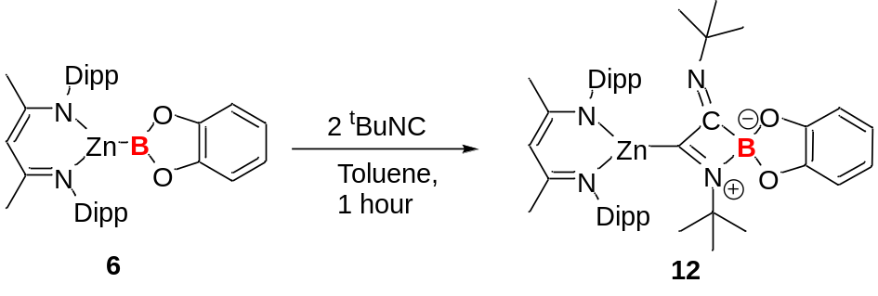
Compound 6 (30.0 mg, 0.05 mmol) was dissolved in 0.5mL of toluene in a vial, to which one equivalent of ^{t}BuNC (8.3 mg, 11.5μL 0.05 mmol) was added. A noticeable color change occured from colorless to dark green and then to dark amber in 60 minutes. The solvent was then removed under vacuum. The residue was extracted with hexane and then filtered to remove insoluble impurities. The pure product was isolated as single crystals by cooling the concentrated solution at -30 ⁰C with a yield of 68% (26.1 mg).
¹H NMR (600 MHz, C₆D₆) δ (ppm) =7.11 (m, 6H, Ar-Nacnac), 7.05 (dd, J = 5.6, 3.3 Hz, 2H，cat- Ph), 6.77 (dd, J = 5.7, 3.3 Hz, 1H, cat- Ph), 4.74 (s, 1H, NC(CH₃)CH), 3.56 (m, 2H, CH(CH₃)₂ ), 3.09 (m, 2H, CH(CH₃)₂ ), 1.59 (s, 6H, NC(CH₃)CH), 1.42 (s, 9H, tBu), 1.25 (m, 12H, CH(CH₃)₂), 1.16 (m, 12H, CH(CH₃)₂), 0.68 (s, 9H, tBu).
¹³C NMR (151 MHz, C₆D₆) δ(ppm) =168.96, 151.68, 143.58, 128.35, 126.50, 120.24, 110.68, 97.03, 58.49, 56.61, 30.77, 28.83, 23.58.
¹¹B NMR (96 MHz, C₆D₆) δ (ppm) = 17.35.
HRMS: simulated (M+H)⁺ = 767.4416, found =767.4410

Synthesis of 13

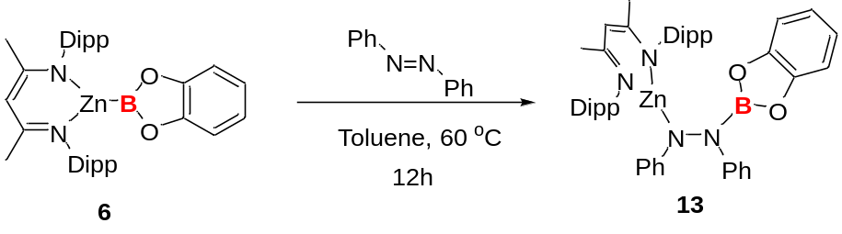
Compound 6 (30.0 mg, 0.05 mmol) was dissolved in 0.5mL of toluene in a J-Young NMR tube, to which one equivalent of azobenzene (9.2 mg, 0.05 mmol) was added. The tube was then heated at 60 ⁰C for 12 hours, during which the deep orange solution gradually faded to light yellow. Afterward, the solvent was removed under vacuum. The residue was then extracted with a mixed solution of toluene/hexane/THF(2:4:1, 0.7 mL). The pure product was isolated as single crystals by cooling the extracted solution at -30°C, yielding 30.2 mg (77%).
¹H NMR (400 MHz, C₆D₆) δ (ppm) = 7.40 (m, 2H, N-Ph), 7.02 (m, 5H, N-Ph), 6.94 (m, 6H, Ar-Nacnac), 6.79 (m, 5H, N-Ph(4H), cat-Ph(1H)), 6.45 (m, 3H, cat-Ph), 4.97 (s, 1H, NC(CH₃)CH), 3.28 (m, br, 4H, CH(CH₃)₂), 1.64 (s, 6H, NC(CH₃)CH), 1.11 (m, br, 24H, CH(CH₃)₂).
¹³C NMR (101 MHz, C₆D₆) δ (ppm) = 170.24, 156.57, 148.82, 145.76, 144.06, 141.93, 129.16, 128.82, 126.63, 124.15, 122.28, 121.66, 117.79, 115.64, 112.27, 111.83, 96.04, 28.73, 24.36, 24.20, 24.02.
¹¹B NMR (128 MHz, C₆D₆) δ (ppm) = 27.02.
HRMS: simulated (M+H)⁺ = 783.3790, found = 783.5130

Reversible generation of compound 6 from compound 13
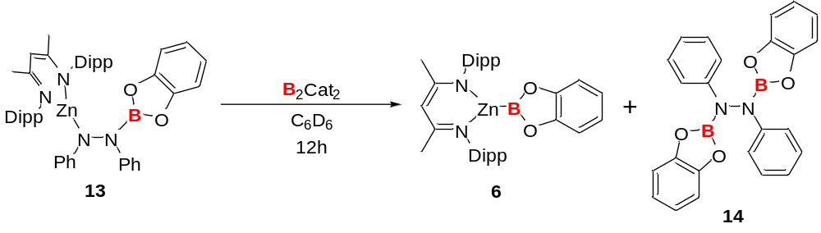
Compound 16 (19.6 mg, 0.025 mmol) was dissolved in 0.5mL of C₆D₆ in a J-Young NMR tube, to which one equivalent of B₂cat₂ (6.0 mg, 0.025 mmol) was added. After 12 hours, the NMR spectrum showed regeneration of compound 6 and a set of signals of diborylated azobenzene products.

Catalytic diborylation of azobenzene catalyzed by compound 6
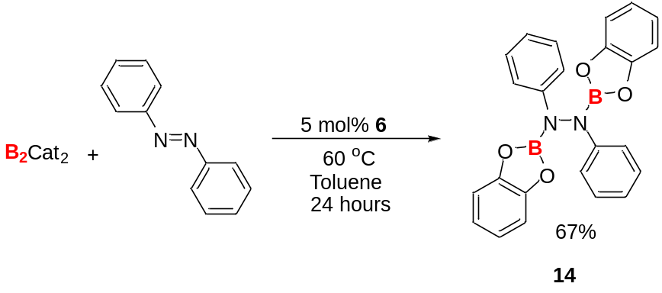
Azobenzene (182.2 mg, 1 mmol), B₂cat₂ (237.8 mg, 1 mmol), and 5% of compound 6 (30 mg, 0.05 mmol) were dissolved in 10 mL of toluene in a sealed Schlenk tube. The solution was heated to 60 ºC and stirred for 24 hours. Afterward, the solvent was removed, and the crude product was recrystallized from concentrated toluene (4 mL) at -30°C. The off-white crystalline product was washed with cold hexane (3 × 3 mL) and further dried under vacuum, yielding 281.4 mg (67%).
¹H NMR (300 MHz, C₆D₆) δ (ppm) = 7.72 (m, 4H, N-Ph), 7.14 (m, 4H, N-Ph), 6.88 (t, J = 7.4 Hz, 1H, N-Ph), 6.81 (dd, J = 5.9, 3.4 Hz, 4H, cat-Ph), 6.66 (dd, J = 5.9, 3.4 Hz, 4H, cat-Ph).
¹³C NMR (101 MHz, C₆D₆) δ (ppm) = 148.73, 129.72, 123.58, 122.74, 117.60, 112.51.
¹¹B NMR (128 MHz, C₆D₆) δ (ppm) = 27.18.
HRMS: simulated (M)⁺= 420.1455, found = 420.3459

NMR spectrum
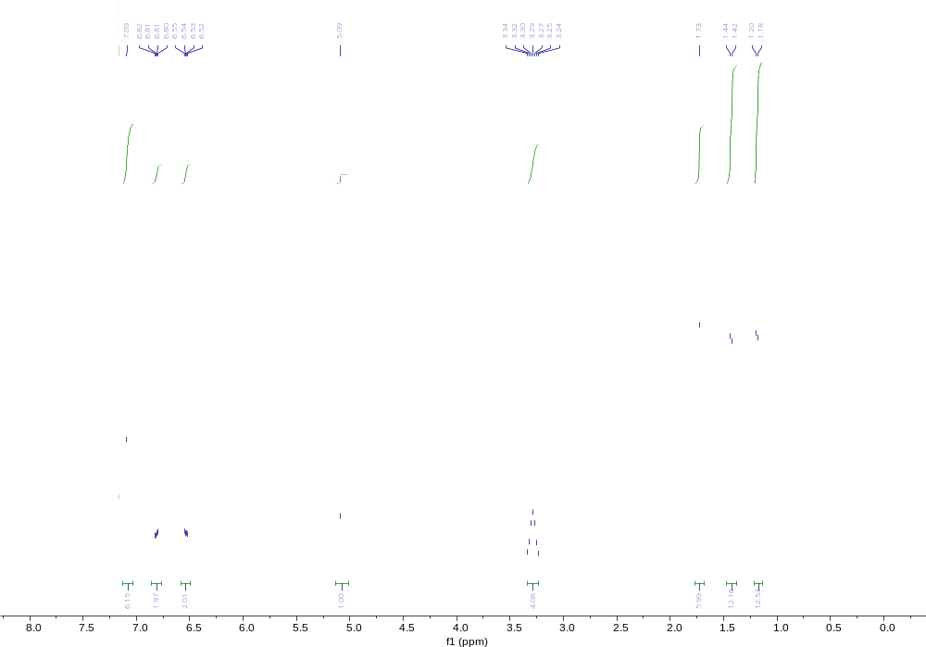
Figure S1: ¹H NMR spectrum of 6 in C₆D₆

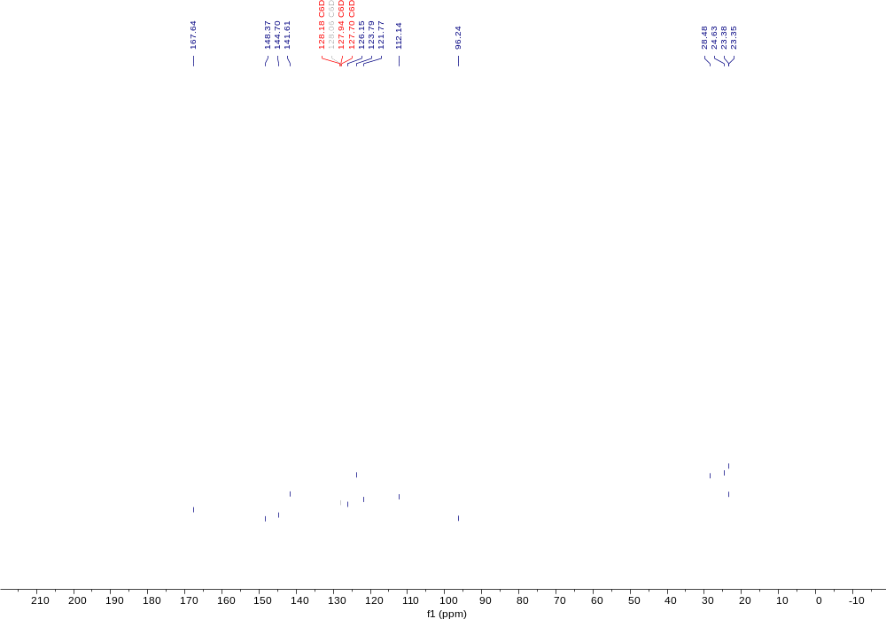
Figure S2: ¹³C NMR spectrum of 6 in C₆D₆

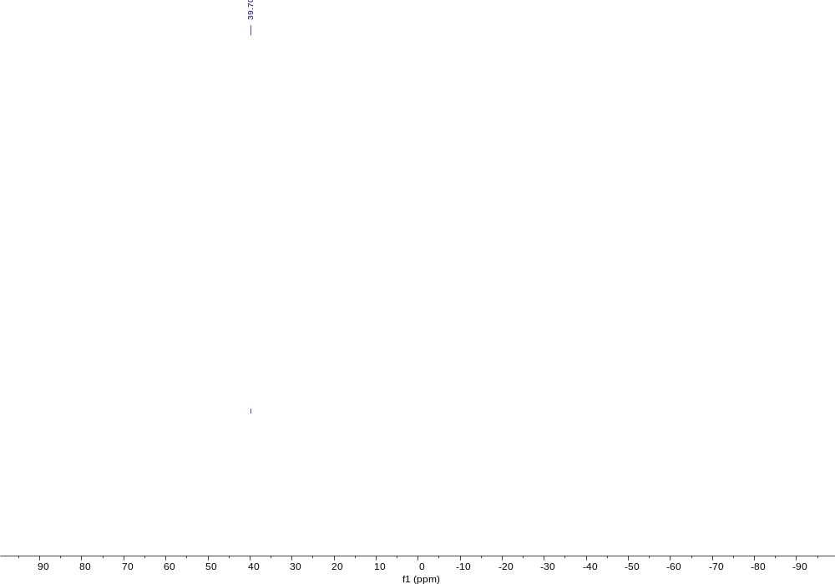
Figure S3: ¹¹B NMR spectrum of 6 in C₆D₆

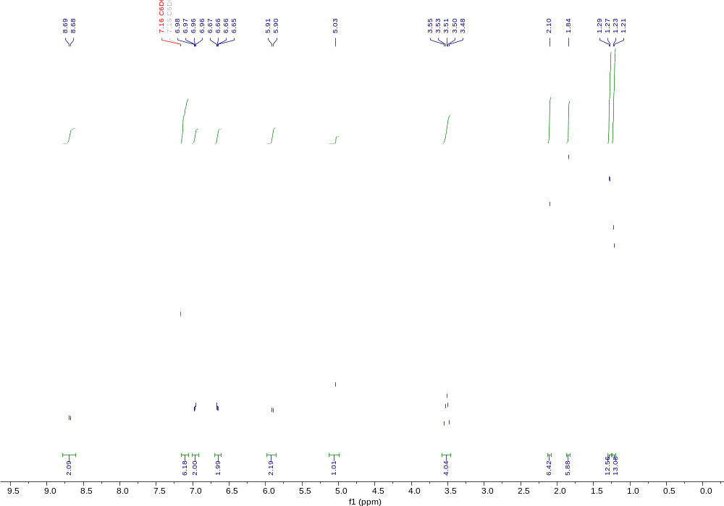 Figure S4: ¹H NMR spectrum of 8 in C₆D₆

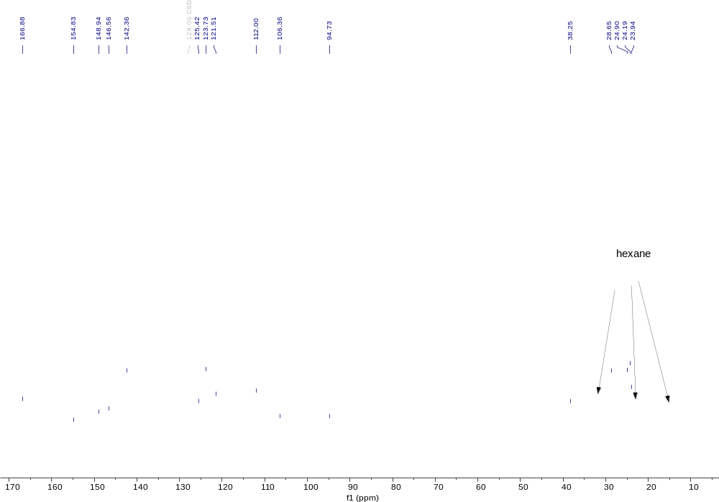
Figure S5: ¹³C NMR spectrum of 8 in C₆D₆

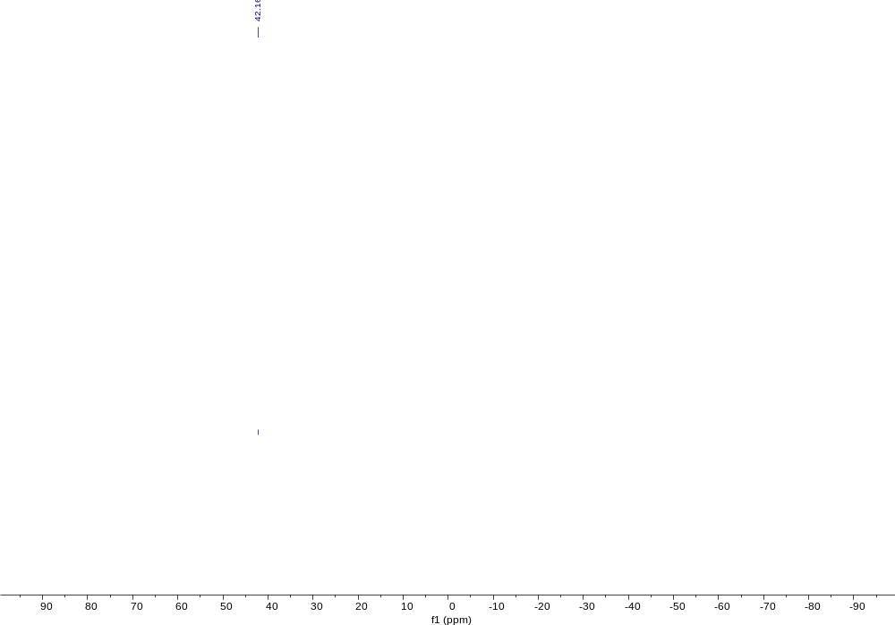
Figure S6: ¹¹B NMR spectrum of 8 in C₆D₆

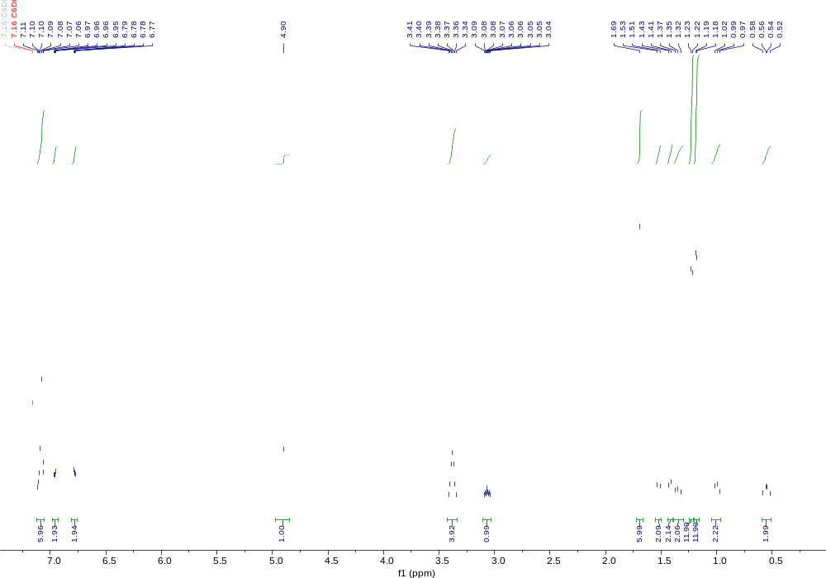
Figure S7: ¹H NMR spectrum of 10 in C₆D₆.
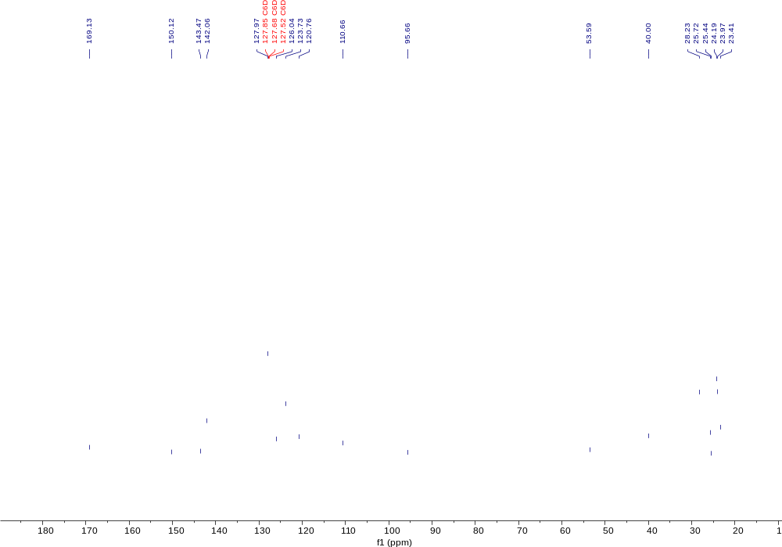 Figure S8: ¹³C NMR spectrum of 10 in C₆D₆.

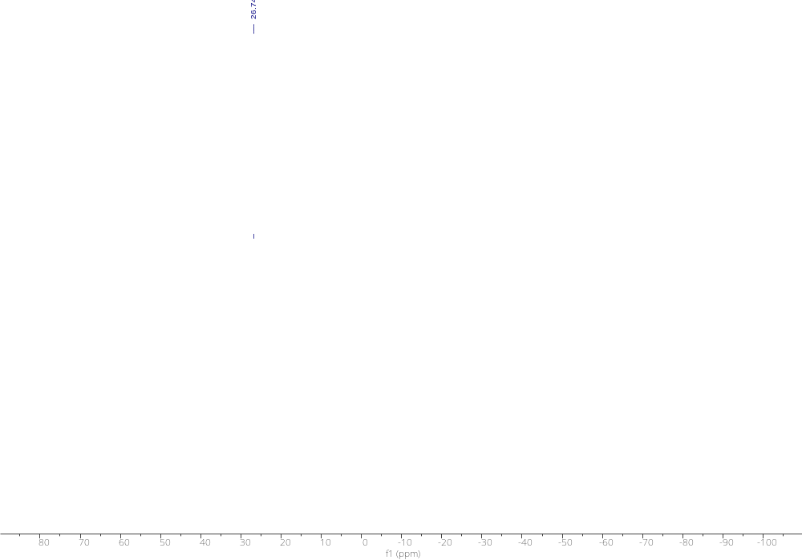 Figure S9: ¹¹B NMR spectrum of 10 in C₆D₆
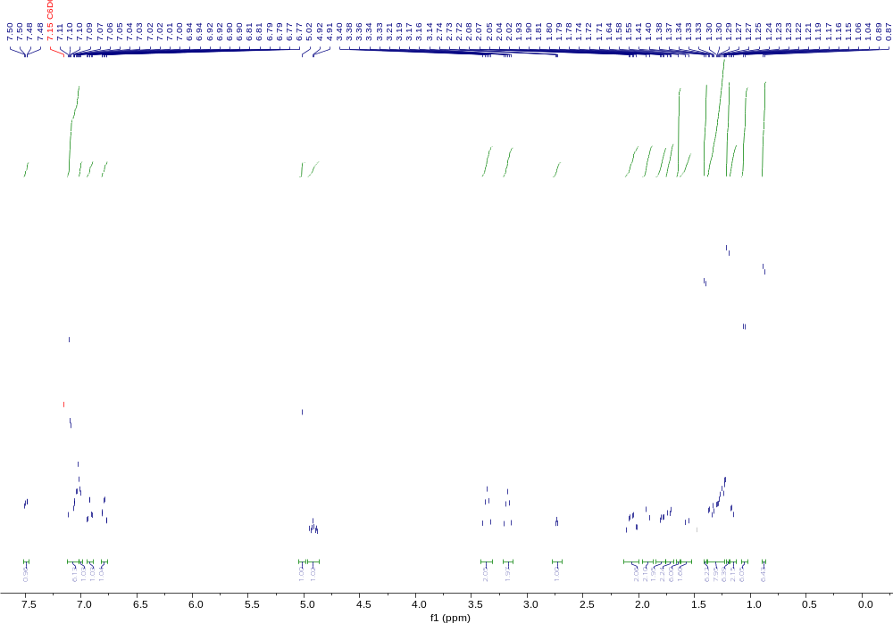 Figure S10: ¹H NMR spectrum of 11 in C₆D₆.

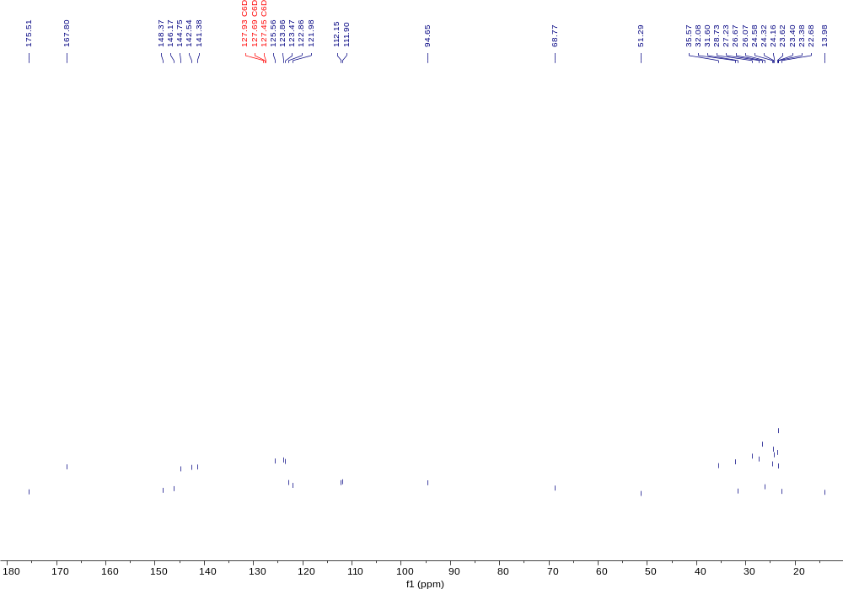 Figure S11: ¹³C NMR spectrum of 11 in C₆D₆.
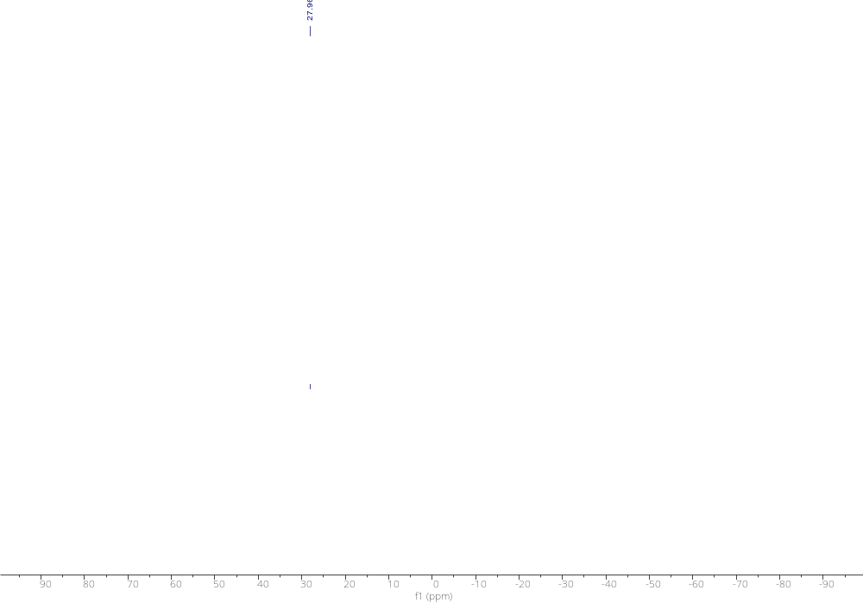 Figure S12: ¹¹B NMR spectrum of 11 in C₆D₆
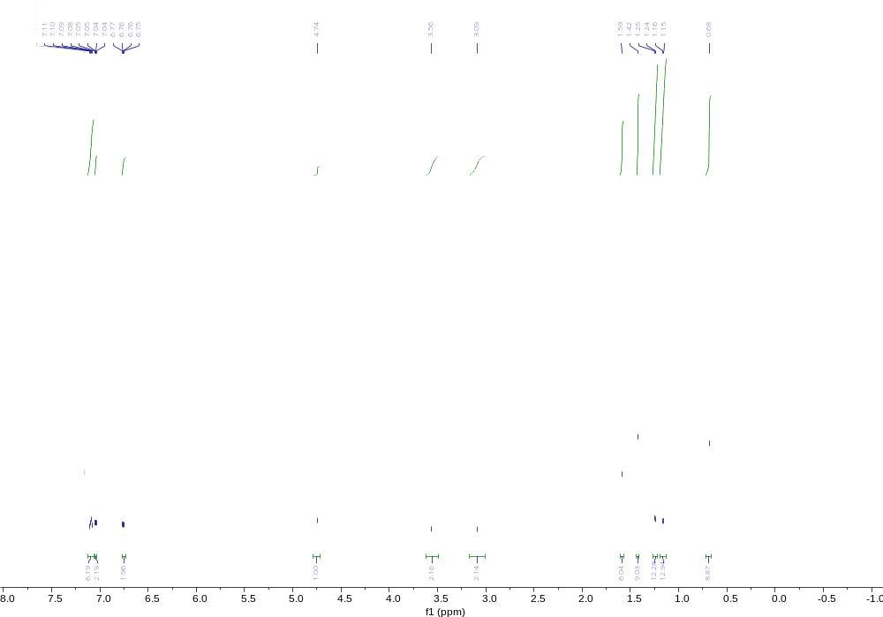
Figure S13: ¹¹H NMR spectrum of 12 in C₆D₆
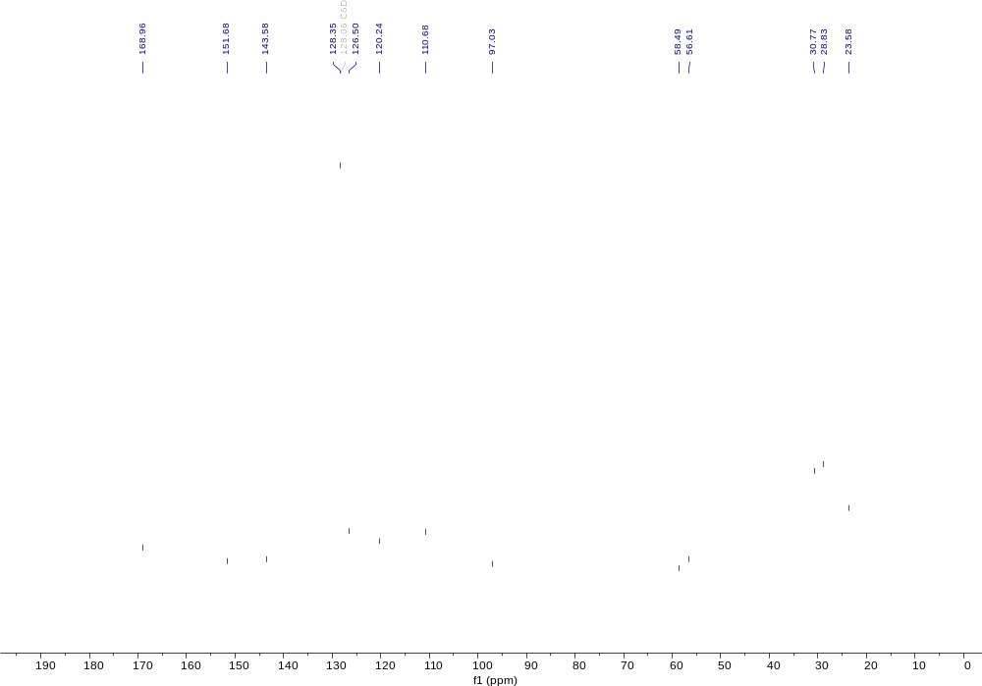
Figure S14: ¹³C NMR spectrum of 12 in C₆D₆
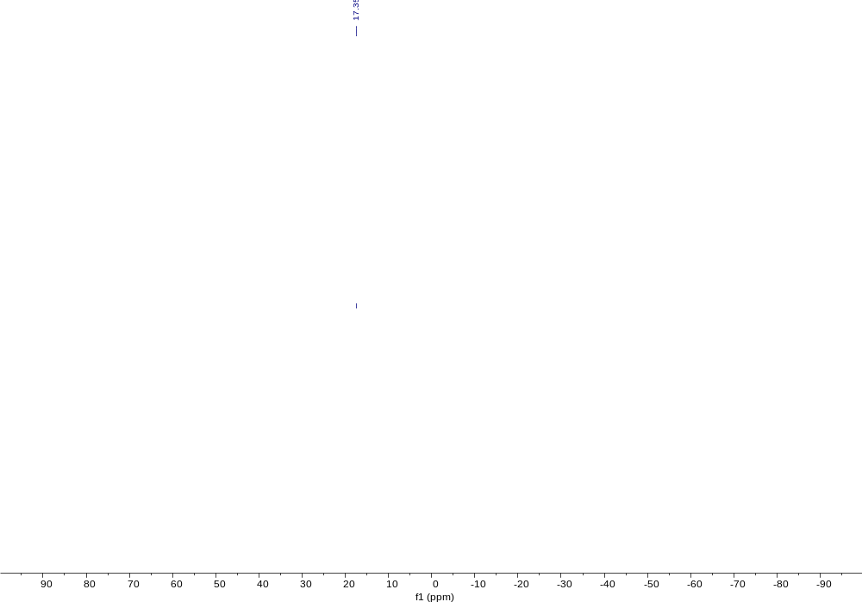
Figure S15: ¹¹B NMR spectrum of 12 in C₆D₆

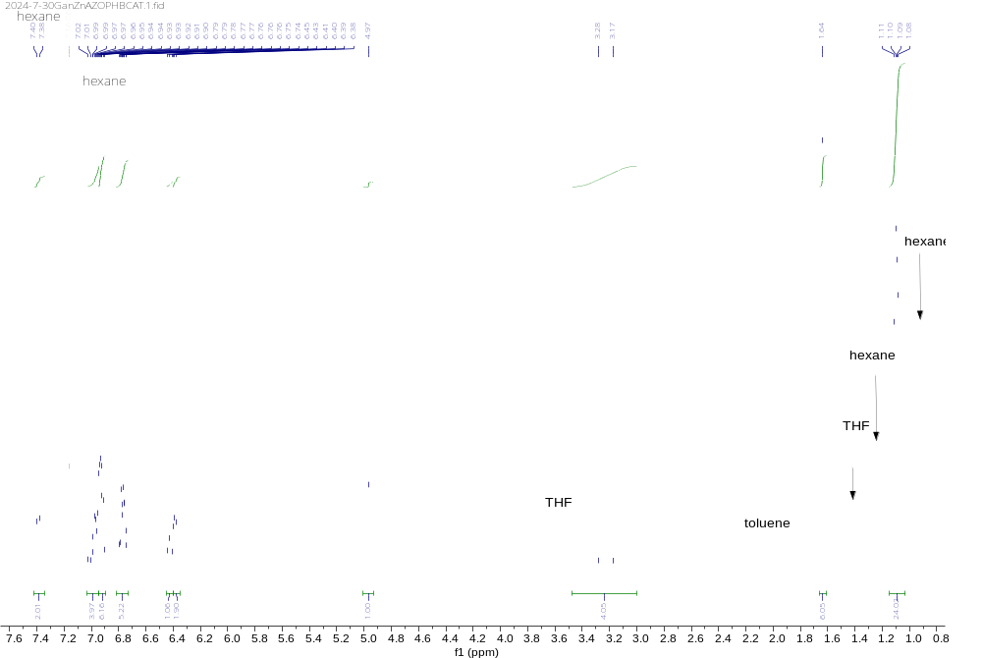
Figure S16: ¹H NMR spectrum of 13 in C₆D₆.

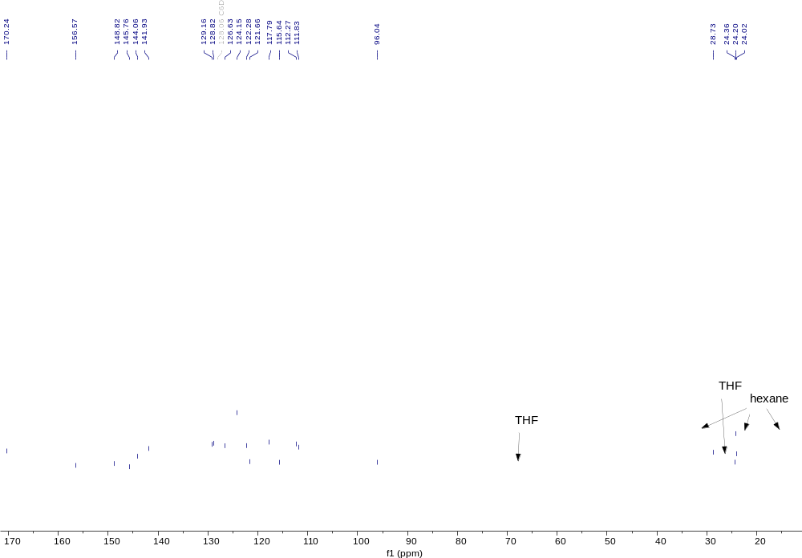 Figure S17: ¹³C NMR spectrum of 13 in C₆D₆.
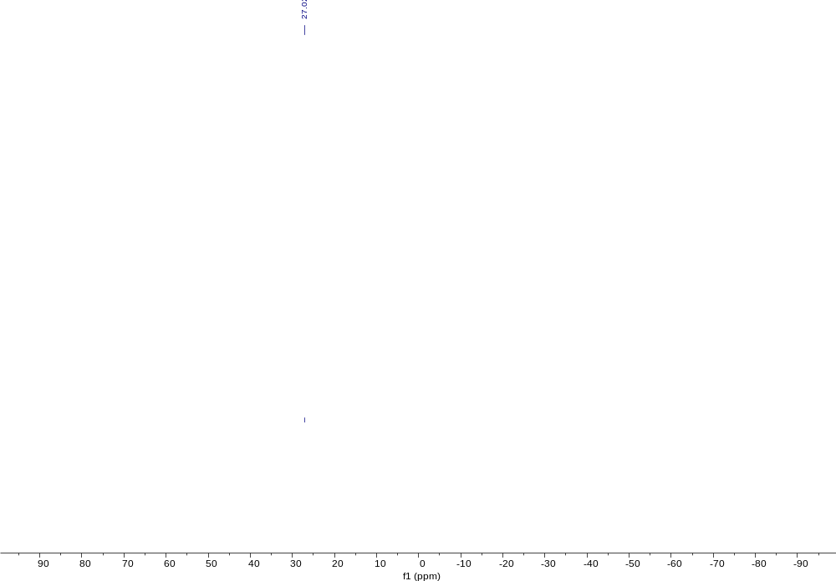
Figure S18: ¹¹B NMR spectrum of 13 in C₆D₆.
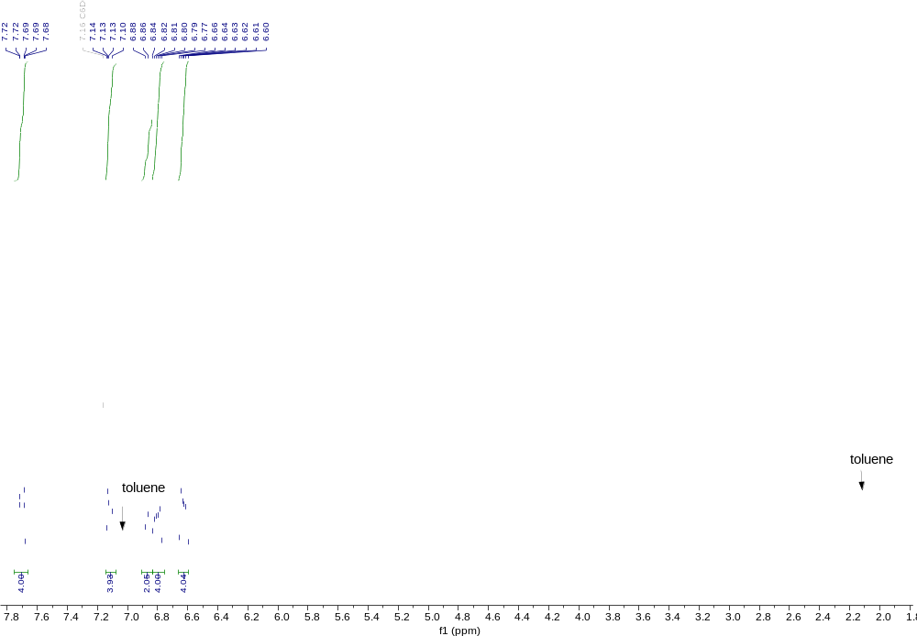
Figure S19: ¹H NMR spectrum of 14 in C₆D₆.

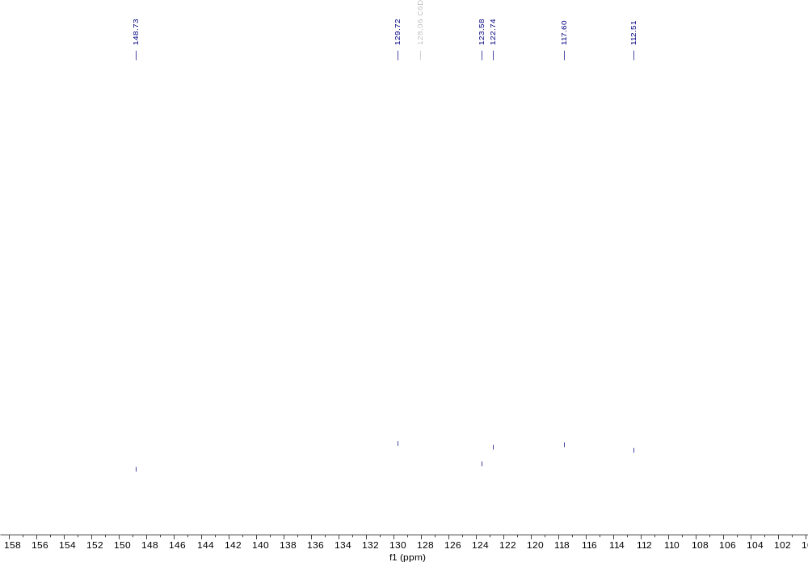
Figure S20: ¹³C NMR spectrum of 14 in C₆D₆.

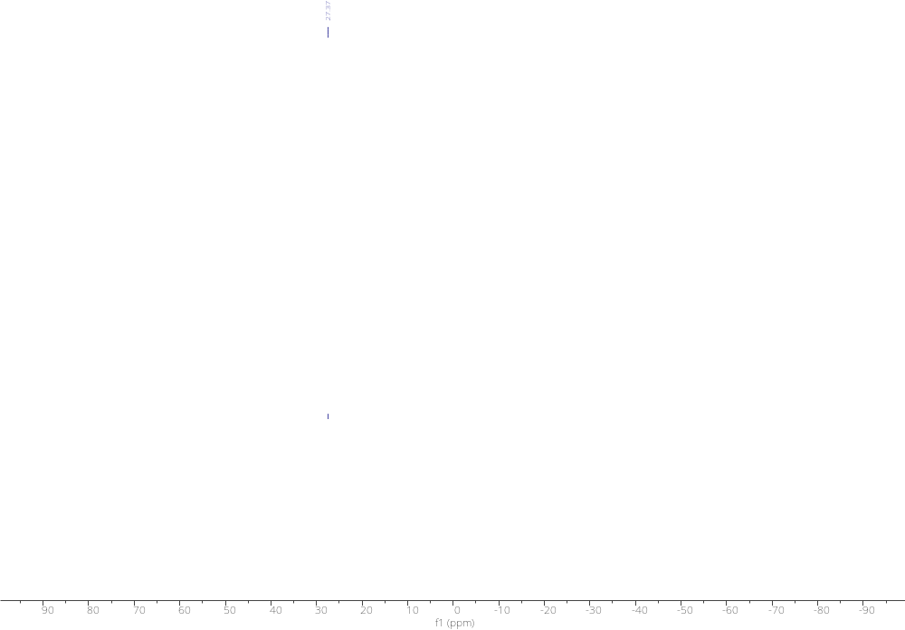 Figure S21: ¹¹B NMR spectrum of 14 in C₆D₆.

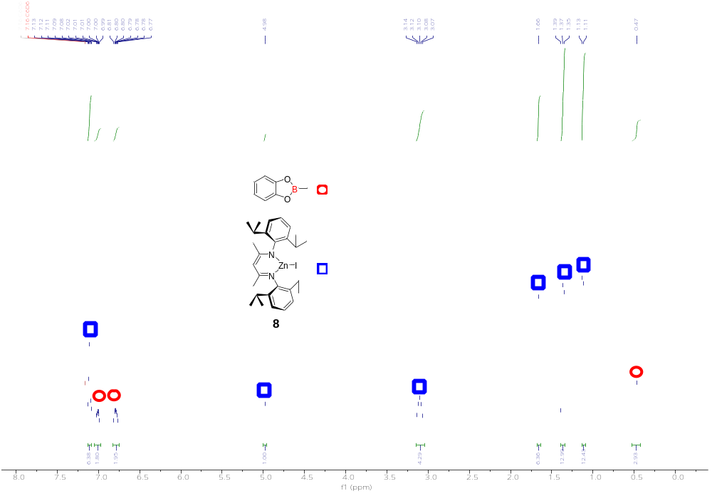
Figure S22: In-situ ¹¹H NMR spectrum of the reaction CH₃-I with compound 6 .
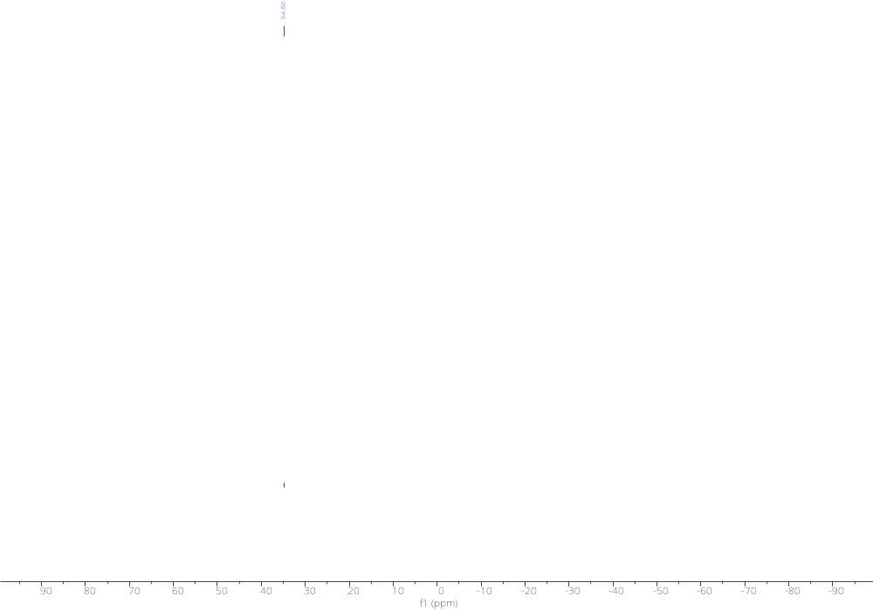
Figure S23: In-situ ¹¹B NMR spectrum of the reaction CH₃-I with compound 6
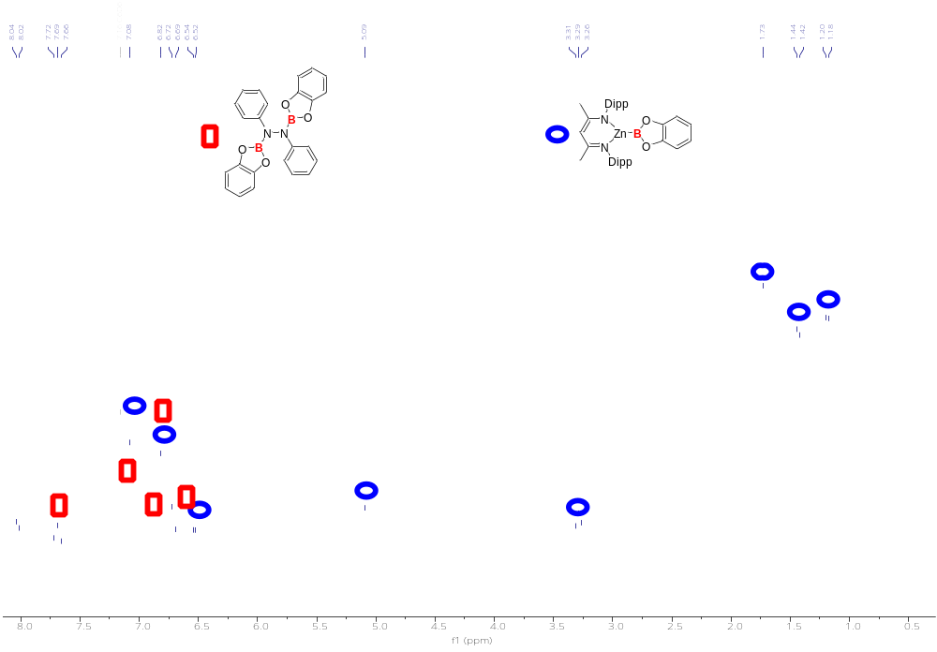
Figure S24: In-situ ¹H NMR spectrum of the reaction B₂cat₂ with compound 13

X-Ray Single-Crystal Diffraction
Single crystals of 6, 8, 10, 12 and 13 were mounted on a Hampton loop using polybutene and diffracted on a Bruker D8 Venture diffractometer with a PHOTON II CMOS detector at 100(2)K using Cu-Kα radiation (λ = 1.54178 Å) or Mo-Kα radiation (λ = 0.71073Å). Single crystals of 11 were mounted on a Hampton loop using APIEZON N Grease and diffracted on a Rigaku XtaLAB Synergy-S diffractometer with a CCD detector at room temperature using Cu-Kα radiation (λ = 1.54178 Å). Data was collected using multi-scan (φ and ω scans). All Bruker data were integrated by SANIT and scaled with either a numerical or multi-scan absorption correction using SADABS⁴, and Rigaku data was integrated and scaled using CrysAlisPr Packages. Structures were solved by SHELXT⁵ and refined with SHELXL⁶ using the OLEX2⁷ program. All non-hydrogen atoms were refined anisotropically, and all hydrogen atoms were added at idealized positions and refined using the riding model. X-ray crystallographic data have been deposited with the Cambridge Crystallographic Data Center: 2385047 (for 11), 2385048 (for 13), 2385050 (for 8), 2385052 (for 10), 2385054 (for 6), and 2385056 (for 12) .

Identification code | 2385056 | 2385054 | 2385048
Empirical formula | C51 H77 B N4 O2 Zn | C76 H104 B2 N4 O4 Zn2 | C50 H62 B N4 O2 Zn
Formula weight | 854.34 | 1289.99 | 827.21
Temperature | 99.99 K | 100.00 K | 100.00 K
Wavelength | 0.71073 Å | 1.54178 Å | 1.54178 Å
Crystal system | Triclinic | Monoclinic | Triclinic
Space group | P-1 | P 1 21/n 1 | P-1
Unit cell dimensions | a = 11.3848(7) Å α= 81.733(2)°. | a = 13.3489(2) Å α= 90°. | a = 10.9759(13) Å α= 100.700(13)°.
 | b = 13.2226(8) Å β= 82.039(2)°. | b = 14.1103(2) Å β= 91.4610(10)°. | b = 11.303(3) Å β= 91.091(9)°.
 | c = 17.9690(9) Å γ = 66.802(2)°. | c = 18.9440(3) Å γ = 90°. | c = 19.281(4) Å γ = 108.195(15)°.
Volume | 2450.5(2) Å³ | 3567.08(9) Å³ | 2225.4(8) Å³
Z | 2 | 2 | 2
Density (calculated) | 1.158 Mg/m³ | 1.201 Mg/m³ | 1.234 Mg/m³
Absorption coefficient | 0.542 mm⁻¹ | 1.204 mm⁻¹ | 1.093 mm⁻¹
F(000) | 924 | 1380 | 882
Crystal size | 0.06 x 0.06 x 0.05 mm³ | 0.08 x 0.06 x 0.04 mm³ | 0.14 x 0.05 x 0.04 mm³
Theta range for data collection | 2.300 to 27.551°. | 3.907 to 70.019°. | 2.340 to 68.283°.
Index ranges | -14<=h<=13, -17<=k<=17, -23<=l<=23 | -11<=h<=15, -17<=k<=16, -23<=l<=23 | -13<=h<=13, -13<=k<=13, 0<=l<=23
Reflections collected | 40247 | 44784 | 7964
Independent reflections | 11269 [R(int) = 0.0834] | 6712 [R(int) = 0.0353] | 7964 [R(int) = ?]
Completeness to theta = 25.242° | 99.90% | 99.40% | 97.80%
Absorption correction | Semi-empirical from equivalents | Semi-empirical from equivalents | Semi-empirical from equivalents
Max. and min. transmission | 0.7456 and 0.6469 | 0.7533 and 0.6723 | 0.652 and 0.411
Refinement method | Full-matrix least-squares on F² | Full-matrix least-squares on F² | Full-matrix least-squares on F²
Data / restraints / parameters | 11269 / 0 / 550 | 6712 / 64 / 437 | 7964 / 0 / 535
Goodness-of-fit on F2 | 1.037 | 1.057 | 1.071
Final R indices [I>2sigma(I)] | R1 = 0.0574, wR2 = 0.1299 | R1 = 0.0336, wR2 = 0.0880 | R1 = 0.0403, wR2 = 0.0949
R indices (all data) | R1 = 0.0935, wR2 = 0.1565 | R1 = 0.0373, wR2 = 0.0909 | R1 = 0.0457, wR2 = 0.1001
Largest diff. peak and hole | 0.594 and -0.588 e.Å⁻³ | 0.743 and -0.558 e.Å⁻³ | 0.520 and -0.413 e.Å⁻³
Crystal table
Identification code | 2385047 | 2385052 | 2385050
Empirical formula | C48 H67 B N4 O2 Zn | C41 H56 B N3 O2 Zn | C42 H55 B N4 O2 Zn
Formula weight | 808.23 | 699.06 | 724.08
Temperature | 298 K | 100.00 K | 100.00 K
Wavelength | 1.54178 Å | 1.54178 Å | 1.54178 Å
Crystal system | Orthorhombic | Monoclinic | Monoclinic
Space group | P2₁2₁2₁ | P 1 21/n 1 | P 1 21/c 1
Unit cell dimensions | a = 12.1946(4) Å α= 90°. | a = 12.2475(3) Å α= 90°. | a = 12.6072(4) Å α= 90°.
 | b = 18.2169(6) Å β= 90°. | b = 19.2194(5) Å β= 95.633(2)°. | b = 19.2243(8) Å β= 94.982(3)°.
 | c = 20.8605(6) Å γ = 90°. | c = 16.4279(4) Å γ = 90°. | c = 16.2759(6) Å γ = 90°.
Volume | 4634.1(3) Å³ | 3848.28(17) Å³ | 3929.8(3) Å³
Z | 4 | 4 | 4
Density (calculated) | 1.158 Mg/m³ | 1.207 Mg/m³ | 1.224 Mg/m³
Absorption coefficient | 1.035 mm⁻¹ | 1.162 mm⁻¹ | 1.165 mm⁻¹
F(000) | 1736 | 1496 | 1544
Crystal size | 0.09 x 0.04 x 0.02 mm³ | 0.08 x 0.08 x 0.05 mm³ | 0.09 x 0.05 x 0.03 mm³
Theta range for data collection | 3.221 to 68.263°. | 3.549 to 68.274°. | 3.519 to 72.380°.
Index ranges | -14<=h<=12, -20<=k<=21, -24<=l<=25 | -14<=h<=14, -18<=k<=23, -15<=l<=19 | -15<=h<=12, -23<=k<=16, -17<=l<=19
Reflections collected | 17608 | 25279 | 21793
Independent reflections | 7698 [R(int) = 0.0689] | 6993 [R(int) = 0.0529] | 7541 [R(int) = 0.1047]
Completeness to theta = 25.242° | 99.60% | 99.30% | 98.60%
Absorption correction | Semi-empirical from equivalents | Semi-empirical from equivalents | None
Max. and min. transmission | 1 and 0.65482 | 0.7531 and 0.6660 | 0.7536 and 0.4740
Refinement method | Full-matrix least-squares on F² | Full-matrix least-squares on F² | Full-matrix least-squares on F²
Data / restraints / parameters | 7698 / 0 / 515 | 6993 / 0 / 443 | 7541 / 108 / 523
Goodness-of-fit on F2 | 0.98 | 1.017 | 1.021
Final R indices [I>2sigma(I)] | R1 = 0.0679, wR2 = 0.1666 | R1 = 0.0350, wR2 = 0.0833 | R1 = 0.0524, wR2 = 0.1208
R indices (all data) | R1 = 0.0798, wR2 = 0.1768 | R1 = 0.0440, wR2 = 0.0873 | R1 = 0.0813, wR2 = 0.1363
Largest diff. peak and hole | 0.699 and -0.502 e.Å⁻³ | 0.380 and -0.287 e.Å⁻³ | 0.574 and -0.703 e.Å⁻³

Computational Details
For Natural Population Analysis (NPA) and orbital energy calculations, the methodology used in the literature of Mg-Bpin⁸ was employed for the purpose of meaningful comparison with the computational result from the literature. Within this literature methodology, using G09 Gaussian package⁹ at the BP86¹⁰ level of theory was used. SDD basis set with associated pseudopotential was used for Zn¹¹ and Mg¹² atoms, and 6-31G** was used for the rest of the atoms¹³. Ultrafine grid was employed. NPA charge was calculated using NBO version 3¹⁴ with the better basis set 6-311++G**basis set for all atoms.
For the energy profiles presented, DFT calculations were carried out using G16 Gaussian package¹⁵ at the ωB97X-D¹⁶ level of theory. 6-311G* basis set was used for all atoms¹⁷ for optimization. The switch of the DFT methodology considers that the energy barriers obtained with the DFT methodology above are too low to be reasonable. Single point calculation was also carried out using 6-311+G* basis set for all atoms and solvation effect of toluene is added using SMD model¹⁸. Vibrational frequency calculation was performed to verify all optimized intermediates as local minima and all optimized transition states as local maxima and to give relative free energies at 298 K. Intrinsic Reaction Coordinate¹⁹ (IRC) calculation was performed on optimized transition states to ensure that the transition states are on the same reaction pathway as the preceding and subsequent intermediates in the energy profile.

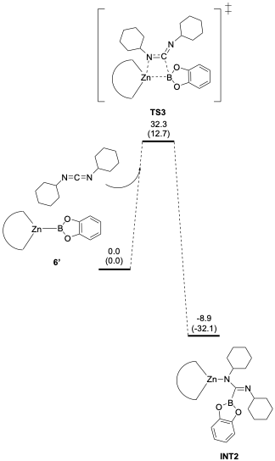
Figure S25. Energy Profile considering nucleophilic attack of Bcat of 6' on DCC.

Cartesian Coordiantes of Optimized Structure
6' (BP86 functional)
Charge:0 Multiplicity:1 E=-1558.519307 G=-1558.101122
Zn 0.00800600 -0.35111000 -0.00090000
O -0.05217400 2.49481900 1.15537800
O -0.05015400 2.49553900 -1.15637100
N -1.44255300 -1.71478800 -0.00038900
N 1.51211800 -1.65526100 -0.00025700
C -2.79021900 -1.21673100 0.00001300
C 1.34044100 -2.99199700 -0.00054900
C -1.21722100 -3.04350100 -0.00064900
C -3.42897800 -0.93464500 1.23552700
C 2.83867800 -1.10344600 0.00026200
C -0.07963800 3.80453000 0.70198700
C 0.07376300 -3.62128100 -0.00087300
H 0.09577200 -4.71345800 -0.00122900
C 3.46551700 -0.79598600 1.23583400
C -0.07842100 3.80497000 -0.70220900
C 3.46621700 -0.79530200 -1.23478900
C -3.42942900 -0.93387700 -1.23509800
C -0.10553900 4.98631100 1.44079400
H -0.10626700 4.97414800 2.53407200
C -2.71672500 -1.18392300 2.54684600
H -1.79697700 -0.57550100 2.62354400
C -2.40435700 -3.99383200 -0.00056600
H -3.04378100 -3.82748600 0.88335100
H -2.07356200 -5.04264500 -0.00213400
H -3.04577700 -3.82534100 -0.88260100
C 2.76337500 -1.07274300 2.54711000
H 1.82131700 -0.49945500 2.62416400
C -4.73066500 -0.39899300 1.21261200
H -5.23076400 -0.18218900 2.16363800
C 2.56487200 -3.89371700 -0.00037200
H 2.27658200 -4.95500600 -0.00212200
H 3.19692800 -3.70186400 0.88367600
H 3.19915700 -3.69941300 -0.88225400
B -0.03392500 1.68129100 -0.00074900
C -0.13060600 6.18899000 0.70490500
H -0.15147200 7.14225200 1.24241500
C 4.74488400 -0.20900500 1.21304100
H 5.23581100 0.02763600 2.16411600
C -4.73111000 -0.39823200 -1.21138900
H -5.23154700 -0.18084100 -2.16210300
C -5.38388300 -0.13580700 0.00081200
H -6.39600200 0.28192800 0.00113300
C 4.74557200 -0.20832900 -1.21095900
H 5.23702700 0.02884300 -2.16162800
C 5.38727600 0.07982400 0.00130300
H 6.38202000 0.53739700 0.00171400
C -0.12938100 6.18942900 -0.70373600
H -0.14931000 7.14302500 -1.24068800
C 2.76484900 -1.07145500 -2.54660100
H 1.82245400 -0.49872000 -2.62364000
C -0.10303700 4.98720700 -1.44032800
H -0.10185900 4.97572300 -2.53361300
C -2.71768300 -1.18245500 -2.54682300
H -1.79780000 -0.57422100 -2.62344300
H -3.36571500 -0.92456400 -3.39970900
H -2.40487600 -2.23534600 -2.66175900
H 3.40276800 -0.78922400 -3.39941100
H 2.49247400 -2.13553500 -2.66130600
H 3.40108100 -0.79157200 3.40042900
H 2.49025900 -2.13672900 2.66086400
H -3.36453500 -0.92675100 3.40011800
H -2.40361200 -2.23680500 2.66100300

Mg-Bpin Complex
Charge:0 Multiplicity:1 E=-2232.965214 G=-2232.110281
Mg -0.15610700 0.02137700 -0.11228800
O -2.27822700 0.04717100 2.49977700
O -0.09088700 -0.12782600 3.18170700
N -0.33115200 1.62188400 -1.50655800
N -0.56961000 -1.44167600 -1.60173600
N 2.05595700 -0.14036900 0.07501300
N 6.25088200 -0.47935100 0.53282700
C -0.16343800 2.58822800 -3.78744700
H -1.14012100 3.10278500 -3.78694800
H 0.05622600 2.26577200 -4.81589100
H 0.58012500 3.34223400 -3.48191800
C -0.18662200 1.40530800 -2.82656100
C -0.09229000 0.11984300 -3.42775900
H 0.07002000 0.14076100 -4.50846400
C -0.37798400 -1.17152700 -2.90567600
C -0.51504000 -2.28674700 -3.93553300
H 0.05951300 -3.17990900 -3.64061600
H -0.18108700 -1.95658100 -4.93040000
H -1.56762500 -2.61008300 -4.01589700
C -0.58996400 2.96209100 -1.04411700
C -1.93870600 3.39386700 -0.86555900
C -3.13518000 2.49325200 -1.17931600
H -2.73877800 1.51320400 -1.49745100
C -4.01100500 2.26410000 0.07342100
H -3.44215400 1.77675500 0.88222700
H -4.87134300 1.61775800 -0.17388400
H -4.41524400 3.21696200 0.45984300
C -3.98449000 3.05682500 -2.34220700
H -4.81625300 2.37124200 -2.58224000
H -3.38567400 3.19590500 -3.25858500
H -4.42395700 4.03585900 -2.08008000
C -2.17978500 4.69421300 -0.38111900
H -3.21573500 5.02774700 -0.25058800
C -1.13194600 5.56476400 -0.06316300
H -1.34184500 6.57304000 0.30985200
C 0.18755400 5.12729400 -0.21904800
H 1.01300400 5.80025000 0.04123500
C 0.48414100 3.83792700 -0.70221000
C 1.94987900 3.41568400 -0.81143500
H 1.97034700 2.40293900 -1.24766900
C 2.77251900 4.34543500 -1.73218900
H 2.81844600 5.37368200 -1.33186500
H 2.34537600 4.40507500 -2.74768000
H 3.81066000 3.97897600 -1.82258000
C 2.60243900 3.33895400 0.58783000
H 3.63493600 2.95304700 0.51797500
H 2.03293300 2.67564800 1.25866900
H 2.64519200 4.33665800 1.06028900
C -1.05462600 -2.74497300 -1.22474800
C -2.46094500 -2.97507800 -1.14406000
C -3.48754400 -1.88676600 -1.46415500
H -2.93106400 -0.98125900 -1.76203900
C -4.32906300 -1.53393200 -0.21618500
H -5.06658600 -0.74874600 -0.45951800
H -3.69707000 -1.16623600 0.60929600
H -4.89066000 -2.41399100 0.14591200
C -4.40413700 -2.28479000 -2.64380800
H -5.01326500 -3.17327600 -2.39935100
H -3.82530400 -2.51948200 -3.55357500
H -5.09938500 -1.46225100 -2.88752000
C -2.92185700 -4.24233700 -0.73798000
H -4.00194100 -4.41999100 -0.67890100
C -2.03616100 -5.27349100 -0.40652900
H -2.41608800 -6.25277100 -0.09590500
C -0.65921100 -5.03461400 -0.46800900
H 0.03993400 -5.83499200 -0.19837400
C -0.14586700 -3.78567000 -0.86878600
C 1.36942500 -3.58398000 -0.88470200
H 1.56098800 -2.56263200 -1.25385600
C 2.08938100 -4.57142200 -1.83080500
H 3.17472800 -4.36670900 -1.85027800
H 1.71245200 -4.49852000 -2.86522200
H 1.95505400 -5.61724400 -1.50222500
C 1.95237200 -3.68564000 0.54325200
H 1.45672000 -2.97875200 1.22867100
H 3.03385400 -3.46162700 0.54160800
H 1.81832200 -4.70174500 0.95569700
C 2.89131800 -0.17607900 -0.99561100
H 2.40879600 -0.11314500 -1.97905800
C 4.27551500 -0.28592900 -0.90029700
H 4.86778400 -0.30791700 -1.81697800
C 4.88891400 -0.36861900 0.38444900
C 4.00806400 -0.32992000 1.50325700
H 4.38524500 -0.38664400 2.52602700
C 2.63427900 -0.21774600 1.30252100
H 1.94192400 -0.18661600 2.15420700
C 7.11527500 -0.51498200 -0.64413300
H 6.88584600 -1.37998100 -1.29510800
H 8.16143300 -0.60236700 -0.31976200
H 7.02108500 0.40689100 -1.24887300
C 6.83519100 -0.56583300 1.86906500
H 6.61004700 0.33379100 2.47260200
H 7.92701100 -0.65078600 1.77958800
H 6.46663500 -1.45203500 2.41961100
B -0.94584300 -0.02122900 2.06627300
C -2.33547800 -0.23369500 3.94201800
C -0.86854100 0.09500800 4.41054500
C -3.42974800 0.64244000 4.56144300
H -4.40908300 0.36516000 4.13758100
H -3.48037400 0.49896500 5.65549500
H -3.26199100 1.70995300 4.35471000
C -2.70535800 -1.72150300 4.08661200
H -3.65223400 -1.90731400 3.55437300
H -1.93422800 -2.36747100 3.63692400
H -2.83968600 -2.01125700 5.14334300
C -0.31303800 -0.81953000 5.50772800
H -0.90023200 -0.72371600 6.43825200
H -0.31791600 -1.87531200 5.19800800
H 0.72835600 -0.53631800 5.73620500
C -0.66539200 1.57125500 4.79897400
H 0.41375300 1.76782200 4.91048600
H -1.05305100 2.24274000 4.01613000
H -1.16098400 1.81738600 5.75408500

6’ (B97x-D functional)
Chage:0 Multiplicity:1 E=-3110.016499 G=-3109.574245
Zn -0.02703800 -0.38473400 0.08511100
O 0.16561300 2.46520200 1.26218500
O 0.15682900 2.41088600 -1.02103700
N -1.55315400 -1.55959600 -0.10413300
N 1.33460300 -1.74673800 -0.10520700
C -2.84025800 -0.95881700 0.02418700
C 1.07038300 -3.01484100 -0.40675700
C -1.45477900 -2.85127100 -0.40566200
C -3.48509000 -0.97007300 1.27043800
C 2.68834900 -1.31658200 0.02289200
C 0.25070300 3.74360000 0.78439800
C -0.23082700 -3.52830300 -0.54650200
H -0.29904900 -4.57967500 -0.80270000
C 3.32724100 -1.41219900 1.26861400
C 0.24538400 3.71144600 -0.60645700
C 3.32738400 -0.72943600 -1.07976500
C -3.39971600 -0.29622400 -1.07895800
C 0.33236400 4.93089200 1.48735200
H 0.33570100 4.94294600 2.57302800
C -2.82631300 -1.61976500 2.46099400
H -1.86442700 -1.13966000 2.68647500
C -2.71941300 -3.65003300 -0.63432900
H -3.35896600 -3.63601000 0.25577400
H -2.49367000 -4.68888500 -0.88737300
H -3.30772100 -3.20874200 -1.44791100
C 2.59149400 -1.97407700 2.45878700
H 1.69927300 -1.37505200 2.68603700
C -4.72680500 -0.34440100 1.38505200
H -5.23763700 -0.35008400 2.34616900
C 2.22120400 -3.96994700 -0.63689700
H 1.86310400 -4.97098400 -0.88971400
H 2.85834400 -4.03875100 0.25236800
H 2.86052800 -3.60804900 -1.45117400
B 0.10657500 1.62605700 0.14372700
C 0.40975900 6.10557400 0.73089600
H 0.47542700 7.06224600 1.24275800
C 4.63886700 -0.95078500 1.38311800
H 5.14528800 -1.02326900 2.34384800
C -4.64251100 0.31958000 -0.92724200
H -5.08764100 0.83278200 -1.77758600
C -5.30898200 0.29129900 0.29325900
H -6.27671100 0.77585700 0.39712100
C 4.63886200 -0.27796600 -0.92812800
H 5.14544800 0.17543600 -1.77806600
C 5.29694700 -0.39306800 0.29179600
H 6.31873700 -0.03635200 0.39560100
C 0.40433900 6.07310800 -0.66539500
H 0.46578600 7.00480800 -1.22188400
C 2.59053000 -0.56372900 -2.38460000
H 1.75469900 0.14117100 -2.27107500
C 0.32131000 4.86414700 -1.36527100
H 0.31622400 4.82555900 -2.45039700
C -2.64874500 -0.22830100 -2.38450100
H -1.72873300 0.36280400 -2.27240400
H -3.25596000 0.24542300 -3.16303700
H -2.34864200 -1.22167200 -2.74046400
H 3.25330700 -0.17147300 -3.16313000
H 2.16441600 -1.50962300 -2.74128800
H 3.23017800 -1.97890600 3.34834400
H 2.24241400 -2.99997100 2.28609000
H -3.45949100 -1.54128200 3.35104100
H -2.61173400 -2.68219600 2.28984700

DCC
Charge:0 Multiplicity:1 E:-617.955742 G:-617.659636
C 0.00007600 -0.98129300 -0.00093900
N -1.14614200 -1.05602200 -0.42137200
N 1.14627600 -1.05678000 0.41940100
C -2.25638600 -0.23982700 0.07422100
C -2.69762900 0.74036000 -1.01797600
C -3.41243100 -1.15698200 0.48377000
H -1.94162600 0.34090000 0.95748300
C -3.91917600 1.55262700 -0.57636400
H -2.93606600 0.16208100 -1.92224800
H -1.86059300 1.40272700 -1.27422400
C -4.63431000 -0.34660000 0.92774800
H -3.67139500 -1.78778500 -0.37877100
H -3.07847600 -1.83039500 1.28285300
C -5.07583600 0.63836600 -0.15954700
H -4.23270100 2.22340000 -1.38621100
H -3.64181600 2.19506700 0.27342900
H -5.45653200 -1.02526100 1.18715100
H -4.38840400 0.21209800 1.84383400
H -5.92663400 1.23674000 0.19060800
H -5.42455500 0.07427400 -1.03778200
C 2.25681000 -0.24056800 -0.07549900
C 2.69572400 0.74143100 1.01602400
C 3.41405900 -1.15758700 -0.48189100
H 1.94310700 0.33873400 -0.96007100
C 3.91749500 1.55380600 0.57522800
H 2.93304900 0.16458200 1.92150100
H 1.85788600 1.40367500 1.26998200
C 4.63616500 -0.34710200 -0.92505900
H 3.67202100 -1.78701000 0.38195900
H 3.08179600 -1.83234100 -1.28054600
C 5.07537100 0.63965900 0.16155000
H 4.22931600 2.22590200 1.38463500
H 3.64110900 2.19488500 -0.27590900
H 5.45920300 -1.02563400 -1.18219900
H 4.39138700 0.21016100 -1.84232100
H 5.92636200 1.23805900 -0.18809100
H 5.42303100 0.07701700 1.04113400

TS1
Charge:0 Multiplicity:1 E=-3727.977623 G=-3727.211888
Zn 0.30570100 -0.67244700 0.18268500
O -2.35555100 0.47452300 -0.46050900
O -1.85339600 0.46489300 1.84786400
N 0.29763700 -2.06098000 -1.21171600
N 1.77735700 -1.43147100 1.22943800
C -0.87320200 -2.17752700 -2.02123100
C 2.52485500 -2.44198800 0.80039200
C 1.26093900 -2.96710700 -1.33044000
C -1.96457900 -2.90995400 -1.52845300
C 1.88582000 -1.00191500 2.58800600
C -3.33653900 -0.13632500 0.23741800
C 2.35734400 -3.06629900 -0.45144300
H 3.07305900 -3.84758700 -0.68364200
C 0.98875300 -1.53342400 3.53037300
C -3.03750200 -0.14693200 1.60973500
C 2.82313200 -0.02553400 2.96072500
C -0.95184600 -1.51440900 -3.25444500
C -4.49576100 -0.71053100 -0.24714900
H -4.70738300 -0.70340600 -1.31240100
C -1.92307500 -3.51202200 -0.14807400
H -1.97595800 -2.71741600 0.60965400
C 1.17023300 -4.00516400 -2.42905600
H 0.31867200 -4.67184300 -2.24418700
H 2.07922100 -4.61010800 -2.48143200
H 0.99479500 -3.53908800 -3.40497200
C -0.08116400 -2.50730300 3.10688800
H 0.30234300 -3.28990700 2.44201900
C -3.11083900 -3.01778800 -2.31567000
H -3.96065400 -3.58047600 -1.93451800
C 3.57713600 -3.02845000 1.71810600
H 4.18573500 -3.77372100 1.19948600
H 3.08964500 -3.51366200 2.57329500
H 4.23482200 -2.25648000 2.13115500
B -1.24667100 0.68639000 0.51348800
C -5.36131600 -1.31726200 0.67889400
H -6.27740000 -1.78301700 0.32252400
C 1.07185600 -1.10462500 4.85508000
H 0.38028100 -1.51564200 5.58814100
C -2.11400900 -1.64119700 -4.01481700
H -2.17691300 -1.13377800 -4.97597900
C -3.18748400 -2.39728400 -3.55729700
H -4.08721500 -2.49051400 -4.16092500
C 2.87804400 0.37790200 4.29581700
H 3.60797800 1.12961100 4.59128600
C 2.01433600 -0.15943000 5.24308300
H 2.06967700 0.16463100 6.27953000
C -5.06210700 -1.33458700 2.03646900
H -5.74433400 -1.81444700 2.73429700
C 3.73240400 0.61013200 1.94058600
H 3.15829700 1.26471800 1.27229800
C -3.88427100 -0.74280400 2.52491900
H -3.63743400 -0.74795300 3.58331200
C 0.18303700 -0.64635400 -3.73094600
H 0.26200200 0.25243200 -3.10362000
H 0.02315100 -0.31990900 -4.76443400
H 1.15128800 -1.15928000 -3.68035300
H 4.50134700 1.21920100 2.42868200
H 4.23807600 -0.13236200 1.31128900
H -0.87685400 -1.97684800 2.56487400
H -0.54270300 -2.98749800 3.97637300
H -2.78012700 -4.17241600 0.01876300
H -1.00248400 -4.07867800 0.03681600
N 1.57182800 2.28141300 -0.45559300
C 2.33464600 2.02085700 -1.67305400
C 3.50528800 3.00255800 -1.74997100
C 2.83270700 0.56973900 -1.69231200
H 1.67379000 2.18019600 -2.53909100
C 4.35892500 2.73524500 -2.99385300
H 4.11409600 2.88299800 -0.84216300
H 3.12615700 4.03202500 -1.75029500
C 3.67602300 0.30576300 -2.94089200
H 3.43015200 0.38486300 -0.79235400
H 1.98475500 -0.12191100 -1.65859400
C 4.85032100 1.28438600 -3.03658200
H 5.20738800 3.42998100 -3.01372900
H 3.76251300 2.94277700 -3.89531500
H 4.03085600 -0.73177000 -2.91830300
H 3.04458100 0.40530800 -3.83684300
H 5.42300600 1.10515200 -3.95500900
H 5.53639400 1.10941700 -2.19436800
N -0.73405500 2.15512000 0.36614100
C -1.51777500 3.40610700 0.42369300
C -0.74430900 4.53130900 1.11057400
C -1.99859600 3.80770600 -0.97378100
H -2.38493000 3.13597000 1.03801600
C -1.59511400 5.80501400 1.17126200
H 0.17811700 4.73279900 0.54438200
H -0.44377500 4.21122400 2.11549100
C -2.84423100 5.08279200 -0.90669700
H -1.11635900 3.98416900 -1.61028000
H -2.55737500 2.97312900 -1.41077400
C -2.08260900 6.22197700 -0.22064500
H -1.01741300 6.61427900 1.63469100
H -2.46411900 5.62620700 1.82179400
H -3.15093400 5.37886300 -1.91747200
H -3.76794000 4.87279200 -0.34731800
H -2.71769000 7.11370700 -0.14694200
H -1.21541600 6.50115600 -0.83863500
C 0.43515600 2.05800600 -0.12337200

INT1
Charge:0 Multiplicity:1 E=-3728.073124 G=-3727.297018
Zn -0.43114500 -0.58281500 0.08430000
O -0.73995800 1.51895400 -0.83500600
O 0.73077300 3.28035600 -1.07489500
N -2.13758500 -1.52477700 0.00450400
N -0.47029300 -0.28073800 2.03213700
C -3.01072900 -1.40294700 -1.11197400
C -1.09193900 -1.13697900 2.81966600
C -2.48196700 -2.28702500 1.04704000
C -4.21531900 -0.68527800 -0.97846000
C 0.20251400 0.87071300 2.53354000
C -1.44237800 2.70112600 -0.83817300
C -1.91074400 -2.18200600 2.32504400
H -2.27053700 -2.89111700 3.06306900
C -0.52275700 2.06604000 2.68009200
C -0.54571800 3.75854200 -0.96277900
C 1.59054100 0.83744800 2.74740700
C -2.62518900 -1.92398700 -2.36079000
C -2.80461500 2.89019300 -0.76733400
H -3.48465600 2.04620600 -0.71470500
C -4.65334000 -0.11401800 0.34908400
H -3.79974200 0.15865900 0.97704100
C -3.56003000 -3.33449800 0.86269100
H -4.56188500 -2.89511200 0.92855800
H -3.48209800 -4.10496900 1.63496900
H -3.47754800 -3.80656600 -0.12219900
C -2.01559400 2.08170100 2.48214100
H -2.53882100 1.60633100 3.32351800
C -5.01889000 -0.50127600 -2.10566400
H -5.94710800 0.05924200 -2.00630500
C -0.96311000 -0.99477000 4.31925000
H -1.36344500 -1.86904300 4.83920800
H -1.51579800 -0.11029500 4.66036500
H 0.08199000 -0.84872800 4.61390600
B 0.61746700 1.89358600 -1.00464200
C -3.25299100 4.21716600 -0.78151800
H -4.31970600 4.41613900 -0.72323500
C 0.16359900 3.23354800 3.01607200
H -0.39160300 4.16474000 3.11078800
C -3.45725600 -1.72193000 -3.46146000
H -3.16215200 -2.12733800 -4.42745500
C -4.64845700 -1.01418300 -3.34225300
H -5.28257200 -0.85976500 -4.21171400
C 2.23869600 2.02216100 3.10120300
H 3.31373400 2.00354700 3.27130100
C 1.53804900 3.21712500 3.22365900
H 2.06312200 4.13348900 3.48146000
C -2.35758300 5.28219700 -0.87620500
H -2.73691000 6.30062400 -0.88414000
C 2.37182100 -0.44006700 2.58180900
H 2.44656300 -0.71577400 1.52352100
C -0.97628500 5.06992200 -0.97731200
H -0.27158700 5.89040100 -1.06965000
C -1.33986400 -2.69653000 -2.51110000
H -0.46235700 -2.06333100 -2.32230600
H -1.24469600 -3.10120800 -3.52418900
H -1.28931700 -3.53477200 -1.80452600
H 3.39004000 -0.32644700 2.96934800
H 1.89930700 -1.28142400 3.10391600
H -2.29843300 1.52982100 1.58124600
H -2.39202500 3.10501600 2.38364600
H -5.27995300 0.77401400 0.20531200
H -5.25269300 -0.83307400 0.92393900
N 2.22639200 -1.27213900 -1.07603400
C 2.06548200 -2.69212200 -0.80025500
C 3.43660300 -3.22371300 -0.35334300
C 0.99167100 -3.12405200 0.20995400
H 1.82596900 -3.18046200 -1.76238800
C 3.43665300 -4.73744000 -0.12843400
H 3.71365300 -2.71119100 0.58177000
H 4.18484900 -2.93522200 -1.10154500
C 0.98416900 -4.63896100 0.43213800
H 1.16752100 -2.61914400 1.17107300
H -0.00178400 -2.82897700 -0.13748200
C 2.35662900 -5.14948000 0.87600600
H 4.42558700 -5.06892200 0.21407200
H 3.24932600 -5.24624100 -1.08682000
H 0.21523500 -4.89327800 1.17355300
H 0.69835900 -5.14035700 -0.50588900
H 2.33902500 -6.24041200 0.99846800
H 2.59764000 -4.72235600 1.86172400
N 1.64876000 0.95333100 -1.10696500
C 3.01145700 1.41613200 -1.43455400
C 4.02366300 1.11031300 -0.32295500
C 3.50035000 0.91984200 -2.80188700
H 2.93371800 2.51059400 -1.49824100
C 5.39080700 1.71119100 -0.66426800
H 4.11292800 0.02445900 -0.21042500
H 3.64587200 1.51568900 0.62530300
C 4.87206800 1.51905100 -3.12952400
H 3.55705900 -0.17303000 -2.77628900
H 2.76503300 1.19502900 -3.57004700
C 5.89038900 1.21509000 -2.02535000
H 6.11511600 1.46229800 0.12246400
H 5.31580200 2.80986400 -0.68650700
H 5.22779800 1.13291600 -4.09361600
H 4.78048100 2.61097600 -3.24275000
H 6.86036000 1.67067200 -2.26496000
H 6.05166500 0.12767100 -1.97413600
C 1.31280500 -0.40949700 -0.84189100

TS2
Charge:0 Multiplicity:1 E=-3728.026075 G=-3727.255024
Zn -0.10041400 -0.88449300 -0.60020100
O 2.08209700 1.55324700 -0.22925800
O 2.22915300 1.31764000 2.06036300
N 1.37284700 -1.97963700 -1.22255600
N -1.50159400 -2.25586200 -0.63236500
C 2.71291800 -1.50809900 -1.07609900
C -1.31331700 -3.41892000 -1.24399400
C 1.17347500 -3.20408000 -1.70026200
C 3.31908600 -0.80494300 -2.12675800
C -2.73025200 -1.97786100 0.03145100
C 3.27285400 2.05417100 0.20274800
C -0.08390800 -3.83255100 -1.78630800
H -0.08653400 -4.81003900 -2.25560900
C -3.68843800 -1.17258300 -0.61064400
C 3.36782000 1.90394400 1.58583500
C -2.93553200 -2.43364900 1.34429200
C 3.37555700 -1.70889900 0.14339500
C 4.27829500 2.64377200 -0.53506300
H 4.18868800 2.75557300 -1.61119600
C 2.54266500 -0.50594000 -3.38264600
H 1.66941600 0.11887700 -3.15122500
C 2.36815700 -4.01172700 -2.16206900
H 2.95264800 -3.46469200 -2.91008700
H 2.05808700 -4.96992600 -2.58604000
H 3.04305600 -4.20526800 -1.31938600
C -3.50719000 -0.77891900 -2.05425500
H -3.57580100 -1.65429300 -2.71424200
C 4.63129200 -0.36425100 -1.96260000
H 5.11509600 0.17648800 -2.77418000
C -2.46872200 -4.39152600 -1.34589800
H -2.25262200 -5.18505600 -2.06589900
H -3.39017000 -3.88050800 -1.64522300
H -2.66394700 -4.85827200 -0.37284100
B 1.42704900 1.08375400 0.92634700
C 5.41771500 3.06106100 0.16481400
H 6.23534000 3.52500800 -0.38129100
C -4.82614900 -0.78785000 0.09806500
H -5.57014800 -0.16223600 -0.39255700
C 4.68106900 -1.23203500 0.28027500
H 5.20106200 -1.37175600 1.22575500
C 5.31446100 -0.57917200 -0.76983900
H 6.32666000 -0.20348500 -0.64619700
C -4.08768300 -2.02658600 2.02164100
H -4.24604000 -2.36611600 3.04398300
C -5.02257200 -1.19806000 1.41353700
H -5.90887300 -0.88187200 1.95794300
C 5.52214700 2.89161700 1.54501100
H 6.42007000 3.22408400 2.05977400
C -1.95863500 -3.36797200 2.01389700
H -0.94948200 -3.26817700 1.60227100
C 4.48582300 2.30830900 2.28696700
H 4.55032500 2.17930100 3.36330300
C 2.67917100 -2.41220700 1.28063700
H 1.78107300 -1.86032200 1.58525700
H 3.33592500 -2.49274500 2.15300400
H 2.35426000 -3.42310900 1.00148900
H -1.91465700 -3.18422600 3.09301800
H -2.26245200 -4.41513600 1.87568400
H -2.52317100 -0.33125300 -2.23077600
H -4.27550100 -0.06264400 -2.36690300
H 3.16216300 0.03133200 -4.10896600
H 2.16349400 -1.41544900 -3.86550600
N -1.33282300 2.04508400 -0.70876700
C -2.23813700 2.67203500 -1.66404700
C -3.61394700 2.80680100 -1.00546400
C -1.69085400 4.04029500 -2.07625000
H -2.33604600 2.04547500 -2.56550700
C -4.59826900 3.50668300 -1.94576900
H -3.49665600 3.38824000 -0.07947800
H -3.97722300 1.81470200 -0.71068000
C -2.67111800 4.75092100 -3.01557700
H -1.53280100 4.63915000 -1.16798800
H -0.71084300 3.91546100 -2.55287500
C -4.06398400 4.87396300 -2.38732900
H -5.57182700 3.61709200 -1.45185600
H -4.76535500 2.87713800 -2.83364600
H -2.28124400 5.74233900 -3.27764800
H -2.74706000 4.18508800 -3.95665800
H -4.75891000 5.34452600 -3.09444300
H -4.00656300 5.53646900 -1.51059900
N 0.16540300 0.47095200 0.88615200
C -0.74667200 0.48588600 2.02873800
C -0.31204400 -0.47552200 3.14285400
C -0.96710300 1.89396000 2.60192900
H -1.72666400 0.13818000 1.65835800
C -1.33402700 -0.50374300 4.28322200
H 0.66750200 -0.15339300 3.52376400
H -0.17608400 -1.48034400 2.72515500
C -1.99860100 1.86860100 3.73403100
H -0.00971500 2.27770200 2.98452200
H -1.28837400 2.56053500 1.79412700
C -1.58155500 0.89993700 4.84533100
H -0.99688800 -1.18228200 5.07848700
H -2.28509200 -0.90513700 3.90097500
H -2.13892500 2.87867800 4.14094300
H -2.97193500 1.55281400 3.32673600
H -2.34732000 0.86532300 5.63170000
H -0.65774600 1.26849000 5.31663200
C -0.76410500 0.98761000 -0.86033100

13
Charge:0 Multiplicity:1 E:-3400.049232 G:-3399.441147
Zn 0.39644000 0.56810400 0.11535600
O -1.91015000 -2.88381100 0.32814100
O -2.06293500 -0.90454100 -0.86109400
N -0.66250300 2.16738100 0.28772300
N 2.00364600 1.34435700 -0.61114500
N -0.05273600 -1.20194200 0.51153900
C -2.03307700 2.03465900 0.66697900
C 2.12506100 2.65599800 -0.80801100
C -3.10115800 -2.83330000 -0.33553900
C -0.15305700 3.37264300 0.05361700
C 1.14274700 3.59533500 -0.45109500
H 1.40569900 4.63350400 -0.62102600
C -3.19646400 -1.63510400 -1.04831100
C -2.35553300 1.83990100 2.01656000
C 3.04225200 0.45134500 -1.00857000
C 4.94842400 -1.43862100 -1.75997200
H 5.69171700 -2.17669500 -2.05069700
C -3.02121000 2.01234900 -0.32987500
C -4.11565100 -3.76880300 -0.35571000
H -4.03200700 -4.69685700 0.20197100
C -4.68581500 1.62859200 1.38983400
H -5.72317600 1.46547500 1.67094400
C -5.25034200 -3.46311100 -1.12166100
H -6.07059400 -4.17546800 -1.16006500
C -3.69310400 1.64063600 2.36248500
H -3.95378800 1.48745400 3.40801500
C 3.38419100 3.18609200 -1.45670400
H 4.24825000 3.05803400 -0.79421200
H 3.28816100 4.24766500 -1.69734400
H 3.60353000 2.63181100 -2.37649600
C 5.11677900 -0.69904600 -0.59752200
H 5.99312300 -0.86185600 0.02803900
C 0.82874400 -2.06416200 1.28826900
H 0.22076000 -2.76975700 1.87811400
C -1.27114300 1.82243900 3.06313300
H -0.61772500 0.94903700 2.93089600
C 2.85076200 -0.30304000 -2.18199800
C 4.17149100 0.25157300 -0.20050700
C 1.59577200 -0.13363000 -3.00069600
H 0.72615000 -0.55273200 -2.47285700
C -4.34680100 1.81347200 0.05327300
H -5.12181000 1.78702600 -0.71029100
C -4.30727000 -1.32396100 -1.80521400
H -4.36624100 -0.38832100 -2.35369200
C -1.00289100 4.59279400 0.33368700
H -1.88576500 4.61587400 -0.31525400
H -0.43553600 5.51468900 0.18410900
H -1.37443800 4.56796700 1.36489300
C 3.81713800 -1.23760000 -2.54643900
H 3.67347300 -1.82426100 -3.45160300
C -5.34446800 -2.26747200 -1.83052300
H -6.23695700 -2.05897700 -2.41519200
C 4.38809700 1.01522100 1.08355200
H 5.20482000 1.74244900 0.98010000
C -2.64649600 2.14442400 -1.78345200
H -2.07607200 3.05757800 -1.99346800
C 3.57032000 -2.87760300 2.13708600
H 4.25181500 -3.50332400 2.72846100
H 4.19529200 -2.19228000 1.54542800
C 1.75552400 -2.88623400 0.38043600
H 2.31105100 -2.19276400 -0.26722000
H 1.14102000 -3.51454400 -0.27755900
C 2.74383800 -3.74032700 1.17898800
H 2.19213200 -4.49767900 1.75724700
H 3.40532600 -4.28658700 0.49413400
B -1.26587000 -1.66308400 0.03481700
C 1.65706700 -1.22760200 2.26919400
H 0.98205500 -0.69155900 2.95107700
H 2.20220000 -0.46570400 1.68729900
C 2.66344900 -2.06254200 3.06384000
H 3.26226400 -1.41010500 3.71358100
H 2.11495100 -2.74759700 3.72797700
H 1.67923100 -0.65814400 -3.95833000
H 1.37402300 0.92088200 -3.20254800
H 4.66648000 0.33168000 1.89531200
H 3.49246500 1.56175500 1.39326600
H -0.63104600 2.71179500 3.00829300
H -1.69711800 1.76876900 4.07058900
H -3.54090200 2.15605200 -2.41647500
H -2.02387400 1.29437200 -2.08817600

Cy-NC
Charge:0 Multiplicity:1 E:-327.986936 G:-327.847656
C 3.27157800 0.00009300 -0.23342300
N 2.13395000 -0.00012000 0.06574100
C 0.74233600 -0.00006400 0.39175300
C 0.06616400 1.26815100 -0.14735900
C 0.06605700 -1.26820000 -0.14741300
H 0.67162300 -0.00008300 1.48903700
C -1.42873100 1.26393300 0.18655500
H 0.20952300 1.30000700 -1.23656700
H 0.56075200 2.15291400 0.27028300
C -1.42883700 -1.26386900 0.18650400
H 0.20941300 -1.30002200 -1.23662200
H 0.56057200 -2.15302200 0.27019200
C -2.11724000 0.00007200 -0.33898500
H -1.90102000 2.16092300 -0.23201600
H -1.55760100 1.32159000 1.27802600
H -1.90120100 -2.16080200 -0.23210300
H -1.55771000 -1.32155900 1.27797300
H -3.17701800 0.00011000 -0.05541700
H -2.08294600 0.00009200 -1.43876400

TS3
Charge:0 Multiplicity:1 E: -3727.982552 G:-3727.212951
Zn 0.79859800 -0.17255200 -0.44100300
O -0.52106600 2.06097400 1.18074100
O -2.05919600 1.10948300 -0.21324100
N 2.10814800 1.08020300 -1.17643100
N 0.65830900 -1.35822000 -1.99647600
C 2.18939300 2.38610500 -0.60999500
C 1.57457800 -1.32359400 -2.95847800
C 2.82550800 0.76758800 -2.24630900
C 1.36703800 3.40035800 -1.12713800
C -0.50705500 -2.16462700 -2.15847800
C -1.53361500 2.94659600 0.96802000
C 2.64130900 -0.40495000 -3.00773900
H 3.33525200 -0.53978500 -3.83019100
C -1.62617300 -1.61984700 -2.81170500
C -2.47750200 2.36829100 0.12474100
C -0.55162900 -3.45793800 -1.61531300
C 2.99205800 2.61055900 0.51658800
C -1.67832300 4.23372600 1.45085700
H -0.92248100 4.67771700 2.09089700
C 0.43936900 3.11508100 -2.28030200
H -0.28328600 2.33228100 -2.01487000
C 3.88343600 1.73944000 -2.72412800
H 3.41438000 2.65256500 -3.11121500
H 4.49545100 1.30300400 -3.51767000
H 4.53444400 2.04652900 -1.89780500
C -1.59343400 -0.21251500 -3.35078300
H -0.67060300 0.00411200 -3.90106900
C 1.38622600 4.65494500 -0.51868900
H 0.74343900 5.44261700 -0.90718400
C 1.45430000 -2.29165200 -4.11681400
H 2.33585900 -2.25065000 -4.76152100
H 0.57198000 -2.04845900 -4.72214000
H 1.31881200 -3.31999000 -3.76341700
B -0.82358800 0.91748800 0.43260400
C -2.83034600 4.92362900 1.05962400
H -2.98610400 5.93897200 1.41511800
C -2.78199400 -2.39418900 -2.92136200
H -3.65214100 -1.97735300 -3.42538200
C 2.99161500 3.87943100 1.09690300
H 3.61544300 4.06262900 1.96997800
C 2.19788300 4.89965000 0.58429000
H 2.20476700 5.88270600 1.04942500
C -1.72167200 -4.20660900 -1.75064900
H -1.75845400 -5.21221400 -1.33544100
C -2.83408600 -3.68221100 -2.39921600
H -3.74017800 -4.27556500 -2.49667500
C -3.78379300 4.33748200 0.22249300
H -4.66779900 4.90367900 -0.05907000
C 0.63219600 -4.01489100 -0.87007900
H 0.76168200 -3.48893100 0.08294900
C -3.62225000 3.03655300 -0.26634100
H -4.35074900 2.57089200 -0.92339700
C 3.79262600 1.48277800 1.11249500
H 3.11569000 0.73226400 1.54076800
H 4.45316600 1.84355100 1.90855200
H 4.40560600 0.96805400 0.36217400
H 0.49719300 -5.08004700 -0.65329400
H 1.56814100 -3.89295700 -1.42811000
H -1.65622900 0.50686900 -2.52499100
H -2.44283600 -0.03092000 -4.01846300
H -0.12438400 4.01065600 -2.56143100
H 0.97370400 2.75234300 -3.16768300
N 1.01333900 -1.00805700 1.38798300
C 1.72012000 -2.02251200 2.17789700
C 3.03548800 -2.36649100 1.47714900
C 1.98047000 -1.53644300 3.60861900
H 1.10041200 -2.93447900 2.23860000
C 3.82366500 -3.41531100 2.26633500
H 3.63206700 -1.44770800 1.38548700
H 2.83714700 -2.71178000 0.45476600
C 2.76966200 -2.57855900 4.40778200
H 2.54768700 -0.59520500 3.55668800
H 1.02548500 -1.31021300 4.09786900
C 4.07926500 -2.94980700 3.70399500
H 4.77268000 -3.63047600 1.75907500
H 3.25603700 -4.35847000 2.28488700
H 2.97200300 -2.20091800 5.41812100
H 2.15465100 -3.48355300 4.52878400
H 4.60843300 -3.72850600 4.26839900
H 4.73902400 -2.06899300 3.68350400
N -1.16746200 -1.00561500 2.42438900
C -2.56641200 -1.34526700 2.26060200
C -3.46109400 -0.14559300 2.60725200
C -2.88354300 -1.93498900 0.87936400
H -2.76892300 -2.12317100 3.01384400
C -4.94335200 -0.49648100 2.44892900
H -3.21732100 0.69200500 1.94467000
H -3.24027100 0.18248200 3.63023800
C -4.37079000 -2.26880600 0.74759100
H -2.60974500 -1.21280100 0.10149500
H -2.26887300 -2.82900400 0.71526400
C -5.23864100 -1.04320900 1.04855800
H -5.55553400 0.39083900 2.65383700
H -5.22397500 -1.25328300 3.19799900
H -4.56702600 -2.64581500 -0.26351400
H -4.63375900 -3.07862000 1.44630100
H -6.30307300 -1.29503200 0.95494500
H -5.02609400 -0.26088600 0.30410200
C -0.23800800 -0.79633400 1.64286700

INT2
Charge:0 Multiplicity:1 E:-3728.050661 G:-3727.275236
Zn 0.98138400 -0.47272400 -0.25982500
O -0.16239000 0.85770600 1.18139000
O -2.35384600 1.39392300 0.85591900
N 2.87969900 -0.11660400 -0.19023300
N 0.68187200 0.34516500 -2.02978900
C 3.52260600 0.32332000 1.00018400
C 1.64052200 0.24098300 -2.93118200
C 3.55844100 -0.18780200 -1.34056400
C 3.97625000 1.65233500 1.10963600
C -0.57232900 0.95201000 -2.32930900
C -0.31260400 2.21574700 1.33735000
C 2.96016900 -0.16521200 -2.61020700
H 3.63192700 -0.29948400 -3.45146000
C -0.68862500 2.34866400 -2.18191700
C -1.64471700 2.53644900 1.11890400
C -1.69202900 0.16711700 -2.65221200
C 3.61573600 -0.55264300 2.09851400
C 0.64100100 3.15579800 1.66543600
H 1.67083800 2.86934900 1.86054400
C 3.88445700 2.63979000 -0.03068200
H 3.24005800 2.28576300 -0.83911100
C 5.06947700 -0.25950700 -1.29715600
H 5.50776200 0.74551600 -1.27686700
H 5.45046200 -0.76807200 -2.18777200
H 5.41594900 -0.79027800 -0.40466100
C 0.51811200 3.18588600 -1.84668400
H 1.19144400 3.29287800 -2.70880400
C 4.52355100 2.07866400 2.32362700
H 4.87253600 3.10682400 2.40962600
C 1.34130600 0.58828400 -4.37148300
H 2.18731500 0.35860400 -5.02420600
H 1.10995100 1.65634600 -4.46555100
H 0.45855300 0.04123100 -4.72260400
B -1.45044000 0.35137200 0.89504200
C 0.19693700 4.48061300 1.73269600
H 0.90614000 5.26471600 1.98368900
C -1.93719400 2.94370800 -2.34879400
H -2.03103800 4.02016000 -2.21851800
C 4.16754500 -0.08931100 3.29103900
H 4.24086900 -0.76866900 4.13801500
C 4.62148700 1.22055700 3.41050100
H 5.04670800 1.56952200 4.34820500
C -2.92389400 0.80547800 -2.82203100
H -3.79510700 0.20195800 -3.06918100
C -3.05523100 2.17806400 -2.66380000
H -4.02656500 2.65111300 -2.78594500
C -1.13809700 4.81451700 1.48770400
H -1.44609700 5.85496000 1.54785600
C -1.61469100 -1.33021200 -2.80630600
H -2.04615200 -1.82727800 -1.92702400
C -2.09448900 3.84037900 1.17969300
H -3.13540000 4.08623600 0.99576500
C 3.12276500 -1.97006500 1.98315700
H 2.03488300 -2.00353300 1.83700400
H 3.35327600 -2.54236600 2.88795400
H 3.57700500 -2.48384500 1.12684400
H -2.18645200 -1.65475700 -3.68404700
H -0.58522400 -1.68025400 -2.91895300
H 1.10386200 2.73145400 -1.04264200
H 0.22140000 4.18884800 -1.52201900
H 3.48975100 3.60217700 0.31776900
H 4.87535800 2.83936200 -0.46084800
N -0.34565400 -1.69861500 0.32925200
C -0.25074700 -3.11595300 0.01258100
C 0.99592900 -3.38749800 -0.83672800
C -0.24504700 -3.99261100 1.27449900
H -1.13964300 -3.40703400 -0.57139800
C 1.13886000 -4.87200300 -1.18337300
H 1.89158100 -3.06213300 -0.28499300
H 0.95915100 -2.79156700 -1.76141200
C -0.11394400 -5.47742500 0.92425900
H 0.59851500 -3.69116200 1.91386000
H -1.16714700 -3.80123200 1.83245900
C 1.13607900 -5.74056400 0.07872900
H 2.05676500 -5.03679300 -1.76280200
H 0.29920100 -5.17113100 -1.82869400
H -0.08875900 -6.08256700 1.84013000
H -1.00485500 -5.79603900 0.36192700
H 1.20335800 -6.80267700 -0.19192700
H 2.03131100 -5.50825800 0.67690000
N -2.61946500 -1.98863600 0.69662000
C -3.96048500 -1.53403100 1.01684700
C -4.10559200 -0.86828700 2.39756700
C -4.59749700 -0.68588400 -0.09786400
H -4.56526300 -2.45478500 1.07294900
C -5.56726300 -0.51952100 2.69625100
H -3.51300400 0.05372000 2.44193600
H -3.70171000 -1.54701500 3.16024700
C -6.05111000 -0.32753500 0.22571100
H -4.02119000 0.23468500 -0.24442400
H -4.53898800 -1.24990000 -1.03887500
C -6.16238900 0.35923800 1.59089900
H -5.64478900 -0.01681700 3.66951400
H -6.15536900 -1.44708700 2.77369600
H -6.46481000 0.31695300 -0.56180300
H -6.66191200 -1.24369200 0.23526400
H -7.21079600 0.59730300 1.81523700
H -5.61657000 1.31484800 1.55850600
C -1.58887000 -1.20710700 0.64963700

References
- Chisholm, M. H.; Gallucci, J.; Phomphrai, K. Coordination Chemistry and Reactivity of Monomeric Alkoxides and Amides of Magnesium and Zinc Supported by the Diiminato Ligand CH(CMeNC₆H3-2,6-iPr₂)₂. A Comparative Study. Inorg. Chem. 2002, 41, 2785-2794.
2. Blake, M. P.; Kaltsoyannis, N.; Mountford, P. Synthesis, molecular and electronic structure, and reactions of a Zn–Hg–Zn bonded complex. Chem. Comm. 2015, 51, 5743-5746.
3. Vedani, L.; Gnägi-Lux, M.; Dénès, F.; Renaud, P. Intramolecular Asymmetric Cyclopropanation Using Air-Stable Alkylboronic Esters. Synlett 2023, 34, 2232-2238.
4. Sheldrick, G. SADABS—Bruker AXS Area Detector Scaling and Absorption. 2008.
5. Sheldrick, G. SHELXT - Integrated space-group and crystal-structure determination. Acta Crystallogr. A 2015, 71, 3-8.
6. Sheldrick, G. Crystal structure refinement with SHELXL. Acta Crystallogr. C 2015, 71, 3-8.
7. Dolomanov, O. V.; Bourhis, L. J.; Gildea, R. J.; Howard, J. A. K.; Puschmann, H. OLEX2: a complete structure solution, refinement and analysis program. J. Appl. Crystallogr. 2009, 42, 339-341.
8. Pécharman, A.-F.; Colebatch, A. L.; Hill, M. S.; McMullin, C. L.; Mahon, M. F.; Weetman, C. Easy access to nucleophilic boron through diborane to magnesium boryl metathesis. Nat. Commun. 2017, 8, 15022.
9. Frisch, M. J.; Trucks, G. W.; Schlegel, H. B.; Scuseria, G. E.; Robb, M. A.; Cheeseman, J. R.; Scalmani, G.; Barone, V.; Mennucci, B.; Petersson, G. A.; Nakatsuji, H.; Caricato, M.; Li, X.; Hratchian, H. P.; Izmaylov, A. F.; Bloino, J.; Zheng, G.; Sonnenberg, J. L.; Hada, M.; Ehara, M.; Toyota, K.; Fukuda, R.; Hasegawa, J.; Ishida, M.; Nakajima, T.; Honda, Y.; Kitao, O.; Nakai, H.; Vreven, T.; Montgomery, J. A., Jr.; Peralta, J. E.; Ogliaro, F.; Bearpark, M.; Heyd, J. J.; Brothers, E.; Kudin, K. N.; Staroverov, V. N.; Kobayashi, R.; Normand, J.; Raghavachari, K.; Rendell, A.; Burant, J. C.; Iyengar, S. S.; Tomasi, J.; Cossi, M.; Rega, N.; Millam, J. M.; Klene, M.; Knox, J. E.; Cross, J. B.; Bakken, V.; Adamo, C.; Jaramillo, J.; Gomperts, R.; Stratmann, R. E.; Yazyev, O.; Austin, A. J.; Cammi, R.; Pomelli, C.; Ochterski, J. W.; Martin, R. L.; Morokuma, K.; Zakrzewski, V. G.; Voth, G. A.; Salvador, P.; Dannenberg, J. J.; Dapprich, S.; Daniels, A. D.; Farkas, O.; Foresman, J. B.; Ortiz, J. V.; Cioslowski, J.; Fox, D. J. Gaussian 09 (Revision D.01); Gaussian Inc.: Wallingford, CT, 2009.
10. Becke, A. D, Density functional exchange energy approximation with correct asymptotic behaviour. Phys. Rev. A: At., Mol., Opt. Phys. 1988, 38, 3098-3100
11. Dolg, M.; Wedig, U.; Stoll, H.; Preuss, H., Energy-adjusted ab initio pseudopotentials for the first row transition elements. J. Chem. Phys., 1987, 86, 866-72.
12. Fuentealba, H; Stoll, P. H.; Szentpály, L.V., A Proper Account of Core-polarization with Pseudopotentials - Single Valence-Electron Alkali Compounds. Chem. Phys. Lett., 1982, 89, 418-22.
13. Ditchfield R.; Hehre, W. J.; Pople, J. A., Self-Consistent Molecular Orbital Methods. 9. Extended Gaussian-type basis for molecular-orbital studies of organic molecules. J. Chem. Phys., 1971, 54, 724. DOI: 10.1063/1.1674902
14. Reed, A. E.; Weinstock, R.B.; Weinhold, F, Natural-population analysis. J. Chem. Phys., 1985, 83, 735-46. DOI: 10.1063/1.449486
15. Frisch, M. J.; Trucks, G. W.; Schlegel, H. B.; Scuseria, G. E.; Robb, M. A.; Cheeseman, J. R.; Scalmani, G.; Barone, V.; Petersson, G. A.; Nakatsuji, H.; Li, X.; Caricato, M.; Marenich, A. V.; Bloino, J.; Janesko, B. G.; Gomperts, R.; Mennucci, B.; Hratchian, H. P.; Ortiz, J. V.; Izmaylov, A. F.; Sonnenberg, J. L.; Williams-Young, D.; Ding, F.; Lipparini, F.; Egidi, F.; Goings, J.; Peng, B.; Petrone, A.; Henderson, T.; Ranasinghe, D.; Zakrzewski, V. G.; Gao, J.; Rega, N.; Zheng, G.; Liang, W.; Hada, M.; Ehara, M.; Toyota, K.; Fukuda, R.; Hasegawa, J.; Ishida, M.; Nakajima, T.; Honda, Y.; Kitao, O.; Nakai, H.; Vreven, T.; Throssell, K.; Montgomery, J. A., Jr.; Peralta, J. E.; Ogliaro, F.; Bearpark, M. J.; Heyd, J. J.; Brothers, E. N.; Kudin, K. N.; Staroverov, V. N.; Keith, T. A.; Kobayashi, R.; Normand, J.; Raghavachari, K.; Rendell, A. P.; Burant, J. C.; Iyengar, S. S.; Tomasi, J.; Cossi, M.; Millam, J. M.; Klene, M.; Adamo, C.; Cammi, R.; Ochterski, J. W.; Martin, R. L.; Morokuma, K.; Farkas, O.; Foresman, J. B.; Fox, D. J. Gaussian 16, Revision C.01, Gaussian, Inc., Wallingford CT, 2016.
16. Chai, J.-D; Head-Gordon, M., Long-range corrected hybrid density functionals with damped atom–atom dispersion corrections. Phys. Chem. Chem. Phys. 2008, 10, 6615–6620.
17. a), Wachters, A. J. H., Gaussian basis set for molecular wavefunctions containing third-row atoms. J. Chem. Phys., 1971, 52, 1033. b), McLean, A. D.; Chandler, G. S, Contracted Gaussian-basis sets for molecular calculations. 1. 2nd row atoms, Z=11-18. J. Chem. Phys., 1980, 72, 5639-48.
18. Marenich, A. V.; Cramer, C. J.; Truhlar, D. J., Universal solvation model based on solute electron density and a continuum model of the solvent defined by the bulk dielectric constant and atomic surface tensions. J. Phys. Chem. B, 2009, 113, 6378-96.
19. Hratchian, H. P.; Schlegel, H. B., Accurate reaction paths using a Hessian based predictor-corrector integrator. J. Chem. Phys. 2004, 120, 9918–9924.

