Supplementary online-only material

Impact of comorbidity on the association between socioeconomic factors and long-term mortality of intensive care patients

eFigure S1. Flow chart describing the selection of the study population.

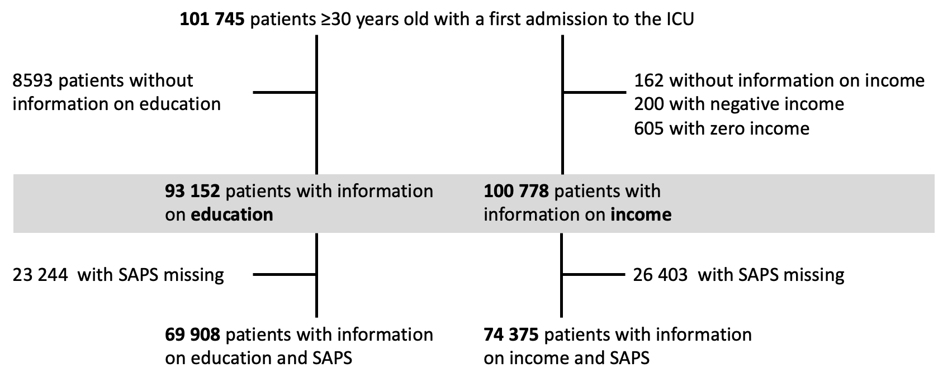

eFigure S2. The association between the summary comorbidity score and survival probability was verified by dividing the study population into four categories, depending on the level of the comorbidity score, and showing the survival probability in these categories. Shaded areas indicate 95% confidence intervals. The distribution of the comorbidity score is shown in the embedded density plot, where the hashed lines indicates the arbitrary cut-offs for the four comorbidity score categories.

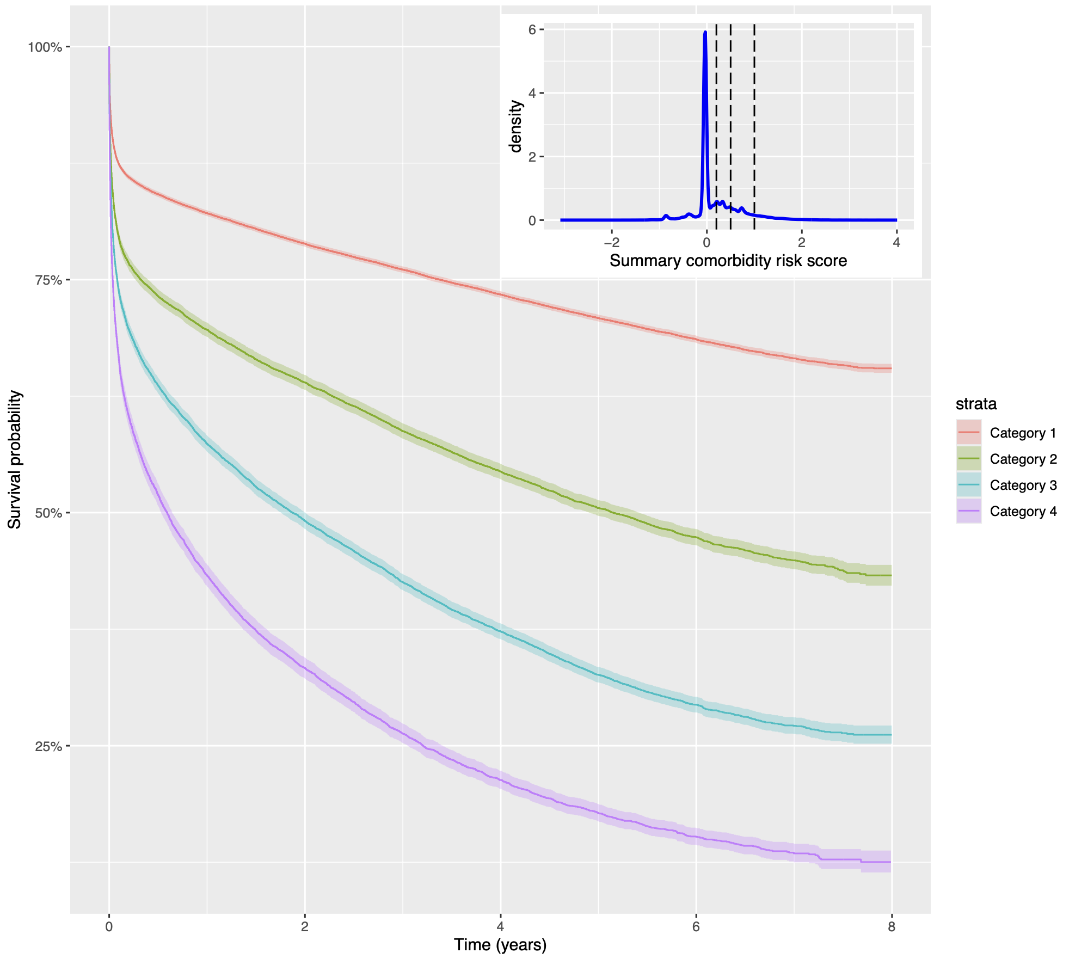

eFigure S3. -log-log plot to evaluate the proportional hazards assumption. Largely parallel lines do not suggest any concern regarding this assumption for the Cox regression in the main analysis of educational level.
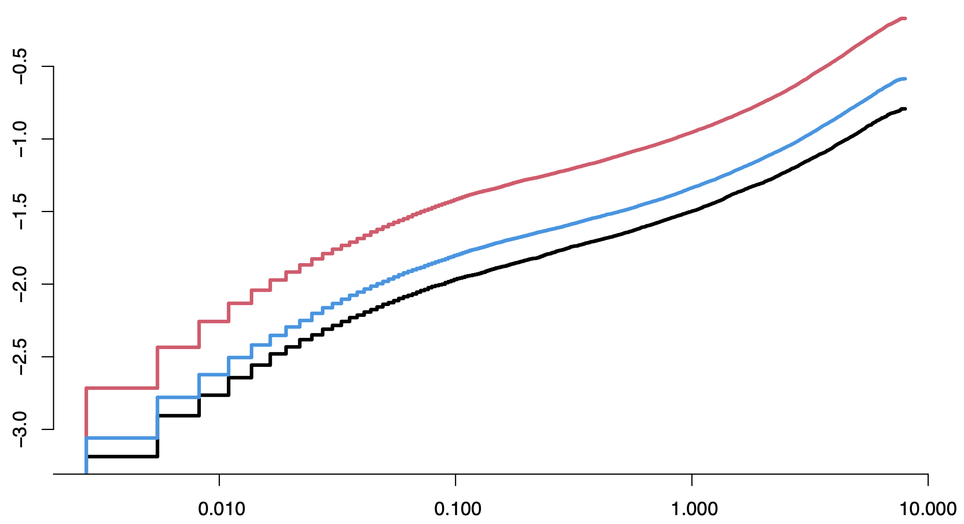

eFigure S4. Variance inflation values for the independent variables in the main analysis of educational level. The hashed line indicates the level generally thought to indicate a potential concern for collinearity if exceeded.
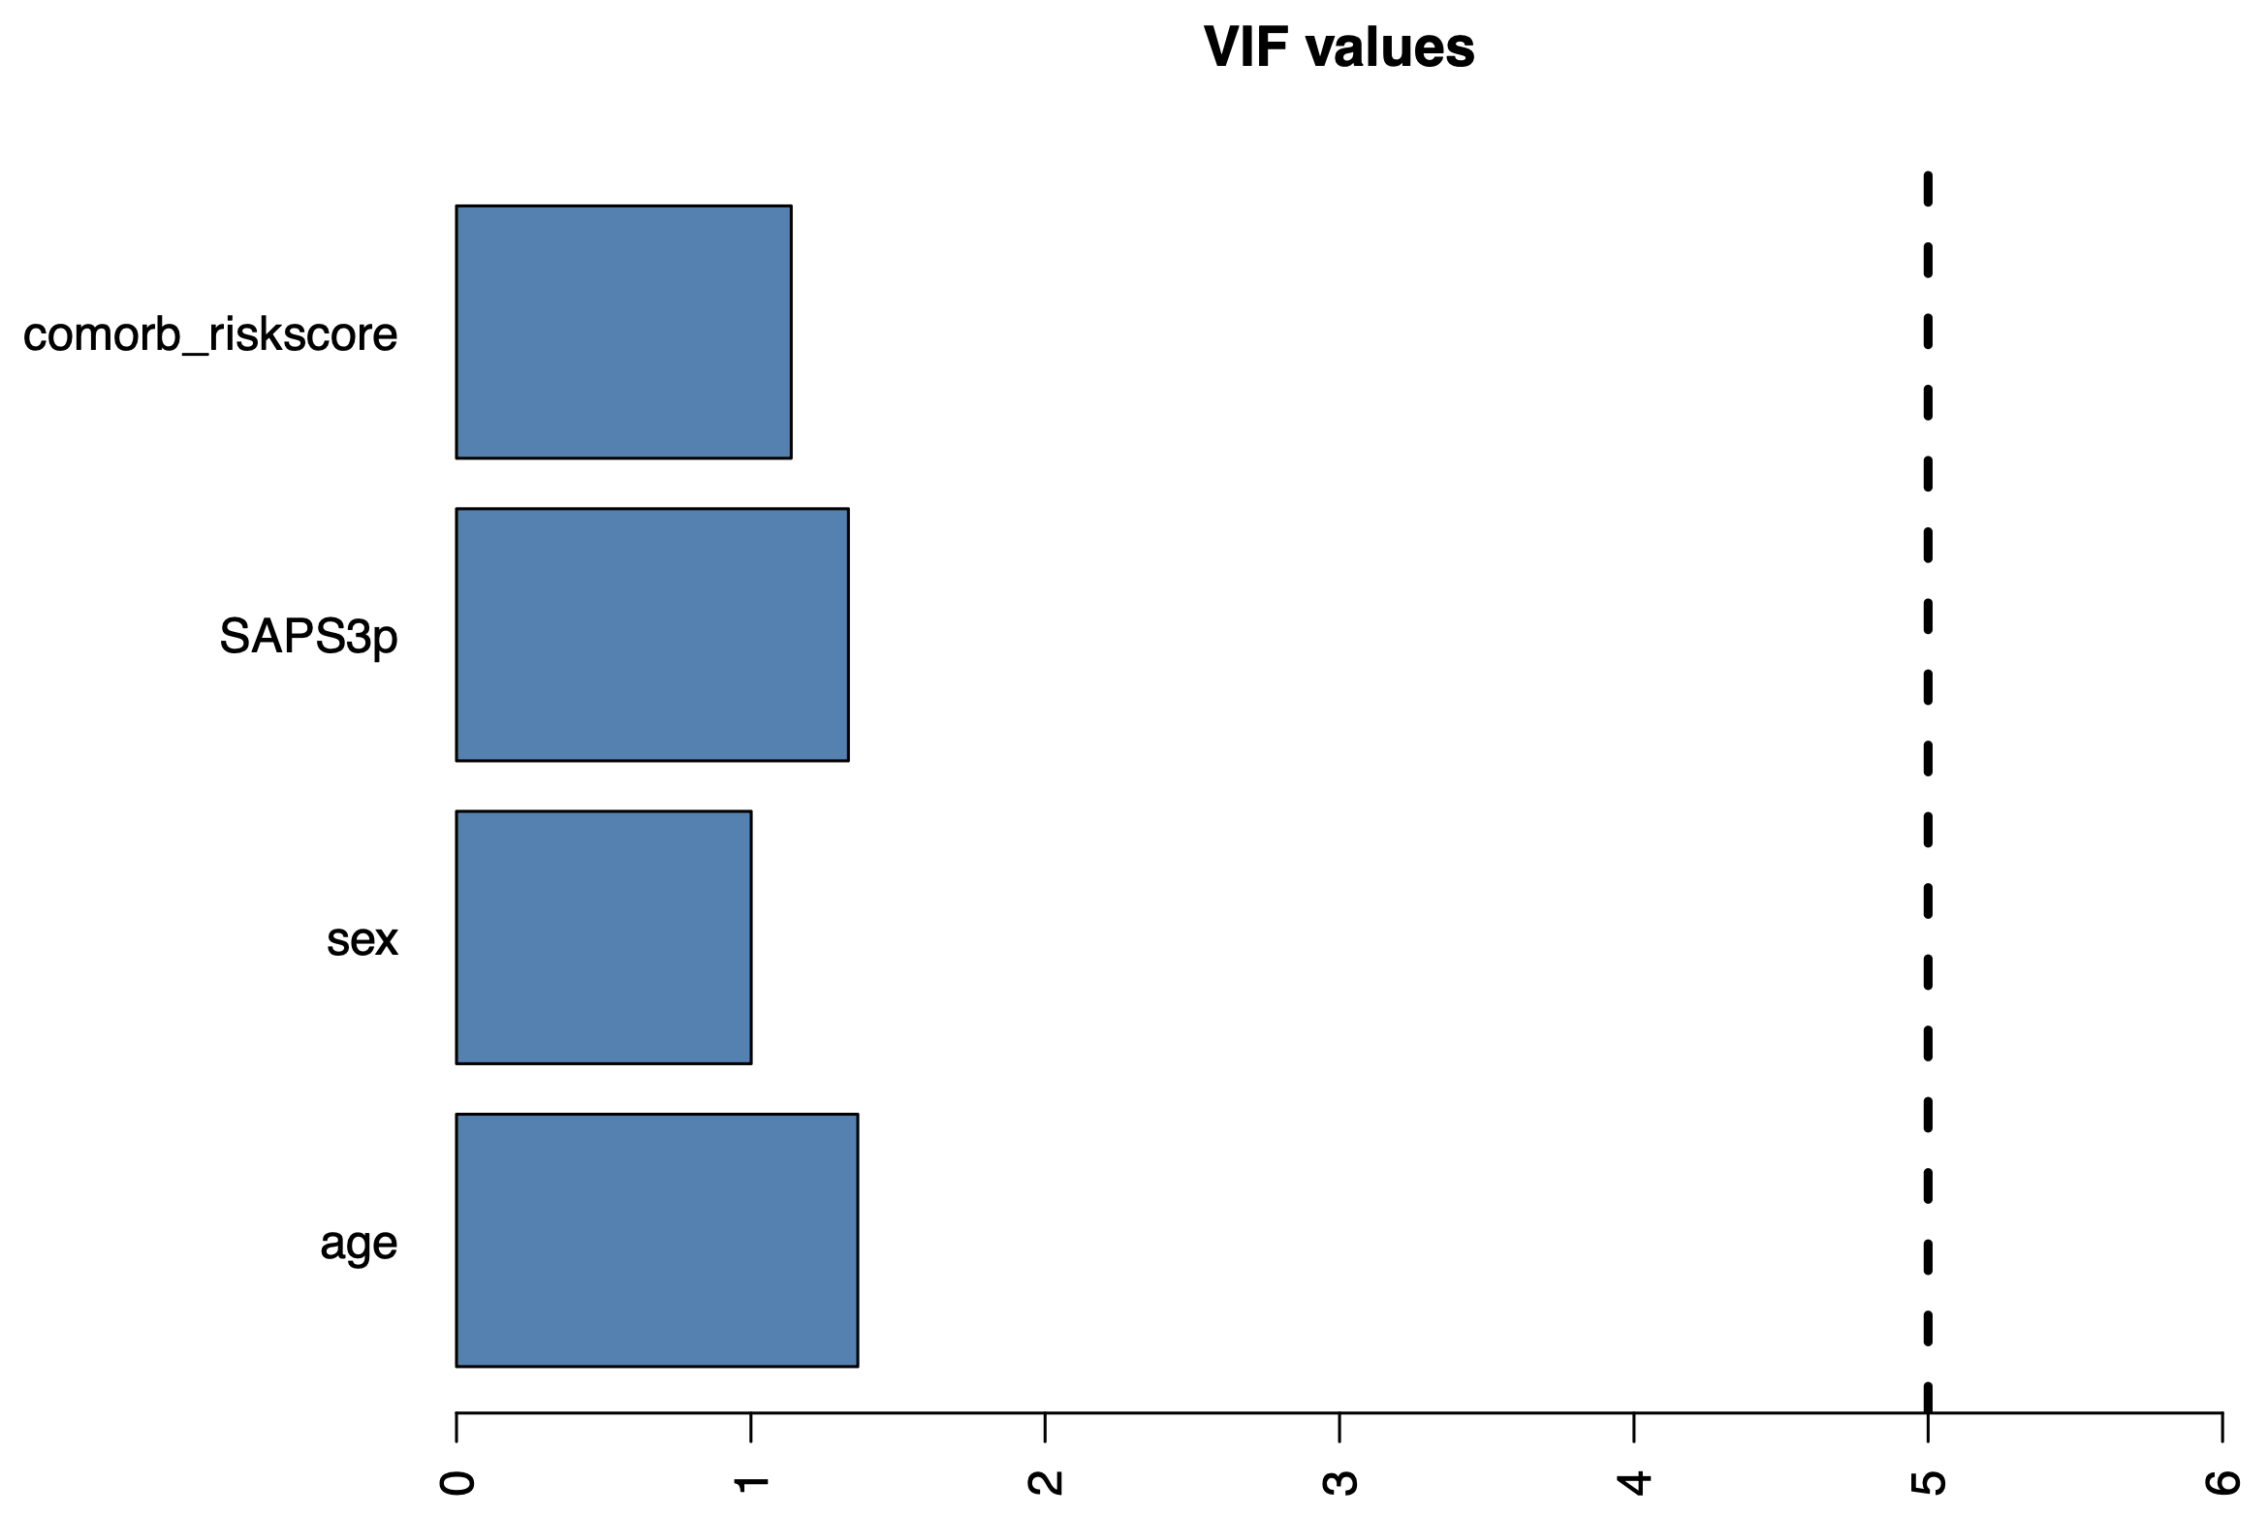
eFigure S5. Directional acyclic graphs (DAG) describing the assumed associations between Socioeconomic status with the outcome all-cause death.
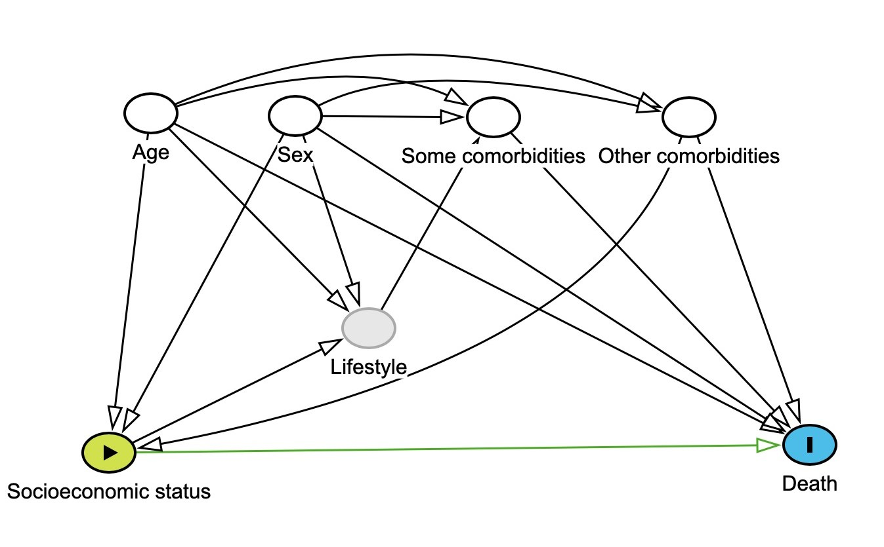

eTable S1. Baseline characteristics of 100 778 ICU patients with individual-level information on annual income.
 | Income category
 | 0-9999 € | 10 000-29 999 € | 30 000-49 999 € | ≥50 000 €
 | (N = 7874) | (N = 76 453) | (N = 13 108) | (N = 3343)
Age (years), % (n)
30-49 | 24% (1873) | 14% (11 003) | 27% (3479) | 16% (542)
50-69 | 34% (2711) | 37% (28 046) | 57% (7443) | 58% (1948)
70-89 | 40% (3172) | 47% (35 889) | 16% (2106) | 25% (830)
90+ | 1% (118) | 2% (1515) | 1% (80) | 1% (23)
Sex, % (n)
Female | 57% (4464) | 44% (33 371) | 25% (3229) | 20% (659)
Admission diagnoses, % (n)
Respiratory, other | 23% (1846) | 24% (18 062) | 21% (2789) | 21% (703)
Neurological | 24% (1853) | 21% (15 967) | 20% (2646) | 19% (649)
Circulatory (excl. septic shock) | 18% (1395) | 19% (14 683) | 16% (2038) | 16% (536)
Gastrointestinal | 13% (1023) | 13% (9804) | 10% (1345) | 11% (374)
Metabolic | 13% (1034) | 12% (9226) | 8% (1063) | 8% (272)
Renal | 8% (661) | 10% (7331) | 6% (820) | 6% (216)
Trauma | 7% (541) | 6% (4210) | 8% (1113) | 6% (209)
Septic shock | 4% (342) | 5% (3522) | 3% (457) | 5% (156)
Respiratory, acute-on-chronic | 4% (329) | 5% (3699) | 2% (262) | 3% (86)
Haematological | 3% (269) | 3% (2661) | 3% (436) | 4% (128)
SAPS3
Median (interquartile range) | 53 (43-65) | 55 (45-65) | 47 (38-60) | 51 (41-63)
Missing, % (n) | 24% (1899) | 25% (19 232) | 31% (4098) | 35% (1174)
Comorbiditiesª, % (n)
Hypertension | 24% (1871) | 27% (20 646) | 16% (2137) | 18% (612)
Infectious disease | 20% (1575) | 20% (15 648) | 11% (1455) | 13% (437)
Ischemic heart disease | 12% (977) | 16% (11 942) | 9% (1174) | 10% (337)
Cardiac arrhythmias | 11% (889) | 14% (10 866) | 9% (1124) | 11% (384)
Diabetes mellitus | 12% (948) | 14% (10 322) | 7% (947) | 8% (254)
Bone/muscle disease | 12% (932) | 13% (9930) | 7% (908) | 8% (280)
Neurological disease | 11% (883) | 13% (9575) | 7% (901) | 9% (301)
Injury | 14% (1080) | 12% (9480) | 6% (845) | 7% (247)
Heart failure | 10% (785) | 11% (8421) | 5% (709) | 6% (203)
Chronic pulmonary disease | 9% (683) | 11% (8235) | 4% (486) | 4% (148)
Tumour non-metastatic | 6% (489) | 9% (6759) | 8% (1076) | 10% (336)
Cerebrovascular disease | 7% (515) | 8% (5944) | 4% (476) | 5% (155)
Other anaemias | 7% (553) | 7% (5292) | 3% (448) | 4% (148)
Peripheral vascular disease | 6% (438) | 7% (5128) | 4% (530) | 5% (152)
Alcohol abuse | 9% (688) | 6% (4587) | 3% (422) | 4% (125)
Valvular disease | 5% (379) | 6% (4220) | 5% (684) | 7% (225)
Renal disease | 5% (407) | 6% (4502) | 3% (405) | 4% (130)
Other endocrine disease | 5% (429) | 5% (3696) | 2% (274) | 3% (93)
Depression | 5% (379) | 5% (3712) | 2% (308) | 3% (84)
Fluid balance disorder | 4% (304) | 4% (2954) | 2% (212) | 2% (68)
Drug abuse | 7% (575) | 3% (2572) | 1% (157) | 1% (32)
Rheumatic/autoimmune disease | 4% (313) | 4% (2686) | 2% (212) | 2% (70)
Hepatic disease | 6% (490) | 3% (2296) | 2% (222) | 2% (73)
Poisoning | 3% (253) | 2% (1832) | 1% (159) | 1% (38)
Obesity | 2% (180) | 2% (1468) | 1% (180) | 1% (39)
Tumour metastatic | 1% (113) | 2% (1360) | 2% (297) | 3% (95)
Pulmonary circulation disorders | 2% (140) | 2% (1463) | 1% (142) | 1% (50)
Haematological disease | 2% (122) | 2% (1217) | 2% (234) | 2% (63)
Haematological malignancy | 1% (106) | 2% (1152) | 2% (217) | 2% (77)
Psychoses | 2% (171) | 2% (1260) | 0% (29) | 0% (14)
Blood loss anaemia | 1% (73) | 1% (808) | 1% (84) | 1% (31)
Transplantation-related disorder | 0% (31) | 1% (485) | 1% (67) | 1% (20)
Malnutrition | 1% (48) | 1% (446) | 0% (32) | 0% (8)
Coagulopathy | 0% (29) | 0% (382) | 0% (56) | 0% (15)
Immunodeficiency | 0% (21) | 0% (160) | 0% (26) | 0% (6)

ª A patient may have multiple comorbidity categories

