Supplementary Information for
Modeling the Productivity of Opportunity Crops across Africa under Climate Change in Support of the Vision for Adapted Crops and Soils
Jose Rafael Guarin^{1,2,*}, Meijian Yang^{1,2*}, Dilys S. MacCarthy³, Kevin Karl^{1,2}, Jonas Jägermeyr^{1,2}, Alex C. Ruane², Andres Castellano^{2,4}, Bright S. Freduah³, Gershom O. Wesley³, Stephen Narh³, Elena Mendez Leal¹, Cynthia E. Rosenzweig^{1,2}
¹Center for Climate Systems Research, Columbia Climate School, Columbia University, New York, NY 10025 USA
²NASA Goddard Institute for Space Studies, New York, NY 10025 USA
³Soil and Irrigation Research Centre, University of Ghana, Kpong, Ghana
⁴Autonomic Integra, Bethesda, MD
*These authors contributed equally to this work.

This file includes:
Tables S1 to S4
Figures S1 to S33
References

Supplementary Tables
Table S1 | Individual GCM detrended maize yield response compared to detrended extreme climate hazards in Africa. Table providing the coefficient of determination (r²) between the simulated detrended average maize yields and the detrended average extreme drought and heat events over the historical (1990-2018), SSP1-2.6 (2035-2063), and SSP3-7.0 (2035-2063) scenarios for each GCM; the last year of each period is excluded from the analyses due to incomplete maturity in areas where season extends past study period. Detrended yields are the difference between the simulated yields (annual area-weighted means across currently cultivated areas; see Methods) and the predicted values from linear regression for each scenario. Detrended climate hazards are the difference between the frequency of extreme hazards (annual area-weighted means across currently cultivated areas; see Methods) and the predicted values from linear regression for each scenario. Drought days are defined as days when Agricultural Reference Index for Drought (ARID) is > 0.7 indicating significant drought¹. Heat days are defined as days when daily maximum temperature exceeds the maize heat threshold based on the literature indicating onset of heat stress, i.e., SIMPLE model “MaxT” maize parameter, 34 °C².
GCM | Scenario | r²_{heat} | r²_{drought}
GFDL-ESM4 | Historical | 0.68 | 0.57
 | SSP1-2.6 | 0.82 | 0.60
 | SSP3-7.0 | 0.66 | 0.48
IPSL-CM6A-LR | Historical | 0.56 | 0.30
 | SSP1-2.6 | 0.86 | 0.32
 | SSP3-7.0 | 0.55 | 0.52
MPI-ESM1-2-HR | Historical | 0.80 | 0.70
 | SSP1-2.6 | 0.81 | 0.67
 | SSP3-7.0 | 0.84 | 0.43
MRI-ESM2-0 | Historical | 0.56 | 0.51
 | SSP1-2.6 | 0.78 | 0.55
 | SSP3-7.0 | 0.79 | 0.54
Average | Historical | 0.66 | 0.39
 | SSP1-2.6 | 0.86 | 0.46
 | SSP3-7.0 | 0.75 | 0.54

Table S2 | Overview of CMIP6 general circulation models (GCMs) used in this study. GCMs are downscaled and bias-adjusted by ISIMIP, see Methods section and the references therein. Equilibrium Climate Sensitivity (ECS, global warming at equilibrium for a doubling of [CO₂]) and Transient Climate Response (TCR, surface temperature warming by the time of [CO₂] doubling in a simulation with 1% per year [CO₂] increase) rates are based on Meehl et al.³. Table modified after: Jägermeyr et al.⁴.
GCM | Member | Reference | ECS [°C] | TCR [°C]
GFDL-ESM4 | r1i1p1f1 | Krasting et al.⁵ | 2.6 | 1.6
IPSL-CM6A-LR | r1i1p1f1 | Boucher et al.⁶ | 4.6 | 2.3
MPI-ESM1-2-HR | r1i1p1f1 | Jungclaus et al.⁷ | 3.0 | 1.7
MRI-ESM2-0 | r1i1p1f1 | Yukimoto et al.⁸ | 3.2 | 1.6
Ensemble mean (mean across all CMIP6 models) | - | - | 3.4 (3.7) | 1.8 (2.0)
Ensemble SD (SD across all CMIP6 models) | - | - | 0.9 (1.1) | 0.3 (0.4)

Table S3 | Data sources for crop calendar and crop area of each crop. Global Gridded Crop Model Intercomparison (GGCMI) crop calendar from Jägermeyr et al.⁴. CROPGRIDS harvest area maps from Tang et al.⁹. If proxy CROPGRIDS map was used, the area was subset based on the list of countries that produce the crop obtained from FAOSTAT¹⁰ and/or FAO crop calendar (https://cropcalendar.apps.fao.org/#/home). Derived crop calendars use representative sowing dates from either the FAO crop calendar (https://cropcalendar.apps.fao.org/#/home), supplemented by the International Fertilizer Association’s Fertilizer Use by Country crop calendar¹¹, or other literature sources¹²⁻¹⁴ (Fig. S33).
Crop | Crop type | Crop calendar source | CROPGRIDS map exists (Y) or proxy crop map used | Countries used to subset proxy CROPGRIDS map (based on FAO)
Maize | Cereals | GGCMI (maize) | Y
Fonio | Cereals | Derived | Y
Teff | Cereals | Derived | Wheat | Eritrea, Ethiopia, Guinea, Kenya, Mozambique, South Africa.
Finger Millet | Cereals | GGCMI (millet) | Millet | Burundi, Democratic Republic of Congo, Ethiopia, Kenya, Malawi, Nigeria, Rwanda, Uganda, Tanzania, Zambia, Zimbabwe.
Sorghum | Cereals | GGCMI (sorghum) | Y
Pearl millet | Cereals | GGCMI (millet) | Millet
Soybean | Legumes | GGCMI (soybean) | Y
Cowpea | Legumes | GGCMI (soybean) | Y
Grass pea | Legumes | GGCMI (peas) | Pea | Algeria, Egypt, Ethiopia, Kenya, Libya, Morocco, S. Sudan, Sudan, Tunisia.
Mung bean/Green gram | Legumes | GGCMI (peas) | Bambara groundnut | Angola, Benin, Burkina Faso, Cameroon, Chad, Democractic Republic of the Congo, Ethiopia, Gabon, Ghana, Guinea, Kenya, Madagascar, Malawi, Mali, Mozambique, Niger, Nigeria, Senegal, Sierra Leone, Somalia, Sudan, Togo, Uganda, Zambia, Zimbabwe.
Pigeon pea | Legumes | GGCMI (peas) | Y
Lablab/Bonavist | Legumes | GGCMI (soybean) | Soybean | Every country EXCEPT Algeria, Egypt, Libya, Mauritania, Morocco, Western Sahara.
Bambara groundnut | Legumes | GGCMI (nut) | Y
Groundnut | Oilseeds | GGCMI (nut) | Y
Sesame | Oilseeds | Derived | Y
Cassava | Roots & Tubers | GGCMI (cassava) | Y
Cocoyam/Elephant ear | Roots & Tubers | GGCMI (cassava) | Taro | Benin, Democratic Republic of Congo, Equatorial Guinea, Ghana, Guinea, Liberia, Swaziland, Togo, Uganda, Zimbabwe.
Taro | Roots & Tubers | Derived | Y
Sweet potato | Roots & Tubers | GGCMI (potato) | Y
Yams | Roots & Tubers | GGCMI (cassava) | Y | Benin, Burkina Faso, Burundi, Cameroon, Central African Republic, Chad, Democratic Republic of the Congo, Ethiopia, Equatorial Guinea, Gabon, Ghana, Guinea, Ivory Coast, Kenya, Lesotho, Liberia, Mali, Mauritania, Mozambique, Nigeria, Republic of the Congo, Rwanda, Sao Tome and Principe, Senegal, Sierra Leone, Togo, S. Sudan, Sudan, Togo, Uganda, United Republic of Tanzania, Zambia.
Tomato | Vegetables | Derived | Y
Okra | Vegetables | Derived | Y
African eggplant | Vegetables | Derived (tomato) | Eggplant | Angola, Benin, Cameroon, Central African Republic, Democratic Republic of the Congo, Egypt, Equatorial Guinea, Eritrea, Ethiopia, Gabon, Ghana, Guinea, Guinea-Bissau, Ivory Coast, Kenya, Madagascar, Malawi, Mali, Mozambique, Nigeria, Senegal, Sierra Leone, Sudan, S. Sudan, Tanzania, Togo, Uganda, Zambia, Zimbabwe.
Amaranth/Joseph's Coat (leaves) | Vegetables | Derived | Okra | Angola, Benin, Burundi, Cameroon, Central African Republic, Egypt, Eritrea, Ethiopia, Gabon, Mauritius, Mozambique, Sierra Leone, Sudan, Zambia.

Table S4 | Genetic parameters for the SIMPLE crop model. Calibrated cultivar and species parameters for the SIMPLE crop model. Crop names in bold indicate the five staple crops representing each crop type. Model calibration and parameterization described in detail in Yang et al.². T_{sum}: Cumulative temperature requirement from sowing to maturity (°C d). HI: Harvest index. I_{50A}: Cumulative temperature requirement for leaf area development to intercept 50% of radiation (°C d). I_{50B}: Cumulative temperature for maturity to reach 50% radiation interception due to leaf senescence (°C d). T_{base}: Base temperature for phenology development and growth (°C). T_{opt}: Optimal temperature for biomass growth (°C). RUE: Radiation use eﬃciency (above ground only and without respiration) (g MJ⁻¹ m⁻²). I_{50maxH}: The maximum daily reduction in I_{50B} due to heat stress (°C d). I_{50maxW}: The maximum daily reduction in I_{50B} due to drought stress (°C d). T_{max}: Threshold temperature to start accelerating senescence from heat stress (°C). T_{extreme}: The extreme temperature threshold when RUE becomes 0 due to heat stress (°C). S_{CO2}: Relative increase in RUE per ppm elevated CO₂ above 350 ppm. S_{water}: Sensitivity of RUE to drought stress.
 |  |  | Cultivar parameters |  |  |  | Species parameters
Crop | Species name | Crop type | T_{sum} | HI | I_{50A} | I_{50B} | T_{base} | T_{opt} | RUE | I_{50maxH} | I_{50maxW} | T_{max} | T_{extreme} | S_{CO2} | S_{water}
Maize | Zea mays | Cereals | 1550 | 0.34 | 600 | 250 | 8 | 28 | 2.10 | 100 | 12 | 34 | 50 | 0.01 | 1.5
Fonio | Digitaria exilis | Cereals | 1320 | 0.24 | 700 | 400 | 10 | 33 | 1.90 | 100 | 12 | 46 | 50 | 0.03 | 0.9
Teff | Eragrostis tef | Cereals | 1100 | 0.27 | 350 | 50 | 8 | 30 | 1.24 | 100 | 25 | 42 | 50 | 0.03 | 0.4
Finger Millet | Eleusine coracana | Cereals | 2015 | 0.24 | 700 | 550 | 10 | 33 | 1.00 | 100 | 12 | 46 | 50 | 0.03 | 0.9
Sorghum | Sorghum bicolor | Cereals | 2000 | 0.50 | 570 | 450 | 10 | 32 | 1.30 | 100 | 12 | 38 | 50 | 0.03 | 0.9
Pearl millet | Pennisetum glaucum | Cereals | 1550 | 0.19 | 700 | 480 | 10 | 33 | 1.90 | 100 | 12 | 45 | 50 | 0.03 | 0.9
Soybean | Glycine max | Legumes | 2250 | 0.28 | 490 | 370 | 6 | 22 | 0.86 | 120 | 20 | 34 | 45 | 0.07 | 0.9
Cowpea | Vigna unguiculata | Legumes | 1800 | 0.50 | 700 | 600 | 3 | 30 | 1.00 | 100 | 20 | 36 | 45 | 0.14 | 0.8
Grass pea | Lathyrus sativus | Legumes | 2050 | 0.45 | 480 | 460 | 3 | 25 | 1.17 | 100 | 25 | 34 | 45 | 0.08 | 0.5
Mung bean/Green gram | Vigna radiata | Legumes | 2800 | 0.30 | 550 | 250 | 5 | 27 | 0.80 | 90 | 20 | 32 | 45 | 0.07 | 0.8
Pigeon pea | Cajanus cajan | Legumes | 2100 | 0.18 | 650 | 520 | 6 | 27 | 1.40 | 120 | 20 | 36 | 50 | 0.07 | 0.9
Lablab/Bonavist | Lablab purpureus | Legumes | 2200 | 0.34 | 450 | 200 | 3 | 22 | 0.90 | 100 | 20 | 30 | 45 | 0.07 | 0.5
Bambara groundnut | Vigna subterranea | Legumes | 2500 | 0.20 | 680 | 540 | 6 | 30 | 1.10 | 100 | 20 | 35 | 50 | 0.07 | 1.5
Groundnut | Arachis hypogea | Oilseeds | 1987 | 0.24 | 670 | 600 | 10 | 28 | 1.20 | 100 | 5 | 36 | 50 | 0.07 | 2.0
Sesame | Sesamum indicum | Oilseeds | 1269 | 0.20 | 600 | 350 | 13 | 34 | 1.09 | 100 | 12 | 46 | 50 | 0.07 | 0.9
Cassava | Manihot esculenta | Roots & Tubers | 5400 | 0.65 | 650 | 300 | 12 | 28 | 1.10 | 100 | 15 | 38 | 50 | 0.07 | 1.0
Cocoyam/Elephant ear | Xanthosoma sagittifolium | Roots & Tubers | 2550 | 0.53 | 650 | 450 | 10 | 21 | 1.20 | 50 | 30 | 35 | 45 | 0.10 | 0.7
Taro | Colocasia esculenta | Roots & Tubers | 2600 | 0.60 | 650 | 450 | 10 | 28 | 1.40 | 50 | 30 | 35 | 45 | 0.10 | 1.0
Sweet potato | Ipomea batatas | Roots & Tubers | 1200 | 0.60 | 500 | 300 | 15 | 22 | 1.61 | 50 | 30 | 35 | 45 | 0.10 | 0.6
Yams | Dioscorea sp. | Roots & Tubers | 3600 | 0.75 | 650 | 540 | 12 | 28 | 1.20 | 100 | 15 | 38 | 50 | 0.07 | 1.2
Tomato | Solanum lycopersicum | Vegetables | 2000 | 0.50 | 550 | 300 | 6 | 26 | 1.00 | 100 | 5 | 32 | 45 | 0.07 | 2.5
Okra | Abelmoschus spp. | Vegetables | 3500 | 0.56 | 400 | 220 | 7 | 30 | 1.00 | 100 | 25 | 35 | 43 | 0.03 | 0.3
African eggplant | Solanum aethiopicum/ macrocarpon | Vegetables | 3750 | 0.70 | 650 | 590 | 6 | 26 | 1.40 | 100 | 5 | 35 | 45 | 0.09 | 0.7
Amaranth/Joseph's Coat (leaves) | Amaranthus spp. | Vegetables | 1380 | 0.90 | 300 | 200 | 10 | 28 | 1.75 | 100 | 30 | 35 | 45 | 0.03 | 0.4

Supplementary Figures
Climate figures:
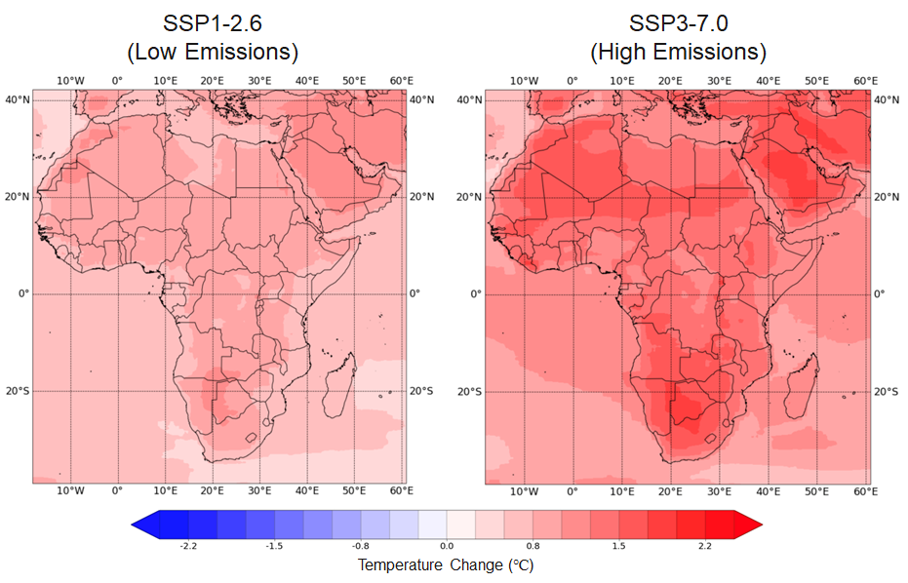
Fig. S1 | Mid-century mean temperature change. Average temperature change (2035-2064 compared to 1990-2019) for SSP126 (left), and SSP370 (right) scenarios across Africa. Temperature change is averaged across the four GCMs (GFDL-ESM4, IPSL-CM6A-LR, MPI-ESM1-2-HR, and MRI-ESM2-0).

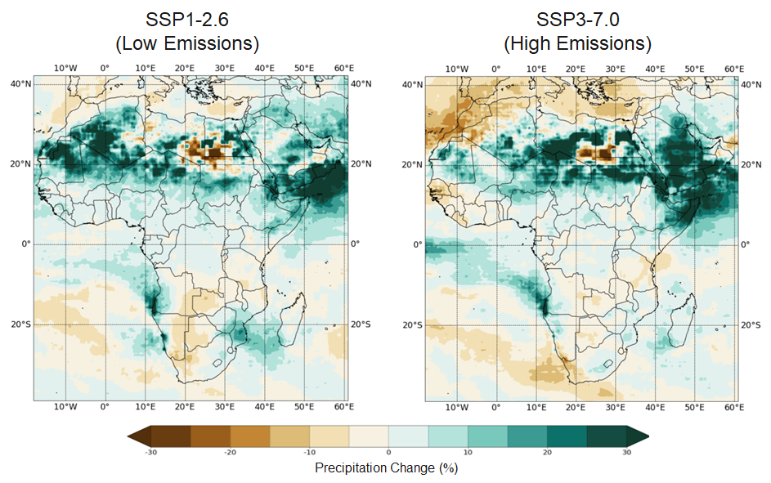
Fig. S2 | Mid-century mean precipitation change. Average precipitation change (2035-2064 compared to 1990-2019) for SSP126 (left), and SSP370 (right) scenarios across Africa. Precipitation change is averaged across the four GCMs (GFDL-ESM4, IPSL-CM6A-LR, MPI-ESM1-2-HR, and MRI-ESM2-0).

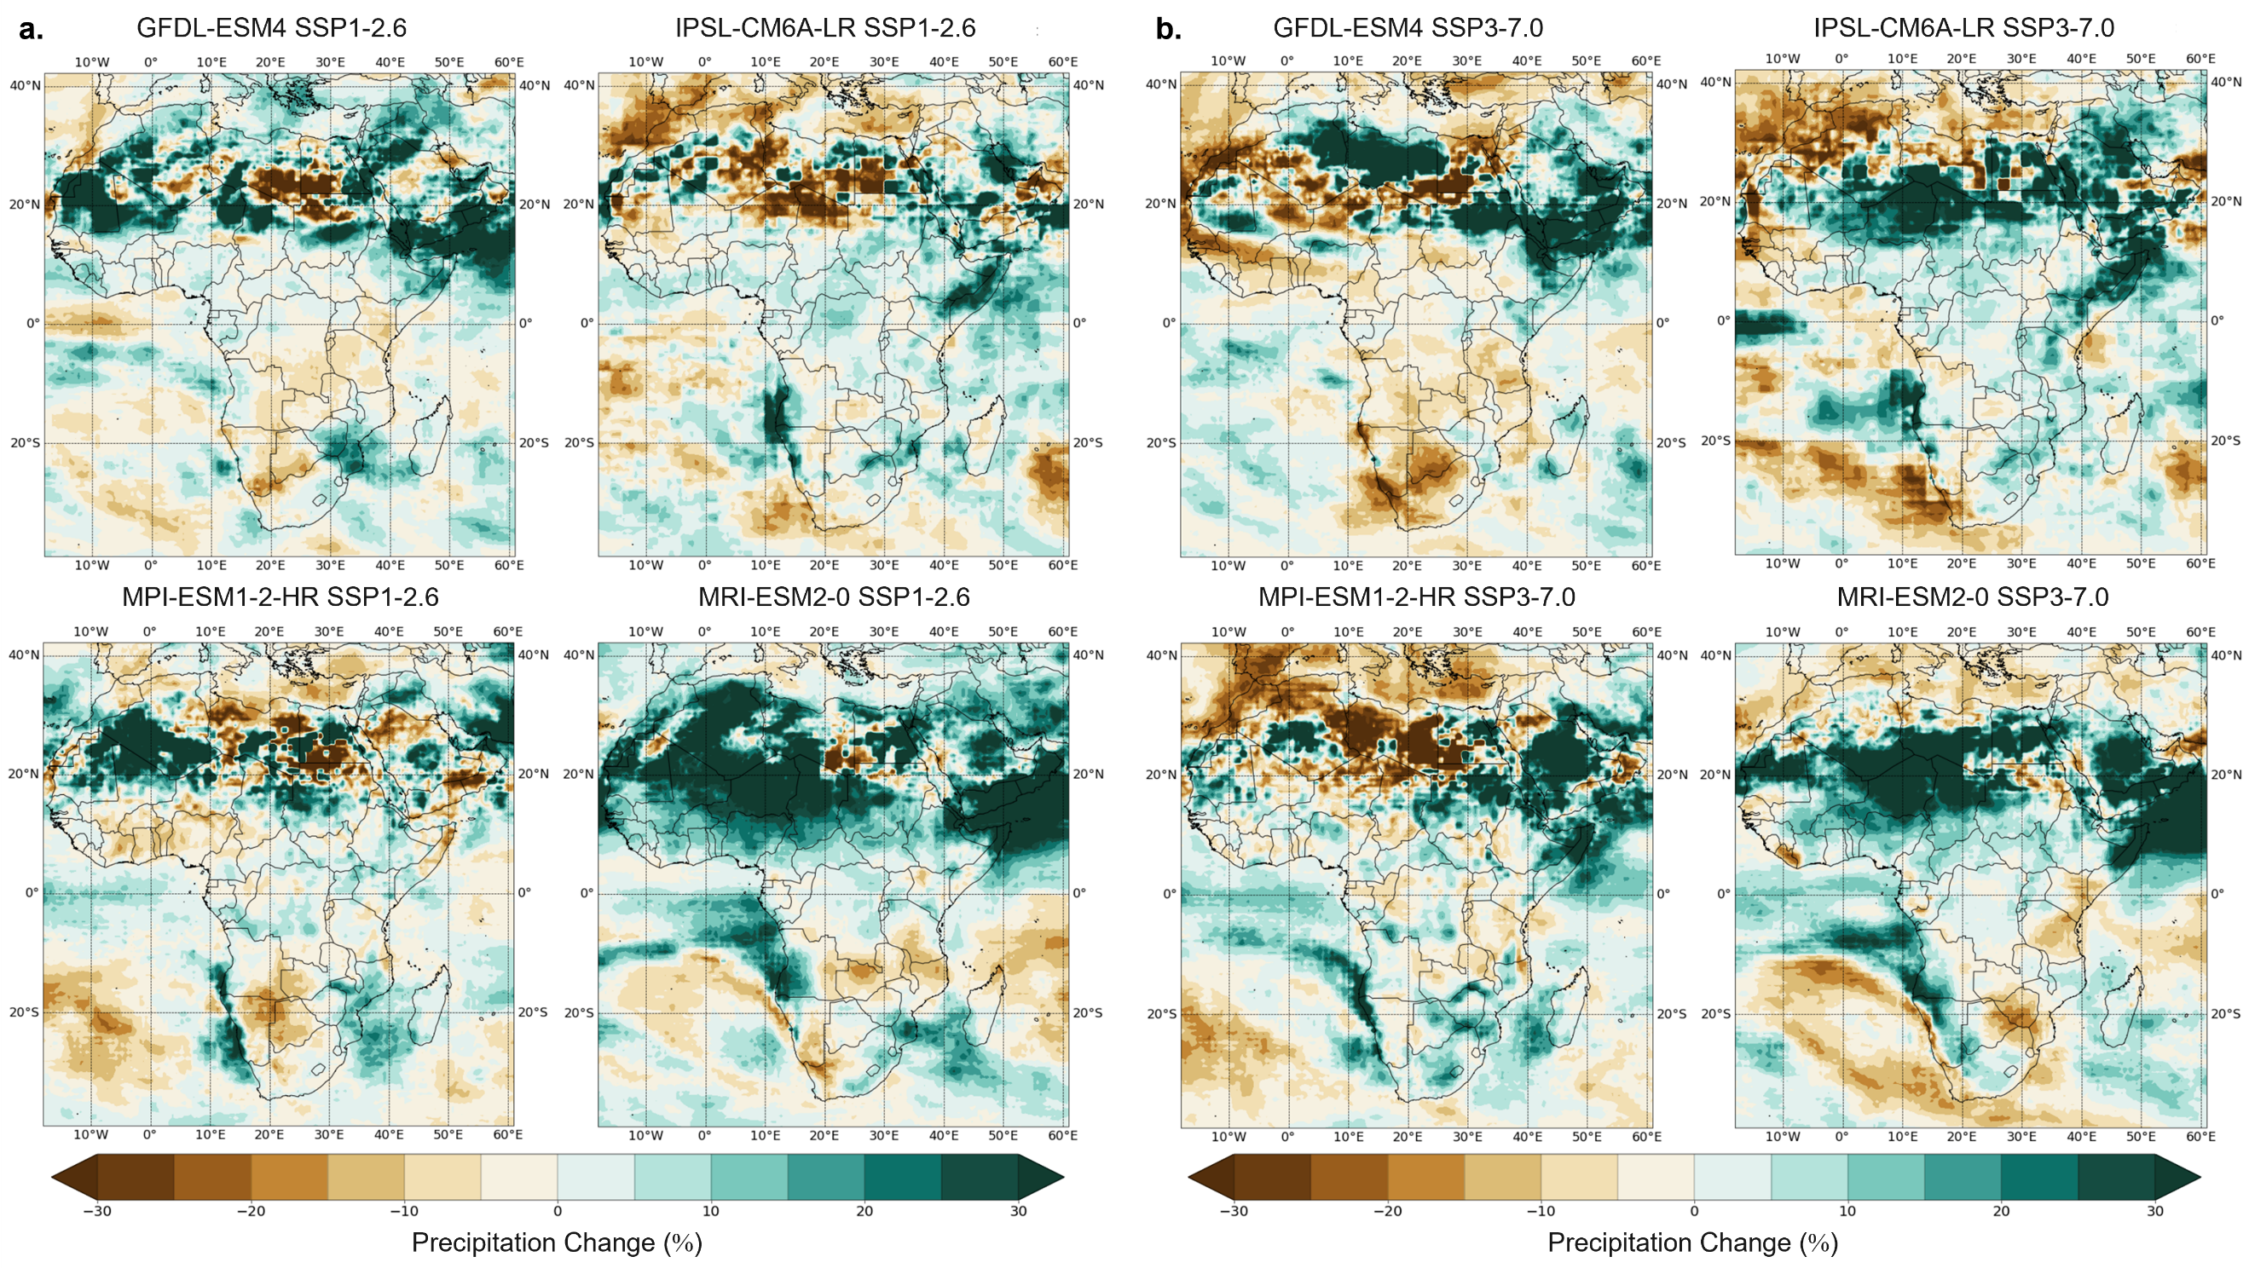
Fig. S3 | Mid-century individual GCM precipitation change. Projected precipitation change (2035-2064 compared to 1990-2019) for SSP126 (a), and SSP370 (b) scenarios across Africa for the four GCMs (GFDL-ESM4, IPSL-CM6A-LR, MPI-ESM1-2-HR, and MRI-ESM2-0).

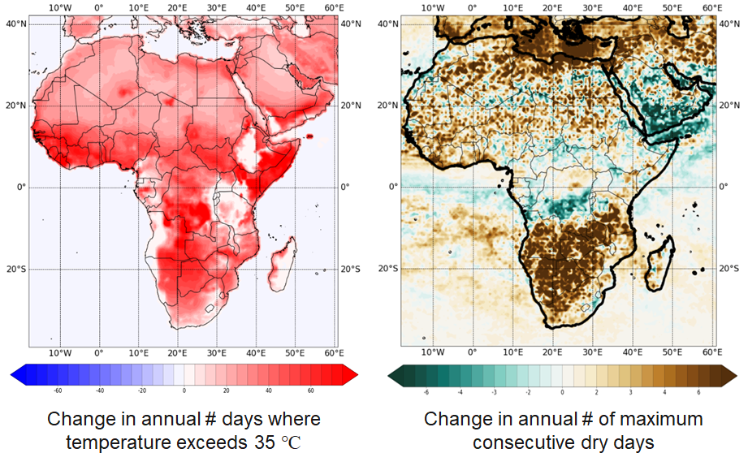
Fig. S4 | Mid-century changes in hot and dry extremes. Average changes (2035-2064 compared to 1990-2019) in number of days where temperature exceeds 35 °C (left) and in number of maximum consecutive dry days (right) for SSP370 across Africa. Dry day is defined as day where precipitation is below 0.01 mm. Changes are averaged across the four GCMs (GFDL-ESM4, IPSL-CM6A-LR, MPI-ESM1-2-HR, and MRI-ESM2-0).

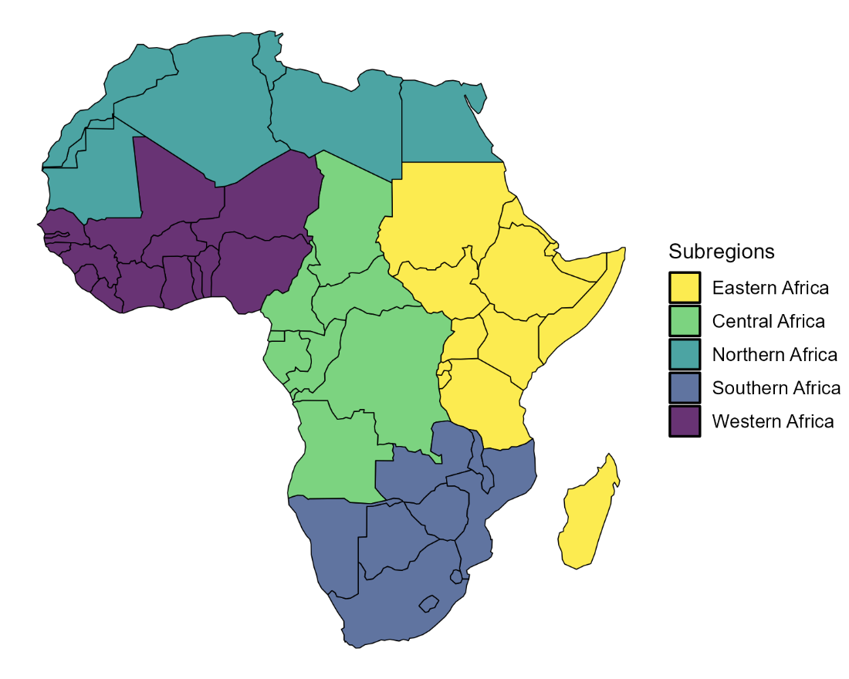
Fig. S5 | African subregions defined by the African Union. Map of the African subregions examined in this study.

Regional yield change figures:
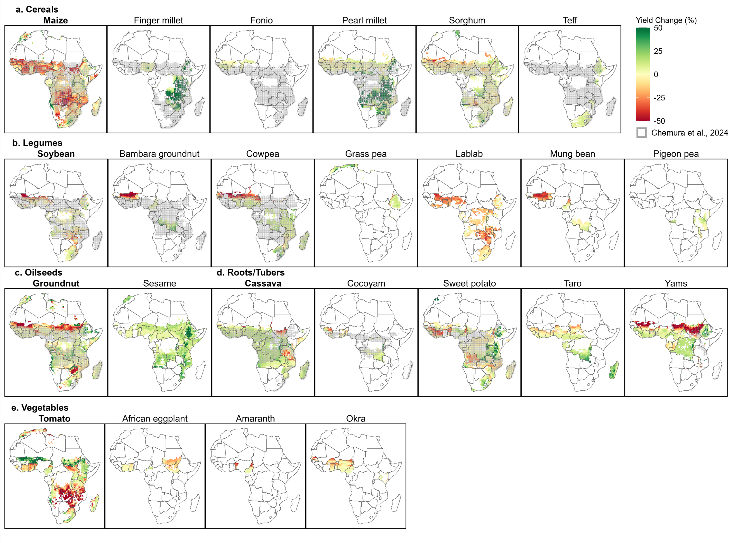
Fig. S6 | Simulated mid-century crop yield changes for Africa under a projected low emissions scenario (SSP1-2.6). Maps showing the average yield changes (2035-2064 compared to 1990-2019) for cereals (a), legumes (b), oilseeds (c), roots and tubers (d), and vegetables (e) for each grid cell. Simulated crop area is based on the current harvest area of each crop using the CROPGRIDS dataset⁹ only including grid cells with harvested area > 5 ha (see Methods). Gray shaded areas indicate future projected suitable agricultural areas under the low emissions scenario from Chemura et al.¹⁵: data are not available for all crops simulated here. Yield change is averaged across the four GCMs. Grid cells are 0.5° x 0.5°. Yield change under SSP3-7.0 shown in Fig. 3. Enlarged individual maps for each crop are available in Figs. S7-S30. Interactive versions of these maps for all 24 crops are available online at: https://vacs.theplotline.org/.

Enlarged individual yield change figures for each crop are provided below (sorted alphabetically by crop name). Uncertainty points indicate disagreement in yield change direction based on GCM projections, i.e., yield change from at least one GCM projection had opposite (positive/negative) change than other GCMs. Interactive versions of these maps for all crops are available online at: https://vacs.theplotline.org/.
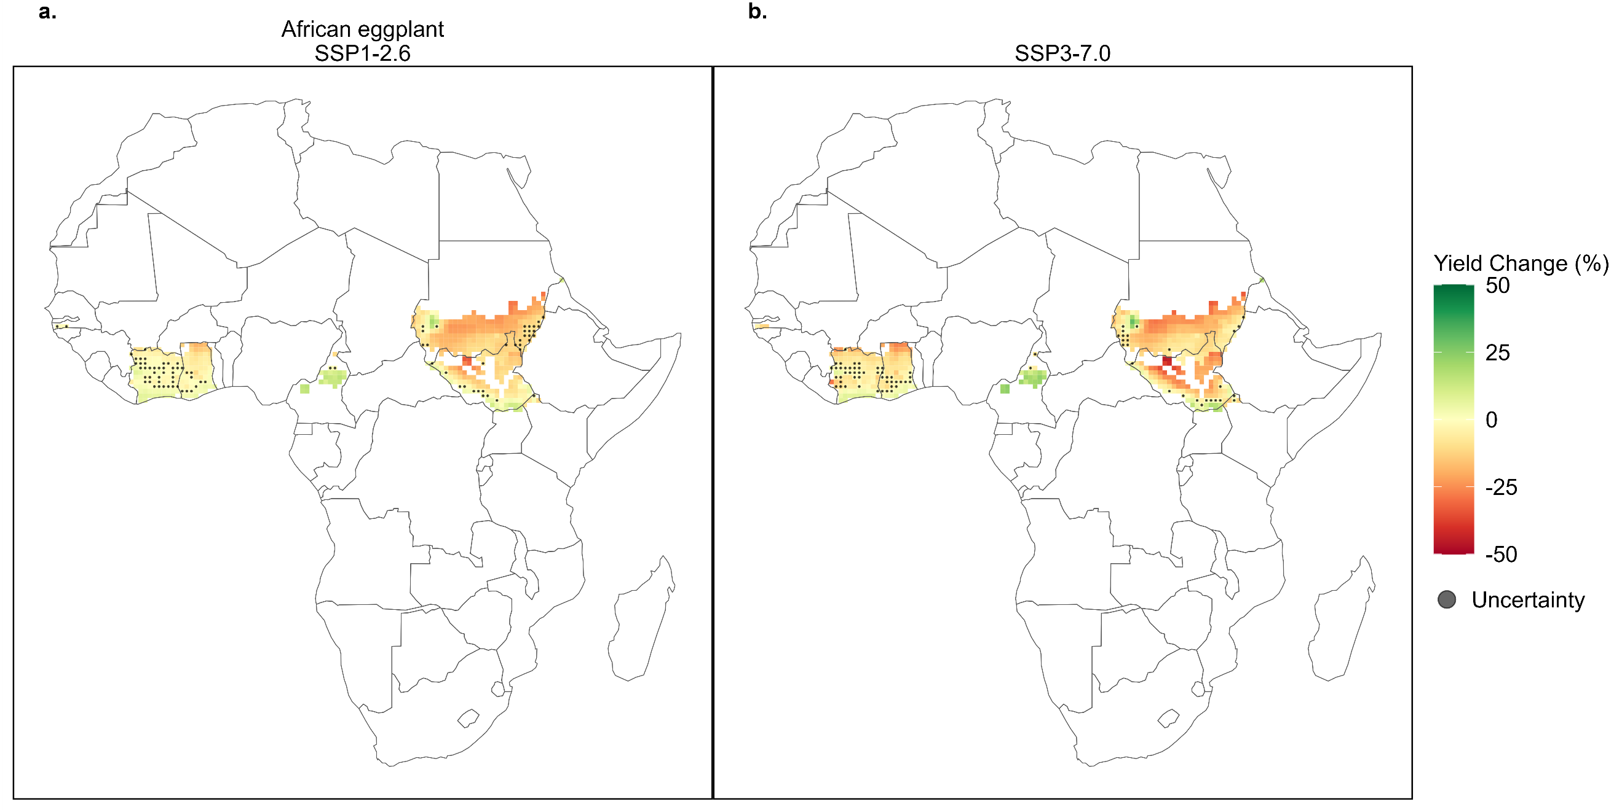
Fig. S7 | Simulated mid-century yield change for African eggplant. Maps showing the average yield changes (2035-2064 compared to 1990-2019) for African eggplant under low emissions, SSP126 (a), and high emissions, SSP370 (b), scenarios for each grid cell. Simulated crop area is based on the current harvest area of each crop using the CROPGRIDS dataset. Yield change is averaged across the four GCMs. Uncertainty points indicate that there was disagreement within the grid cell between the simulated yields using the different GCMs. Grid cells are 0.5° x 0.5°.
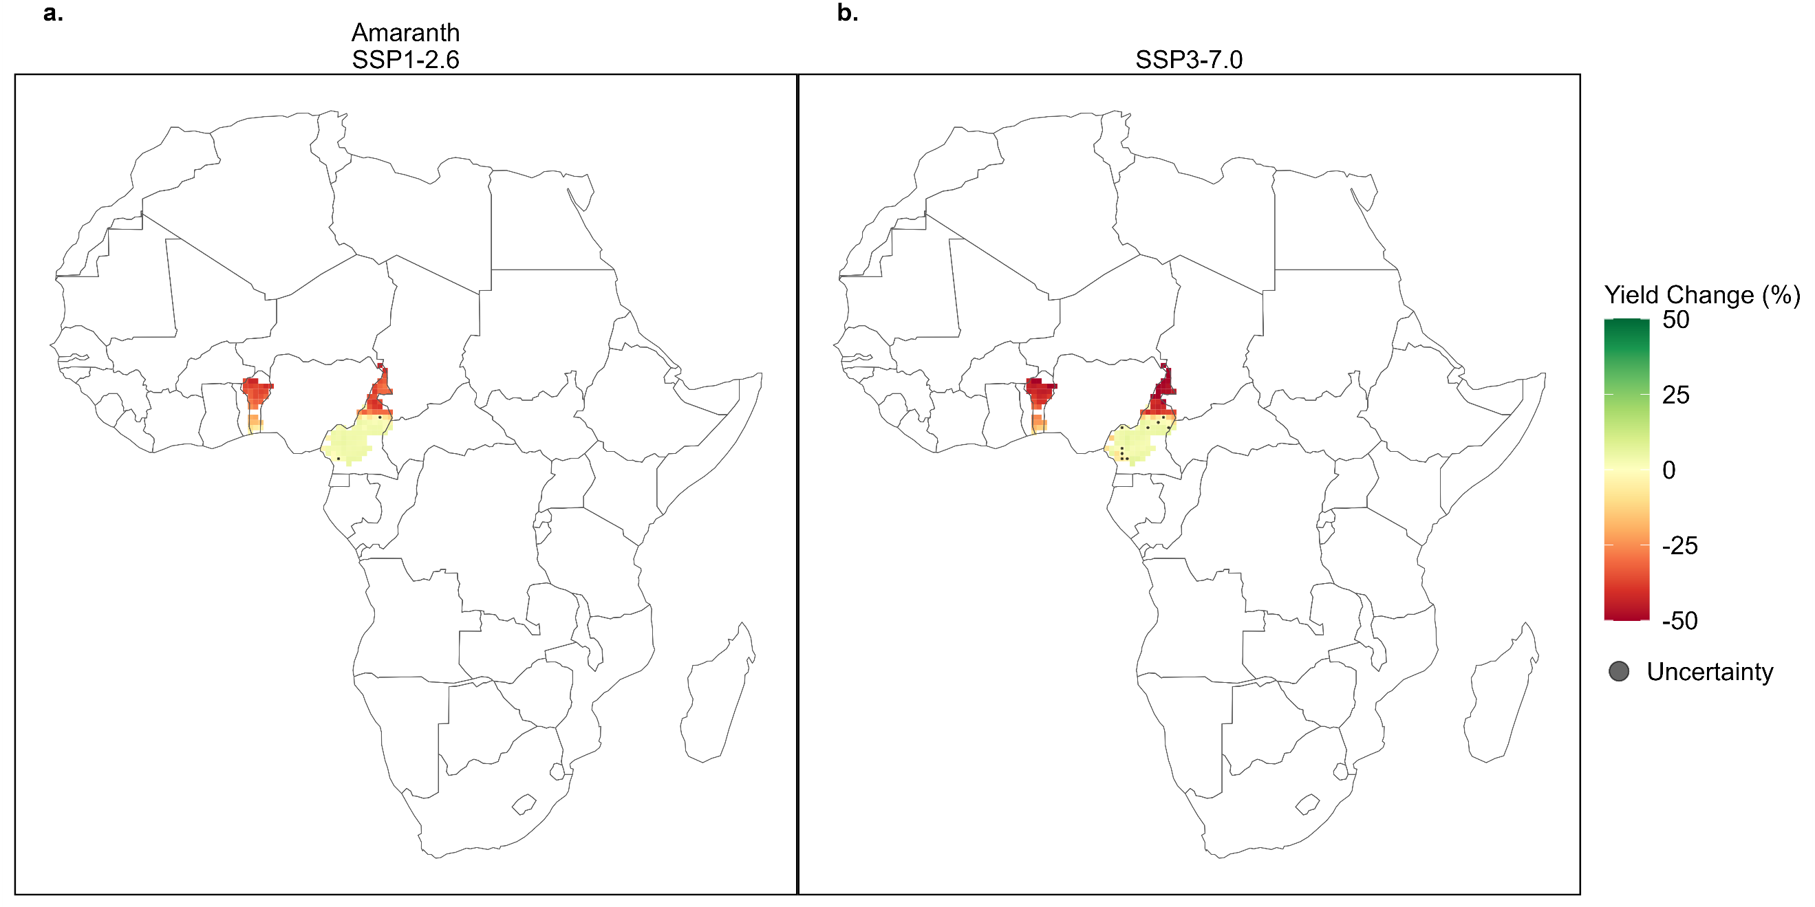
Fig. S8 | Simulated mid-century yield change for amaranth. Maps showing the average yield changes (2035-2064 compared to 1990-2019) for amaranth under low emissions, SSP126 (a), and high emissions, SSP370 (b), scenarios for each grid cell. Simulated crop area is based on the current harvest area of each crop using the CROPGRIDS dataset. Yield change is averaged across the four GCMs. Uncertainty points indicate that there was disagreement within the grid cell between the simulated yields using the different GCMs. Grid cells are 0.5° x 0.5°.
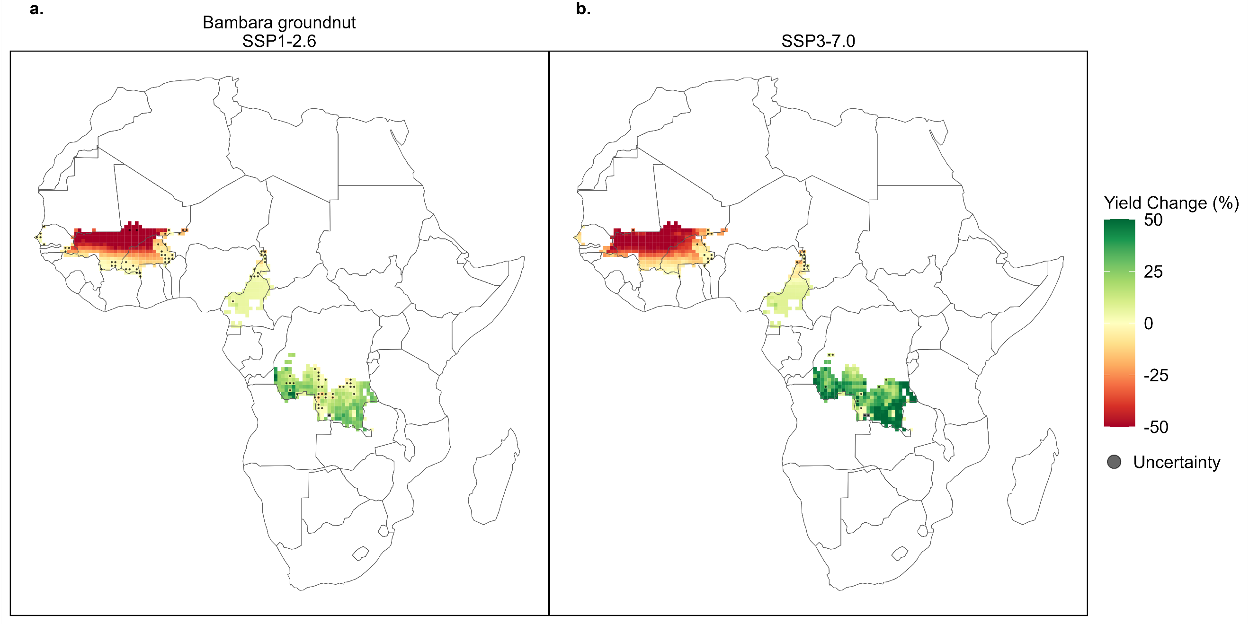
Fig. S9 | Simulated mid-century yield change for bambara groundnut. Maps showing the average yield changes (2035-2064 compared to 1990-2019) for bambara groundnut under low emissions, SSP126 (a), and high emissions, SSP370 (b), scenarios for each grid cell. Simulated crop area is based on the current harvest area of each crop using the CROPGRIDS dataset. Yield change is averaged across the four GCMs. Uncertainty points indicate that there was disagreement within the grid cell between the simulated yields using the different GCMs. Grid cells are 0.5° x 0.5°.
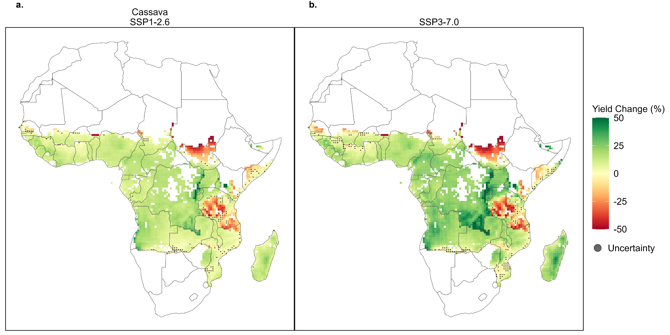
Fig. S10| Simulated mid-century yield change for cassava. Maps showing the average yield changes (2035-2064 compared to 1990-2019) for cassava under low emissions, SSP126 (a), and high emissions, SSP370 (b), scenarios for each grid cell. Simulated crop area is based on the current harvest area of each crop using the CROPGRIDS dataset. Yield change is averaged across the four GCMs. Uncertainty points indicate that there was disagreement within the grid cell between the simulated yields using the different GCMs. Grid cells are 0.5° x 0.5°.
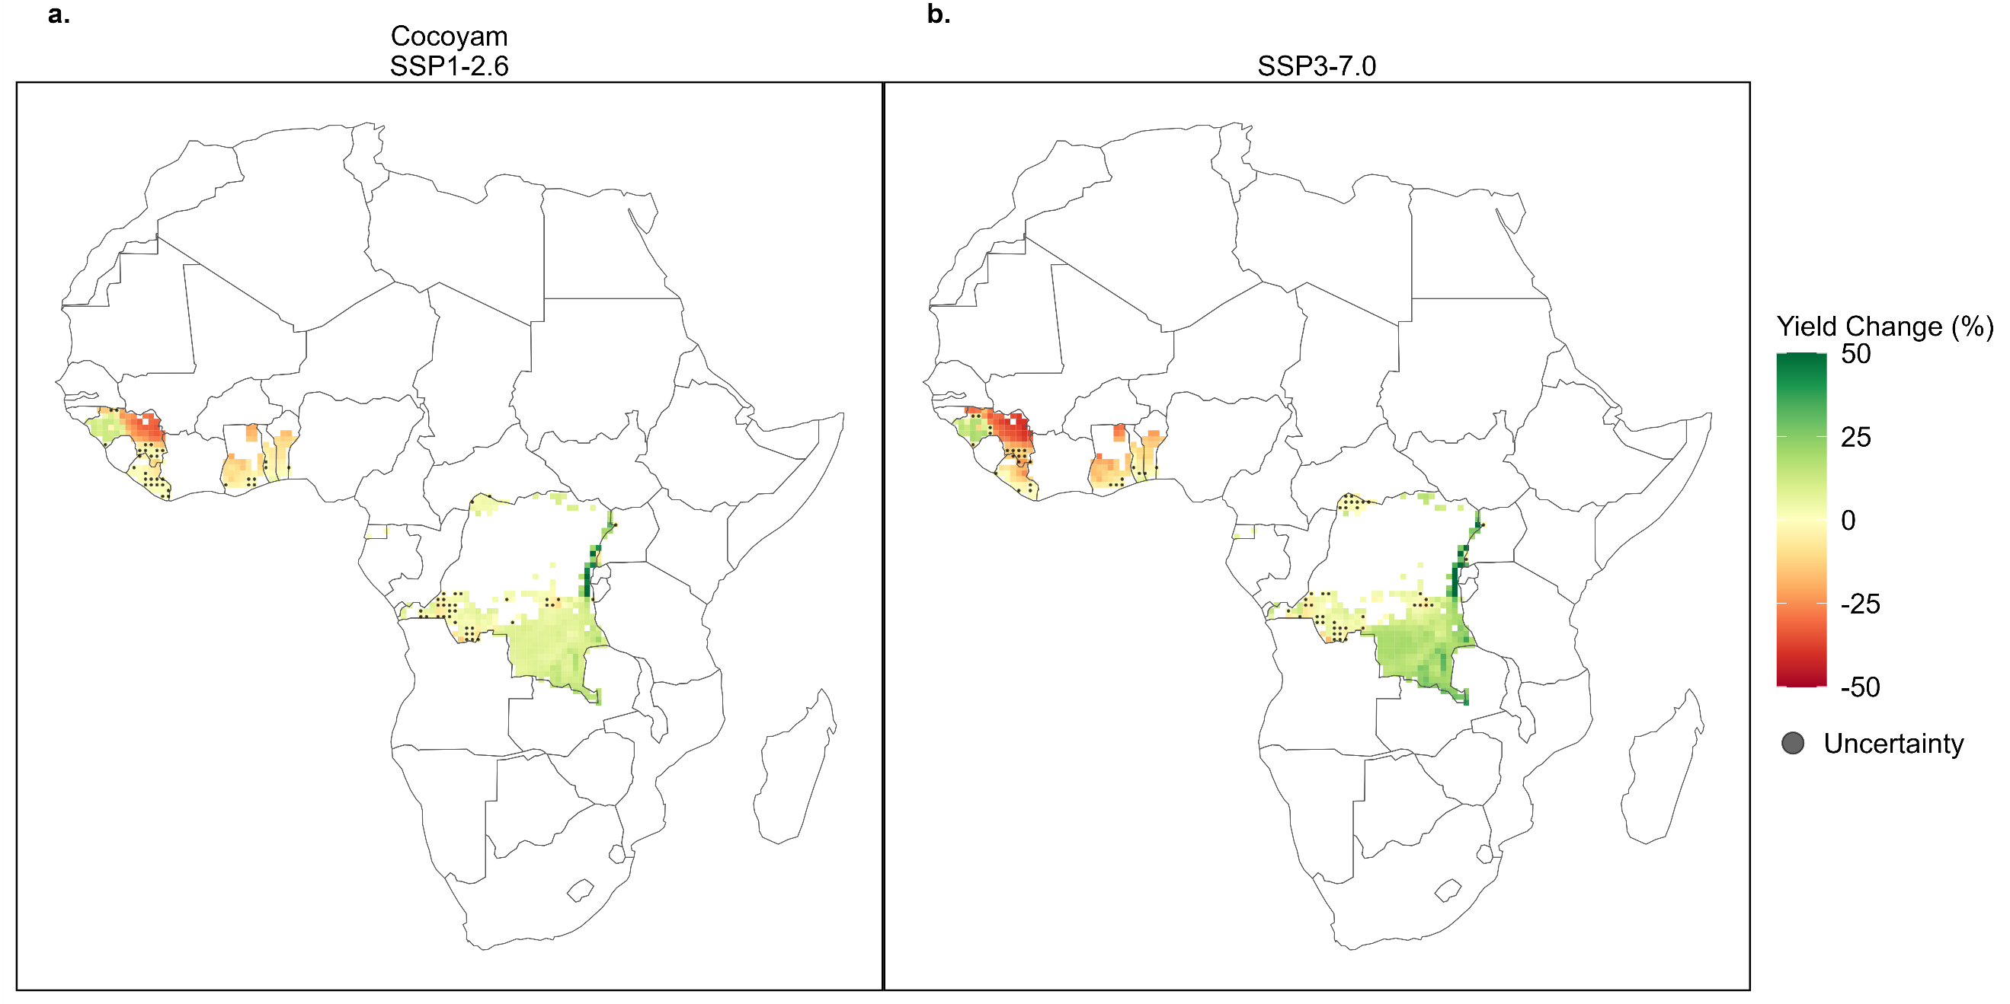
Fig. S11 | Simulated mid-century yield change for cocoyam. Maps showing the average yield changes (2035-2064 compared to 1990-2019) for cocoyam under low emissions, SSP126 (a), and high emissions, SSP370 (b), scenarios for each grid cell. Simulated crop area is based on the current harvest area of each crop using the CROPGRIDS dataset. Yield change is averaged across the four GCMs. Uncertainty points indicate that there was disagreement within the grid cell between the simulated yields using the different GCMs. Grid cells are 0.5° x 0.5°.
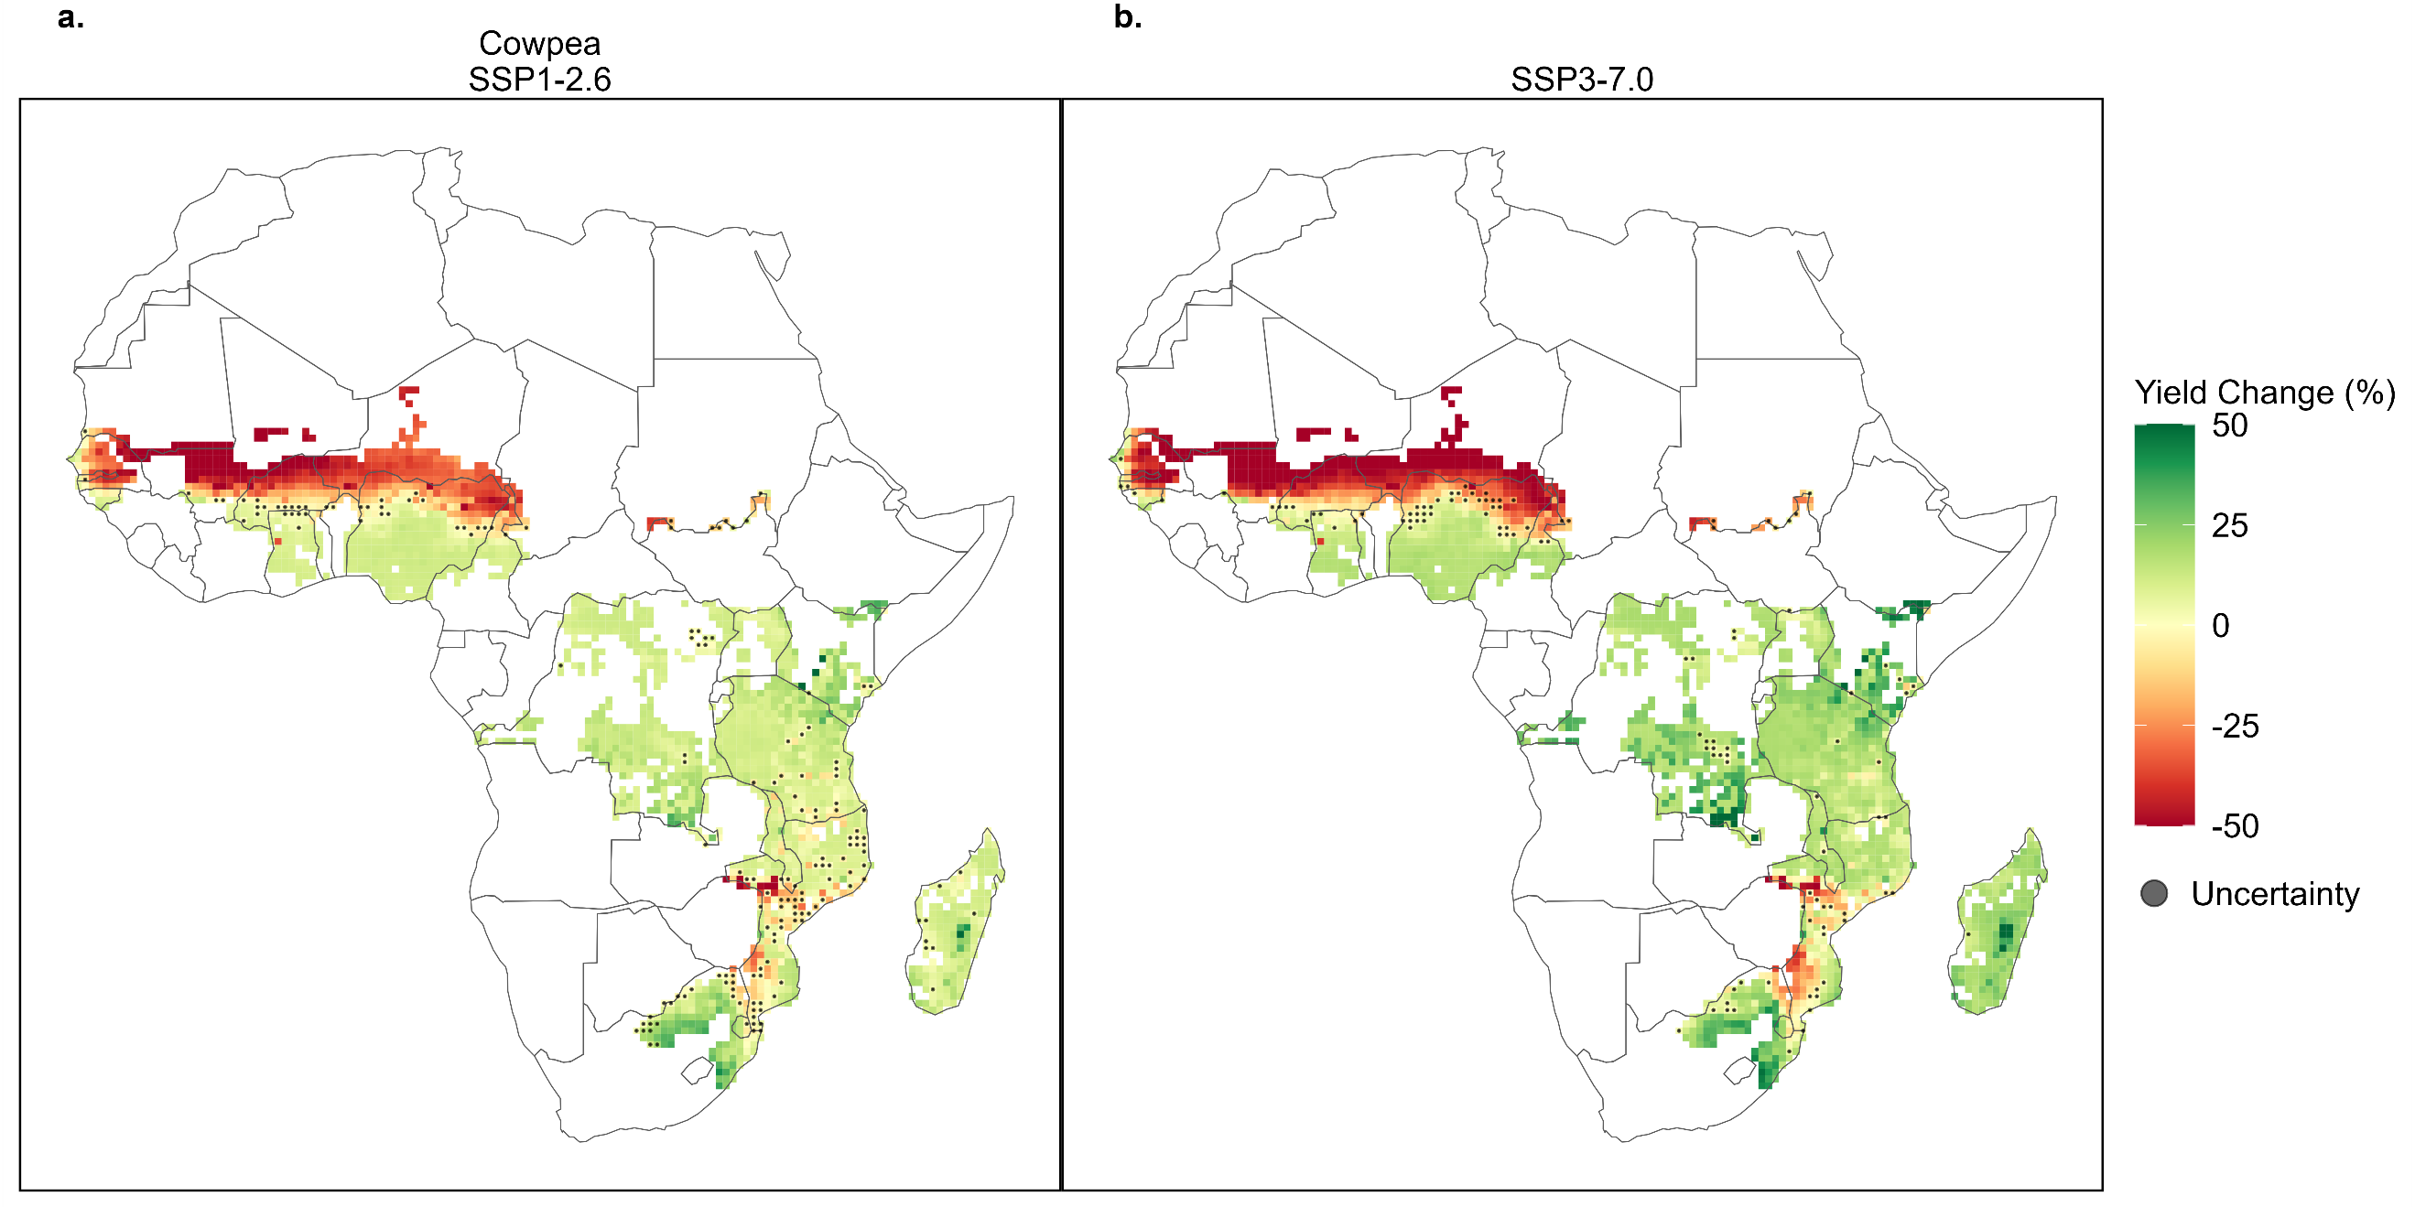
Fig. S12 | Simulated mid-century yield change for cowpea. Maps showing the average yield changes (2035-2064 compared to 1990-2019) for cowpea under low emissions, SSP126 (a), and high emissions, SSP370 (b), scenarios for each grid cell. Simulated crop area is based on the current harvest area of each crop using the CROPGRIDS dataset. Yield change is averaged across the four GCMs. Uncertainty points indicate that there was disagreement within the grid cell between the simulated yields using the different GCMs. Grid cells are 0.5° x 0.5°.
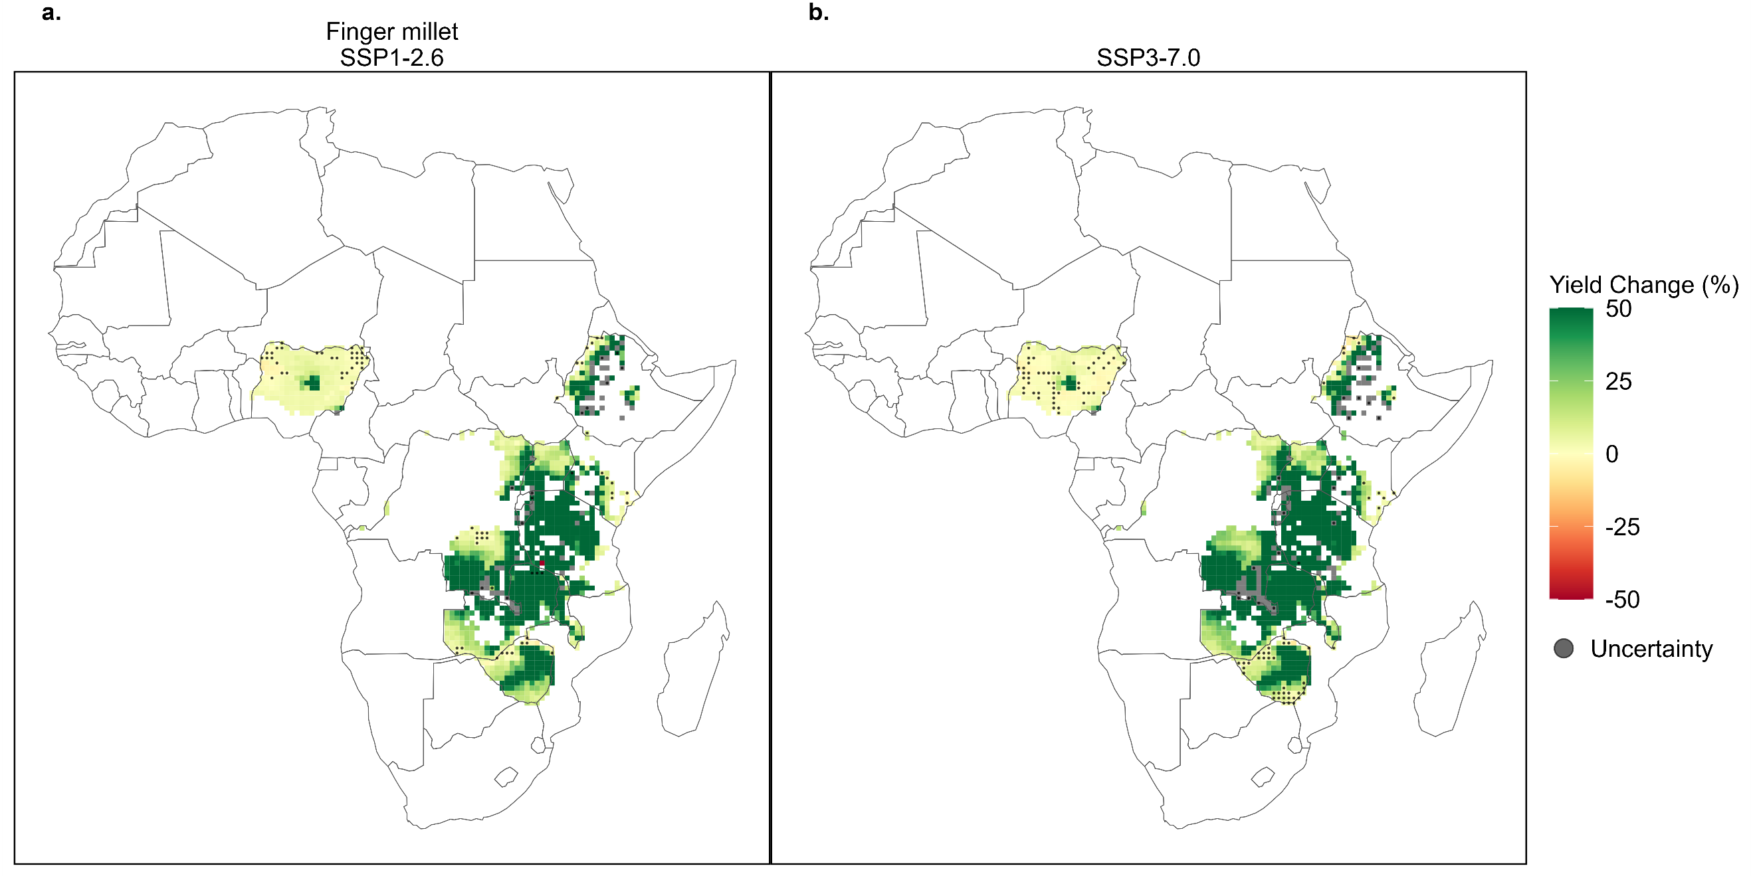
Fig. S13| Simulated mid-century yield change for finger millet. Maps showing the average yield changes (2035-2064 compared to 1990-2019) for finger millet under low emissions, SSP126 (a), and high emissions, SSP370 (b), scenarios for each grid cell. Simulated crop area is based on the current harvest area of each crop using the CROPGRIDS dataset. Yield change is averaged across the four GCMs. Uncertainty points indicate that there was disagreement within the grid cell between the simulated yields using the different GCMs. Grid cells are 0.5° x 0.5°.
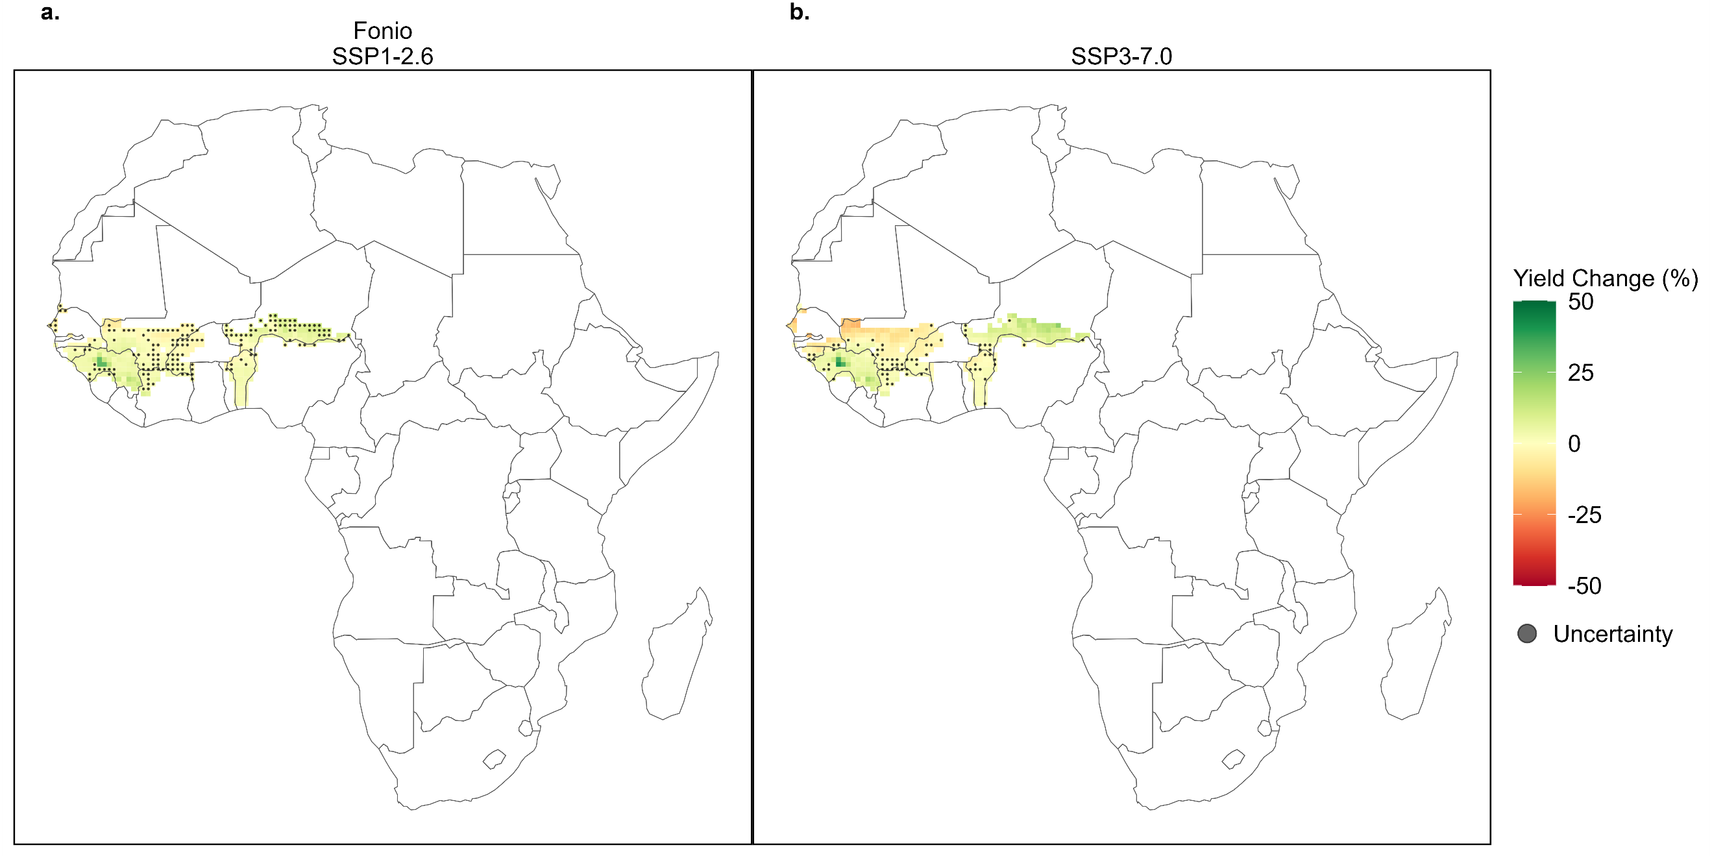
Figure S14 | Simulated mid-century yield change for fonio. Maps showing the average yield changes (2035-2064 compared to 1990-2019) for fonio under low emissions, SSP126 (a), and high emissions, SSP370 (b), scenarios for each grid cell. Simulated crop area is based on the current harvest area of each crop using the CROPGRIDS dataset. Yield change is averaged across the four GCMs. Uncertainty points indicate that there was disagreement within the grid cell between the simulated yields using the different GCMs. Grid cells are 0.5° x 0.5°.
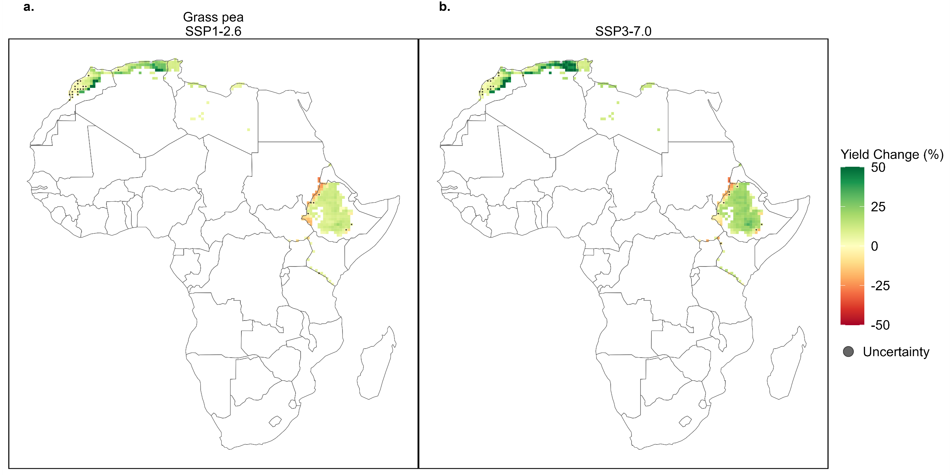
Fig. S15 | Simulated mid-century yield change for grasspea. Maps showing the average yield changes (2035-2064 compared to 1990-2019) for grasspea under low emissions, SSP126 (a), and high emissions, SSP370 (b), scenarios for each grid cell. Simulated crop area is based on the current harvest area of each crop using the CROPGRIDS dataset. Yield change is averaged across the four GCMs. Uncertainty points indicate that there was disagreement within the grid cell between the simulated yields using the different GCMs. Grid cells are 0.5° x 0.5°.
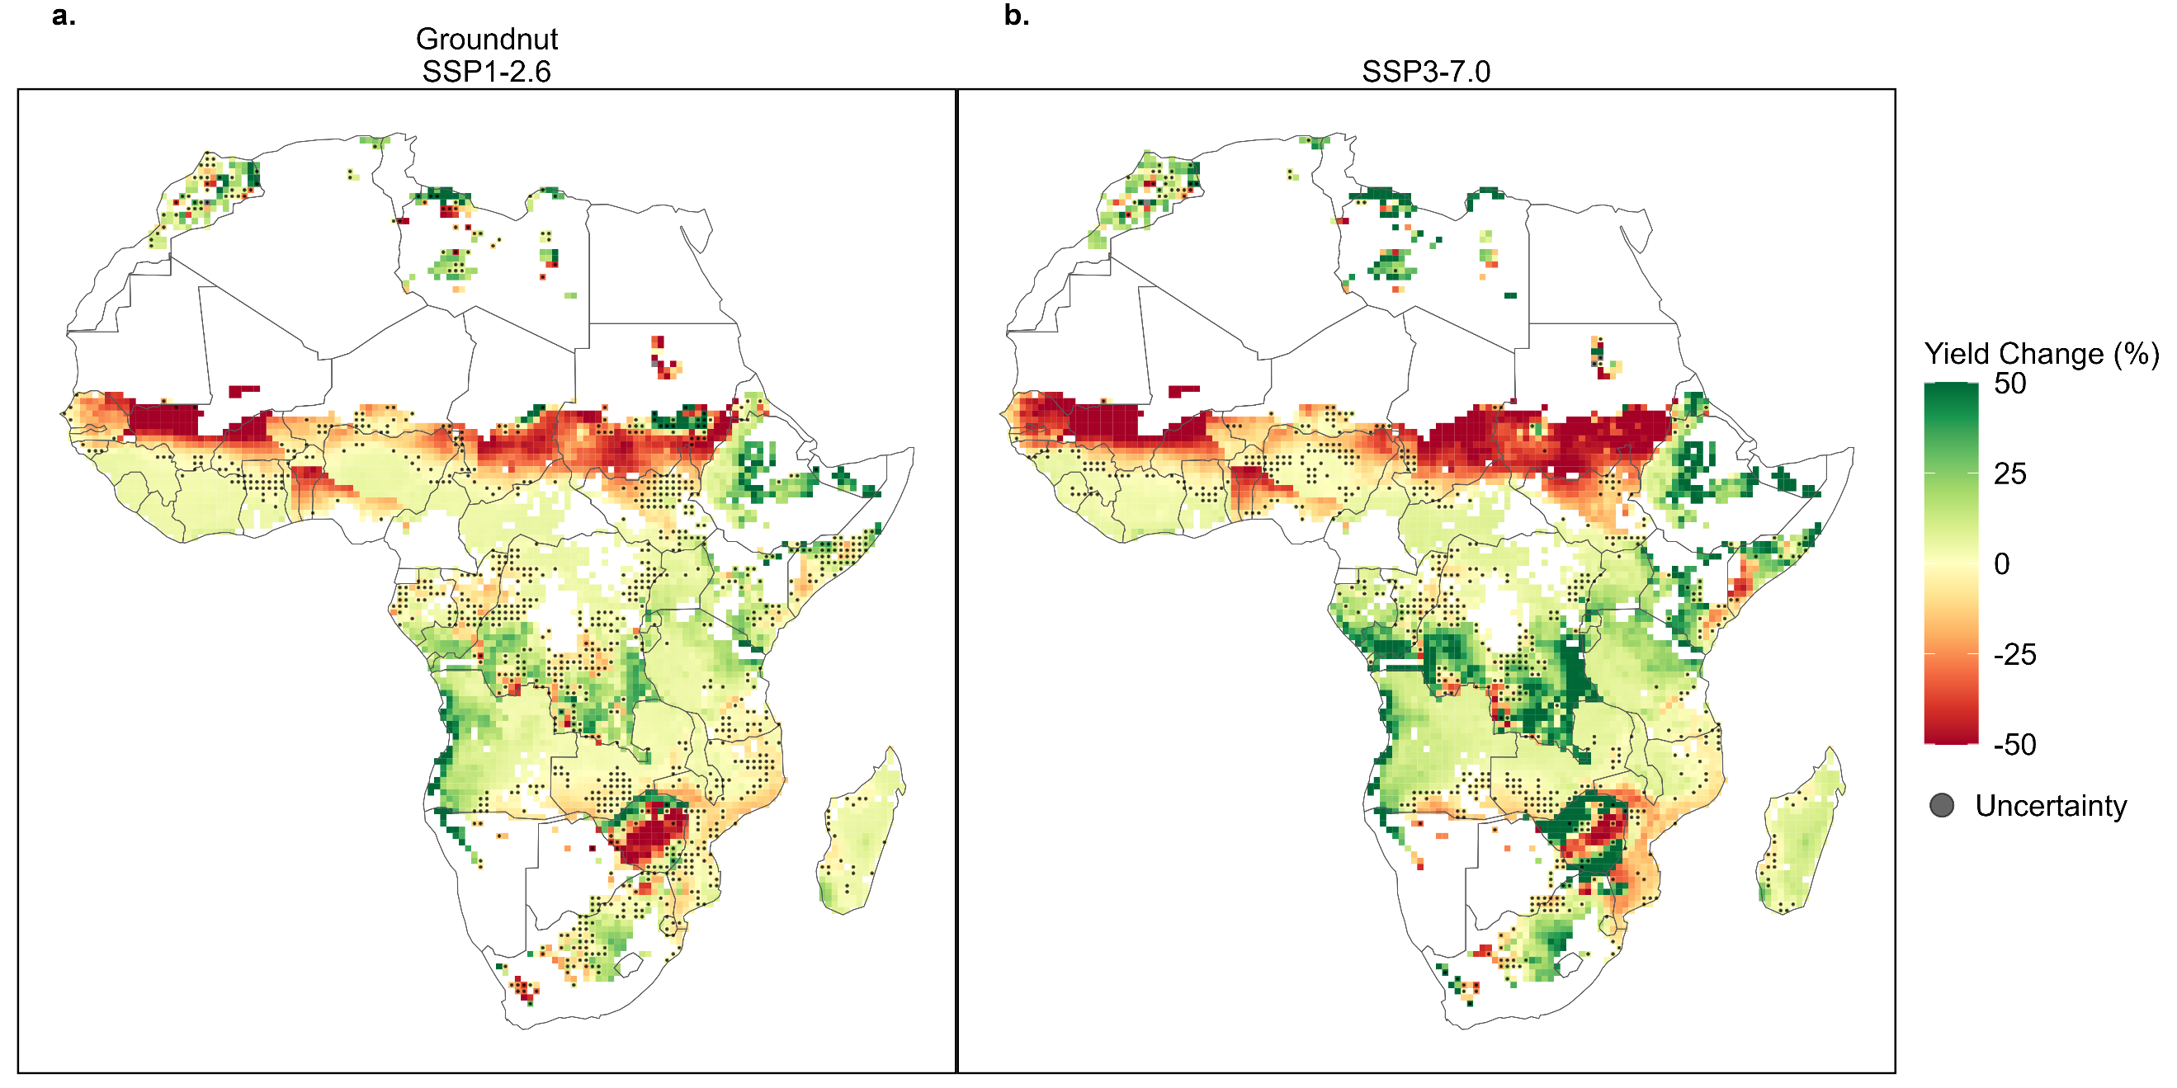
Fig. S16 | Simulated mid-century yield change for groundnut. Maps showing the average yield changes (2035-2064 compared to 1990-2019) for groundnut under low emissions, SSP126 (a), and high emissions, SSP370 (b), scenarios for each grid cell. Simulated crop area is based on the current harvest area of each crop using the CROPGRIDS dataset. Yield change is averaged across the four GCMs. Uncertainty points indicate that there was disagreement within the grid cell between the simulated yields using the different GCMs. Grid cells are 0.5° x 0.5°.
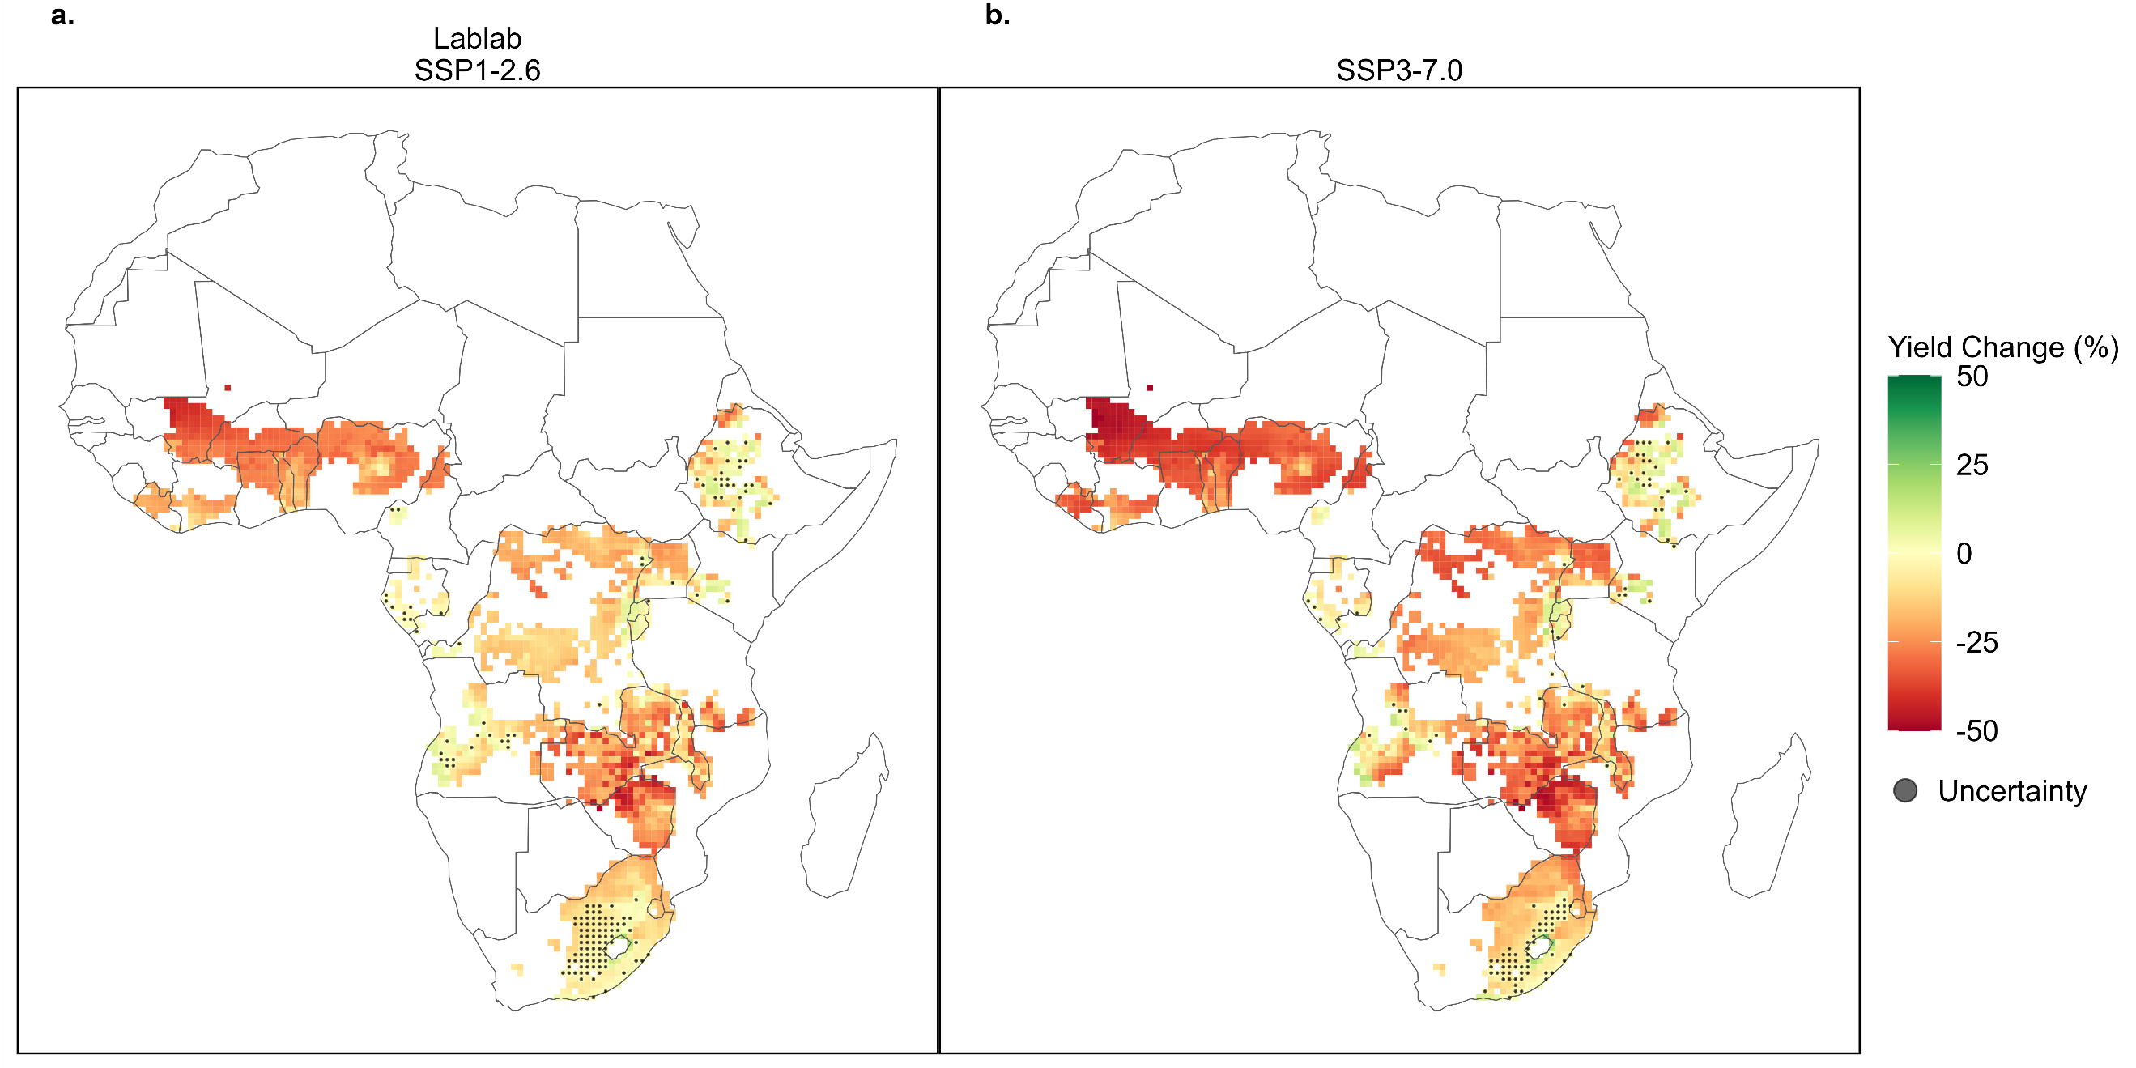
Fig. S17 | Simulated mid-century yield change for lablab. Maps showing the average yield changes (2035-2064 compared to 1990-2019) for lablab under low emissions, SSP126 (a), and high emissions, SSP370 (b), scenarios for each grid cell. Simulated crop area is based on the current harvest area of each crop using the CROPGRIDS dataset. Yield change is averaged across the four GCMs. Uncertainty points indicate that there was disagreement within the grid cell between the simulated yields using the different GCMs. Grid cells are 0.5° x 0.5°.
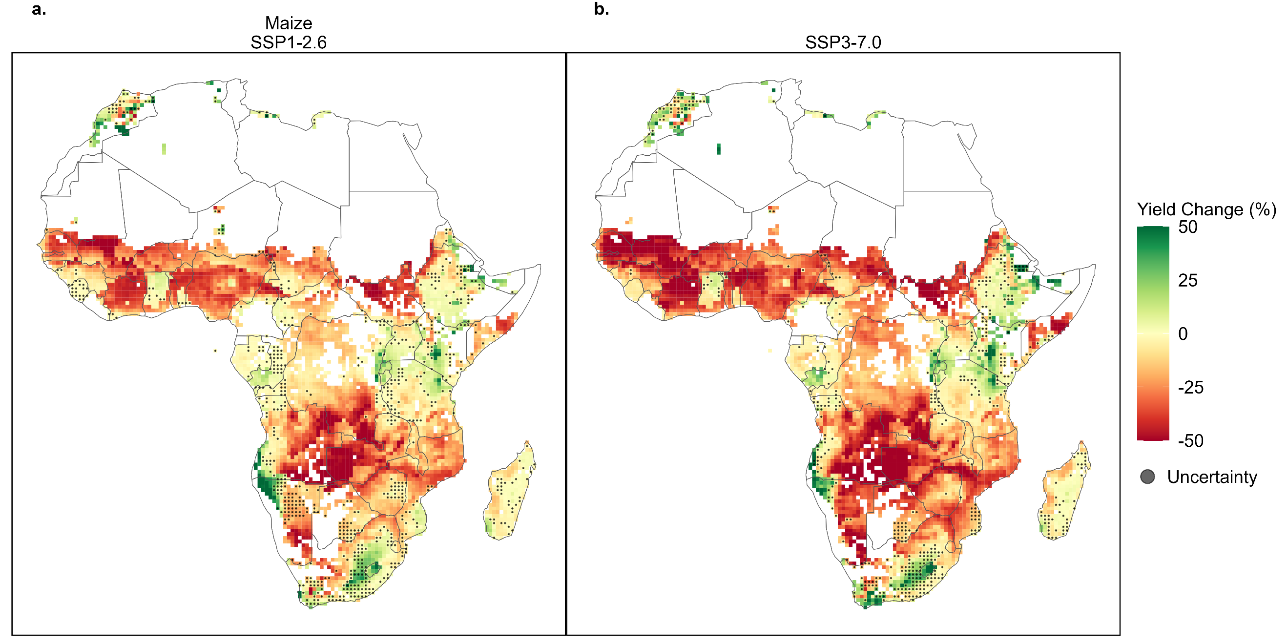
Fig. S18 | Simulated mid-century yield change for maize. Maps showing the average yield changes (2035-2064 compared to 1990-2019) for maize under low emissions, SSP126 (a), and high emissions, SSP370 (b), scenarios for each grid cell. Simulated crop area is based on the current harvest area of each crop using the CROPGRIDS dataset. Yield change is averaged across the four GCMs. Uncertainty points indicate that there was disagreement within the grid cell between the simulated yields using the different GCMs. Grid cells are 0.5° x 0.5°.
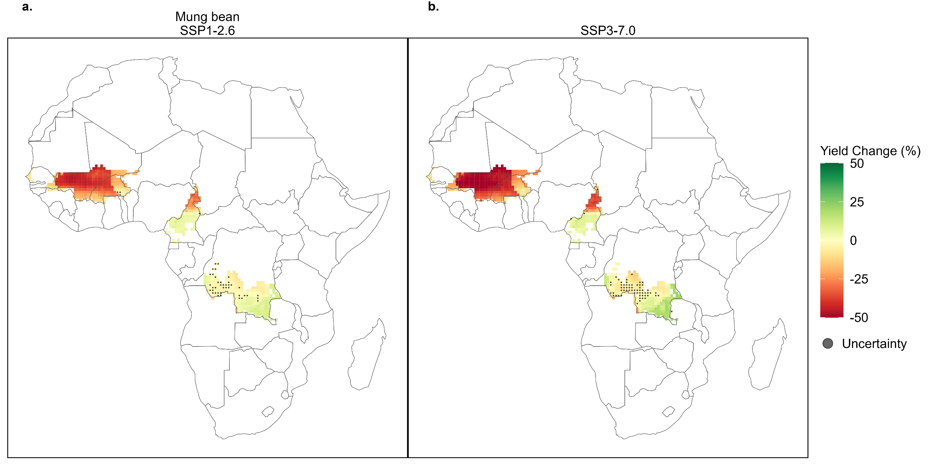
Fig. S19 | Simulated mid-century yield change for mung bean. Maps showing the average yield changes (2035-2064 compared to 1990-2019) for mung bean under low emissions, SSP126 (a), and high emissions, SSP370 (b), scenarios for each grid cell. Simulated crop area is based on the current harvest area of each crop using the CROPGRIDS dataset. Yield change is averaged across the four GCMs. Uncertainty points indicate that there was disagreement within the grid cell between the simulated yields using the different GCMs. Grid cells are 0.5° x 0.5°.
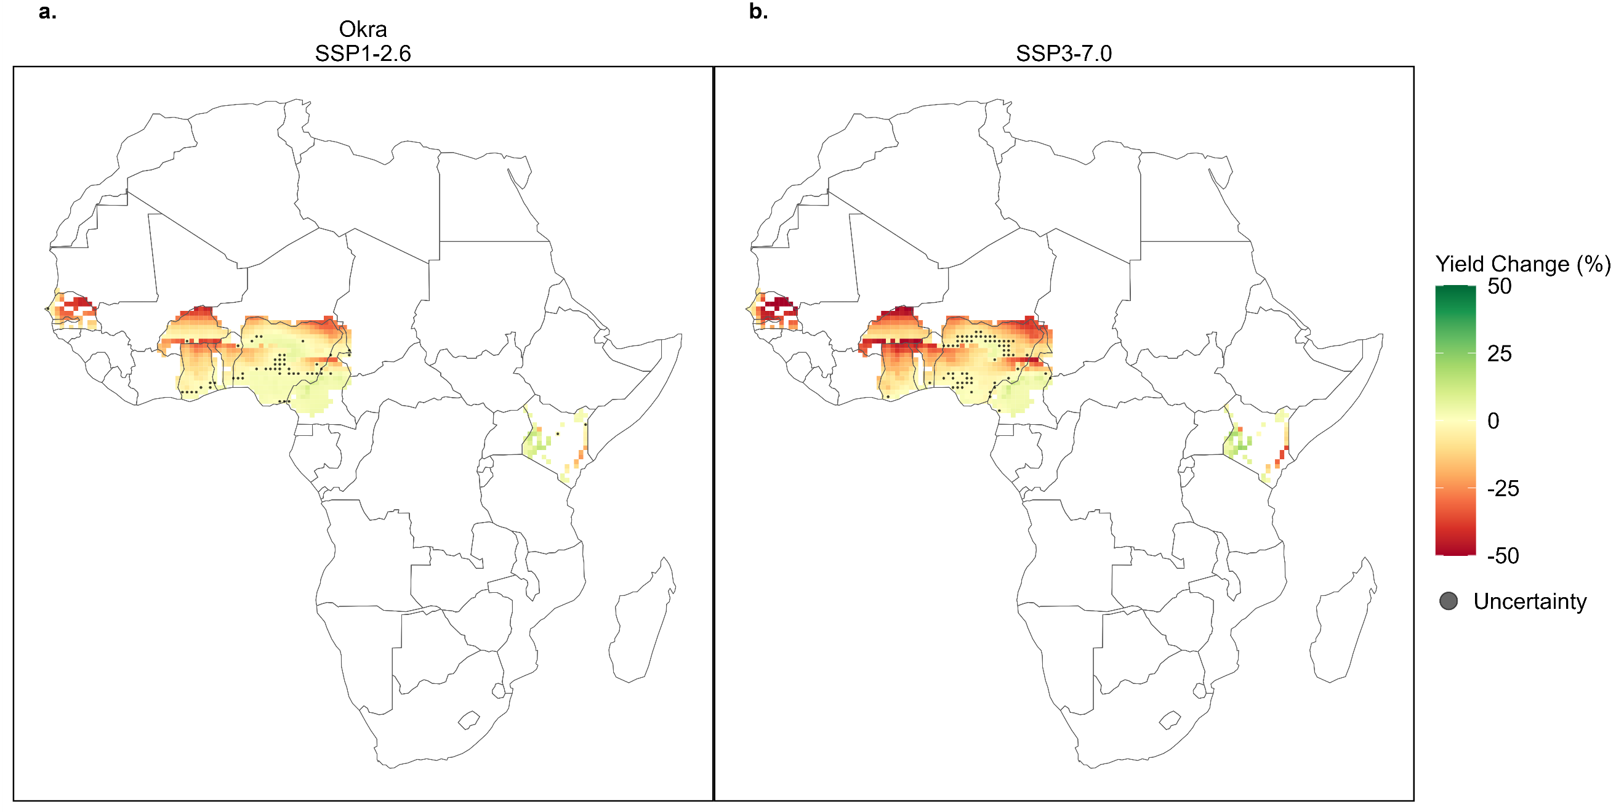
Fig. S20 | Simulated mid-century yield change for okra. Maps showing the average yield changes (2035-2064 compared to 1990-2019) for okra under low emissions, SSP126 (a), and high emissions, SSP370 (b), scenarios for each grid cell. Simulated crop area is based on the current harvest area of each crop using the CROPGRIDS dataset. Yield change is averaged across the four GCMs. Uncertainty points indicate that there was disagreement within the grid cell between the simulated yields using the different GCMs. Grid cells are 0.5° x 0.5°.
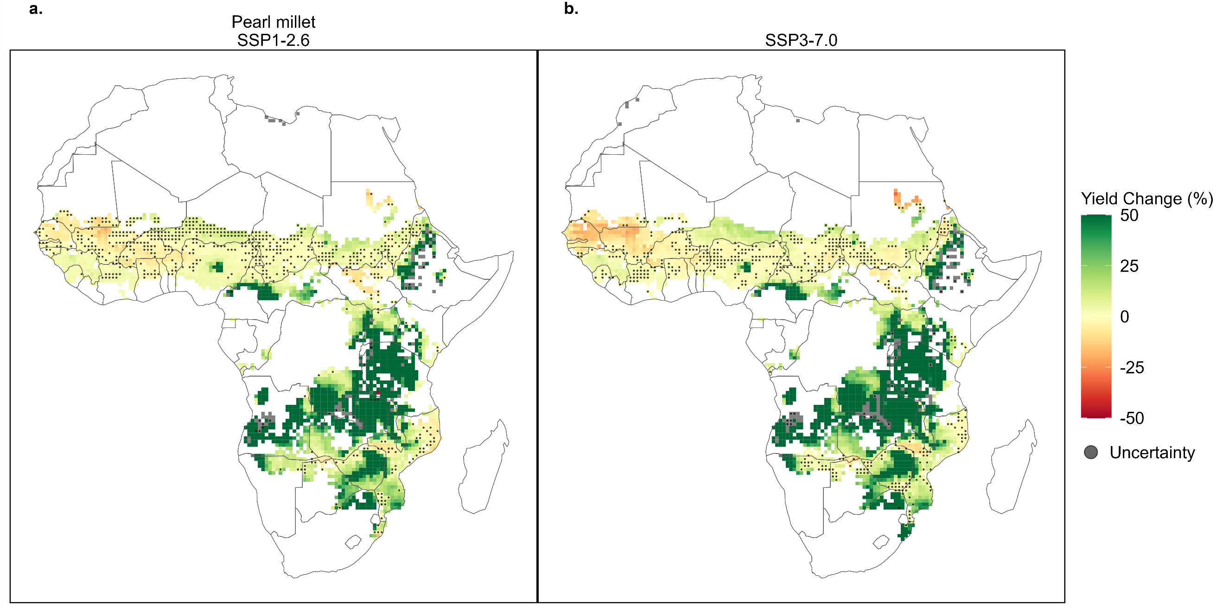
Fig. S21 | Simulated mid-century yield change for pearl millet. Maps showing the average yield changes (2035-2064 compared to 1990-2019) for pearl millet under low emissions, SSP126 (a), and high emissions, SSP370 (b), scenarios for each grid cell. Simulated crop area is based on the current harvest area of each crop using the CROPGRIDS dataset. Yield change is averaged across the four GCMs. Uncertainty points indicate that there was disagreement within the grid cell between the simulated yields using the different GCMs. Grid cells are 0.5° x 0.5°.
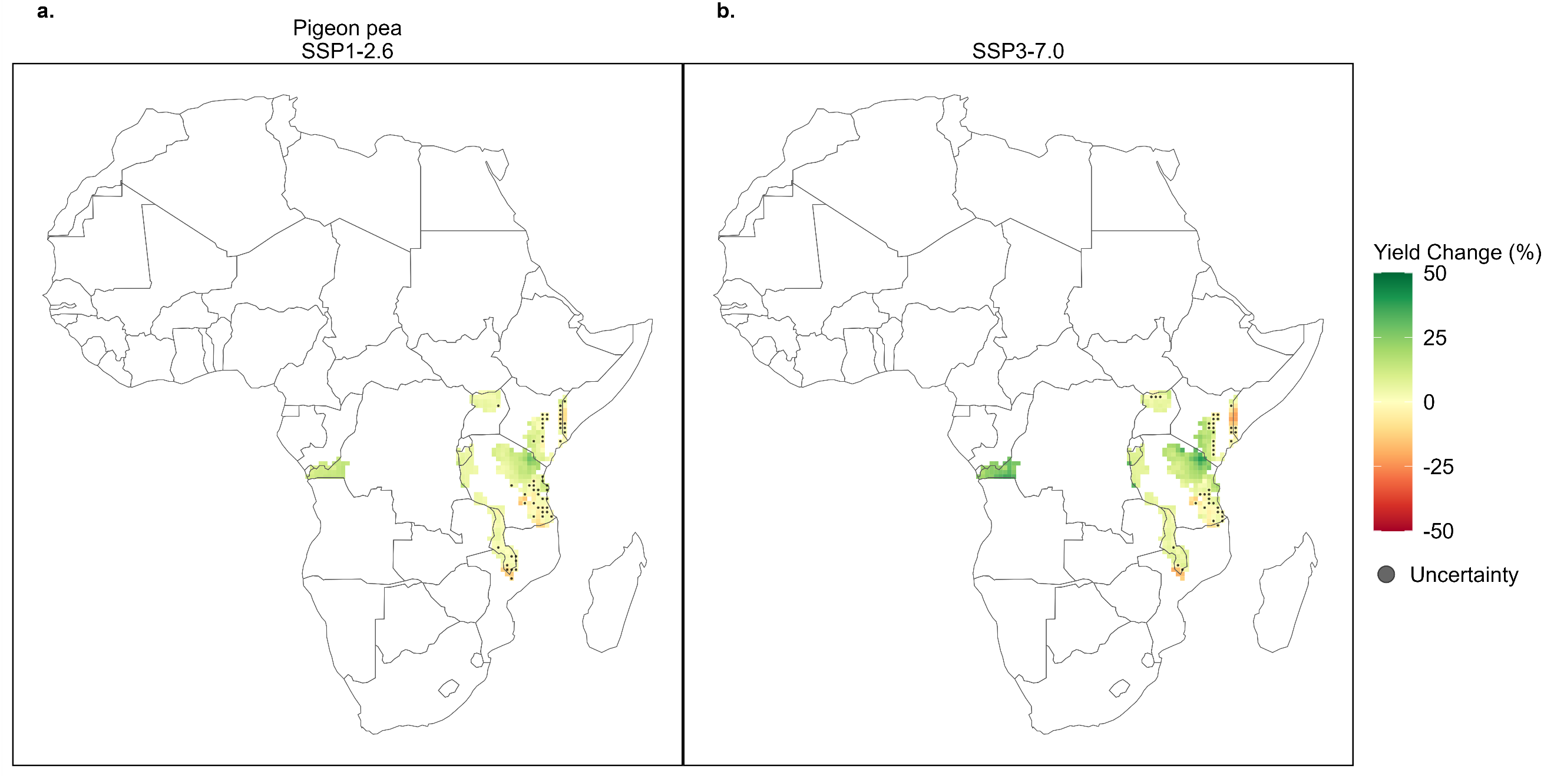
Fig. S22 | Simulated mid-century yield change for pigeon pea. Maps showing the average yield changes (2035-2064 compared to 1990-2019) for pigeon pea under low emissions, SSP126 (a), and high emissions, SSP370 (b), scenarios for each grid cell. Simulated crop area is based on the current harvest area of each crop using the CROPGRIDS dataset. Yield change is averaged across the four GCMs. Uncertainty points indicate that there was disagreement within the grid cell between the simulated yields using the different GCMs. Grid cells are 0.5° x 0.5°.
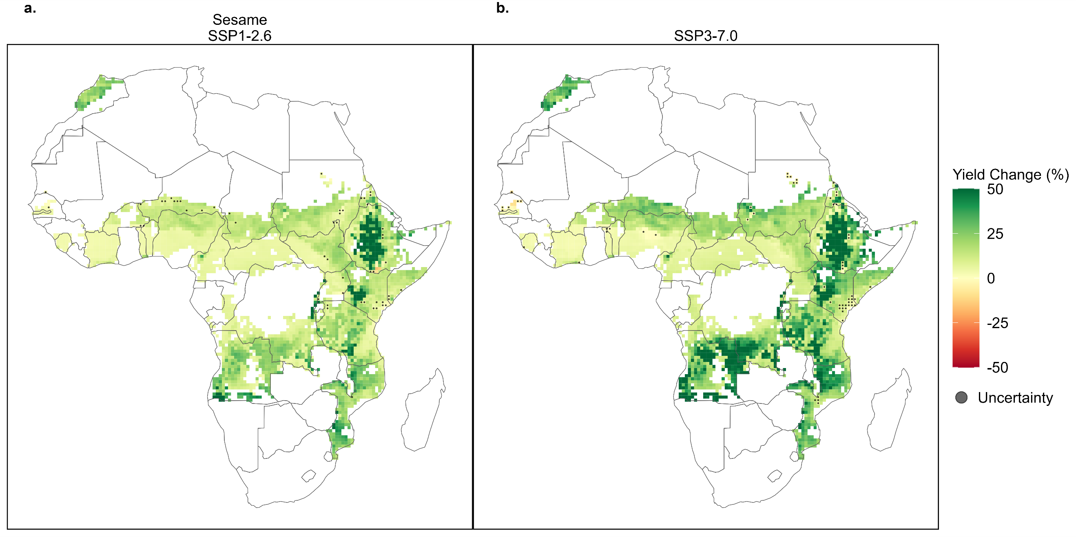
Fig. S23 | Simulated mid-century yield change for sesame. Maps showing the average yield changes (2035-2064 compared to 1990-2019) for sesame under low emissions, SSP126 (a), and high emissions, SSP370 (b), scenarios for each grid cell. Simulated crop area is based on the current harvest area of each crop using the CROPGRIDS dataset. Yield change is averaged across the four GCMs. Uncertainty points indicate that there was disagreement within the grid cell between the simulated yields using the different GCMs. Grid cells are 0.5° x 0.5°.
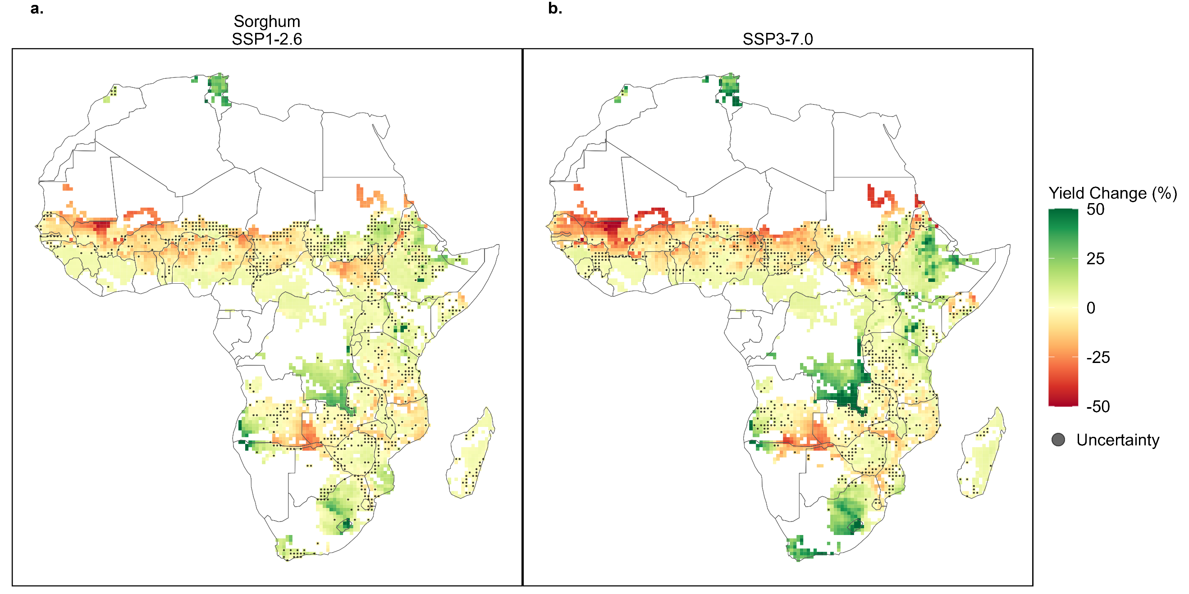
Figure 24 | Simulated mid-century yield change for sorghum. Maps showing the average yield changes (2035-2064 compared to 1990-2019) for sorghum under low emissions, SSP126 (a), and high emissions, SSP370 (b), scenarios for each grid cell. Simulated crop area is based on the current harvest area of each crop using the CROPGRIDS dataset. Yield change is averaged across the four GCMs. Uncertainty points indicate that there was disagreement within the grid cell between the simulated yields using the different GCMs. Grid cells are 0.5° x 0.5°.
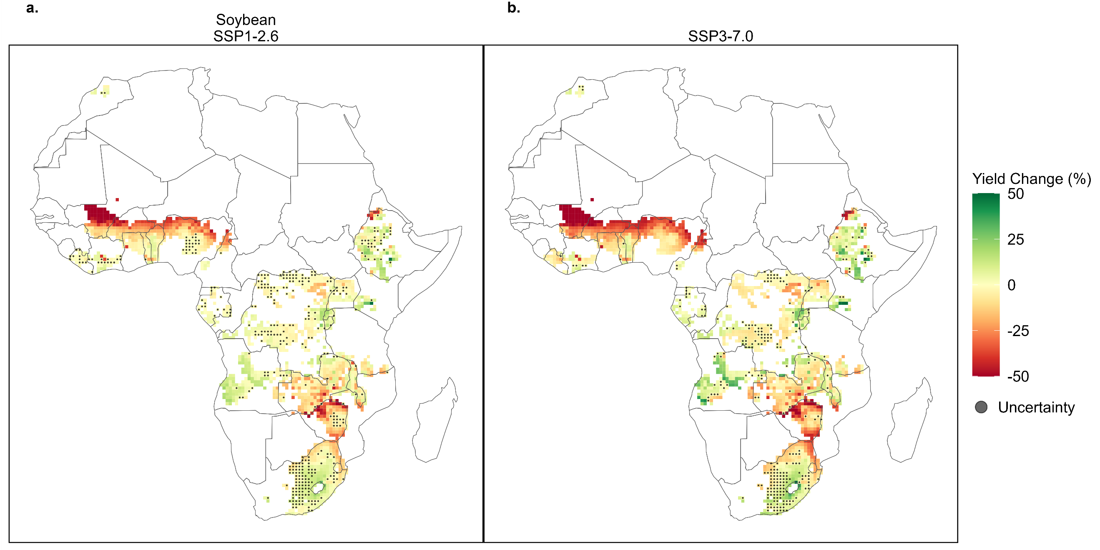
Fig. S25 | Simulated mid-century yield change for soybean. Maps showing the average yield changes (2035-2064 compared to 1990-2019) for soybean under low emissions, SSP126 (a), and high emissions, SSP370 (b), scenarios for each grid cell. Simulated crop area is based on the current harvest area of each crop using the CROPGRIDS dataset. Yield change is averaged across the four GCMs. Uncertainty points indicate that there was disagreement within the grid cell between the simulated yields using the different GCMs. Grid cells are 0.5° x 0.5°.
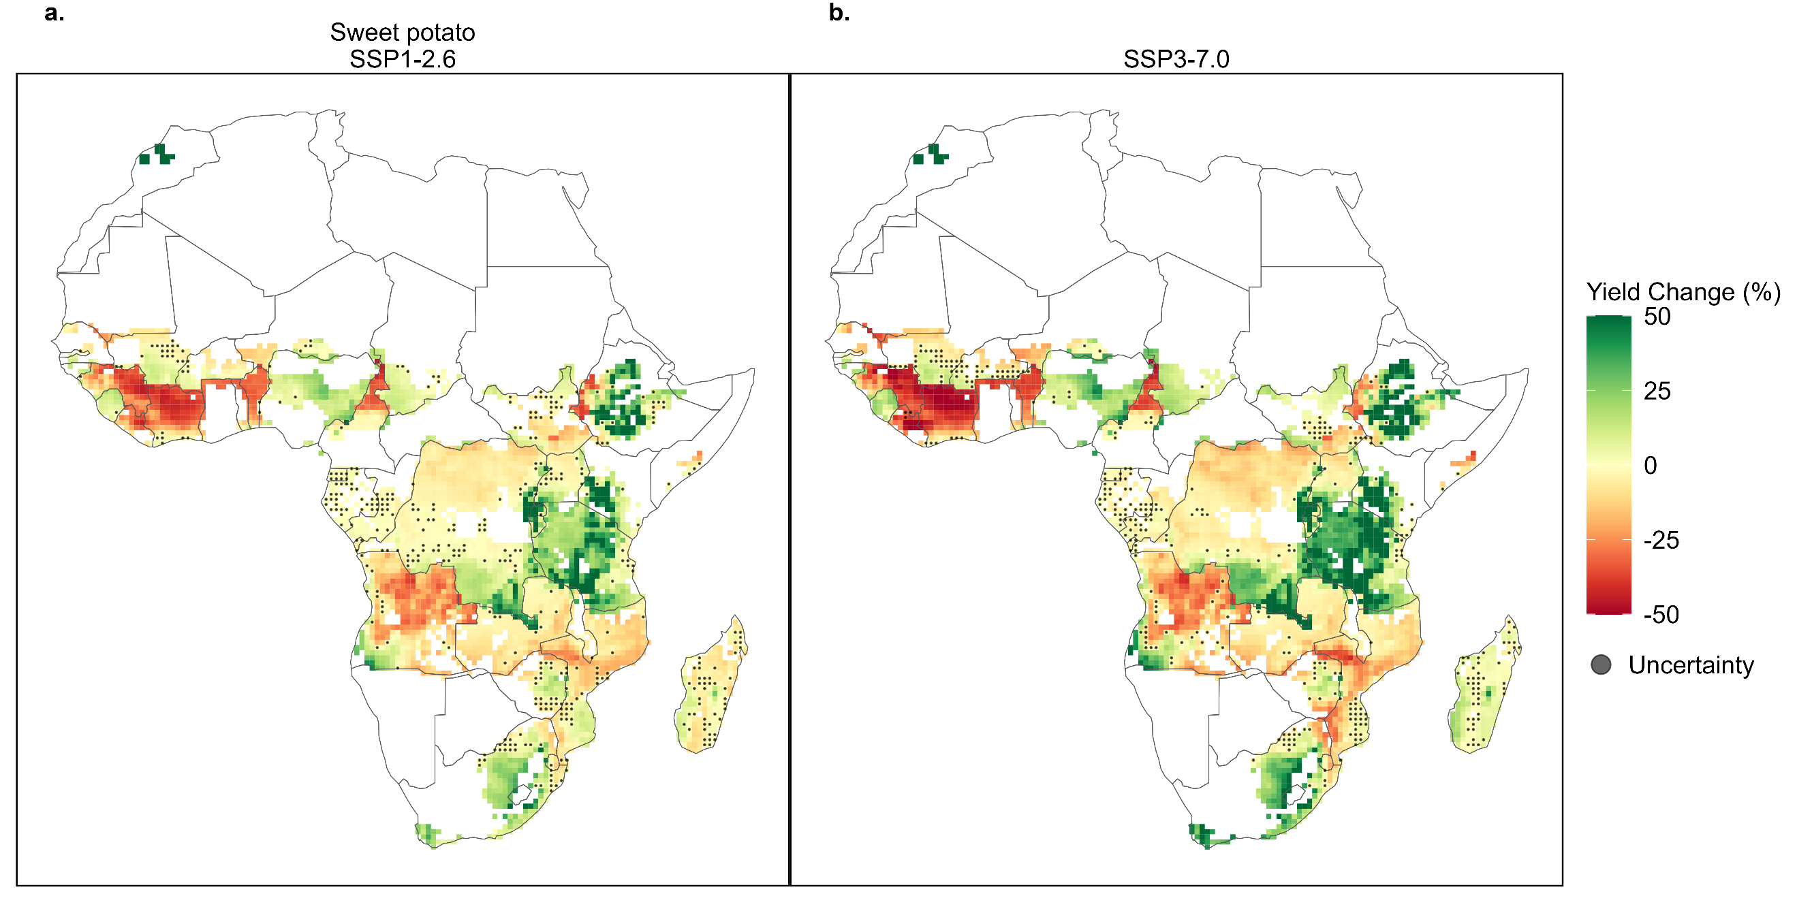
Fig. S26 | Simulated mid-century yield change for sweet potato. Maps showing the average yield changes (2035-2064 compared to 1990-2019) for sweet potato under low emissions, SSP126 (a), and high emissions, SSP370 (b), scenarios for each grid cell. Simulated crop area is based on the current harvest area of each crop using the CROPGRIDS dataset. Yield change is averaged across the four GCMs. Uncertainty points indicate that there was disagreement within the grid cell between the simulated yields using the different GCMs. Grid cells are 0.5° x 0.5°.
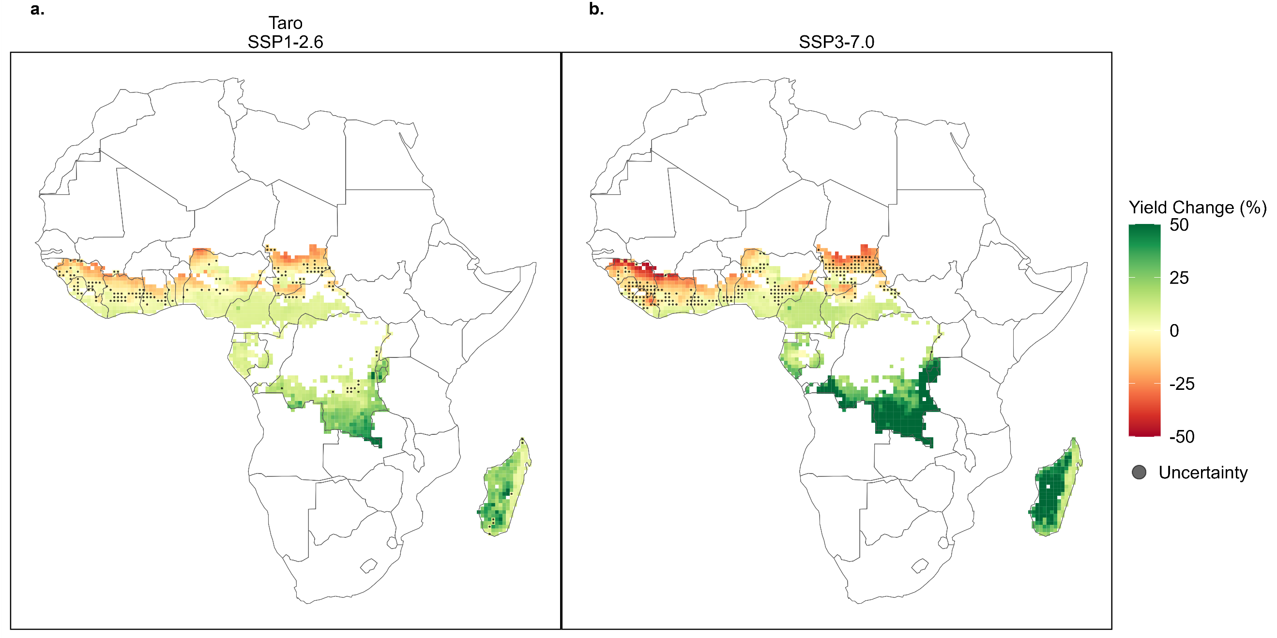
Fig. S27 | Simulated mid-century yield change for taro. Maps showing the average yield changes (2035-2064 compared to 1990-2019) for taro under low emissions, SSP126 (a), and high emissions, SSP370 (b), scenarios for each grid cell. Simulated crop area is based on the current harvest area of each crop using the CROPGRIDS dataset. Yield change is averaged across the four GCMs. Uncertainty points indicate that there was disagreement within the grid cell between the simulated yields using the different GCMs. Grid cells are 0.5° x 0.5°.
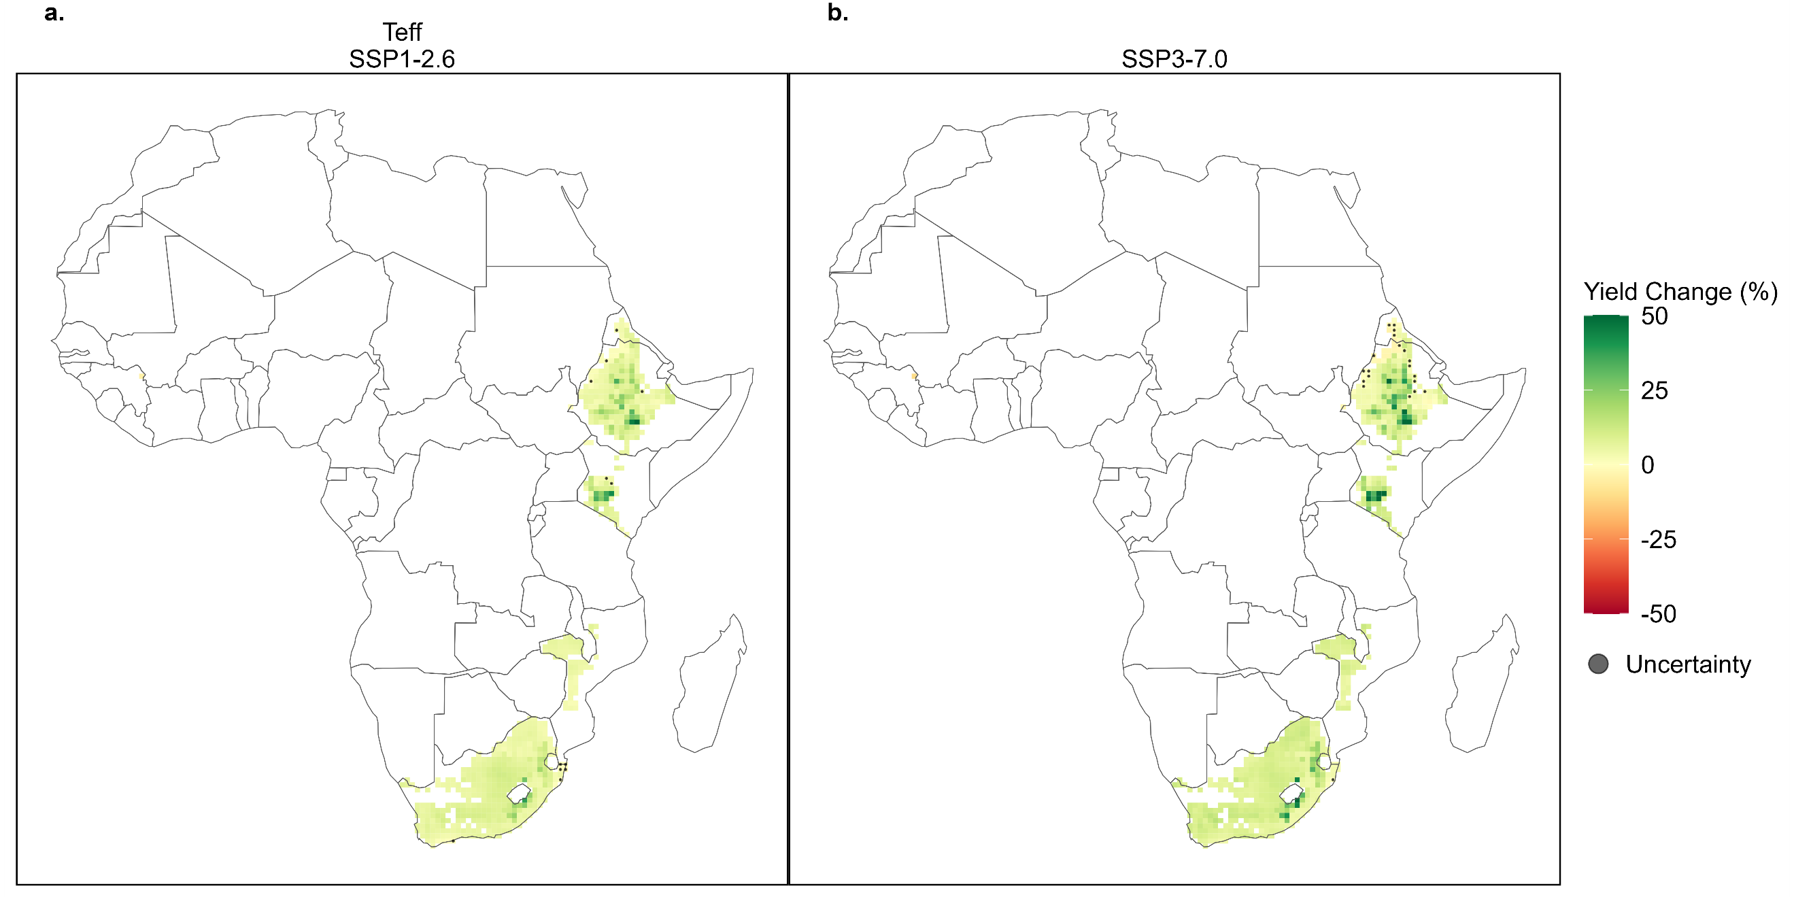
Fig. S28 | Simulated mid-century yield change for teff. Maps showing the average yield changes (2035-2064 compared to 1990-2019) for teff under low emissions, SSP126 (a), and high emissions, SSP370 (b), scenarios for each grid cell. Simulated crop area is based on the current harvest area of each crop using the CROPGRIDS dataset. Yield change is averaged across the four GCMs. Uncertainty points indicate that there was disagreement within the grid cell between the simulated yields using the different GCMs. Grid cells are 0.5° x 0.5°.
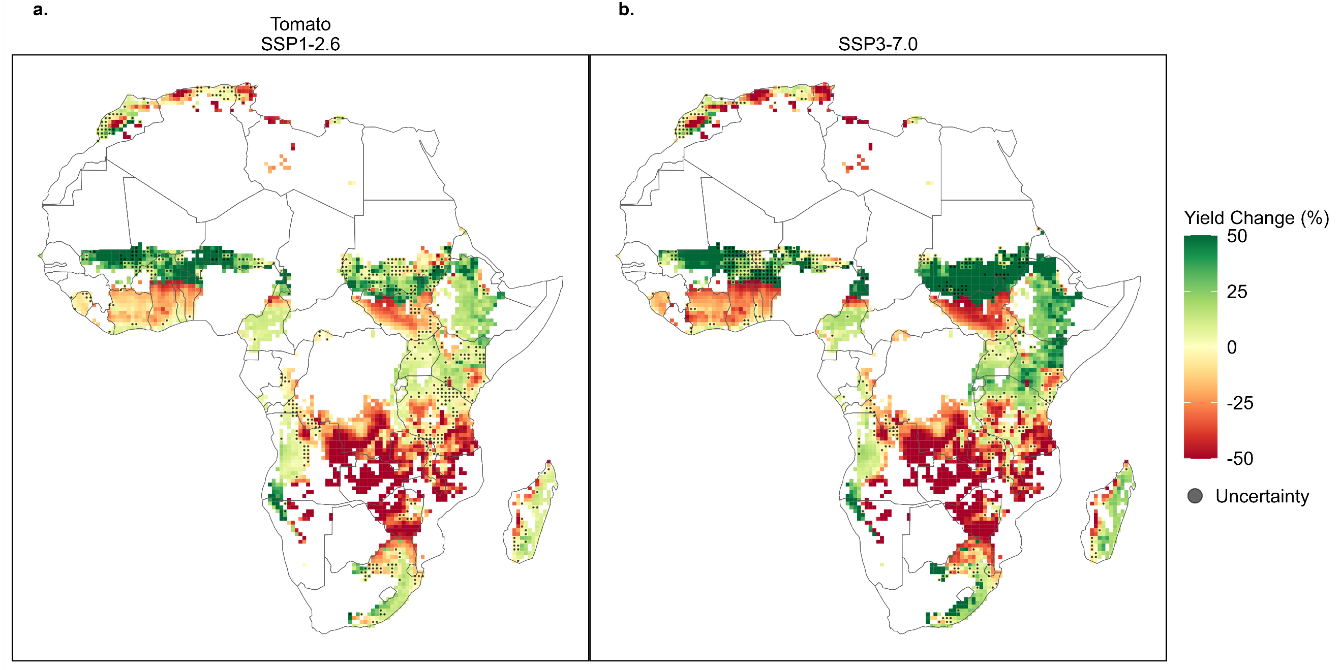
Fig. S29 | Simulated mid-century yield change for tomato. Maps showing the average yield changes (2035-2064 compared to 1990-2019) for tomato under low emissions, SSP126 (a), and high emissions, SSP370 (b), scenarios for each grid cell. Simulated crop area is based on the current harvest area of each crop using the CROPGRIDS dataset. Yield change is averaged across the four GCMs. Uncertainty points indicate that there was disagreement within the grid cell between the simulated yields using the different GCMs. Grid cells are 0.5° x 0.5°.
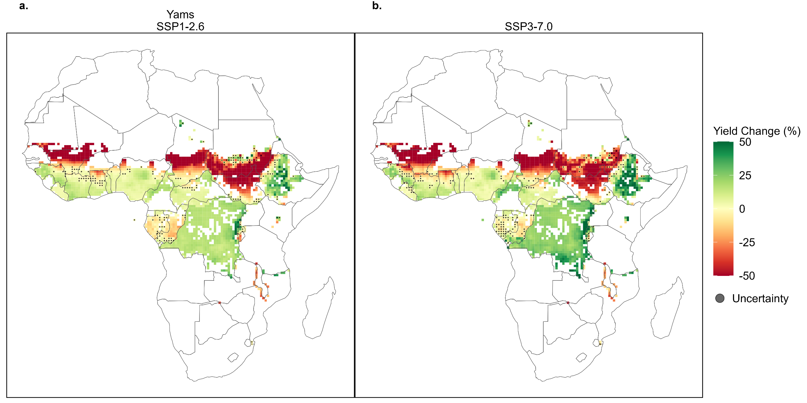
Fig. S30 | Simulated mid-century yield change for yams. Maps showing the average yield changes (2035-2064 compared to 1990-2019) for yams under low emissions, SSP126 (a), and high emissions, SSP370 (b), scenarios for each grid cell. Simulated crop area is based on the current harvest area of each crop using the CROPGRIDS dataset. Yield change is averaged across the four GCMs. Uncertainty points indicate that there was disagreement within the grid cell between the simulated yields using the different GCMs. Grid cells are 0.5° x 0.5°.

Crop resiliency figures:
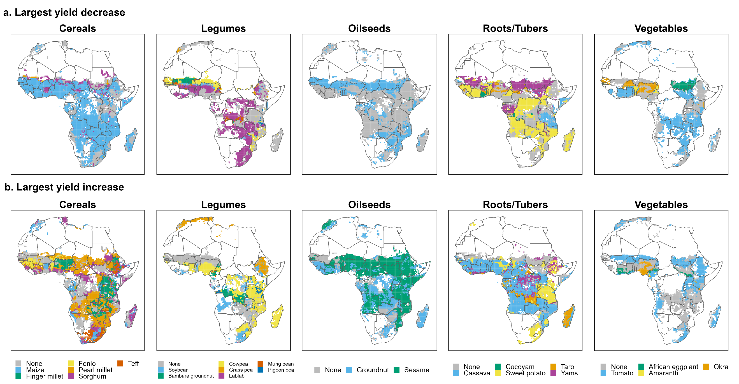
Fig. S31 | Best and worst performing crops under projected low emissions. Maps showing the cereals, legumes, oilseeds, roots and tubers, and vegetables with the largest simulated average yield decrease (a) and increase (b) compared to the other crops within each crop type for each grid cell under the low emissions scenario, SSP1-2.6 (high emissions scenario, SSP3-7.0, shown in Fig. 4). Simulations are based on the current harvest areas of each crop, thus not every crop is simulated in each grid cell. “None” indicates that none of the simulated crops showed a yield decrease or increase in that grid cell. Benchmark crop for each group is in blue.

Additional data inputs:
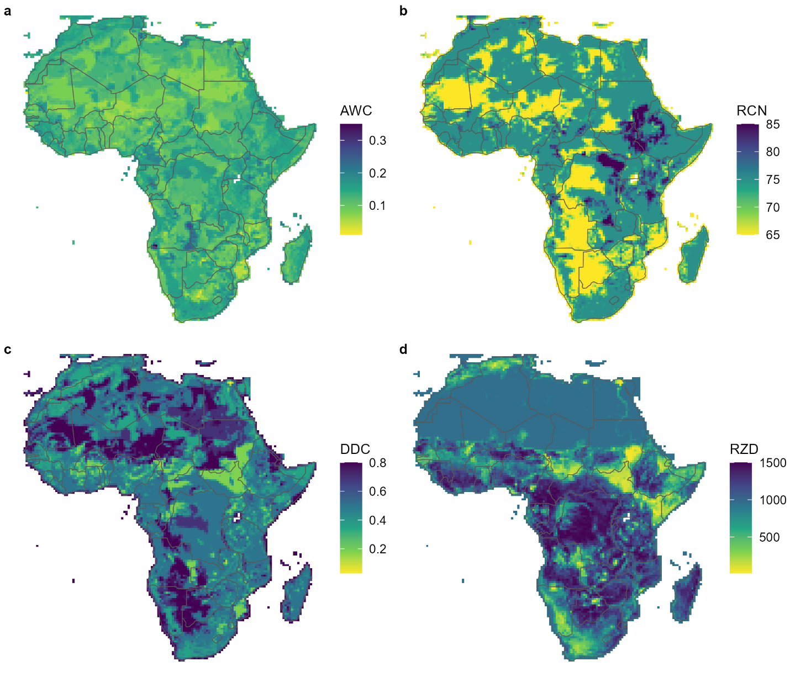
Fig. S32 | Maps of Africa soil input data. Maps showing the available water capacity (a), runoff curve number (b), deep drainage coefficient (c), and root zone depth (d) for soils across Africa used as input into the crop model. Available water capacity, runoff curve number, and deep drainage coefficient are from the Global Soil Dataset for use in Earth Systems Models (GSDE)¹⁶. Root zone depth is from Africa Soil Information Service (AfSIS)¹⁷. Grid cells are 0.5° x 0.5°.

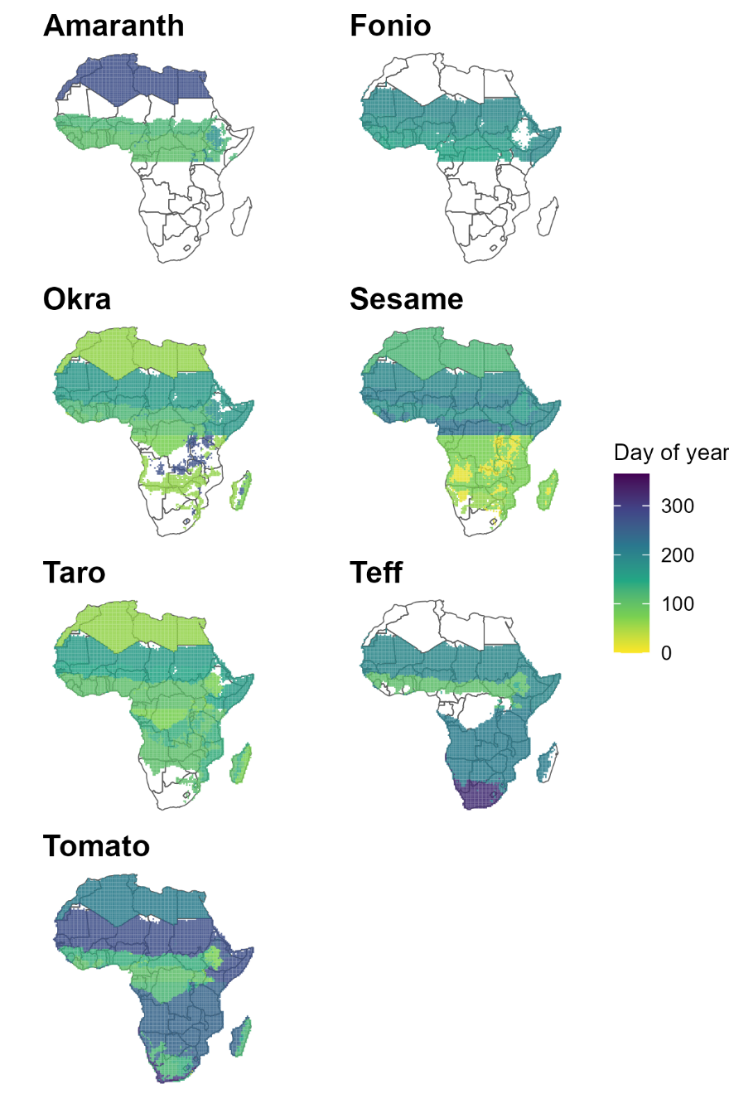
Fig. S33 | Maps of derived Africa crop calendars. Maps showing the planting day of the year for the crops that are not available in the GGCMI crop calendar dataset⁴. Planting days are based on the defined agroecological regions¹⁸, where each region is filled with the dominant representative sowing dates from the FAO crop calendar (https://cropcalendar.apps.fao.org/#/home), supplemented by the International Fertilizer Association’s Fertilizer Use by Country crop calendar¹¹ and other literature sources¹²⁻¹⁴. Note, we use the tomato crop calendar as a proxy for African eggplant due to limited phenological data and because they are both solanaceous fruit-bearing plants. Blank areas indicate missing data in the agroecological region so simulations in these areas used the average planting day from the crop calibration. Grid cells are 0.5° x 0.5°.

References
1 Woli, P., Jones, J. W., Ingram, K. T. & Fraisse, C. W. Agricultural Reference Index for Drought (ARID). Agronomy Journal 104, 287-300 (2012). https://doi.org/10.2134/agronj2011.0286
2 Yang, M. et al. (in prep., in prep., 2024).
3 Meehl, G. A. et al. Context for interpreting equilibrium climate sensitivity and transient climate response from the CMIP6 Earth system models. Science Advances 6, 10 (2020). https://doi.org/10.1126/sciadv.aba1981
4 Jägermeyr , J. et al. Climate impacts on global agriculture emerge earlier in new generation of climate and crop models. Nature Food 2, 875-+ (2021). https://doi.org/10.1038/s43016-021-00400-y
5 Krasting, J. P. et al. (World Data Center for Climate (WDCC) at DKRZ, 2023).
6 Boucher, O. et al. Presentation and Evaluation of the IPSL-CM6A-LR Climate Model. Journal of Advances in Modeling Earth Systems 12, e2019MS002010 (2020). https://doi.org/https://doi.org/10.1029/2019MS002010
7 Jungclaus, J. et al. (Earth System Grid Federation, 2019).
8 Yukimoto, S. et al. (Earth System Grid Federation, 2019).
9 Tang, F. H. M. et al. CROPGRIDS: a global geo-referenced dataset of 173 crops. Scientific Data 11, 14 (2024). https://doi.org/10.1038/s41597-024-03247-7
10 FAOSTAT. (FAO, 2024).
11 IFASTAT. (International Fertilizer Association, 2024).
12 Malherbe, S. & Marais, D. Economics, Yield and Ecology: A Case Study from the South African Tomato Industry. Outlook on Agriculture 44, 37-47 (2015). https://doi.org/10.5367/oa.2015.0195
13 Robinson, E. J. Z. & Kolavalli, S. L. The case of tomato in Ghana: Productivity. Ghana Strategy Support Program working papers 19 (2010).
14 Kamga, R. T., Some, S., Tenkouano, A., Issaka, Y. B. & Ndoye, O. Assessment of traditional African vegetable production in Burkina Faso. Journal of Agricultural Extension and Rural Development 8, 141-150 (2016). https://doi.org/10.5897/JAERD2016.0788
15 Chemura, A., Gleixner, S. & Gornott, C. Dataset of the suitability of major food crops in Africa under climate change. Scientific Data 11, 294 (2024). https://doi.org/10.1038/s41597-024-03118-1
16 Shangguan, W., Dai, Y. J., Duan, Q. Y., Liu, B. Y. & Yuan, H. A global soil data set for earth system modeling. Journal of Advances in Modeling Earth Systems 6, 249-263 (2014). https://doi.org/10.1002/2013ms000293
17 Leenaars, J. G. B. et al. Mapping rootable depth and root zone plant-available water holding capacity of the soil of sub-Saharan Africa. Geoderma 324, 18-36 (2018). https://doi.org/https://doi.org/10.1016/j.geoderma.2018.02.046
18 HarvestChoice & International Food Policy Research Institute. (eds International Food Policy Research Institute & HarvestChoice) (Harvard Dataverse, 2015).

