Prevalence, incidence and impact of cancer in atrial Fibrillation: a systematic review and meta-analysis of 6,600,000 patients

Supplementary Materials

Shaobin Mao, MM,^{1,3} Leigang Wang, MD,² Hongxuan Fan, MM,² Ling Yang, MM,^{1,3} Zhuoxuan Yang, MD,^{1,3} Wenjing Zhang, MD,² Miao Wang, MM,² Liuyi Hao, PhD,^{1,3} Bin Liang, PhD,^{2, *}

1, Department of Cardiology, Yuncheng Central Hospital affiliated Shanxi Medical University, Yuncheng 044000, Shanxi Province, China
2, Department of Cardiology, The Second Hospital of Shanxi Medical University, Taiyuan 030000, Shanxi Province, China
3, Yuncheng Key Laboratory of Tumor Cardiology, Yuncheng 044000, Shanxi Province, China
*, Corresponding author: Liang Bin, Tel: 0351-3985328, E-mail: liangbin@sxmu.edu.cn

Supplemental Table 1 Full Search Strategy
PubMed
#1 (atrial fibrillation[MeSH]) OR (atrial fibrillation[Title/Abstract])
#2 (((neoplasms[Title/Abstract]) OR (((((((cancer[Title/Abstract]) OR (carcinoma[Title/Abstract])) OR (tumour[Title/Abstract])) OR (tumor[Title/Abstract])) OR (lymphoma[Title/Abstract])) OR (leukaemia[Title/Abstract])) OR (leukemia[Title/Abstract]))) OR (neoplasms[MeSH Terms]))
#3 #1 AND #2
Embase
#1 atrial fibrillation:ab,kw,ti
#2 neoplasms:ab,kw,ti OR cancer:ab,kw,ti OR carcinoma:ab,kw,ti OR tumour:ab,kw,ti OR tumor:ab,kw,ti OR 'lymphoma':ab,kw,ti OR leukaemia:ab,kw,ti OR 'leukemia':ab,kw,ti
#3 #1AND #2
Web of science
#1 (TS=(atrial fibrillation)) OR TS=(AF)
#2 (((((((TS=(Neoplasms)) OR TS=(cancer )) OR TS=(carcinoma)) OR TS=( tumour)) OR TS=( tumor)) OR TS=(lymphoma)) OR TS=(leukaemia)) OR TS=(leukemia)
#3 #1 AND #2
Cochrane Library
#1 atrial fibrillation:ab,kw,ti
#2 neoplasms:ab,kw,ti OR cancer:ab,kw,ti OR carcinoma:ab,kw,ti OR tumour:ab,kw,ti OR tumor:ab,kw,ti OR 'lymphoma':ab,kw,ti OR leukaemia:ab,kw,ti OR 'leukemia':ab,kw,ti
#3 #1 AND #2

Supplemental Table2 Critical appraisal checklists for case series
Questions | Details
- Were the clear criteria for inclusion in the case series? | Inclusion and exclusion criteria should be clearly reported in the manuscript
- Was the condition measured in a standard, reliable way for all participants included in the case series? | The paper should clearly describe the methods used to assess the patient's condition, and the methods should be standard and credible
- Were valid methods used for identification of the condition for all participants included in the case series? | Cases should have clear diagnostic criteria, preferably based on accepted diagnostic criteria or clear definitions.
- Did the case series have consecutive inclusion of participants? | Whether the methods of inclusion of subjects in the case series are consistent directly affects the credibility of the results.
- Did the case series have complete inclusion of participants? | Cases should be included from multiple centers or from different levels of institutions as much as possible, and not only cases with good and typical efficacy, but also cases with poor efficacy, atypical and poor compliance should be included to explore the reasons for adverse reactions of interventions or poor compliance of patients.
- Was there clear reporting of the demographics of the participants in the study? | Case series studies should clearly describe the demographic information of the included research subjects, including age, gender, education level, marital status, race, etc., to provide a basis for the extrapolation of research results or the handling of similar cases by other clinical staff.
- Was there clear reporting of clinical information of the participants? | Case series studies should clearly describe the clinical information of the study subjects, including disease type, disease status, comorbidities, disease severity, previous diagnosis results and treatment, especially the treatment/intervention plan adopted should be described in detail, so that other clinical staff can learn from similar cases.
- Were the outcomes or follow up results of cases clearly reported? | The selection of outcome indicators for case series was mainly based on research objectives, and most studies focused on the efficacy and safety of treatment/intervention strategies.
- Was there clear reporting of the presenting site(s)/clinic(s) demographic information? | Geographic/social information of cases should be described in detail in case series to provide reference for other clinical personnel
- Was statistical analysis appropriate? | Case series studies often analyze and report the outcome indicators at different levels, such as disease stage or patient characteristics.
Each query can be selected to answered by “Yes”, “No”, “Unclear”, “Not applicable”.

Supplement Table 3 Baseline characteristics of the studies providing the prevalence cancer in AF patients
Author | Year | Total AF | Cancer event | Cancer type | Age (year) | Female sex (%) | CAD (%) |  | HF (%) |  | HTN (%) |  | Stroke/TIA (%) |  | Diabetes (%) | CKD（%）
Lawrence M. Brass | 1997 | 488 | 16 | Metastatic cancer | N/A | 63.1 | 39.5 | 31.6 |  | 55.3 |  | 26.8 |  | 23.2 |  | N/A
Theresa I. Shireman | 2004 | 10093 | 273 | All cancer | 77.2 | 50.4 | 67.4 | 60.6 |  | 69.1 |  | 32.3 |  | 28.8 |  | N/A
Li-Jen Lin | 2008 | 39541 | 1997 | All cancer | 70.1 | 43.2 | 36.8 | 32.7 |  | 56.8 |  | N/A |  | 18.9 |  | N/A
Karen Smoyer-Tomic | 2012 | 3037 | 252 | All cancer | N/A | 44.1 | 42.3 | 31.1 |  | 71.9 |  | 8.2 |  | 28.2 |  | N/A
Tommy Andersson | 2013 | 272186 | 45183 | All cancer | 72.3 | 44 | NA | 24.8 |  | 25.4 |  | 14.2 |  | 13.4 |  | 1.6
Clare L. Atzema | 2015 | 3510 | 349 | All cancer | N/A | 50.2 | N/A | 6.9 |  | 54 |  | 8.1 |  | 15.1 |  | 3.4
Laurent Fauchier | 2015 | 533044 | 101102 | All cancer | 78.0 | 47.1 | N/A | 29.6 |  | 70.2 |  | 11.1 |  | 24.3 |  | N/A
Ana Filipa Macedo | 2015 | 29717 | 1189 | All cancer | 73.51 | 44.08 | N/A | N/A |  | 53.35 |  | 10.79 |  | 12.31 |  | 17.32
O. HANON | 2015 | 1072 | 158 | All cancer | 78.0 | 45.8 | 11.5 | 17.3 |  | 81.1 |  | 12 |  | 18.4 |  | N/A
Thomas Lardaro | 2015 | 420 | 100 | All cancer | N/A | 36.2 | 23.8 | 13.6 |  | 61.4 |  | 12.4 |  | 21.2 |  | N/A
Fredrik Björck | 2015 | 4583 | 481 | All cancer | 75.6 | 45.8 | NA | 21.8 |  | 65.9 |  | 100 |  | 19 |  | N/A
Marco Proietti | 2016 | 558 | 76 | All cancer | 82 | 53.2 | 24.6 | 33.2 |  | 84.4 |  | 15.6 |  | 33 |  | 28.7
Laurent Fauchier | 2016 | 8962 | 163 | All cancer | N/A | 38.7 | 30.3 | 54.8 |  | 41.7 |  | 8.2 |  | 15.5 |  | N/A
Jose´ Moreno-Arribas | 2016 | 1290 | 102 | All cancer | 73.8 | 42 | 18 | 28 |  | 81 |  | 16 |  | 29 |  | N/A
Dingxin Qin | 2016 | 5952 | 643 | All cancer | N/A | 40 | 40.2 | 23.5 |  | 64.2 |  | N/A |  | 21.3 |  | 8.4
José Miguel Rivera-Caravaca | 2017 | 1361 | 105 | All cancer | 76 | 51.3 | 18.7 | 31.5 |  | 82 |  | 19.6 |  | 26.7 |  | N/A
Hee Tae Yu | 2017 | 5833 | 78 | Genitourinary tract cancer | N/A | 49.9 | N/A | 21.7 |  | 56.5 |  | 15.7 |  | 16.5 |  | N/A
Chiara Melloni | 2017 | 18183 | 1236 | All cancer | N/A | 35.3 | 33.2 | 35.4 |  | 87.4 |  | 19.5 |  | N/A |  | N/A
Mu-Mei Hu | 2017 | 3662 | 343 | All cancer | 69.9 | 45.5 | N/A | 18.1 |  | 52.1 |  | 7.3 |  | 20.8 |  | N/A
Kathryn F. Flack | 2017 | 546 | 44 | Gastrointestinal cancer | N/A | 34.4 | N/A | N/A |  | N/A |  | N/A |  | N/A |  | N/A
Chiara Melloni | 2017 | 9749 | 2318 | All cancer | N/A | 42.6 | N/A | 32.9 |  | 83.2 |  | 15.2 |  | 29.5 |  | 37.2
Alanna M. Chamberlain | 2017 | 1430 | 557 | All cancer | 72.7 | 51.4 | 39 | 18.2 |  | 71.1 |  | 14.6 |  | 30.6 |  | 20.2
Olivier Hanon | 2017 | 7225 | 233 | Active cancer | 71.5 | 40 | 23.4 | 21.3 |  | 72.5 |  | 8.48 |  | 22.4 |  | N/A
Oliver Königsbrügge | 2017 | 166 | 56 | All cancer | 71.5 | 28.9 | 50 | 42.2 |  | 92.2 |  | 27.1 |  | 41.6 |  | N/A
Hideki Koike | 2018 | 509 | 86 | All cancer | 69.7 | 35.4 | N/A | 33.2 |  | 59.9 |  | 13.8 |  | 22.6 |  | N/A
Maria D’Souza | 2018 | 122053 | 12014 | All cancer | N/A | 50.7 | N/A | 21.6 |  | 58.2 |  | 13.9 |  | 11 |  | 5.9
Paweł Balsam | 2018 | 2657 | 211 | All cancer | N/A | 40.2 | 42.6 | 37 |  | 71.4 |  | 12.7 |  |  |  | 19.8
Husam Abdel-Qadir | 2018 | 136156 | 11134 | All cancer | 79.57 | 49.8 | 48.7 | 29.1 |  | 69.6 |  | 3.9 |  | 28.8 |  | 13.5
Ayman Elbadawi | 2018 | 732069 | 15802 | All cancer | N/A | 49.2 | 39.3 | 12.9 |  | 70.7 |  | N/A |  | 29.4 |  | 5.5
Euijae Lee | 2018 | 15411 | 2173 | All cancer | 63.9 | 46.6 | N/A | 23.8 |  | 64.2 |  | 15.5 |  | 21.9 |  | N/A
Maria Cristina Vedovati | 2018 | 2288 | 289 | All cancer | 77.9 | 49 | N/A | 21.3 |  | 87.5 |  | 27.1 |  | NA |  | N/A
Wesley T. O’Neal | 2018 | 388045 | 64016 | All cancer | 68 | 41 | N/A | 25.8 |  | 72.3 |  | 21.2 |  | 27.8 |  | N/A
Takao Sato | 2018 | 2272 | 263 | All cancer | 73 | 37 | 9.8 | N/A |  | NA |  | 14.9 |  | N/A |  | N/A
Peter C. Kahr | 2019 | 46 | 10 | Colorectal cancer | 72 | 19.6 | 28 | N/A |  | 63 |  | N/A |  | 46 |  | N/A
Yu-Feng Hu | 2019 | 395 | 42 | All cancer | N/A | 34.9 | 12.4 | 20.8 |  | 75.9 |  | 29.9 |  | 24.6 |  | N/A
Hendrik Bonnemeier | 2019 | 15749 | 4583 | All cancer | N/A |  | N/A | N/A |  | N/A |  | N/A |  | N/A |  | N/A
Lucas Yixi Xing | 2019 | 24489 | 3112 | All cancer | 69.14 | 41.3 | N/A | 12.6 |  | 57 |  | 14.6 |  | 12 |  | 1.8
Sean T. Chen | 2019 | 14264 | 640 | All cancer | N/A | 39.6 | N/A | 62.4 |  | 90.3 |  | 54.6 |  | 39.8 |  | N/A
Chun-Li Wang | 2019 | 8356 | 1244 | All cancer | 77.0 | 48 | N/A | 40.6 |  | 57.3 |  | 22.4 |  | 25.3 |  | N/A
Daniele Pastori | 2019 | 5215 | 134 | Active cancer | 75.0 | 45.4 | N/A | 15.5 |  | 80.2 |  | N/A |  | 20.1 |  | 45.2
Hye-Yoon Song | 2019 | 4517 | 507 | All cancer | N/A | 46.4 | N/A | 47.1 |  | 70.3 |  | 36.1 |  | 29.4 |  | N/A
J’Neka S. Claxton | 2020 | 275617 | 65873 | All cancer | 83.2 | 50.7 | 36 | 24 |  | 31.1 |  | 17.7 |  | 25.4 |  | 19.6
Daniele Pastori | 2020 | 2092 | 367 | All cancer | 73.7 | 42.1 | N/A | 13.5 |  | 86.9 |  | 14.1 |  | 21.4 |  | N/A
Hyun Su Ha | 2020 | 10529 | 1011 | All cancer | 66.9 | 35.1 | N/A | 9.7 |  | 65 |  | 14.3 |  | 24.7 |  | 9.4
Hawa O. Abu | 2020 | 1235 | 377 | All cancer | 75.5 | 48.7 | N/A | 37.2 |  | 9.1 |  | 9.8 |  | 31.1 |  | 28.5
Adriano Atterman | 2020 | 512010 | 22596 | Active cancer | N/A | 41 | N/A | 25.8 |  | 48.1 |  | 17.6 |  | 15.5 |  | N/A
Sara Aspberg | 2020 | 294989 | 71882 | All cancer | N/A | 45.9 | N/A | 25.4 |  | 49.6 |  | 9.2 |  | 15.7 |  | N/A
Gordon Chu | 2020 | 18040 | 1880 | Active cancer | 71.4 | 36.4 | 27.8 | N/A |  | 78.8 |  | 21.8 |  | 23.3 |  | N/A
Pascal Meyre | 2020 | 2387 | 380 | All cancer | 73.2 | 27.3 | 30.5 | 23.9 |  | 69.5 |  | 19.9 |  | 17 |  | N/A
Pascal Meyre* | 2020* | 1300 | 238 | All cancer | 69.8 | 29.7 | 22.1 | 20.3 |  | 67.4 |  | 14.1 |  | 13.3 |  | N/A
A. Atterman | 2020 | 52471 | 1518 | Active cancer | N/A | 53.1 | N/A | 31.3 |  | 82.9 |  | 28.5 |  | 23.8 |  | N/A
Adriano Atterman | 2021 | 331622 | 8228 | Active cancer | N/A | 43.1 | NA | 22.8 |  | 50 |  | 19.5 |  | 15.7 |  | N/A
Yi-Hsin Chan | 2021 | 85641 | 7955 | All cancer | N/A | NA | N/A | N/A |  | N/A |  | N/A |  | N/A |  | N/A
Naoharu Yagi | 2021 | 671 | 72 | All cancer | 60±9 | 17 | NA | 35 |  | 67 |  | 15 |  | 33 |  | N/A
Peter Vibe Rasmussen | 2021 | 125063 | 11360 | All cancer | 74 | NA | NA | NA |  | NA |  | NA |  | NA |  | N/A
Luise Adam | 2021 | 2147 | 339 | All cancer | 73.4 | 27.5 | 16.4 | 26.5 |  | 70.6 |  | 20.6 |  | 17.4 |  | N/A
Daniele Pastori | 2021 | 2435541 | 399344 | All cancer | 77.2 | 47.2 | 24.5 | 30 |  | 59.9 |  | 7.1 |  | 20.9 |  | N/A
Anna Szpotowicz | 2021 | 3614 | 186 | All cancer | 73.6 | 43.5 | 54.8 | 70 |  | 87.4 |  | 17.9 |  | 37.1 |  | N/A
Markus Gulilat | 2022 | 23884 | 9692 | All cancer | N/A | 54.8 | 42.1 | 28.4 |  | 77.2 |  | 5.7 |  | 33.4 |  | 9.3
Daniele Pastori | 2022 | 5171 | 704 | All cancer | 75.0 | 45.3 | NA | 15.5 |  | N/A |  | 16.5 |  | 20.2 |  | 45.1
Yong Wei | 2022 | 559 | 18 | All cancer | 76 | 47.9 | 37.6 | 16.1 |  | 56.2 |  | 11.1 |  | 12.2 |  | N/A
Takanori Ikeda | 2022 | 32725 | 3569 | Active cancer | N/A | 42.7 | NA | 37.5 |  | 75.3 |  | 22.6 |  | 27.1 |  | 20.5
Oriol Yuguero | 2022 | 634 | 69 | All cancer | N/A | 50.6 | NA | 15.6 |  | 78.5 |  | 9.5 |  | 27.1 |  | 18.5
Vincenzo L. Malavasi | 2022 | 10383 | 786 | All cancer | 70 | 40.3 | 28.9 | 41.8 |  | 62.2 |  | 9.2 |  | 23.1 |  | 35.4
Sergio Raposeiras Roubín | 2022 | 16056 | 1137 | All cancer | N/A | 51.2 | 10.4 | 8.3 |  | 71.2 |  | 6.3 |  | 19.1 |  | N/A
AF, atrial fibrillation; CAD, coronary artery disease; HF, heart failure; HTN, hypertension; TIA, transient ischemic attack; CKD, chronic kidney disease; N/A, not available; *, article external validation of cohort

Supplement Table 4 Baseline characteristics of studies providing the incidence cancer in AF patients
Author | Year | AF patients | Person-years of AF | Cancer event | Cancer type | Age (year) | Follow up time (year) | Female sex (%) | CAD (%) | HF (%) | HTN (%) | Stroke/TIA (%) | Diabetes (%) | CKD（%）
Eva B. Ostenfeld | 2014 | 269742 | 917122.8* | 37869 | All cancer | 74 | 3.4 | 47 | N/A | N/A | N/A | N/A | 8 | N/A
David Conen | 2016 | 1467 | 28019.7* | 147 | All cancer | 58 | 19.1 | 100 | N/A | N/A | N/A | N/A | N/A | N/A
Gry S. Haaland | 2017 | 33313 | 135617 | 2058 | All cancer | N/A | 4.2 | N/A | N/A | N/A | N/A | N/A | N/A | N/A
Sylvia Wassertheil-Smoller | 2017# | 3213 | 49158.9* | 198 | Breast Cancer | N/A | 15.3 | 100 | N/A | N/A | N/A | N/A | N/A | N/A
Sylvia Wassertheil-Smoller | 2017# | 3781 | 60117.9* | 64 | Colorectal Cancer | N/A | 15.9 | 100 | N/A | N/A | N/A | N/A | N/A | N/A
Nicklas Vinter | 2018 | 4487 | 19336* | 606 | All cancer | N/A | N/A | 38.1 | N/A | N/A | N/A | N/A | N/A | N/A
Hideki Koike | 2018 | 509 | 1408.45* | 20 | All cancer | 69.7 | 2.9 | 35.4 | N/A | 33.2 | 59.9 | 13.8 | 22.6 | N/A
Christina L. Fanola | 2018 | 21105 | 59094* | 1153 | All cancer | N/A | 2.8 | 38.1 | 33.3 | 57.4 | 93.6 | 28.3 | 36.1 | N/A
Chi-Sheng Hung | 2018 | 5130 | 16688 | 330 | All cancer | 71.4 | 3.4 | 46.4 | N/A | 25.8 | 67.8 | 24.8 | 58.1 | N/A
Yu-Feng Hu | 2019 | 395 | 1106* | 18 | All cancer | N/A | 2.8 | 34.9 | 12.4 | 20.8 | 75.9 | 29.9 | 24.6 | N/A
Yi-Ping Hung | 2019 | 332555 | 1385140 | 22911 | All cancer | 70.8 | 3.1 | 44.8 | 2.5 | 41.1 | 68.5 | 34.9 | 28.4 | N/A
Sergio Raposeiras Roubín | 2020 | 8753 | 25719* | 479 | All cancer | 82.7 | 3 | 61.7 | 12.1 | 12.1 | 63.3 | 8.6 | 20.2 | N/A
Ting-Yung Chang | 2020 | 10845 | 10845* | 290 | Gastrointestinal cancer | 77.02 | 1 | 45.7 | N/A | 74.3 | 89.8 | 54.6 | 46.1 | N/A
Devin Abrahami | 2020 | 28880 | 63194 | 1119 | All cancer | 74 | 2.8 | 43.8 | N/A | N/A | N/A | 10.6 | N/A | N/A
Peter Vibe Rasmussen | 2021 | 125063 | 125063 | 769 | Genitourinary tract cancer | 74 | 1 | 43 | N/A | 18 | N/A | 15 | 12 | N/A
Adina A. Iftimi | 2022 | 39989 | 114802.94 | 1622 | All cancer | NA | 2.94 | 47.9 | 18.1 | 17.8 | 79.7 | 20.4 | 34.9 | N/A
AF, atrial fibrillation; CAD, coronary artery disease; HF, heart failure; HTN, hypertension; TIA, transient ischemic attack; N/A, not available; *, calculated person-years, #, two outcomes of the study cohort in the article.

Supplement Table 5 Quality assessment the risk of bias in the included articles
Author | Year | Term1 | Term2 | Term3 | Term4 | Term5 | Term6 | Term7 | Term8 | Term9 | Term10
Lawrence M. Brass | 1997 | Y | U | U | U | N | Y | Y | Y | N | Y
Theresa I. Shireman | 2004 | Y | Y | U | U | Y | Y | Y | Y | N | Y
Li-Jen Lin | 2008 | Y | Y | Y | Y | Y | Y | Y | Y | N | Y
Karen Smoyer-Tomic | 2012 | Y | Y | Y | U | Y | Y | Y | Y | Y | Y
Tommy Andersson | 2013 | Y | Y | Y | U | Y | Y | Y | Y | N | Y
Eva B. Ostenfeld | 2014 | Y | Y | Y | U | Y | Y | Y | Y | N | Y
Clare L. Atzema | 2015 | Y | Y | Y | U | N | Y | Y | Y | Y | Y
Laurent Fauchier | 2015 | Y | Y | Y | U | Y | Y | Y | Y | N | Y
Ana Filipa Macedo | 2015 | Y | U | Y | U | Y | Y | Y | Y | N | Y
O. HANON | 2015 | Y | Y | U | U | Y | Y | Y | NA | N | Y
Thomas Lardaro | 2015 | Y | Y | U | U | Y | Y | Y | Y | N | Y
Fredrik Björck | 2015 | Y | U | Y | U | Y | Y | Y | Y | N | Y
Marco Proietti | 2016 | Y | Y | Y | N | Y | Y | Y | Y | N | Y
Laurent Fauchier | 2016 | Y | Y | Y | Y | N | Y | Y | Y | N | Y
Jose´ Moreno-Arribas | 2016 | Y | U | U | U | Y | Y | Y | Y | N | Y
Dingxin Qin | 2016 | Y | U | Y | Y | N | Y | Y | Y | N | Y
David Conen | 2016 | Y | Y | Y | U | Y | Y | Y | Y | N | Y
Gry S. Haaland | 2014 | Y | Y | Y | U | Y | Y | Y | Y | N | Y
José Miguel Rivera-Caravaca | 2017 | Y | Y | Y | Y | N | Y | Y | Y | N | Y
Hee Tae Yu | 2017 | Y | Y | Y | U | N | Y | Y | Y | N | Y
Chiara Melloni | 2017 | Y | Y | Y | U | Y | Y | Y | Y | N | Y
Mu-Mei Hu | 2017 | Y | Y | Y | Y | N | Y | Y | Y | N | Y
Kathryn F. Flack | 2017 | Y | Y | Y | U | Y | Y | N | Y | N | Y
Chiara Melloni | 2017 | Y | Y | U | U | Y | Y | Y | Y | Y | Y
Alanna M. Chamberlain | 2017 | Y | Y | Y | U | Y | Y | Y | Y | N | Y
Olivier Hanon | 2017 | Y | Y | U | U | Y | Y | Y | Y | N | Y
Oliver Königsbrügge | 2017 | Y | Y | U | U | Y | Y | Y | NA | N | Y
Sylvia Wassertheil-Smoller | 2017 | Y | Y | U | U | Y | Y | Y | Y | N | Y
Nicklas Vinter | 2018 | Y | U | Y | U | U | Y | Y | Y | N | Y
Hideki Koike | 2018 | Y | U | U | U | N | Y | Y | Y | N | Y
Maria D’Souza | 2018 | Y | Y | Y | U | Y | Y | Y | Y | N | Y
Paweł Balsam | 2018 | Y | Y | U | U | Y | Y | Y | NA | N | Y
Christina L. Fanola | 2018 | Y | Y | Y | Y | Y | Y | Y | Y | Y | Y
Husam Abdel-Qadir | 2018 | Y | Y | U | U | Y | Y | Y | Y | N | Y
Ayman Elbadawi | 2018 | Y | Y | Y | U | Y | Y | Y | Y | N | Y
Euijae Lee | 2018 | Y | Y | Y | U | Y | N | N | Y | N | Y
Maria Cristina Vedovati | 2018 | Y | Y | Y | Y | Y | Y | Y | Y | N | Y
Wesley T. O’Neal | 2018 | Y | Y | Y | U | Y | Y | Y | Y | N | Y
Takao Sato | 2018 | Y | Y | U | Y | N | Y | Y | Y | N | Y
Chi-Sheng Hung | 2018 | Y | Y | U | U | Y | Y | Y | Y | N | Y
Peter C. Kahr | 2019 | Y | Y | U | Y | Y | Y | Y | Y | N | Y
Yu-Feng Hu | 2019 | Y | Y | U | U | N | Y | Y | Y | N | Y
Hendrik Bonnemeier | 2019 | Y | Y | U | U | Y | Y | Y | Y | N | Y
Lucas Yixi Xing | 2019 | Y | Y | U | U | Y | Y | Y | Y | N | Y
Sean T. Chen | 2019 | Y | Y | Y | U | Y | Y | Y | Y | N | Y
Yi-Ping Hung | 2019 | Y | Y | Y | U | Y | Y | Y | Y | Y | Y
Chun-Li Wang | 2019 | Y | Y | Y | N | N | Y | Y | Y | N | Y
Daniele Pastori | 2019 | Y | Y | Y | U | Y | Y | Y | Y | N | Y
Hye-Yoon Song | 2019 | Y | Y | Y | U | Y | Y | Y | NA | Y | Y
J’Neka S. Claxton | 2020 | Y | Y | Y | U | Y | Y | Y | Y | N | Y
Daniele Pastori | 2020 | Y | Y | Y | U | N | Y | Y | Y | N | Y
Hyun Su Ha | 2020 | Y | Y | Y | U | Y | Y | Y | NA | N | Y
Hawa O. Abu | 2020 | Y | Y | U | U | Y | Y | Y | NA | N | Y
Adriano Atterman | 2020 | Y | Y | U | U | Y | Y | Y | Y | N | Y
Sergio Raposeiras Roubín | 2020 | Y | Y | Y | U | Y | Y | Y | Y | N | Y
Sara Aspberg | 2020 | Y | Y | Y | U | Y | Y | Y | Y | N | Y
Ting-Yung Chang | 2020 | Y | Y | Y | U | Y | Y | Y | Y | N | Y
Gordon Chu | 2020 | Y | Y | Y | U | Y | Y | Y | Y | N | Y
Pascal Meyre | 2020 | Y | Y | U | U | Y | Y | Y | Y | N | Y
Devin Abrahami | 2020 | Y | Y | U | U | Y | Y | Y | Y | N | Y
A. Atterman | 2020 | Y | Y | U | U | Y | Y | Y | NA | N | Y
Adriano Atterman | 2021 | Y | Y | U | U | Y | Y | Y | Y | N | Y
Yi-Hsin Chan | 2021 | Y | Y | U | U | Y | Y | Y | Y | N | Y
Naoharu Yagi | 2021 | Y | Y | Y | U | Y | Y | Y | NA | N | Y
Peter Vibe Rasmussen | 2021 | Y | Y | Y | U | Y | Y | Y | Y | N | Y
Daniele Pastori | 2021 | Y | Y | Y | U | Y | Y | Y | Y | N | Y
Luise Adam | 2021 | Y | Y | Y | U | Y | Y | Y | Y | N | Y
Anna Szpotowicz | 2021 | Y | Y | U | U | Y | Y | Y | NA | N | Y
Markus Gulilat | 2022 | Y | Y | Y | U | Y | Y | Y | Y | N | Y
Adina A. Iftimi | 2022 | Y | Y | Y | U | Y | Y | Y | Y | Y | Y
Daniele Pastori | 2022 | Y | Y | U | U | Y | Y | Y | Y | N | Y
Yong Wei | 2022 | Y | Y | U | U | Y | Y | Y | Y | N | Y
Takanori Ikeda | 2022 | Y | Y | U | U | Y | Y | Y | Y | N | Y
Oriol Yuguero | 2022 | Y | Y | U | U | Y | Y | Y | Y | N | Y
Vincenzo L. Malavasi | 2022 | Y | Y | U | U | Y | Y | Y | Y | N | Y
Sergio Raposeiras Roubín | 2022 | Y | Y | U | U | Y | Y | Y | Y | N | Y
Y, yes; N, no; U, unclear, NA, not applicable

Supplement Table 6 Meta-regression of potential effect modifiers for prevalence of cancer in AF patients
Variable | Coefficient | Standard error | Lower 95% CI | Upper 95% CI | P value
Univariable analysis
Age | 0.0038 | 0.0251 | -0.0454 | 0.0529 | 0.8805
Sex (female %) | -0.0038 | 0.0144 | -0.0321 | 0.0245 | 0.7936
Publication years | 0.0594 | 0.0300 | 0.0007 | 0.1182 | 0.0474
Geographic location
Asia | - | - | - | - | -
Europe | 0.1488 | 0.2653 | -0.3712 | 0.6687 | 0.5749
North America | 0.4221 | 0.3039 | -0.1734 | 1.0177 | 0.1648
Others | 0.0752 | 0.4913 | -0.8877 | 1.0381 | 0.8783
CAD | -0.0103 | 0.0124 | -0.0346 | 0.0140 | 0.4076
HF | -0.0157 | 0.0079 | -0.0311 | -0.0003 | 0.0452
HTN | -0.0031 | 0.0070 | -0.0167 | 0.0106 | 0.6607
Stroke/TIA | -0.0058 | 0.0072 | -0.0200 | 0.0083 | 0.4185
Diabetes | 0.0158 | 0.0157 | -0.0149 | 0.0466 | 0.3129
Multivariable analysis
Publication years | 0.0468 | 0.0308 | -0.0136 | 0.1072 | 0.1288
HF | -0.0133 | 0.0078 | -0.0286 | 0.0021 | 0.0897
CAD, coronary artery disease; HF, heart failure; HTN, hypertension; TIA, transient ischemic attack; CI, confidence interval. The random effect used, and the prevalence was determined using generalized linear mixed models.

Supplement Table 7 Meta-regression of potential effect modifiers for incidence of cancer in AF patients
Variable | Coefficient | Standard error | Lower 95% CI | Upper 95% CI | P value
Univariable analysis
Age | 0.0096 | 0.0528 | -0.0938 | 0.1131 | 0.8553
Sex (female %) | -0.0101 | 0.0213 | -0.0519 | 0.0318 | 0.6373
Publication years | 0.1391 | 0.0621 | 0.0175 | 0.2608 | 0.0250
Follow up time | -0.2493 | 0.3336 | -0.9032 | 0.4046 | 0.4549
Geographic location
Asia | - | - | - | - | -
Europe | 0.0857 | 0.1514 | -0.2110 | 0.3825 | 0.5713
North America | -1.4152 | 0.2353 | -1.8765 | -0.9540 | <0.0001
Others | 0.1373 | 0.2371 | -0.3274 | 0.6020 | 0.5626
CAD | 0.0041 | 0.0050 | -0.0057 | 0.0138 | 0.4166
HF | 0.0027 | 0.0031 | -0.0034 | 0.0087 | 0.3891
HTN | 0.0011 | 0.0048 | -0.0084 | 0.0105 | 0.8257
Stroke/TIA | -0.0002 | 0.0048 | -0.0096 | 0.0092 | 0.4185
Diabetes | 0.0237 | 0.0095 | 0.0050 | 0.0424 | 0.0130
Multivariable analysis
Publication years | 0.1204 | 0.0495 | 0.0234 | 0.2175 | 0.0150
Diabetes | 0.0170 | 0.0078 | 0.0017 | 0.0322 | 0.0291
CAD, coronary artery disease; HF, heart failure; HTN, hypertension; TIA, transient ischemic attack; CI, confidence interval. The random effect used, and the incidence was determined using generalized linear mixed models.

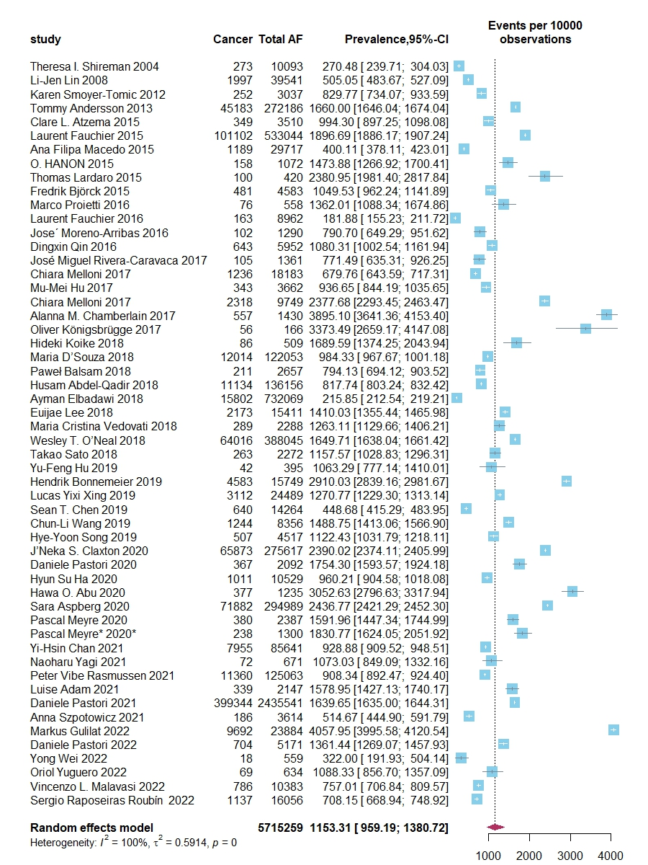
Supplement Figure 1 Pooled prevalence of cancer in AF patients. CI, confidence interval; I², Higgins’ and Thompson’s I² statistic. The random effect used, and the prevalence was determined using generalized linear mixed models.

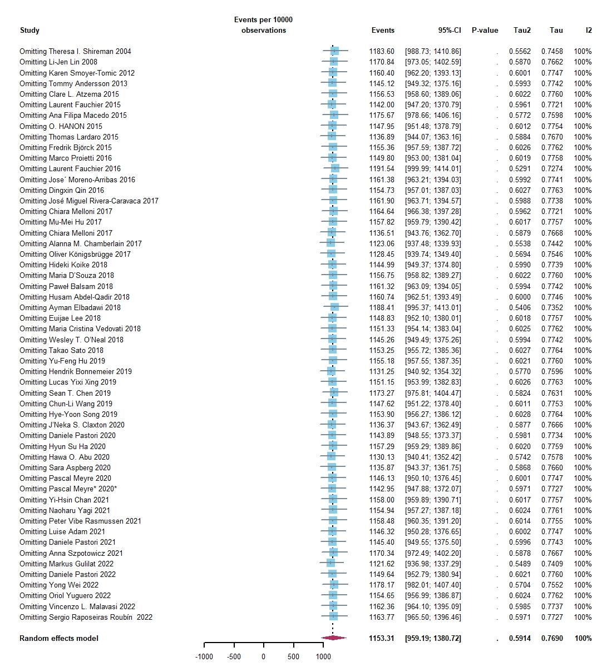
Supplement Figure 2 Leave-one-out sensitivity analysis of the influence of single study on the pooled prevalence of cancer in AF patients. CI, confidence interval; I², Higgins’ and Thompson’s I² statistic. The random effect used, and the prevalence was determined using generalized linear mixed models.

A | B | C
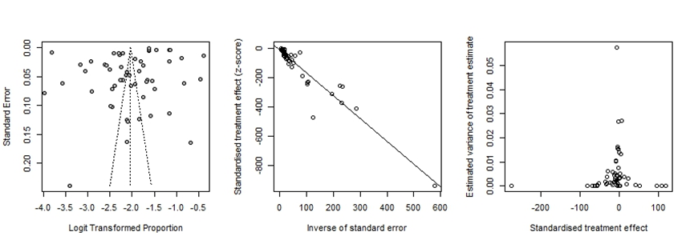
Supplement Figure 3 Publication bias of studies on the prevalence of cancer in AF patients. A: Funnel plot; B: Egger’s test; C: Begg’s test.

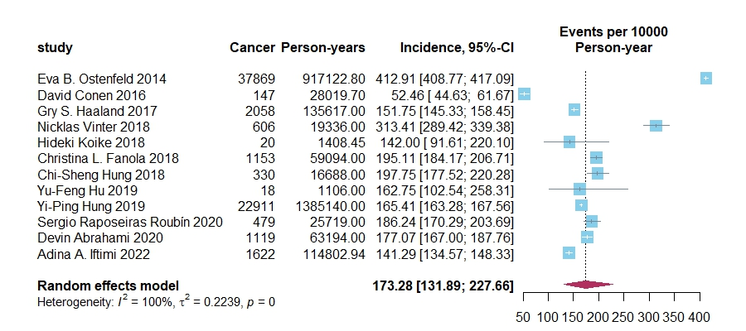

Supplement Figure 4 Pooled incidence of cancer in AF patients; CI, confidence interval; I², Higgins’ and Thompson’s I² statistic. The random effect used, and the incidence was determined using generalized linear mixed models.
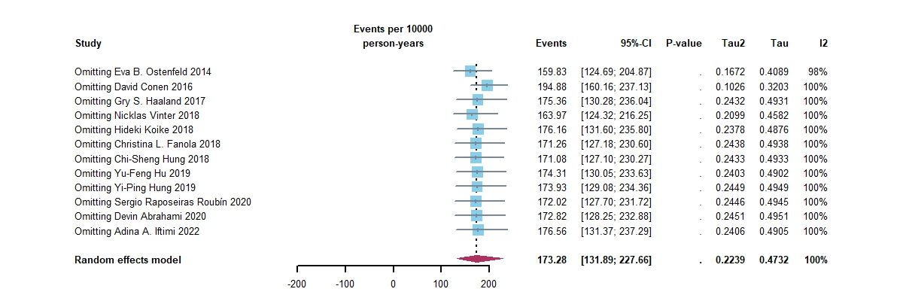
Supplement Figure 5 Leave-one-out sensitivity analysis of the influence of single study on the pooled incidence of cancer in AF patients. CI, confidence interval; I², Higgins’ and Thompson’s I² statistic. The random effect used, and the incidence was determined using generalized linear mixed models.
A | B | C
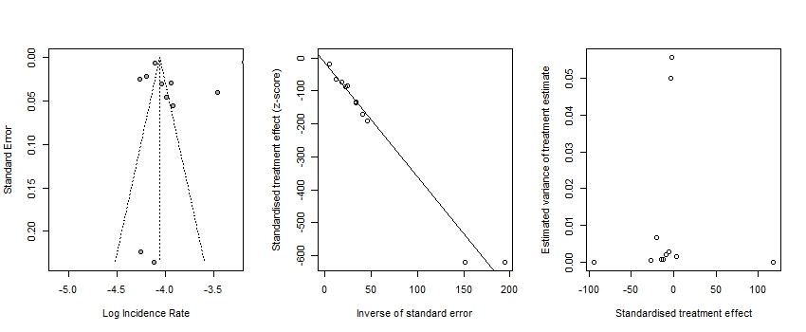
Supplement Figure 6 Publication bias of studies on the incidence of cancer in AF patients. A: Funnel plot; B: Egger’s test; C: Begg’s test.

A
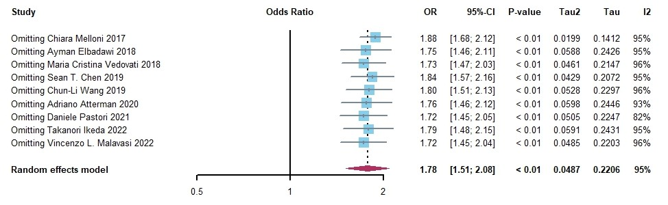
B
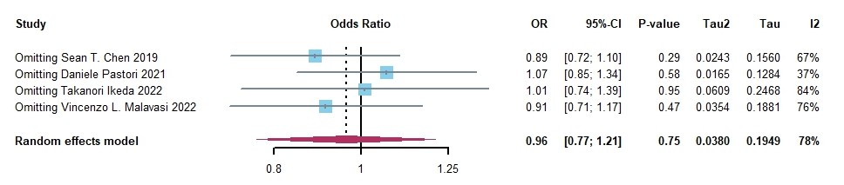
C
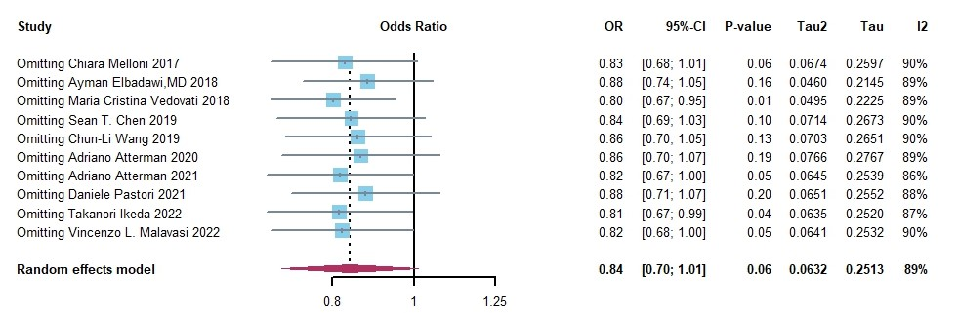
D
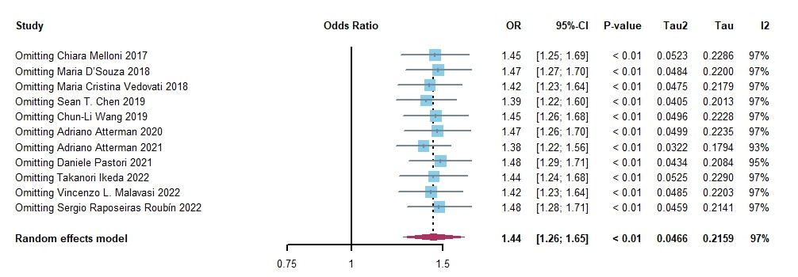
Supplement Figure 7 Leave-one-out sensitivity analysis of the influence of single study on the pooled risk of outcomes in cancer vs. non-cancer patients. (A) all-death; (B) cardiovascular death; (C) ischemic stroke; and (D) bleeding. CI, confidence interval; OR, odds ratio; I², Higgins’ and Thompson’s I² statistic. The random effect used, and OR was determined using Mantel–Haenszel method.

