STATISTICAL ANNEX
Table A1: Doctors density per type of municipalities
Type of municipality per population | 2013 |  | 2023
Type of municipality per population | N | Density | N | Density
≥ 500 mil | 232,312 | 3.92 | 366,737 | 6.23
100 a 500 mil | 94,256 | 1.79 | 142,437 | 2.51
50 a 100 mil | 22,831 | 0.97 | 39,205 | 1.67
20 a 50 mil | 18,915 | 0.58 | 31,652 | 0.99
10 a 20 mil | 6,415 | 0.33 | 10,801 | 0.56
5 a 10 mil | 2,202 | 0.25 | 4,063 | 0.49
≤ 5 mil | 856 | 0.20 | 1,901 | 0.43

Table A2: Evolving geographic distribution of medical students 2003-2022, selected years
Year | Medical Students in Densely and Scarcely Populated Municipalities
Year | State capital city areas |  | Non-capital areas with >300,000 inhabitants |  | Areas with 100,000 to 300,000 inhabitants |  | Areas with fewer than <100,000 inhabitants
2003 | 30,716 | 50.50% | 14,704 | 24.18% | 11,444 | 18.82% | 3,698 | 6.08%
2006 | 36,982 | 50.05% | 16,839 | 22.79% | 14,131 | 19.12% | 5,930 | 8.02%
2010 | 52,977 | 51.27% | 20,651 | 19.98% | 20,382 | 19.73% | 9,302 | 9.00%
2013 | 54,759 | 49.24% | 25,767 | 23.17% | 21,072 | 18.94% | 9,600 | 8.63%
2016 | 63,173 | 46.44% | 32,442 | 23.85% | 27,180 | 19.98% | 13,209 | 9.71%
2019 | 78,519 | 41.82% | 45,772 | 24.38% | 42,123 | 22.44% | 21,296 | 11.34%
2022 | 94,918 | 38.66% | 58,507 | 23.83% | 57,541 | 23.43% | 34,535 | 14.06%
Data source: National Institute of Educational Studies and Investigations Anísio Teixeira, INEP (‘undergraduate courses’ unit of the Higher Education Census). Population estimates from 2013 to 2022 were based on The Brazilian Institute of Geography and Statistics (IBGE)

Figure A1: Medical students’ headcount and annual growth rate 2003-2023
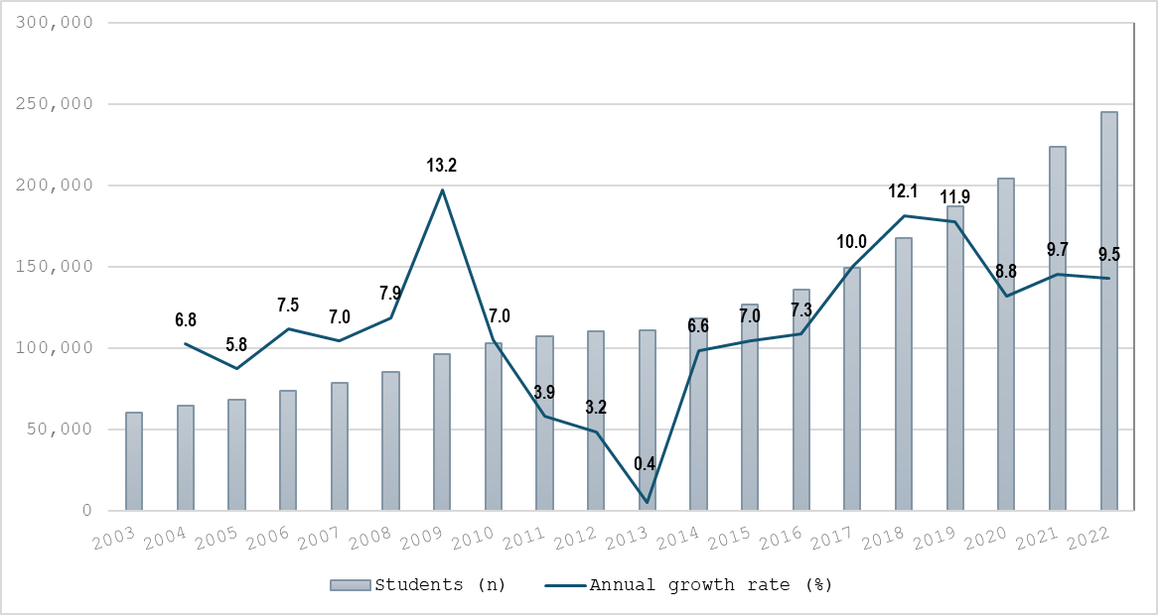

Figure A2: Annual growth rates for registered doctors and medical students, 2003-2023
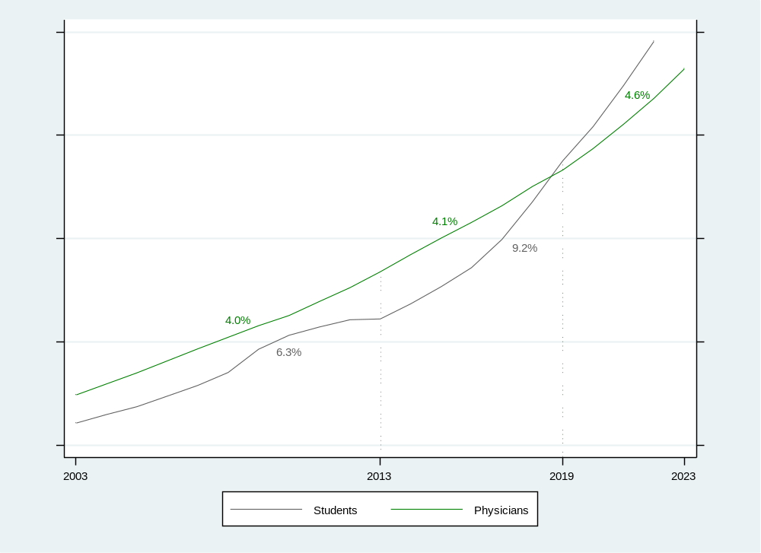

Figure A3: Proportion of medical students type of classes and student to teacher ratios, by type of medical school (2022)>
