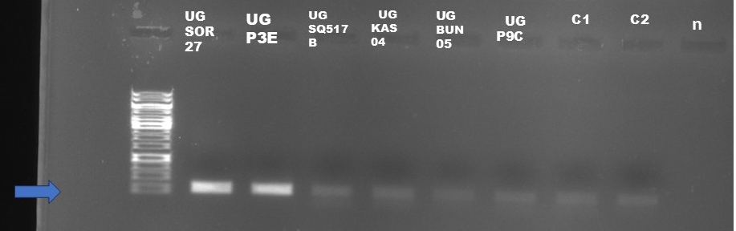
Figure 2 : Gel electrophoresis of 6 PCR products of the different ASFV isolates-UG-SOR27, UG-P3E, UG-SQ517B,UG KAS 04,UGBUN 05,UG P9C . Blue arrows indicate ASFV genome size (278bp) on 1Kb ladder. C: are the positive controls, n is negative control.

