Supplementary Materials

Biomimic opto-nanobiointerface enables multiscale biomodulation

Authors
Christoph Alexander Müller¹, Yuge Zhang², Lingyuan Meng³, Jesper Guldsmed Madsen⁴, Kjeld Kaj Klompmaker¹, Thomas Stax Jakobsen^{4,5}, Asbjørn C. Jørgensen^{5,6}, Anne Louise Askou^{5,4}, Ge Huang⁷, Wen Li⁸, Rasmus Schmidt Davidsen⁶, Toke Bek⁴, Nikos S. Hatzakis⁷, Thomas J. Corydon^{5,4}, Mingdong Dong², Bozhi Tian^{8,9,10}, and Menglin Chen*^{1,2}

Affiliations
¹Department of Biological and Chemical Engineering, Aarhus University, 8000 Aarhus C, Denmark.
²Interdisciplinary Nanoscience Center, Aarhus University, 8000 Aarhus C, Denmark.
³Pritzker School of Molecular Engineering, University of Chicago, Chicago, IL, USA.
⁴Department of Ophthalmology, Aarhus University Hospital, 8200 Aarhus N, Denmark.
⁵Department of Biomedicine, Aarhus University, 8000 Aarhus C, Denmark
⁶Department of Electrical and Computer Engineering, Aarhus University, 8000 Aarhus C, Denmark.
⁷Department of Chemistry & Nanoscience Center, University of Copenhagen, 1172 Copenhagen, Denmark
⁸Department of Chemistry, University of Chicago, Chicago, IL, USA.
⁹The James Franck Institute, University of Chicago, Chicago, IL, USA.
¹⁰The Institute for Biophysical Dynamics, University of Chicago, Chicago, IL, USA.

Email: menglin@bce.au.dk

This Supplementary file includes:
Fig. S1 to S7

Other Supplementary Materials for this manuscript include the following:
Videos S1 to S12

Fig. S1.
Diffusion coefficient distribution of hg-C₃N₄ derived from particle tracking analysis.

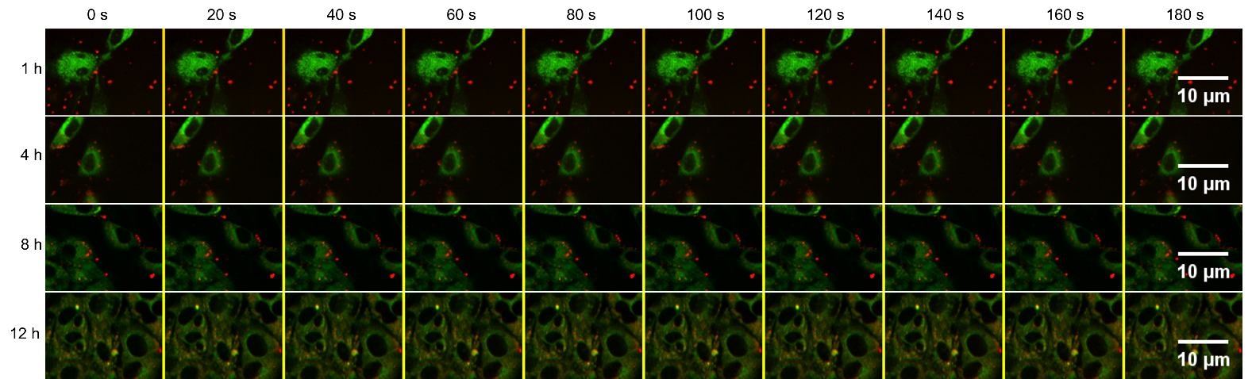
Fig. S2.
Images acquired with SPT used for colocalization study. NIH/3T3 fibroblasts where lysosomes are stained with LysoTracker Deep Red (green) and hg-C₃N₄ NP excited with 488 nm shown in red. The cells were imaged at 1h, 4h, 8h, and 12h with 1 frame per 20 seconds for 3 min.
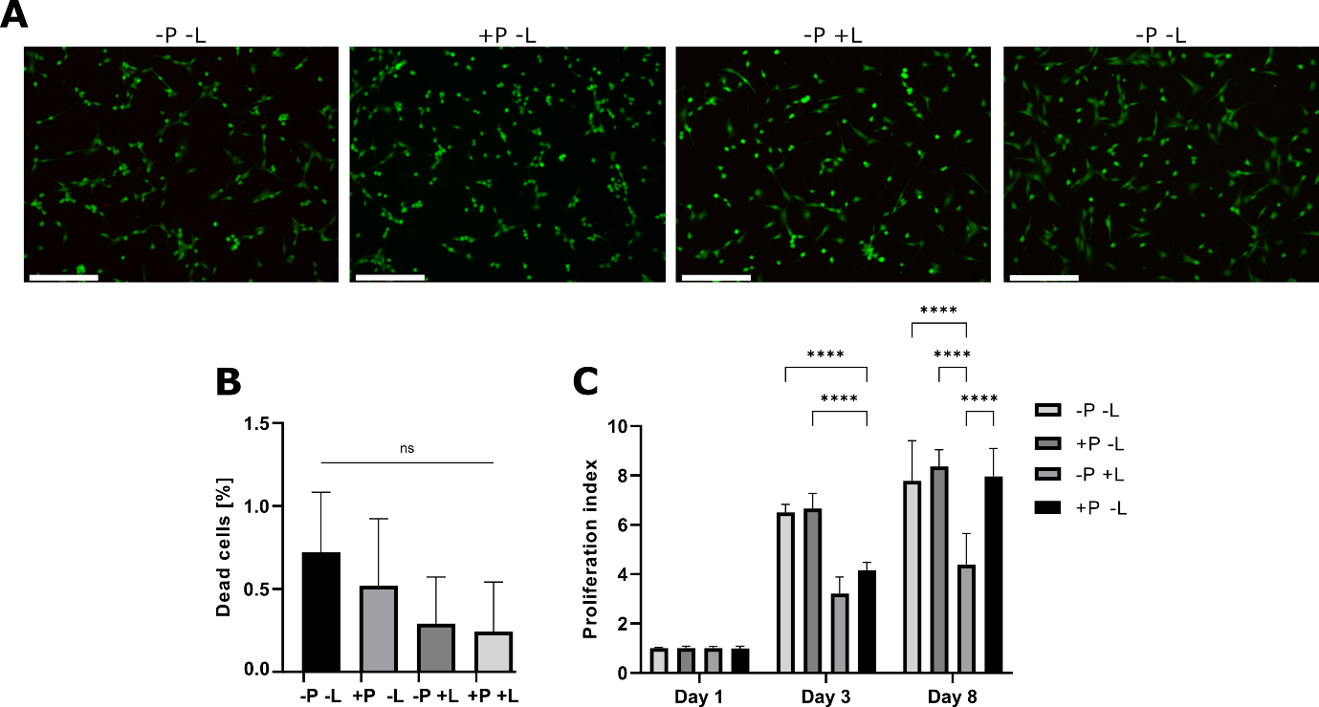

Fig. S3.
Cytocompatibility of hg-C₃N₄. (A) Live dead staining of NIH/3T3 fibroblasts with (B) percentage of dead cells based on live dead staining and (C) CCK-8 proliferation assay of NIH/3T3 cells cultured with 2.0 µg/cm² hg-C₃N₄ (+P), cultured without hg-C₃N₄ (-P), light treated (+L), and non-light treated (-L). Light-treated groups were irradiated with a 450 nm blue light (75 mW/cm², 1 Hz, 100 ms pulse) for 10 minutes bidaily. Statistical analysis was performed with one-way ANOVA and Tukey’s test for multiple comparisons where p<0.0001 is denoted as **** with n=7 and ns=no significance (p>0.05)

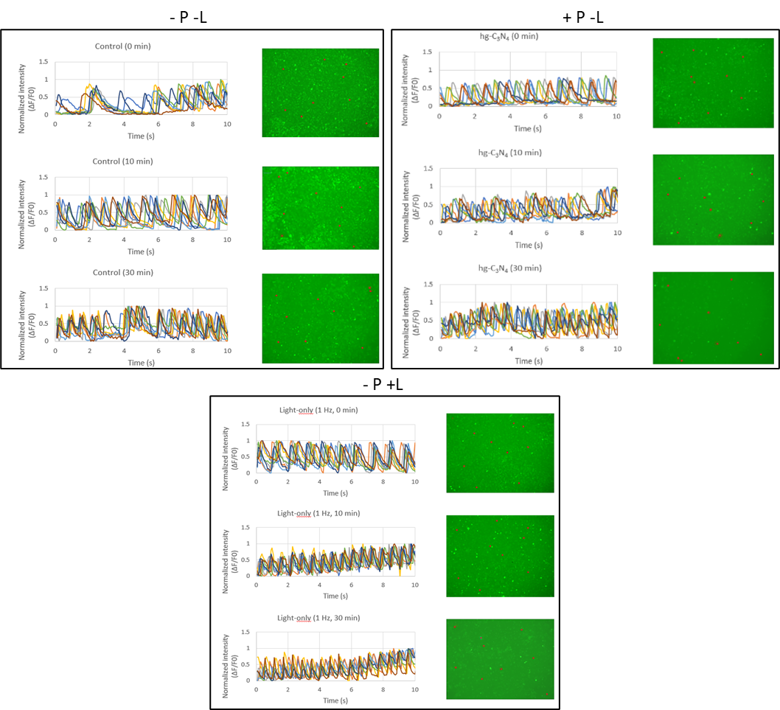

Fig. S4.
Control groups for HL-1 cardiomyocyte pacing. HL-1 cells stained with fluo-4 calcium stain incubated with or without 2.0 µg/cm² hg-C₃N₄ particles (+P; -P) and with or without photostimulation photostimulation (+L; -L) at 0 min, 10 min, and 30 min. Red circles indicate ROIs for ΔF/F₀ plots. ΔF/F₀ plots show 8 different ROIs showing beating frequency of HL-1 cells. Light source was 10 mW/cm² of 450 nm with pulse width of 100 ms and 1 Hz frequency.

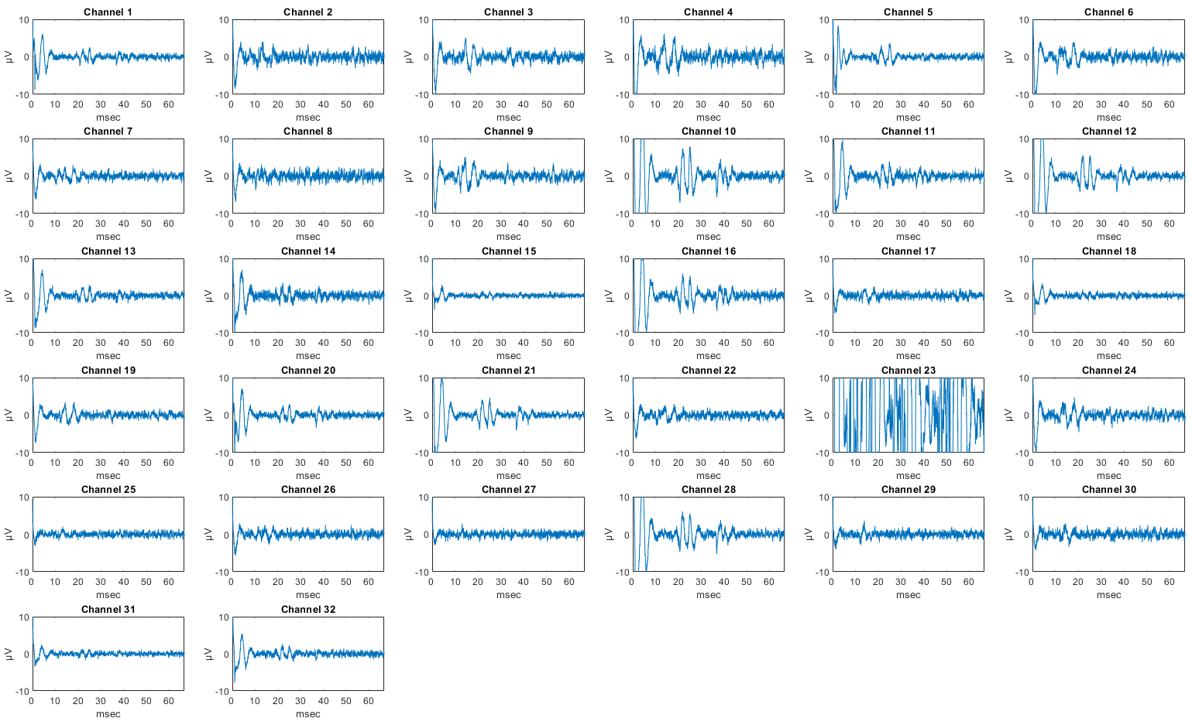

Fig. S5
Stimulation response data of all 32 MEA channels before applying particles with LED stimulation of 1 msec duration. Stimulus artefact and evoked light responses can be seen on all channels, except channel 23 which malfunctioned.

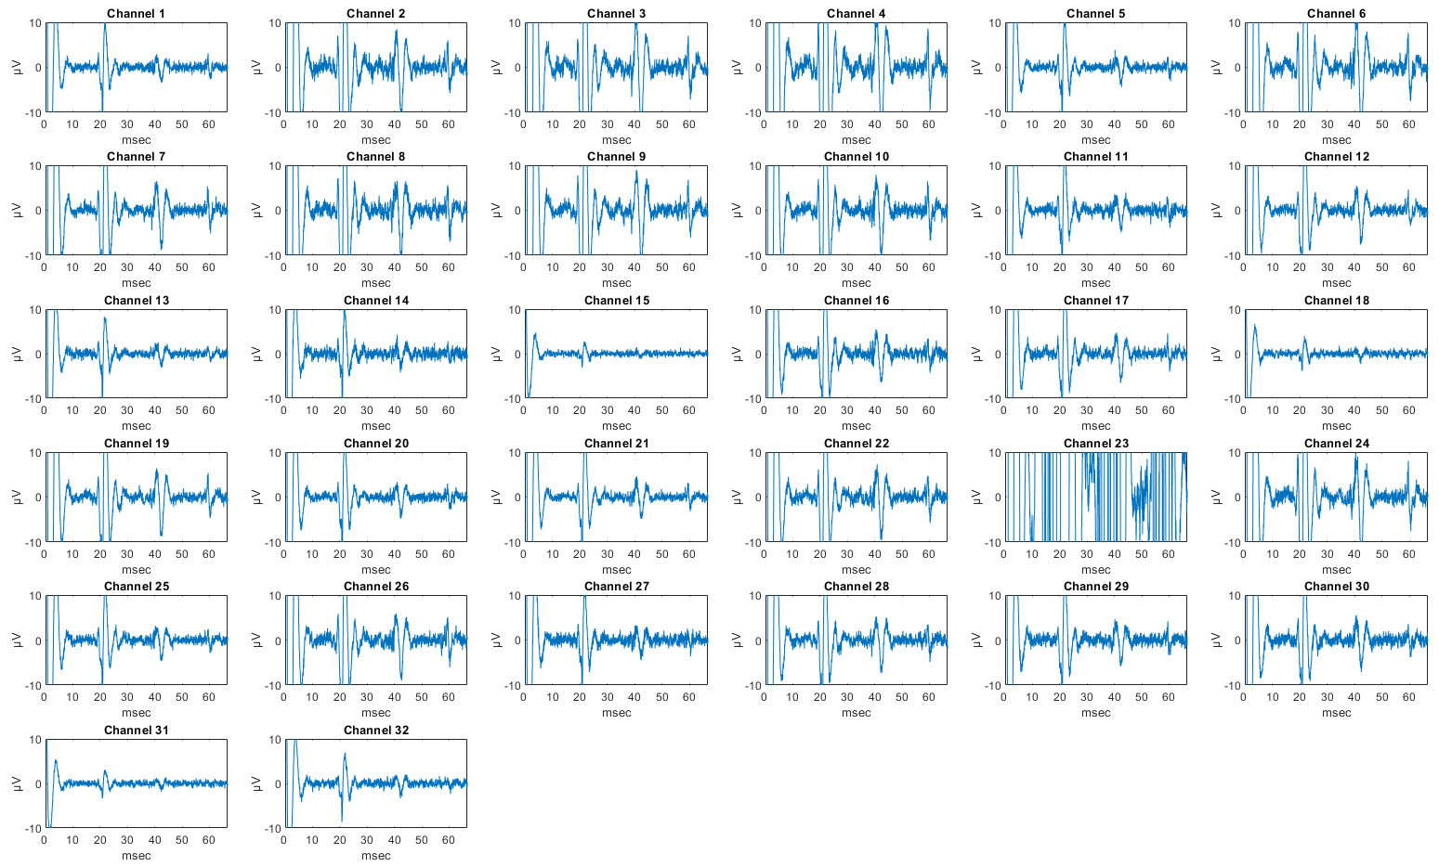

Fig. S6
Stimulation response data of all 32 MEA channels after applying particles with LED stimulation of 1 msec duration. Stimulus artefact and evoked light responses can be seen on all channels, except channel 23 which malfunctioned. All evoked potentials display larger peak-peak amplitude than before particle application.

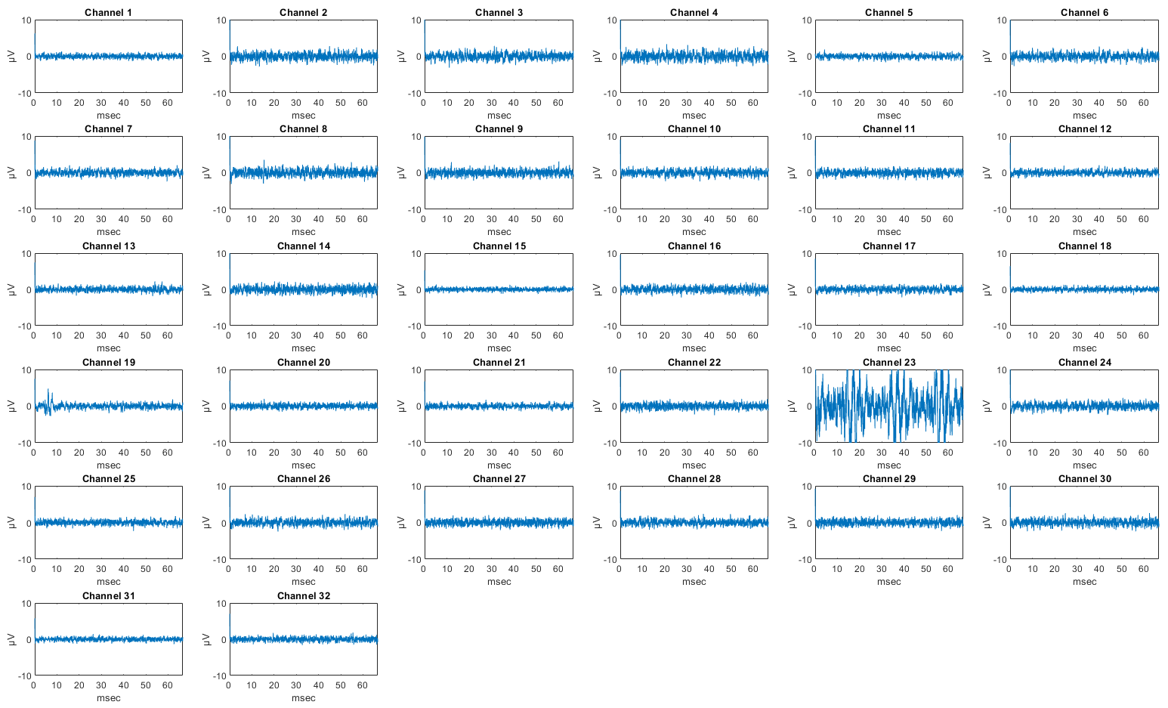
Fig. S7
Stimulation response data of all 32 MEA channels after applying TTX with LED stimulation of 1 msec duration. Stimulus artefact can still be seen after TTX application, but no clear evoked potentials are visible on any channel.

Video descriptions

S1 hg-C₃N₄ Internalization
Internalization of hg-C₃N₄ by single NIH/3T3 fibroblast cell
S2 Laser stimulation of NIH/3T3 fibroblasts without hg-C₃N₄ NPs
Laser stimulation of 4 NIH/3T3 fibroblast cells as non-particle control with 200 ms laser pulse, 473 nm, spot size 3 µm, and 8.8 mW/µm². Green fluorescence is calcium staining.
S3 Laser stimulation of NIH/3T3 fibroblast cell with hg-C₃N₄ NPs
Laser stimulation of internalized hg-C₃N₄ NPs of single NIH/3T3 fibroblast cell with 200 ms laser pulse, 473 nm, spot size 3 µm, and 8.8 mW/µm². Green fluorescence is calcium staining and hg-C₃N₄ NPs. Red arrow indicates location of laser stimulation.
S4 Laser stimulation of NIH/3T3 fibroblast cell with hg-C₃N₄ NPs as ΔF/F₀ video.
ΔF/F₀ video of laser stimulation of internalized hg-C₃N₄ NPs of single NIH/3T3 fibroblast cell with 200 ms laser pulse, 473 nm, spot size 3 µm, and 8.8 mW/µm². ΔF/F₀ video is generated based on Supplementary video S3.
S5 Laser stimulation of HELA cell with hg-C₃N₄ NPs
Laser stimulation of internalized hg-C₃N₄ NPs of single NIH/3T3 fibroblast cell with 200 ms laser pulse, 473 nm, spot size 3 µm, and 8.8 mW/µm². Green fluorescence is calcium staining and hg-C₃N₄ NPs. Red arrow indicates location of laser stimulation.
S6 Laser stimulation of HELA cell with hg-C₃N₄ NPs as ΔF/F₀ video.
Laser stimulation of internalized hg-C₃N₄ NPs of single NIH/3T3 fibroblast cell with 200 ms laser pulse, 473 nm, spot size 3 µm, and 8.8 mW/µm². ΔF/F₀ video is generated based on Supplementary video S5.
S7 Laser stimulation and signal propagation of CMs with hg-C₃N₄ NPs
Laser stimulation of CM with hg-C₃N₄ NPs resulting in immediate intracellular calcium flux and beating in all 4 adjacent CMs. Stimulation with 200 ms laser pulse, 473 nm, spot size 3 µm, and 8.8 mW/µm². Green fluorescence is calcium staining and hg-C₃N₄ NPs. Red arrow indicates location of laser stimulation.
S8 Laser stimulation and signal propagation of CFs with hg-C₃N₄ NPs
Laser stimulation of CF with hg-C₃N₄ NPs resulting in immediate intracellular calcium flux and signal propagation to adjacent CF. Stimulation with 200 ms laser pulse, 473 nm, spot size 3 µm, and 8.8 mW/µm². Green fluorescence is calcium staining and hg-C₃N₄ NPs. Red arrow indicates location of laser stimulation.
S9 Laser stimulation and signal propagation of CF to CM with hg-C₃N₄ NPs
Laser stimulation of CF with hg-C₃N₄ NPs resulting in immediate intracellular calcium flux and signal propagation to adjacent CM. Stimulation with 200 ms laser pulse, 473 nm, spot size 3 µm, and 8.8 mW/µm². Green fluorescence is calcium staining and hg-C₃N₄ NPs. Red arrow indicates location of laser stimulation.
S10 Pacing of HL1 CM cell calcium dynamics via LED stimulation of hg-C₃N₄ NPs: calcium dynamics before stimulation.
HL1 cell calcium dynamics before application of LED stimulation. Green fluorescence is calcium staining.
S11 Pacing of HL1 CM cell calcium dynamics via LED stimulation of hg-C₃N₄ NPs: after 10 min stimulation.
HL1 cell calcium dynamics after application of 10 min pulsed LED stimulation. Green fluorescence is calcium staining. Light source was 10 mW/cm² of 450 nm with pulse width of 100 ms and 1 Hz frequency.
S12 Pacing of HL1 CM cell calcium dynamics via LED stimulation of hg-C₃N₄ NPs: after 30 min stimulation.
HL1 cell calcium dynamics after application of 30 min pulsed LED stimulation. Green fluorescence is calcium staining. Light source was 10 mW/cm² of 450 nm with pulse width of 100 ms and 1 Hz frequency.

