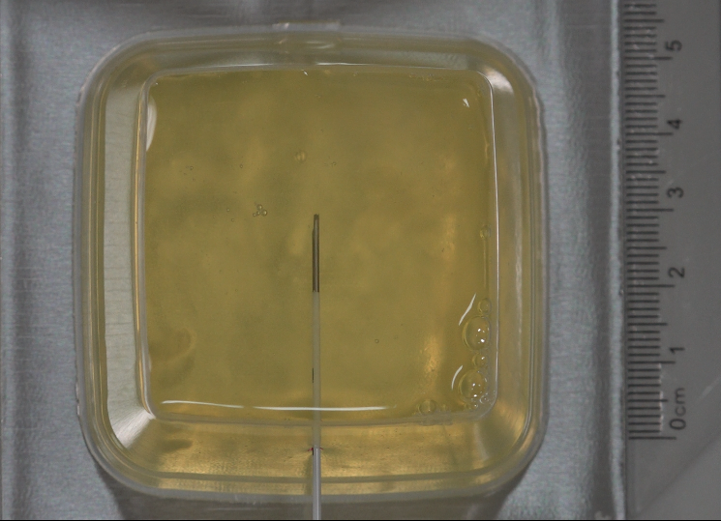
Subsidiary Figure 1a. The active tip of the needle was wrapped by ovalbumin in CRF group.

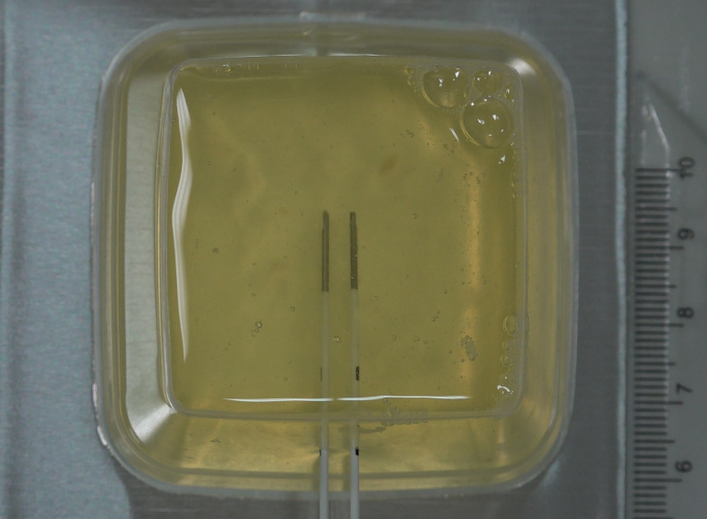
Subsidiary Figure 1b. The active tip of the needle was wrapped by ovalbumin in DCRF group.

