Association of peripheral blood biomarkers with response to anti-PD-1 immunotherapy for patients with dMMR metastatic colorectal cancer: a multicenter cohort study
INDEX OF SUPPLEMENTARY INFORMATION

SUPPLEMENTARY TABLES 1
SUPPLEMENTARY FIGURES 6

Table S1. Clinical outcomes of the entire cohort
Clinical outcomes | No. of patients (%)
Complete response | 4 (10)
Partial response | 19 (46)
Stable disease | 10 (24)
Progressive disease | 8 (20)
Death | 8 (20)

Table S2 Overall survival and associations with clinicopathologic features using Cox regression
Clinicopathologic parameters | HR | 95%CI | P value
Age (y)
Continuous | 1.03 | 0.99-1.08 | 0.17
Gender
Female versus male | 1.03 | 0.25-4.14 | 0.97
Location
Rectum versus colon | 0.55 | 0.13-2.33 | 0.42
Grade
High versus moderate/ low | 0.038 | 0.0-16.09 | 0.29
KRAS mutation
Yes versus no | 0.96 | 0.10-9.30 | 0.97
BRAF mutation
Yes versus no | 0.04 | 0.00-10781.31 | 0.61
Frequency of CD4+ T cell ª (%)
Continuous | 1.09 | 1.02-1.18 | 0.019
>39.5 versus ≤ 39.5 | 3.86 | 0.91-16.38 | 0.017
Frequency of CD8+ T cell ª (%)
Continuous | 0.91 | 0.83-1.001 | 0.054
Ratio of CD4+/CD8+ ª (%)
Continuous | 1.88 | 1.07-3.27 | 0.027
>1.64 versus ≤ 1.64 | 6.82 | 1.37-33.99 | 0.019
CEA (ng/mL)
Continuous | 1.002 | 0.999-1.005 | 0.17
CRP (mg/L)
Continuous | 1.01 | 1.002-1.02 | 0.02
> 2.21 versus ≤ 2.21 | 5.71 | 0.70-46.51 | 0.10
LDH (U/L)
Continuous | 1.002 | 0.999-1.005 | 0.22
Neutrophils ª (10E9/L)
Continuous | 1.12 | 1.03-1.23 | 0.012
>4.35 versus ≤ 4.35 | 9.08 | 1.11-74.21 | 0.05
Lymphocytes (10E9/L)
Continuous | 0.56 | 0.15-2.12 | 0.39
NLR
Continuous | 1.12 | 1.03-1.23 | 0.012
>3.99 versus ≤ 3.99 | 13.28 | 1.62-108.70 | 0.016
Monocytes (10E9/L)
Continuous | 1.38 | 0.15-13.06 | 0.78
Platelets (10E9/L)
Continuous | 1.00 | 0.99-1.007 | 0.96
LMR
Continuous | 0.82 | 0.52-1.29 | 0.39
PLR
Continuous | 1.00 | 0.997-1.004 | 0.79
ALb (g/L)
Continuous | 0.87 | 0.78-0.97 | 0.014
>37.4 versus ≤ 37.4 | 0.29 | 0.07-1.16 | 0.08
CHO (mmol/L)
Continuous | 0.32 | 0.06-1.64 | 0.17
TG (mmol/L)
Continuous | 0.85 | 0.25-2.84 | 0.79
HDL ª (mmol/L)
Continuous | 0.06 | 0.005-0.76 | 0.03
>0.875 versus ≤ 0.875 | 0.16 | 0.04-0.67 | 0.01
LDL (mmol/L)
Continuous | 1.78 | 0.90-3.50 | 0.10
ApoA1 ª (g/L)
Continuous | 0.01 | 0.001-0.21 | 0.003
>0.865 versus ≤ 0.865 | 0.097 | 0.02-0.40 | 0.001
ApoB (g/L)
Continuous | 0.35 | 0.01-10.37 | 0.54
ª Optimal cut-off points were estimated by receiver operating characteristics (ROC) curve analysis.
HR= hazard ratio, CI= confidential interval, CEA=carcinoembryonic antigen, CRP=C-reactive protein, LDH=lactate dehydrogenase, ALB= albumin, NLR=neutrophil-to-lymphocyte ratio, PLR=platelet-to-lymphocyte ratio, LMR=lymphocyte-to-monocyte ratio, CHO=cholesterol, TG= triglyceride, HDL=high-density lipoprotein, LDL=low-density lipoprotein, ApoA1=apolipoprotein A1, and ApoB= apolipoprotein B

Table S3. The association between Frequency of CD4+ T cell or CD4+/CD8+ ratio with other potentially related factors
 | Frequency of CD4+ T cell, median | P value | Ratio of CD4+/CD8+, median | P value
HDL (mmol/L) |  | 0.35 |  | 0.37
>0.875 (n=31) | 36.0 |  | 1.30
≤ 0.875 (n=9) | 40.0 |  | 1.66
ApoA1 (g/L) |  | 0.52 |  | 0.21
>0.865 (n=34) | 40.0 |  | 1.25
≤ 0.865 (n=7) | 36.5 |  | 1.98
NLR |  | 0.43 |  | 0.67
>3.99 (n=17) | 36.0 |  | 1.16
≤ 3.99 (n=24) | 38.9 |  | 1.38
NLR=neutrophil-to-lymphocyte ratio, HDL=high-density lipoprotein, and ApoA1=apolipoprotein A1

Table S4. Multivariate survival analysis after variable selection for overall survival
Clinicopathologic parameters# | HR | 95%CI | P value | HR | 95%CI | P value
HDL ª (mmol/L)
>0.875 versus ≤ 0.875 | 19769.9 | 0.00-2.15 E+137 | 0.95 | 738.67 | 0.00-5.81 E+98 | 0.95
ApoA1 ª (g/L)
>0.865 versus ≤ 0.865 | 0.00 | 0.00-1.14 E+128 | 0.94 | 0.00 | 0.00-1.27 E+92 | 0.94
NLR ª
>3.99 versus ≤ 3.99 | 32.48 | 1.86-568.57 | 0.017 | 19.31 | 1.60-233.20 | 0.02
Frequency of CD4+ T cell ª (%)
>39.5 versus ≤ 39.5 | 16.21 | 1.43-184.21 | 0.025
Ratio of CD4+/CD8+ ª (%)
>1.64 versus ≤ 1.64 |  |  |  | 15.22 | 2.00-115.80 | 0.009
# Since Frequency of CD4+ T cell was strongly correlated with ratio of CD4+/CD8+ with rho value of 0.73 (p<0.001), these two parameters were separately included in the Cox model.
ª Optimal cut-off points were estimated by receiver operating characteristics (ROC) curve analysis.
HR= hazard ratio, CI= confidential interval, CEA=carcinoembryonic antigen, LDH=lactate dehydrogenase, LDL=low-density lipoprotein, ApoA1=apolipoprotein A1, and ApoB= apolipoprotein B

Figure S1. Representative flow-cytometry gating strategy for quantifying the numbers of various immune cell subsets in PBMC

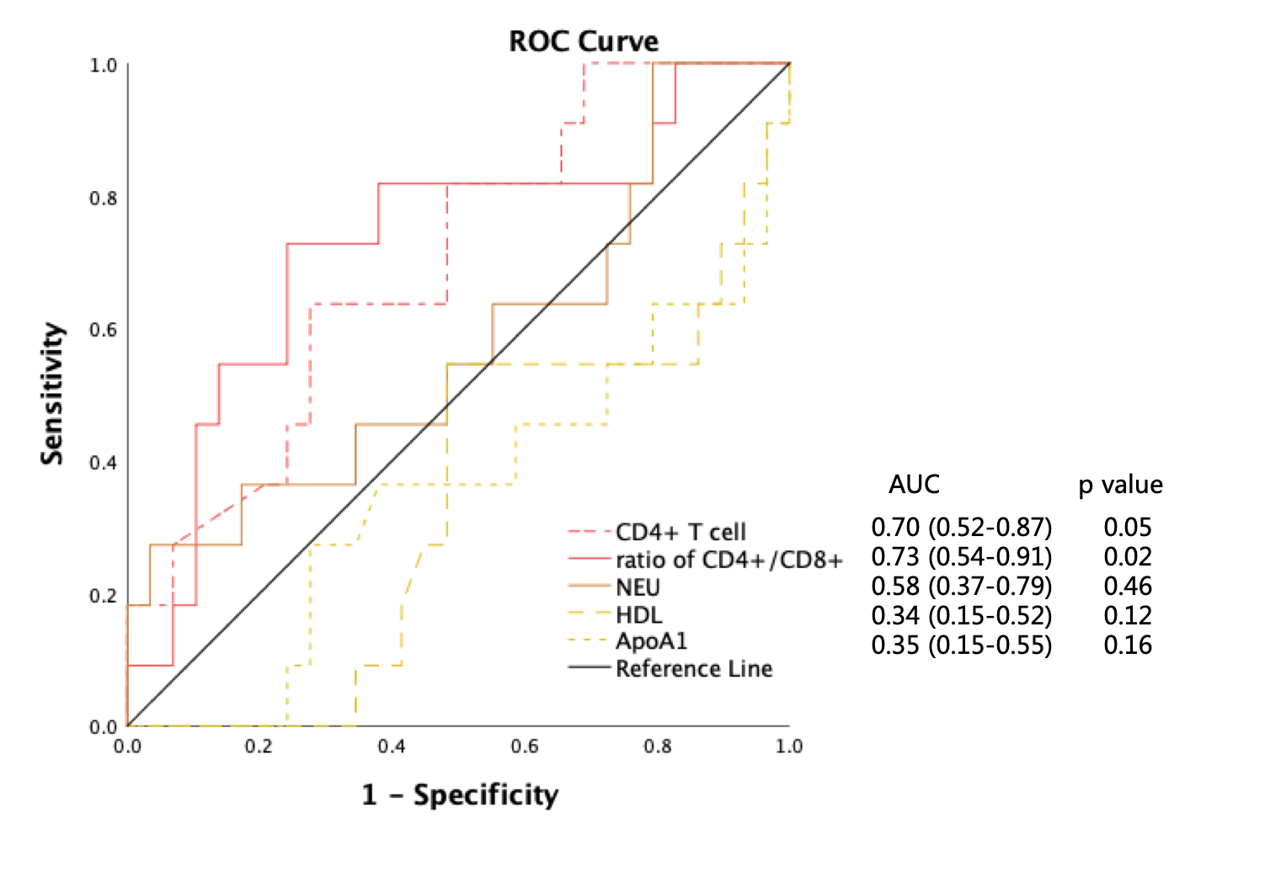
Figure S2. ROC curves for the cut-off points for frequency of CD4+ T cell, ratio of CD4+/CD8+, NEU, HDL, and ApoA1. NEU= Neutrophils, HDL=high-density lipoprotein, ApoA1=apolipoprotein A1.

