Carratalá et al
Supplementary information
Figure S1. Extended confocal microscopy visualization of E. coli ClearColi cells producing the recombinant fluorescent proteins. a Visual field of cells producing L6K2-containing constructs and VP1GFPH6 (aggregation control) analyzed in Fig. 2. b Visual fields of cells producing simultaneously GFP and EBFP2 constructs analyzed in fig 5. Scale bar indicates 4 μm.
a
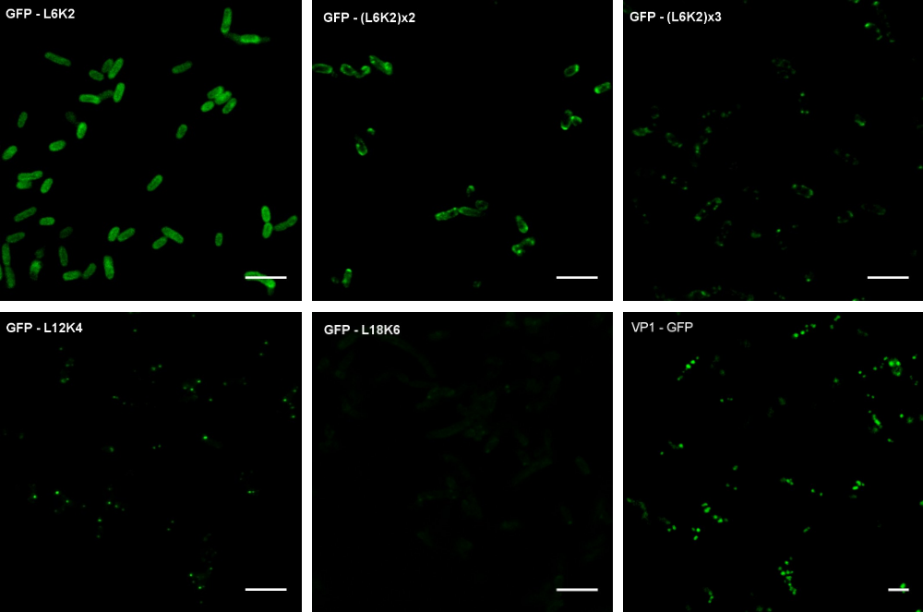
b
