Carratalá et al.
Supplementary information

Figure S2. PEP-FOLD server-generated models of aggregation prone peptides fused to GFP scaffold protein. a. Regular polypeptide helices in a right-handed alpha-helical conformation are shown. All structures are reproduced at the same scale. b. Helical conformation of two L6K2-containing peptides (blue) in the presence of PT linker (grey).
a
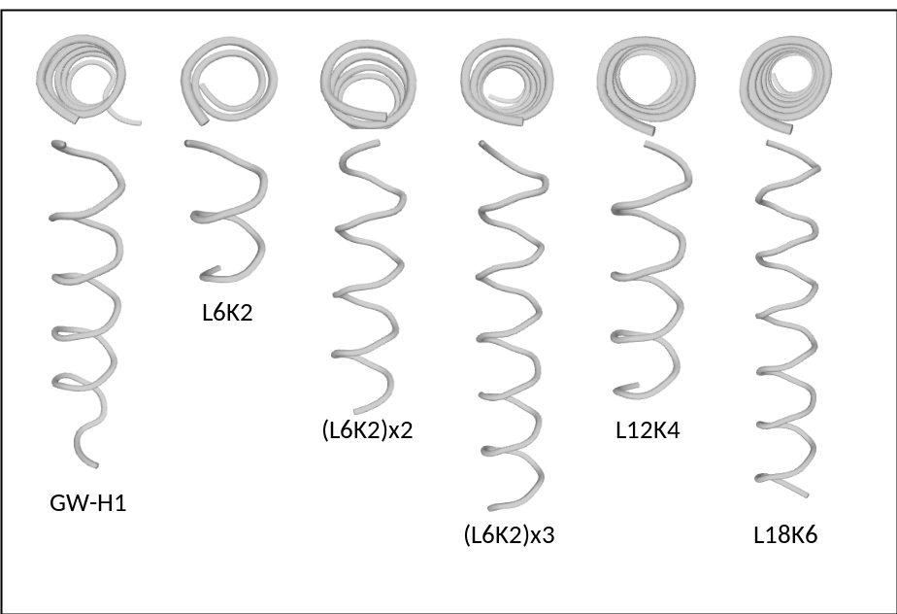
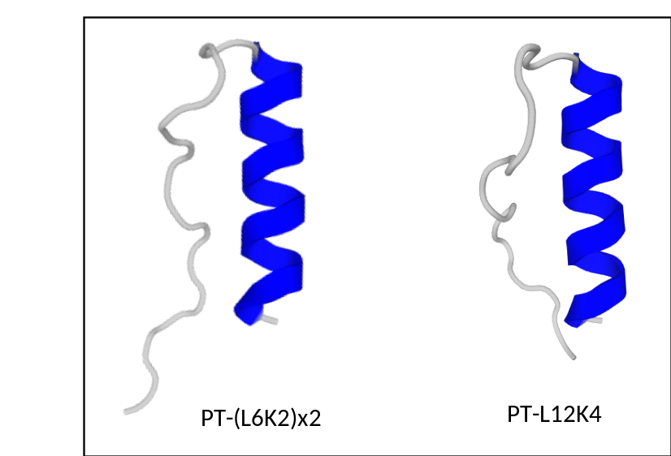
b

