In Silico Approach on Structural and Functional Characterization of Heat shock protein from Sulfobacillus acidophilus
Pritish Mitra¹, Sabyasachi Chatterjee^{1*}
^{1*}PG Department of Botany, Ramananda College, Bishnupur, Bankura, W.B., India
Corresponding author’s E-mail:
schatterjeebiotech@gmail.com

Supplementary Fig. 1a:GlobPlot presentation of SaHsp70-1 to SaHsp70-9. Blue color repsented disordered regions and green color marked ordered or globular regions.

Supplementary Fig. 1b:GlobPlot presentation of SaHsp70-10 to SaHsp70-15. Blue color repsented disordered regions and green color marked ordered or globular regions.

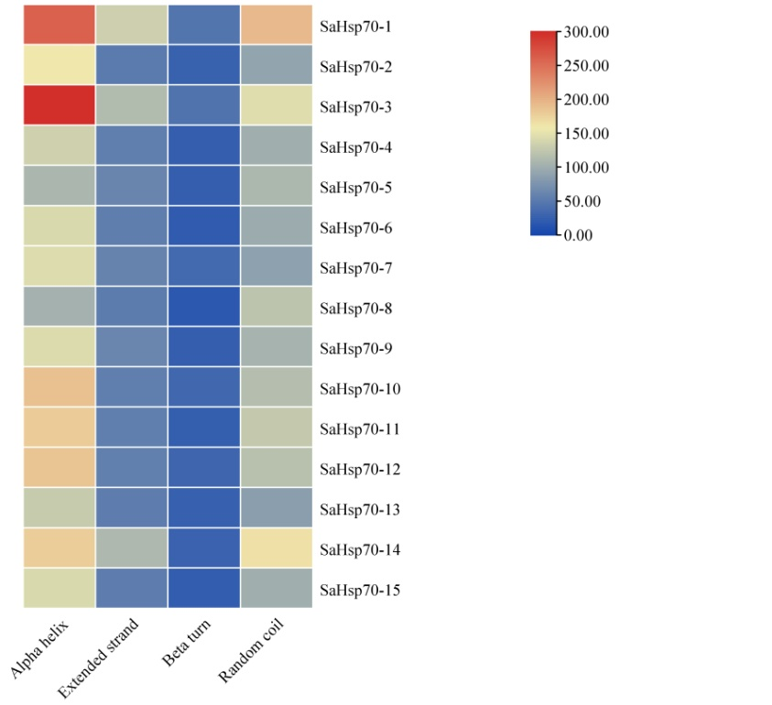
Supplementary Fig. 2: Predicted secondary structure of SaHsp70 proteins by SOPMA server.
Supplementary Fig. 3a: Z-score analysis of SaHsp70-1 to SaHsp70-12
Supplementary Fig. 3b: Z-score analysis of SaHsp70-12 to SaHsp70-15.

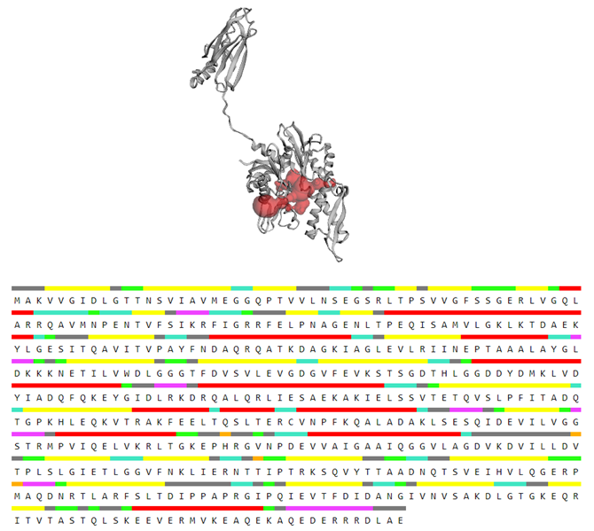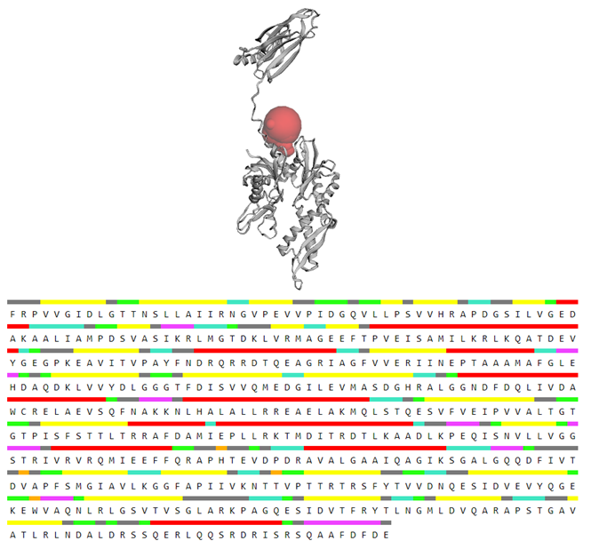
- (b)
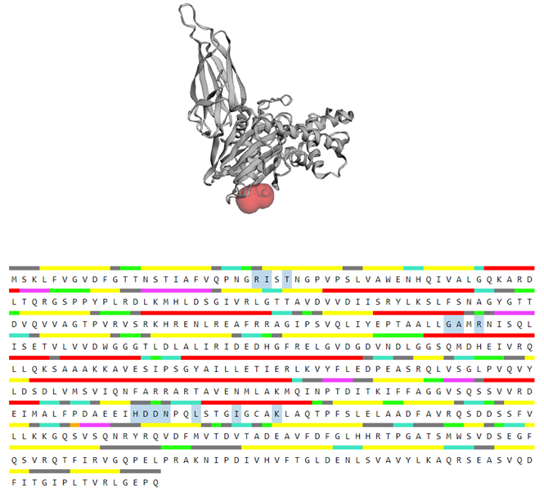
(c)
Supplementary Fig. 4: Visualization of pockets identified on the structure of the active site of the SaHsp70 proteins and green color illustrated the amino acids position in active site.

Supplementary Table 1: Functional pockets of fifteen different Hsp70 proteins of Sulfobacillus acidophilus with pocket score, amino acid count.
Name | Pocket rank | Pocket score | Probability score | A.A. count | Ave. conservation | Ave.Alpha Fold
SaHsp70-1 | 1 | 39.34 | 0.936 | 38 | 1.382 | 96.237
SaHsp70-1 | 2 | 0.98 | 0.005 | 9 | 0 | 90.008
SaHsp70-2 | 1 | 10.35 | 0.533 | 20 | 0.637 | 91.356
SaHsp70-2 | 2 | 2.41 | 0.052 | 12 | 0.494 | 92.866
SaHsp70-2 | 3 | 1.9 | 0.032 | 9 | 0 | 90.451
SaHsp70-3 | 1 | 28.87 | 0.88 | 26 | 1.874 | 95.59
SaHsp70-3 | 2 | 3.33 | 1.03 | 15 | 0.56 | 94.621
SaHsp70-3 | 3 | 2.14 | 0.041 | 12 | 0.687 | 80.542
SaHsp70-3 | 4 | 1.48 | 0.018 | 10 | 0 | 93.557
SaHsp70-3 | 5 | 1.11 | 0.008 | 7 | 0 | 60.999
SaHsp70-4 | 1 | 49.01 | 960 | 39 | 1.79 | 91.778
SaHsp70-4 | 2 | 2.75 | 0.07 | 13 | 1.734 | 95.722
SaHsp70-4 | 3 | 1.24 | 0.011 | 8 | 1.125 | 90.366
SaHsp70-5 | 1 | 49.21 | 0.96 | 41 | 1.552 | 91.338
SaHsp70-5 | 2 | 3.24 | 0.098 | 13 | 1.997 | 92.381
SaHsp70-5 | 3 | 2.1 | 0.04 | 8 | 0.504 | 85.25
SaHsp70-5 | 4 | 1.97 | 0.035 | 11 | 1.539 | 89.04
SaHsp70-5 | 5 | 0.82 | 0.003 | 8 | 1.148 | 94.374
SaHsp70-6 | 1 | 42.04 | 0.946 | 34 | 1.819 | 91.177
SaHsp70-7 | 1 | 41.68 | 0.944 | 36 | 1.857 | 90.73
SaHsp70-7 | 2 | 1.93 | 0.033 | 7 | 1.949 | 88.1
SaHsp70-8 | 1 | 51.01 | 0.964 | 47 | 1.377 | 91.964
SaHsp70-9 | 1 | 36.75 | 0.926 | 35 | 1.441 | 92.158
SaHsp70-9 | 2 | 1.85 | 0.03 | 7 | 1.715 | 91.92
SaHsp70-9 | 3 | 1.17 | 0.01 | 9 | 1.964 | 95.264
SaHsp70-10 | 1 | 43.17 | 0.948 | 45 | 1.553 | 91.786
SaHsp70-10 | 2 | 3.2 | 0.095 | 12 | 0.558 | 90.771
SaHsp70-10 | 3 | 2.08 | 0.039 | 10 | 2.025 | 96.361
SaHsp70-10 | 4 | 1.89 | 0.032 | 12 | 0.839 | 91.682
SaHsp70-11 | 1 | 39.61 | 0.937 | 36 | 1.66 | 92.688
SaHsp70-11 | 2 | 1.15 | 0.009 | 6 | 0.267 | 89.832
SaHsp70-12 | 1 | 21.22 | 0.81 | 28 | 1.897 | 90.209
SaHsp70-12 | 2 | 1.78 | 0.028 | 7 | 0.605 | 71.666
SaHsp70-12 | 3 | 1.14 | 0.009 | 8 | 0.07 | 83.704
SaHsp70-12 | 4 | 0.92 | 0.004 | 11 | 1.483 | 90.1
SaHsp70-13 | 1 | 49.85 | 0.962 | 35 | 1.725 | 90.152
SaHsp70-13 | 2 | 3.01 | 0.084 | 11 | 1.454 | 96.29
SaHsp70-13 | 3 | 2 | 0.036 | 7 | 0.997 | 94.091
SaHsp70-13 | 4 | 1.7 | 0.025 | 7 | 2.766 | 95.991
SaHsp70-13 | 5 | 1.25 | 0.012 | 8 | 1.514 | 85.201
SaHsp70-14 | 1 | 25.57 | 0.855 | 24 | 1.619 | 93.097
SaHsp70-14 | 2 | 1.97 | 0.035 | 10 | 0 | 91.763
SaHsp70-14 | 3 | 1.79 | 0.028 | 7 | 0.419 | 91.321
SaHsp70-15 | 1 | 51.55 | 0.965 | 40 | 2.129 | 90.343

Supplementary Table 2: Surface area and volume size (in angstroms) of binding pockets of SaHsp70 proteins with amino acid position.
Name | Area (Å) | Volume (Å) | Amino acid | Position
SaHsp70-1 | 275.236 | 121.830 | ASP | 8, 193, 225, 228, 363
SaHsp70-1 |  |  | GLY | 10, 195, 196, 224, 336, 337
SaHsp70-1 |  |  | THR | 11, 12, 198
SaHsp70-1 |  |  | ASN | 13
SaHsp70-1 |  |  | SER | 33, 269, 338,
SaHsp70-1 |  |  | LEU | 35
SaHsp70-1 |  |  | PRO | 37, 362
SaHsp70-1 |  |  | GLN | 52
SaHsp70-1 |  |  | ARG | 55, 340
SaHsp70-1 |  |  | ALA | 58
SaHsp70-1 |  |  | PHE | 67
SaHsp70-1 |  |  | LYS | 70, 265
SaHsp70-1 |  |  | GLU | 171, 262
SaHsp70-1 |  |  | ILE | 258, 266
SaHsp70-1 |  |  | VAL | 335, 366
SaHsp70-2 | 256.767 | 148.928 | CYS | 10
SaHsp70-2 |  |  | ASP | 11, 12, 166, 297
SaHsp70-2 |  |  | ARG | 29
SaHsp70-2 |  |  | THR | 31, 296
SaHsp70-2 |  |  | VAL | 42, 266
SaHsp70-2 |  |  | PRO | 82
SaHsp70-2 |  |  | GLY | 83, 136, 137, 162, 179, 265
SaHsp70-2 |  |  | LEU | 84
SaHsp70-2 |  |  | HIS | 111, 138
SaHsp70-2 |  |  | SER | 135
SaHsp70-2 |  |  | GLU | 163, 183
SaHsp70-2 |  |  | LEU | 165
SaHsp70-2 |  |  | TYR | 176
SaHsp70-2 |  |  | PRO | 177, 180
SaHsp70-2 |  |  | ALA | 268
SaHsp70-2 |  |  | ASN | 269
SaHsp70-3 | 190.168 | 291.643 | ARG | 148
SaHsp70-3 |  |  | THR | 154
SaHsp70-3 |  |  | MET | 158
SaHsp70-3 |  |  | GLU | 163
SaHsp70-3 |  |  | ASP | 190
SaHsp70-3 |  |  | GLY | 191, 362
SaHsp70-3 |  |  | ILE | 192, 359
SaHsp70-3 |  |  | LEU | 193
SaHsp70-3 |  |  | GLN | 356, 366
SaHsp70-3 |  |  | LYS | 360
SaHsp70-3 |  |  | ALA | 363
SaHsp70-4 | 1032.344 | 1286.165 | ASP | 8, 75, 111, 112
SaHsp70-4 |  |  | GLY | 10, 11, 72, 88, 140, 142, 160, 188, 253, 254, 291, 295
SaHsp70-4 |  |  | THR | 12, 41, 136, 139, 184
SaHsp70-4 |  |  | LYS | 13, 178
SaHsp70-4 |  |  | MET | 15, 109, 158
SaHsp70-4 |  |  | LYS | 29
SaHsp70-4 |  |  | VAL | 70, 81
SaHsp70-4 |  |  | PRO | 71, 73, 189
SaHsp70-4 |  |  | LEU | 74, 157
SaHsp70-4 |  |  | ARG | 82, 193
SaHsp70-4 |  |  | TYR | 83, 134
SaHsp70-4 |  |  | ALA | 85, 116, 159, 175, 190, 208, 288, 294
SaHsp70-4 |  |  | TRP | 89
SaHsp70-4 |  |  | VAL | 90, 173, 257
SaHsp70-4 |  |  | PHE | 94, 212
SaHsp70-4 |  |  | SER | 113, 138, 187, 207
SaHsp70-4 |  |  | ARG | 114
SaHsp70-4 |  |  | ILE | 141, 255
SaHsp70-4 |  |  | GLN | 156
SaHsp70-4 |  |  | GLU | 161, 183, 209, 292
SaHsp70-4 |  |  | HIS | 164, 258
SaHsp70-4 |  |  | CYS | 174, 176
SaHsp70-5 | 729.107 | 711.438 | ASP | 12, 112, 254
SaHsp70-5 |  |  | ILE | 13, 82, 88, 140
SaHsp70-5 |  |  | GLY | 14, 74, 137, 139, 141, 156, 250, 251, 287
SaHsp70-5 |  |  | ALA | 15
SaHsp70-5 |  |  | THR | 16, 183
SaHsp70-5 |  |  | LYS | 17, 84
SaHsp70-5 |  |  | SER | 19, 138, 174, 186
SaHsp70-5 |  |  | HIS | 34, 155, 163
SaHsp70-5 |  |  | PRO | 73, 86, 291
SaHsp70-5 |  |  | VAL | 75, 113, 157
SaHsp70-5 |  |  | LEU | 83
SaHsp70-5 |  |  | CYS | 85, 175
SaHsp70-5 |  |  | ASN | 87, 288
SaHsp70-5 |  |  | ARG | 111, 192
SaHsp70-5 |  |  | TYR | 135
SaHsp70-5 |  |  | GLU | 160, 182, 188
SaHsp70-6 | 745.784 | 898.598 | ASP | 8, 111
SaHsp70-6 |  |  | GLY | 10, 11, 139, 141, 156, 159, 257, 258, 295, 299
SaHsp70-6 |  |  | THR | 12, 113, 135, 138, 212, 261,
SaHsp70-6 |  |  | LYS | 13, 213
SaHsp70-6 |  |  | ALA | 15, 112, 115, 142, 158, 209, 292
SaHsp70-6 |  |  | PHE | 30, 216
SaHsp70-6 |  |  | VAL | 35, 259
SaHsp70-6 |  |  | PRO | 72, 74
SaHsp70-6 |  |  | ASN | 110,
SaHsp70-6 |  |  | TYR | 133
SaHsp70-6 |  |  | SER | 137, 298
SaHsp70-6 |  |  | ILE | 140, 210
SaHsp70-6 |  |  | GLU | 160, 182, 211, 296
SaHsp70-6 |  |  | HIS | 163, 262,
SaHsp70-6 |  |  | LEU | 204, 207
SaHsp70-6 |  |  | GLN | 206
SaHsp70-7 | 414.099 | 271.847 | ASP | 43, 50, 70, 142, 220
SaHsp70-7 |  |  | GLY | 45, 46, 168, 170, 216, 217, 276, 277, 313
SaHsp70-7 |  |  | THR | 47, 169
SaHsp70-7 |  |  | LYS | 48
SaHsp70-7 |  |  | VAL | 68, 116
SaHsp70-7 |  |  | ALA | 69, 113, 146, 172
SaHsp70-7 |  |  | PHE | 71
SaHsp70-7 |  |  | LEU | 72, 219
SaHsp70-7 |  |  | MET | 102
SaHsp70-7 |  |  | PRO | 114
SaHsp70-7 |  |  | ASN | 115, 141, 166, 310
SaHsp70-7 |  |  | TRP | 119
SaHsp70-7 |  |  | ILE | 171, 278
SaHsp70-7 |  |  | GLU | 191, 211, 212
SaHsp70-7 |  |  | TYR | 194
SaHsp70-7 |  |  | ARG | 221, 281
SaHsp70-8 | 764.949 | 772.357 | GLU | 7, 151, 177, 183
SaHsp70-8 |  |  | GLY | 9, 10, 60, 130, 132, 134, 182, 229, 230, 231, 277
SaHsp70-8 |  |  | THR | 11, 103, 128, 131
SaHsp70-8 |  |  | LYS | 12, 79
SaHsp70-8 |  |  | LEU | 14
SaHsp70-8 |  |  | ALA | 29, 108
SaHsp70-8 |  |  | PHE | 59, 171
SaHsp70-8 |  |  | PRO | 61, 150, 170, 193, 270
SaHsp70-8 |  |  | ARG | 76, 78, 186, 273
SaHsp70-8 |  |  | SER | 77, 181
SaHsp70-8 |  |  | ASP | 104, 194
SaHsp70-8 |  |  | VAL | 105, 232
SaHsp70-8 |  |  | TYR | 126
SaHsp70-8 |  |  | ILE | 133
SaHsp70-8 |  |  | HIS | 149, 154, 172
SaHsp70-8 |  |  | CYS | 169
SaHsp70-8 |  |  | GLN | 187, 234
SaHsp70-8 |  |  | ASN | 192, 274
SaHsp70-9 | 548.625 | 594.528 | ASP | 8, 111, 310
SaHsp70-9 |  |  | ILE | 9, 28, 269
SaHsp70-9 |  |  | GLY | 10, 11, 70, 71, 115, 137, 139, 141, 162, 309
SaHsp70-9 |  |  | THR | 12, 135, 138, 222
SaHsp70-9 |  |  | LYS | 13
SaHsp70-9 |  |  | ALA | 15, 112, 223
SaHsp70-9 |  |  | ARG | 25
SaHsp70-9 |  |  | PRO | 72, 83, 87
SaHsp70-9 |  |  | ASN | 85, 110
SaHsp70-9 |  |  | LEU | 86
SaHsp70-9 |  |  | MET | 140
SaHsp70-9 |  |  | GLU | 160, 181, 224, 306
SaHsp70-9 |  |  | HIS | 163
SaHsp70-9 |  |  | TYR | 174
SaHsp70-9 |  |  | SER | 268
SaHsp70-9 |  |  | GLN | 307
SaHsp70-9 |  |  | VAL | 308
SaHsp70-10 | 655.163 | 663.821 | ASP | 87, 194
SaHsp70-10 |  |  | GLN | 89, 263, 268
SaHsp70-10 |  |  | ILE | 90, 218, 237
SaHsp70-10 |  |  | HIS | 92, 243, 369, 370
SaHsp70-10 |  |  | TYR | 94, 166
SaHsp70-10 |  |  | ARG | 109, 272
SaHsp70-10 |  |  | PRO | 154, 168
SaHsp70-10 |  |  | GLY | 155, 198, 217, 219, 221
SaHsp70-10 |  |  | LEU | 156, 167
SaHsp70-10 |  |  | ASN | 193, 215
SaHsp70-10 |  |  | ALA | 195, 372
SaHsp70-10 |  |  | PHE | 213, 289
SaHsp70-10 |  |  | VAL | 220
SaHsp70-10 |  |  | GLU | 240, 262, 267, 366
SaHsp70-10 |  |  | SER | 254, 266, 368
SaHsp70-10 |  |  | VAL | 290
SaHsp70-10 |  |  | LYS | 291
SaHsp70-10 |  |  | THR | 336
SaHsp70-10 |  |  | MET | 375
SaHsp70-11 | 229.009 | 187.262 | MET | 14
SaHsp70-11 |  |  | ILE | 17, 57
SaHsp70-11 |  |  | LEU | 20, 77, 101, 228, 379
SaHsp70-11 |  |  | THR | 21
SaHsp70-11 |  |  | ARG | 24, 25
SaHsp70-11 |  |  | TRP | 143
SaHsp70-11 |  |  | VAL | 195, 223
SaHsp70-11 |  |  | TYR | 198, 199
SaHsp70-11 |  |  | GLY | 225, 226
SaHsp70-11 |  |  | ASN | 227
SaHsp70-11 |  |  | ASP | 380
SaHsp70-11 |  |  | ALA | 382
SaHsp70-12 | 458.592 | 277.165 | THR | 86, 218
SaHsp70-12 |  |  | SER | 88, 237
SaHsp70-12 |  |  | PRO | 89, 149, 163
SaHsp70-12 |  |  | LEU | 91, 215, 254, 356
SaHsp70-12 |  |  | ARG | 108, 314
SaHsp70-12 |  |  | GLY | 150, 219
SaHsp70-12 |  |  | ILE | 151, 220, 221
SaHsp70-12 |  |  | PHE | 161
SaHsp70-12 |  |  | GLN | 166,
SaHsp70-12 |  |  | ASN | 190, 352
SaHsp70-12 |  |  | ASP | 191, 217, 351
SaHsp70-12 |  |  | ALA | 192, 195, 353
SaHsp70-12 |  |  | TYR | 213
SaHsp70-12 |  |  | GLU | 240, 264, 350
SaHsp70-12 |  |  | CYS | 255
SaHsp70-13 | 587.127 | 775.846 | ASP | 11, 109
SaHsp70-13 |  |  | GLY | 14, 71, 160
SaHsp70-13 |  |  | THR | 15
SaHsp70-13 |  |  | LYS | 16
SaHsp70-13 |  |  | ALA | 18, 113, 139, 203, 280
SaHsp70-13 |  |  | GLU | 31, 158, 178, 198
SaHsp70-13 |  |  | ARG | 33, 279
SaHsp70-13 |  |  | MET | 70
SaHsp70-13 |  |  | ASN | 83, 108, 187
SaHsp70-13 |  |  | VAL | 84, 110, 200
SaHsp70-13 |  |  | ASN | 133
SaHsp70-13 |  |  | GLY | 135, 137, 183, 244, 245, 278, 281
SaHsp70-13 |  |  | SER | 136, 199
SaHsp70-13 |  |  | ILE | 138, 246
SaHsp70-13 |  |  | TYR | 161, 170, 277
SaHsp70-13 |  |  | LEU | 171, 282
SaHsp70-14 | 151.490 | 138.855 | ARG | 25, 151
SaHsp70-14 |  |  | ILE | 26, 335
SaHsp70-14 |  |  | THR | 28
SaHsp70-14 |  |  | GLY | 148
SaHsp70-14 |  |  | ALA | 149
SaHsp70-14 |  |  | HIS | 325
SaHsp70-14 |  |  | ASP | 326, 327
SaHsp70-14 |  |  | ASN | 328
SaHsp70-14 |  |  | LEU | 331
SaHsp70-14 |  |  | LYS | 339
SaHsp70-15 | 666.029 | 819.787 | ASP | 8, 108
SaHsp70-15 |  |  | GLY | 10, 11, 136, 138, 153, 156, 184, 254, 255, 292, 296
SaHsp70-15 |  |  | THR | 12, 110, 132, 135, 188
SaHsp70-15 |  |  | LYS | 13, 210
SaHsp70-15 |  |  | ALA | 15, 109, 112, 139, 155, 209, 289
SaHsp70-15 |  |  | ILE | 30
SaHsp70-15 |  |  | PRO | 69, 71
SaHsp70-15 |  |  | ASN | 107, 259
SaHsp70-15 |  |  | TYR | 130
SaHsp70-15 |  |  | SER | 134, 185, 206, 295
SaHsp70-15 |  |  | ILE | 137
SaHsp70-15 |  |  | GLU | 157, 179, 293
SaHsp70-15 |  |  | HIS | 160
SaHsp70-15 |  |  | LEU | 187, 213
SaHsp70-15 |  |  | VAL | 256, 258
SaHsp70-15 |  |  | GLN | 294

Supplementary Table 3: Closest identity of SaHsp70 protein with string protein
Name | String protein | Identity
SaHsp70-1 | dnaK | 88.6%
SaHsp70-2 | TsaD | 62.2%
SaHsp70-3 | dnaK | 34.3%
SaHsp70-4 | AEW06057 | 32.5%
SaHsp70-5 | AEW06057 | 30.8%
SaHsp70-6 | AEW06057 | 50.2%
SaHsp70-7 | AEW05686 | 48.1%
SaHsp70-8 | AEW05686 | 26.0%
SaHsp70-9 | AEW06057 | 30.4%
SaHsp70-10 | AEW06694 | 100%
SaHsp70-11 | AEW05612 | 100%
SaHsp70-12 | AEW05653 | 100%
SaHsp70-13 | AEW05686 | 100%
SaHsp70-14 | AEW03644 | 100%
SaHsp70-15 | AEW06057 | 100%

Supplementary Table 4: Cofactory v.1.0 showed the involved co-factor with amino acid sequence.
Name | Domain | FAD | NAD | NADP | Sequence length | Sequence
SaHsp70-1 | - | - | - | - | - | -
SaHsp70-2 | - | - | - | - | - | -
SaHsp70-3
SaHsp70-4 | 1 | 0.021 | 0.084 | 0.026 | 245-256 | NPDILVLGGGIV
SaHsp70-5 | - | - | - | - | - | -
SaHsp70-6 | 1 | 0.016 | 0.2 | 0.039 | 250-271 | PEVIVLGGGVGTHAPQAYWQRL
SaHsp70-7 | - | - | - | - | - | -
SaHsp70-8 | - | - | - | - | - | -
SaHsp70-9 | 1 | 0.094 | 0.017 | 0.036 | 309-338 | GDFAAFATAVESLEVQANNVTVCERNSTQP
SaHsp70-10 | - | - | - | - | - | -
SaHsp70-11 | - | - | - | - | - | -
SaHsp70-12 | - | - | - | - | - | -
SaHsp70-13 | - | - | - | - | - | -
SaHsp70-14 | - | - | - | - | - | -
SaHsp70-15 | - | - | - | - | - | -

Supplementary Table 5: Proteolytic cleavage site prediction of SaHsp70 proteins.
 | SaHsp70-1 | SaHsp70-2 | SaHsp70-3 | SaHsp70-4 | SaHsp70-5 | SaHsp70-6 | SaHsp70-7 | SaHsp70-8 | SaHsp70-9 | SaHsp70-10 | SaHsp70-11 | SaHsp70-12 | SaHsp70-13 | SaHsp70-14 | SaHsp70-15
Arg-C proteinase | 36 | 19 | 47 | 22 | 17 | 14 | 28 | 15 | 20 | 32 | 28 | 28 | 15 | 31 | 17
Asp-N endopeptidase | 46 | 16 | 43 | 16 | 15 | 18 | 23 | 16 | 13 | 19 | 15 | 17 | 13 | 34 | 15
Asp-N endopeptidase + N-terminal Glu | 98 | 31 | 94 | 31 | 28 | 29 | 39 | 27 | 34 | 39 | 41 | 38 | 29 | 58 | 34
BNPS-Skatole | 1 | 4 | 4 | 5 | 7 | 7 | 5 | 5 | 8 | 6 | 5 | 7 | 8 | 3 | 5
CNBr | 9 | 6 | 14 | 11 | 6 | 3 | 7 | 6 | 6 | 11 | 12 | 13 | 7 | 10 | 10
Caspase1 | 1 | 1 | 0 | 0 | 1 | 0 | 1 | 0 | 0 | 0 | 0 | 0 | 0 | 1 | 1
Chymotrypsin-high specificity | 26 | 16 | 32 | 16 | 15 | 19 | 25 | 23 | 25 | 29 | 23 | 21 | 33 | 31 | 18
Chymotrypsin-low specificity | 89 | 63 | 106 | 71 | 61 | 62 | 77 | 68 | 65 | 77 | 81 | 90 | 78 | 93 | 65
Clostripain | 36 | 19 | 47 | 22 | 17 | 14 | 28 | 15 | 20 | 32 | 28 | 28 | 15 | 31 | 17
Enterokinase | 0 | 0 | 1 | 0 | 0 | 0 | 0 | 0 | 0 | 0 | 0 | 0 | 0 | 0 | 0
Factor Xa | 0 | 0 | 0 | 0 | 0 | 0 | 0 | 0 | 0 | 0 | 0 | 0 | 1 | 0 | 0
Formic acid | 46 | 16 | 43 | 16 | 15 | 18 | 23 | 16 | 13 | 19 | 15 | 17 | 13 | 34 | 15
Glutamyl endopeptidase | 52 | 15 | 51 | 15 | 13 | 11 | 16 | 11 | 21 | 20 | 26 | 21 | 16 | 24 | 19
Hydroxylamine | 2 | 0 | 2 | 0 | 0 | 1 | 0 | 1 | 2 | 0 | 1 | 0 | 1 | 2 | 1
Iodosobenzoic acid | 1 | 4 | 4 | 5 | 7 | 7 | 5 | 5 | 8 | 6 | 5 | 7 | 8 | 3 | 5
LysC | 39 | 8 | 21 | 5 | 4 | 7 | 5 | 6 | 7 | 4 | 6 | 3 | 7 | 16 | 9
LysN | 39 | 8 | 21 | 5 | 4 | 7 | 5 | 6 | 7 | 4 | 6 | 3 | 7 | 16 | 9
NTCB | 1 | 8 | 1 | 4 | 6 | 4 | 2 | 6 | 4 | 4 | 3 | 4 | 1 | 1 | 3
Pepsin (pH1.3) | 100 | 63 | 113 | 59 | 49 | 58 | 64 | 64 | 62 | 54 | 65 | 83 | 66 | 98 | 55
Pepsin (pH>2) | 115 | 74 | 126 | 77 | 66 | 77 | 79 | 78 | 84 | 82 | 86 | 105 | 89 | 113 | 77
Proline-endopeptidase | 2 | 2 | 3 | 3 | 0 | 1 | 2 | 2 | 0 | 2 | 1 | 2 | 1 | 0 | 0
Proteinase K | 322 | 178 | 330 | 165 | 150 | 168 | 174 | 152 | 181 | 204 | 214 | 195 | 170 | 245 | 161
Staphylococcal peptidase I | 49 | 15 | 45 | 15 | 12 | 11 | 15 | 11 | 21 | 20 | 25 | 20 | 14 | 23 | 19
Thermolysin | 178 | 123 | 188 | 116 | 104 | 114 | 119 | 96 | 110 | 131 | 137 | 124 | 113 | 156 | 107
Thrombin | 0 | 0 | 0 | 1 | 0 | 1 | 1 | 1 | 1 | 0 | 0 | 0 | 0 | 0 | 1
Tobacco etch virus protease | 0 | 0 | 0 | 0 | 0 | 0 | 0 | 0 | 1 | 0 | 0 | 0 | 0 | 0 | 0
Trypsin | 72 | 26 | 64 | 24 | 21 | 20 | 31 | 20 | 27 | 34 | 31 | 30 | 20 | 47 | 25

