Appendix A4. Alternative econometric specification
We tested an alternative econometric specification which does not assume linearity in the effect of the Price, Sensitivity and Specificity attributes. The alternative model lead to qualitatively similar results without significantly outperforming the model presented in the main paper (Likelihood Ratio - test: $\hat{χ}\left(6\right)=7.92, p=0.244$).
Table A2. Alternative model without linearity assumption in the Price, Sensitivity and Specificity attributes
 | Direct effect | Interaction with Curability
Test Type (Ref= Biological)
AI | -0.493***  (0.127) | -0. 002  (0.135)
AI+ | -0.854***  (0.187) | 0.014  (0.152)
Test reading (Ref= Family Doctor)
Self | -0.588***  (0.120) | -0.188  (0.166)
NHI | -0.614***  (0.130) | -0.086  (0.161)
Private Company | -1.200***  (0.115) | -0.293 ·  (0.169)
Sensitivity (Ref = 60%)
70% | 0.259*  (0.102) | 0.081  (0.140)
95% | 1.158***  (0.106) | 0.013  (0.147)
Specificity (Ref=60%)
70% | 0.433**  (0.142) | 0.163  (0.196)
95% | 1.321***  (0.133) | 0.099  (0.186)
Price (Ref = 0€)
20€ | -0.459***  (0.101) | 0.225  (0.143)
90€ | -1.338***  (0.100) | 0.054  (0.139)
N | 10,170
Likelihood Ratio | 2194***
Wald | 1287***

As a robustness check for the subpopulation analysis, we also computed WTP for increasing Sensitivity and Specificity from 60% to 70% and 95%, with a model that assumes linearity in Price and non-linearity in Specificity and Sensitivity. The following figures present the estimated WTP for increasing Sensitivity and Specificity from 60% to 70% and 95%, for subsamples according to gender, age, education, cognitive abilities and income.
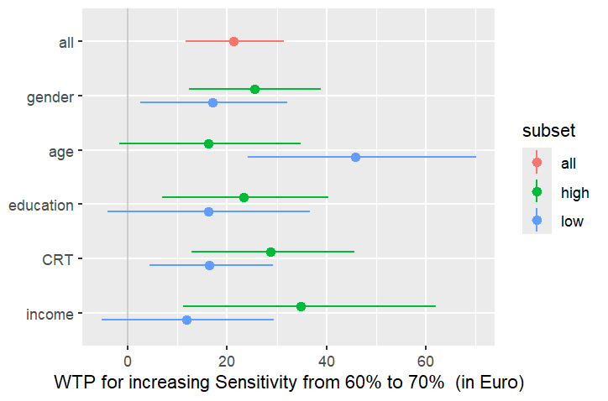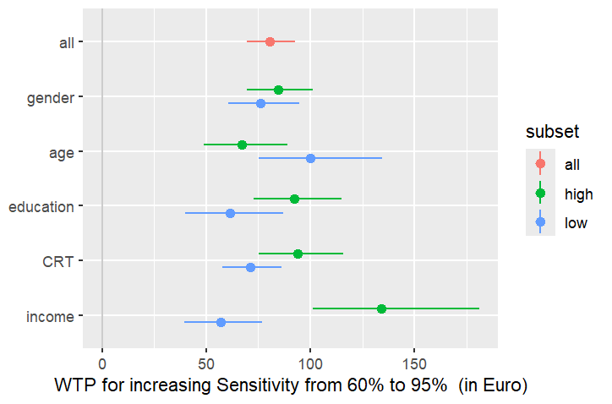
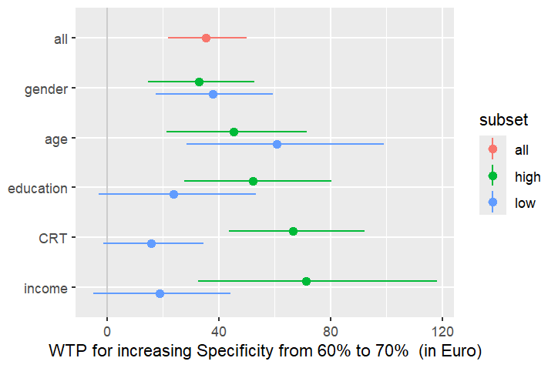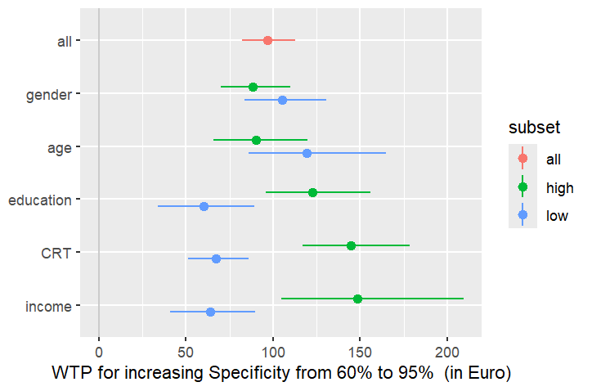
We obtain qualitatively similar results. We observe no difference in terms of willingness to pay for the Reading and Type attributes and observe the same group differences in the willingness to pay for increasing sensitivity and specificity. More precisely, individuals with higher income are willing to pay more for increasing sensitivity from 60% to 95% (M = 133.94€, IC = [101.01; 181.04]) if compared with individuals with lower income (M = 56.78€, IC = [39.30; 76.72]). The willingness to pay for increasing specificity from 60% to 95% is also higher for individuals with higher cognitive abilities (M = 144.62€, IC = [117.20; 178.28]), income (M = 148.31€, IC = [104.79; 209.35]), and education (M = 122.84€, IC = [95.98; 155.71]), if compared with individuals with lower cognitive abilities (M = 67.42€, IC = [51.22; 85.84]), income (M = 64.14€, IC = [41.21; 89.81]), and education (M = 60.07€, IC = [34.04; 89.45]).

