Supporting Information

Nanoneedle-forest NiCo₂O₄@nitrogen-doped Carbon-Mo₂C/CC as Double Functional Electrocatalysts for Water Hydrolysis and Zn-Air Batteries
Changhua Xu, Qiguan Wang,* Shaoting Zhao & Sumin Wang∗
The Youth Innovation Team of Shaanxi Universities, Shaanxi Key Laboratory of Photoelectric Functional Materials and Devices, School of Materials and Chemical Engineering, Xi’an Technological University, Xi’an 710021, People’s Republic of China
Results and Discussion
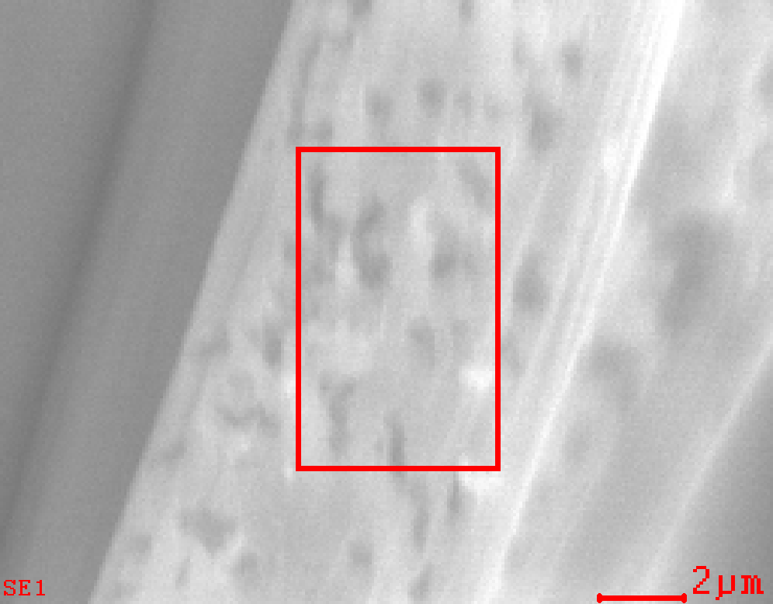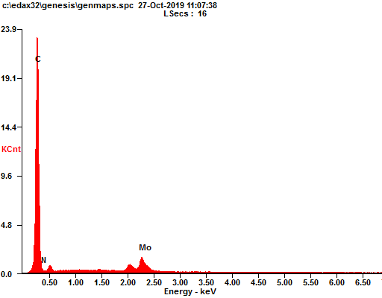
b
C
N
Mo
Fig. S1 EDS spectrum (b) of Mo₂C/CC (a).
The EDS spectrum of NDC-Mo₂C/CC (Fig. S1) showed the peaks of Mo, C and N elements, which is in consistence with the formula of NDC-Mo₂C/CC.
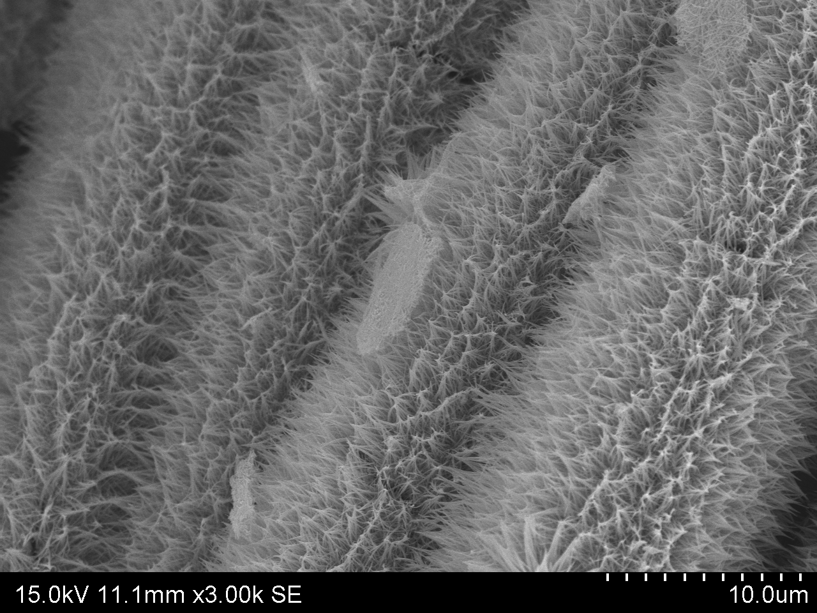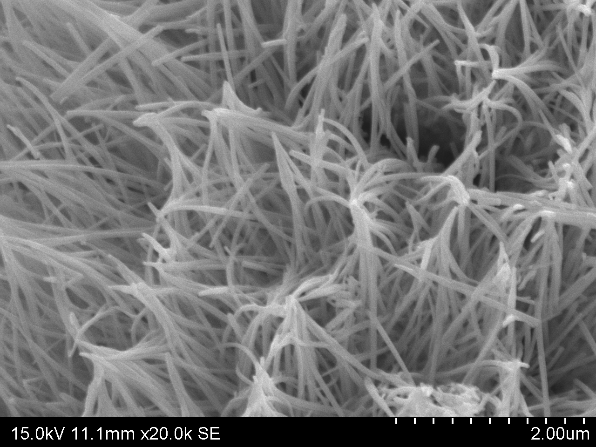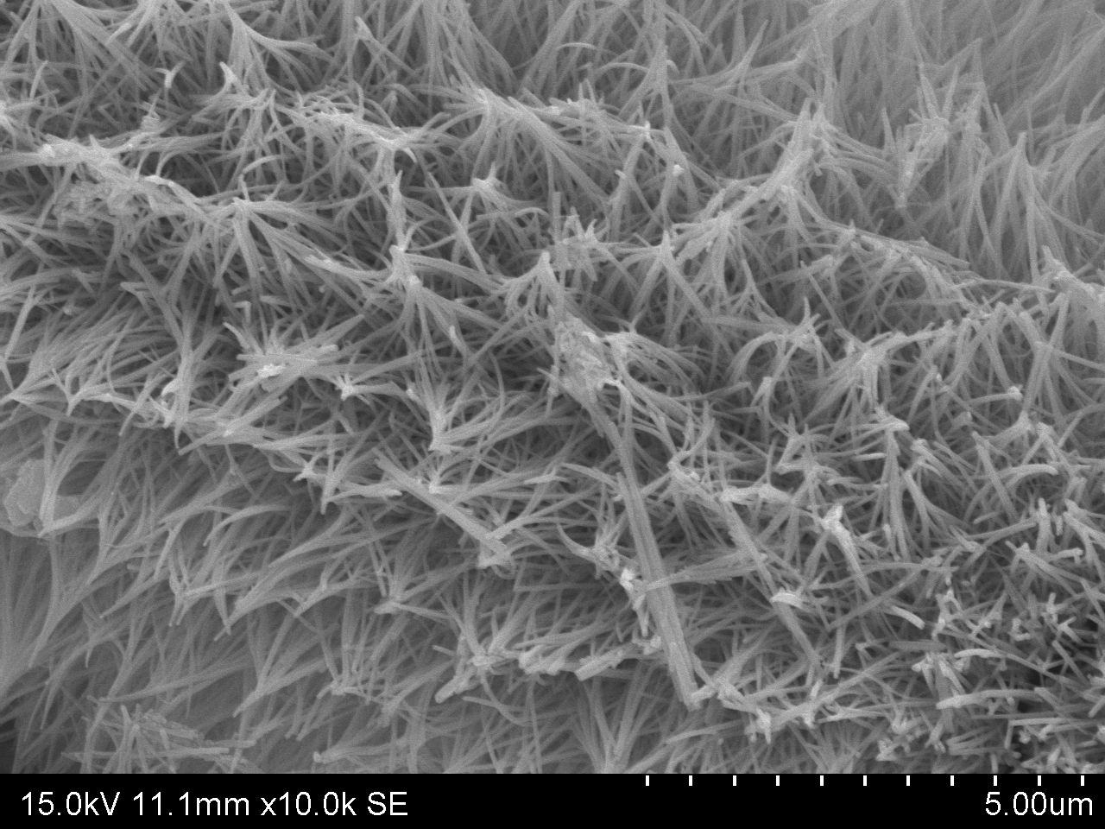
10µm
5µm
a
b
c
80nm
Fig. S2 SEM images of NiCo₂O₄/CC (a, b, c).
The SEM images in Fig. S2 suggest that the obtained NiCo₂O₄ grown on CC shows nanoneedle cluster morphology (a, b, c). Discerned from the high-resolution SEM image in Fig. S2c, the diameter of NiCo₂O₄ needle is ~80 nm.
Fig. S3 CV curves at different scan rates of NiCo₂O₄@NDC-Mo₂C/CC (a), NiCo₂O₄/CC (b) and NDC-Mo₂C/CC (c). (d) relationship between capacitive currents at 0.19 V and scan rate for each catalyst. (e) electrochemical active surface area (ECSA) of NiCo₂O₄@NDC-Mo₂C/CC, NiCo₂O₄/CC and NDC-Mo₂C/CC.
Electrochemical double layer capacitance (EDLC) of the as-prepared catalysts is measured. By means of the CV detected at different scan rates (Fig. S3a-c), a linear relationship between the current density and scan rate is observed as shown in Fig. S3d. The linear slope can reflect the EDLC, which directly correlates with the catalytic behavior. The EDLC of NiCo₂O₄@NDC-Mo₂C/CC, NiCo₂O₄/CC and NDC-Mo₂C/CC are 0.033, 0.028 and 0.0009 mF cm⁻², which corresponds to the electrochemical active surface area (ECSA) of 0.83, 0.7 and 0.02 cm², respectively. It can be clearly observed that NiCo₂O₄@NDC-Mo₂C/CC presents the largest EDLC value. These results support the NiCo₂O₄@NDC-Mo₂C/CC has the largest electroactive surface area and best electrocatalytic activity among the as-derived catalysts.
Table S1 TOF for NiCo₂O4@NDC-Mo₂C/CC, NiCo₂O₄/CC and NDC-Mo₂C/CC at overpotentials of 300, 330 and 360 mV corresponding to OER.
TOF s⁻¹ (mV) | NiCo₂O4@NDC-Mo₂C/CC | NiCo₂O₄/CC | NDC-Mo₂C/CC
300 | 7.36×10⁻² | 3.57×10⁻² | 3.90×10⁻³
330 | 7.94×10⁻² | 4.44×10⁻² | 1.11×10⁻²
360 | 9.12×10⁻² | 6.48×10⁻² | 1.20×10⁻²
From Table S1, O₂ turn over frequencies (TOFs) calculated verify the high intrinsic electrocatalytic activity of NiCo₂O₄@NDC-Mo₂C/CC samples, and the TOF of NiCo₂O₄@NDC-Mo₂C/CC value is significantly larger than that of NiCo₂O₄/CC and NDC-Mo₂C/CC at the same overpotential. In addition, with the increase of overpotential, the TOF value is increased too. This shows the fact that the amount of O₂ caused by the flow of current was proportional to the amount of electricity passed at the NiCo₂O₄@NDC-Mo₂C/CC sample.
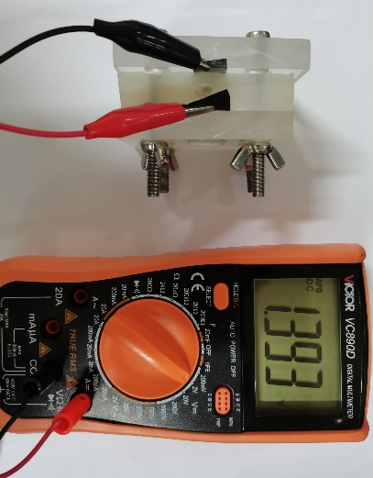
Fig. S4 The open-circuit voltage of NiCo₂O₄@NCD-Mo₂C/CC assembled Zn-air battery.
Table S2 Comparison of overvoltage for overall water splitting activity between NiCo₂O₄@NCD-Mo₂C/CC and previously reported catalysts.
Electrode Materials | η₁₀ (mV) | Reference
NiCo₂O₄@NCD-Mo₂C/CC | 1.64 | This work
NiFe-NiCoO₂ | 1.67 | [1]
NFP@NG | 1.69 | [2]
Ni(OH)₂/NiCo₂O₄ | 1.65 | [3]
Co₅Mo_{1.0}O NSs@NF | 1.68 | [4]
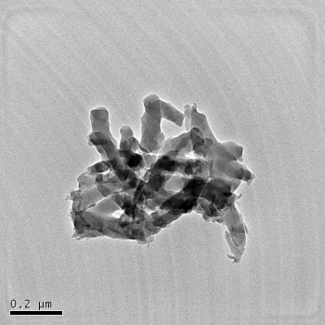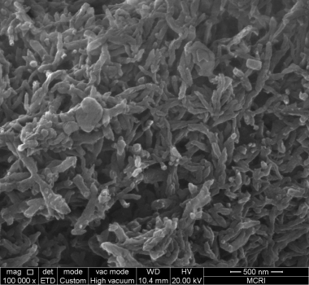
200nm2µm
aa
b
500nm
55nm
Fig. S5 SEM (a) and TEM (b) image of PANI.
The morphological characterization of polyaniline prepared by water/organic interface method is shown in Fig. S5. The as-obtained PANI product presents nanofiber morphology observed by SEM image (Fig. S5a). In addition, from the TEM image shown in Fig. S5b, the diameter is around 55 nm.

∗ Corresponding author. E-mail address: qiguanwang@163.com; suminwang@163.com (S.M. Wang).

