Efficient production of salicylic acid through CmeR-PcmeO biosensor-assisted multiplexing pathway optimization in Escherichia coli

Funding
This work was supported by the National Natural Science, Foundation of China (32370040, 32100055), Natural Science, Foundation of Jiangsu Province (BK20221537, BK20210464), and the, Program of Introducing Talents of Discipline to Universities (111-2-06).

Author contributions
K.W. performed the analysis of the results and organized the data. W.T.Y., W.X.P. designed and supervised the experiments. W.T.Y., W.X.P. and M.Z.R. conducted the testing of the results. M.Z.R. conducted the sponsorship of experimental supplies. All authors participated in writing, review and editing of the manuscript.

Competing interests
The authors declare no competing interests.

Table S1 Gene Sequences Used in This Study
Name | Sequence | Reference
PchB | ATGAATTTTCCACTAGTAGATCCCGACATGAAGACCC  CGGAGCAGTGTAGCGGTTTGGACGACGTTCGCTGCG  GTATTGATGCAATGGATCAGCAAATTATCCAGGCGCT  GGGCAGACGCCTGGCGTACGTCAAGGCGGCCGCTC  AATTCAAACCGACGGAAGATAGCATTGCGGCTCCGG  AGCGTGTTGCGGCTATGTTACCACAGCGTCGCCAGT  GGGCAGAACAGGCGTCCCTGGACCCGATGTTCGTG  GTGCCGCTGTTTGCACAAATCATCCACTGGAACATC  GCCCAACAAGTTCGTCATTGGCGTCGTCAGCACGG  CTTGGACCAGGGTGCGCAAGATGAGTAA | This study
CmeR | ATGAACAGTAATAGGACACCCTCACAAAAAGTCCT  TGCTCGCCAAGAGAAGATCAAAGCGGTGGCCCTGG  AACTGTTCCTGACCAAAGGTTATCAGGAGACGAGC  CTGTCCGACATCATCAAGTTGAGCGGTGGTAGCTAC  AGCAATATTTACGACGGCTTCAAAAGCAAGGAAGGT  CTGTTCTTTGAAATCCTGGATGATATTTGTAAAAAGC  ACTTCCACTTGATCTACTCCAAGACCCAGGAGATCG  AGAACGGTACTCTGAAAGAGATCTTAACCAGCTTTG  GCCTCGCGTTTATCGAAATTTTCAACCAACCGGAAG  CAGTGGCGTTCGGCAAAATCATTTACTCTCAGGTTTA  TGACAAAGATCGTCATTTGGCTAATTGGATTGAAAAC  AACCAACAAAACTTTAGCTATAACATCCTGATGGGTT  TTTTCAAACAGCAGAATAACTCCTACATGAAAAAGAA  CGCCGAAAAGCTGGCGGTGTTGTTCTGCACCATGCTG  AAGGAGCCGTATCATCATTTGAATGTTCTGATTAACGC  ACCGCTGAAGAACAAAAAGGAGCAGAAAGAGCACGT  TGAATTTGTAGTTAATGTGTTTCTGAACGGCATTAATTC  GTCTAAGGCGTAA | This study
P_{O1O3} | GGTATGGAAGCTATACGTTACCAATGTAATAAATATTAC  ATTGACAGCTAGCTCAGTCCTACTTATAATTGTAATAAA  TATTACA | This study
trpE tyrA pheA::sg3-sg3-sg1 | gtctaagaactttaaataatttctactgttgtagatCAGATATCGACAGCAAAG  ATaatttctactgttgtagatCAGCTTTATGCCGACATCATaatttctactgtt  gtagatAAAAAGAATGCGAAGAAAAAaatttctactgttgtagat | This study
P_{J23101} | TTTACAGCTAGCTCAGTCCTAGGTATTATGCTAGC | This study
P_{J23106} | TTTACGGCTAGCTCAGTCCTAGGTATAGTGCTAGC | This study
P_{J23114} | TTTATGGCTAGCTCAGTCCTAGGTACAATGCTAGC | This study
P_{J23119} | TTGACAGCTAGCTCAGTCCTAGGTATAATACTAGT | This study
B0030 | GAATTCATTAAAGAGGAGAAAGGTACCC | This study
B0034 | CTAGTGAAAGAGGAGAAATACTAG | This study
T7RBS | TCTAGAGAAGGAGATATACATATG | This study

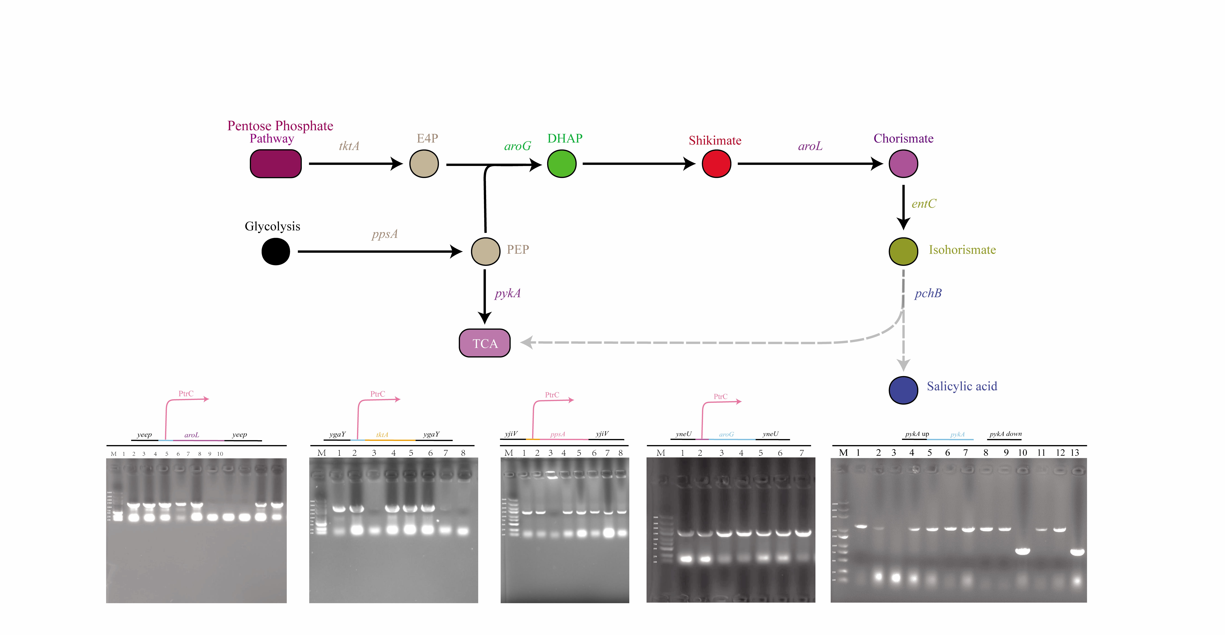
Additional file S1. Nucleic acid gel images illustrating the integration or knockout of the genes tktA, ppsA, aroG^{S180F}, aroL, and pykA within the genome of the W3110K-2 strain. Given that the nucleotide sequences of the target pseudogene loci yeeP, yneU, and ygaY are similar to those of the integrated genes aroL, aroG^{S180F}, and tktA, the validation method involved designing primers within the target genes and placing the downstream primer approximately 1500 bp below the intended pseudogene loci for PCR amplification.

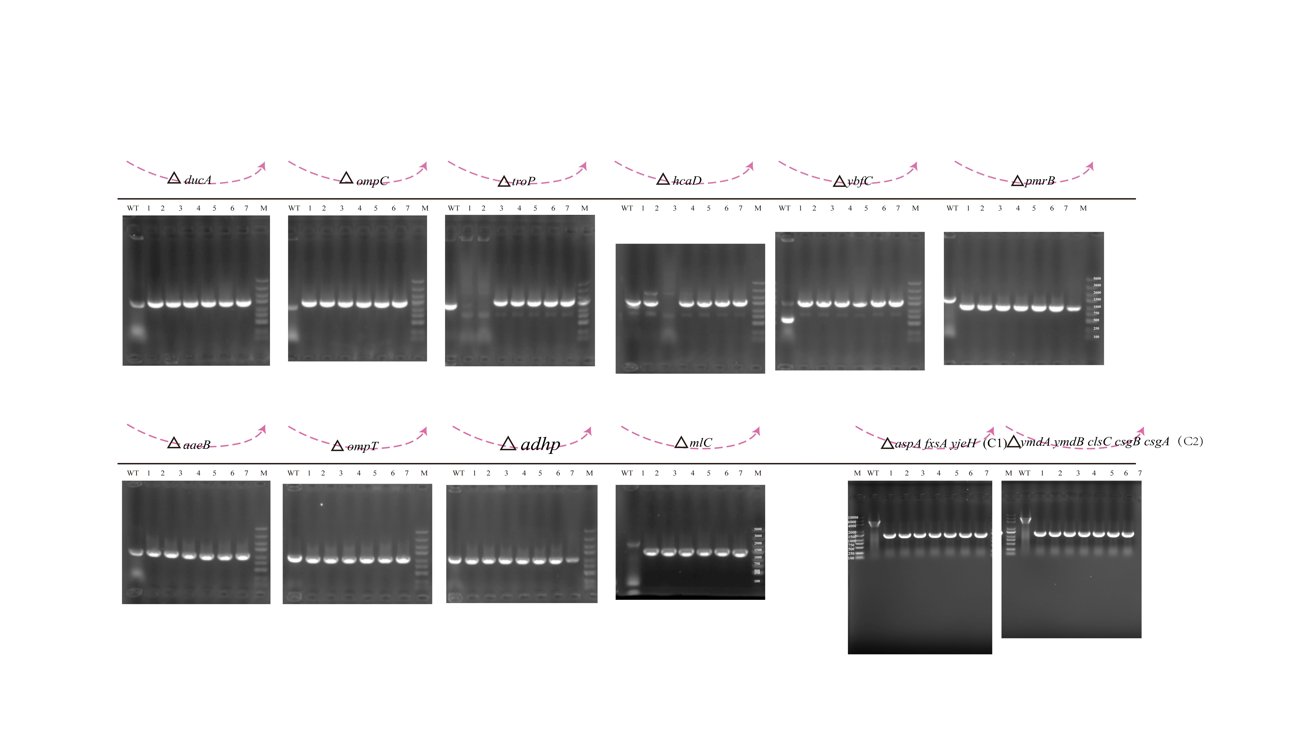
Additional file S2. Nucleic acid gel images depicting the knockout of 12 mutated genes in the W3110K-4 strain. The mutations in Groups C1 and C2 occur upstream or downstream of the genes, prompting the knockout of the most likely affected gene operons.

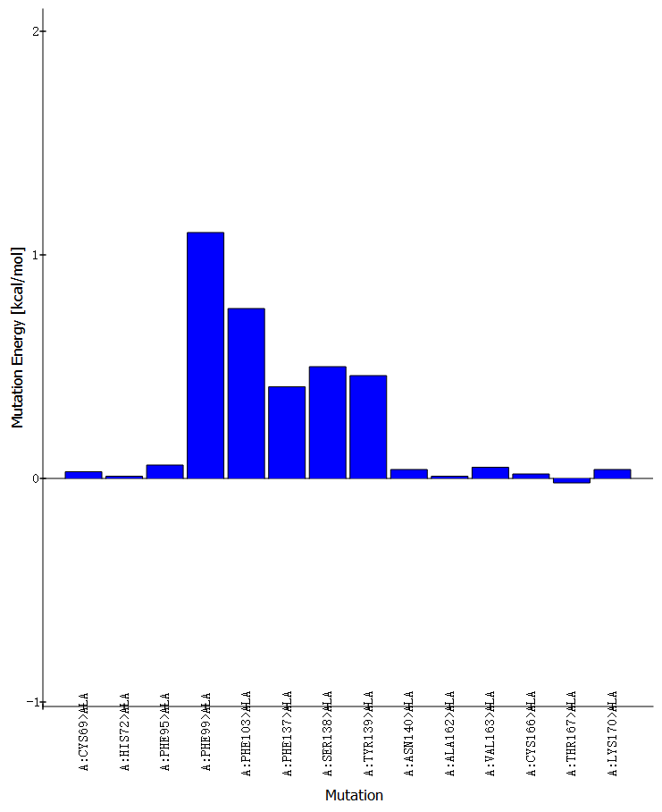
Additional file S3. Energy plots illustrating the amino acid mutations most likely affected by the docking of the CmeR protein with the small molecule salicylic acid (SA). where higher y-values indicate a weaker binding affinity between the CmeR protein and the small molecule.

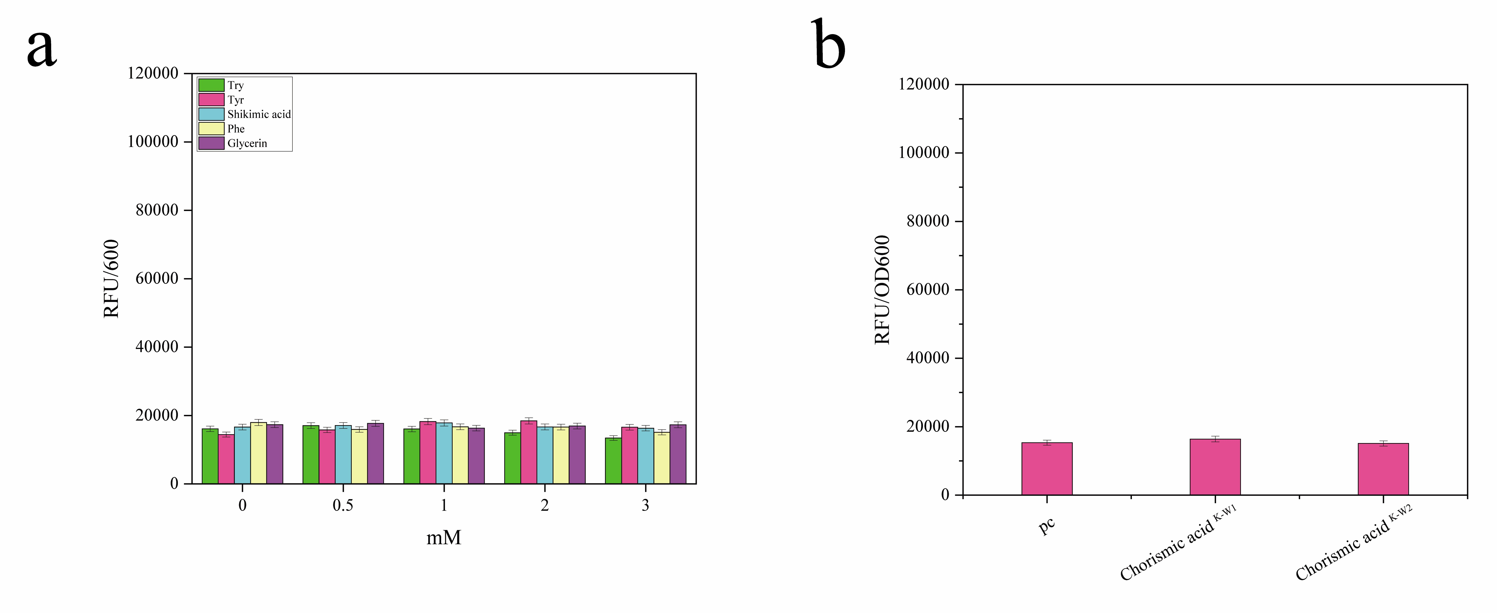
Additional file S4. The developed biosensor CmeRF99A-PO1O3 no longer responds to the precursor substances tryptophan, tyrosine, phenylalanine, branched-chain amino acids, and pyruvate. a. The sensor's response to varying concentrations of tryptophan, tyrosine, phenylalanine, and pyruvate. b. The biosensor's responsiveness was tested using the supernatants of W3110K-W1 and W3110K-W2 strains, which are capable of enhancing chorismic acid pathways.

Additional file S5. Growth curves for the W3110K-4 and W3110K-2 strains. compared to the W3110K-2 strain, the W3110K-4 strain demonstrated a significantly enhanced growth rate under identical fermentation conditions, indicating that the ALE strategy effectively improved tolerance to salicylic acid

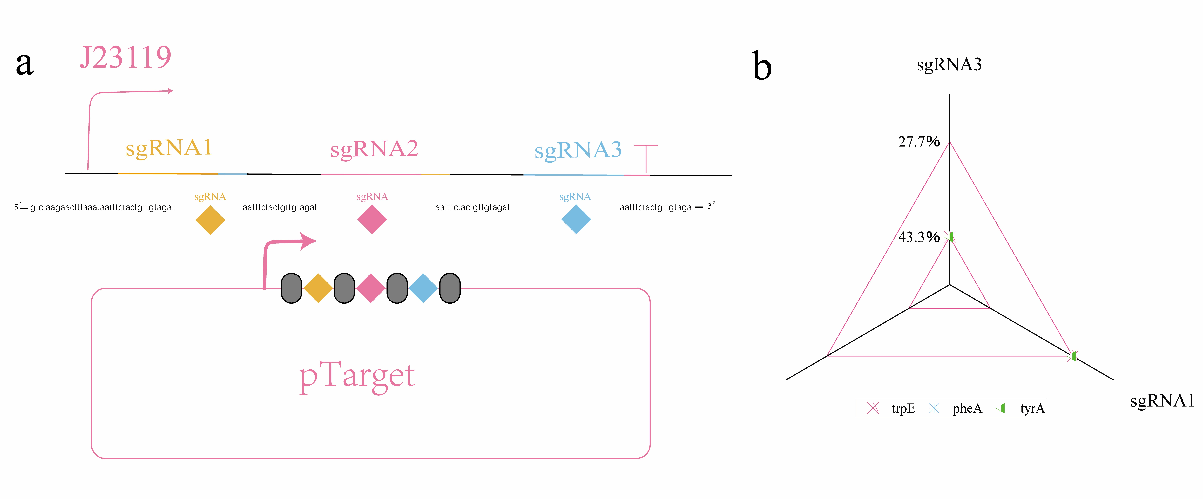

Additional file S6. a. Schematic representation of the multi-pathway sgRNA array construction. b. The inhibitory effects of the multi-pathway sgRNA array construction on trpE, tyrA, and pheA.

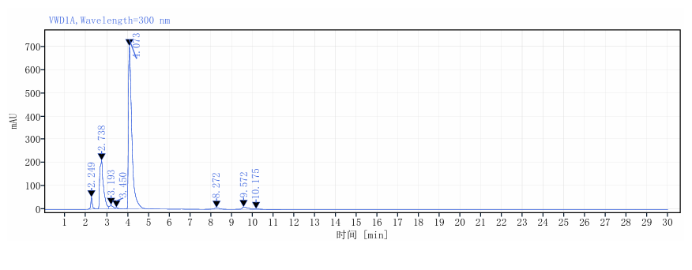
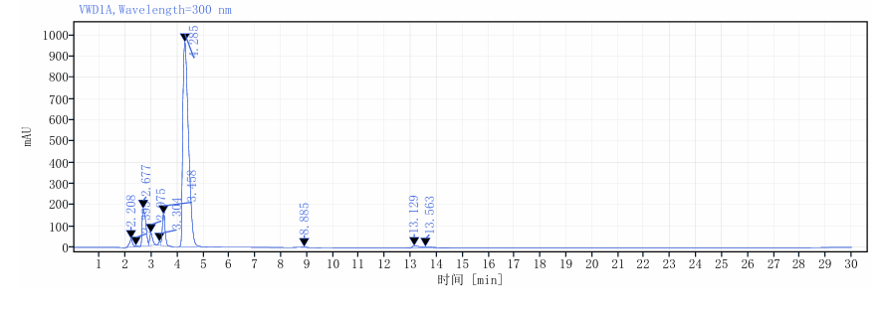
Additional file S7. Salicylic acid yields for the W3110K-1 and W3110K-5 strains. In this study, the HPLC-FACS analysis revealed a salicylic acid peak appearing approximately at 4 minutes.

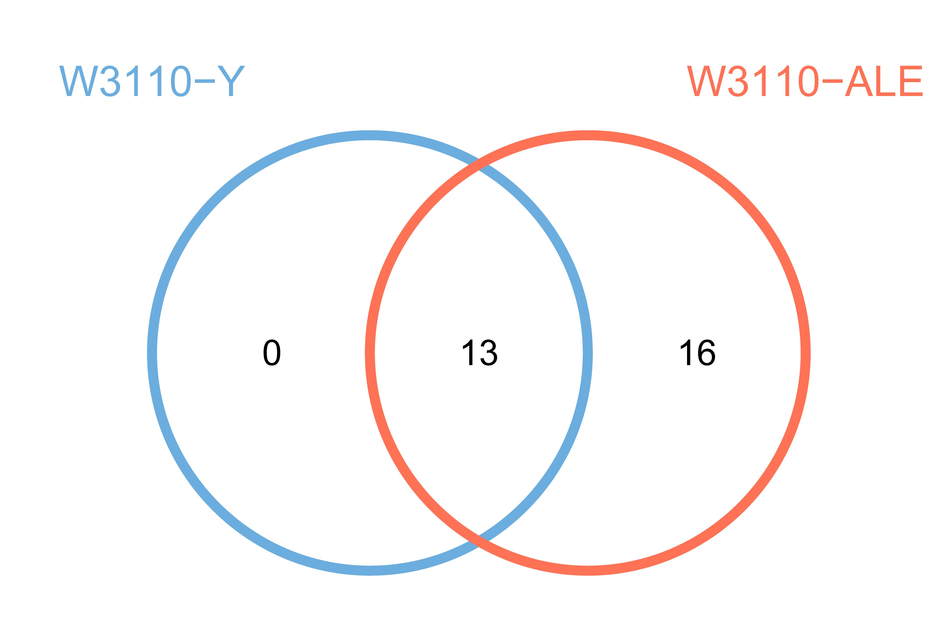
Additional file S8. Overall schematic representation of the mutated genomes of W3110K-2 and W3110K-4. The control group W3110-Y corresponds to the W3110K-2 strain, while W3110-ALE represents the W3110K-4 strain.

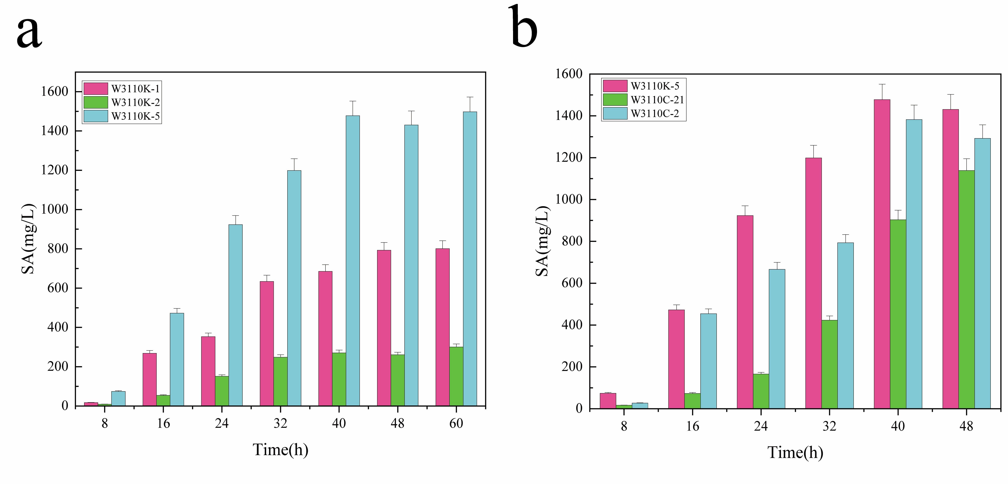

Additional file S9. a. Salicylic acid (SA) production of W3110K-1, W3110K-2, and W3110K-5 over a duration of 0 to 60 hours. b. Salicylic acid (SA) production of W3110K-5, W3110C-21, and W3110C-2 within a timeframe of 0 to 48 hours.

