SUPLEMENTARY INFORMATION(S)
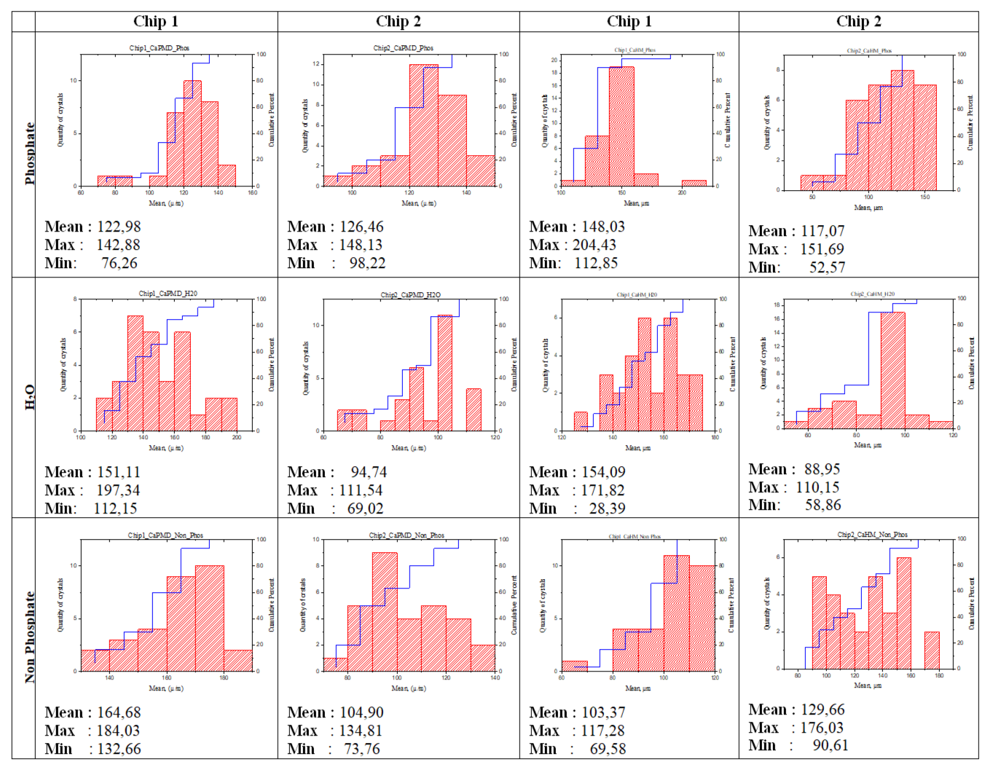
Figure (S1)….. Histograms of all synthesis using Microfluidics technique with three different solvents Buffer solution 7.2 (source non phosphate), H₂O, Buffer solution 7.2 (source phosphate) solvent and three different phosphate reactives PMD and HM at room temperature.

