Supplementary Materials for
Observation of surface Fermi arcs in altermagnetic Weyl semimetal CrSb
Wenlong Lu^{1,†}, Shiyu Feng^{1,†}, Yuzhi Wang^{2,3†}, Dong Chen^{4,5,†}, Zihan Lin^{1,}, Xin Liang^{1,}, Siyuan Liu⁶, Wanxiang Feng⁶, Kohei Yamagami⁷, Junwei Liu⁸, Claudia Felser⁵, Quansheng Wu^{2,3}*, Junzhang Ma^{1,}*
¹Department of Physics, City University of Hong Kong, Kowloon, Hong Kong, China
²Institute of Physics and Beijing National Laboratory for Condensed Matter Physics, Chinese Academy of Sciences, Beijing 100190, China
³University of Chinese Academic of Science, Beijing 101408, China
⁴College of Physics, Qingdao University, Qingdao 266071, China
⁵Max Planck Institute for Chemical Physics of Solids, 01187 Dresden, Germany
⁶Centre for Quantum Physics, Key Laboratory of Advanced Optoelectronic Quantum Architecture and Measurement (MOE), School of Physics, Beijing Institute of Technology, Beijing 100081, China
⁷Japan Synchrotron Radiation Research Institute, 1-1-1, Sayo-cho, Sayo-gun, Hyogo 679–5198, Japan
⁸Department of Physics, The Hong Kong University of Science and Technology, Hong Kong, China.
†The authors contributed equally to this work.
*Corresponding to: Junzhang Ma (junzhama@cityu.edu.hk) Quansheng Wu (quansheng.wu@iphy.ac.cn)

This file contains:
1, Section 1: Discussion about the properties of altermagnetism.
2, Section 2: General agreement between experimental bulk band structure and calculations.
3, Supplementary Figure 1.
4, Supplementary Figure 2.

Section 1: Discussion about the properties of altermagnetism
Altermagnetism enables unconventional high even-parity wave magnetism, such as d-wave, g-wave, and i-wave, to exist within the framework of an effective single-particle description of magnetism [1–3]. Recently, it has even been suggested that altermagnetism can extend to include non-collinear spins and multiple local-structure variations with odd-parity spin symmetry [4]. The study of altermagnetism significantly broadens the symmetry classification in the field of magnetism. Altermagnets are promising candidates for driving the next generation of information technology because of their unique physical properties: C-paired spin-valley locking, nontrivial Berry phase, spin currents, the anomalous Hall effect, stability under perturbing magnetic fields, and giant magnetoresistance, etc [1,5–18].
Section 2: General agreement between experimental bulk band structure and calculations
To confirm the agreement between the bulk experimental band structure and the theoretical calculations, we conducted a systematic soft X-ray ARPES study on CrSb. We cleaved the sample along the (100) side surface. Photon energies versus k_{z} were easily determined using soft X-ray ARPES data as the k_{z} resolution is much higher compared with that of low photon energies, which clearly reveals the periodic structure. This periodicity aligns well with the lattice parameter along the normal direction, allowing us to identify the Γ plane at 760 eV and 583 eV, the M plane at 670 eV. The in-plane Fermi surface along the ΓAHK plane is shown in Fig. 2(a), with a rectangular BZ acquired using a photon energy of 760 eV. The photon energy corresponding to the Γ point was confirmed by scanning photon energy and characterizing along the ΓM direction (k_{z}) in momentum space. We present cuts along the high-symmetry lines ΓA, HK, HA, and ΓK in Figs. 2(b) and 2(c), respectively. The calculated band structure under altermagnetic order is plotted alongside for comparison, indicated by red dotted lines. It can be seen that the experimental results agree well with the calculations in all directions. We verified that the materials are under altermagnetic order by plotting the band structure calculations for the non-magnetic order as a reference, indicated by pink dotted lines in Figs. 2(b) and (d), since the magnetic phase transition temperature exceeds ~700 K, which is beyond our experimental setting. The material retains long-range magnetic order under the conditions of our experiment, as indicated by the non-magnetic order calculations not matching the experimental data.

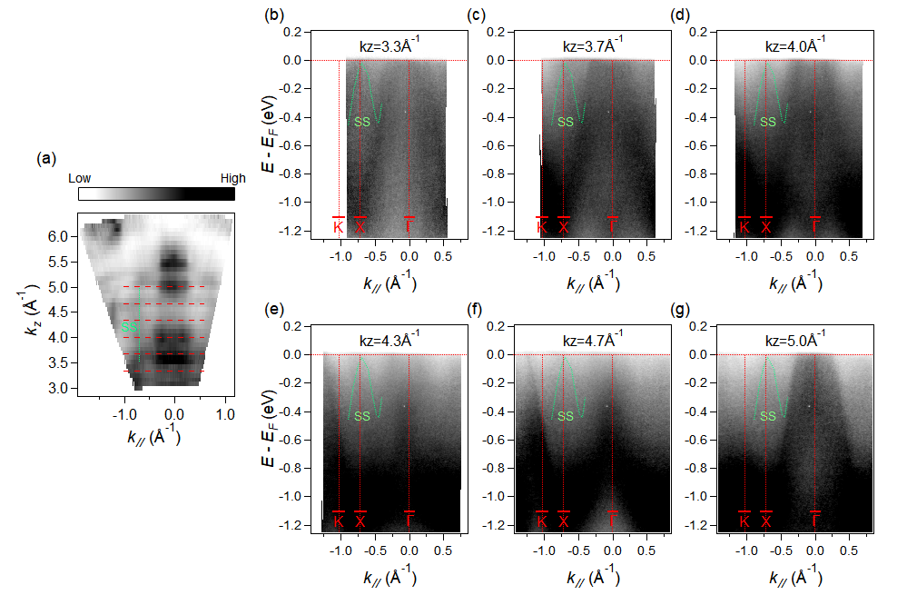
Fig. S1. Surface states identified in photon energy-dependent ARPES measurements, exhibiting no k_{z} dispersion. (a) Fermi surfaces acquired in the plane of k_{z}-k_{x}. The red dotted lines indicate the positions of the cuts in panels (b-g). The green dotted line shows the position of the surface states along k_{z} direction. (b-g) Experimental band spectra along cuts with different k_{z} marked with red dotted lines in (a). The green dotted lines illustrate the same dispersion of the surface bands across different k_{z} values.

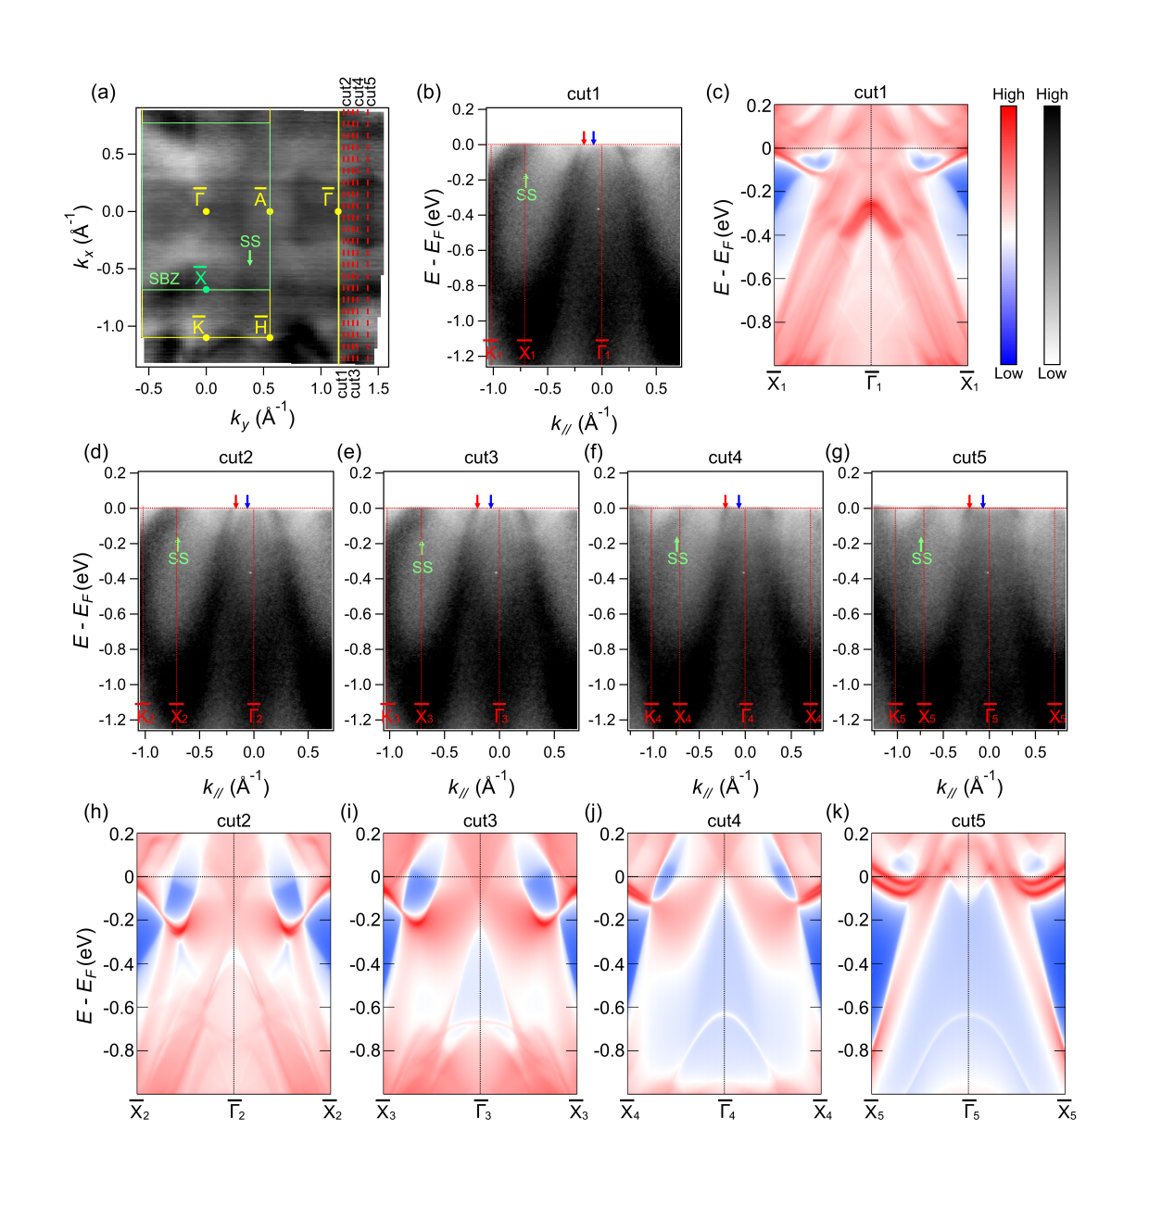Fig. S2. Comparison of surface states between experimental and calculated results along different cuts. (a) ARPES intensity of Fermi surfaces acquired with photon energy 80eV. The yellow line and the green line represent Brillouin zone projection of bulk states and surface states, respectively. The red dotted lines indicate the positions of the cut1-5 in the following panels. (b, d-g) Experimental band dispersion along cut1-5. The red and blue arrows denote bulk states bands with spin splitting. The green arrows denote the surface states. (c, h-k) Calculated surface projected band structure along cut1-5, revealing the same surface bands in experiments.

[1] L. Šmejkal, J. Sinova, and T. Jungwirth, Emerging Research Landscape of Altermagnetism, Phys Rev X 12, 040501 (2022).
[2] L. Šmejkal, J. Sinova, and T. Jungwirth, Beyond Conventional Ferromagnetism and Antiferromagnetism: A Phase with Nonrelativistic Spin and Crystal Rotation Symmetry, Phys Rev X 12, 031042 (2022).
[3] I. I. Mazin, Altermagnetism in MnTe: Origin, predicted manifestations, and routes to detwinning, Phys Rev B 107, L100418 (2023).
[4] S.-W. Cheong and F.-T. Huang, Altermagnetism with non-collinear spins, NPJ Quantum Mater 9, 13 (2024).
[5] M. Naka, S. Hayami, H. Kusunose, Y. Yanagi, Y. Motome, and H. Seo, Spin current generation in organic antiferromagnets, Nat Commun 10, 4305 (2019).
[6] L.-D. Yuan, Z. Wang, J.-W. Luo, E. I. Rashba, and A. Zunger, Giant momentum-dependent spin splitting in centrosymmetric low-𝑍 antiferromagnets, Phys Rev B 102, 014422 (2020).
[7] L. Šmejkal, R. González-Hernández, T. Jungwirth, and J. Sinova, Crystal time-reversal symmetry breaking and spontaneous Hall effect in collinear antiferromagnets, Sci Adv 6, 23 (2020).
[8] I. I. Mazin, K. Koepernik, M. D. Johannes, R. González-Hernández, and L. Šmejkal, Prediction of unconventional magnetism in doped FeSb2, Proceedings of the National Academy of Sciences 118, (42) e2108924118 (2021).
[9] R. González-Hernández, L. Šmejkal, K. Výborný, Y. Yahagi, J. Sinova, T. Jungwirth, and J. Železný, Efficient Electrical Spin Splitter Based on Nonrelativistic Collinear Antiferromagnetism, Phys Rev Lett 126, 127701 (2021).
[10] D.-F. Shao, S.-H. Zhang, M. Li, C.-B. Eom, and E. Y. Tsymbal, Spin-neutral currents for spintronics, Nat Commun 12, 7061 (2021).
[11] H.-Y. Ma, M. Hu, N. Li, J. Liu, W. Yao, J.-F. Jia, and J. Liu, Multifunctional antiferromagnetic materials with giant piezomagnetism and noncollinear spin current, Nat Commun 12, 2846 (2021).
[12] L. Šmejkal, A. H. MacDonald, J. Sinova, S. Nakatsuji, and T. Jungwirth, Anomalous Hall antiferromagnets, Nat Rev Mater 7, 482 (2022).
[13] R. M. Fernandes, V. S. de Carvalho, T. Birol, and R. G. Pereira, Topological transition from nodal to nodeless Zeeman splitting in altermagnets, Phys Rev B 109, 024404 (2024).
[14] A. Bose et al., Tilted spin current generated by the collinear antiferromagnet ruthenium dioxide, Nat Electron 5, 267 (2022).
[15] L. Šmejkal, A. B. Hellenes, R. González-Hernández, J. Sinova, and T. Jungwirth, Giant and Tunneling Magnetoresistance in Unconventional Collinear Antiferromagnets with Nonrelativistic Spin-Momentum Coupling, Phys Rev X 12, 011028 (2022).
[16] S. Karube, T. Tanaka, D. Sugawara, N. Kadoguchi, M. Kohda, and J. Nitta, Observation of Spin-Splitter Torque in Collinear Antiferromagnetic RuO2, Phys Rev Lett 129, 137201 (2022).
[17] X. Zhou, W. Feng, X. Yang, G.-Y. Guo, and Y. Yao, Crystal chirality magneto-optical effects in collinear antiferromagnets, Phys Rev B 104, 024401 (2021).
[18] M. Naka, S. Hayami, H. Kusunose, Y. Yanagi, Y. Motome, and H. Seo, AnAnomalous Hall effect in 𝜅-type organic antiferromagnets, Phys Rev B 102, 075112 (2020).

