Supplementary Information
Table S1
The total number of documents from the WoSCC keyword search (31st March, 2024).
Search Terms | Search Results
“Sludge Digest*” AND “Mixotroph*” | 34
“Sludge Digest*” AND “Aquaculture” | 157
“Mixotroph*” AND “Aquaculture” | 129
“Sludge Digest*” AND “Mixotroph*” AND “Aquaculture” | 0
Total | 320

Table S2
Language distribution of compiled literature on SDMA.
Language | Number
English | 318
Spanish | 1
Portuguese | 1

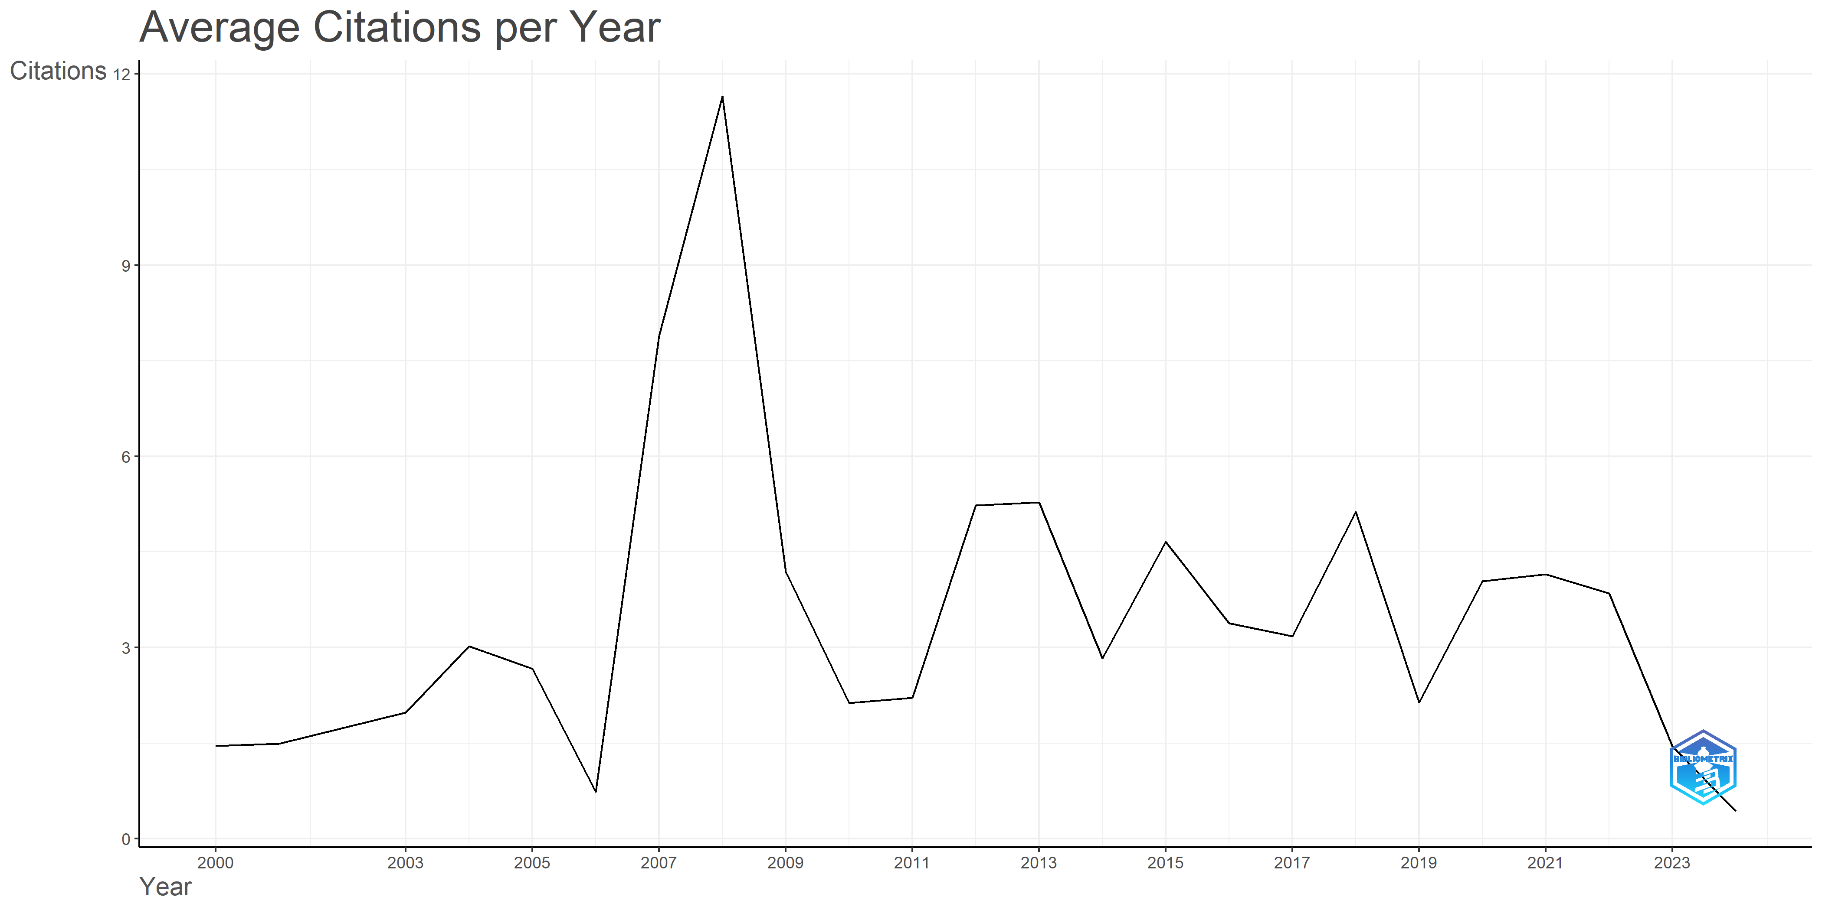

Fig. S1. Annual average citation of scientific production on SDMA over time.

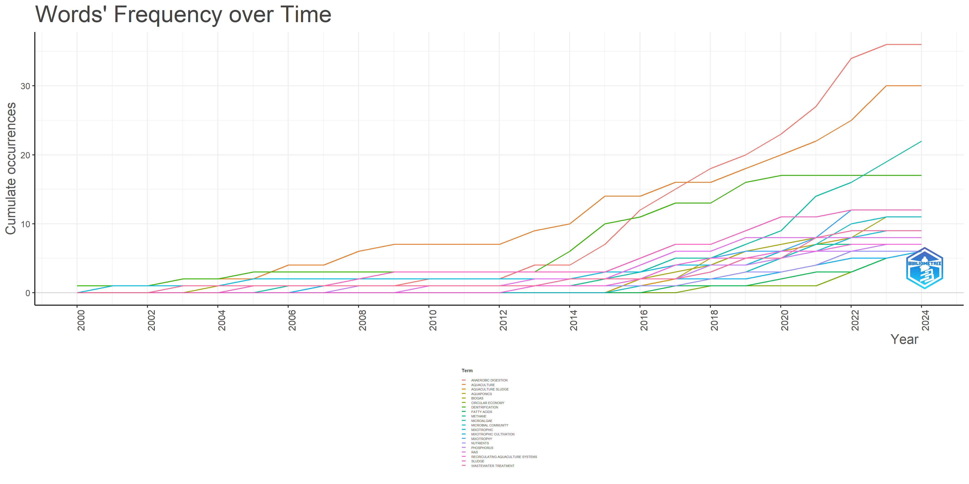
Fig. S2. Frequency of cumulative occurrence of top 20 author’s keyword on SDMA overtime.

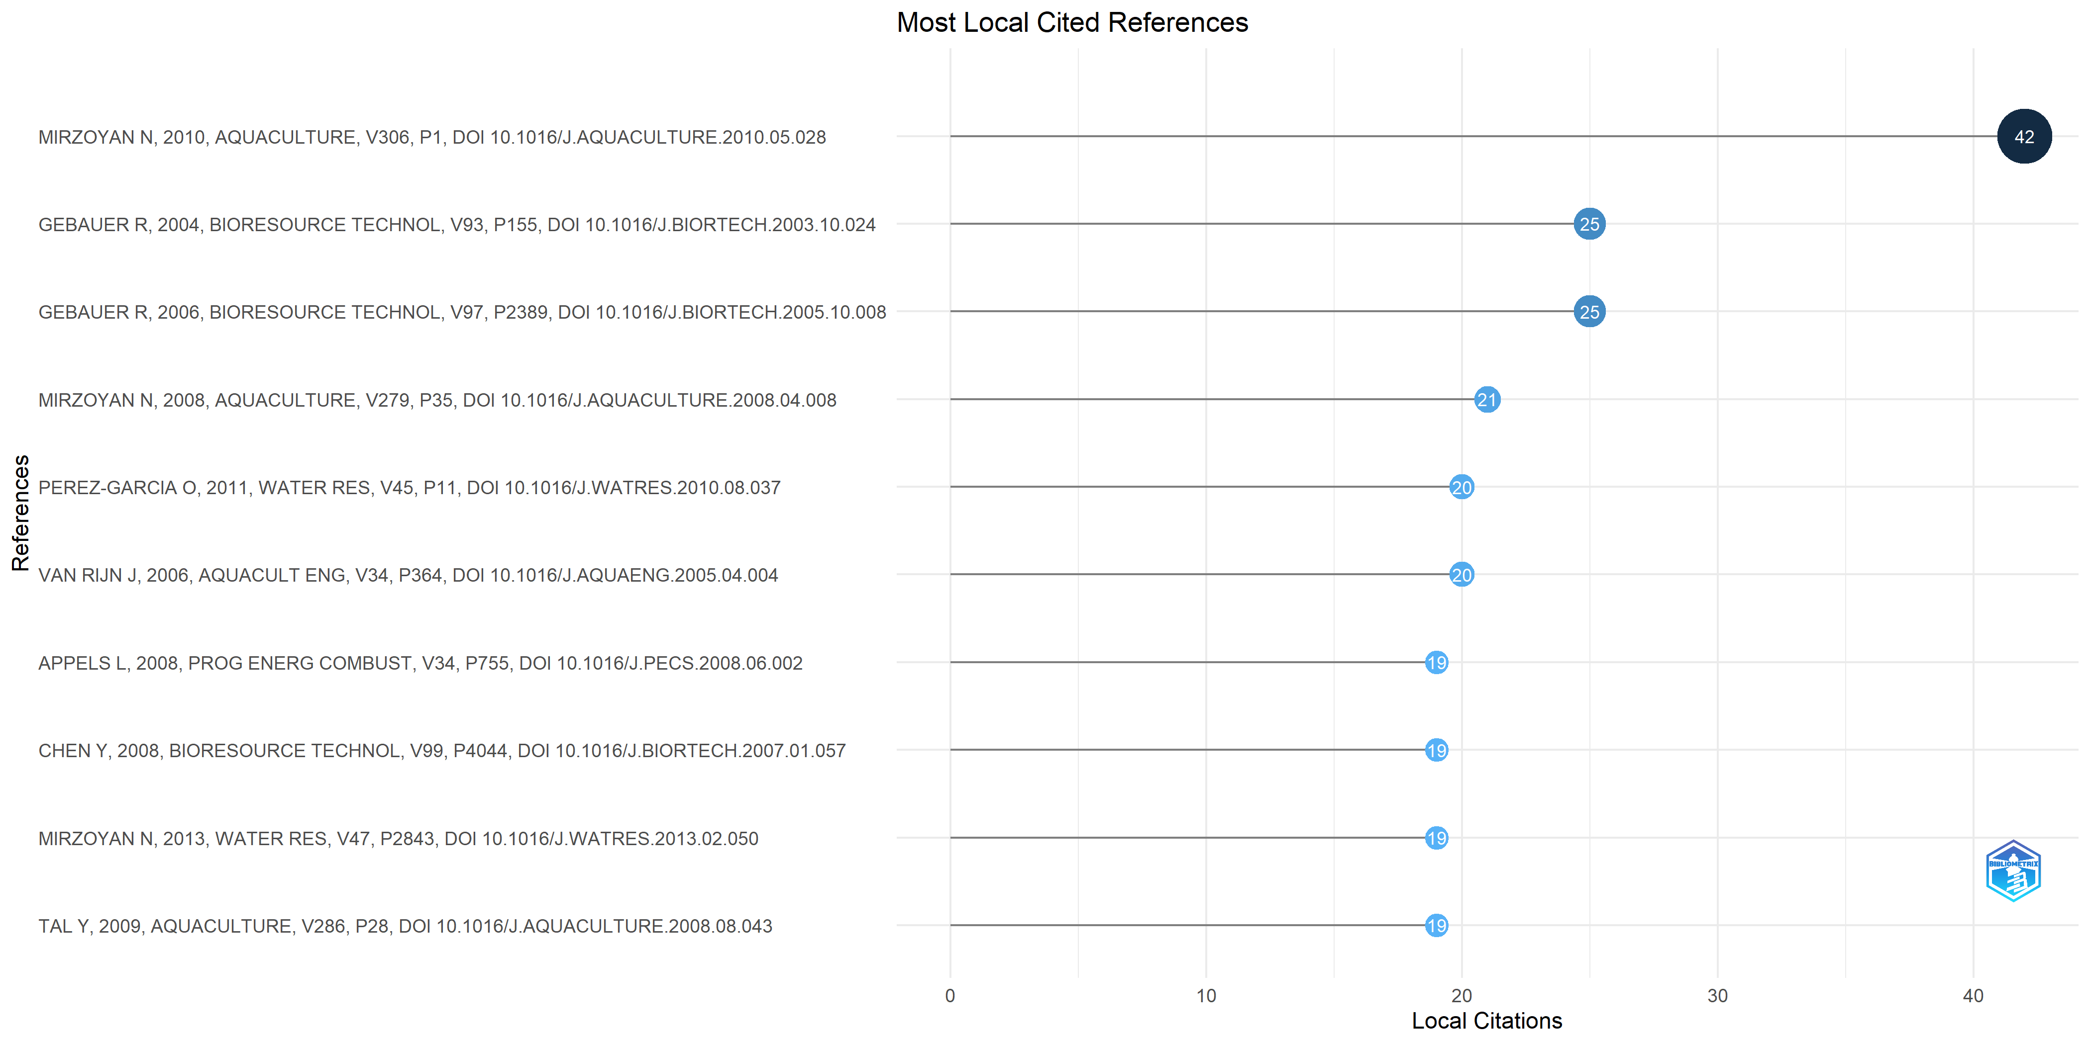
Fig. S3. Top ten local cited references on SDMA.
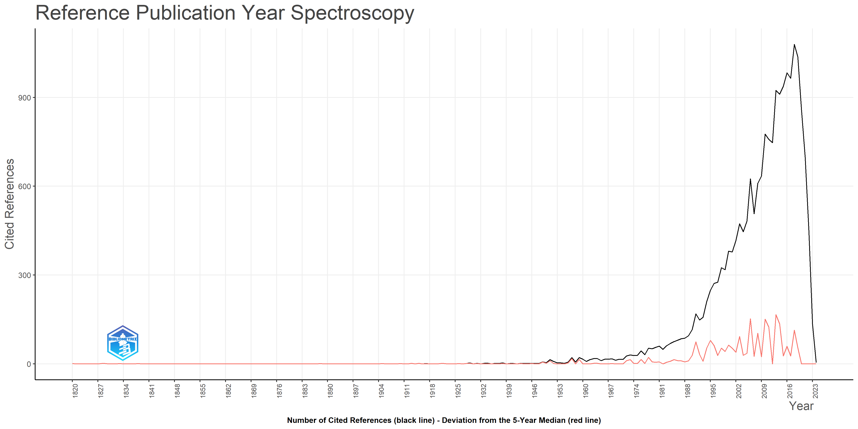
Fig. S4. Reference publication year spectroscopy on SDMA.

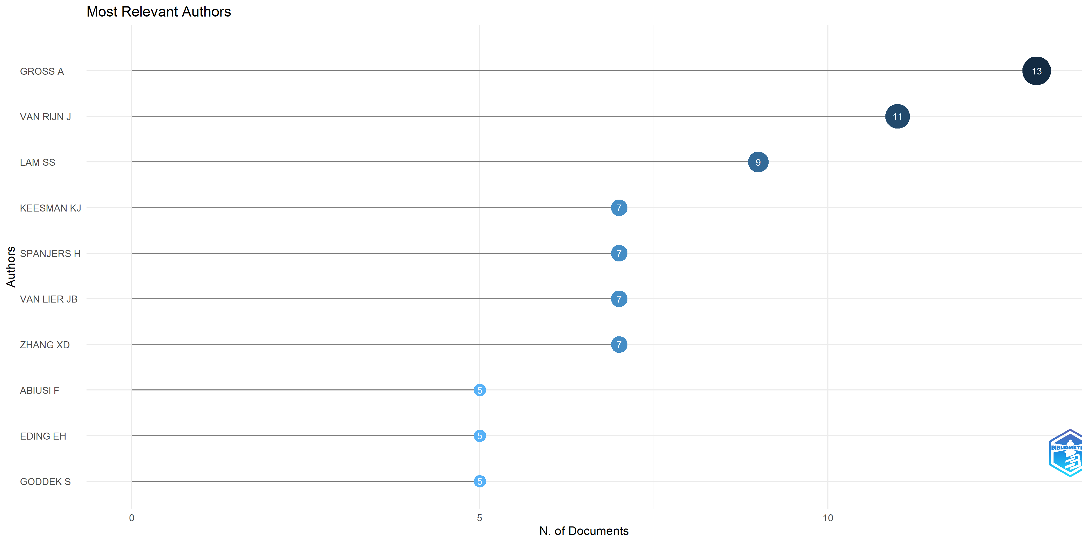
Fig. S5. Top ten scientist publishing on SDMA.
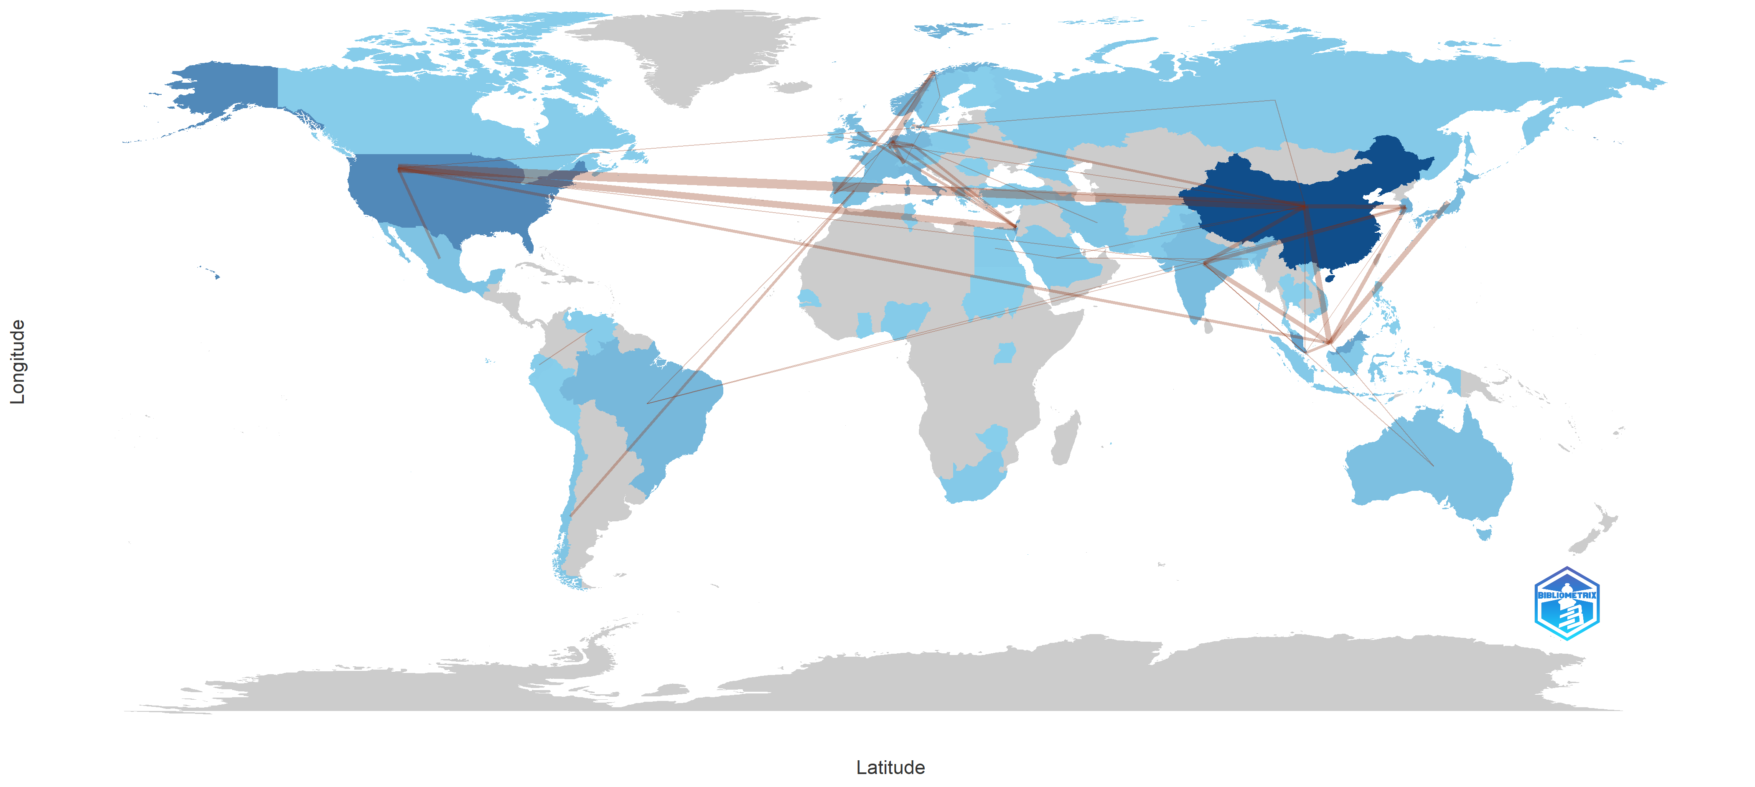
Fig. S6. Countries scientific production and collaboration map on SDMA.
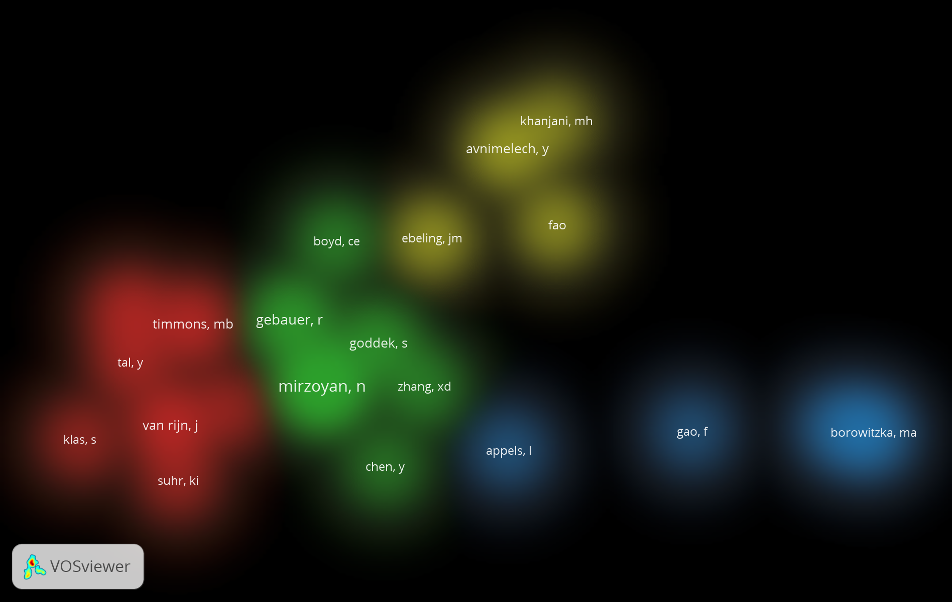
Fig. S7: Density heatmap of cited authors at least 10 times from co-citation analysis

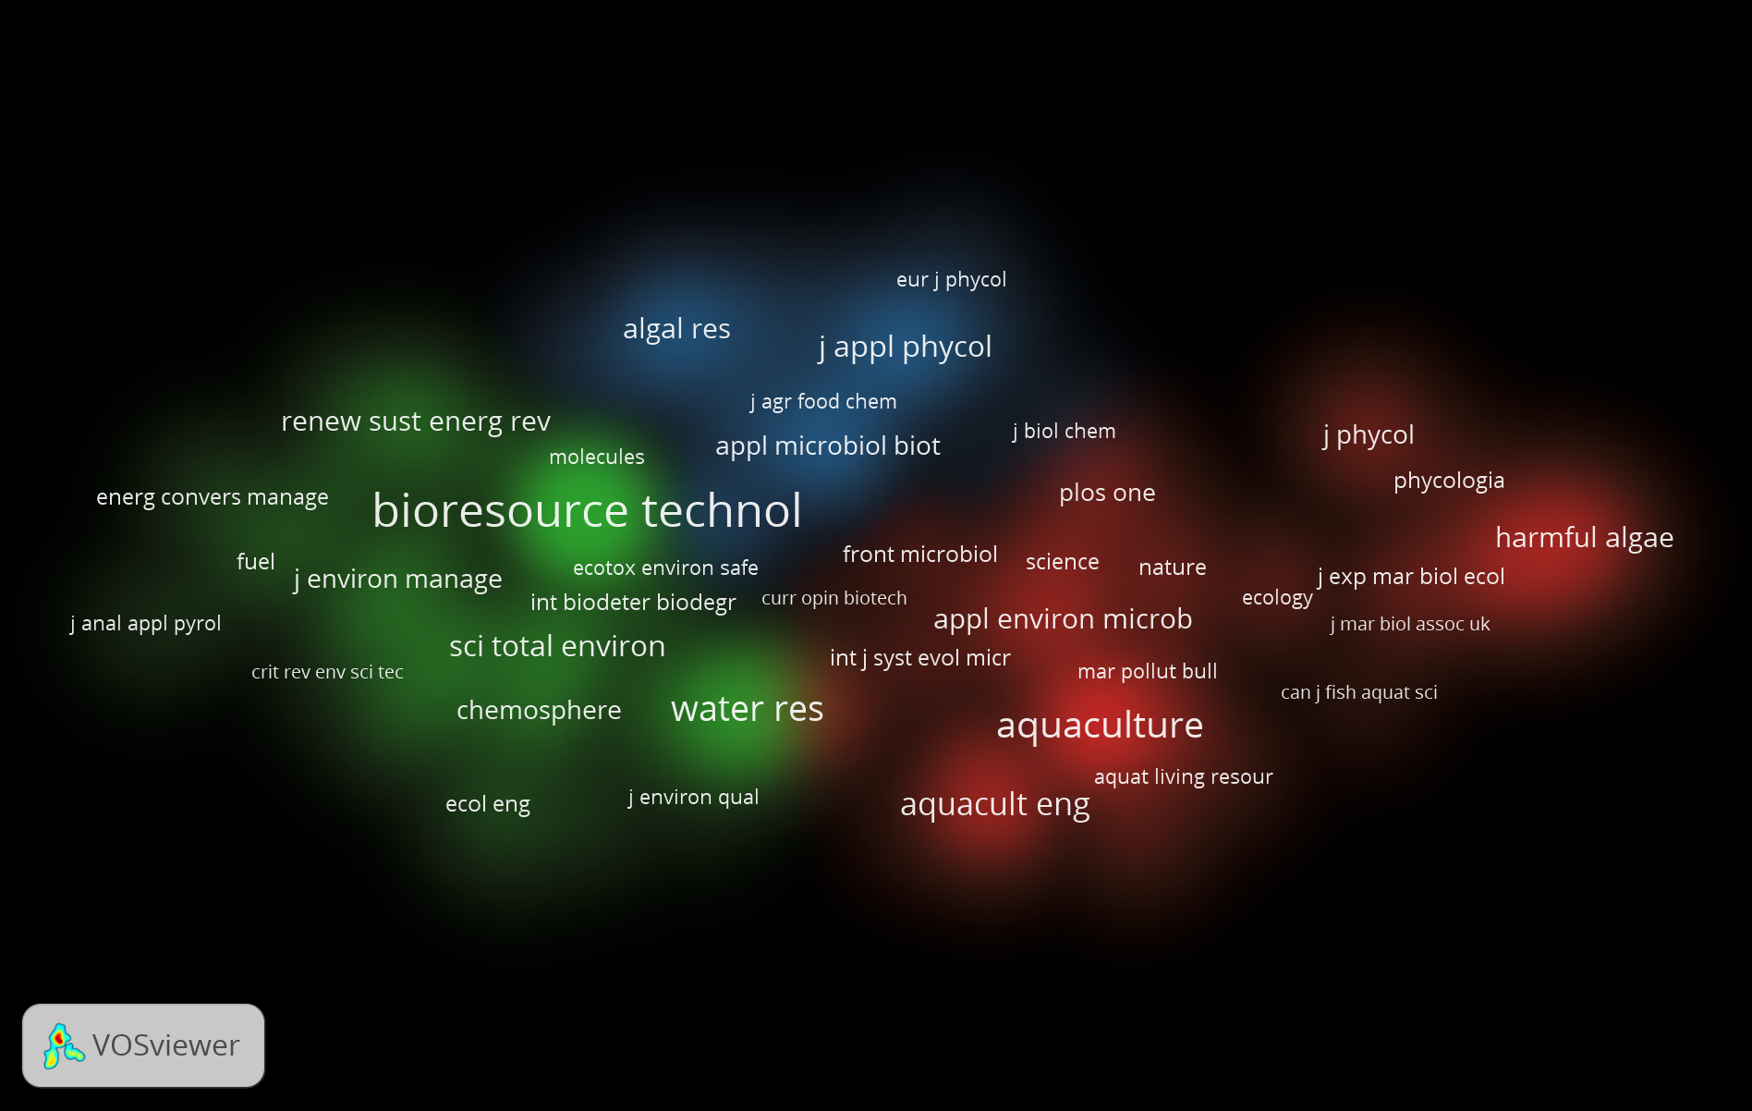
Fig. S8: Density heatmap of cited journals at least 20 times from co-citation analysis on SDMA.

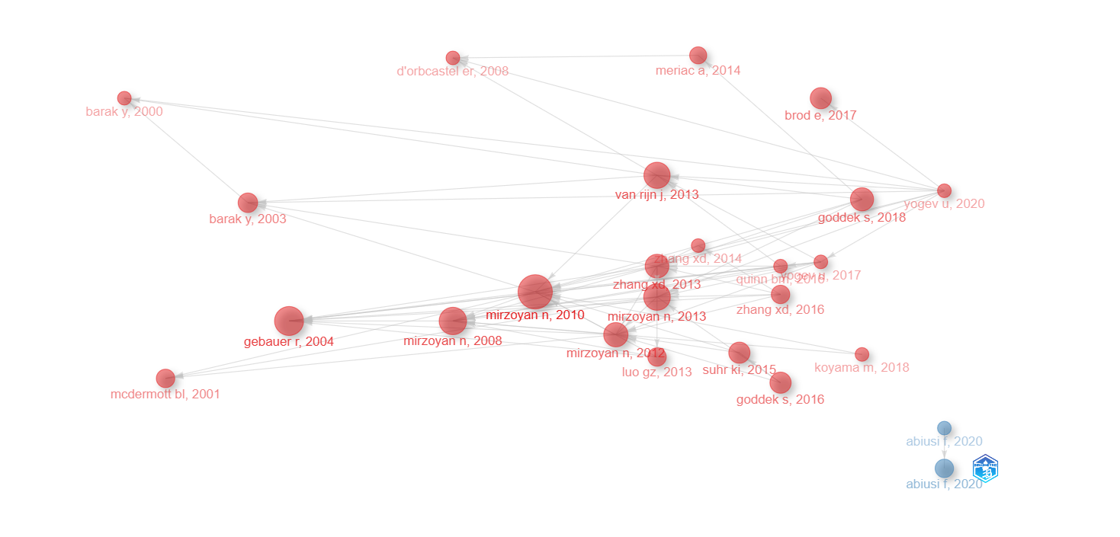
Fig. S9. Historiograph of author cooperation

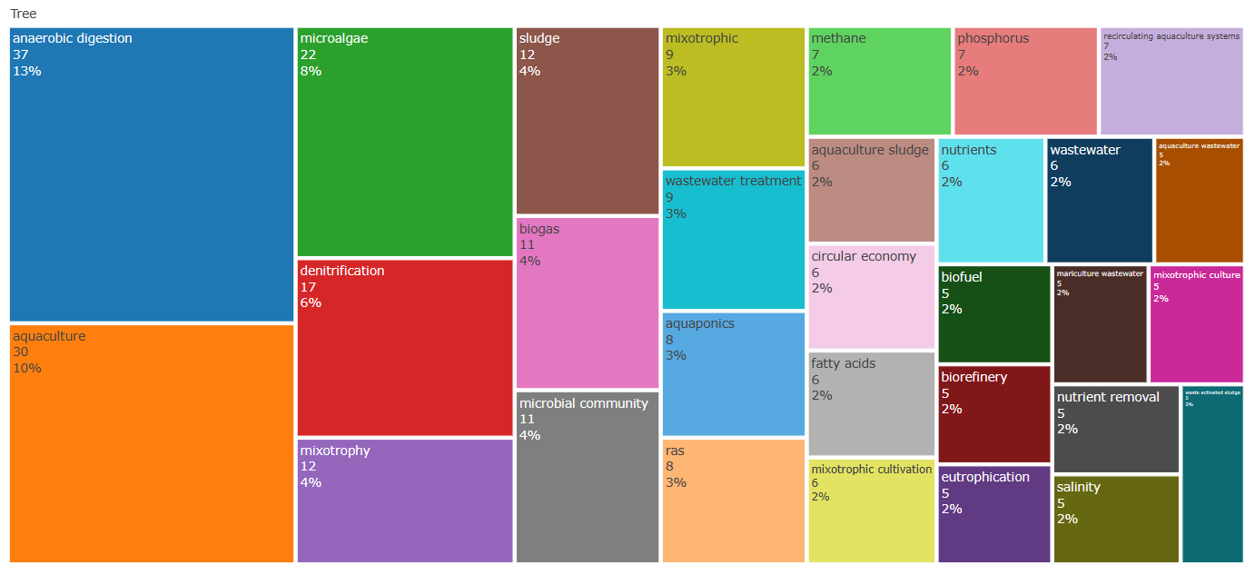
Fig. S10. Tree map of author keywords.
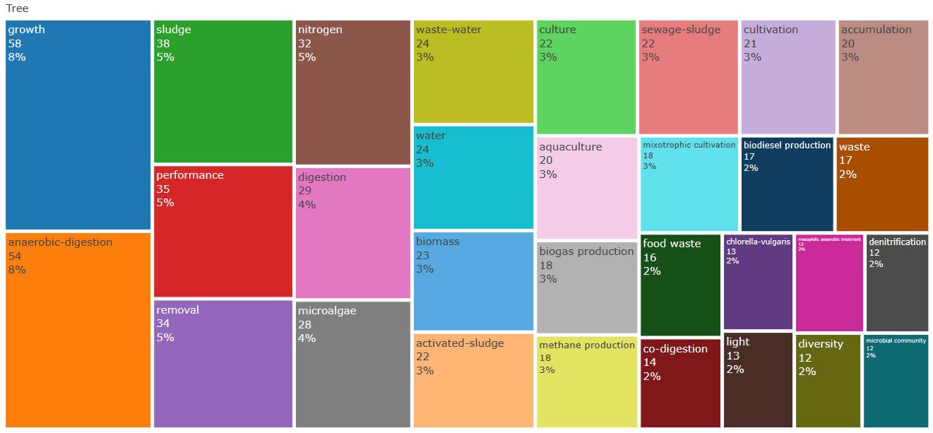
Fig. S11. Tree map of keyword plus.
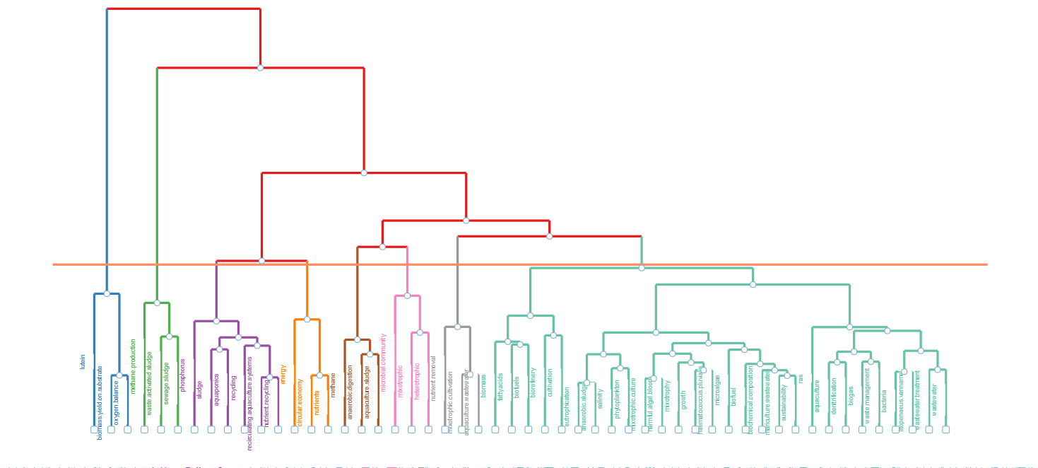
Fig. S12. Dendrogram of author’s keywords
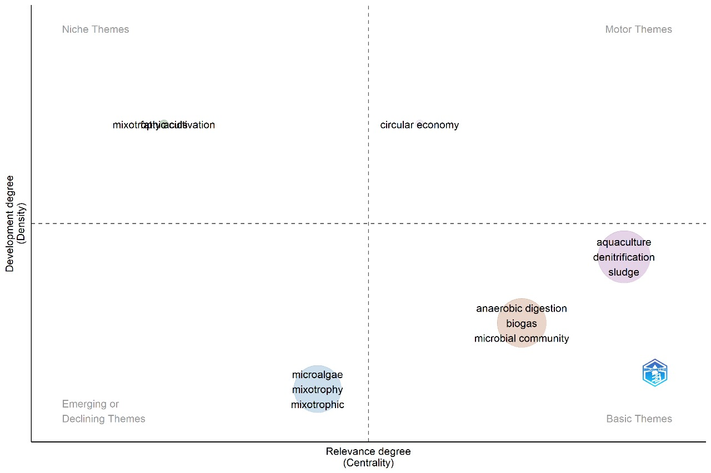
Fig. S13. Thematic map of keywords on SDMA research

