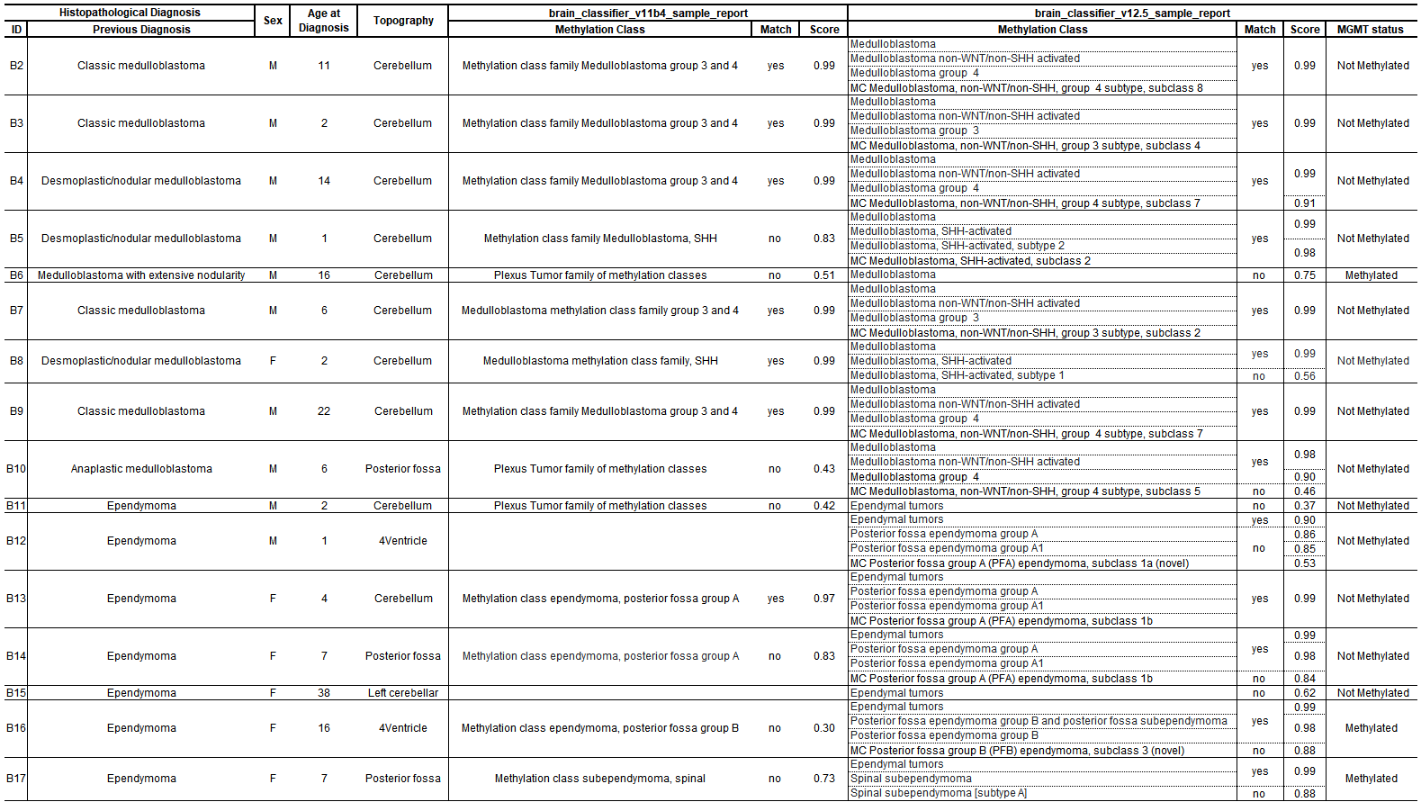
Table 2. The table contains the identification of the samples (ID), the histopathological diagnosis (previous diagnosis), the patient's sex (M) Male and (F) Female, the age at diagnosis, the location of the tumor and the classes of methylation divided according to the Classifier version. It also presents the correspondence with the platform (match) and the score obtained (score), in addition to the methylation status of the MGMT gene promoter. The classification is only valid with scores ≥0.9.

