Supplementary Figure Caption

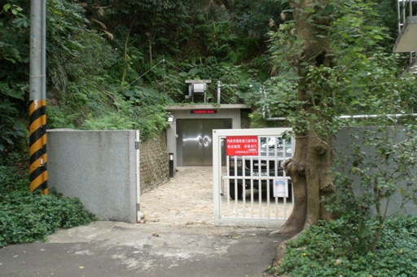
Fig. S1. The picture outside the cave at SBCB station.

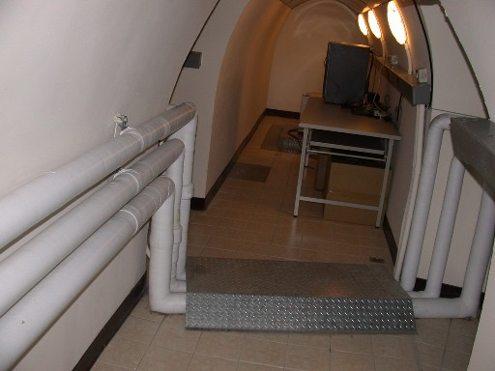
Fig. S2. The picture inside the cave at SBCB station.

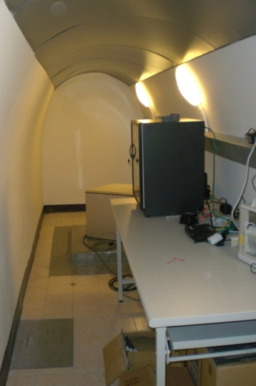
Fig. S3. The picture of the seismometer and recorders at SBCB station.

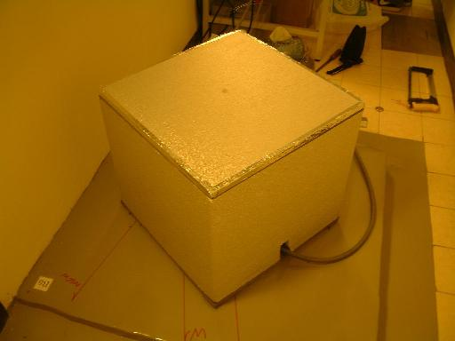
Fig. S4. The picture of the seismometer at SBCB station.

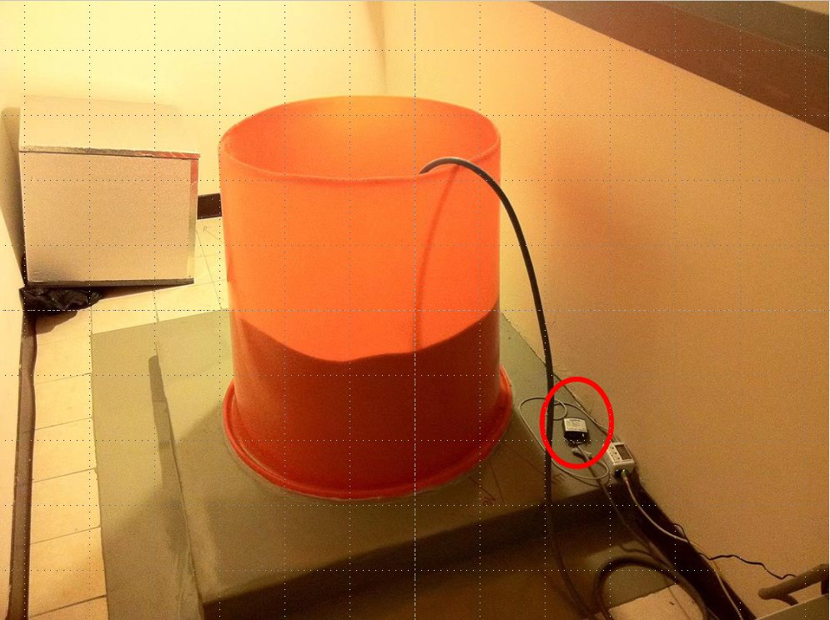
Fig. S5. The picture of the barometer at SBCB station. The barometer is located at the right side of the orange cylinder and marked by the open red circle.

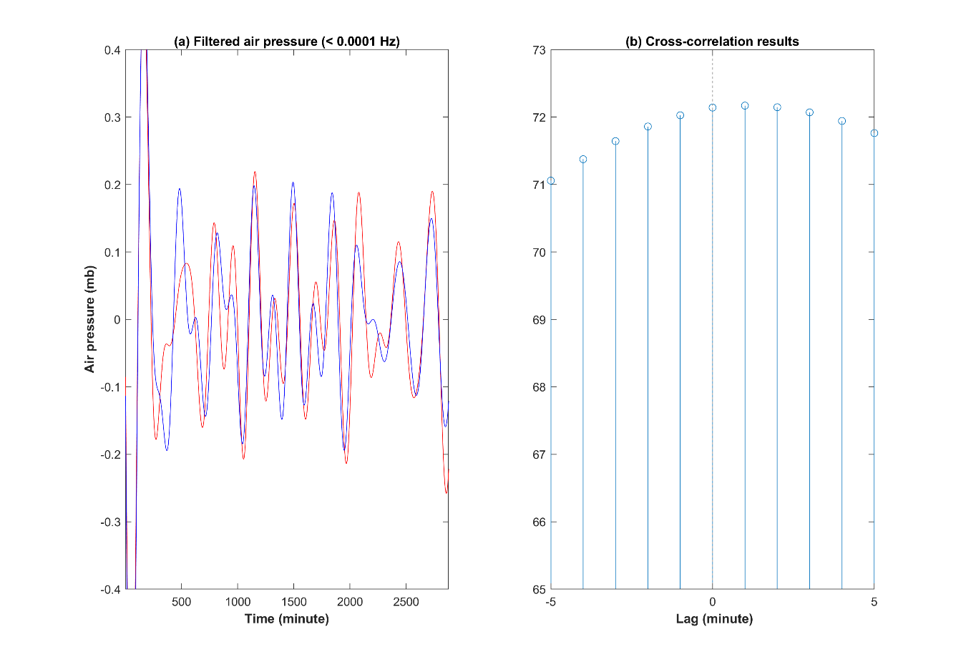
Fig. S6. The filtered air pressure data via a low pass filter and the cross-correlation results. (a) shows the filtered air pressure data through a low pass filter of 0.0001 Hz. Blue and red lines denote the filtered data at the Xinwu and SBCB stations, respectively. (b) reveals the cross-correlation results between two filtered data in (a). The maximum value can be found on the lag of 1. This suggests that the variations of the air pressure at the frequency band in the Xinwu station one-minute lead those at the SBCB station.

For the responses to the reviewer’s comments

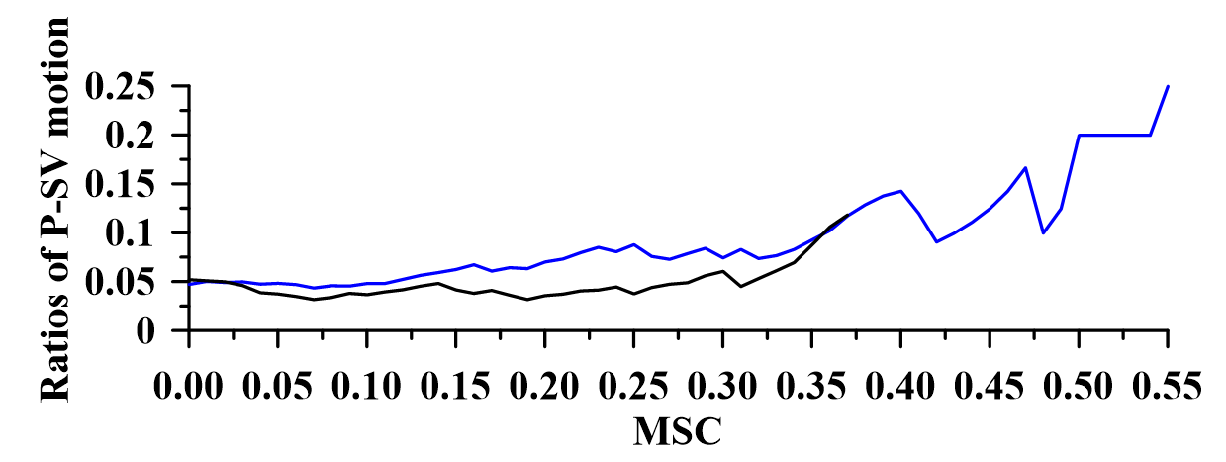
Fig. A. The ratio of P-SV motion to the total coherence greater than the set criteria. The blue and black lines denote the ratio obtained using the air pressure data at the SBCB and Xinwu stations, respectively.

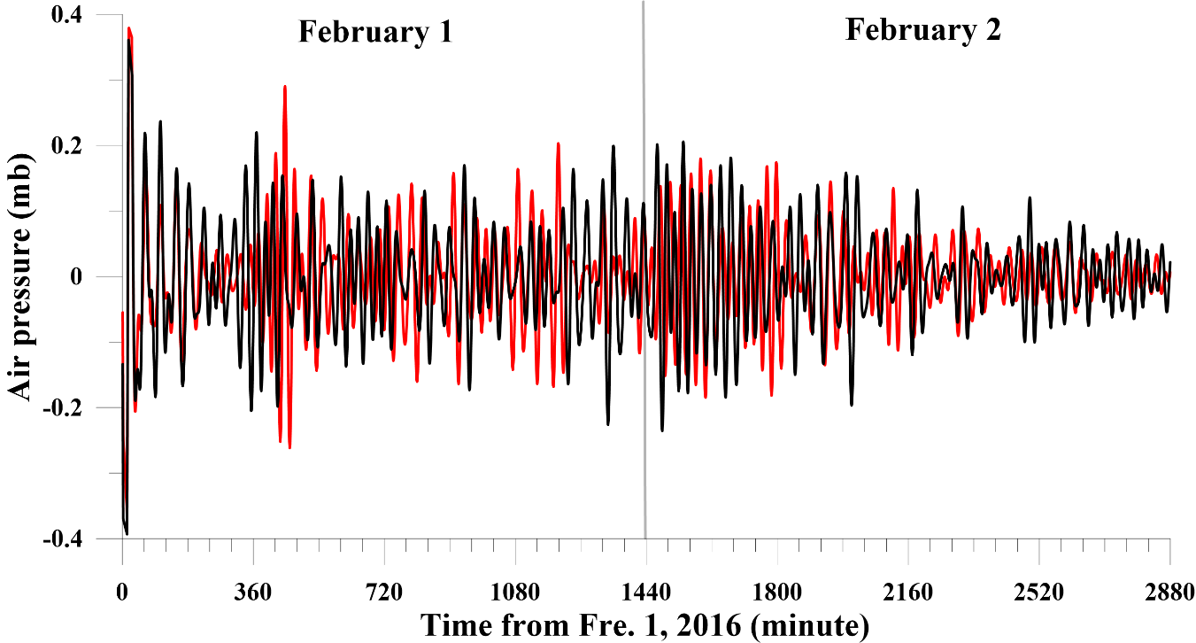
Fig. B. The filtered air pressure data at the SBCB and Xinwu station on February 1-2, 2016. The red and black lines denote the filtered air pressure data via a bandpass filter of 0.4-0.8 mHz at the SBCB and Xinwu stations, respectively.

