Supplementary Figure Caption

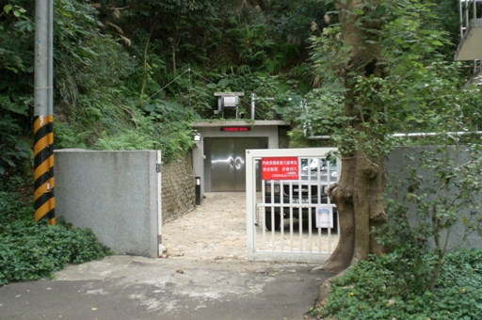
Fig. S1. The picture outside the cave at SBCB station.

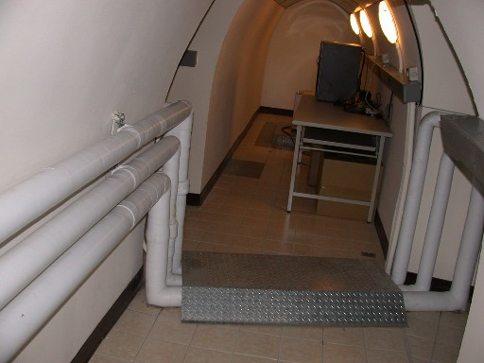
Fig. S2. The picture inside the cave at SBCB station.

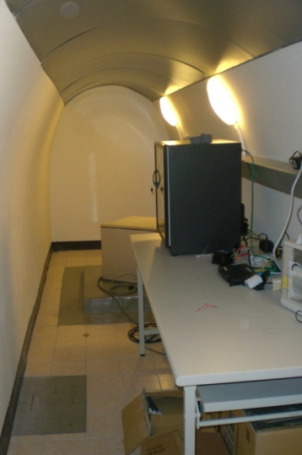
Fig. S3. The picture of the seismometer and recorders at SBCB station.

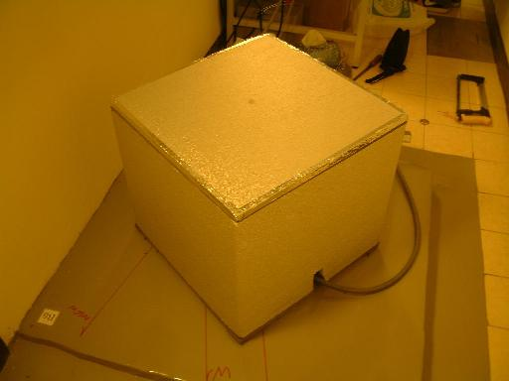
Fig. S4. The picture of the seismometer at SBCB station.

