Supplementary Text

Outlying sequences
The root-to-tip regression performed prior to phylogeographic analysis of the included sequence data showed a single outlying sequence. This was collected in 2020 in South Punjab region (PAK20-ENV-BMS422RD) and was excluded from the phylogenetic analyses as it was found to be most closely related to sequences in the Y cluster despite being previously assigned to the X cluster. This sequence was also found to be an outlier from the clock rate of 0.011 substitutions per site per year (red point in Fig. S1) estimated based on all included sequence data which is in line with previously reported WPV1 VP1 clock rates.¹⁷

AFP data alone
Figure S3 shows the reconstructed movements between regions with AFP data alone, a priori considered less biased than ES sampling which is included in the full analysis. As mentioned in the main text, ES sites are targeted to specific locations and the distribution and catchment of the sites varies across regions. Stool samples, on the other hand, are taken from AFP cases and should therefore more closely follow real-world differences in the distribution of infected individuals in space.

To assess the sensitivity of our model results to the inclusion of ES data we have also analyzed AFP samples alone. As there are fewer stool samples this results in a lower overall number of movements between regions (n = 268, 95% CrI 252-282). The patterns seen are similar to the full analysis shown in figure 2, with clear A and B clusters visible on the tree with all recent detections linked to the B cluster and, as mentioned in the main text, all recent case detections have been limited to the North Corridor AF and Central Corridor PK regions (light blue and bright pink in figure S3).

Karachi remains the largest exporter of virus in this analysis (n = 65, 95% CrI 40-82), with the same major exporting regions for the most part (Fig. S3C) as in the main analysis (Fig 1G). The major importers also remain the same, although the largest importer without ES data is determined to be the North Corridor Pk region. The major change in these movement estimates is the East Pk region, which reports a large number of ES positive detections but rarely reports paralysis cases. This region goes from a major importer and exporter of virus in the main analysis, playing a major role in movement from northern to southern regions during outbreak periods (Fig. 2) to a minor importer and sink region with very few onwards transmissions in this analysis. This highlights the additional utility of ES data when attempting to reconstruct the movement of poliovirus, where paralysis is a very rare outcome (and therefore contacts of paralysis cases are also rare). Incorporating the biases in ES data in future analyses would be of interest to reconstructing corrected movement rates between regions.

Correcting for biased sampling of AFP cases
Although sampling of AFP cases is considered less biased than sampling of ES due to the severity of the outcome leading to healthcare-seeking behavior, there is evidence from non-polio AFP cases that there is still differential reporting across the region (Fig. S5). Non-polio AFP cases, expected to be recorded at a rate of at least two per 100000 people per year in endemic countries to meet WHO reporting guidelines, are paralysis cases not found to be due to polio in testing.^{58,59} This background rate of non-polio paralysis cases should give an indication of the sensitivity of polio monitoring systems to detect paralysis in the population, without the confounding factor of differential polio transmission between regions. Although not a perfectly unbiased metric, due to other (non-polio) infectious causes of paralysis which may be differentially transmitted, this measure is routinely used as an indicator of AFP surveillance performance by the WHO.^{60–62} To test the impact of differences in sampling between regions, we adjust the sampling probabilities at the tips of the phylogeny in a simple discrete trait framework. This process is explained in a preprint (Jorgensen et al. 2023) and is implemented in BEAST using existing methods.^{20,40,63} Adjusting for non-polio AFP rates, averaged (mean) over the full time-period covered by the data and normalized to sup to 1 across regions, led to minor differences compared to the uncorrected model. The main differences were the increase in estimated exports from the city of Karachi to other regions and decreased exportations from the north corridor region. All corrected movement estimates fell within the 95% CrIs of the uncorrected estimates. This method could be expanded in the future to account for sampling changes over time in each region with an epoch model although further testing is required to ensure the correction is robust to these changes.

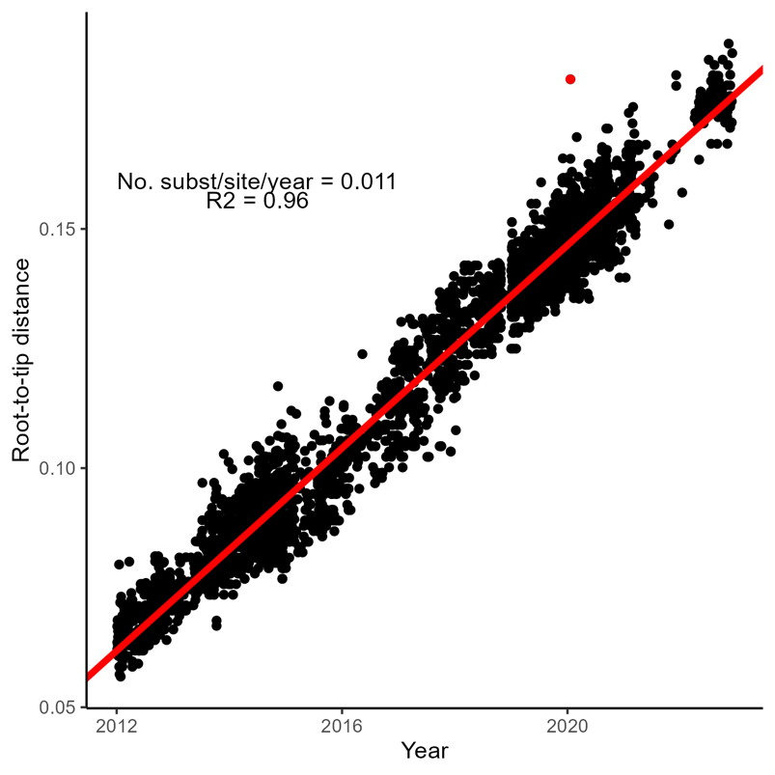

Fig. S1.
Regression of root- to-tip distance on sampling time for the included poliovirus VP1 sequences. The linear trend and high R2 value suggest that these data are consistent with a strict molecular clock at a substitution rate which aligns with previous reporting. The outlying point highlighted in red was excluded from further analysis.

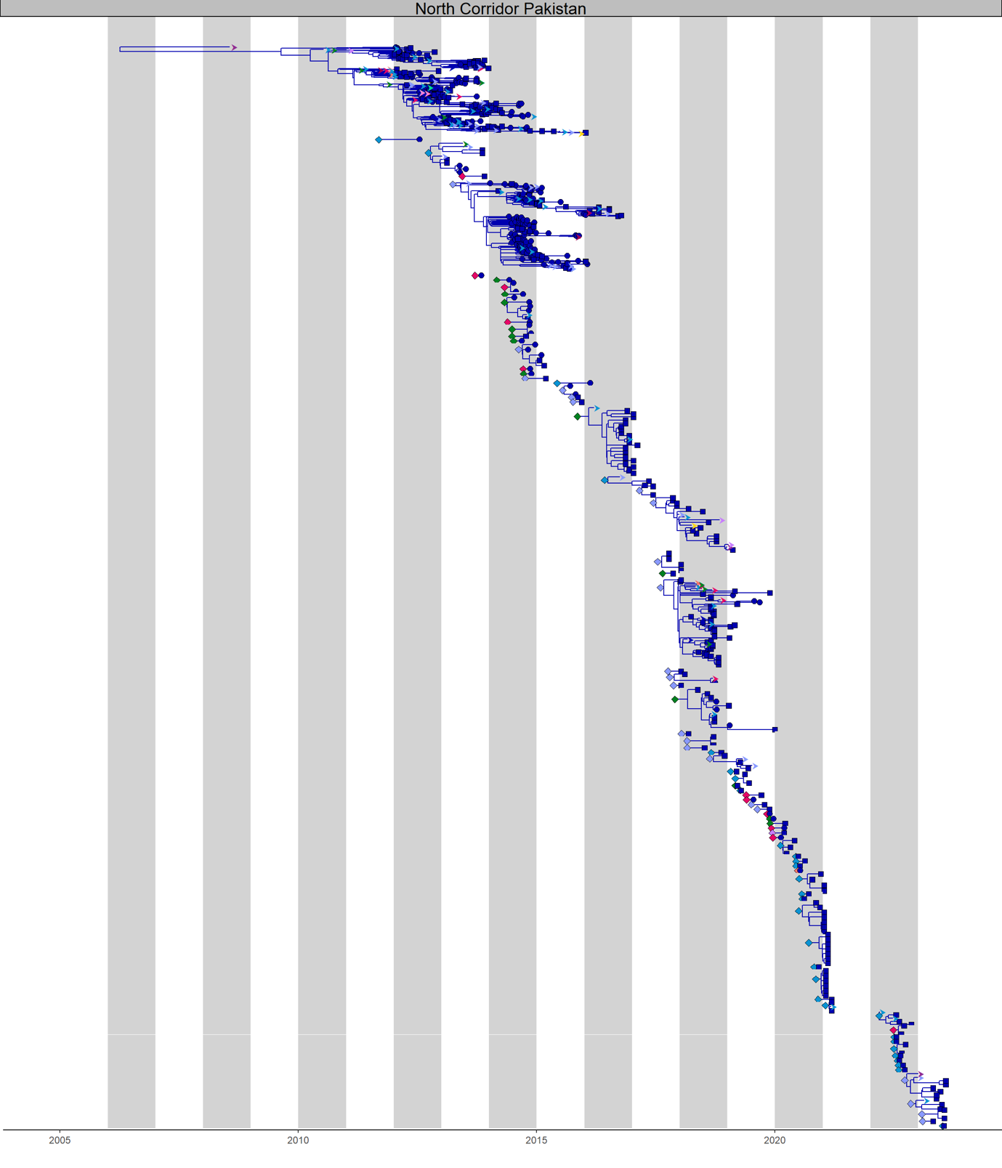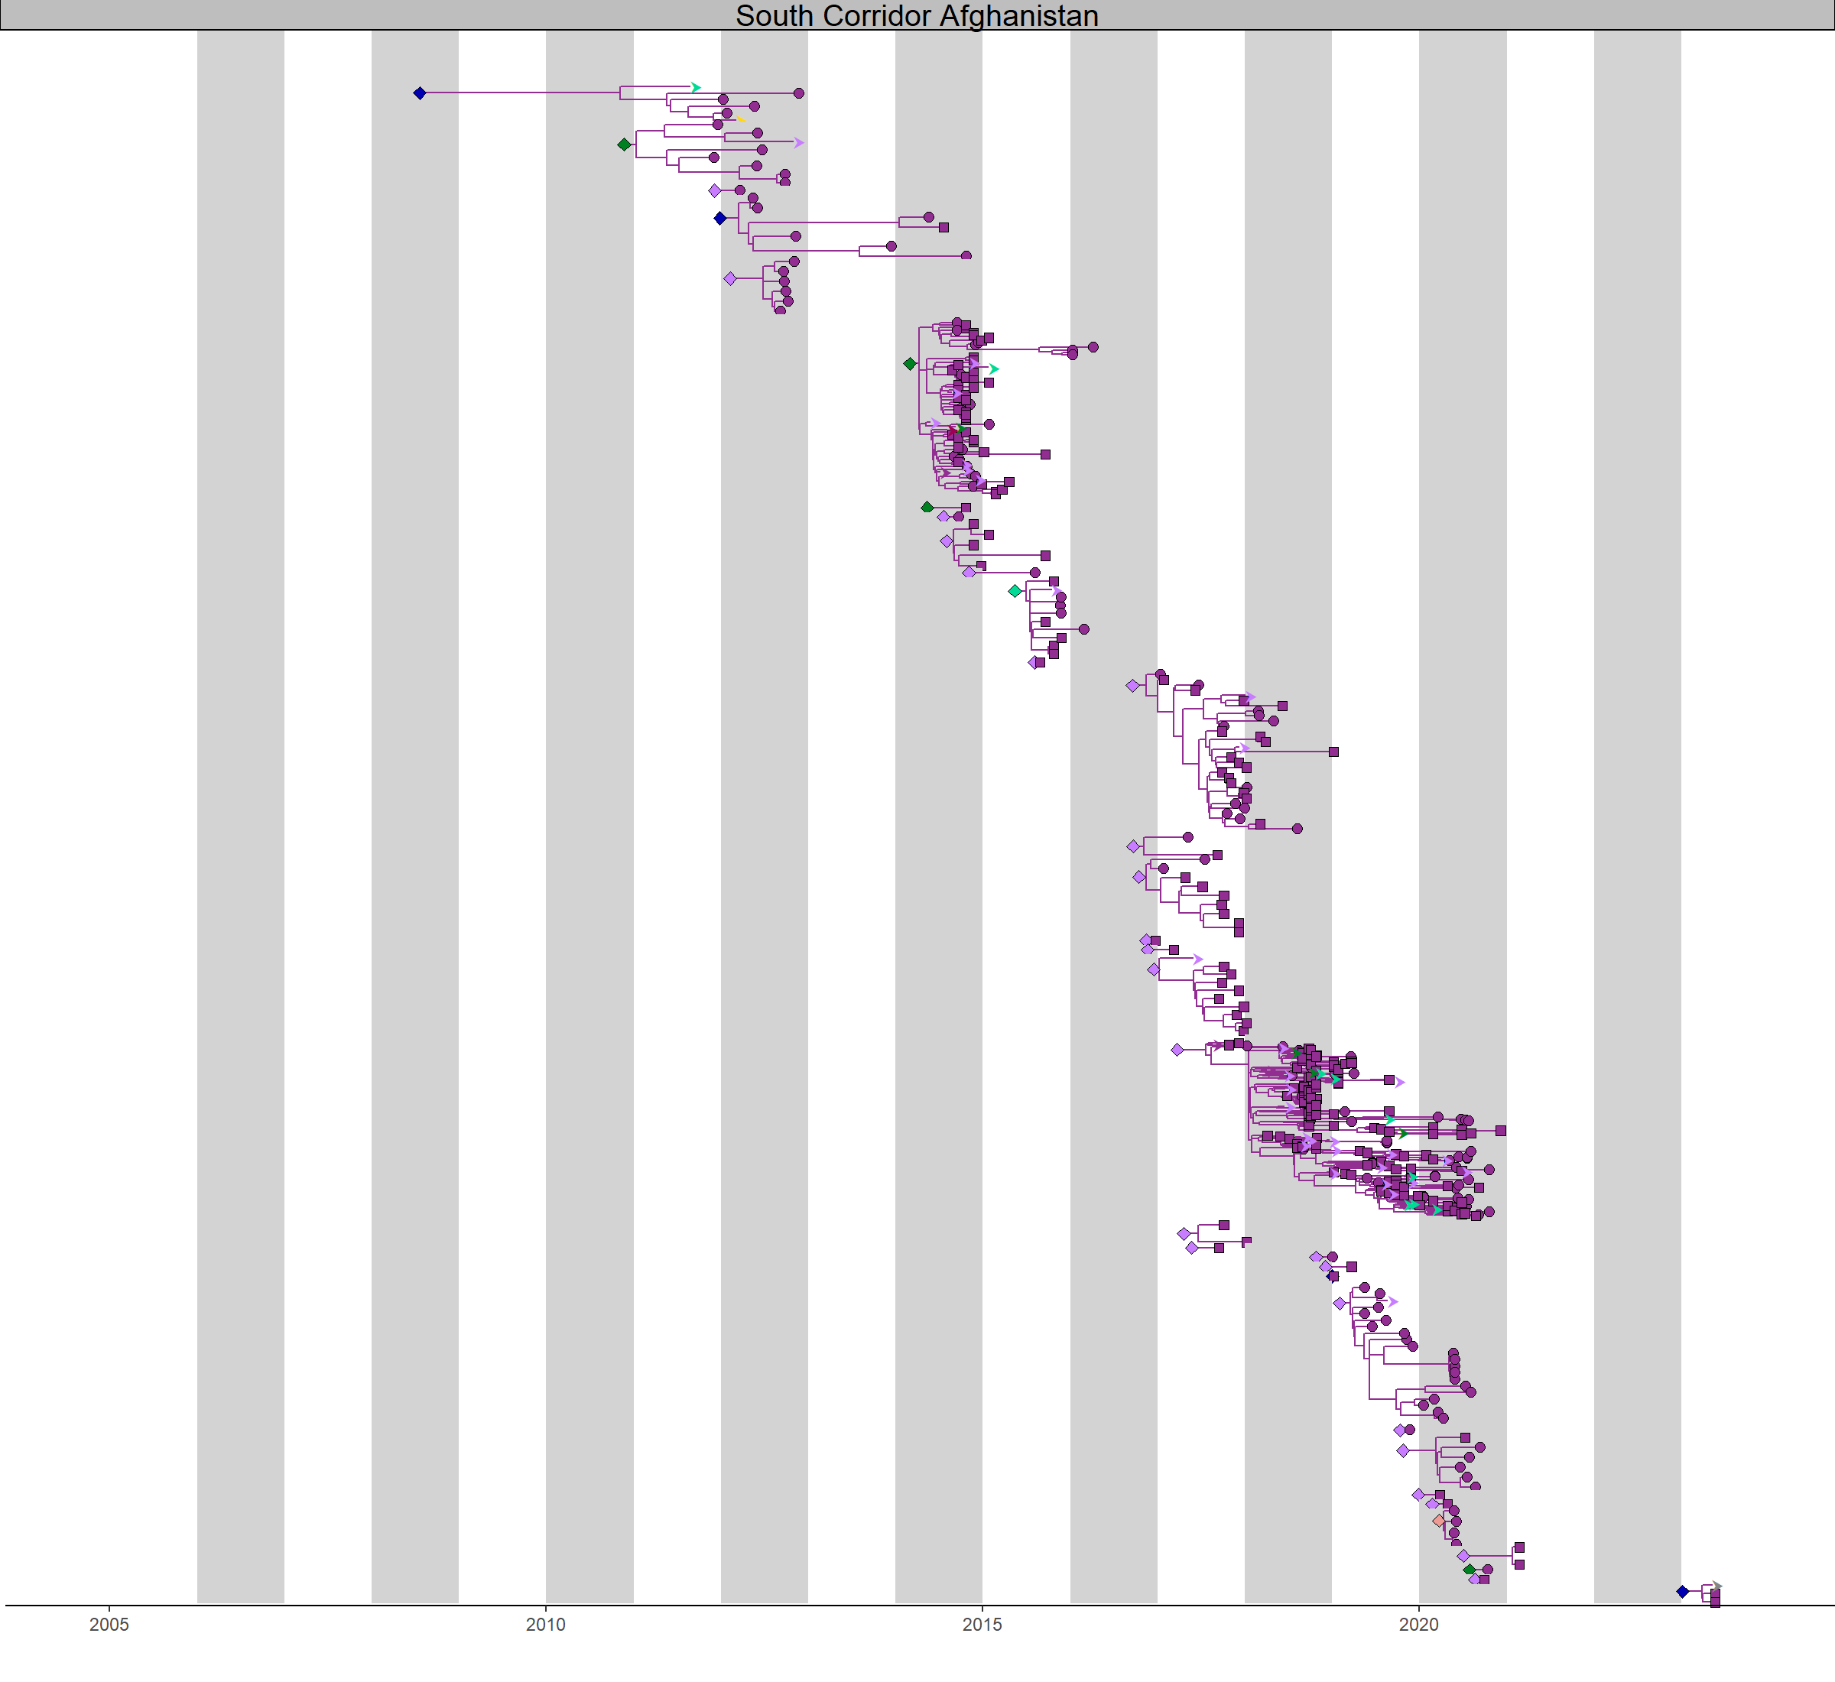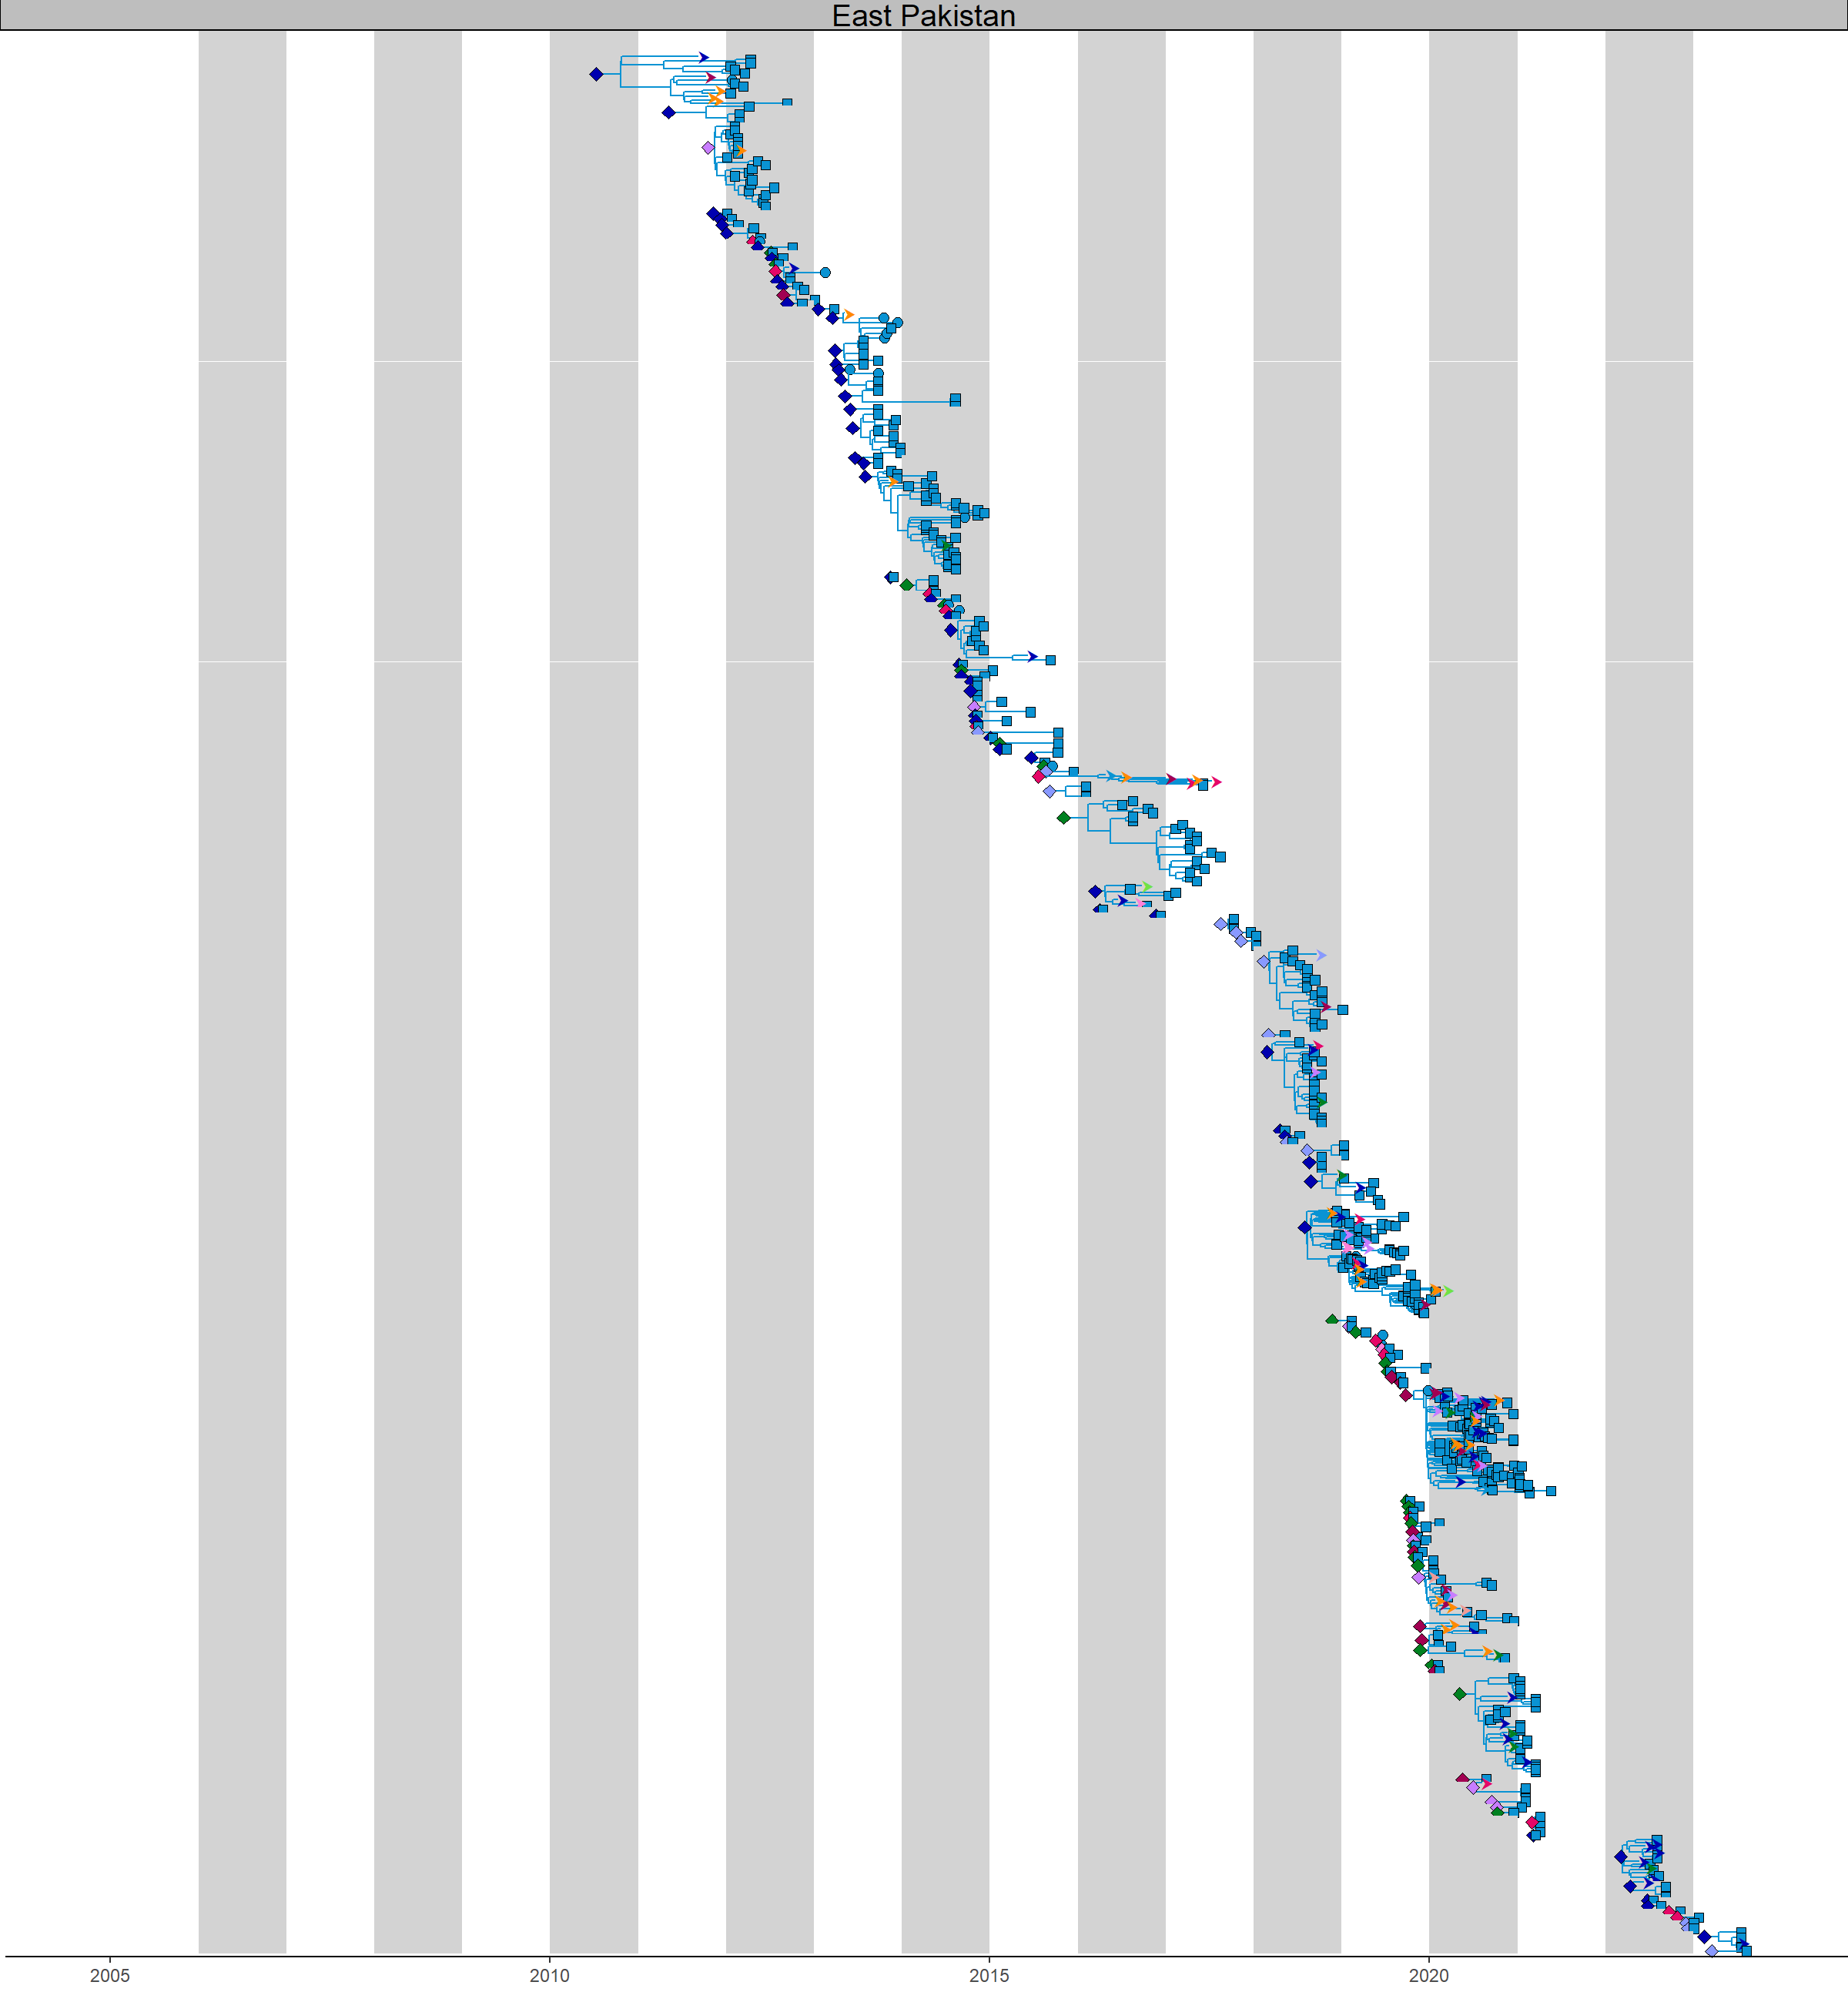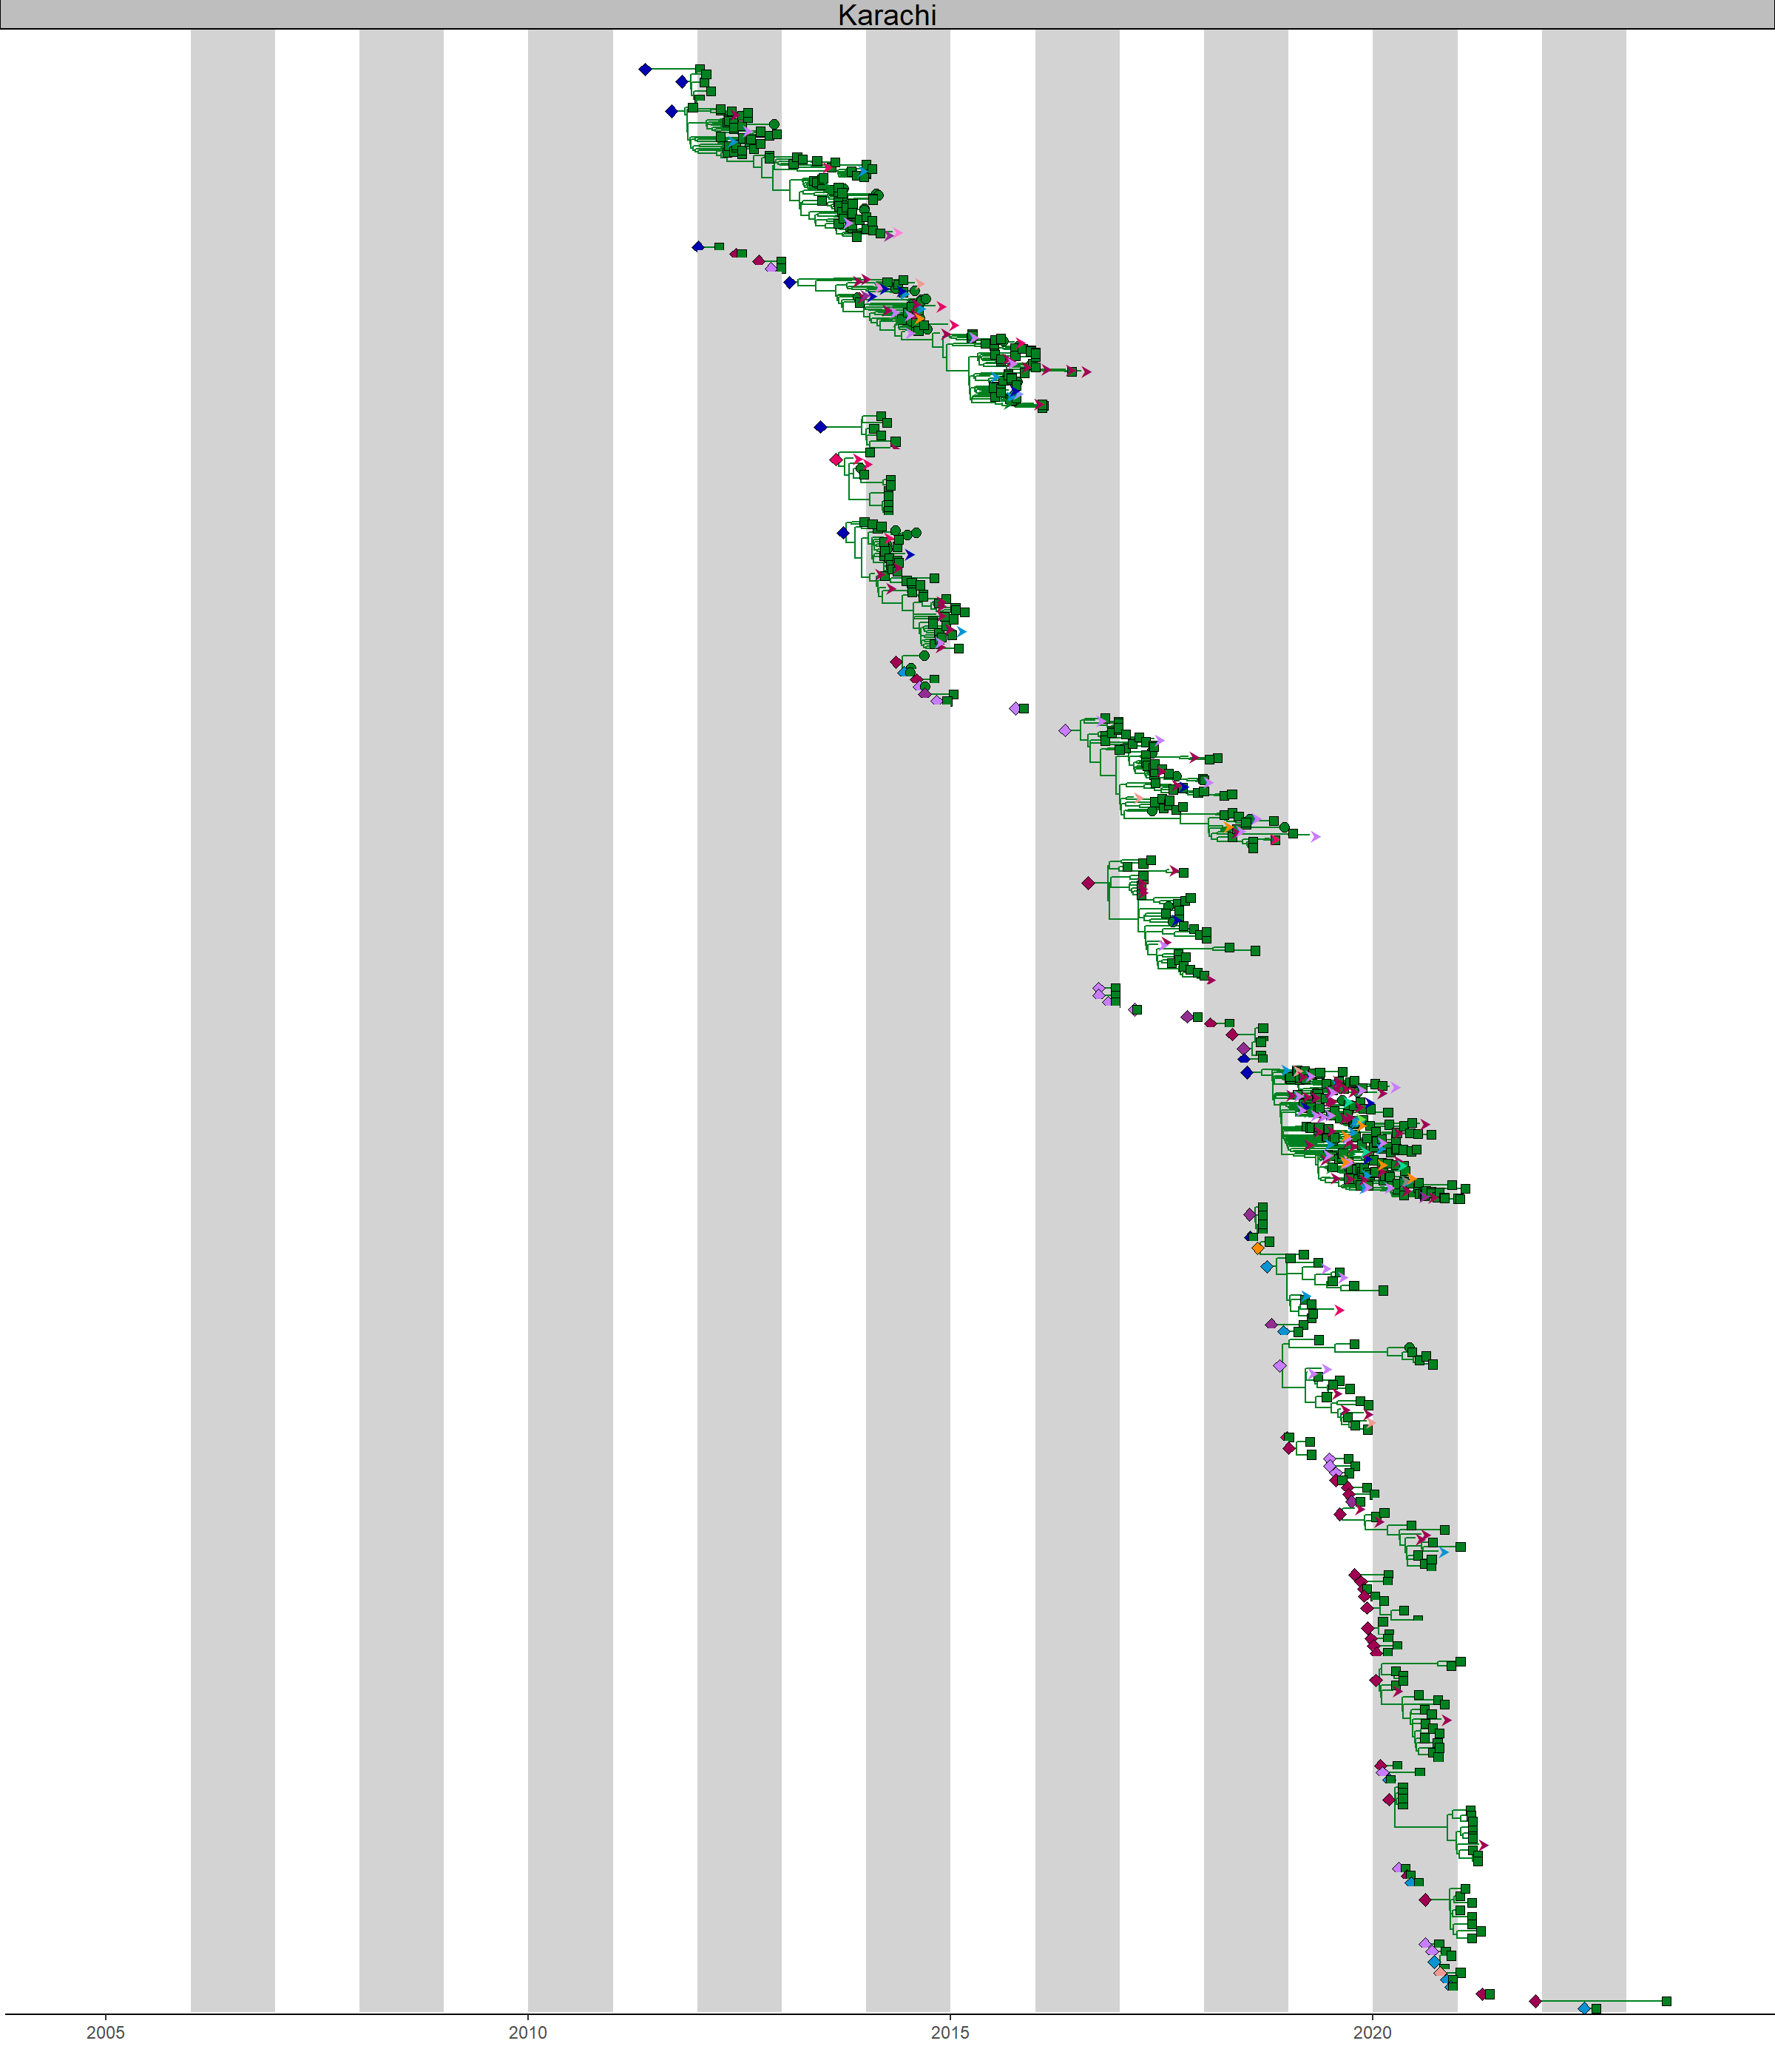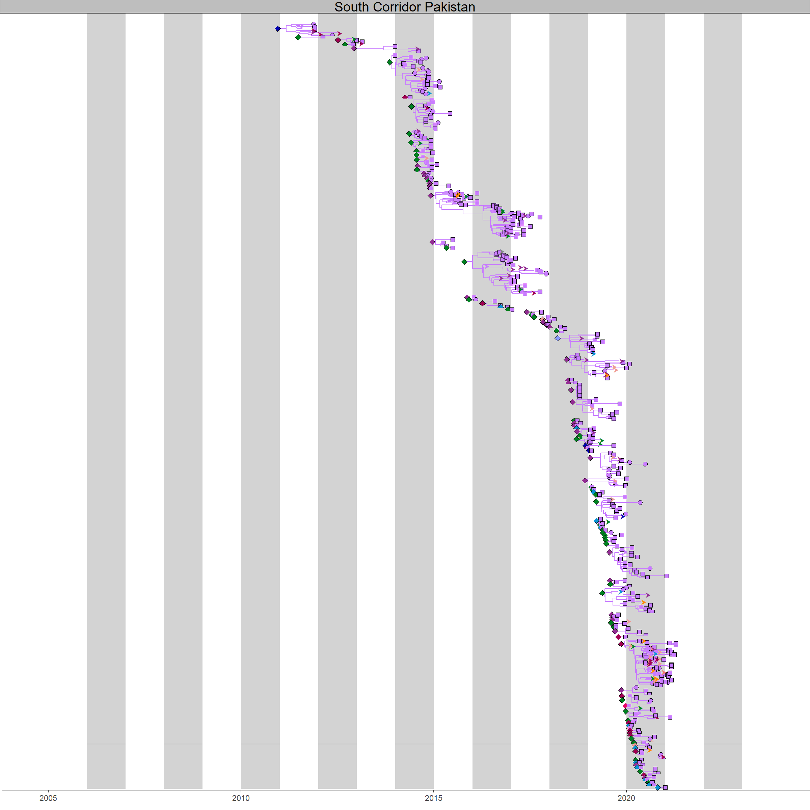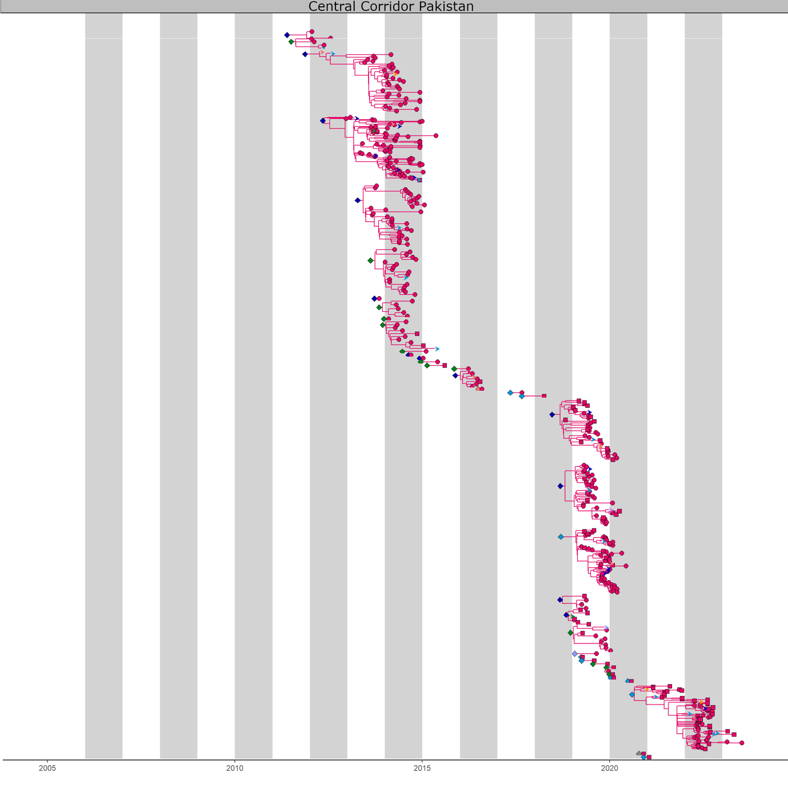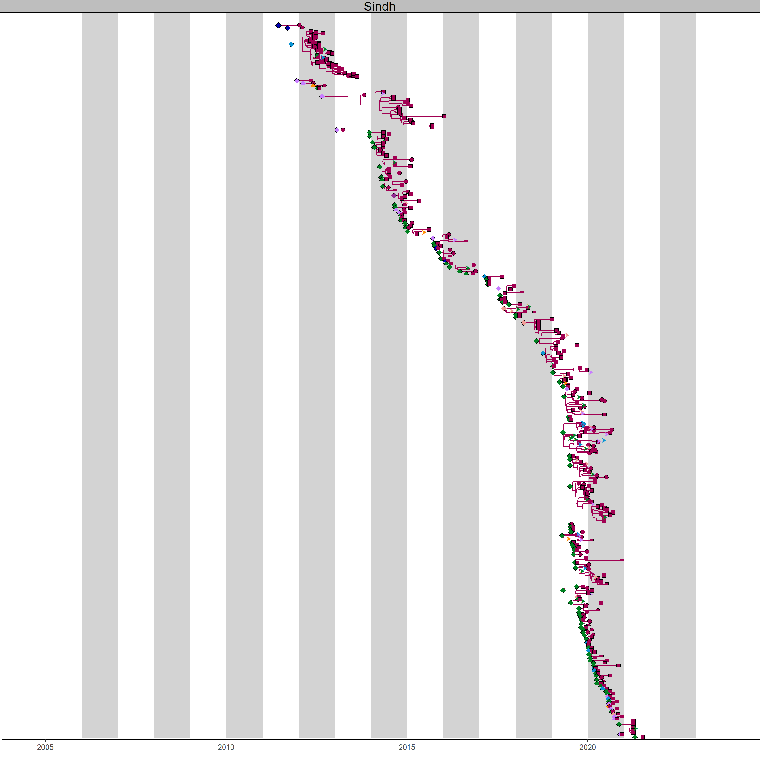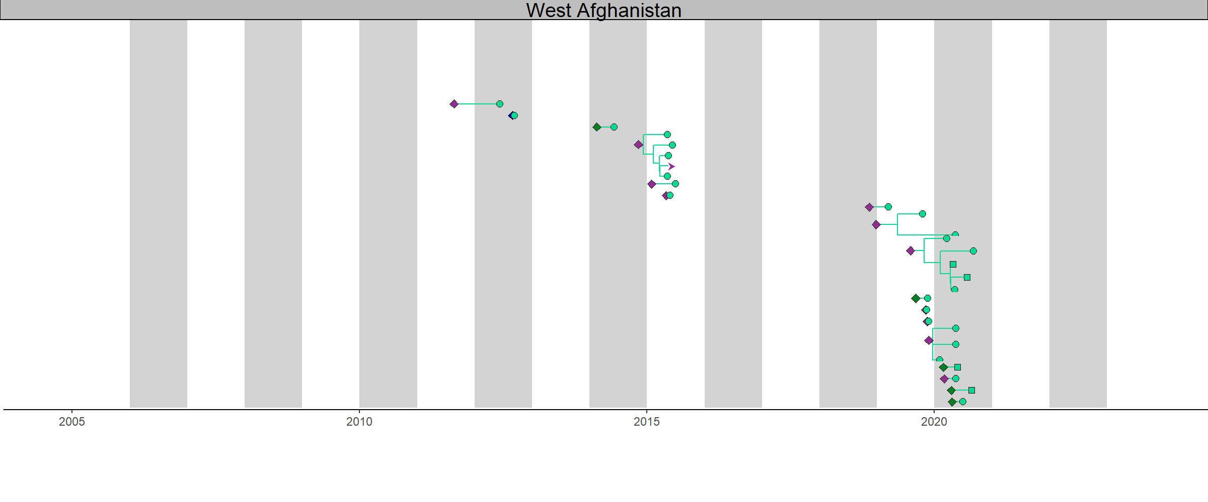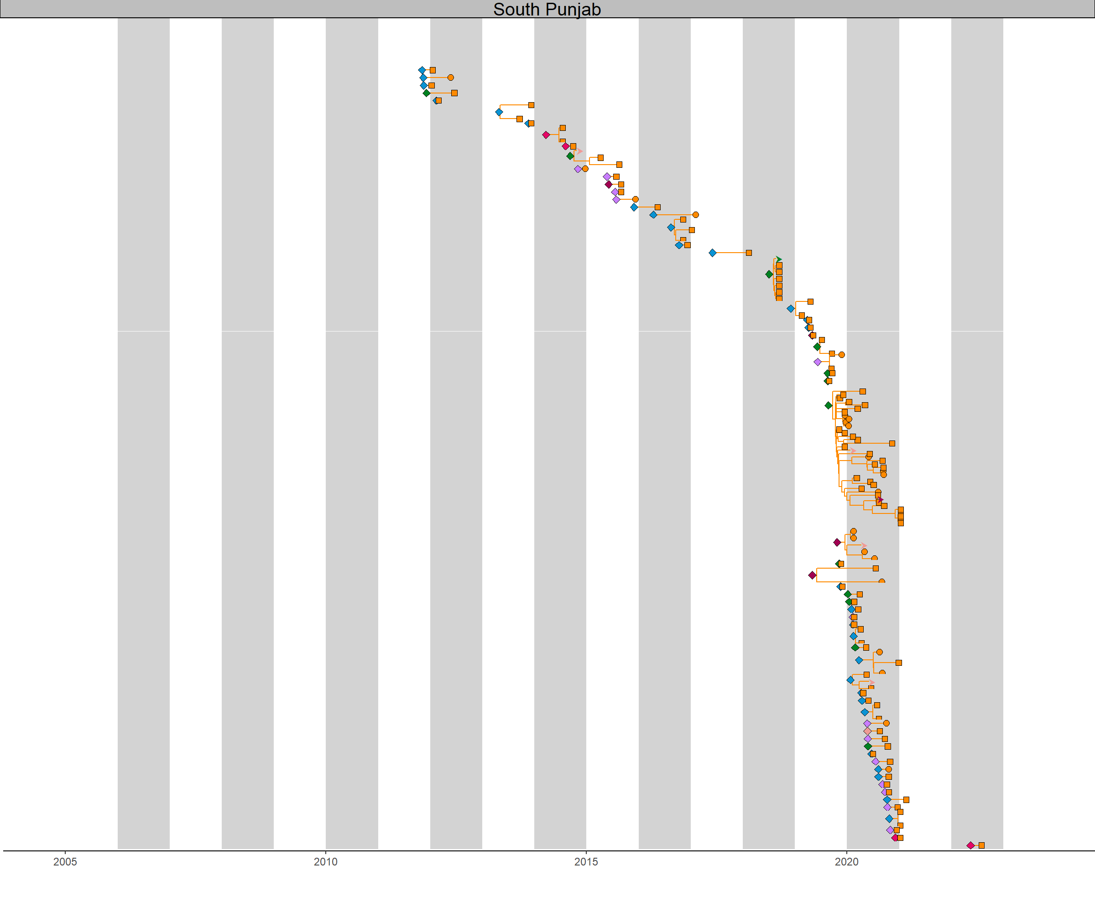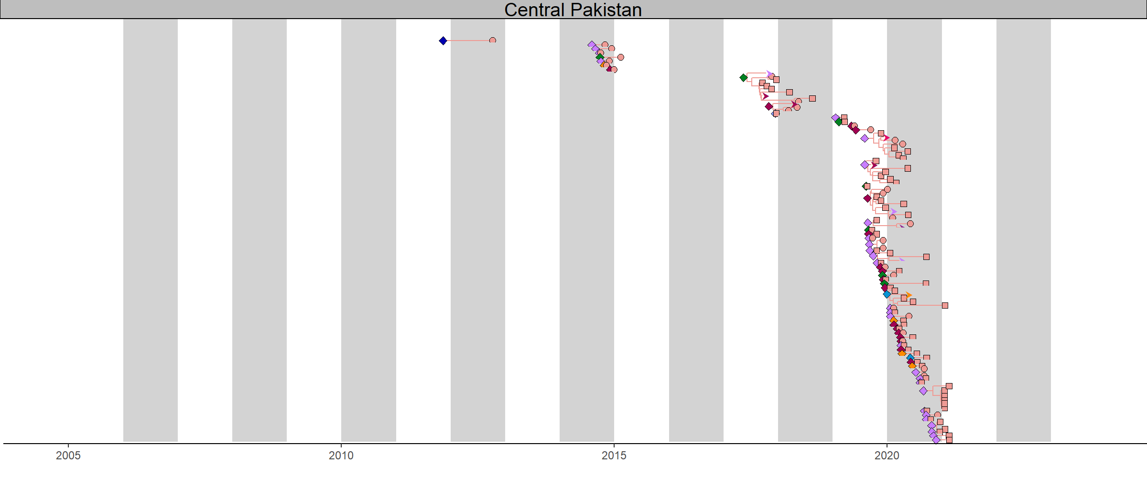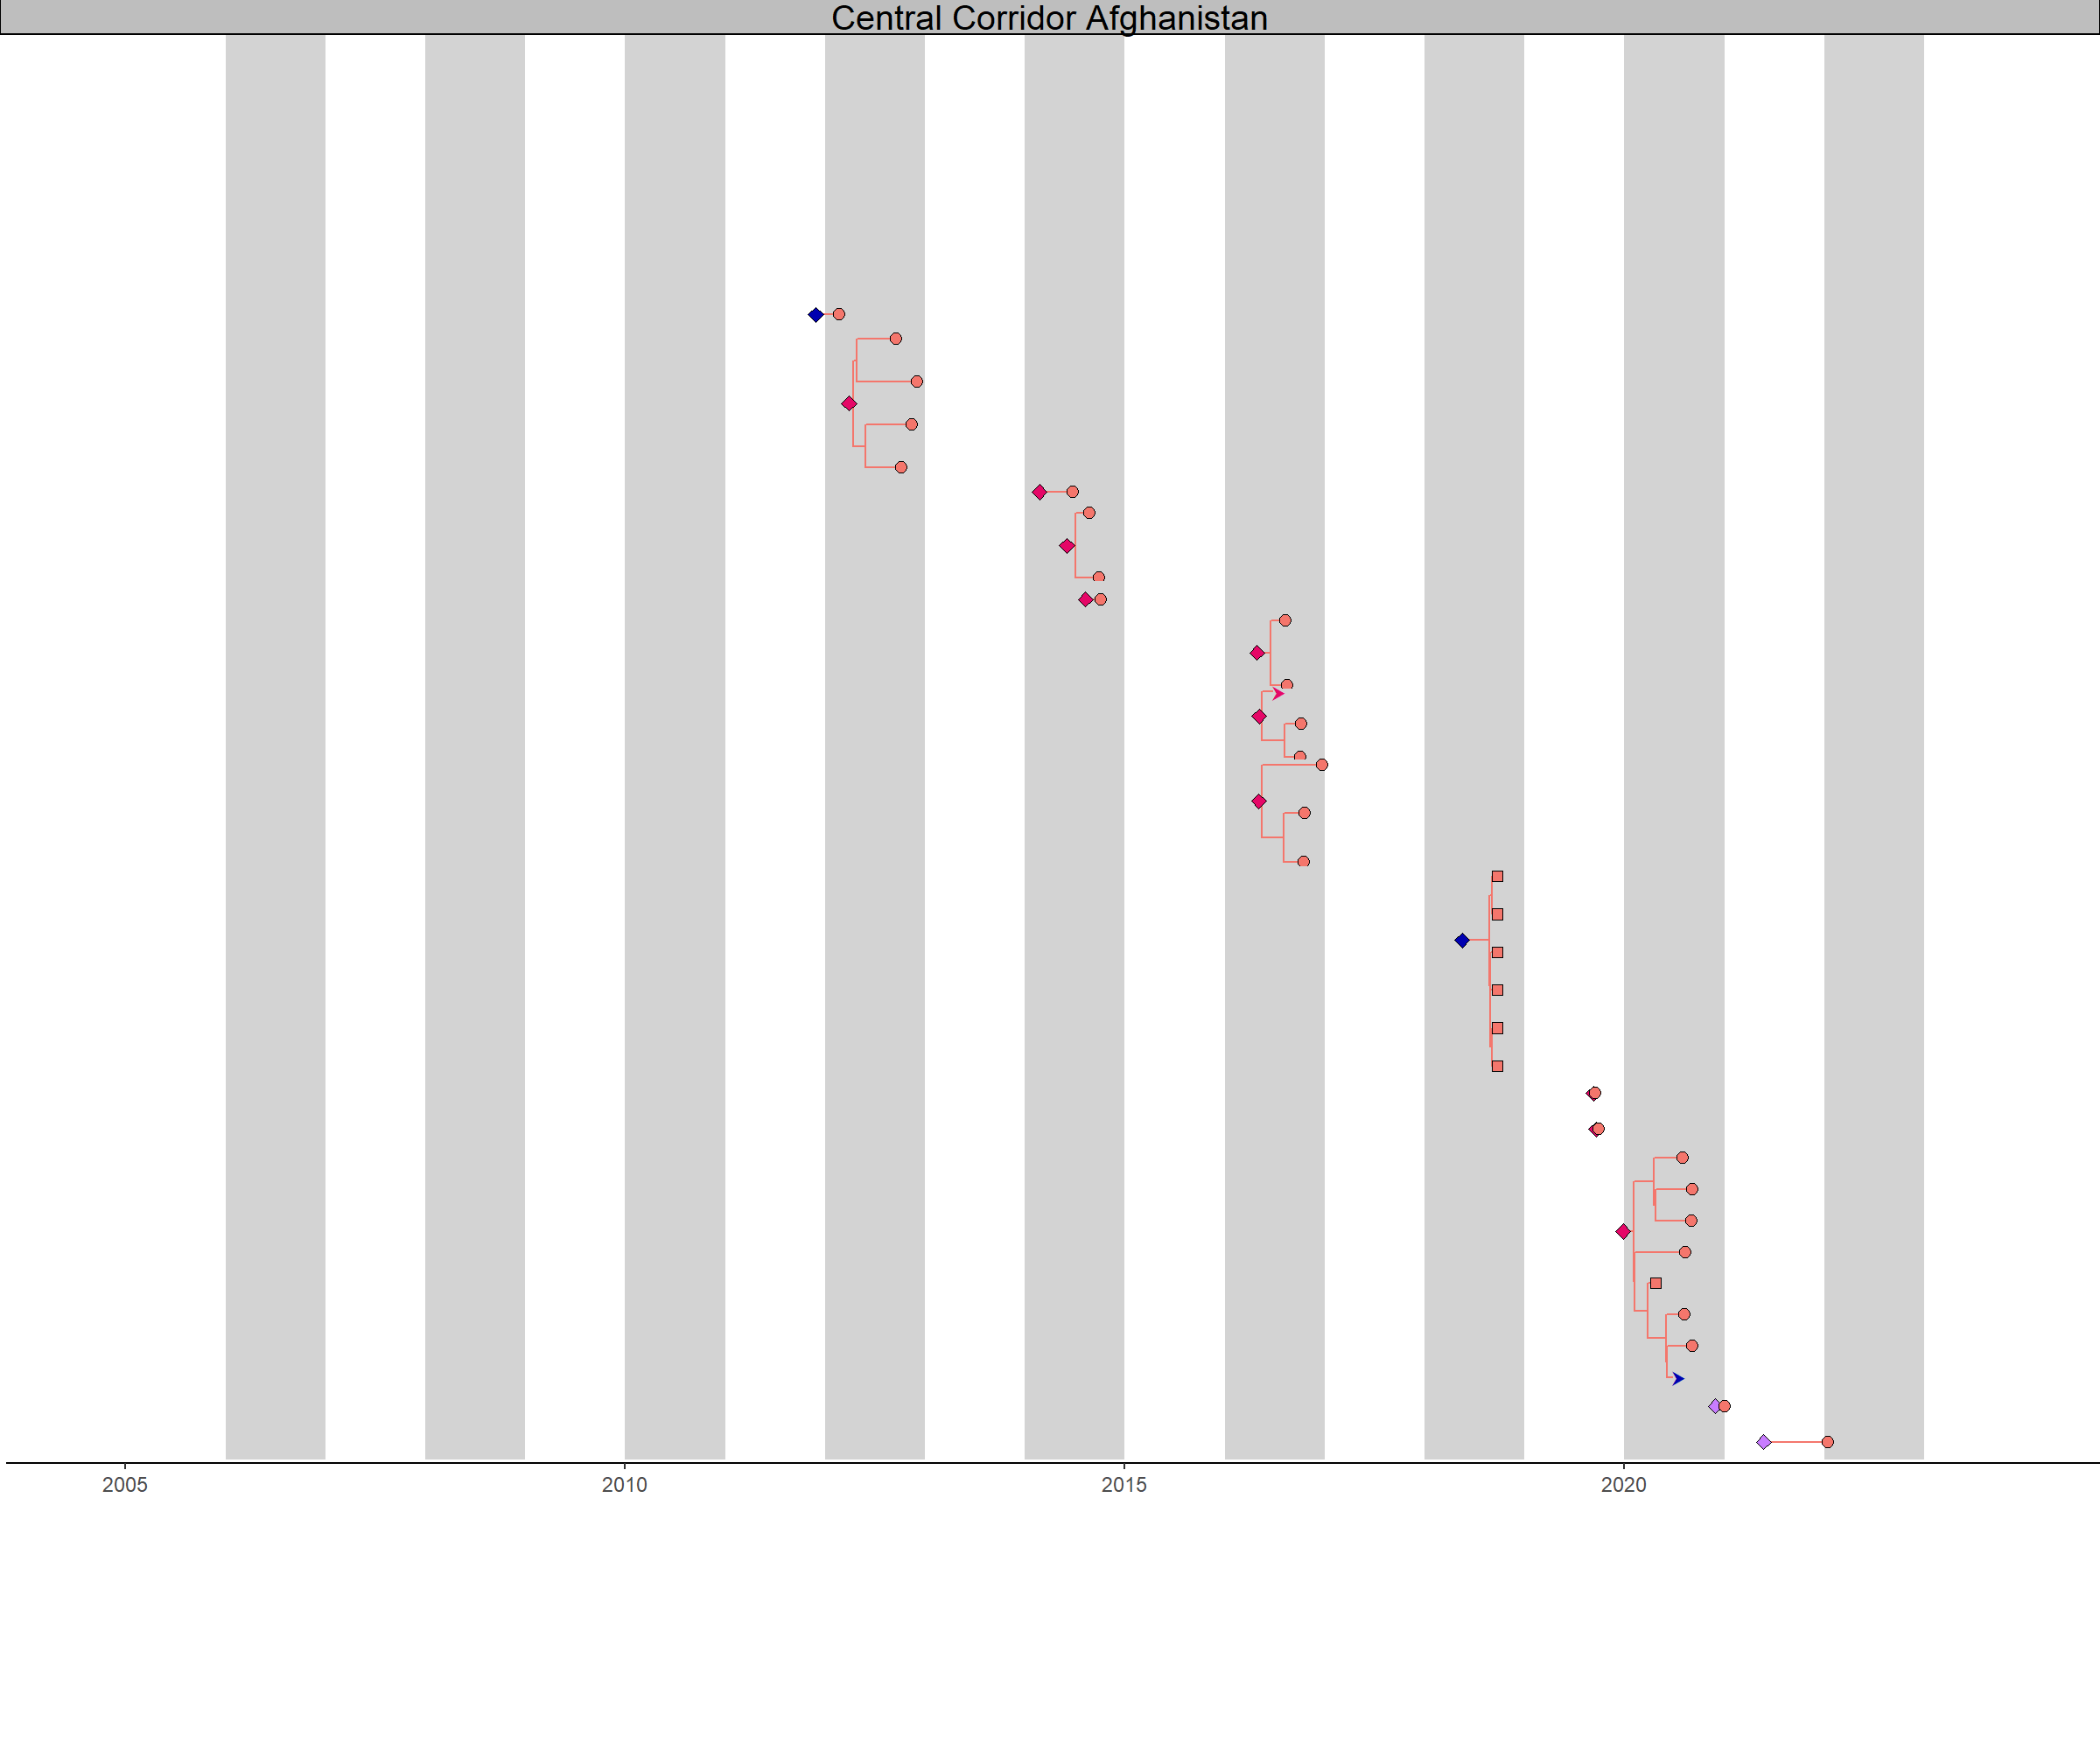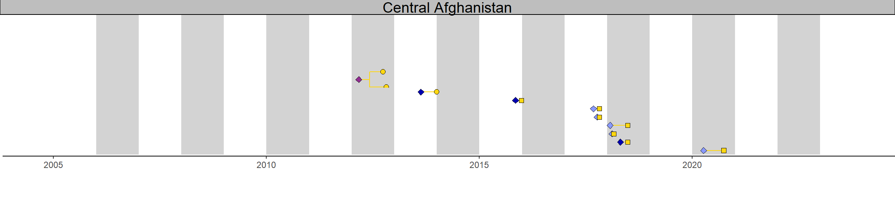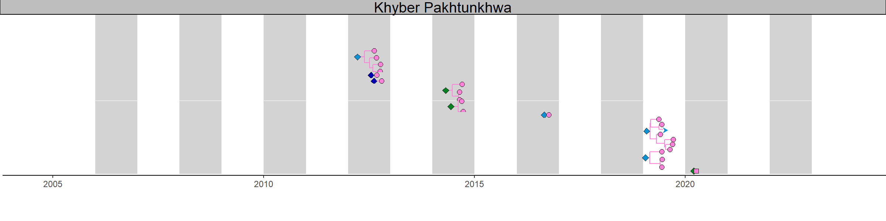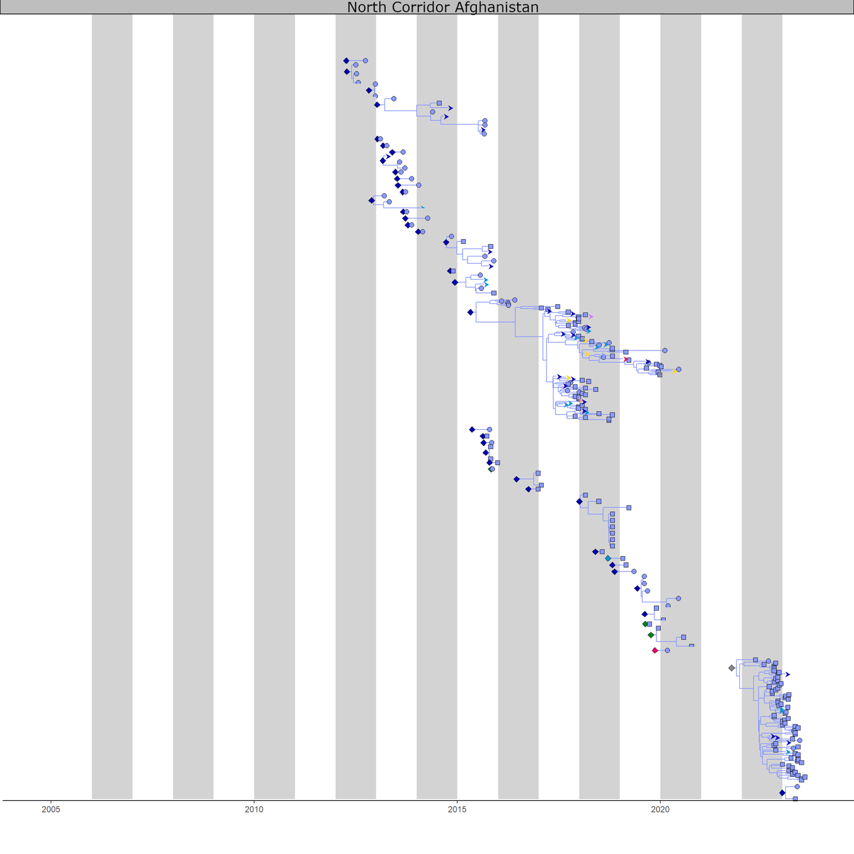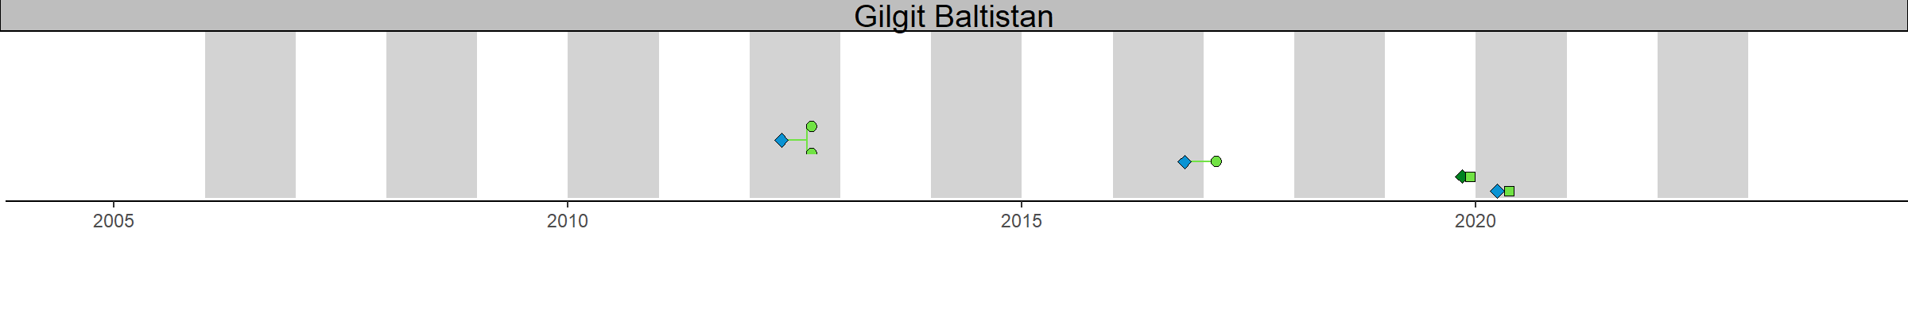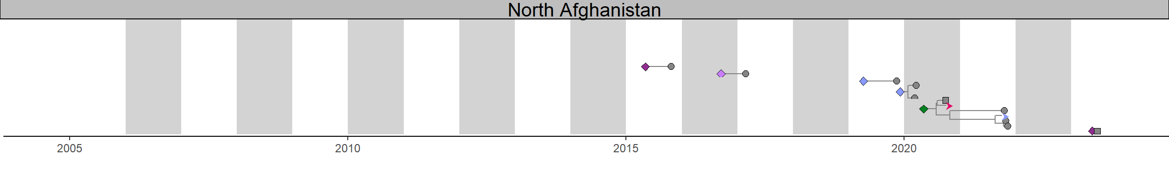Fig. S2.
Example time-resolved phylogenetic tree of the full dataset split by regions. Here we present the inferred movements on the consensus phylogeny from figure 2, producing one set of LTL plots. In the full analysis this is carried out for a set of posterior phylogenies. A new lineage is plotted after each inferred virus movement between regions. The tips represent sequenced viruses, with round tips representing virus isolates from AFP cases and square tips isolations from ES. The root of each lineage is annotated with a diamond colored according to the inferred ancestral location. As the time of the virus movement from one region to the other cannot be precisely inferred, the ancestral location is plotted at the mid timepoint of the ancestral branch. Where a lineage leads to onwards transmissions in another region, this is shown with a branch leading to an arrow colored by the region exported to.

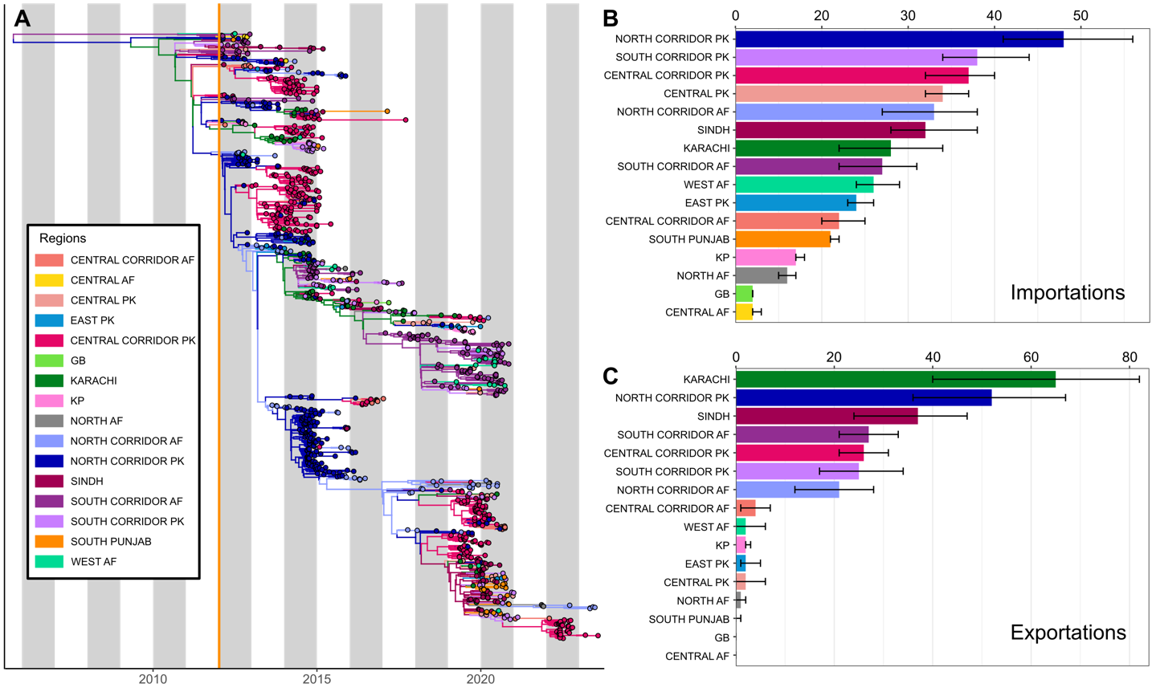

Fig. S3.
A) Phylogenetic tree of stool samples collected between January 2012 and August 2023. The vertical orange line represents the time of the first collected sequence. Branches and internal nodes are colored by their inferred location and tips by their known location. B) Inferred number of importations of virus by region over the full time period. C) Inferred numbers of exportations of virus by region over the full time period. Error bars on B and C represent the 95% credible interval of the estimated number of movements⁴³.

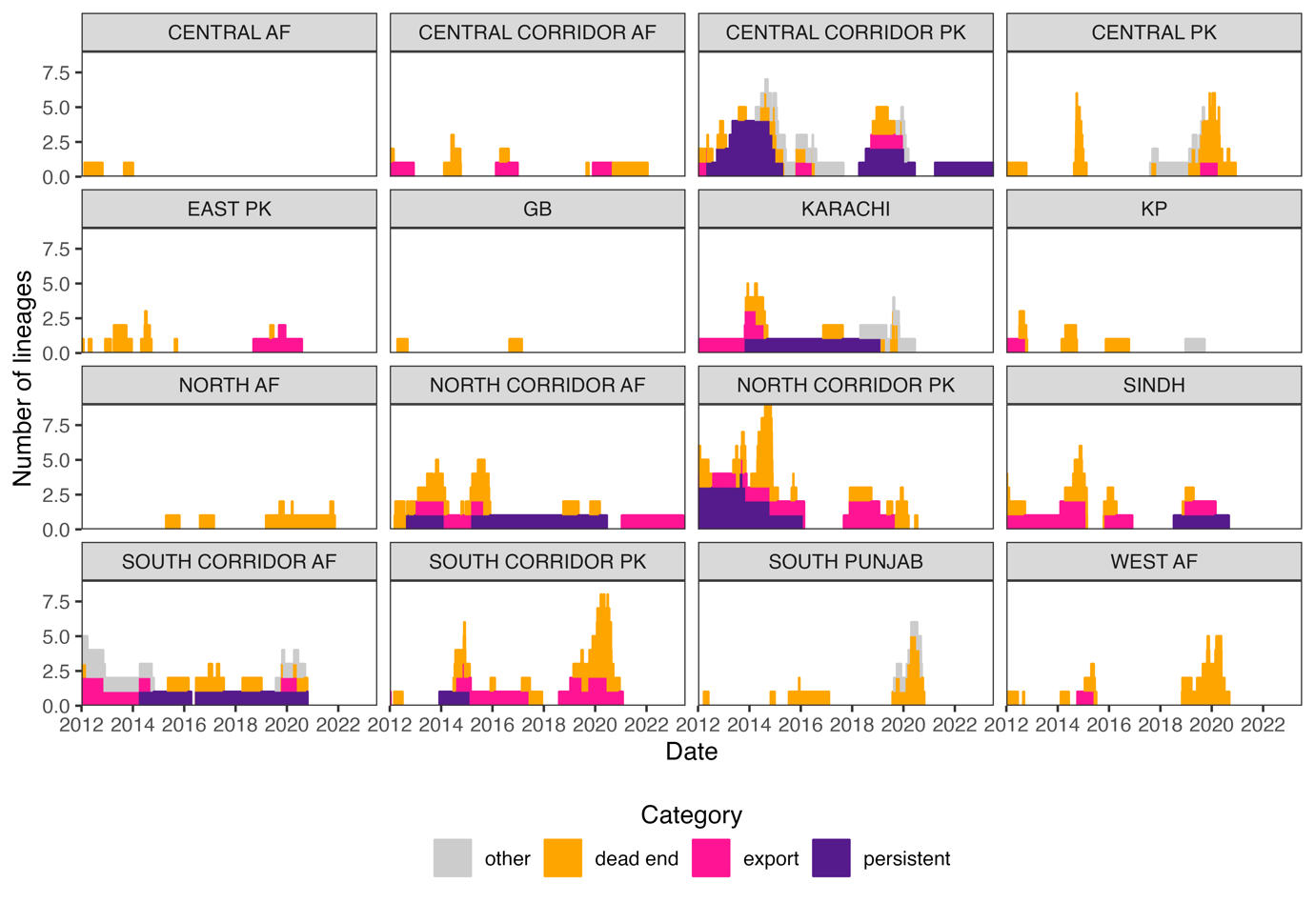Fig. S4.
Median numbers of LTLs in each category over time using AFP data alone. Panels are split by the region in which the LTLs are reported. An example of how these lineages are generated and classified is provided in figure 4.

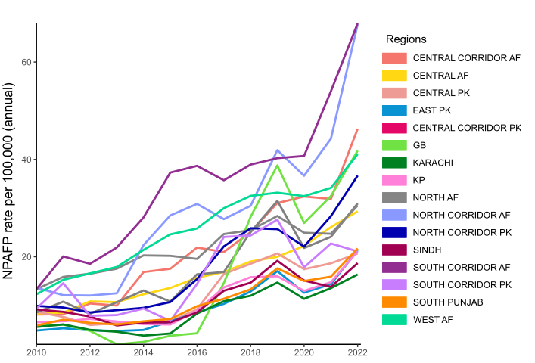

Fig. S5.
Annual non-polio acute flaccid paralysis (NPAFP) rate between 2012 and 2022 across the 16 regions of the polio endemic Pakistan-Afghanistan block. Estimates of population by age group and gender from worldpop.org for 2020 are aggregated to give a denominator of all children under the age of 15 in each region⁴³. Annual NPAFP cases in each region from the POLIS database were divided through by the number of children under the age of 15 measured in 100,000s to calculate the NPAFP rate⁹.

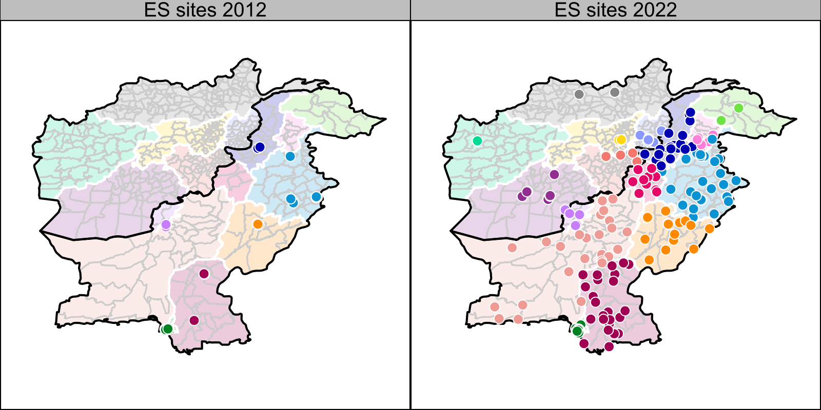

Fig. S6.
The number of environmental surveillance sites reporting samples in the calendar years 2012 and 2022 colored by region. The locations are approximate to the centroid of the district in which a site is located if definite coordinates are not available. This data is extracted from the POLIS database⁹.

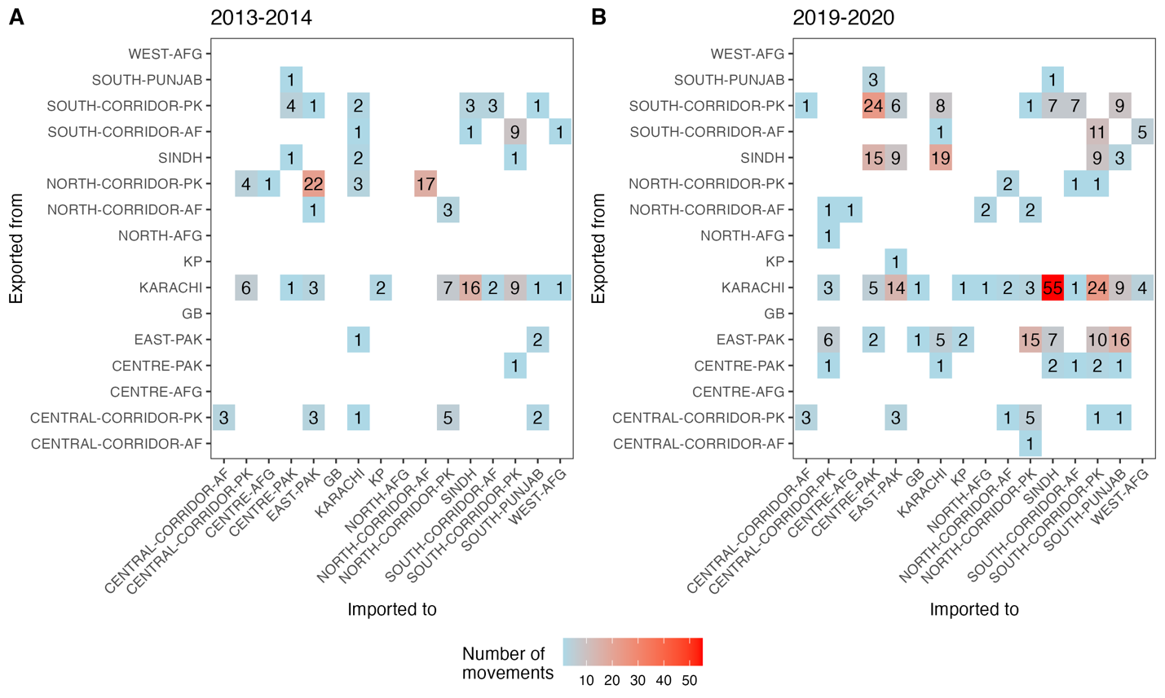

Fig. S7.
Inferred movement events between regions during the A) 2013 to 2014 and B) 2019 to 2020 outbreak periods based on the reconstruction of most likely ancestral regions with sequence data from stool and ES samples using discrete trait analysis. This is an alternative representation of the data plotted in figure 2 of the main text.

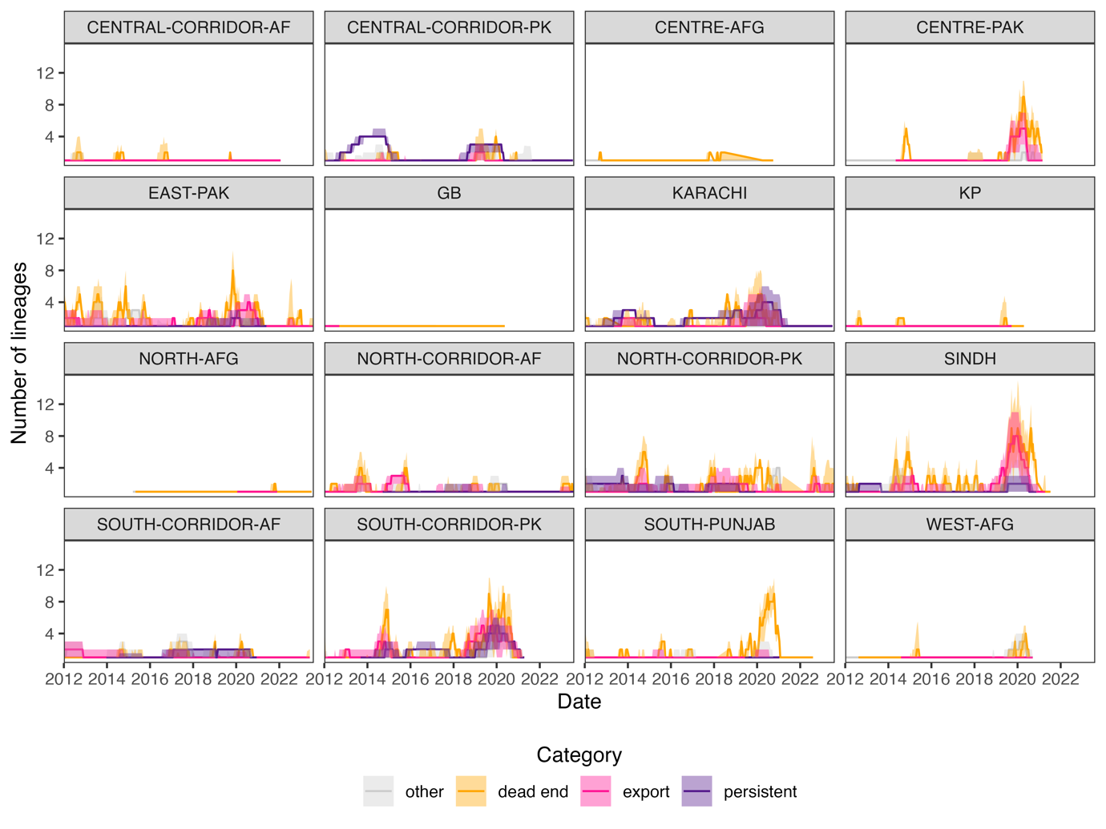

Fig. S8.
Median and 95% credible intervals for the number of LTLs falling into each classification across 300 phylogenies sampled from the posterior of the MJ Bayesian analysis. Median values and the method to designate these categories are shown in figure 4. Figure S2 shows an example set of LTLs on the consensus phylogeny from the same MJ analysis.

Table S1.
Location and sample type metadata for included VP1 sequences. One additional stool sequence was removed from South Punjab as it was an outlier from the molecular clock. Two sequences could not be matched to metadata so were not included in the analysis.

Region | ES | Stool | Total
Central Corridor Af | 7 | 26 | 33
Central Af | 7 | 3 | 10
Central Pk | 67 | 32 | 99
East Pk | 512 | 22 | 534
Central Corridor Pk | 86 | 326 | 412
GB | 2 | 3 | 5
Karachi | 592 | 53 | 645
KP | 1 | 21 | 22
North Af | 2 | 8 | 10
North Corridor Af | 143 | 63 | 206
North Corridor Pk | 357 | 236 | 593
Sindh | 252 | 75 | 327
South Corridor Af | 236 | 145 | 381
South Corridor Pk | 360 | 58 | 418
South Punjab | 99 | 22 | 121
West Af | 4 | 23 | 27
Total | 2727 | 1116 | 3843

