SUPPLEMENTARY INFORMATION
Insights into the use of cytochrome bc₁ inhibitors for future therapeutic strategies for tuberculosis

Clara Aguilar Pérez^{1,*}, Anne J. Lenaerts², Cristina Villellas¹, Jerome Guillemont³, John Dallow⁴, Hannah Painter⁴, Nicole C. Ammerman^{5,6}, Anis Hassan⁴, Guillaume Golovkine⁷, Laure Brock⁷, Sylvie Sordello⁷, Aurélie Chauffour⁸, Alexandra Aubry⁹, Thi Cuc Mai⁸, Sarah Wong⁸, Taane G. Clark⁴, Kiyean Nam¹⁰, Jeongjun Kim¹⁰, Jinho Choi¹⁰, Marjolein Crabbe¹¹, Jorge Esquivias¹², Nacer Lounis¹, Bart Stoops¹¹, Katie Amssoms¹¹, Jose M. Bartolome-Nebreda¹², Veronica Gruppo², Gregory T. Robertson^{2,13}, Nicolas Veziris⁹, Anna Upton¹⁴, Eric L. Nuermberger⁵, Vivian Cox¹, Lluis Ballell¹, Benny Baeten¹, Anil Koul^{1,4}, Alexander S. Pym¹⁵, Richard J. Wall⁴, Dirk A. Lamprecht^{1,*}
¹Janssen Global Public Health, LLC, Janssen Pharmaceutica NV, Turnhoutseweg 30, 2340 Beerse, Antwerpen, Belgium
²Mycobacteria Research Laboratories, Department of Microbiology, Immunology and Pathology, Colorado State University, Fort Collins, Colorado 80521, USA
³Janssen Infectious Diseases Discovery, Janssen-Cilag, Val de Reuil, France.
⁴Department of Infection Biology, Faculty of Infectious and Tropical Disease, London School of Hygiene and Tropical Medicine, London, WC1E 7HT, UK
⁵Center for Tuberculosis Research, Department of Medicine, Johns Hopkins University, Baltimore, MD, USA
⁶Erasmus MC, University Medical Center Rotterdam, Department of Medical Microbiology and Infectious Diseases
⁷Evotec, 195, Route D’Espagne, 31100, Toulouse, France
⁸Sorbonne Université, INSERM, Centre d'Immunologie et des Maladies Infectieuses, U1135, Paris, France
⁹Sorbonne Université, INSERM, U1135, Centre d'Immunologie et des Maladies Infectieuses, (Cimi-Paris), APHP Sorbonne Université, Department of Bacteriology Hôpital Pitié-Salpêtrière, Centre National de Référence des Mycobactéries et de la Résistance des Mycobactéries aux Antituberculeux, Paris, France
¹⁰Qurient Co. Ltd. C-dong 801, 242, Pangyo-ro, Bundang-gu, Seongnam-si, Republic of South Korea
¹¹Janssen Research & Development, LLC, Janssen Pharmaceutica NV, Turnhoutseweg 30, 2340 Beerse, Antwerpen, Belgium
¹²Global Discovery Chemistry, Janssen-Cilag, S.A., c/ Jarama, 75A, 45007 Toledo, Spain
¹³Consortium for Applied Microbial Metrics, Aurora, Colorado, USA.
¹⁴Evotec US inc., 303B College Road East, Princeton, New Jersey, 08540, USA.
¹⁵Janssen Global Public Health, LLC, Janssen Pharmaceutica, 50-100 Holmers Farm Way, High Wycombe, HP12 4DP, UK

Supplementary Tables

Supplementary Table S1: Profiling of JNJ-2901- and JNJ-4052-resistant strains against other cytochrome bc₁ inhibitors and selected clinical compounds – MIC₅₀ values (µM) against other compounds from the series and clinical compounds with fold difference from the starting parental strain shown in brackets. Resistance strains were generated in a cytochrome bd knockout (ΔcydAB; Rv1622 and Rv1623) background in the presence of 100x MIC₉₀ of JNJ-2901 and JNJ-4052. Key resistance mutations shown for each strain.

 | MIC₅₀, µM (fold change)
 | Parent (ΔcydAB) | JNJ-2901-R1 | JNJ-2901-R2 | JNJ-4052-R1 | JNJ-4052-R2 | JNJ-4052-R3 | JNJ-4052-R4 | JNJ-4052-R5
 | Parent (ΔcydAB) | QcrB; A317V | QcrA; L356W | QcrB; A317T | QcrA; L356W | QcrB; A317T | QcrB; T313A | QcrB; A317V
JNJ-2901 | 0.01 | 1.02 (160) | 1.02 (159) | 0.05 (7) | 1.05 (165) | 0.06 (10) | 2.99 (469) | 0.93 (146)
JNJ-4052 | 0.01 | 19 (2717) | 2.3 (324) | 0.41 (57) | 2.46 (344) | 0.51 (71) | 14 (2067) | 6.14 (860)
Q203 | 0.01 | 0.75 (148) | 0.84 (165) | 0.03 (6) | 0.38 (75) | 0.04 (8) | 1.06 (209) | 0.66 (131)
BDQ | 0.05 | 0.04 (1) | 0.03 (1) | 0.02 (0.5) | 0.04 (1) | 0.04 (1) | 0.10 (2) | 0.02 (0.5)
RIF | 0.1 | 0.11 (1) | 0.03 (0.5) | 0.02 (0.25) | 0.04 (0.5) | 0.06 (1) | 0.12 (1) | 0.01 (0.25)
INH | 0.51 | 0.46 (1) | 0.54 (1) | 0.27 (0.5) | 0.32 (1) | 0.36 (1) | 0.60 (1) | 0.56 (1)

Supplementary Table S2: In vitro ADME and toxicology profiles for JNJ-2901 and JNJ-4052. – LM Cl_{int}: liver microsome intrinsic clearance; Hep Clint: hepatocyte intrinsic clearance. ND: Not determined.

 | Parameter | JNJ-2901 | JNJ-4052
Biology activity | MIC₉₀ (H37Rv, µM) | 0.009 | 0.007
Biology activity | MIC₉₀ (H37Rv_CydBd-KO, µM) | 0.006 | 0.007
Biology activity | MBC_{99.9} (H37Rv, µM) | >0.5 | >1.25
Biology activity | MBC_{99.9} (H37Rv_CytBd-KO, µM) | 0.015 | 0.3
Toxicity | Cytotoxicity (HepG2, IC₂₀ in µM) | 11.8 | 98.8
Toxicity | Mitotoxicity (Glu/Gal, IC₅₀ in µM) | >100/>100 | >100/93.2
Toxicity | Mutagenicity (AMES II) | negative | negative
Plasma protein binding | Human (% free) | 0.003 | 1.46
Plasma protein binding | Dog (% free) | ND | 3.43
Plasma protein binding | Rat (% free) | ND | 2.67
Plasma protein binding | Mouse (% free) | ND | 2.44
Metabolic stability | Human Hep Cl_{int} (µL min⁻¹ 10⁶ cells⁻¹) | 10 | 6.7
Metabolic stability | Dog Hep Cl_{int} (µL min⁻¹ 10⁶ cells⁻¹) | 13 | 4.7
Metabolic stability | Rat Hep Cl_{int} (µL min⁻¹ 10⁶ cells⁻¹) | 16 | 19
Metabolic stability | Mouse Hep Cl_{int} (µL min⁻¹ 10⁶ cells⁻¹) | 15 | 12
Metabolic stability | Human LM Cl_{int} (µL min⁻¹ mg protein⁻¹) | 63.3 | 20.4
Metabolic stability | Dog LM Cl_{int} (µL min⁻¹ mg protein⁻¹) | 13.1 | <7.7
Metabolic stability | Rat LM Cl_{int} (µL min⁻¹ mg protein⁻¹) | 17.9 | 16.7
Metabolic stability | Mouse LM Cl_{int} (µL min⁻¹ mg protein⁻¹) | 41.0 | 42
Drug-drug interaction | 3A4 inh., IC₅₀ in µM | >10 | >20
Drug-drug interaction | 2C19 inh., IC₅₀ in µM | >10 | >20
Drug-drug interaction | 2C8 inh., IC₅₀ in µM | >10 | >20
Drug-drug interaction | 2C9 inh., IC₅₀ in µM | >10 | >20
Drug-drug interaction | 2D6 inh., IC₅₀ in µM | >10 | >20
Drug-drug interaction | 1A2 inh., IC₅₀ in µM | >10 | >20
Drug-drug interaction | Cyp3A4 ind. (%ctrl) | 1.25 µM = 3.1  10 µM = 11 | 1 µM = 3.0  10 µM = 21.2

Supplementary Table S3: Pharmacokinetic profiling of JNJ-2901 and JNJ-4052 - Results are expressed as the mean ± SD. n = 3 animals were dosed for the IV and PO arms and n = 3 animals by alternating sampling to limit the number of times blood was collected per animal.
CD-1 mouse
 | JNJ-2901 |  | JNJ-4052
IV (1 mg kg⁻¹) | PEG400:H₂O (70/30)
CLp (mL min⁻¹ kg⁻¹) | 6.4 ± 1.6 (~9% LBF) |  | 8.15 ± 0.82 (~11% LBF)
Vss (L kg⁻¹) | 4.4 ± 0.8 |  | 1.80 ± 0.11
t_{½} (h) | 12 ± 0.2 |  | 3.06 ± 0.51
MRT (h) | 9.1 ± 0.6 |  | 3.62 ± 0.52
PO (5 mg kg⁻¹) | PEG400 (sol.) | 0.5 w/v Methocel (susp.) | PEG400 (sol.) | 0.5 w/v Methocel (susp.)
C_{max} (ng mL⁻¹) | 474 ± 29 | 305 ± 59 | 1228 ± 406 | 787 ± 226
T_{max} (h) | 7.0 (4.0-7.0) | 4.0 | 4.0 | 2.0 (1.0-2.0)
AUC_{0-inf} (ng h mL⁻¹) | 9498 ± 1853 | 5287 ± 656 | 10880 ± 1715 | 5610 ± 2747
t_{½} (h) | 10 | 12 ± 3 | 3.55 ± 0.45 | 3.49 ± 0.91
F (%) | 70 ± 14 | N/A | 106 ± 17 | 55 ± 27

Balb/c mouse
 | JNJ-2901 |  | JNJ-4052
IV (1 mg kg⁻¹) | PEG400:H₂O (70/30)
CLp (mL min⁻¹ kg⁻¹) |  |  | 10.5 ± 1.3
Vss (L kg⁻¹) |  |  | 2.24 ± 0.19
t_{½} (h) |  |  | 2.33 ± 0.30
MRT (h) |  |  | 3.04 ± 1.01
PO (5 mg kg⁻¹) | PEG400 (sol.) | 0.5 w/v Methocel (susp.) | PEG400 (sol.) | 0.5 w/v Methocel (susp.)
C_{max} (ng mL⁻¹) | 2310 ± 767 | 2660 ± 469 | 1027 ± 39 | 1291 ± 121
T_{max} (h) | 7.0 (4.0-7.0) | 2.0 | 1.0 (0.5-1.0) | 2.0
AUC_{0-inf} (ng h mL⁻¹) | 38500 (n=2) | 28500 ± 935 | 7816 ± 660 | 8237 ± 1023
t_{½} (h) | 8.6 ± 2.8 | 5.9 ± 2.0 | 1.81 ± 0.17 | 2.00 ± 0.14
F (%) | N/A | N/A | 98 ± 8 | 103 ± 13

Supplementary Table S4: Lung bacterial burden and percentage of relapse in M. tuberculosis-infected mice (Studies A and B) - BALBc female were infected intranasally with a high inoculum (4.5 log₁₀ CFU) of M. tuberculosis H37Rv. Beginning 2 weeks post-infection (pi) treatment was administered 5 days per week for 4, 8 and 12 weeks. Lung bacterial burden was assessed after 4 and 8 weeks of treatment (n=5 mice/group). Twelve weeks after 8 and 12 weeks of treatment, the proportion of mice with relapse was calculated (n=15 mice/group and n=30 mice/group [pooled data] (5/5)). D-13 = 1 day pi; D0 = day of treatment initiation, 2 weeks pi. Mice received different treatments combinations containing bedaquiline (B; 25 mg kg⁻¹), pretomanid (Pa; 40 mg kg⁻¹), linezolid (L; 100 mg kg⁻¹), clofazimine (C; 20 mg kg⁻¹) and JNJ-2901 (J; 5 mg kg⁻¹). *The proportion of mice with detectable CFU among all mice analysed was determined and expressed as % relapse. **Data are from Studies A and B. N, total number of mice/group; n, number of mice with CFU at plating. CFU, colony-forming unit; D, day; ND, not determined; SD, standard deviation; Tx, treatment; wks, weeks.
 | Mean ± SD log₁₀ CFU lung⁻¹ and relapse (n/N) |  |  |  |  |  |  |  | relapse*, n/N (%)
Treatment | D-13 |  | D0 |  | 4 wks Tx | 8 wks Tx |  |  | 8 wks Tx +  (12 wks relapse) |  | 12 wks Tx +  (12 wks relapse)
Study | A | B | A | B | A | A | B |  | A | B | B
Untreated | 4.46 ± 0.15 | 4.87 ± 0.09 | 7.23 ± 0.20 | 7.19 ± 0.32
BPaMZ |  |  |  |  | 1.25 ± 0.36 (5/5) | 0.00 ± 0.00 (0/5) | ND |  | 0/15 (0%) | ND | ND
BPaL |  |  |  |  | 4.20 ± 0.25  (4/4) | 2.00 ± 0.29  (4/4) | 1.59 ± 0 (5/5) |  | 13/15 (86.6%) | 15/15 (100%) | 4/15  (27%)
BPaM |  |  |  |  | 4.36 ± 0.17 (5/5) | 1.30 ± 0.43 (5/5) | 2.77 ± 0.36 |  | 11/14 (78.5%) | 14/14 (100%) | 0/15  (0%)
BPaMJ |  |  |  |  | 5.09 ± 0.23  (4/4) | 2.96 ± 0.38 (5/5) | 3.08 ± 0.53 |  | 15/15 (100%) | 15/15 (100%) | 5/14  (36%)
BPaJ |  |  |  |  | ND | ND | 4.20 ± 0.82 (5/5) |  | ND | 15/15 (100%) | 4/15  (27%)
BPaC |  |  |  |  | 4.32 ± 0.24  (5/5) | 1.27 ± 0.72  (4/5) | 1.87 ± 1.14 (4/5) |  | 10/15 (66.6%) | 4/15 (27%) | 0/15  (0%)
BPaCJ |  |  |  |  | 3.53 ± 0.24  (5/5) | 0.15 ± 0.27  (1/4) | 0.77 ± 1.09 (2/5) |  | 5/15 (33.3%) | 5/15 (33%) | 0/15  (0%)
Supplementary Table S5: Study A, p-values for using the Fisher's exact test for the proportions of mice relapsing after 8 weeks of treatment with Bonferroni correction. Bedaquiline (B), pretomanid (Pa), linezolid (L), moxifloxacin (M), pyrazinamide (Z), clofazimine (C) and JNJ-2901 (J).

 | BPaMZ | BPaL | BPaM | BPaMJ | BPaC | BPaCJ
BPaMZ |  | 0.0015 | 0.0015 | 0.0015 | 0.003 | 0.6315
BPaL |  |  | >0.999 | 0.0015 | >0.999 | >0.999
BPaM |  |  |  | >0.999 | >0.999 | 0.3795
BPaMJ |  |  |  |  | 0.6315 | 0.003
BPaC |  |  |  |  |  | >0.999
BPaCJ

Supplementary Table S6: Study B, p-values for using the Fisher's exact test for the proportions of mice relapsing after 8 weeks of treatment with Bonferroni correction. Bedaquiline (B), pretomanid (Pa), linezolid (L), moxifloxacin (M), clofazimine (C) and JNJ-2901 (J).

 | BPaL | BPaJ | BPaM | BPaMJ | BPaC | BPaCJ
BPaL |  | >0.999 | >0.999 | >0.999 | 0.0015 | 0.003
BPaJ |  |  | >0.999 | >0.999 | 0.0015 | 0.003
BPaM |  |  |  | >0.999 | 0.0015 | 0.003
BPaMJ |  |  |  |  | 0.0015 | 0.003
BPaC |  |  |  |  |  | >0.999
BPaCJ

Supplementary Table S7: Study B, p-values using the Fisher's exact test for the proportions of mice relapsing after 12 weeks of treatment with Bonferroni correction. Bedaquiline (B), pretomanid (Pa), linezolid (L), moxifloxacin (M), clofazimine (C) and JNJ-2901 (J).

 | BPaL | BPaJ | BPaM | BPaMJ | BPaC | BPaCJ
BPaL |  | >0.999 | >0.999 | >0.999 | >0.999 | >0.999
BPaJ |  |  | >0.999 | >0.999 | >0.999 | >0.999
BPaM |  |  |  | 0.2535 | >0.999 | >0.999
BPaMJ |  |  |  |  | 0.2535 | 0.2535
BPaC |  |  |  |  |  | >0.999
BPaCJ

Supplementary Table S8: Lung bacterial burden and percentage of relapse in M. tuberculosis-infected mice (study C) - Swiss female were infected intravenously with 6.1 log₁₀ M. tuberculosis H37Rv¹. Beginning 2 weeks post-infection (pi) treatment was administered 5 days per week for 16 weeks. Lung bacterial burden was assessed 3 months after 16 weeks of treatment. Twelve weeks after 16 weeks of treatment, the proportion of mice with relapse was calculated (n=20 mice/group initially, mice missing at assessment of relapse correspond to early euthanize due to oral gavage accidents). D-13 = 1 day pi; D0 = day of treatment initiation, 2 weeks pi. Mice received different treatments combinations containing bedaquiline (B; 25 mg kg⁻¹), pretomanid (Pa; 40 mg kg⁻¹), linezolid (L; 100 mg kg⁻¹), moxifloxacin (M; 100 mg kg⁻¹) and JNJ-2901 (J; 10 mg kg⁻¹), rifampicin (R, 10 mg kg⁻¹), isoniazid (H, 25 mg kg⁻¹) and pyrazinamide (Z, 150 mg kg⁻¹). *The proportion of mice with detectable CFU among all mice analysed was determined and expressed as % relapse. CFU, colony-forming unit; D, day; SD, standard deviation; Tx, treatment; wks, weeks.

Treatment | Mean log₁₀ CFU count ± SD |  |  | Relapse, n/N (%)
Treatment | D-13 | D0 | 16 wks Tx + 12 wks | 16 wks Tx + 12 wks
Untreated | 5.73 ± 0.2 | 7.18 ± 03
RHZ |  |  | 1.36 ± 1.1 | 12/18 (67%)
BPaMZ |  |  | 0.49 ± 0.9 | 5/19 (26%)
BPaL |  |  | 2.06 ± 1.3 | 16/18 (89%)
BPaLJ |  |  | 0.95 ± 1.1 | 10/20 (50%)
BPaLM |  |  | 0.87 ± 0.7 | 13/17 (76%)

Supplementary Table S9: Study C, p-values for using the Fisher's exact test for the proportions of mice relapsing after 16 weeks of treatment with Bonferroni correction. Bedaquiline (B), pretomanid (Pa), linezolid (L), moxifloxacin (M) and JNJ-2901 (J), rifampicin (R), isoniazid (H) and pyrazinamide (Z).

 | RHZ | BPaMZ | BPaL | BpaLJ | BPaLM
RHZ |  | 0.217 | >0.999 | >0.999 | >0.999
BPaMZ |  |  | 0.002 | >0.999 | >0.067
BPaL |  |  |  | >0.149 | >0.999
BPaLJ |  |  |  |  | >0.999
BPaLM

Supplementary Table S10: Study C, p-values using the Kruskal-Wallis test for the lung CFUs of mice relapsing after 16 weeks of treatment with adjustment for multiple comparisons (Dunn’s test). Bedaquiline (B), pretomanid (Pa), linezolid (L), moxifloxacin (M) and JNJ-2901 (J), rifampicin (R), isoniazid (H) and pyrazinamide (Z).

 | BPaMZ | BPaL | BpaLJ | BPaLM
RHZ | >0.05 | >0.05 | >0.05 | >0.05
BPaMZ |  | 0.0003 | >0.05 | >0.05
BPaL |  |  | 0.04 | >0.05
BPaLJ |  |  |  | >0.05

Supplementary Table S11: Lung bacterial burden during treatment and relapse period in M. tuberculosis-infected mice (Study D) - Four to 6 weeks old BALB/c female mice were infected by high-dose aerosol with M. tuberculosis H37Rv. Treatment was administered from 2 weeks post-infection (pi), 5 days per week for 8 to 16 weeks (8-week initial phase of BPaL+/- 8-week continuation phase). Mice were held for up to 32 weeks after treatment initiation to determine the proportion of relapse after treatment cessation. Mice received different treatment combinations containing bedaquiline (B; 25 mg kg⁻¹), pretomanid (Pa; 100 mg kg⁻¹), linezolid (L; 100 mg kg⁻¹) and JNJ-2901 (J; 5 mg kg⁻¹). * The BPaL/none group did not receive any treatment after the initial 8 weeks of BPaL. N, total number of mice/group; n, number of mice with CFU at plating. CFU, colony-forming unit; D, day; SD, standard deviation; wks, weeks.

Treatment | Mean ± SD log₁₀ CFU/lung (relapse, n/N) |  |  |  |  |  |  | Relapse, n/N (%)
Treatment | -2 wks | Day 0 | 2 wks | 8 wks | 12 wks | 16 wks | 16 wks (+ 16 wks)
Untreated | 3.68+0.22 | 7.20+0.13 | 9.10+0.50
BPaL/BPa |  |  |  | 0.11+0.24 | 0.07+0.16 (1/5) | 0.00+0.00 (0/5) | 0/15 (0%)
BPaL/none* |  |  |  |  | 0.32+0.20 (4/5) | 0.63+1.18 (2/5) | 4/15 (27%)
BPaL/BJ |  |  |  |  | 0.00+0.00 (0/5) | 0.00+0.00 (0/4) | 0/15 (0%)
BPaL/B |  |  |  |  | 0.07+0.16 (1/5) | 0.25+0.24 (3/5) | 0/15 (0%)

Supplementary Table S12: Lung bacterial burden and percentage of relapse in M. tuberculosis-infected mice (Study E) - Six to 8 weeks old BALB/c female mice were infected by high-dose aerosol with M. tuberculosis Erdman. Treatment was administered from 11 days post-infection (pi) 5 days per week for 4, 6, 8, 12, 16 and 20 weeks. 12 weeks after treatment cessation (+12 wks), the proportion of relapse was calculated (n=15 mice). n= number of mice with CFU at plating/total. D-10 = 1 day pi; D0 = day of treatment initiation, 11 days pi. *One mouse from the indicated groups reached humane end points and was euthanised before the planned date. Gavage errors are suspected. **One mouse reached humane end points and was euthanised before the planned date owing to cage-related trauma. ***Two mice reached humane end points and were euthanised before the planned date, one with an injury-related leg mass and one due to weight loss of unknown cause. Mice received different treatment combinations containing bedaquiline (B; 25 mg kg⁻¹), clofazimine (C; 20 mg kg⁻¹), pyrazinamide (Z; 150 mg kg⁻¹), isoniazid (10 mg kg⁻¹), rifampicin (10 mg kg⁻¹), and ethambutol (100 mg kg⁻¹) and Telacebec (T; 10 mg kg⁻¹). N, total number of mice/groups; n, number of mice with CFU at plating. CFU, colony-forming unit; D, days; M, months; SEM, standard error of the mean, SOC, standard of care.
 | Mean ± SEM log₁₀ CFU lung⁻¹  (Relapse, n/N) |  |  | Relapse, n/N (%)
Treatment | D-10 | D0 | 8 wks | 4 wks (+12 wks) | 6 wks (+12 wks) | 8 wks (+12 wks) | 12 wks (+12 wks) | 16 wks (+12 wks) | 20 wks (+12 wks)
Untreated | 4.17 ± 0.02 | 7.02 ± 0.02
CZ |  |  | 2.63 ± 0.15 (5/5) |  |  |  | 14/14* (100%) | 15/15 (100%)
CZT |  |  | <0.40 ± 0.00 (1/5) |  |  | 4/15 (27%) | 0/15  (0%) | 0/14** (0%)
BCZ |  |  | <0.40 ± 0.00 (0/5) | 9/15 (60%) | 0/15  (0%) | 0/14* (0%)
BCZT |  |  | <0.40 ± 0.00 (0/5) | 5/14* (36%) | 0/14* (0%) | 0/15  (0%)
HRZE (SOC) |  |  | 2.39 ± 0.13 (5/5) |  |  |  |  | 10/15 (67%) | 1/13*** (8%)

Supplementary Table S13: Lung bactericidal treatment statistics for study E (One way ANOVA) - B, bedaquiline; T, telacebec; C, clofamizine; E, ethambutol; H, isoniazid; R, rifampicin; Z, pyrazinamide; wks: weeks.
Number of families | 1
Number of comparisons per family | 5
Alpha | 0.05
Dunnett's multiple comparisons test | Mean Diff. | 95.00% CI of diff. |  | Significant? |  | Summary | Adjusted P Value
Start of Treatment vs. CZ (8 wks) | 4.386 | 4.080 to 4.692 |  | Yes |  | **** | <0.0001
Start of Treatment vs. CZT (8 wks) | 6.616 | 6.310 to 6.922 |  | Yes |  | **** | <0.0001
Start of Treatment vs. BCZ (8 wks) | 6.616 | 6.310 to 6.922 |  | Yes |  | **** | <0.0001
Start of Treatment vs. BCZT (8 wks) | 6.616 | 6.310 to 6.922 |  | Yes |  | **** | <0.0001
Start of Treatment vs. HRZE (8 wks) | 4.622 | 4.316 to 4.928 |  | Yes |  | **** | <0.0001
Test details | Mean 1 | Mean 2 | Mean Diff. |  | SE of diff. |  | n1
Start of Treatment vs. CZ (8 wks) | 7.014 | 2.628 | 4.386 |  | 0.1136 |  | 5
Start of Treatment vs. CZT (8 wks) | 7.014 | 0.3980 | 6.616 |  | 0.1136 |  | 5
Start of Treatment vs. BCZ (8 wks) | 7.014 | 0.3980 | 6.616 |  | 0.1136 |  | 5
Start of Treatment vs. BCZT (8 wks) | 7.014 | 0.3980 | 6.616 |  | 0.1136 |  | 5
Start of Treatment vs. HRZE (8 wks) | 7.014 | 2.392 | 4.622 |  | 0.1136 |  | 5

Number of families | 1
Number of comparisons per family | 15
Alpha | 0.05
Tukey's multiple comparisons test | Mean Diff. |  |  | 95.00% CI of diff. |  | Significant? |  |  | Summary |  |  | Adjusted P Value
Start of Treatment vs. CZ (8 wks) | 4.386 |  |  | 4.035 to 4.737 |  | Yes |  |  | **** |  |  | <0.0001
Start of Treatment vs. CZT (8 wks) | 6.616 |  |  | 6.265 to 6.967 |  | Yes |  |  | **** |  |  | <0.0001
Start of Treatment vs. BCZ (8 wks) | 6.616 |  |  | 6.265 to 6.967 |  | Yes |  |  | **** |  |  | <0.0001
Start of Treatment vs. BCZT (8 wks) | 6.616 |  |  | 6.265 to 6.967 |  | Yes |  |  | **** |  |  | <0.0001
Start of Treatment vs. HRZE(8 wks) | 4.622 |  |  | 4.271 to 4.973 |  | Yes |  |  | **** |  |  | <0.0001
CZ (8 wks) vs. CZT (8 wks) | 2.230 |  |  | 1.879 to 2.581 |  | Yes |  |  | **** |  |  | <0.0001
CZ (8 wks) vs. BCZ (8 wks) | 2.230 |  |  | 1.879 to 2.581 |  | Yes |  |  | **** |  |  | <0.0001
CZ (8 wks) vs. BCZT (8 wks) | 2.230 |  |  | 1.879 to 2.581 |  | Yes |  |  | **** |  |  | <0.0001
CZ (8 wks) vs. HRZE (8 wks) | 0.2360 |  |  | -0.1152 to 0.5872 |  | No |  |  | ns |  |  | 0.3315
CZT (8 wks) vs. BCZ (8 wks) | 0.000 |  |  | -0.3512 to 0.3512 |  | No |  |  | ns |  |  | >0.9999
CZT (8 wks) vs. BCZT (8 wks) | 0.000 |  |  | -0.3512 to 0.3512 |  | No |  |  | ns |  |  | >0.9999
CZT (8 wks) vs. HRZE(8 wks) | -1.994 |  |  | -2.345 to -1.643 |  | Yes |  |  | **** |  |  | <0.0001
BCZ (8 wks) vs. BCZT (8 wks) | 0.000 |  |  | -0.3512 to 0.3512 |  | No |  |  | ns |  |  | >0.9999
BCZ (8 wks) vs. HRZE (8 wks) | -1.994 |  |  | -2.345 to -1.643 |  | Yes |  |  | **** |  |  | <0.0001
BCZT (8 wks) vs. HRZE (8 wks) | -1.994 |  |  | -2.345 to -1.643 |  | Yes |  |  | **** |  |  | <0.0001
Test details | Mean 1 |  | Mean 2 |  | Mean Diff. |  | SE of diff. |  |  | n1 |  |  | n2 |  |  | DF
Start of Treatment vs. CZ (8 wks) | 7.014 |  | 2.628 |  | 4.386 |  | 0.1136 |  |  | 5 |  |  | 5 |  |  | 24
Start of Treatment vs. CZT (8 wks) | 7.014 |  | 0.3980 |  | 6.616 |  | 0.1136 |  |  | 5 |  |  | 5 |  |  | 24
Start of Treatment vs. BCZ (8 wks) | 7.014 |  | 0.3980 |  | 6.616 |  | 0.1136 |  |  | 5 |  |  | 5 |  |  | 24
Start of Treatment vs. BCZT (8 wks) | 7.014 |  | 0.3980 |  | 6.616 |  | 0.1136 |  |  | 5 |  |  | 5 |  |  | 24
Start of Treatment vs. HRZE (8 wks) | 7.014 |  | 2.392 |  | 4.622 |  | 0.1136 |  |  | 5 |  |  | 5 |  |  | 24
CZ (8 wks) vs. CZT (8 wks) | 2.628 |  | 0.3980 |  | 2.230 |  | 0.1136 |  |  | 5 |  |  | 5 |  |  | 24
CZ (8 wks) vs. BCZ (8 wks) | 2.628 |  | 0.3980 |  | 2.230 |  | 0.1136 |  |  | 5 |  |  | 5 |  |  | 24
CZ (8 wks) vs. BCZT (8 wks) | 2.628 |  | 0.3980 |  | 2.230 |  | 0.1136 |  |  | 5 |  |  | 5 |  |  | 24
CZ (8 wks) vs. HRZE (8 wks) | 2.628 |  | 2.392 |  | 0.2360 |  | 0.1136 |  |  | 5 |  |  | 5 |  |  | 24
CZT (8 wks) vs. BCZ (8 wks) | 0.3980 |  | 0.3980 |  | 0.000 |  | 0.1136 |  |  | 5 |  |  | 5 |  |  | 24
CZT (8 wks) vs. BCZT (8 wks) | 0.3980 |  | 0.3980 |  | 0.000 |  | 0.1136 |  |  | 5 |  |  | 5 |  |  | 24
CZT (8 wks) vs. HRZE (8 wks) | 0.3980 |  | 2.392 |  | -1.994 |  | 0.1136 |  |  | 5 |  |  | 5 |  |  | 24
BCZ (8 wks) vs. BCZT (8 wks) | 0.3980 |  | 0.3980 |  | 0.000 |  | 0.1136 |  |  | 5 |  |  | 5 |  |  | 24
BCZ (8 wks) vs. HRZE (8 wks) | 0.3980 |  | 2.392 |  | -1.994 |  | 0.1136 |  |  | 5 |  |  | 5 |  |  | 24
BCZT (8 wks) vs. HRZE (8 wks) | 0.3980 |  | 2.392 |  | -1.994 |  | 0.1136 |  |  | 5 |  |  | 5 |  |  | 24

Supplementary Table S14: Study E, P-values using the Fisher's exact test for the proportions of mice relapsing 12 weeks after the indicated treatment time - B, bedaquiline; T, telacebec; C, clofazimine; E, ethambutol; H, isoniazid; L, linezolid; NA, not applicable; Pa, pretomanid; R, rifampicin; Z, pyrazinamide.
Regimens/  Treatment duration in  months |  | CZ |  | CZT |  |  | BCZ |  |  | BCZT |  |  | HRZE
 |  | 12 wks | 16 wks | 8 wks | 12 wks | 16 wks | 4 wks | 6 wks | 8 wks | 4 wks | 6 wks | 8 wks | 16 wks | 20 wks
CZ | 12 wks | NA | >0.9999 | <0.0001 | <0.0001 | <0.0001 | 0.0407 | <0.0001 | <0.0001 | 0.0006 | <0.0001 | <0.0001 | 0.0421 | <0.0001
CZ | 16 wks |  | NA | <0.0001 | <0.0001 | <0.0001 | 0.0169 | <0.0001 | <0.0001 | 0.0002 | <0.0001 | <0.0001 | 0.0421 | <0.0001
CZT | 8 wks |  |  | NA | 0.0996 | 0.0996 | 0.0656 | 0.0996 | 0.0996 | 0.6999 | 0.0996 | 0.0996 | 0.0656 | 0.3333
CZT | 12 wks |  |  |  | NA | >0.9999 | 0.0002 | >0.9999 | >0.9999 | 0.0169 | >0.9999 | >0.9999 | 0.0002 | 0.4643
CZT | 16 wks |  |  |  |  | NA | 0.0006 | >0.9999 | >0.9999 | 0.0407 | >0.9999 | >0.9999 | 0.0002 | 0.4815
BCZ | 4 wks |  |  |  |  |  | NA | 0.0002 | 0.0006 | 0.2568 | 0.0006 | 0.0002 | >0.9999 | 0.0044
BCZ | 6 wks |  |  |  |  |  |  | NA | >0.9999 | 0.0169 | >0.9999 | >0.9999 | 0.0002 | 0.4643
BCZ | 8 wks |  |  |  |  |  |  |  | NA | 0.0407 | >0.9999 | >0.9999 | 0.0002 | 0.4815
BCZT | 4 wks |  |  |  |  |  |  |  |  | NA | 0.0407 | 0.0169 | 0.1431 | 0.1647
BCZT | 6 wks |  |  |  |  |  |  |  |  |  | NA | >0.9999 | 0.0002 | 0.4815
BCZT | 8 wks |  |  |  |  |  |  |  |  |  |  | NA | 0.0002 | 0.4643
HRZE | 16 wks |  |  |  |  |  |  |  |  |  |  |  | NA | 0.0021
HRZE | 20 wks |  |  |  |  |  |  |  |  |  |  |  |  | NA

Supplementary Table S15: Clinical isolate susceptibility to JNJ-4052 and bedaquiline (BDQ)
Strain Number | Source | Lineage | Isoniazid Susceptibility | Rifampicin Susceptibility | BDQ  MIC₉₀ (nM) | JNJ-4052 MIC₉₀ (nM)
H37Rv | Institut Pasteur | 4 | S | S | 197 | 6
N1283 | Gagneux | 4 | S | S | 104 | 0.73
Mtb-9271 | Karonga | 4 | S | S | 50 | 0.2
Mtb-7489 | Karonga | 1 | S | S | 430 | 2.5
Mtb-4779 | Karonga | 2 | S | S | 45 | 0.29
Mtb-61164 | Karonga | 2 | S | S | 188 | 0.79
Mtb-7496 | Karonga | 3 | R | S | 106 | 0.29
Mtb-2703 | Karonga | 3 | S | R | 64 | 0.13
Mtb-0617 | Karonga | 3 | S | S | 431 | 1.3
Mtb-4980 | Karonga | 4 | S | S | 63 | 0.7
Mtb-6787 | Karonga | 4 | S | S | 53 | 0.71
N0072 | Gagneux | 1 | S | S | 170 | 1.2
N0054 | Gagneux | 3 | S | S | 354 | 0.85

Supplementary Figures

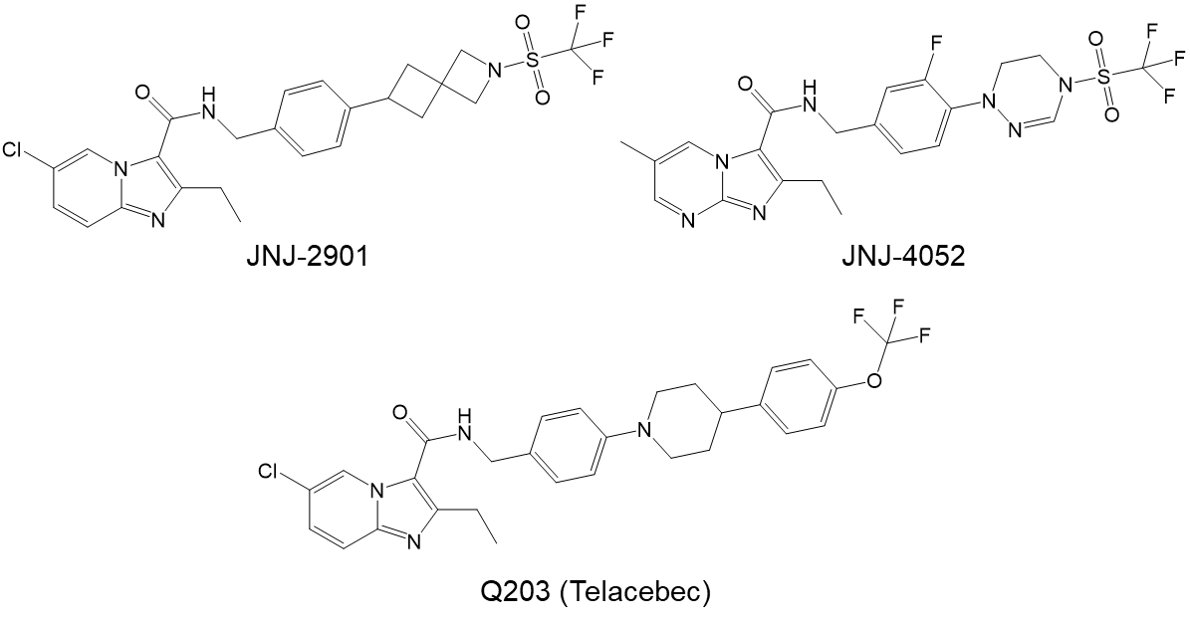
Supplementary Figure S1: Chemical structure of Q203 (Telacebec)² and tool compounds JNJ-2901 and JNJ-4052
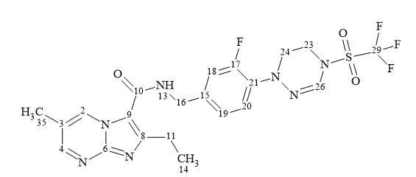
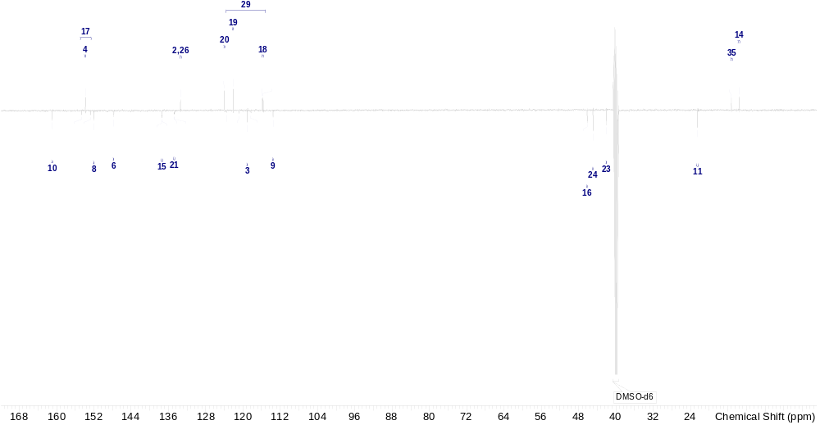

¹³C NMR (125.76 MHz, DMSO-d₆) δ ppm 160.93 (s, 1 C) 153.81 (s, 1 C) 153.67 (br d, J=245.43 Hz, 1 C) 152.01 (s, 1 C) 147.73 (s, 1 C) 137.38 (br d, J=6.43 Hz, 1 C) 134.72 (br d, J=9.19 Hz, 1 C) 133.43 (s, 2 C) 124.02 (d, J=3.68 Hz, 1 C) 122.10 (d, J=1.84 Hz, 1 C) 119.07 (s, 1 C) 115.77 (d, J=20.22 Hz, 1 C) 119.59 (q, J=323.00 Hz, 1 C) 113.56 (s, 1 C) 46.16 (br d, J=5.52 Hz, 1 C) 44.90 (s, 1 C) 42.06 (s, 1 C) 22.50 (s, 1 C) 15.24 (s, 1 C) 13.60 (s, 1 C)

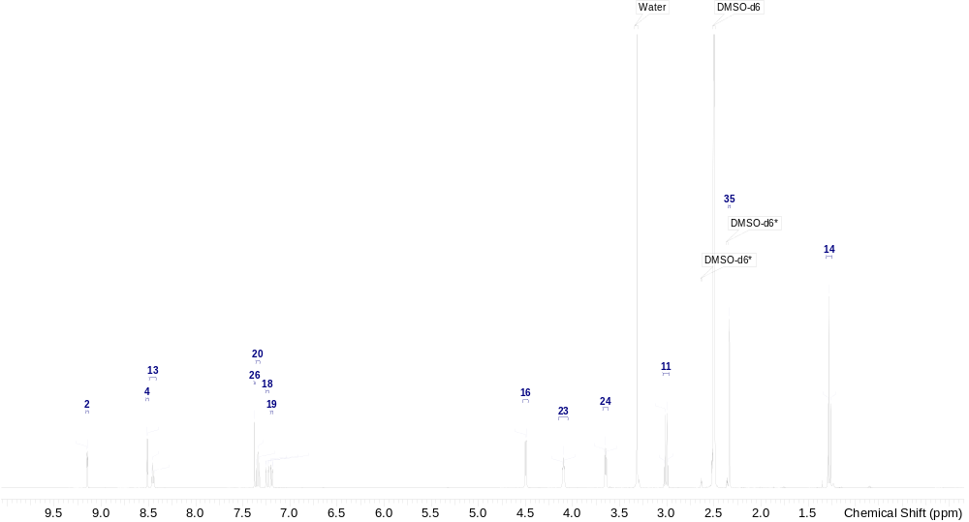

¹H NMR (500 MHz, DMSO-d₆) δ ppm 9.15 (dd, J=2.4, 1.1 Hz, 1 H) 8.51 (d, J=2.5 Hz, 1 H) 8.45 (t, J=5.9 Hz, 1 H) 7.38 (s, 1 H) 7.34 (t, J=8.6 Hz, 1 H) 7.24 (dd, J=13.2, 1.8 Hz, 1 H) 7.19 (dd, J=8.4, 1.8 Hz, 1 H) 4.50 (d, J=5.9 Hz, 2 H) 4.10 (t, J=4.6 Hz, 2 H) 3.62 - 3.68 (m, 2 H) 3.01 (q, J=7.5 Hz, 2 H) 2.34 (d, J=0.8 Hz, 3 H) 1.28 (t, J=7.5 Hz, 3 H)

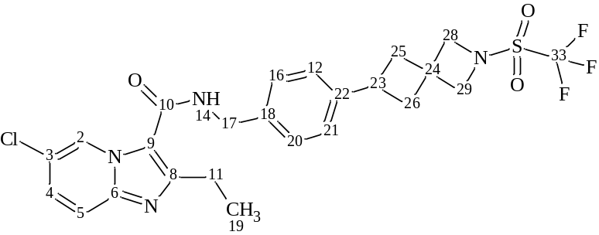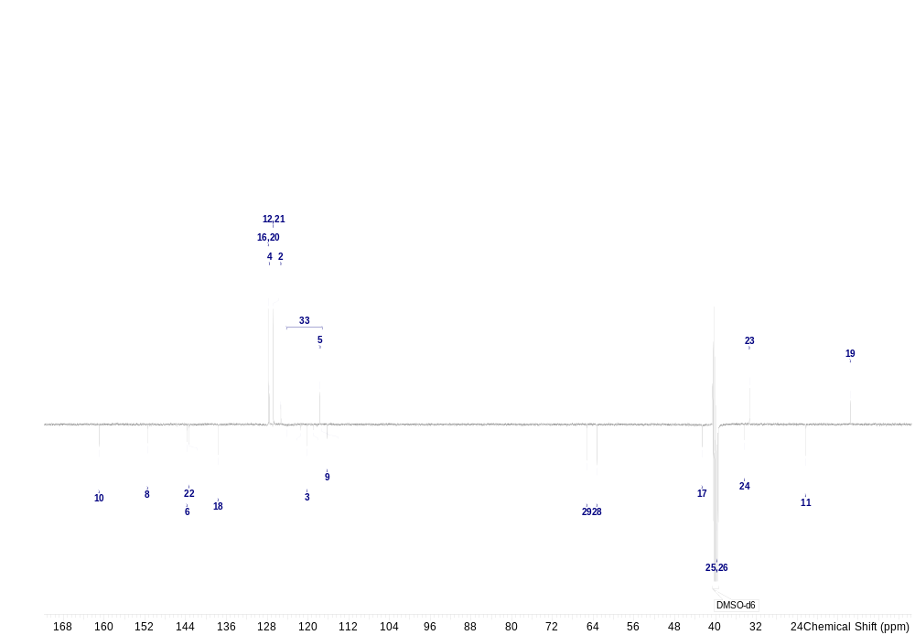

¹³C NMR (125.76 MHz, DMSO-d₆) δ ppm 160.99 (s, 1 C) 151.51 (s, 1 C) 143.77 (s, 1 C) 143.30 (s, 1 C) 137.60 (s, 1 C) 127.80 (s, 2 C) 127.52 (s, 1 C) 126.77 (s, 2 C) 125.29 (s, 1 C) 120.13 (s, 1 C) 117.65 (s, 1 C) 120.62 (q, J=323.00 Hz, 1 C) 116.20 (s, 1 C) 65.25 (s, 1 C) 63.28 (d, J=4.60 Hz, 1 C) 42.64 (s, 1 C) 39.70 (s, 2 C) 34.29 (s, 1 C) 33.34 (s, 1 C) 22.32 (s, 1 C) 13.54 (s, 1 C)

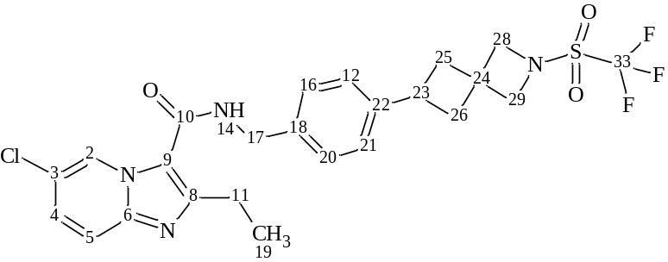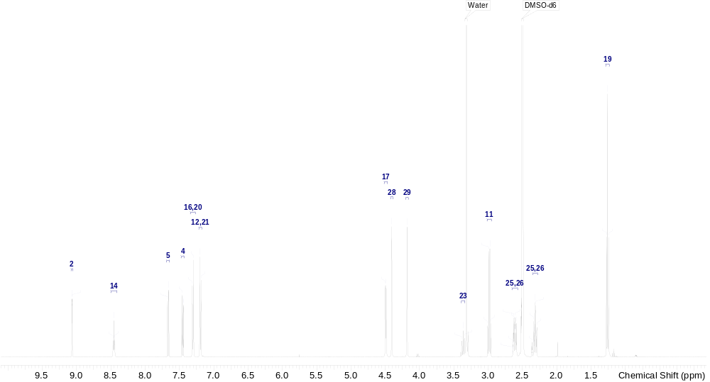

¹H NMR (500 MHz, DMSO-d₆) δ ppm 9.07 (dd, J=2.1, 0.7 Hz, 1 H) 8.46 (t, J=6.1 Hz, 1 H) 7.66 (dd, J=9.5, 0.9 Hz, 1 H) 7.45 (dd, J=9.5, 2.1 Hz, 1 H) 7.30 (m, J=8.1 Hz, 2 H) 7.19 (m, J=8.1 Hz, 2 H) 4.49 (d, J=5.9 Hz, 2 H) 4.41 (s, 2 H) 4.18 (s, 2 H) 3.34 - 3.39 (m, 1 H) 2.98 (q, J=7.5 Hz, 2 H) 2.57 - 2.65 (m, 2 H) 2.28 - 2.35 (m, 2 H) 1.26 (t, J=7.5 Hz, 3 H)

Supplementary Figure S2: ¹H and ¹³C NMR spectra for JNJ-2901 and JNJ-4052
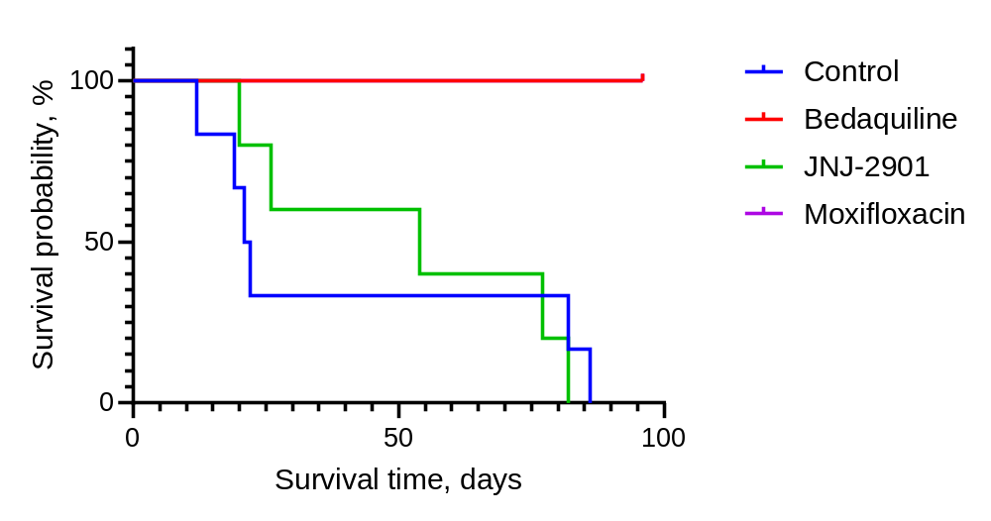
Supplementary Figure S3: Survival probability of monotherapy treatment in intravenous model (IV)

References
1. Kort, F., et al. Fully weekly antituberculosis regimen: a proof-of-concept study. Eur Respir J 56(2020).
2. Pethe, K., et al. Discovery of Q203, a potent clinical candidate for the treatment of tuberculosis. Nature Medicine 19, 1157-1160 (2013).

