Supplementary information

Effect of combined treatment with Fallopia Japonica and Prunella vulgaris extract on myopia progress

Chia-Hung Lin¹, Chih-Sheng Chen^{2,3}, Yao-Chien Wang⁴, En-Shyh Lin⁵, Ching-Yao Chang⁶, Jamie Jiin-Yi Chen⁷, Ming-Yen Wu⁷, Hui-Ju Lin^{1,7,*}, Lei Wan^{1,6,8,*}

- School of Chinese Medicine, China Medical University, Taichung, Taiwan
- Department of Food Nutrition and Health Biotechnology, Asia University, Taichung, Taiwan
- Division of Chinese Medicine, Asia University Hospital, Taichung, Taiwan
- Department of Emergency Medicine, Taichung Tzu Chi Hospital, Taichung, Taiwan
- Department of Beauty Science, National Taichung University of Science and Technology, Taichung, Taiwan
- Department of Medical Laboratory Science and Biotechnology, Asia University, Taichung, Taiwan
- Eye center, China Medical University Hospital, Taichung, Taiwan
- Department of Obstetrics and Gynecology, China Medical University Hospital, Taichung, Taiwan

Figure of Contents
Supplementary Fig. S1
Supplementary Fig. S2
Supplementary Fig. S3

Supplementary data
Supplementary Fig. S1

Supplementary Fig. S1: Increased expression of TNF-α in retina of hamsters after MFD induced myopia progression

Immunofluorescence analysis of TNF-α expression in MFD eyes (Right eye MFD), and FJE + PVE (150 ng/ml)-treated MFD eyes (Right eye).

Supplementary Fig. S2: Original Blots of Fig. 5

Uncropped western blot images
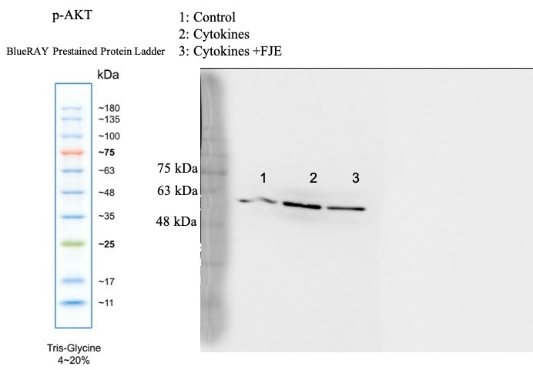

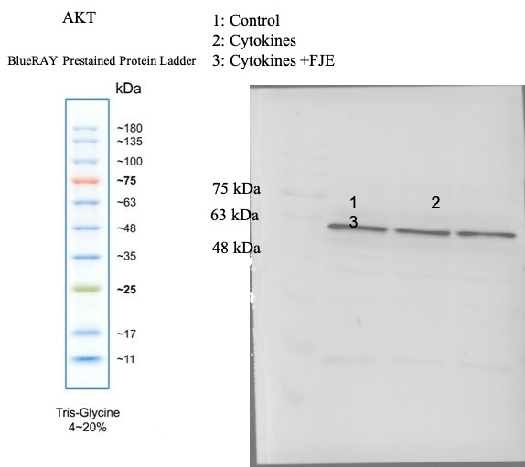

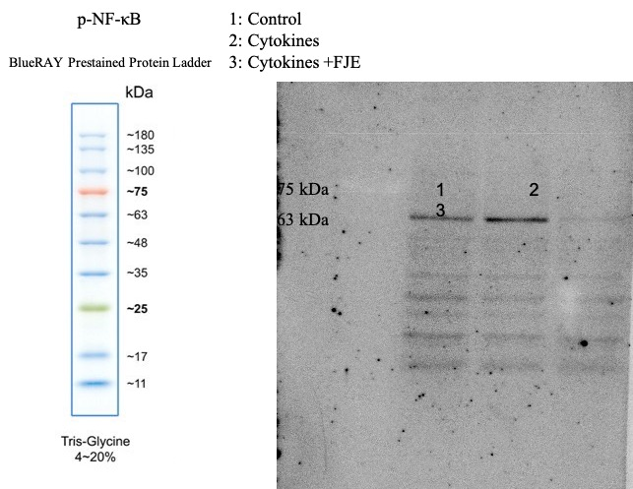

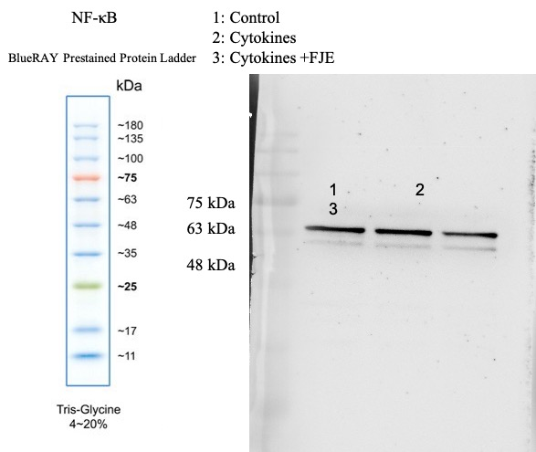

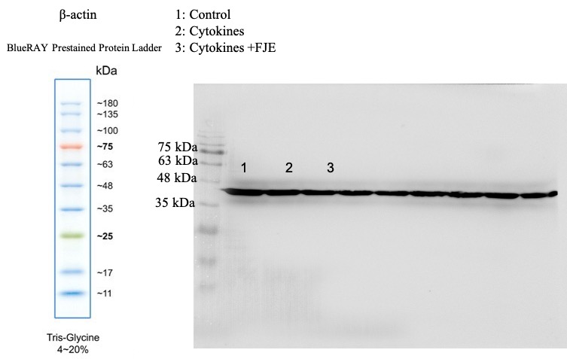

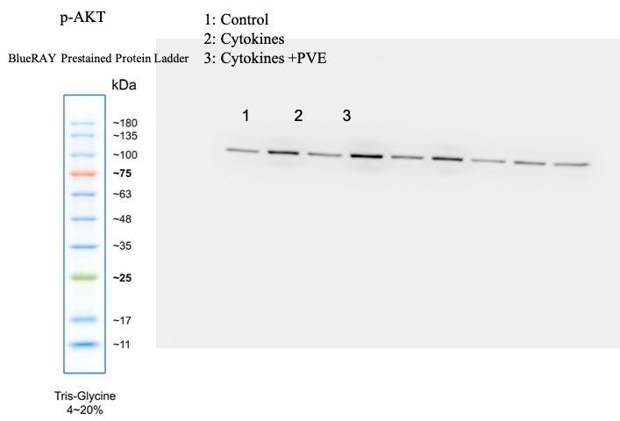

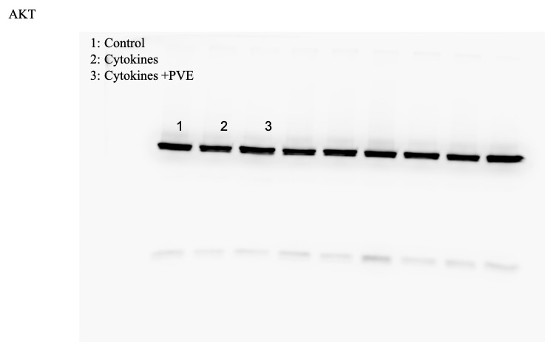

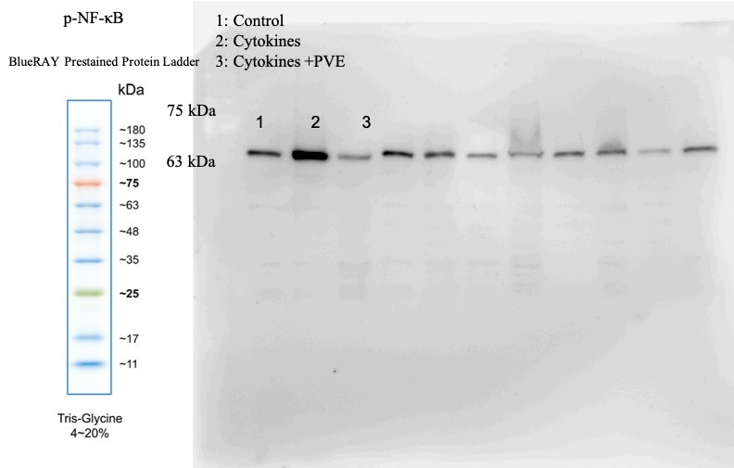

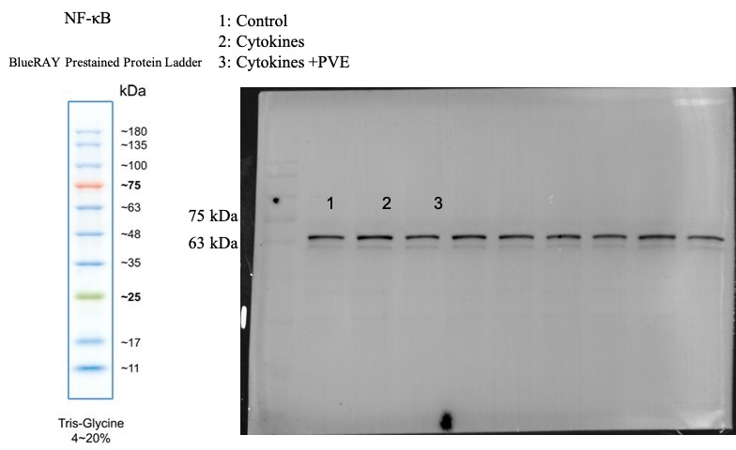

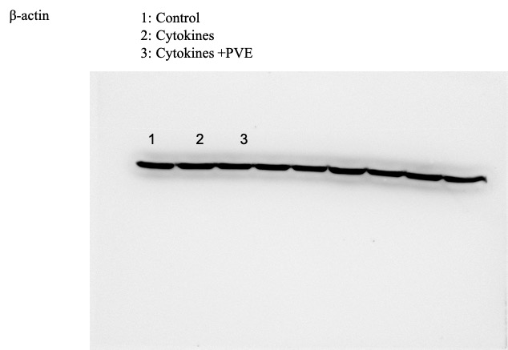

Supplementary Fig. S3: Original IHC of Fig. 6

Uncropped IHC images

B
C

D

