Online Resources: Variation in the detectability of predator-prey interactions may lead to misleading conclusions in trophic ecology studies

Ambre Sacco--Martret de Préville^{1,2}*, Manuel Plantegenest^{3†} & Elsa Canard^{1†}
¹: IGEPP, INRAE, Institut Agro, Univ Rennes, 35653, Le Rheu, France
²: Functional Diversity in Agro-Ecosystems, Crop Research Institute, Drnovská 507, Ruzyně, 161 06, Praha 6, Czech Republic
³: IGEPP, INRAE, Institut Agro, Univ Rennes, 35000, Rennes, France
†: These authors share the last authorship
*: Correspondence:
Ambre Sacco--Martret de Préville
ambresacco@gmail.com
ORCID:
Ambre Sacco--Martret de Préville: https://orcid.org/0000-0002-9259-4904
Manuel Plantegenest: https://orcid.org/0000-0002-7964-1374
Elsa Canard: https://orcid.org/0000-0001-9623-7691

Journal of Pest Science

Online Resource 1: Scheme of the feeding trial.

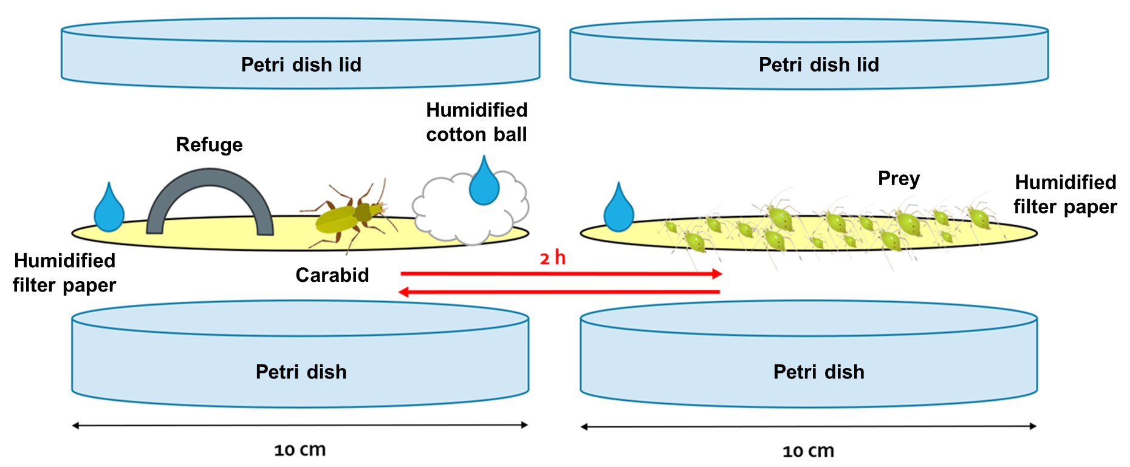

Online Resource 2: Distribution of carabid samples in the feeding trial depending on prey, digestion time interval and carabid species. Framed species were the most abundant ones and were tested multiple times for all combinations of prey and digestion time intervals.

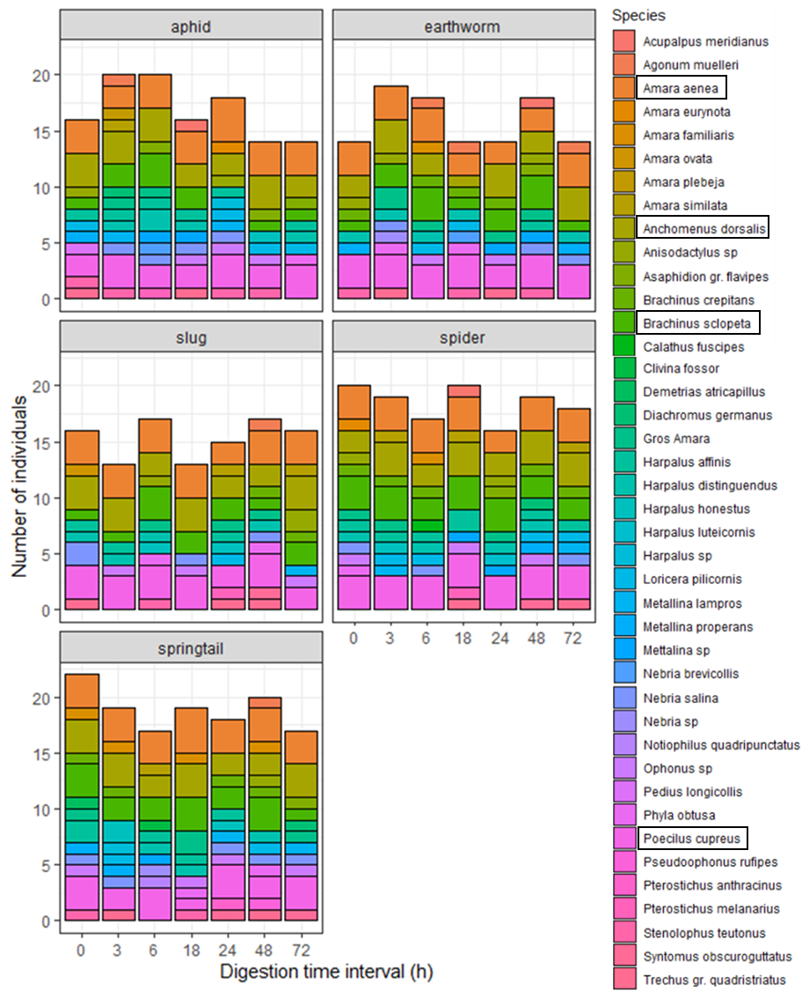

Online Resource 3: Distribution of carabid samples in the feeding trial depending on prey, digestion time interval and carabid size.

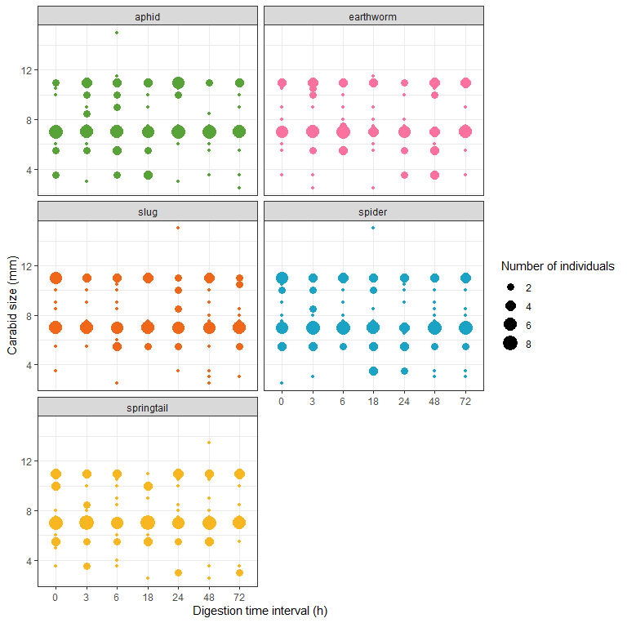

Online Resource 4: Number and proportion of individuals and number of species assigned detection rates for each precision level and each session. Total number of individuals and species in the community as reference.

Session | Precision level of detection rates assignment |  |  | Total
Session | Species level | Genus level | Community level | Total
April | 572 individuals (76%)  4 species | 123 individuals (16%)  15 species | 63 individuals (8%)  13 species | 758 individuals  32 species
May | 1074 individuals (87%)  6 species | 52 individuals (4%)  6 species | 111 individuals (9%)  19 species | 1237 individuals  31 species
June | 940 individuals (77%)  7 species | 118 individuals (10%)  13 species | 156 individuals (13%)  21 species | 1214 individuals  41 species

Online Resource 5: Analysis of Deviance Table testing the significance of the effect of prey type and carabid size on the probability of log-transformed carabid voracity.

 |  | Log(Carabid voracity (mg))
Predictors | Sum Sq |  | Df | F value | Pr(>F)
Carabid size (mm) | 343.81 |  | 1 | 402.32 |  | 2.2e-16 ***
Prey | 40.64 |  | 4 | 11.89 |  | 2.7e-09 ***
 | * p<0.05 ** p<0.01 *** p<0.001

Online Resource 6: Regression plot of the effect of carabid size for each prey type on carabid voracity.

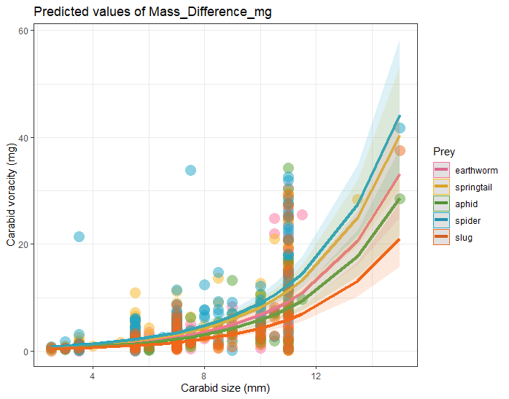

Online Resource 7: Pairwise comparisons whose significance changed with the use of the digestion speed correction in the predation intensity index (NS: not significant, *: p-value<0.05, **: p-value<0.01, ***: p-value<0.001).

Predictors | Modality | Contrast | Estimates and p-values for the uncorrected model | Estimates and p-values for the corrected model
Prey type: Session | April | 1. Aphid - Earthworm  2. Earthworm - spider | -0.338 (**)  0.279 (*) | -0.19 (NS)  0.146 (NS)
Prey type: Session | June | 1. Aphid - Earthworm  2. Aphid - Slug  3. Spider - Springtail | -0.375 (***)  0.137 (NS)  -0.325 (**) | -0.076 (NS)  0.233 (*)  -0.094 (NS)
Prey type: Agricultural system | Conventional | 1. Aphid - Earthworm  2. Aphid - Spider | -0.306 (***)  -0.207 (NS) | -0.125 (NS)  -0.174 (*)
Agricultural system: Prey | Aphid | Conventional - Conservation | -0.091 (NS) | -0.125 (*)
Session: Prey | Aphid | April - June | -0.205 (NS) | -0.280 (***)
Session: Prey | Earthworm | April - June | -0.241 (*) | -0.164 (NS)
Session: Agricultural system | Conventional | April - June | -0.116 (NS) | -0.361 (***)

