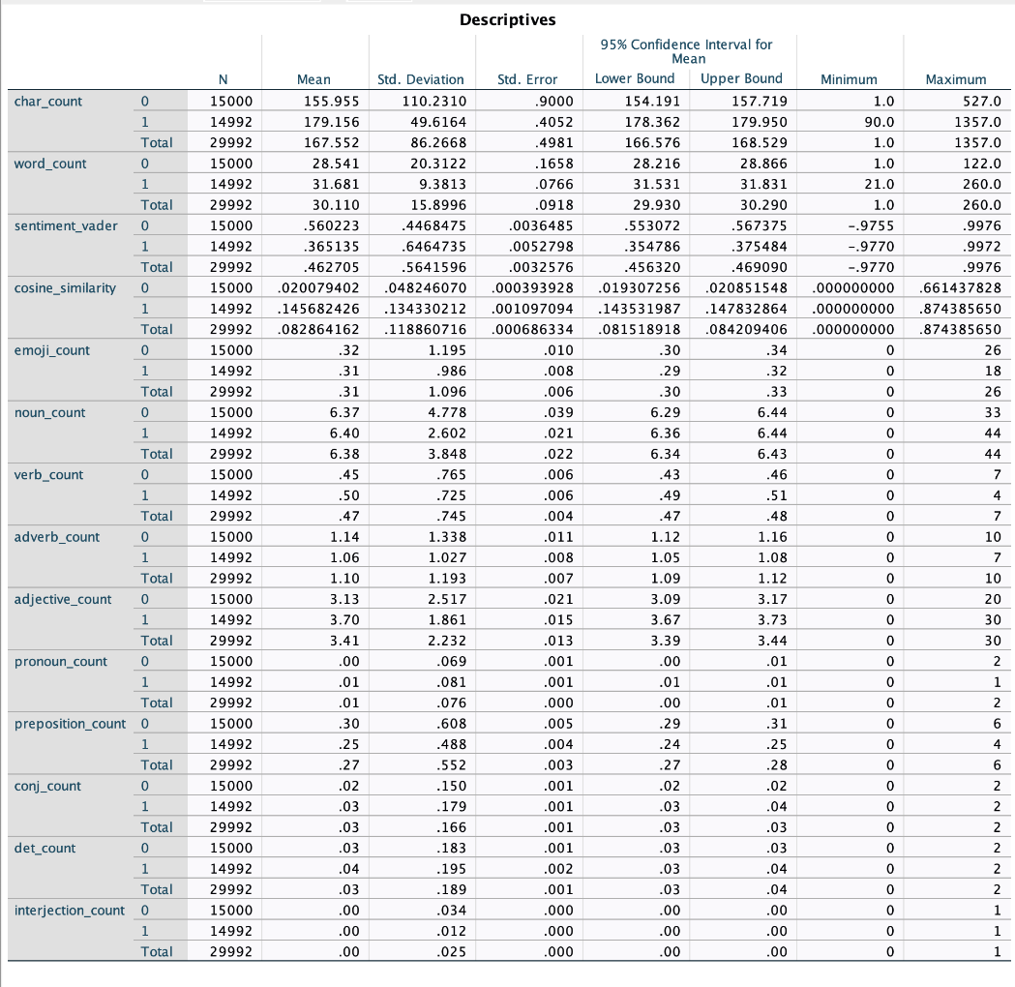
Appendix 1: Desriptives of the Variables

