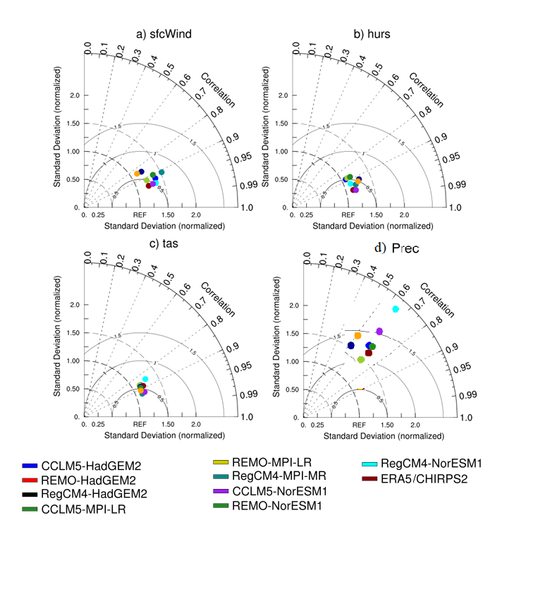
Figure S1: The same as Fig. 2 for Guinea coast zone.

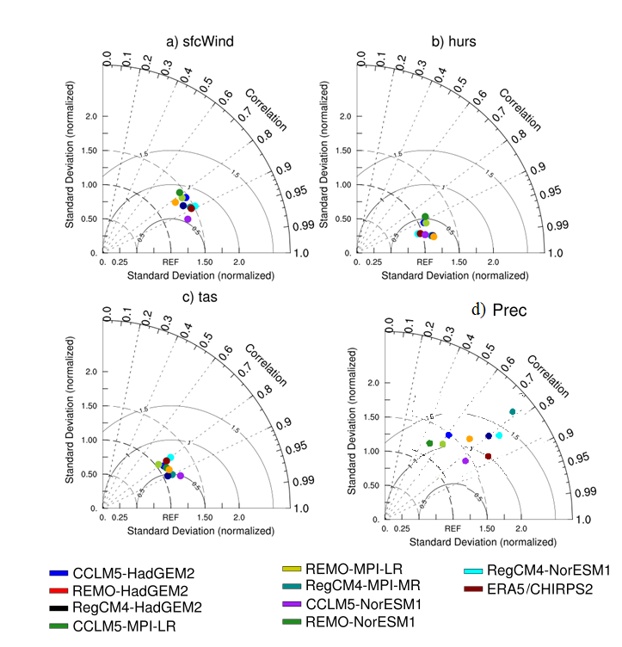
Figure S2: The same as Fig. 2 for Savannah zone.

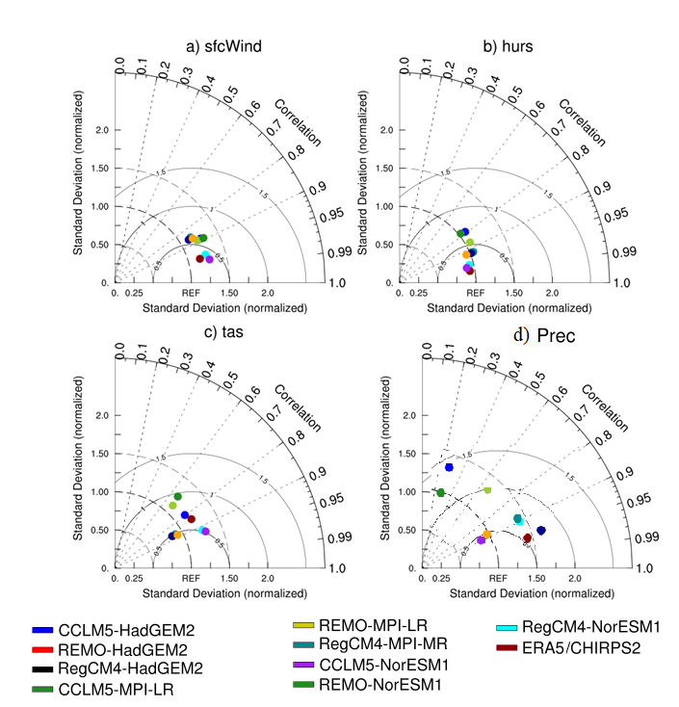

Figure S3: The same as Fig. 2 for Sahel zone.

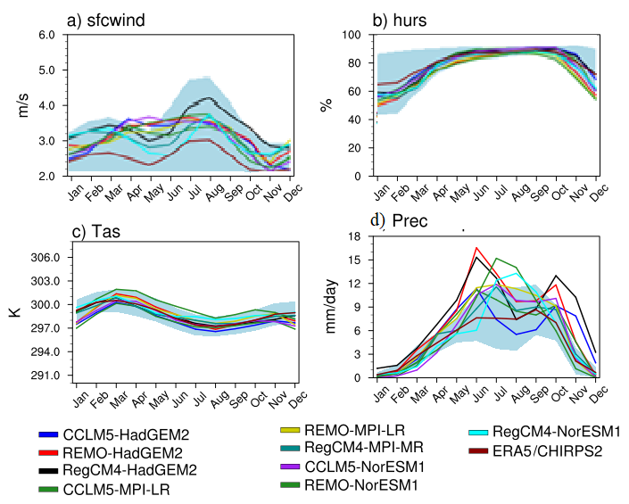

Figure S4: The same as Fig. 3 for Guinea coast zone.

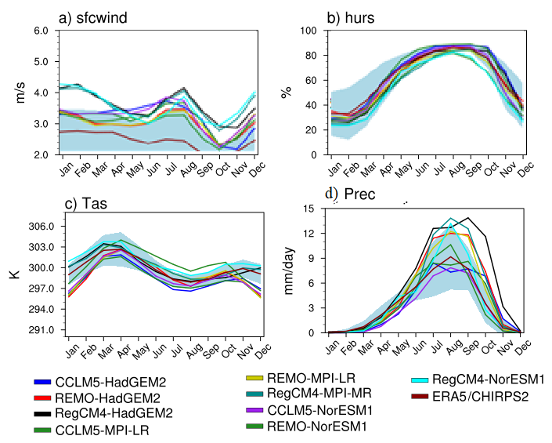

Figure S5: The same as Fig. 3 for Savannah zone.

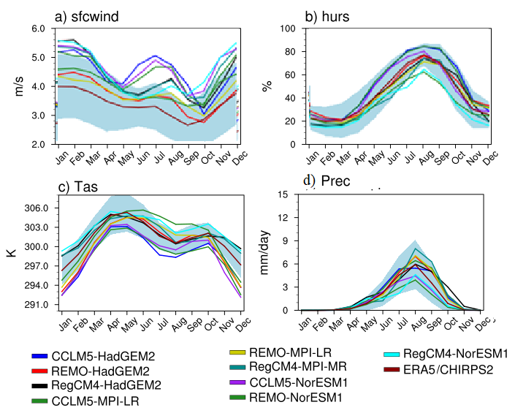

Figure S6: The same as Fig. 3 for Sahel zone.

