supporting materials
Lists of Tables
Table S1 Composition of PMF etching solution.

Table S1 Composition of PMF etching solution.

_{Parameters} | _{Na3PO4} | _{KH2PO4} | _{NaCl} | _{K2HPO4} | _{KCl} | _{Na2CO3}
_{Concentration (g L}⁻¹₎ | ₆ | ₆ | ₂₀ | ₆ | ₁₀ | ₂

List of Figures

Figure S1 Flowchart of PMF preparation.
Figure S2 EDS of PMF.
Figure S3 The XRD data and possible chemical composition formula of PMF

Figure S1 Flowchart of PMF preparation.
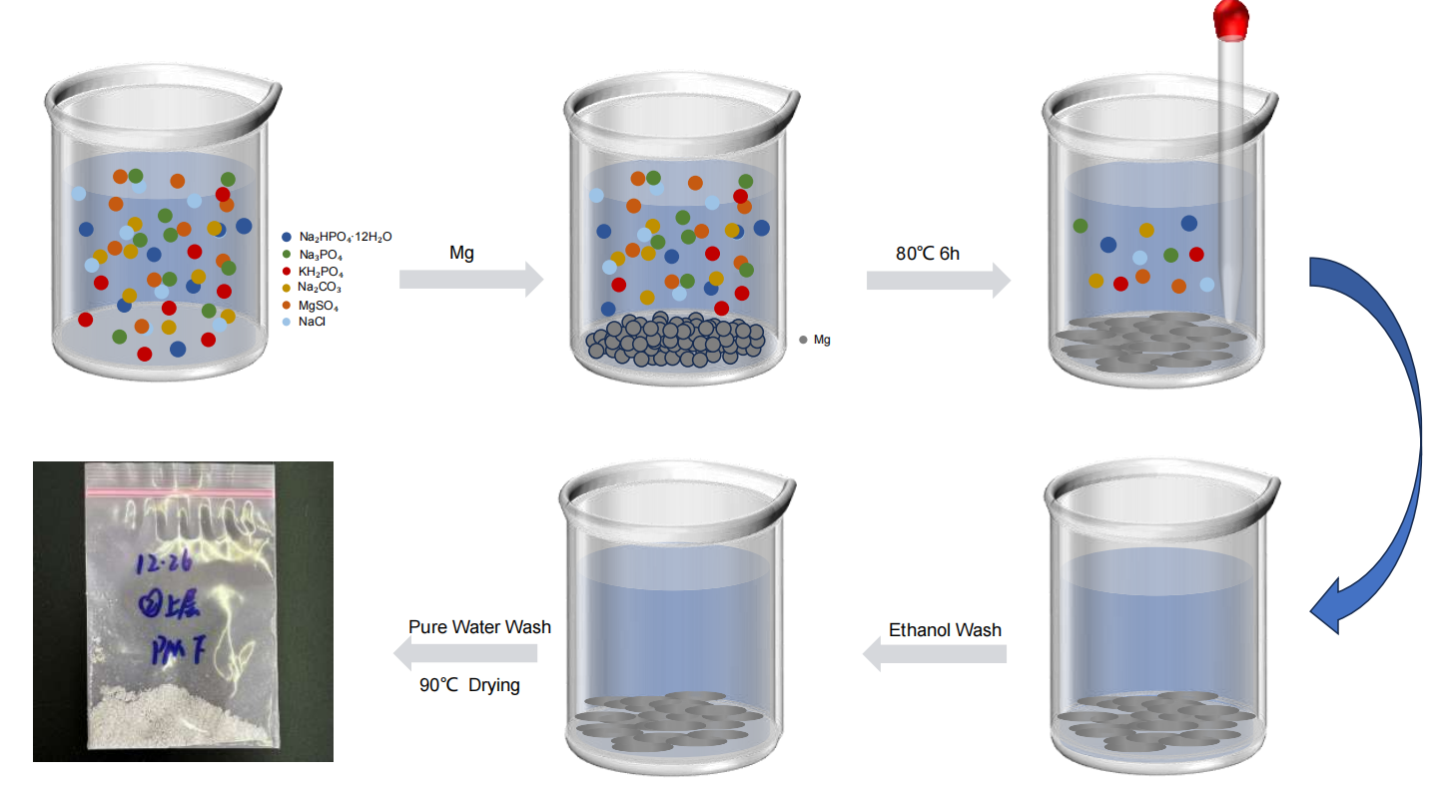
Figure S2 EDS of PMF.

PMF is mainly composed of magnesium salt compounds containing phosphorus, magnesium, and oxygen, with the content of phosphorus, magnesium, and oxygen exceeding 60wt%.
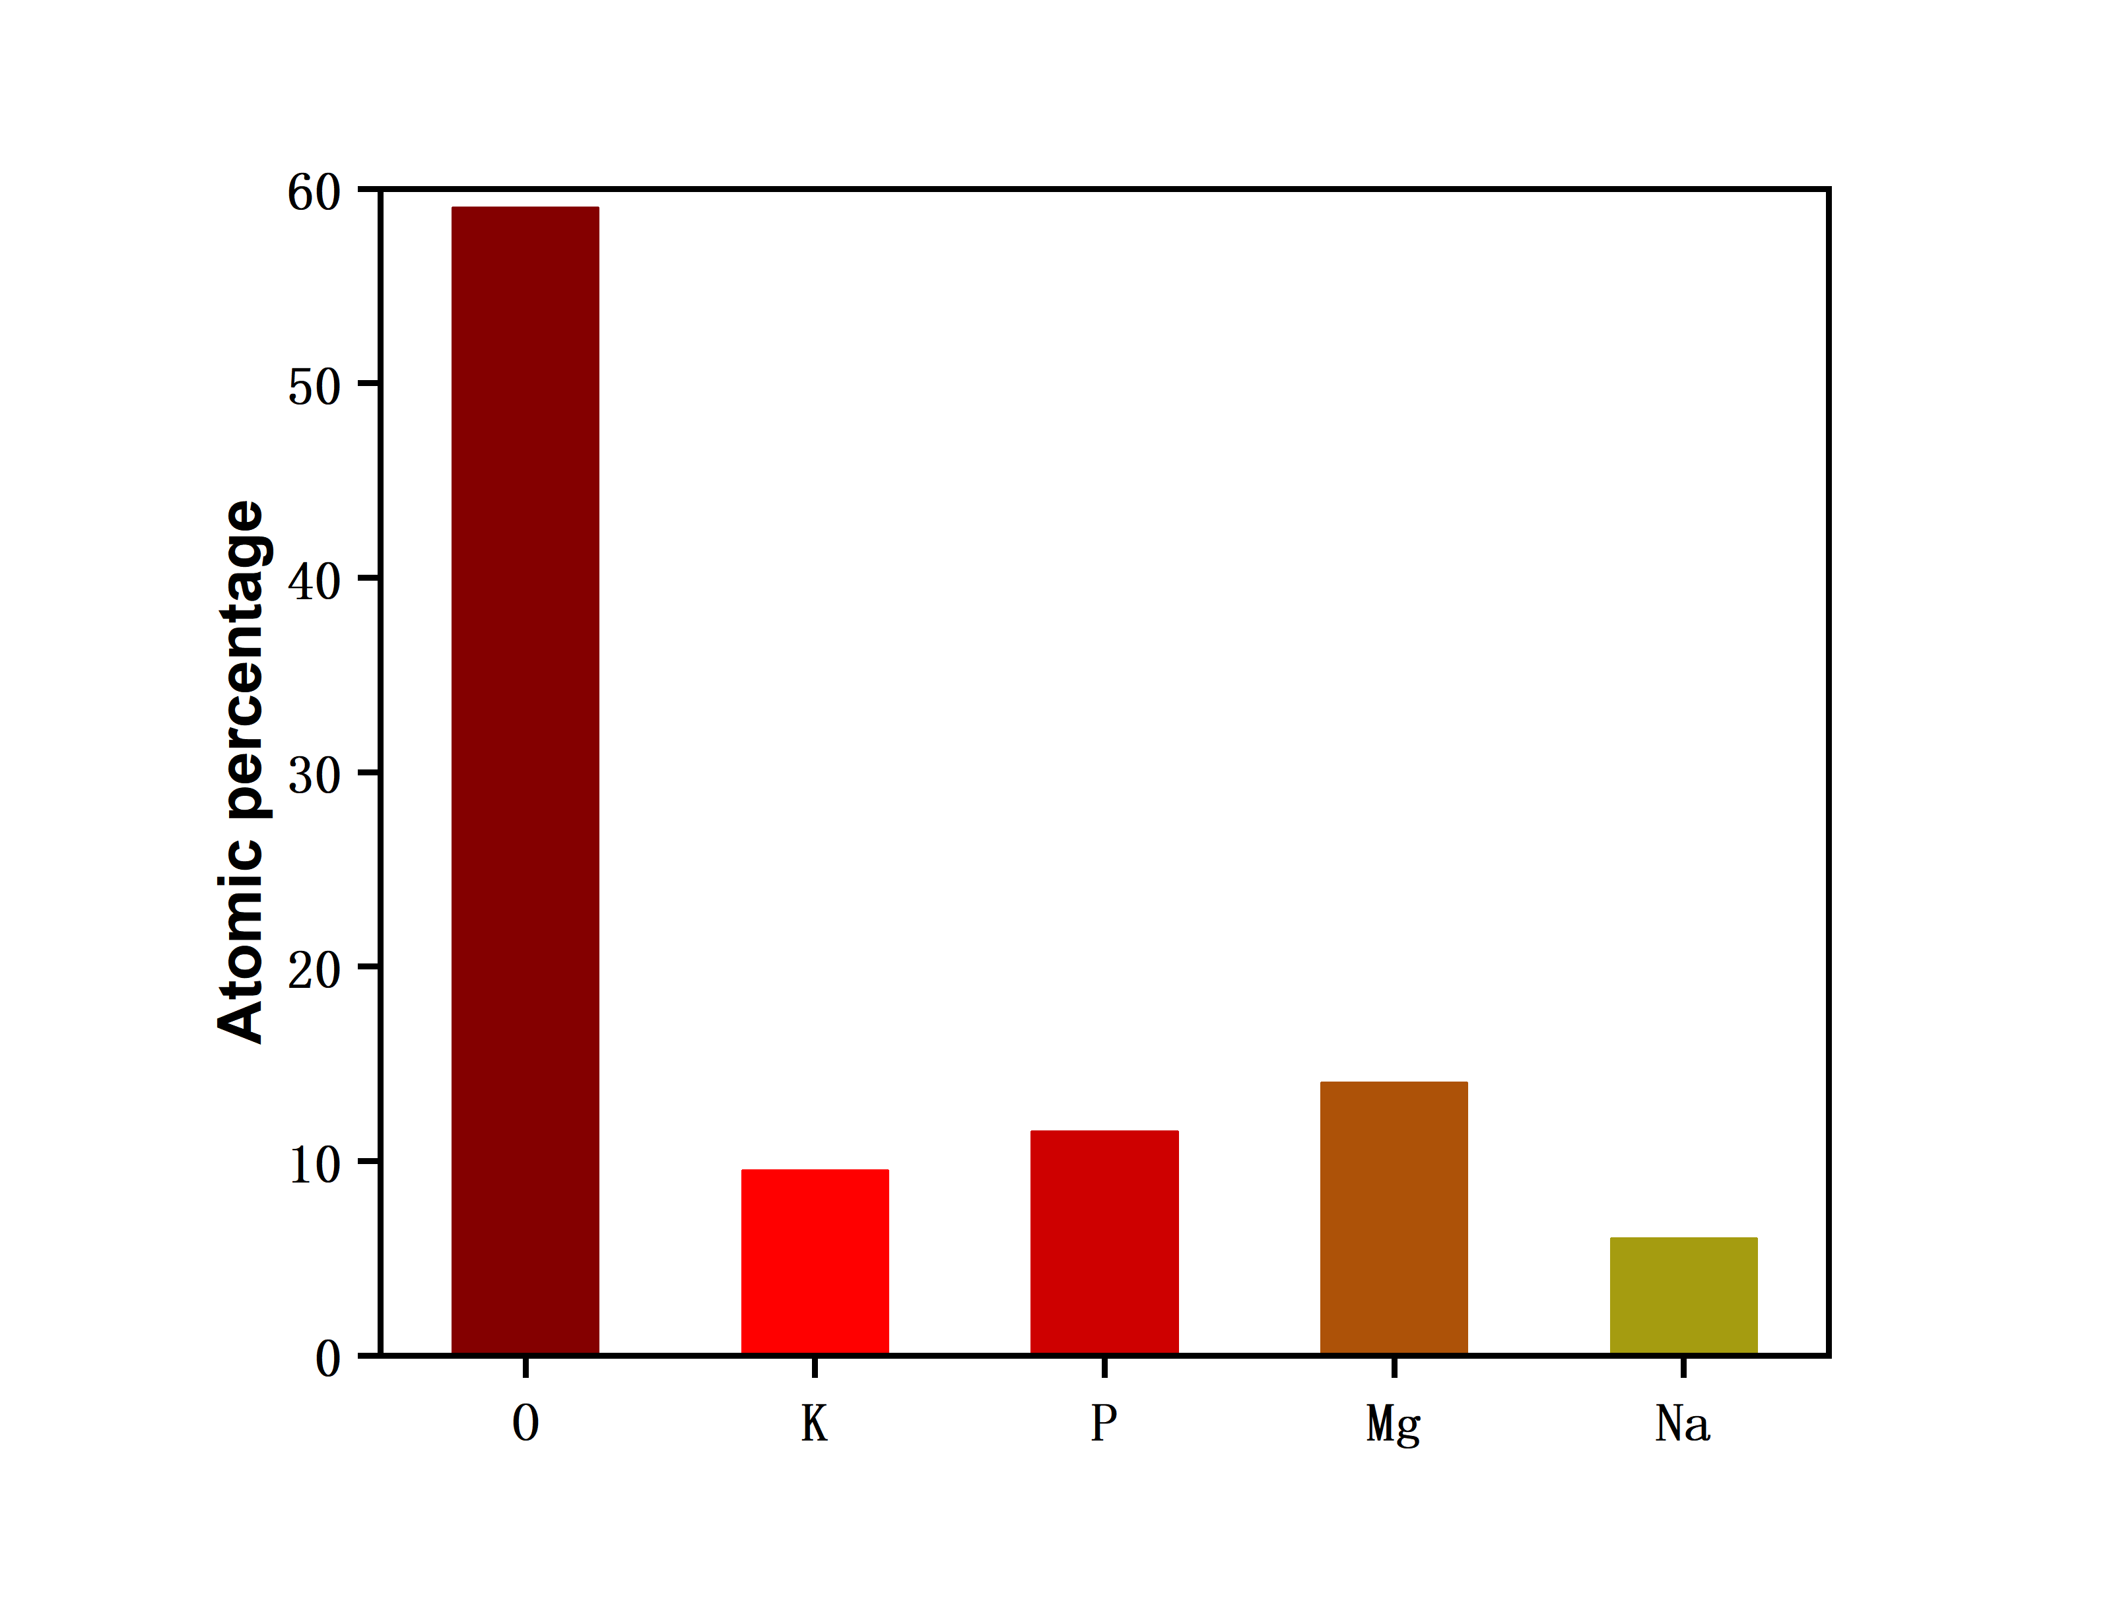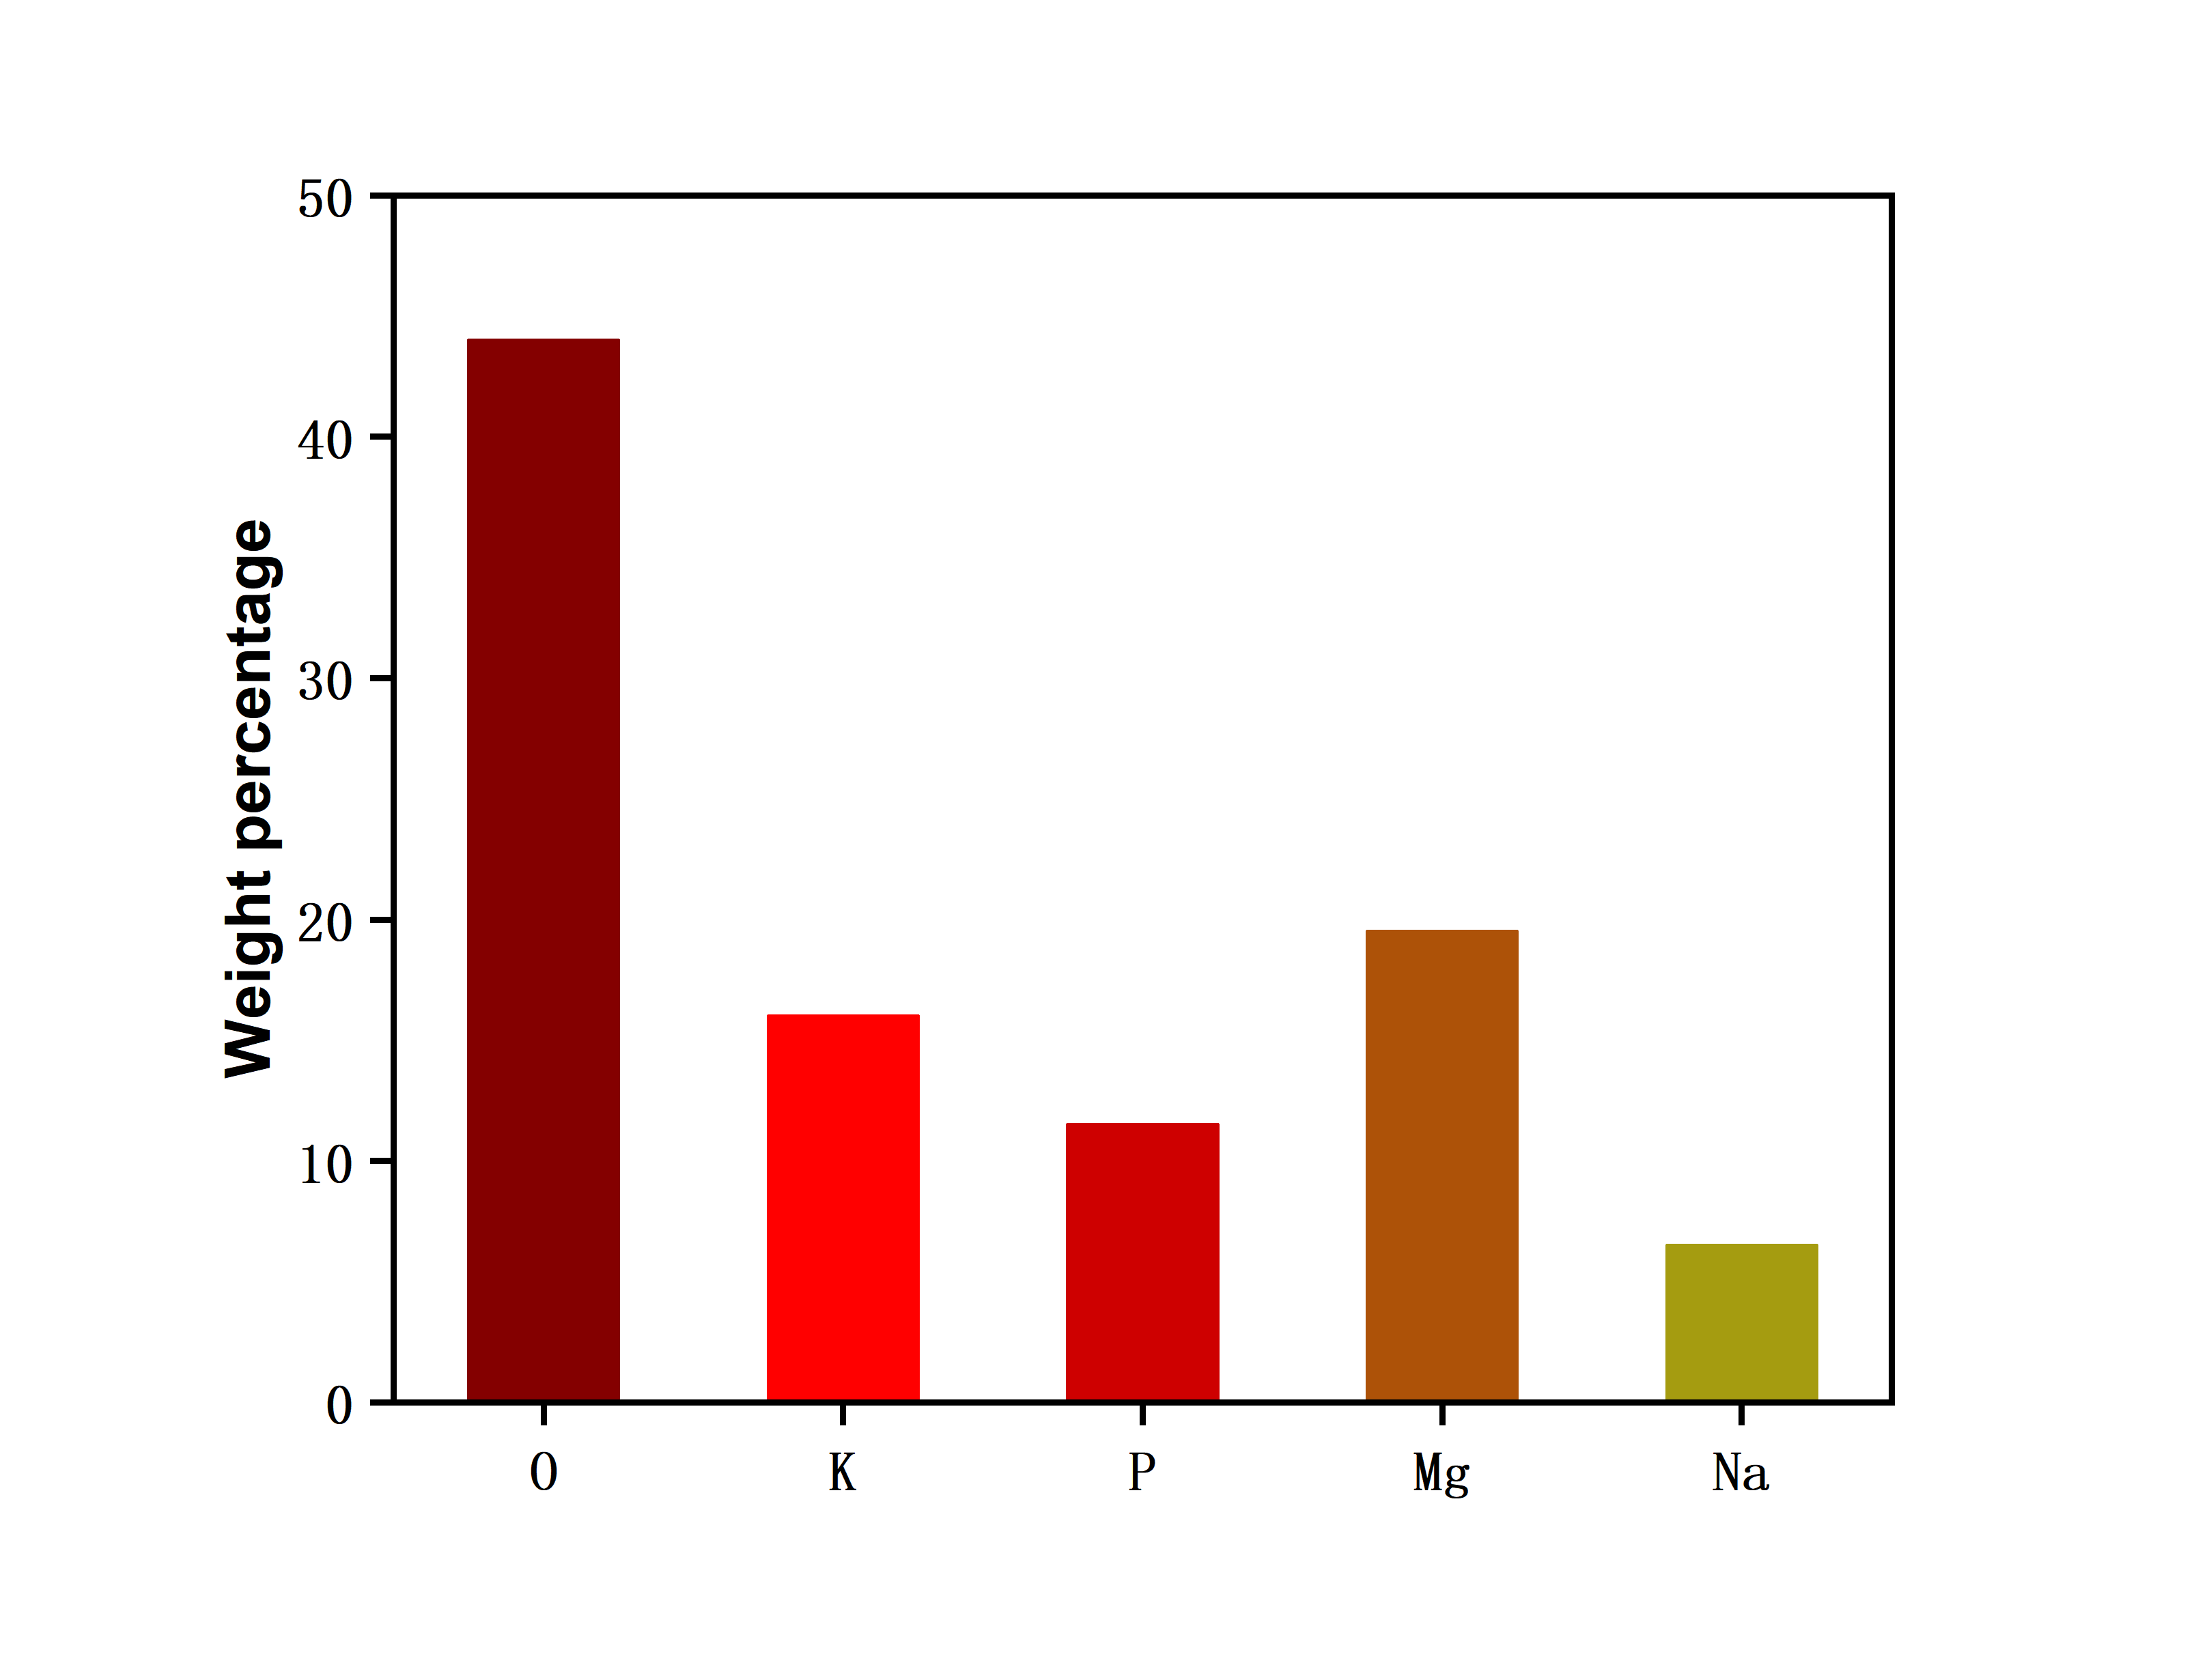

Figure S3 The XRD data and possible chemical composition formula of PMF.
