Algorithms | Equation | Criteria
ROR | 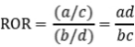  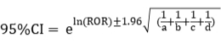 | a≥3, lower limit of 95%Cl＞1
PRR | 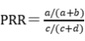  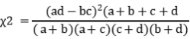 | a≥3, PRR≥2
BCPNN | IC=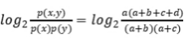  E(IC)=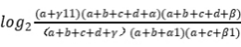  V(IC)=  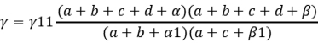  IC-2SD=E(IC)-2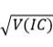  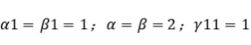 | 1.According to the strength of the signal  ①No signal(-):IC-2SD≤0;  ②Weak signal(+): 0＜IC-2SD≤1.5;  ③Medium signal(++): 1.5＜IC-2SD≤3;  ④Strong signal(+++): IC-2SD＞3  2.According to whether there is signal or not  a≥3, IC-2SD＞0
MGPS | 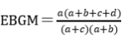  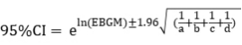 | EBGM₀₅＞2

Table S1 Four methods of disproportionality analysis.

Table S2 Horizontal pleiotropy between exposure and outcomes.

Outcome | Exposure | Target gene | Egger_intercept | Se | Pval
Type 2 diabetes | Blood glucose levels | ABCC8/KCNJ11 | -0.04888 | 0.017652 | 0.220637
Peak insulin response | Blood glucose levels | ABCC8/KCNJ11 | -0.04924 | 0.085406 | 0.667056
Body mass index | Blood glucose levels | ABCC8/KCNJ11 | 0.003415 | 0.008412 | 0.754479
Waist circumference | Blood glucose levels | ABCC8/KCNJ11 | -0.00033 | 0.005158 | 0.95969
Hip circumference | Blood glucose levels | ABCC8/KCNJ11 | 0.001764 | 0.005746 | 0.810405
Schizophrenia | Blood glucose levels | ABCC8/KCNJ11 | -0.05597 | 0.071879 | 0.578819
Bipolar disorder | Blood glucose levels | ABCC8/KCNJ11 | -0.02301 | 0.026754 | 0.547871
Major Depressive Disorder | Blood glucose levels | ABCC8/KCNJ11 | 0.016975 | 0.022738 | 0.591741

Table S3 The heterogeneity of instrumental variables from UK Biobank.

Outcome | Exposure | Target gene | Method | Q | Pval
Type 2 diabetes | Blood glucose levels | ABCC8/KCNJ11 | MR Egger | 0.27 | 0.60
Type 2 diabetes | Blood glucose levels | ABCC8/KCNJ11 | Inverse variance weighted | 3.88 | 0.14
Peak insulin response | Blood glucose levels | ABCC8/KCNJ11 | MR Egger | 2.04 | 0.15
Peak insulin response | Blood glucose levels | ABCC8/KCNJ11 | Inverse variance weighted | 2.71 | 0.26
Body mass index | Blood glucose levels | ABCC8/KCNJ11 | MR Egger | 3.16 | 0.08
Body mass index | Blood glucose levels | ABCC8/KCNJ11 | Inverse variance weighted | 3.68 | 0.16
Waist circumference | Blood glucose levels | ABCC8/KCNJ11 | MR Egger | 0.58 | 0.45
Waist circumference | Blood glucose levels | ABCC8/KCNJ11 | Inverse variance weighted | 0.59 | 0.75
Hip circumference | Blood glucose levels | ABCC8/KCNJ11 | MR Egger | 0.36 | 0.55
Hip circumference | Blood glucose levels | ABCC8/KCNJ11 | Inverse variance weighted | 0.46 | 0.80
Schizophrenia | Blood glucose levels | ABCC8/KCNJ11 | MR Egger | 0.09 | 0.76
Schizophrenia | Blood glucose levels | ABCC8/KCNJ11 | Inverse variance weighted | 0.70 | 0.71
Bipolar disorder | Blood glucose levels | ABCC8/KCNJ11 | MR Egger | 0.20 | 0.66
Bipolar disorder | Blood glucose levels | ABCC8/KCNJ11 | Inverse variance weighted | 0.94 | 0.63
Major Depressive Disorder | Blood glucose levels | ABCC8/KCNJ11 | MR Egger | 0.08 | 0.77
Major Depressive Disorder | Blood glucose levels | ABCC8/KCNJ11 | Inverse variance weighted | 0.64 | 0.73

