Bisphenols Exposure Correlated with Metabolic Syndrome Incidence via Inflammatory Response: Evidence from NHANES 2013-2015
Xiaoting Li^{1†}, Zhiyuan Dong^{1†}, Liping He¹, Xiaoming Ji^{2*}

- Department of Nutrition and Food Safety, School of Public Health, Nanjing Medical University, Nanjing, China.
- Department of Occupational Medicine and Environmental Health, School of Public Health, Nanjing Medical University, Nanjing 211166, China.
† contributing equally

* Corresponding Author: Xiaoming Ji, Department of Occupational Medicine and Environmental Health, School of Public Health, Nanjing Medical University, 101 Longmian Avenue, Nanjing, 211166, China. Tel: 025-86868417, E-mail: xmji@njmu.edu.cn

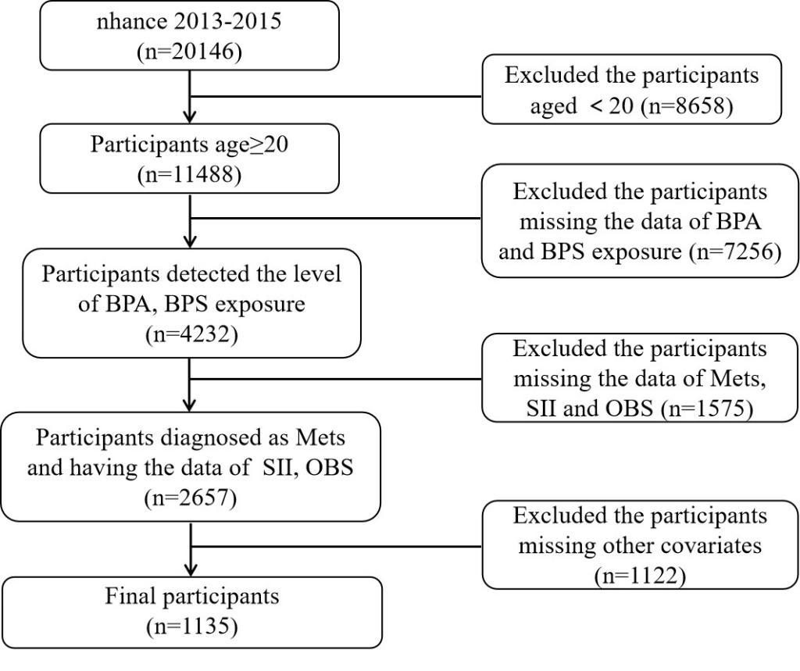
Fig. S1. Flowchart of the study population. Abbreviations. BPA: Bisphenol A, BPS: Bisphenol S, Mets: metabolic syndrome, SII: systemic immune-inflammation index, OBS: oxidative balance score.

Table 1. Baseline characteristics according to Mets, NHANES 2013 to 2015 (n = 1135).

 | Non-Mets | Mets | Standardize diff. | P value
Age | 45.71 ± 17.34 | 53.22 ± 15.71 | 0.454 (0.453, 0.454) | <0.001
Log BPA | 0.36 ± 0.98 | 0.40 ± 0.96 | 0.051 (0.051, 0.052) | 0.402
Log BPS | -0.32 ± 1.05 | -0.22 ± 1.06 | 0.097 (0.096, 0.097) | 0.112
Log SII | 6.04 ± 0.52 | 6.16 ± 0.50 | 0.225 (0.224, 0.225) | <0.001
OBS | 19.09 ± 9.05 | 17.67 ± 7.95 | 0.167 (0.166, 0.167) | 0.007
BMI | 27.06 ± 5.75 | 34.07 ± 6.97 | 1.098 (1.097, 1.098) | <0.001
BFP | 32.00 ± 9.32 | 40.76 ± 8.40 | 0.987 (0.986, 0.987) | <0.001
LAP | 32.02 ± 22.85 | 95.47 ± 65.92 | 1.286 (1.286, 1.287) | <0.001
VAI | 1.14 ± 0.85 | 3.11 ± 2.79 | 0.955 (0.955, 0.956) | <0.001
TG | 95.77 ± 57.90 | 182.69 ± 121.73 | 0.912 (0.911, 0.912) | <0.001
HDL-C | 60.13 ± 17.66 | 44.79 ± 12.45 | 1.004 (1.004, 1.005) | <0.001
GLu | 5.49 ± 1.01 | 7.00 ± 2.54 | 0.783 (0.782, 0.783) | <0.001
Gender |  |  |  | 0.980
Male | 53.45 | 53.53 | 0.002 (0.001, 0.002)
Female | 46.55 | 46.47 | 0.002 (0.001, 0.002)
Race |  |  |  | 0.229
Mexican American | 7.78 | 9.13 | 0.048 (0.048, 0.049)
Non-Hispanic White | 63.31 | 66.65 | 0.070 (0.070, 0.071)
Non-Hispanic Black | 13.14 | 9.49 | 0.115 (0.115, 0.116)
Others | 15.77 | 14.72 | 0.029 (0.029, 0.030)
Education |  |  |  | 0.286
College graduate | 63.85 | 59.17 | 0.096 (0.096, 0.097)
High school | 21.07 | 23.91 | 0.068 (0.068, 0.068)
Less than 9th grade | 15.08 | 16.92 | 0.050 (0.050, 0.051)
Hypertension |  |  |  | <0.001
No | 71.52 | 39.68 | 0.677 (0.676, 0.677)
Yes | 28.48 | 60.32 | 0.677 (0.676, 0.677)
Hyperlipidemia |  |  |  | <0.001
No | 44.05 | 8.23 | 0.893 (0.892, 0.893)
Yes | 55.95 | 91.77 | 0.893 (0.892, 0.893)
Obese |  |  |  | <0.001
No | 76.01 | 26.76 | 1.132 (1.132, 1.133)
Yes | 23.99 | 73.24 | 1.132 (1.132, 1.133)
Smoke |  |  |  | 0.434
Never | 56.38 | 53.94 | 0.049 (0.049, 0.050)
Former | 24.51 | 27.95 | 0.078 (0.078, 0.079)
Now | 19.11 | 18.11 | 0.026 (0.025, 0.026)
Alcohol |  |  |  | <0.00
Never | 10.85 | 11.91 | 0.034 (0.033, 0.034)
Former | 11.88 | 20.51 | 0.236 (0.235, 0.236)
Now | 77.27 | 67.58 | 0.218 (0.218, 0.219)
BPA: Bisphenol A, BPS: Bisphenol S, Mets: metabolic syndrome, SII: systemic immune-inflammation index, OBS: oxidative balance score. HDL-C: Cholesterol - HDL, TG: triglyceride, GLu: fasting glucose, BMI: body mass index, BFP: body fat percentage, LAP: lipid accumulation product, and VAI: visceral adiposity index.

Fig. S2. Forest plot of stratified analyses of the interaction of obesity-related biomarkers with BPS exposure. Each strata were adjusted for age, sex, race, education; BMI: body mass index, BFP: body fat percentage, LAP: lipid accumulation product, VAI: visceral adiposity index, TG: triglyceride, HDL-C: Cholesterol - HDL, GLu: fasting glucose.

Table 2. Associations between the combined BPS exposure with SII and risk of Mets.
 | Low |  |  |  | High |  |  | P for  interaction
Variables | N(%) | OR (95%CI) | P-value |  | N(%) | OR (95%CI) | P-value | P for  interaction
BPS Log quartile |  |  |  |  |  |  |  | 0.101
Q1 | 130 (33.88) |  |  |  | 152 (36.06) | 1
Q2 | 127 (30.44) | 0.89 (0.42, 1.87) | 0.752 |  | 117 (45.27) | 1.70 (0.86, 3.36) | 0.1243
Q3 | 154 (44.60) | 1.57 (0.79, 3.12) | 0.195 |  | 169 (42.02) | 1.43 (0.76, 2.69) | 0.2704
Q4 | 156 ( 31.49) | 0.82 (0.42, 1.63) | 0.578 |  | 130 (46.96) | 1.99 (1.02, 3.86) | 0.0427
Adjusted for age, gender, education, race, BMI, alcohol and smoke.

