Point-by-Point Reply: Supplementary Material to Reviewers

We are truly grateful to the reviewers for their careful analysis of our manuscript entitled “Exosomal miR-125b-5p derived from mesenchymal stem cells enhances anti-PD-1 therapy in mouse colon cancer model”. We would like to express our appreciation for their insight, pertinent remarks and thoughtful suggestions on our manuscript. We have carefully studied the reviewer’s comments, and the manuscript has been revised accordingly. We hope our revision can help reviewers and editors endorse the quality of this research. The following represent our point-by-point reply to the comments/suggestions from reviewer 1, reviewer 2, and reviewer 3.
Responses to 1st reviewer’s comments
1. Reviewer 1: The Materials and Methods Section is well-detailed, describing each step of the experimental process. However, more details on the statistical methods, sample sizes, experimental replicates, and control groups are needed.
Response: According to the reviewer’s suggestions, we have clarified our sample size, experimental replicates, and statistical methods in the Methods section of the revised manuscript (Page 7, and Page 8), and it now reads as follows:
“C57BL/6J (female, 8 ~ 12 weeks old) were subcutaneously injected with 0.1 ml PBS containing 5×10⁵ cells of MC38 in the right flank, when tumor size reached 50 ~ 100 mm3, the mice were randomly divided into four groups (n=5 mice/group). The tumor-bearing mice were administrated MSC-EXO-miR-125b-5p (100μg/mice) via intravenous injection into the tail veil, and intraperitoneal (i.p.) injection of anti-PD-1 antibody (100μg/mice) alone or in combination twice a week for two weeks. The control group was injected with MSC-EXO-miR-NC (100μg/mice) via intravenous injection in conjunction with IgG (i.p., 100μg/mice) for the same duration.” (Page 7)
“All in vitro and in vivo experiments were performed at least two or three times. The statistical significance between two groups were analyzed by two tailed student’s t test, and the multiple groups comparison were analyzed by one-way ANOVA and Tukey’s post hoc test.” (Page 8)

2. Reviewer 1: A simple schematic graphical abstract summarizing the study design and mechanism by which MSC-EXO-miR-125b-5p enhances anti-PD-1 efficacy would be helpful in visualizing the findings.
Response: We thank the reviewer for the good comment. We have presented a specific schematic graphical abstract in the submitting system. The graphical abstract was shown as below.
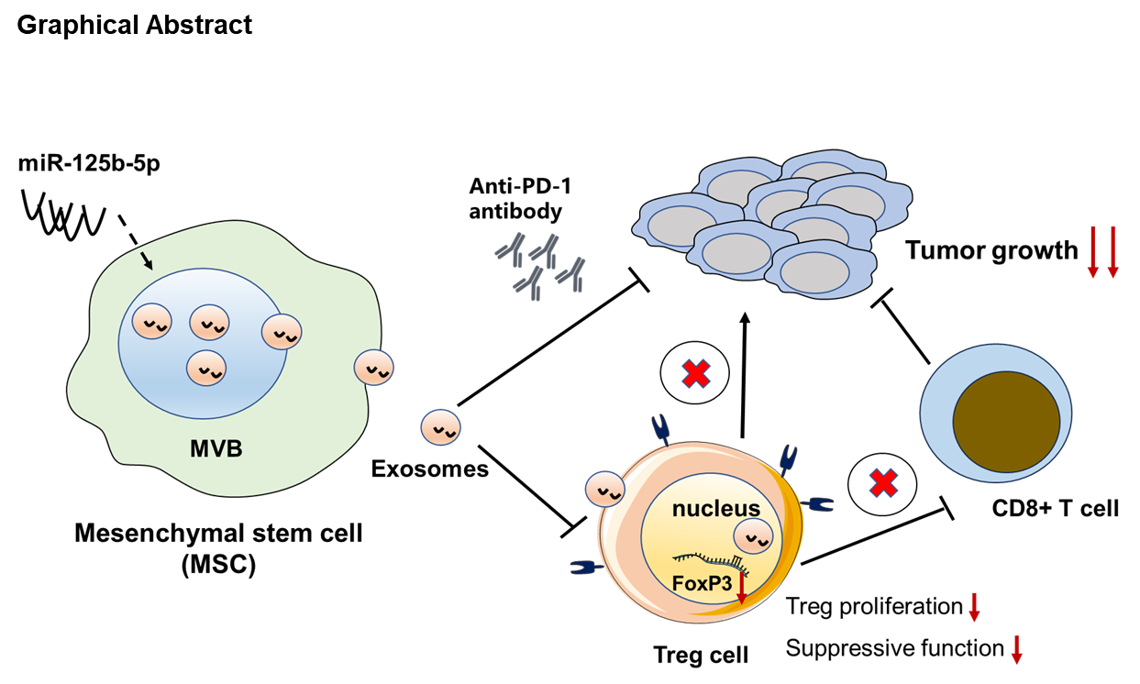
3. Reviewer 1: The discussion is well-written and comprehensively analyzes the study's findings. However, highlighting potential translational challenges (e.g., stability of exosomes, delivery mechanisms in humans, and potential off-target effects) would provide a balanced perspective and highlight areas for future research.
Response: We thank the reviewer’s suggestion. Exosomes derived from mesenchymal stem cells exhibit significant potential in the treatment of a wide range of diseases, as evidenced by the completion of over 200 preclinical studies in various animal models. Despite the need for further investigation into their mechanisms of action, stability, and potential off-target effects, the in vivo data evaluating their therapeutic efficacy has been encouraging. We further discussed this possibility in the revised manuscript on page 12.
“At present, research has shown that MSC-derived exosomes mediate the primary therapeutic effects of MSCs across various diseases, thereby establishing them as a promising cell-free therapeutic strategy in cancer treatment [28]. However, the clinical translation of MSC-derived exosomes is accompanied by both opportunities and challenges. Key issues necessitating immediate attention include improving the stability of exosomes, elucidating their mechanisms of action, and reducing potential off-target effects. Given that multiple factors can affect the stability of exosomes, numerous studies have been dedicated to enhancing their structural integrity and preserving their internal bioactive molecules through targeted modifications, and the incorporation of nanomaterials [29]. Moreover, the biodistribution of exosomes within the body is modulated by various factors, including the route of administration and the intrinsic physical and chemical properties of the exosomes [30]. Nevertheless, MSC-derived exosomes remain show significant promise for clinical use. Thus, by thoroughly studying how exosomes interact with different cell types and identifying crucial factors and targets for their therapeutic effects, we can improve therapeutic designs for more precise and effective outcomes.” (Page 12)

Responses to 2nd reviewer’s comments

Major points:
1. Reviewer 2: In Figure 1B, it appears that the arrows in the TEM image point to structures that are debris rather than exosomes. Exosomes are typically characterized by a distinct size range of 30-150 nm, and the authors did indeed mention this size distribution in their manuscript. The authors measure the sizes by NTA, which are 106.5 nm and 122.5 nm. Although the visible scale bar is absent, the typical saucer-like structure in the image is consistent with EVs by experience, while here the reader is misled by several arrows pointing to debris.
Response: We thank the Reviewer for raising this point. We apologize for a typographical error in indicating the exact exosomes in Fig. 1B. We re-analyzed the results and modified the right arrow points. Moreover, the scale bar is now clearly defined, as shown in the revised Fig. 1B, which hopefully can convince the reviewer and other audience that the results are impressive.
2. Reviewer 2: The language seriously compromises the readability of the manuscript. This affects not only simple grammar but also the logical flow, with sentences ending without proper connections or conclusions. This makes it hard to read. Just reading the abstract provides examples of the multiple language issues. The language requires substantial improvement by a native speaker, as causal connections are not logical, and sentences are incoherent.
Response: Thanks very much for the reviewer’s kind evaluation and suggestions for our manuscript. According to the referee’s suggestion, we have further polished the language using English check service to improve the logic and readability in the revised manuscript.
3. Reviewer 2: Statistics should be performed using non-parametric tests unless a test for normality justifying the use of a parametric t-test is provided. If parametric tests are used, the test for normality should be provided for the reviewer. The survival analysis does not provide statistics. A log-rank test is missing here.
Response: The statistical significance between two groups were analyzed by two tailed student’s t test, and the multiple groups comparison were analyzed by one-way ANOVA and Tukey’s post hoc test. Kaplan-Meier analysis was utilized to assess the survival curve of tumor-bearing mice, then compared using a nonparametric log-rank test. Statistical analysis was added to the revised figure 2B.

4. Reviewer 2: In Figure 1A: the asterisk should clearly indicate which time point the comparison is made. For the first comparison between control and MSC-EXO-miR-125b-5p, the upper end of the bracket has no data point. You cannot compare groups where tumors do not exist anymore. It needs to be stated that the statistics refer to day 32.
Response: We thank the Reviewer for the comment. The data shown in Figure 1A is the relative expression of miR-125b-5p in exosomes derived from MSC, as assessed by RT-qPCR. For the first comparison between control and MSC-EXO-miR-125b-5p, we added the statistical analysis and improved it in the revised figure 1A.
Data shown in figure 2A are tumor growth curves. In the control group of tumor-bearing mice, the tumor still exists but reaches an endpoint, resulting in a missing data. According to the reviewer’s suggestions, we further supplemented the relevant experimental data and made this point clear in the revised figure 2A, hopefully it will be easier for reviewers and other audiences to read and understand.

5. Reviewer 2: In the in vivo experiments, the authors delivered 100μg of MSC-derived exosomes containing miR-125b-5p via intravenous injection. The authors should provide specific data on the miR-125b-5p concentration in the exosomes (e.g., in nanograms per μg of exosome protein) to enable a more accurate estimation of the miR-125b-5p dose.
Response: We indeed agree that the concentration of miR-125b-5p in the exosomes is important for further research. In fact, the accurate concentration of miR-125b-5p could not be determined without absolute quantification. It is known that the dosage range of mesenchymal stem cell-derived exosomes may be around 10-100 μg/mouse. Moreover, as we previously reported, the dose of miR-125b-5p for the treatment of tumor-bearing mice is usually 2.5nmol/mouse. Therefore, to validate the optimal dosage, in this research, we utilized different doses of MSC-EXO-miR-125b-5p to treat tumors and compared to single treatment of AgomiR-125b-5p. The results indicated 100 μg/mouse MSC-EXO-miR-125b-5p is equaled to 2.5nmol AgomiR-125b-5p (as shown below). Finally, although the concentration was not measured, the dosage of exosomes utilized in vivo was quite reasonable.
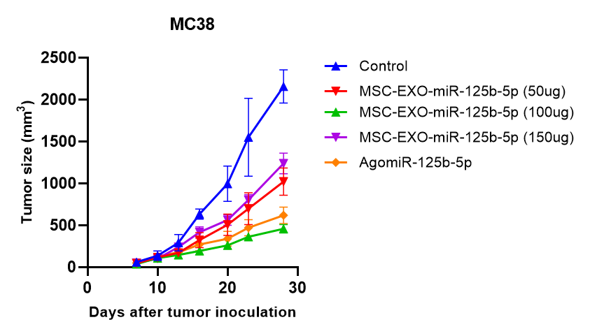
Tumor growth of MSC-EXO-miR-125b-5p and AgomiR-125b-5p treated mice

6. Reviewer 2: Why did the authors use BM-derived MSCs? The rationale needs to be discussed.
Response: In this study, the bone morrow derived mesenchymal stem cell (MSC) utilized were purchased from Wuhan Pricella Biotechnology Co., Ltd, a commercial supplier of well-established cell lines and primary cells. Since MSC derived from bone marrow are obtained from the bone marrow of adult individuals, they exhibit relatively low immunogenicity and circumvent the ethical concerns associated with embryonic sources. Moreover, these BM-derived MSCs demonstrate a relatively stable capacity for proliferation and differentiation under optimal culture conditions, thereby facilitating their manipulation and investigation by researchers. We implemented the suggestion from the reviewer and discussed it in the revised manuscript. (Page 4)
“At present, exosomes are considered to be excellent delivery vectors for lots of miRNAs [8]. Mesenchymal stem cell (MSC) has been identified as “multi-potent mesenchymal stromal cells” [9], with capable of continuously and stably secreting a significant quantity of exosomes. Notably, MSC-derived exosomes (MSC-EXO) have shown a great ability to target tumor tissues, exhibit substantial anti-tumor effects by modulating the tumor immune microenvironment or directly targeting tumor cells. However, since bone marrow (BM)-derived MSC presents a more stable capacity for proliferation and differentiation under optimal culture conditions, thereby facilitating their manipulation and investigation [10]. Therefore, in this study, we chose BM-derived MSC as carriers for the production of exosomes containing miR-125b-5p for anti-tumor immunotherapy.” (Page 4)

Minor points:
1. Reviewer 2: The MSC from mouse bone marrow were purchased from Procell. Please provide more details and the catalog number.
Response: We implemented the suggestion from the reviewer and added the catalog number of mouse MSCs in the Materials and methods section. (Page 5)
“The mesenchymal stem cell (MSC) from mouse bone marrow were purchased from Wuhan Pricella Biotechnology Co., Ltd. (Cat# CP-M131)” (Page 5)
Responses to 3rd reviewer’s comments
1. Reviewer 3: The authors did not provide detailed information on the way they treated the animals.
Response: In the section of Materials and methods, we described the treatment of mouse colon cancer model by MSC-EXO-miR-125b-5p with or without anti-PD-1 antibody. According to the reviewer’s suggestions, we further provided more detailed information on the way we treated animals, as shown in the revised manuscript. (Page 7)
“C57BL/6J (female, 8-12 weeks old) were subcutaneously injected with 0.1 ml PBS containing 5×10⁵ cells of MC38 in the right flank, when tumor size reached 50-100 mm3, the mice were randomly divided into four groups (n=5 mice/group). The tumor-bearing mice were administrated MSC-EXO-miR-125b-5p (100μg/mice) via intravenous injection into the tail veil, and intraperitoneal (i.p.) injection of anti-PD-1 antibody (100μg/mice) alone or in combination twice a week for two weeks. The control group was injected with MSC-EXO-miR-NC (100μg/mice) via intravenous injection in conjunction with IgG (i.p., 100μg/mice) for the same duration.” (Page 7)

2. Reviewer 3: It is not clear how they measured the RNA content of exosomes. They have to detail, after exosomes' isolation what protocol they used. Moreover, the miRNA-125b-5p exosome content may be different batch to batch. Have they considered this issue? Indeed, the evaluated the total RNA content and not the miRNA-125b-5p concentration.
Response: The relative expression of miR-125b-5p in exosomes was identified by RT-qPCR, to be detailed, after the isolation of exosome, we utilized RNeasy Mini Kit (Qiagen, Cat# 74104) to purify total RNA, and 0.5～1μg of total RNA was transcribed into cDNA with specific miRNA RT primers (this information is clearly indicated in the Materials and Methods section, page 6 ). According to the current experimental protocols, the concentration of total RNA, but not miRNA, was examined by ultraviolet spectrophotometric methods. Additionally, to exclude the possible variance between experiments, we performed at least three separate performances in all in vitro studies. Moreover, to obtain enough exosomes, we also expanded large numbers of MSC cells (～1×10⁹ cells) in one experiment panel, to ensure the conduct of relative in vitro and in vivo experiments.
“QIAzol-based total RNA purification from MSC-derived exosomes was performed by using RNeasy Mini Kit (Qiagen, Cat# 74104), and 0.5～1μg of total RNA was transcribed into cDNA with specific miRNA RT primers. The Bulge-loopTM miRNA RT-qPCR primer sets for the quantification of miR-125b-5p were synthesized by RiboBio.” (Page 6)

3. Reviewer 3: The authors did not indicate the concentration of exosomal RNA they used to treat cells. Did they perform a dose response curve? Otherwise how did they select the quantity to deliver cells and mice?
Response: The data shown in Figure 2 contains important in vivo experimental data in this study. In general, the dosage range of mesenchymal stem cell-derived exosomes may be around 10-100 μg/mouse. However, as we previously reported, the dose of miR-125b-5p for the treatment of tumor-bearing mice is usually 2.5nmol/mouse. In this research, we utilized different doses of MSC-EXO-miR-125b-5p to treat tumors and compared to single treatment of AgomiR-125b-5p. The results indicated the efficacy of 100ug/mouse MSC-EXO-miR-125b-5p is equaled to 2.5nmol AgomiR-125b-5p. The tumor growth curve was shown as referred to Reviewer 2 Question 5. Thus, we believe this in vivo experimental design is quite reasonable.

4. Reviewer 3: In the Introduction, it is important to provide a clear and accurate definition of mesenchymal stromal cells (MSCs). While the paper refers to these cells as stem cells, they are technically classified as stromal cells. Moreover, the authors should specify that the current methods for isolating MSCs result in heterogeneous, non-clonal populations of stromal cells, which can include stem cells with various multipotent capabilities, committed progenitors, and differentiated cells (PMID: 34943786, 34398443).
Response: We thank the reviewer for pointing out this issue. Mesenchymal stromal cells are present in the stromal component of several tissues, including multipotent stem cells, progenitors, and differentiated cells. The term “mesenchymal stem cell (MSC)” was introduced by Caplan in the early 1990s, has been named as ‘multi-potent mesenchymal stromal cells’. Though they have some common characteristics, the biophysical properties between them are still different when they are present together. This statement inspired the scientific community to approve this nomenclature in all written documents and oral communications. Additionally, under optimal culture conditions, bone marrow-derived mesenchymal stem cells (MSCs) are capable of continuously and stably secreting a significant quantity of exosomes, whereas the secretion from mesenchymal stromal cells may be comparatively lower. Nevertheless, in this study, we utilized MSC obtained from a commercial company, which are expected to produce exosomes with greater precision and efficacy. We implemented the suggestion from the reviewer and discussed it in the introduction section in the revised manuscript.

Again, we are grateful to the reviewers for their time and suggestions to improve the clarity and scientific quality of this review article. We hope our manuscript is now acceptable for publication in the “Stem cell research & therapy”.

