Supplementary Information for
Identification and evaluation of tumor pyroptosis-associated antigens for design a vaccine candidate against lung cancer
Truc Ly Nguyen¹, Heebal Kim^{1,2,3*}
¹ Department of Agricultural Biotechnology and Research Institute of Agriculture and Life Sciences, Seoul National University, Seoul 08826, Republic of Korea
² Interdisciplinary Program in Bioinformatics, Seoul National University, Seoul 08826, Republic of Korea
³ eGnome, Inc., Seoul 05836, Republic of Korea
*Corresponding author: Heebal Kim. heebal@snu.ac.kr

I. Supplementary Figure
Figure S1. The three-dimensional structure and information of model 1 predicted by SWISS-MODEL.
Figure S2. Prediction and validation of three-dimensional structure of the vaccine construct. (A) The 3D structure of rank_1 (model 1) predicted by I-TASSER representation in cartoon retrieved from PyMOL. (B) Ramachandran plot validation of model 1 by PROCHECK tool. (C) The 3D structure of model 3 after refining by GalaxyRefine representation in cartoon retrieved from PyMOL. (D) Ramachandran plot validation of refined structure by PROCHECK tool.
Figure S3. Prediction and validation of three-dimensional structure of the vaccine construct. (A) Predicted LDDT per residue for the 5 models obtained from AlphaFold Colab. (B) The 3D structure of rank_1 (model 2) representation in cartoon retrieved from PyMOL. (C) Ramachandran plot validation by PROCHECK tool.
II. Supplementary Table
Table S1. Sequence of the protein CARD8 (UniProt ID: Q9Y2G2).
Table S2. Sequence of the protein NAIP (UniProt ID: Q13075).
Table S3. Sequence of the protein NLRP1 (UniProt ID: Q9C000).
Table S4. Sequence of the protein NLRP3 (UniProt ID: Q96P20).
Table S5. Structure information of 5 models predicted by I-TASSER.
Table S6. Structure information of 5 refined models obtained from GalaxyRefine.
I. Supplementary Figure
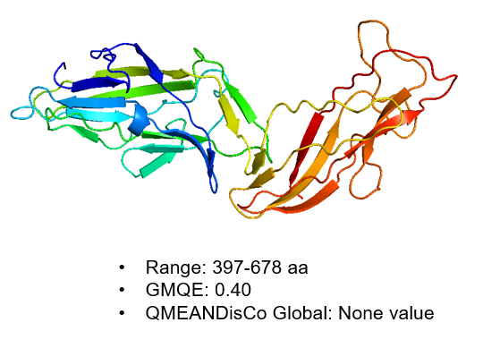
Figure S1. The three-dimensional structure and information of model 1 predicted by SWISS-MODEL.

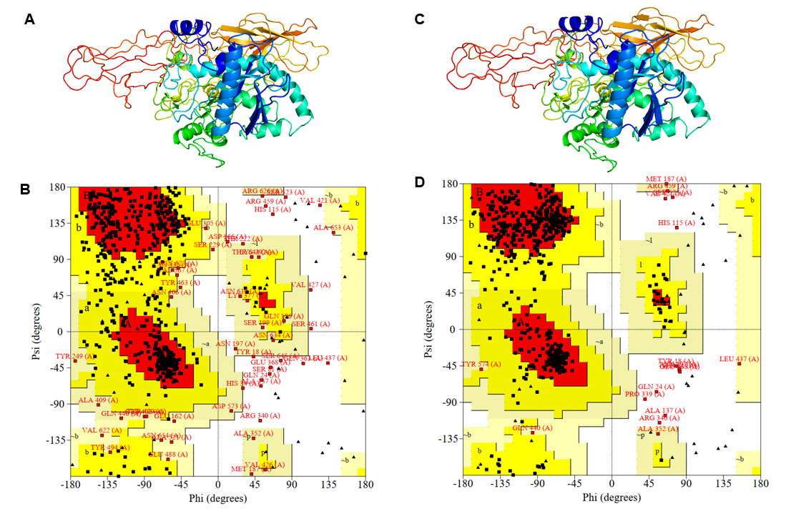
Figure S2. Prediction and validation of three-dimensional structure of the vaccine construct. (A) The 3D structure of rank_1 (model 1) predicted by I-TASSER representation in cartoon retrieved from PyMOL. (B) Ramachandran plot validation of model 1 by PROCHECK tool. (C) The 3D structure of model 3 after refining by GalaxyRefine representation in cartoon retrieved from PyMOL. (D) Ramachandran plot validation of refined structure by PROCHECK tool.

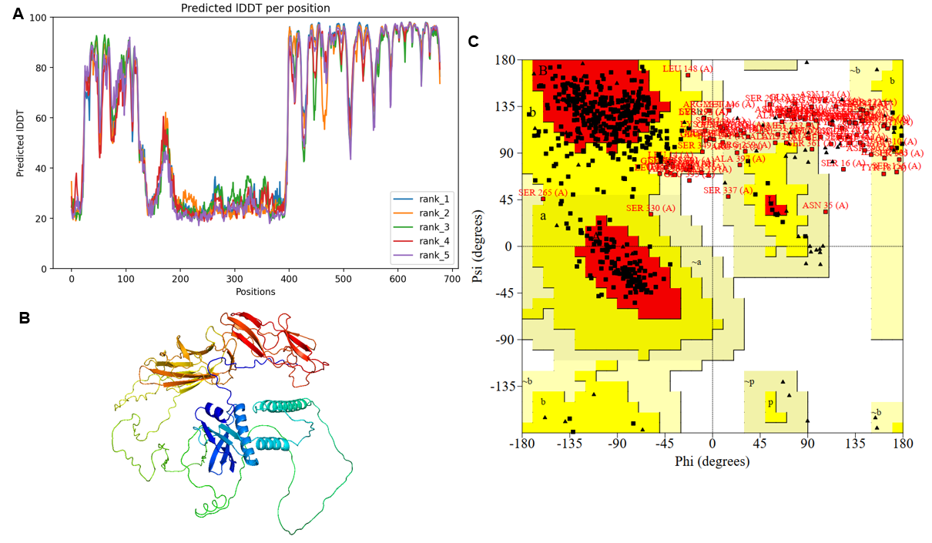
Figure S3. Prediction and validation of three-dimensional structure of the vaccine construct. (A) Predicted LDDT per residue for the 5 models obtained from AlphaFold Colab. (B) The 3D structure of rank_1 (model 2) representation in cartoon retrieved from PyMOL. (C) Ramachandran plot validation by PROCHECK tool.

II. Supplementary Table
Table S1. Sequence of the protein CARD8 (UniProt ID: Q9Y2G2).
>sp|Q9Y2G2|CARD8_HUMAN Caspase recruitment domain-containing protein 8 OS=Homo sapiens OX=9606 GN=CARD8 PE=1 SV=2
MEKKECPEKSSSSEEELPRRDSGSSRNIDASKLIRLQGSRKLLVDNSIRELQYTKTGIFF
QAEACVTNDTVYRELPCVSETLCDISHFFQEDDETEAEPLLFRAVPECQLSGGDIPSVSE
EQESSEGQDSGDICSEENQIVSSYASKVCFEIEEDYKNRQFLGPEGNVDVELIDKSTNRY
SVWFPTAGWYLWSATGLGFLVRDEVTVTIAFGSWSQHLALDLQHHEQWLVGGPLFDVTAE
PEEAVAEIHLPHFISLQAGEVDVSWFLVAHFKNEGMVLEHPARVEPFYAVLESPSFSLMG
ILLRIASGTRLSIPITSNTLIYYHPHPEDIKFHLYLVPSDALLTKAIDDEEDRFHGVRLQ
TSPPMEPLNFGSSYIVSNSANLKVMPKELKLSYRSPGEIQHFSKFYAGQMKEPIQLEITE
KRHGTLVWDTEVKPVDLQLVAASAPPPFSGAAFVKENHRQLQARMGDLKGVLDDLQDNEV
LTENEKELVEQEKTRQSKNEALLSMVEKKGDLALDVLFRSISERDPYLVSYLRQQNL
Table S2. Sequence of the protein NAIP (UniProt ID: Q13075).
>sp|Q13075|BIRC1_HUMAN Baculoviral IAP repeat-containing protein 1 OS=Homo sapiens OX=9606 GN=NAIP PE=1 SV=3
MATQQKASDERISQFDHNLLPELSALLGLDAVQLAKELEEEEQKERAKMQKGYNSQMRSE
AKRLKTFVTYEPYSSWIPQEMAAAGFYFTGVKSGIQCFCCSLILFGAGLTRLPIEDHKRF
HPDCGFLLNKDVGNIAKYDIRVKNLKSRLRGGKMRYQEEEARLASFRNWPFYVQGISPCV
LSEAGFVFTGKQDTVQCFSCGGCLGNWEEGDDPWKEHAKWFPKCEFLRSKKSSEEITQYI
QSYKGFVDITGEHFVNSWVQRELPMASAYCNDSIFAYEELRLDSFKDWPRESAVGVAALA
KAGLFYTGIKDIVQCFSCGGCLEKWQEGDDPLDDHTRCFPNCPFLQNMKSSAEVTPDLQS
RGELCELLETTSESNLEDSIAVGPIVPEMAQGEAQWFQEAKNLNEQLRAAYTSASFRHMS
LLDISSDLATDHLLGCDLSIASKHISKPVQEPLVLPEVFGNLNSVMCVEGEAGSGKTVLL
KKIAFLWASGCCPLLNRFQLVFYLSLSSTRPDEGLASIICDQLLEKEGSVTEMCVRNIIQ
QLKNQVLFLLDDYKEICSIPQVIGKLIQKNHLSRTCLLIAVRTNRARDIRRYLETILEIK
AFPFYNTVCILRKLFSHNMTRLRKFMVYFGKNQSLQKIQKTPLFVAAICAHWFQYPFDPS
FDDVAVFKSYMERLSLRNKATAEILKATVSSCGELALKGFFSCCFEFNDDDLAEAGVDED
EDLTMCLMSKFTAQRLRPFYRFLSPAFQEFLAGMRLIELLDSDRQEHQDLGLYHLKQINS
PMMTVSAYNNFLNYVSSLPSTKAGPKIVSHLLHLVDNKESLENISENDDYLKHQPEISLQ
MQLLRGLWQICPQAYFSMVSEHLLVLALKTAYQSNTVAACSPFVLQFLQGRTLTLGALNL
QYFFDHPESLSLLRSIHFPIRGNKTSPRAHFSVLETCFDKSQVPTIDQDYASAFEPMNEW
ERNLAEKEDNVKSYMDMQRRASPDLSTGYWKLSPKQYKIPCLEVDVNDIDVVGQDMLEIL
MTVFSASQRIELHLNHSRGFIESIRPALELSKASVTKCSISKLELSAAEQELLLTLPSLE
SLEVSGTIQSQDQIFPNLDKFLCLKELSVDLEGNINVFSVIPEEFPNFHHMEKLLIQISA
EYDPSKLVKLIQNSPNLHVFHLKCNFFSDFGSLMTMLVSCKKLTEIKFSDSFFQAVPFVA
SLPNFISLKILNLEGQQFPDEETSEKFAYILGSLSNLEELILPTGDGIYRVAKLIIQQCQ
QLHCLRVLSFFKTLNDDSVVEIAKVAISGGFQKLENLKLSINHKITEEGYRNFFQALDNM
PNLQELDISRHFTECIKAQATTVKSLSQCVLRLPRLIRLNMLSWLLDADDIALLNVMKER
HPQSKYLTILQKWILPFSPIIQK

Table S3. Sequence of the protein NLRP1 (UniProt ID: Q9C000).
>sp|Q9C000|NLRP1_HUMAN NACHT, LRR and PYD domains-containing protein 1 OS=Homo sapiens OX=9606 GN=NLRP1 PE=1 SV=1
MAGGAWGRLACYLEFLKKEELKEFQLLLANKAHSRSSSGETPAQPEKTSGMEVASYLVAQ
YGEQRAWDLALHTWEQMGLRSLCAQAQEGAGHSPSFPYSPSEPHLGSPSQPTSTAVLMPW
IHELPAGCTQGSERRVLRQLPDTSGRRWREISASLLYQALPSSPDHESPSQESPNAPTST
AVLGSWGSPPQPSLAPREQEAPGTQWPLDETSGIYYTEIREREREKSEKGRPPWAAVVGT
PPQAHTSLQPHHHPWEPSVRESLCSTWPWKNEDFNQKFTQLLLLQRPHPRSQDPLVKRSW
PDYVEENRGHLIEIRDLFGPGLDTQEPRIVILQGAAGIGKSTLARQVKEAWGRGQLYGDR
FQHVFYFSCRELAQSKVVSLAELIGKDGTATPAPIRQILSRPERLLFILDGVDEPGWVLQ
EPSSELCLHWSQPQPADALLGSLLGKTILPEASFLITARTTALQNLIPSLEQARWVEVLG
FSESSRKEYFYRYFTDERQAIRAFRLVKSNKELWALCLVPWVSWLACTCLMQQMKRKEKL
TLTSKTTTTLCLHYLAQALQAQPLGPQLRDLCSLAAEGIWQKKTLFSPDDLRKHGLDGAI
ISTFLKMGILQEHPIPLSYSFIHLCFQEFFAAMSYVLEDEKGRGKHSNCIIDLEKTLEAY
GIHGLFGASTTRFLLGLLSDEGEREMENIFHCRLSQGRNLMQWVPSLQLLLQPHSLESLH
CLYETRNKTFLTQVMAHFEEMGMCVETDMELLVCTFCIKFSRHVKKLQLIEGRQHRSTWS
PTMVVLFRWVPVTDAYWQILFSVLKVTRNLKELDLSGNSLSHSAVKSLCKTLRRPRCLLE
TLRLAGCGLTAEDCKDLAFGLRANQTLTELDLSFNVLTDAGAKHLCQRLRQPSCKLQRLQ
LVSCGLTSDCCQDLASVLSASPSLKELDLQQNNLDDVGVRLLCEGLRHPACKLIRLGLDQ
TTLSDEMRQELRALEQEKPQLLIFSRRKPSVMTPTEGLDTGEMSNSTSSLKRQRLGSERA
ASHVAQANLKLLDVSKIFPIAEIAEESSPEVVPVELLCVPSPASQGDLHTKPLGTDDDFW
GPTGPVATEVVDKEKNLYRVHFPVAGSYRWPNTGLCFVMREAVTVEIEFCVWDQFLGEIN
PQHSWMVAGPLLDIKAEPGAVEAVHLPHFVALQGGHVDTSLFQMAHFKEEGMLLEKPARV
ELHHIVLENPSFSPLGVLLKMIHNALRFIPVTSVVLLYHRVHPEEVTFHLYLIPSDCSIR
KAIDDLEMKFQFVRIHKPPPLTPLYMGCRYTVSGSGSGMLEILPKELELCYRSPGEDQLF
SEFYVGHLGSGIRLQVKDKKDETLVWEALVKPGDLMPATTLIPPARIAVPSPLDAPQLLH
FVDQYREQLIARVTSVEVVLDKLHGQVLSQEQYERVLAENTRPSQMRKLFSLSQSWDRKC
KDGLYQALKETHPHLIMELWEKGSKKGLLPLSS
Table S4. Sequence of the protein NLRP3 (UniProt ID: Q96P20).
>sp|Q96P20|NLRP3_HUMAN NACHT, LRR and PYD domains-containing protein 3 OS=Homo sapiens OX=9606 GN=NLRP3 PE=1 SV=3
MKMASTRCKLARYLEDLEDVDLKKFKMHLEDYPPQKGCIPLPRGQTEKADHVDLATLMID
FNGEEKAWAMAVWIFAAINRRDLYEKAKRDEPKWGSDNARVSNPTVICQEDSIEEEWMGL
LEYLSRISICKMKKDYRKKYRKYVRSRFQCIEDRNARLGESVSLNKRYTRLRLIKEHRSQ
QEREQELLAIGKTKTCESPVSPIKMELLFDPDDEHSEPVHTVVFQGAAGIGKTILARKMM
LDWASGTLYQDRFDYLFYIHCREVSLVTQRSLGDLIMSCCPDPNPPIHKIVRKPSRILFL
MDGFDELQGAFDEHIGPLCTDWQKAERGDILLSSLIRKKLLPEASLLITTRPVALEKLQH
LLDHPRHVEILGFSEAKRKEYFFKYFSDEAQARAAFSLIQENEVLFTMCFIPLVCWIVCT
GLKQQMESGKSLAQTSKTTTAVYVFFLSSLLQPRGGSQEHGLCAHLWGLCSLAADGIWNQ
KILFEESDLRNHGLQKADVSAFLRMNLFQKEVDCEKFYSFIHMTFQEFFAAMYYLLEEEK
EGRTNVPGSRLKLPSRDVTVLLENYGKFEKGYLIFVVRFLFGLVNQERTSYLEKKLSCKI
SQQIRLELLKWIEVKAKAKKLQIQPSQLELFYCLYEMQEEDFVQRAMDYFPKIEINLSTR
MDHMVSSFCIENCHRVESLSLGFLHNMPKEEEEEEKEGRHLDMVQCVLPSSSHAACSHGL
VNSHLTSSFCRGLFSVLSTSQSLTELDLSDNSLGDPGMRVLCETLQHPGCNIRRLWLGRC
GLSHECCFDISLVLSSNQKLVELDLSDNALGDFGIRLLCVGLKHLLCNLKKLWLVSCCLT
SACCQDLASVLSTSHSLTRLYVGENALGDSGVAILCEKAKNPQCNLQKLGLVNSGLTSVC
CSALSSVLSTNQNLTHLYLRGNTLGDKGIKLLCEGLLHPDCKLQVLELDNCNLTSHCCWD
LSTLLTSSQSLRKLSLGNNDLGDLGVMMFCEVLKQQSCLLQNLGLSEMYFNYETKSALET
LQEEKPELTVVFEPSW
Table S5. Structure information of 5 models predicted by I-TASSER.
Model | C-score | Exp. TM-Score | Exp. RMSD | No. of decoys | Cluster density
Model 1 | -2.10 | 0.46±0.15 | 13.2±4.1Å | 128 | 0.0410
Model 2 | -2.10 | ˗ | ˗ | 126 | 0.0412
Model 3 | -2.35 | ˗ | ˗ | 114 | 0.0322
Model 4 | -4.11 | ˗ | ˗ | 112 | 0.0055
Model 5 | -4.12 | ˗ | ˗ | 102 | 0.0055

Table S6. Structure information of 5 refined models obtained from GalaxyRefine.
Model | GDT-HA | RMSD | MolProbity | Clash score | Poor rotamers | Rama favored
Initial* | 1.0000 | 0.000 | 3.097 | 7.6 | 13.1 | 71.3
MODEL 1 | 0.9218 | 0.483 | 2.321 | 16.8 | 0.4 | 88.2
MODEL 2 | 0.9314 | 0.459 | 2.260 | 16.1 | 0.7 | 89.9
MODEL 3 | 0.9399 | 0.448 | 2.390 | 17.1 | 1.3 | 88.9
MODEL 4 | 0.9314 | 0.464 | 2.309 | 15.8 | 1.1 | 88.9
MODEL 5 | 0.9310 | 0.468 | 2.276 | 15.6 | 0.5 | 88.8
*Initial is the 3D structure which was predicted by I-TASSER (Model 3).

