Supplementary information

Renal replacement therapy and concurrent fluconazole therapy increase linezolid-related thrombocytopenia among adult patients
Yueh-chun Hsu (1), Szu-ying Chen (3)(4), Yung-jun Hung (1), Yu-wei Huang (2)

Affiliations
- Department of Pharmacy, E-Da hospital, Kaohsiung 824, Taiwan;
- Department of Anesthesiology, Emergency and Critical Care Center, E-Da hospital, I-Shou University, Kaohsiung 824, Taiwan; Department of Nursing, Fooyin University, Kaohsiung 831, Taiwan.;
- Division of Occupational Medicine, E-Da Hospital, I-Shou University, Kaohsiung 824, Taiwan;
- Division of Surgical Intensive Care, Department of Critical Care Medicine, E-Da Hospital, I-Shou University, Kaohsiung 824, Taiwan; Department of Nursing, Fooyin University, Kaohsiung 831, Taiwan.

Figure Legend (Supplementary information)
Figure 1S.
Enrolled patients were classified into four groups according to renal function, including CrCL≥ 60, 60> CrCL≥ 30, CrCL< 30 mL/min, and renal replacement therapy (RRT). Patients received renal replacement therapy (RRT) were with higher to develop thrombocytopenia (with vs without RRT: 79.2% vs 44.6%, p=0.0032). But, there was no significant difference between CrCL≥ 60, 60 >CrCL≥ 30, CrCL< 30 mL/min.

Figure 2S.
All patients were also classified into two groups according to the duration of linezolid, including 14>duration≥ 5 and duration≥ 14 days. Patients with duration≥ 14 days were with higher risk of thrombocytopenia (14>duration≥ 5 days vs duration≥ 14 days: 43.14% vs 63.83% p= 0.0403).

Figure 1S.
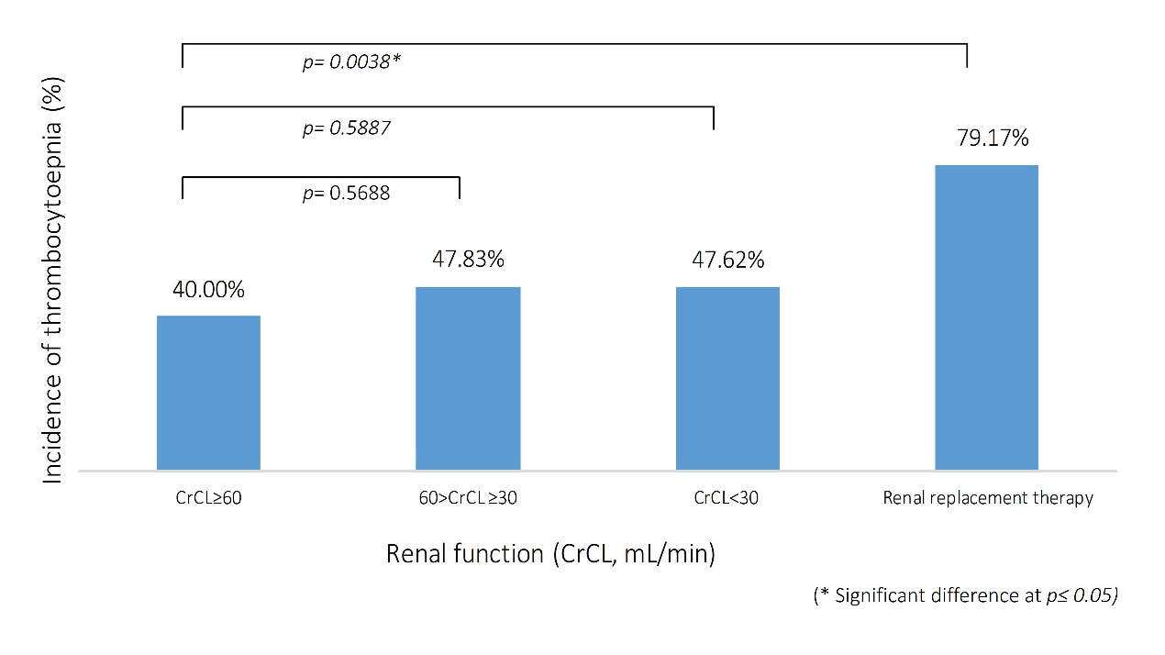

Figure 2S.
