Supplementary Figure

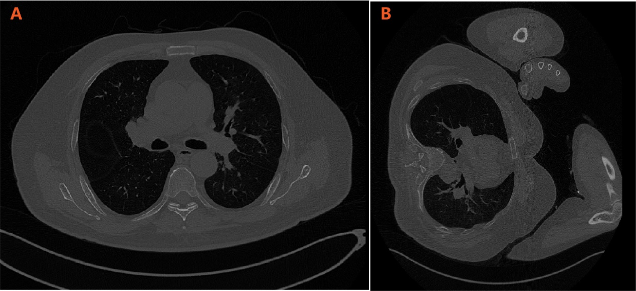
Figure S1. Different posture while performing two CT scans in the same patient. (A) pre-compression CT in supine position. (B) post-compression CT in prone position.

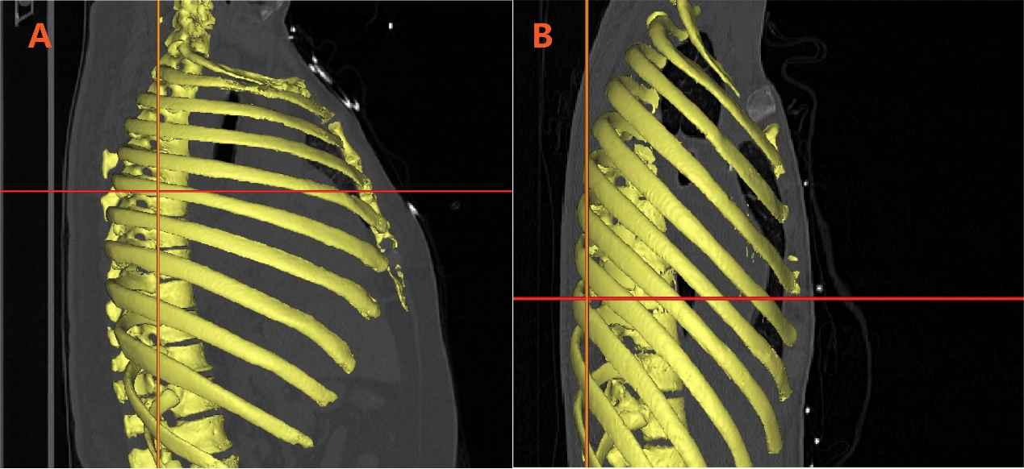
Figure S2. Two patients were randomly selected and their bony thorax were reconstructed, the horizontal line indicated the fourth intercostal plane. A. 46, M, CA of cardiac origin, the forth intercostal plane were at the same level of the sixth vertebral plane, discharged with good neurological outcome; B. 23Y, F, CA of non-cardiac origin, discharged with unfavorable neurological outcome the forth intercostal plane were at the same level of the nineth vertebral plane

