Supplementary File

Figure S1: Variation in weight loss of carbon steel coupons (left side) and corrosion inhibition (right side) versus the testing time; [a] in pure water, [b] in formation water, [c] in diesel fuel and [d] in sulfuric acid.
[a] | 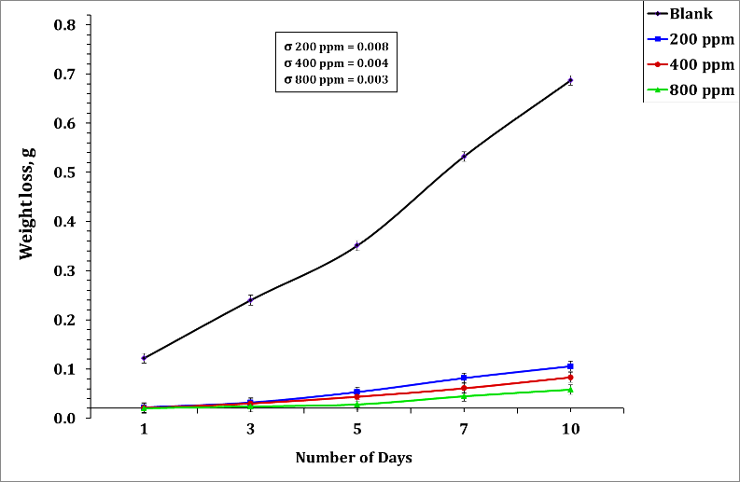 | 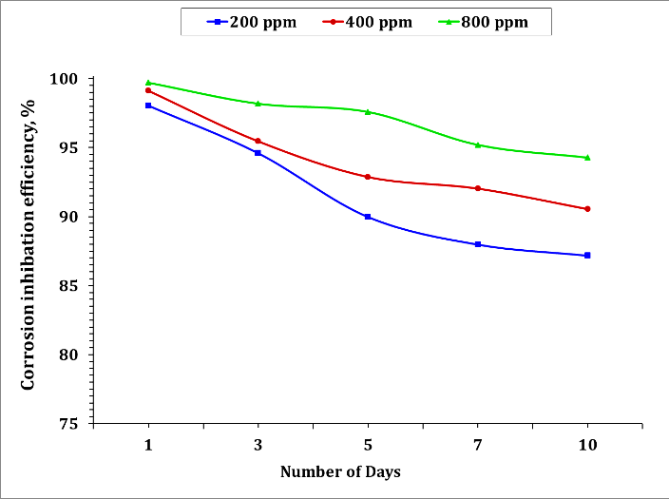
[b] | 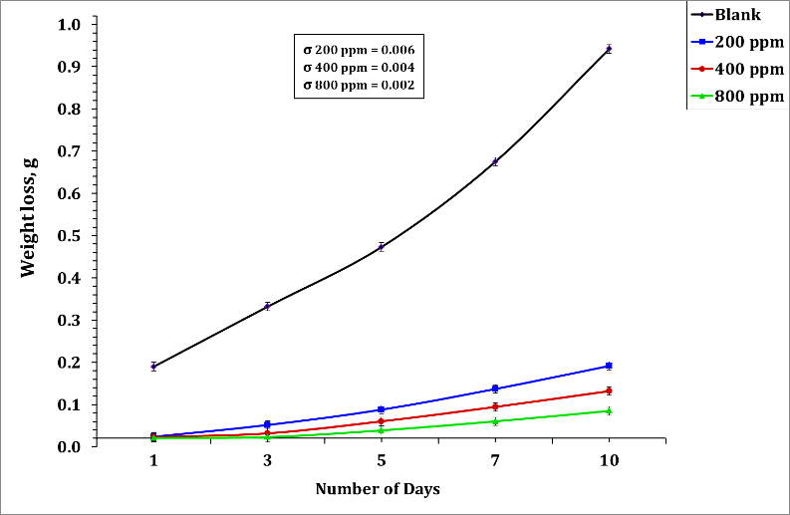 | 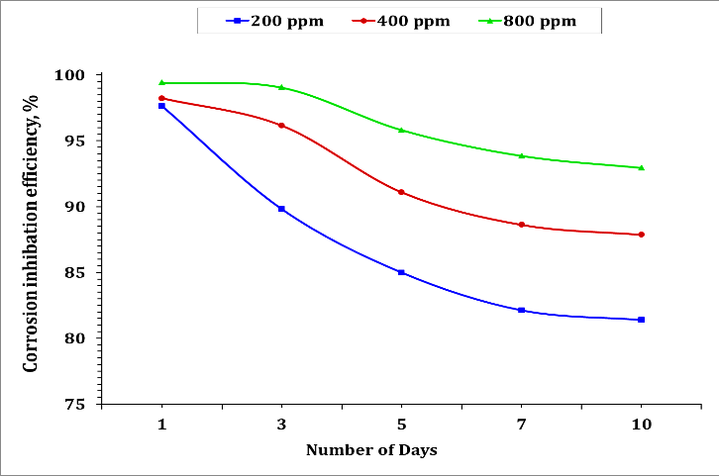
[c] | 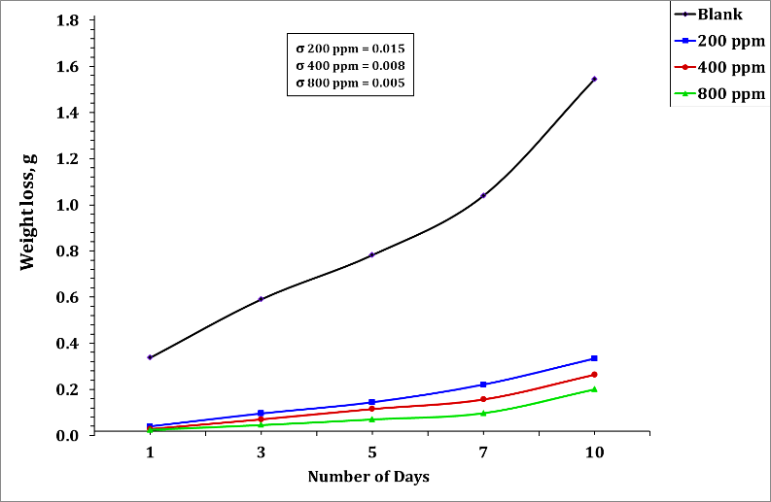 | 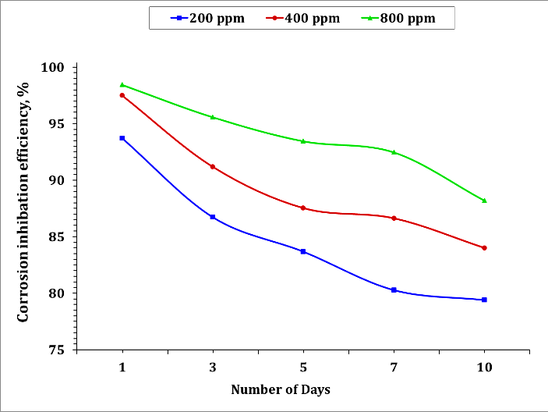
[d] | 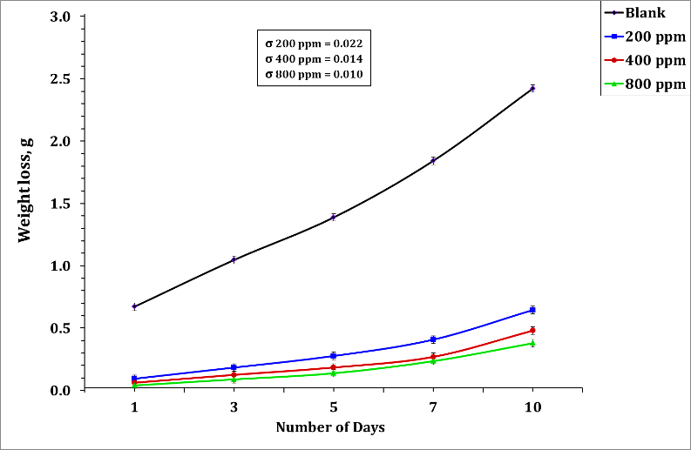 | 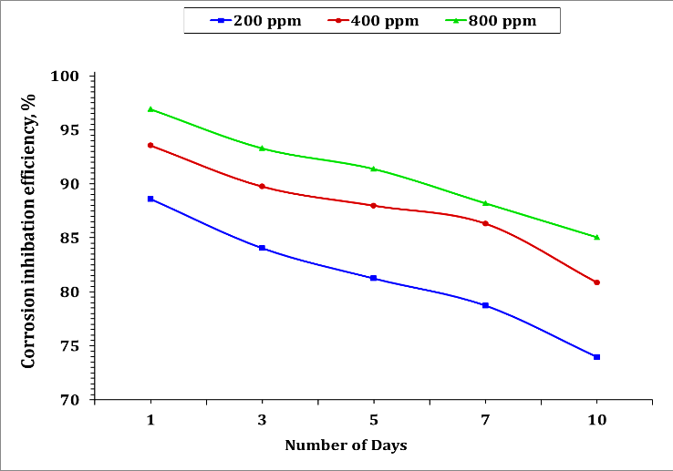

Figure S2: Variation in weight loss of carbon steel coupons (left side) and corrosion inhibition (right side) versus the testing time at different temperature; [a] in pure water, [b] in formation water, [c] in diesel fuel and [d] in sulfuric acid.
[a] | 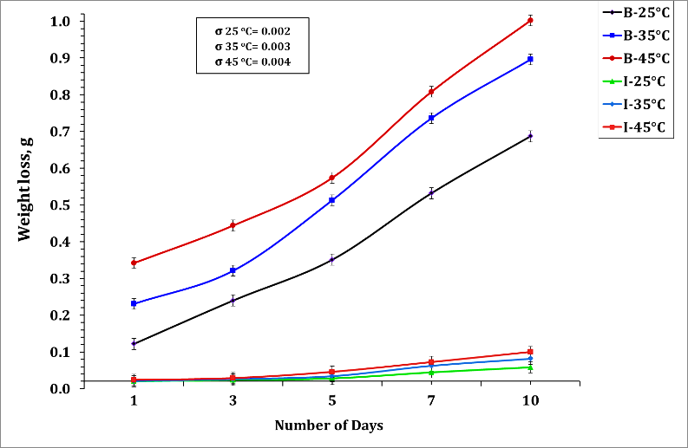 | 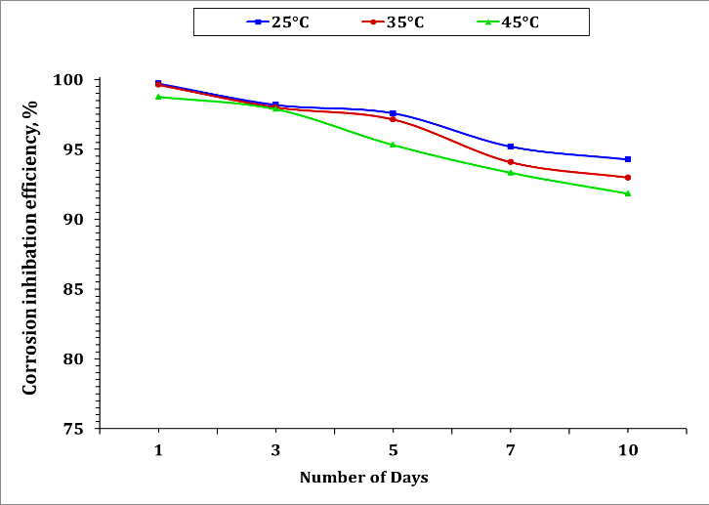
[b] | 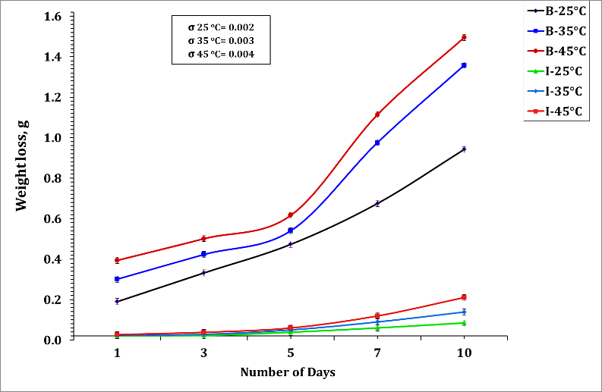 | 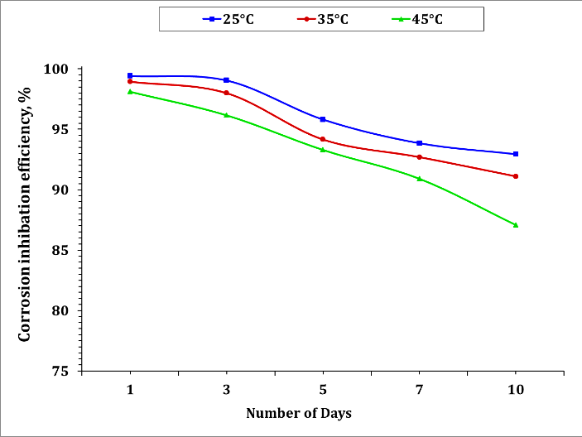
[c] | 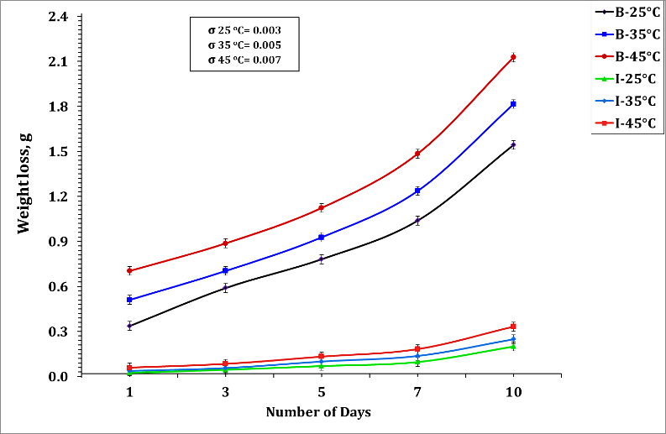 | 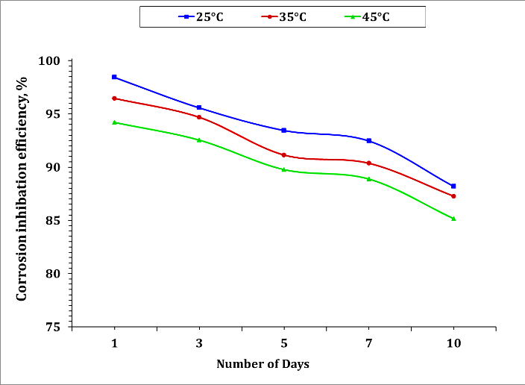
[d] | 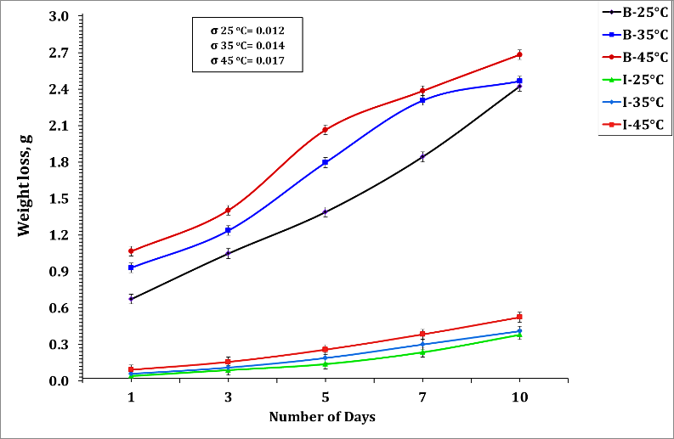 | 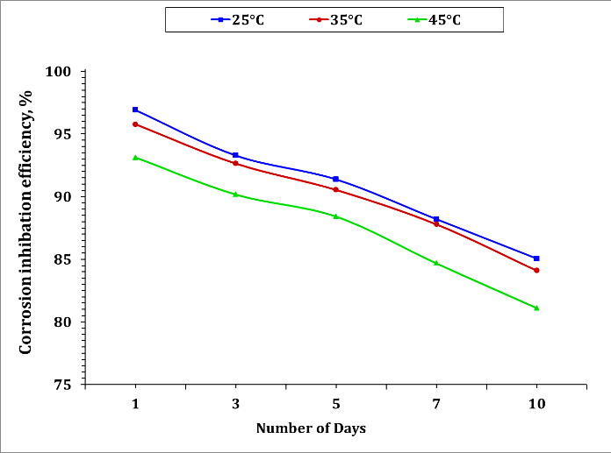

Table 1. List of the utilized chemical reagents and their suppliers.
No. | Name of chemical reagent | Source and purity
1 | Styrene monomer | Fisher Chemical (USA), 99.5%
2 | Potassium persulfate (_{KOOSO4}) | Solvay Chemicals (USA),98 %
3 | Anionic – alkyl sulfonates surfactant | Zschimmer&Schwars (Germany)
4 | Zinc chloride (ZnCl₂) | Sigma-Aldrich (Germany), 99.99%
5 | Tri-ethyl amine (C₂H₅)₃N | Fisher Chemical (USA), 99.0%

