Supplementary Information for
Cationic polymer-in-salt electrolytes for fast metal ion conduction and solid-state battery applications

Fangfang Chen^{1,2*}, Xiaoen Wang^{1*}, Michel Armand³, Maria Forsyth^{1,2∗}

¹Institute for Frontier Materials, Deakin University, Geelong, VIC 3217, Australia.
²ARC Centre of Excellence for Electromaterials Science (ACES), Deakin University, Burwood, 3125, Australia.
³CIC Energigune, Parque Tecnológico de Álava, Albert Einstein 48, 01510 Miñano, Álava, Spain.
*e-mail: fangfang.chen@deakin.edu.au, xiaoen.wang@deakin.edu.au, maria.forsyth@deakin.edu.au.

The Supplementary file includes below contents:
Page 2 | Supplementary Figure 1
Page 3 | Supplementary Figure 2, Table 1
Page 4 | Detailed analysis of cation-anion coordination structure
Page 5 | Supplementary Figure 3
Page 6 | Supplementary Figure 4
Page 7 | Supplementary Figure 5
Page 8 | Supplementary Figure 6
Page 9 | Supplementary Figure 7
Page 10-13 | Supplementary Computational and Experimental Details

Supplementary Figure 1. Snapshots of the simulated K⁺ and Mg²⁺ systems. a-b, the K11 and K12 systems; c-d, the Mg11 and Mg12 systems. e. chemical structure of PDADMA FSI. Color codes: polycations, transparent blue; FSI– coordinated only by Polycations, Purple; FSI– coordinated only by metal ions, green; K⁺, yellow; Mg²⁺, blue.

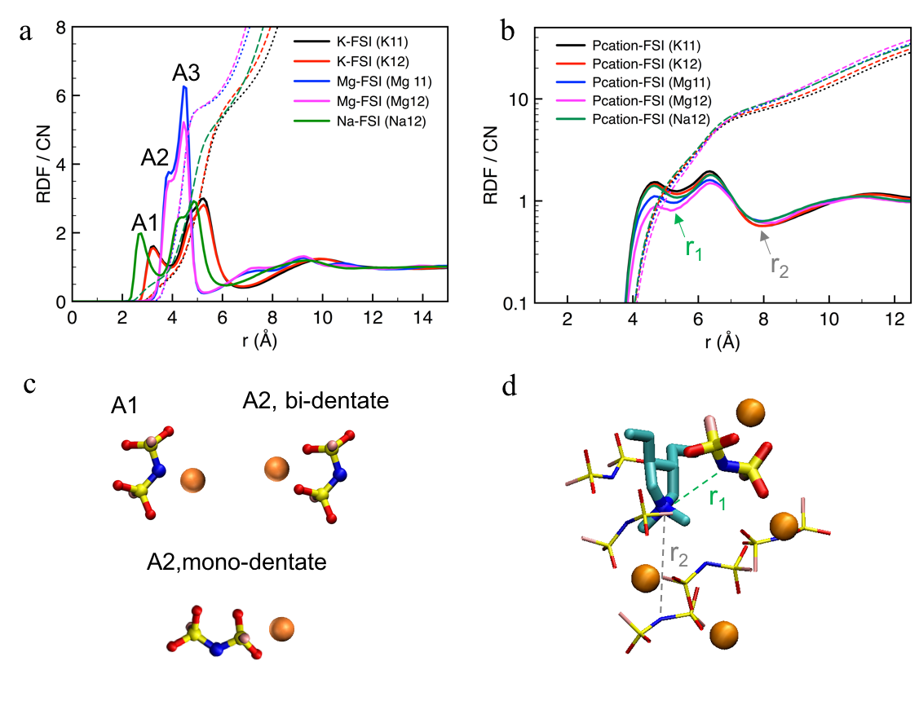Supplementary Figure 2. Radial distribution function (RDF) of cation-anion and the illustration of their coordination structures. a-b, RDF of Me⁺-FSI– and Polycation-FSI– (through the nitrogen atoms in both polycation and FSI–) for K11, K12, Mg11, Mg12 and Na12 systems. c, three types of Me⁺-FSI– coordination structures related to three split RDF peaks between 2 and 6 Å in a. d, a snapshot to show the FSI– anions surrounding a selected polycation, and the FSI– within a cutoff distance of r₁ or r₂ (marked in b) is displaced using bold or thin sticks, respectively.

Supplementary Table 1. Coordination number CN calculated at different cutoff distances decided in RDF for different ion-ion coordination.
 | Li 1:1.5^{[1]} | Na12 | K11 | K12 | Mg11 | Mg12
Me⁺-FSI– | 5.65 / 4.8 | 6.15 / 5.6 | 6.75 / 6.0 | 6.85 / 6.4 | 5.25 / 5.7 | 5.25 / 5.7
P⁺-FSI– (at r₁) | 5.35 / 1.9 | 5.35 / 1.9 | 5.35 / 1.8 | 5.35 / 1.8 | 5.25 / 1.5 | 5.15 / 1.2
P⁺-FSI– (at r₂) | 7.85 / 8.5 | 7.85 / 8.7 | 7.95 / 7.7 | 7.95 / 8.1 | 7.95 / 8.6 | 8.05 / 9.2

Detailed analysis of cation-anion coordination structure
The radial distribution functions (RDF) are calculated to investigate the ion-ion coordination geometries. Supplementary Figure 2a shows the RDFs calculated between the metal ions (Me⁺) and the nitrogen atom in FSI–. The first prominent RDF peak between 2 Å and 6 Å is related to the first Me-FSI coordination shell, and different coordination geometries result in 2-3 subdivided peaks. Both Na-FSI and K-FSI RDFs have three subdivided peaks, A1, A2 and A3, relating to different Me-FSI coordination geometries of Me-nitrogen, Me-O(bidentate) and Me-O (monodentate), respectively, as shown in Supplementary Figure 2c. This variety is due to the delocalized negative charges on these atomic sites in a FSI –. These three Me-FSI coordination structures are also commonly seen in FSI –-based ionic liquids.¹⁻² The Me-nitrogen coordination is energetically less favorable compared to the other two types of Me-O coordination.¹ In the case of Mg-FSI coordination, only bidentate and monodentate Mg-O coordination are present. The monodentate peaks are prominent for all cases, which sterically more effective to support the coordination with a large number of FSI–, particularly at high salt concentrations. ²
The coordination distance of the same type of mono or bidentate Me-FSI coordination is obviously different, partially due to the difference in ionic radii of metal ions, which follows Mg²⁺ (0.072 nm) < Li⁺ (0.076nm) < Na⁺ (0.102 nm) < K⁺ (0.138 nm). The left shift of the monodentate peak of Mg-FSI is 0.08 nm relative to that of K-FSI, which is larger than their ionic radii difference of 0.066 nm. This is consistent with the fact that Mg²⁺ has much stronger polarizing power than K⁺. Although the coordination distance of Mg-FSI is relatively short, it has a CN of 5.7 that is very similar to the CN of 6.0 for K-FSI in K11 system. This inarguably reflects that the higher binding energy is required to stabilize a more compact solvation structure for Mg²⁺ than for K⁺ since both have the similar CN of FSI –.
The RDFs of the polycation-FSI coordination are very similar among all systems. It is noted that the coordination number of Polycation-FSI is read at r₂, the valley near 8 Å in Supplementary Figure 2b instead of at the first split position r₁. The snapshot in Supplementary Figure 2d shows the FSI– surrounding one selected polycation unit, and it suggests that the r₂ (the first pronounced valley) should be used to calculate the CN of Polycation-FSI. The CN is affected slightly by the anion concentration, the lowest CN is 7.7 for K11 system, and the highest CN is 9.2 for Mg12 system. The CNs of all the other systems are between 8 and 9, as seen in Supplementary Table 1.
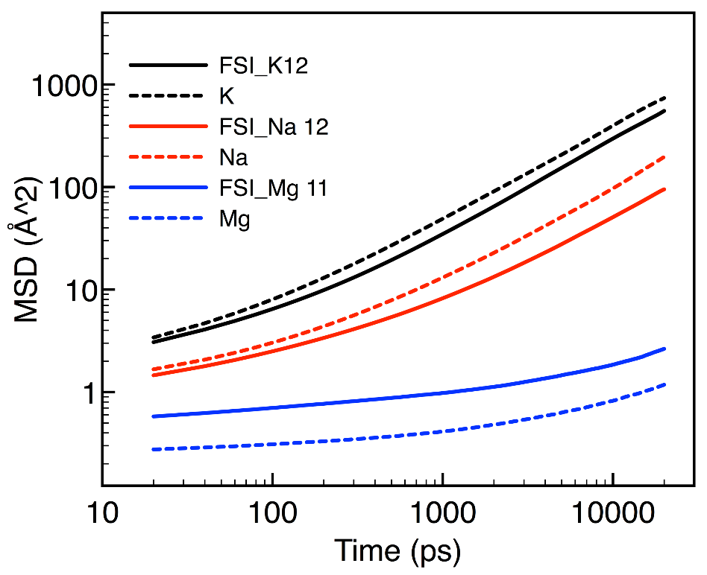
Supplementary Figure 3. The 20 ns mean square displacement (MSD) of FSI– and metal ions of the K12, N12 and Mg11 systems, calculated using a 30 ns MD trajectory file at 353 K.

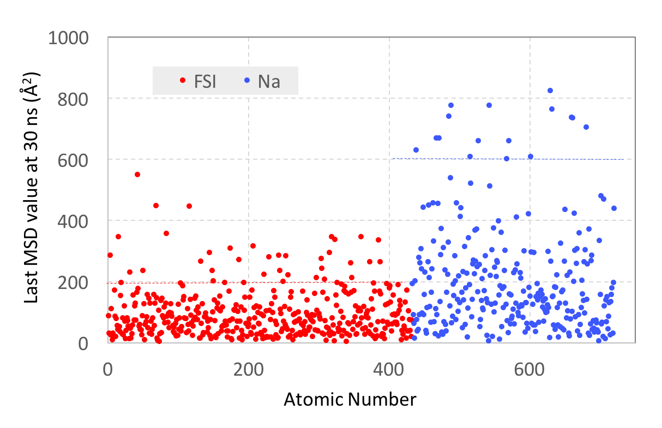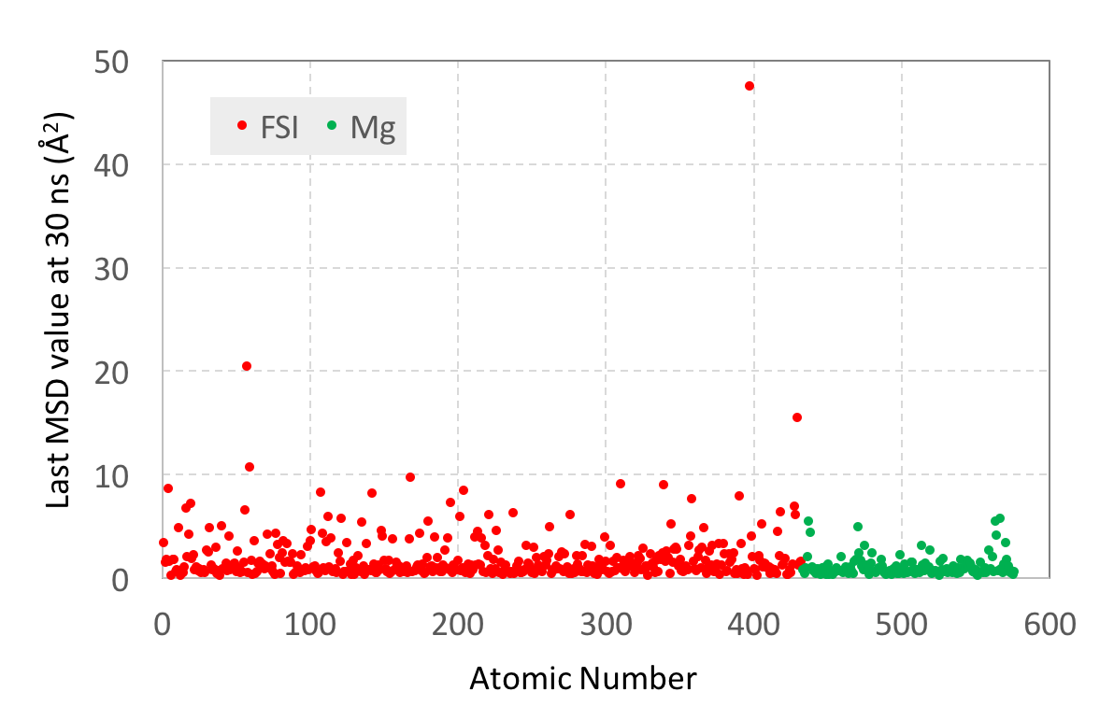
a
b
Supplementary Figure 4. The last MSD value of each metal ion and FSI– after 30 ns of trajectory used to distinguish the most and least diffusive ions. a, for the Na12 system; b, for the Mg11 system. According to the last MSD value, the fast and slow ions were arbitrary selected from the top and bottom 6% of Na⁺ or Mg²⁺, and the top and bottom 8% of FSI–.

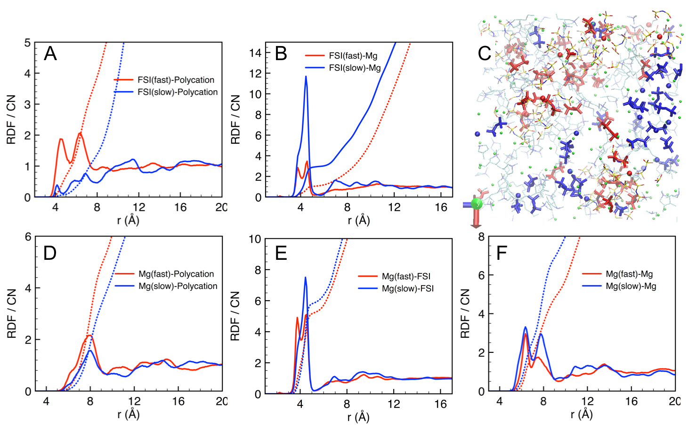
Supplementary Figure 5. RDFs and coordination number (CN) of different fast or slow group of ions for the Mg11 system. a-b, fast or slow FSI – coordinated with polycations and Mg²⁺; c, a snapshot showing the selected fast and slow Mg²⁺ (red and blue sphere) as well as the fast and slow FSI – (red and blue stick). d-f, fast or slow Mg²⁺ coordinated with polycations, FSI– and Mg²⁺.

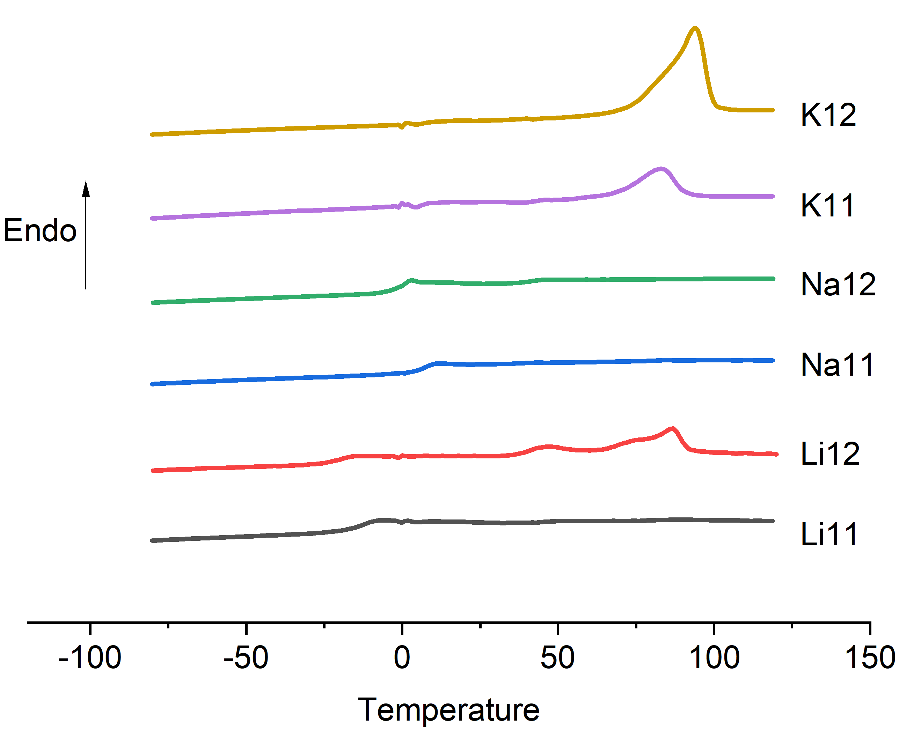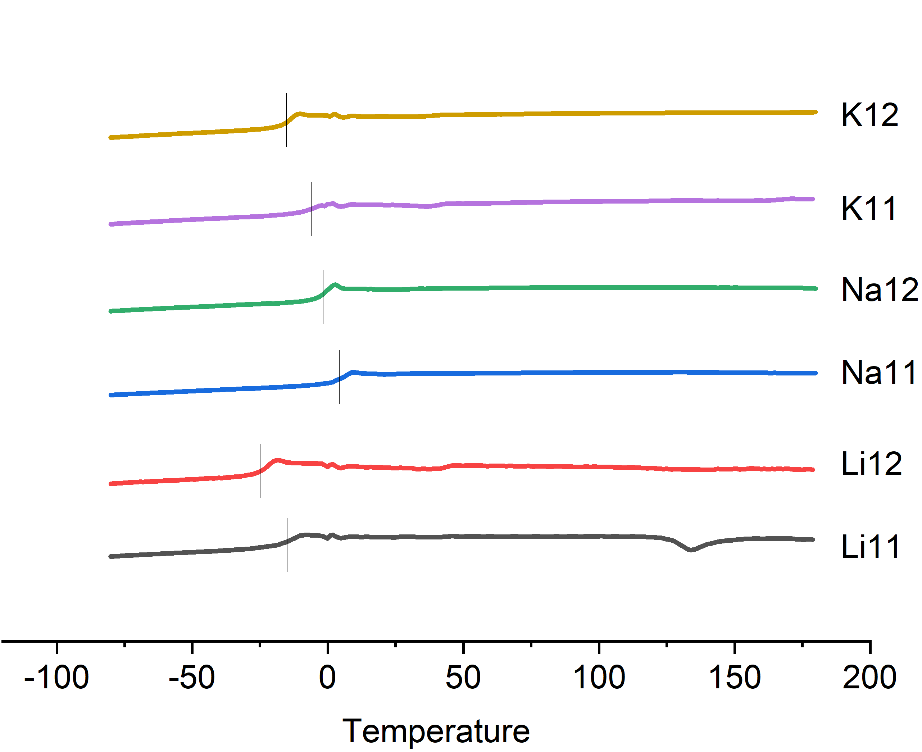
(b)
(a)
Supplementary Figure 6. The DSC traces of different PolyIL-in-salt systems. a, the first heating cycle. b, the second heating cycle.

Supplementary Figure 7. Electrochemical properties of the Na14 system. a, the chronoamperometry profile of Na/Na14 PE/Na symmetric cell with a constant polarization voltage of 10 mV. b. the Nyquist plots of the cell before and after polarization; d, Na plating/stripping test of a Na/Na12 PE/Na symmetric cell with increased applied current density of 0.05 to 0.6 mA cm⁻². All tests were performed at 80 ºC.

Supplementary Computational and Experimental Details

Table 2. Number of the salt ions added to the PDADMA FSI
system | Me⁺ (Na, K, Mg) | FSI⁻
K11 | 144 | 144
K12/Na12 | 288 | 288
Na14 | 576 | 576
Mg11 | 144 | 288
Mg12 | 288 | 576

The binding energy E_{b} of Me-FSI was calculated using the optimized conformational energy of the ion pair and each individual ion based on the equation of E_{b} = E (Me-FSI) – E(Me) – E(FSI). Please note that the binding energy of Mg-FSI is calculated using an Mg(FSI)₂ ion pair based on the equation of E_{b} = [E(Mg(FSI)₂) – E(Mg) – 2E(FSI)]/2. The geometry optimization was conducted using density functional theory at B3LYP/6311++g** level of theory. The frequency was calculated to check if there are any imaginary frequencies.
The self-diffusion coefficient D was estimated using the last part of the MSD profile based on equation:
$$D=\frac{1}{N}\sum_{i=1}^{N}{\frac{∆MSD(t)}{6∆t}}$$
The averaged D is obtained by selecting N different starting time-points in the MSD profile, and multiple different Δt time periods are also used to ensure that the same D is reached.
The cage-restructuration correlation function C(t) in Fig 2b was calculated based on equation³:
$$C\left(t\right)=\frac{〈h(0)∙h(t)〉}{〈{h(0)}^{2}〉}$$
The h(t) is defined in this work as a coordination-state step function, which has three different values, as shown in Fig 3a, corresponding to three specific situations. h(0) =1 means that the initial cage A is formed at an initial time. At time t, if the coordinated anions are all the old anions in the initial cage A, even if there are some left, h(t) =1; if the coordinated anions are mixed with both old and new anions, h(t) =0.9; if only one or no old anions remains in the coordination shell, it is defined that a new coordination shell/cage is formed, and h(t) =0. All cage-restructuration periods were identified throughout the 30 ns MD trajectory for all ions, and each initial cage should consist of no less than 3 FSI– anions as the smaller coordination number will not be considered as a cage.
Accumulative distance as a function of cage restructuration period in Fig 3c & 3e is used to analyse the total distance that metal ions can move in the same cage restructuration period. First, all cage restructuration periods are identified throughout the 30 ns trajectory for all metal ions. Then, those restructuration periods are grouped according to their time length, and the number of occurrences of each period is also counted as frequency. Finally, the final travel distance of the metal ions in the same group of restructuration periods is accumulated. Fig 3d calculates the average travel distance for each type of restructuration period, that is, the accumulative distance divided by the frequency. A cage- restructuration period is counted as the time period between two initial time points of cage A and cage B, which appear one after another, as illustrated in Fig 3a.

Materials and electrolyte preparation
Materials: Poly(diallyldimethylammonium) chloride (20 wt% water solution, Mw = 400 000 ~500 000) (PDADMC) was purchased from SigmaAldrich. Potassium bis(uorosulfonyl)imide (KFSI, >99.9%, Suzhou Fluolyte China), sodium bis(fluorosulfonyl)imide (NaFSI, 99.99%, University of Wollongong) and lithium bis(fluorosulfonyl)imide (LiFSI, >99.9%) were used as received. Acetonitrile (HPLC, >99.9%) was purchased from SigmaAldrich and used without further purification.
PolyIL synthesis: The poly(diallyldimethylammonium) bis(fluorosulfonyl)imide, PDADMA FSI is prepared according to previous literature ⁴ but with slight adjust. In particular, the diluted PDADMC and LiFSI) solutions (in DI water) were mixed and stirred at least for 4 hours. The mole ratio of PDADMAC repeat units and LiFSI salt was kept 1:1.1. The precipitated white solid was thoroughly wash by DI water. Then the filtrate water solution was checked with AgNO₃ solution until no AgCl precipitate appeared. Finally, the prepared PDADMA FSI was dried in vacuum oven for at least 24 hours before further use.
Polymer electrolyte preparations: For thermal property characterisations, polyIL-salt binary electrolytes were prepared according to previous method.⁵ For conductivity and electrochemical tests, the flexible composite electrolytes incorporated electrospun PVDF nanofibers were prepared by solution casting method. First the casting solution was prepared by dissolving PDADMA FSI and salt in to acetonitrile, then the mixture was stirred at room temperature for 4 hours to make sure the polymer and salt were completely dissolved. The cast solution was applied onto the PVDF mat, the mass fraction of PDADMA FSI-salt mixture in composite electrolyte was kept around 90 %. The solvent was remove in a homemade dry box flowed under dry Ar gas and the composite membranes were finally dried in vacuum oven at least 48 hours at 60 ºC. The final thickness of composite electrolytes is around 100 μm.

Characterisations
Differential scanning calorimetry (DSC): The glass transition temperature (T_{g}) of the PEs was determined by differential scanning calorimetry using A Netzsch DSC (214 polyma). First, the instrument was calibrated by measuring the cyclohexane sample. Then, the electrolytes samples were cut into pieces (6-8 mg) and packed in the Al pans in an argon-filled glove box. The samples were first cooled down to -80 ºC and then heated up to 180 ºC, followed by another heating and cooling circle. The heating and cooling rate was 10 ºC/min.
Ionic conductivity: The ionic conductivity was measured by electrochemical impedance spectroscopy (EIS) by using MTZ-35 impedance analyser (Bio-Logic), equipped with Eurotherm 2204 temperature controller. First, cast membrane was cut into round samples (with diameter of 13 mm). Then electrolyte was sealed into a home-designed barrel cell. The measurements were performed from 30 ºC to 100 ºC with 10 ºC of interval. The frequency range for the impedance measurement was from 1 MHz to 1 Hz, with applied amplitude of 10 mV. In order to improve the contact between solid polymer electrolyte and electrodes, two heating scans were performed and the conductivities reported in this work were based on the second scan if not specified. The conductivity (σ) of the electrolyte is calculated from the following equation:
$$σ=\frac{l}{R×S}$$
Where $l$ is the sample thickness, R is the resistance obtained by EIS and S is sample area.
Transference number: The transference number (t_{Na+}) is defined as the ratio of the current carried by target ions (e.g. Na+ in Na electrolyte systems) to the total ionic current carried by all the charge species. To measure the t_{Na+}, the Bruce-Vincent method was used.⁶ Typically, a Na/PE/Na symmetric cell was assembled and a constant voltage of 10 mV was applied on the cell. Then the resultant current decay profile as function of time was recorded till a steady state reached (4 hours in this study). Before and after the polarization, EIS was performed to determine the interfacial resistance, and the t_{Na+} was calculated via the following equation:
$$t_{Na+}=\frac{I_{ss}(∆V-I_{0}R_{i,0})}{I_{0}(∆V-I_{ss}R_{i,ss})}$$
Where I₀ and I_{ss} are the initial current and steady state current, respectively. $∆$V is the applied constant voltage which is 10 mV, R_{i,0} and R_{i,ss} are the interfacial resistances determined from Nyquist plots before and after polarization, respectively.
Plating/stripping measurements: Galvanostatic cycling measurements were carried out using the Multi Potentiostat VMP3 at 80±1ºC. The current density for the Na plating/stripping was set at 0.5 mA cm⁻², with 1 hour charge and 1 hour discharge (0.5 mAh cm⁻²).
Reference

1. Han, S.-D., Borodin, O., Seo, D.M., Zhou, Z.-B. & Henderson, W.A. Electrolyte Solvation and Ionic Association. Journal of The Electrochemical Society 161, A2042-A2053 (2014).
2. Chen, F., Howlett, P. & Forsyth, M. Na-Ion Solvation and High Transference Number in Superconcentrated Ionic Liquid Electrolytes: A Theoretical Approach. The Journal of Physical Chemistry C 122, 105-114 (2018).
3. Rabani, E., Gezelter, J.D. & Berne, B.J. Calculating the hopping rate for self-diffusion on rough potential energy surfaces: Cage correlations. The Journal of Chemical Physics 107, 6867-6876 (1997).
4. Wang, X. et al. Preparation and characterization of gel polymer electrolytes using poly(ionic liquids) and high lithium salt concentration ionic liquids. Journal of Materials Chemistry A 5, 23844-23852 (2017).
5. Wang, X. et al. Poly(Ionic Liquid)s-in-Salt Electrolytes with Co-coordination-Assisted Lithium-Ion Transport for Safe Batteries. Joule 3, 2687-2702 (2019).
6. Evans, J., Vincent, C.A. & Bruce, P.G. Electrochemical measurement of transference numbers in polymer electrolytes. Polymer 28, 2324-2328 (1987).

