Table 1. Respondents distribution by organizational units

Organizational unit | The percentage of respondents in relation  to the number of employees
Orthopedics (Orth) | 100.00
Endocrine surgery (End sur) | 86.67
Otorhinolaryngology (ORL) | 75.00
Digestive surgery (Dig sur) | 61.33
Ophthalmology (Opht) | 60.71
Thoracic surgery (Thor sur) | 57.14
Vascular surgery (Vasc sur) | 44.12
Emergency Room (ER) | 43.48
Urology (Urol) | 41.67
Pediatric surgery (Pediat sur) | 40.91
Gynecology (Gynec) | 39.08
Plastic and rec. surgery (Plast sur) | 37.14
Minimally invasive surgery (MISur) | 36.36
Neurosurgery (Neuro sur) | 35.09
Cardiac surgery (Cardio sur) | 34.51
Anesthesiology (Anesth) | 10.18

Table 2. Respondents distribution by gender, profession,
place of living, age and length of service

 | The answer | Frequency | Percentage
Gender | f | 330 | 66.00
Gender | m | 170 | 34.00
Profession | nurse | 336 | 67.20
Profession | midwife | 21 | 4.20
Profession | doctor of medicine | 123 | 24.60
Profession | other | 20 | 4.00
Place of living | city | 403 | 80.60
Place of living | the countryside | 97 | 19.40
Age distribution of respondents | up to 21 years | 2 | 0.40
Age distribution of respondents | 22-31 years | 89 | 17.80
Age distribution of respondents | 32-41 years | 180 | 36.00
Age distribution of respondents | 42-51 years | 141 | 28,20
Age distribution of respondents | 52-61 years | 68 | 13.60
Age distribution of respondents | 62-71 years | 19 | 3.80
Age distribution of respondents | more than 71 years | 1 | 0.20
Years of service | up to 10 years | 169 | 33.80
Years of service | 11-20 years | 166 | 33.20
Years of service | 21-30 years | 109 | 21.80
Years of service | 31-40 years | 54 | 10.80
Years of service | more than 40 years | 2 | 0.40

Table 3. Results of the comparison of categories of respondents in relation to scores
on the HH questionnaire; Z-Mann Whintney test, χ2-Kruskal Wallis test;

 |  | N | Mean | Std. Deviation | Z/χ2 | sig
Gender | f | 330 | 4.52 | 4.97 | -1.029 ^{Z} | .303
Gender | m | 170 | 3.74 | 5.81 | -1.029 ^{Z} | .303
Place of living | city | 403 | 4.28 | 5.04 | -.259 ^{Z} | .795
Place of living | the countryside | 97 | 4.14 | 6.19 | -.259 ^{Z} | .795
Organizational Unit (OU) | Anesth | 23 | 5.91 | 4.69 | 96.489 ^{χ2} | .000
Organizational Unit (OU) | MISur | 8 | -1.38 | 4.66 | 96.489 ^{χ2} | .000
Organizational Unit (OU) | Pediat sur | 28 | 2.93 | 6.05 | 96.489 ^{χ2} | .000
Organizational Unit (OU) | Dig sur | 46 | 6.67 | 3.29 | 96.489 ^{χ2} | .000
Organizational Unit (OU) | End sur | 26 | 3.08 | 6.73 | 96.489 ^{χ2} | .000
Organizational Unit (OU) | Gynec | 68 | 2.66 | 5.72 | 96.489 ^{χ2} | .000
Organizational Unit (OU) | Thor sur | 20 | 9.55 | 4.06 | 96.489 ^{χ2} | .000
Organizational Unit (OU) | Cardio sur | 39 | 2.51 | 5.84 | 96.489 ^{χ2} | .000
Organizational Unit (OU) | Neuro sur | 20 | 7.00 | 4.19 | 96.489 ^{χ2} | .000
Organizational Unit (OU) | Opht | 34 | 7.21 | 3.65 | 96.489 ^{χ2} | .000
Organizational Unit (OU) | ORL | 39 | 0.92 | 5.60 | 96.489 ^{χ2} | .000
Organizational Unit (OU) | Orth | 71 | 4.83 | 3.68 | 96.489 ^{χ2} | .000
Organizational Unit (OU) | Plast sur | 13 | 5.69 | 4.11 | 96.489 ^{χ2} | .000
Organizational Unit (OU) | ER | 30 | 3.00 | 5.63 | 96.489 ^{χ2} | .000
Organizational Unit (OU) | Urol | 20 | 4.70 | 3.67 | 96.489 ^{χ2} | .000
Organizational Unit (OU) | Vasc sur | 15 | 2.80 | 1.08 | 96.489 ^{χ2} | .000
Profession | Midwives | 21 | -2.29 | 2.28 | 40.331 ^{χ2} | .000
Profession | MD | 20 | 4.75 | 5.16 | 40.331 ^{χ2} | .000
Profession | Other | 11 | 5.09 | 4.37 | 40.331 ^{χ2} | .000
Profession | Nurse | 336 | 4.37 | 5.26 | 40.331 ^{χ2} | .000
Profession | Specialization, MD | 46 | 5.11 | 5.67 | 40.331 ^{χ2} | .000
Profession | MD specialist | 57 | 4.81 | 4.71 | 40.331 ^{χ2} | .000
Profession | Student | 1 | 1.00 |  | 40.331 ^{χ2} | .000
Profession | Terapist | 6 | 7.17 | 4.12 | 40.331 ^{χ2} | .000
Profession | Student volonter | 2 | 2.00 | 2.83 | 40.331 ^{χ2} | .000
Formal hand  hygiene training | No | 132 | 3.77 | 5.70 | -1.058 ^{Z} | .290
Formal hand  hygiene training | Yes | 368 | 4.43 | 5.11 | -1.058 ^{Z} | .290
Alcohol based hand wash | No | 40 | 3.73 | 6.18 | -.205 ^{Z} | .837
Alcohol based hand wash | Yes | 460 | 4.30 | 5.20 | -.205 ^{Z} | .837

Table 4. Correlation of knowledge about hand hygiene with job satisfaction
and assessment of the manager's leadership qualities

 |  | Score  10 | Score  11 | Score  12 | Score  13 | Score  14 | Score  15 | Score  16a | Score  16b | Score  16c | Score  16d | Score  16e | Score  16f | Score  17 | SCORE
Overall  rating of the leader | R | .202 | -.028 | -.209 | .000 | -.321 | -.007 | .261 | .259 | .835 ** | -.401 | .307 | .254 | -.550 | -.132
Overall  rating of the leader | sig | .552 | .935 | .538 | 1,000 | .335 | .984 | .438 | .442 | .001 | .222 | .358 | .452 | .080 | .699
Job satisfaction | R | -.406 | .422 | .008 | -.507 | .025 | -.163 | -.375 | -.468 | -.099 | .800 ** | -.030 | -.240 | -.052 | -.122
Job satisfaction | sig | .216 | .196 | .982 | .112 | .942 | .631 | .256 | .147 | .771 | .003 | .929 | .477 | .879 | .721
*Scores 10 to 17 represents answers on WHO HHC questionaire

Table 5. Correlation between total leader rating, job satisfaction and HH knowledge questionnaire score on the one hand and percentage of staff who had formal
HH trainingand percentage of staff using alcohol-based agents

 |  | Formal hand hygiene training |  | Alcohol based hand wash
Total_leader_rating | R | .337 | 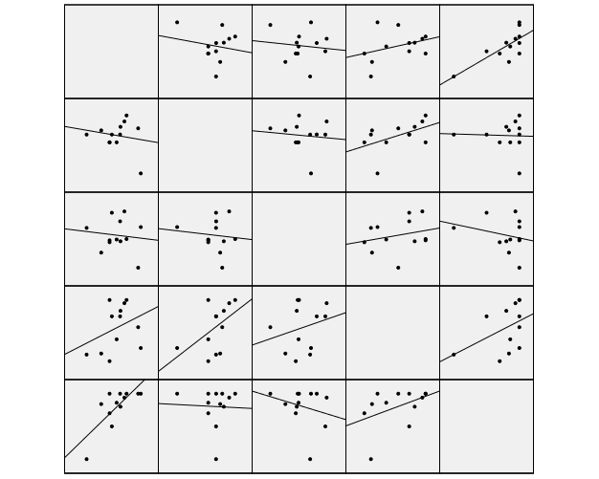 | .755 **
Total_leader_rating | sig | .284 |  | .004
Job_satisfaction | R | .494 |  | -.039
Job_satisfaction | sig | .103 |  | .904
SCORE | R | .246 |  | -.254
SCORE | sig | .441 |  | .426

Table 6. Correlation between overall leader rating, job satisfaction and HH questionnaire score on the one hand and clinic overbooking characteristics on the other

 |  | Number of beds |  | Number of doctors |  | Number of med ses tech |  | Average length of treatment |  | Number of BO days
Overall rating of the leader | R | -.024 | 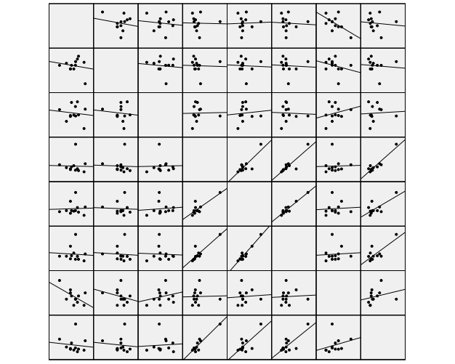 | .035 |  | -.060 |  | -.586 * |  | -.103
Overall rating of the leader | sig | .940 |  | .913 |  | .852 |  | .045 |  | .749
Job satisfaction | R | -.034 |  | -.044 |  | -.057 |  | -.272 |  | -.092
Job satisfaction | sig | .916 |  | .892 |  | .859 |  | .393 |  | .777
SCORE | R | .022 |  | .086 |  | -.043 |  | .245 |  | .059
SCORE | sig | .947 |  | .789 |  | .894 |  | .443 |  | .855

 |  | Number of operations |  | Number of patients |  | No. Dr. Po Post |  | No. Tech Po Post |  | No. Pac By Post
Overall rating of the leader | R | .106 | 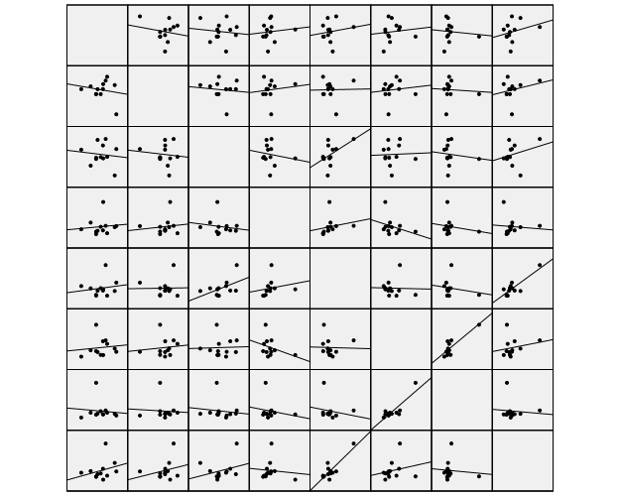 | .157 |  | .110 |  | -.096 |  | .285
Overall rating of the leader | sig | .742 |  | .626 |  | .733 |  | .768 |  | .369
Job satisfaction | R | .122 |  | .018 |  | .112 |  | -.062 |  | .249
Job satisfaction | sig | .706 |  | .956 |  | .728 |  | .848 |  | .435
SCORE | R | -.160 |  | .503 |  | .037 |  | -.125 |  | .284
SCORE | sig | .619 |  | .095 |  | .909 |  | .699 |  | .371

Table 7. Comparison of clinics in relation to the percentage of staff (80%) who had HH training and the percentage of staff using alcohol-based agents

training course |  | N | Mean | Std. Deviation | t | sig
Total_leader_rating | up to 80% | 6 | 3.90 | 0.80 | -.365 | .722
Total_leader_rating | above 80% | 6 | 4.03 | 0.26 | -.365 | .722
Job_satisfaction | up to 80% | 6 | 104.19 | 20.14 | -1.621 | .136
Job_satisfaction | above 80% | 6 | 119.70 | 11.98 | -1.621 | .136
SCORE | up to 80% | 6 | 2.42 | 2.36 | -1,767 | .108
SCORE | above 80% | 6 | 4.73 | 2.15 | -1,767 | .108

Table 8. Comparison of clinics in relation to the percentage of staff (95%) who had HH training and the percentage of staff using alcohol-based agents

Alcohol based HH |  | N | Mean | Std. Deviation | t | sig
Total_leader_rating | up to 95% | 6 | 3.61 | 0.47 | -2,743 | .021
Total_leader_rating | above 95% | 6 | 4.33 | 0.44 | -2,743 | .021
Job_satisfaction | up to 95% | 6 | 112.39 | 7.62 | .083 | .935
Job_satisfaction | above 95% | 6 | 111.50 | 25.20 | .083 | .935
SCORE | up to 95% | 6 | 3.45 | 2.11 | -.159 | .877
SCORE | above 95% | 6 | 3.69 | 2.99 | -.159 | .877

Table 9. Total score and score on questions of knowledge about HH
in relation to the profession

 | midwifes | doctors | nurses | other | χ2 | Sig
score 10 | 0.95±0.22 | 0.67±0.47 | 0.75±0.44 | 0.85±0.37 | 9,002 | .029
score 11 | 0.67±0.48 | 0.43±0.5 | 0.39±0.49 | 0.1±0.31 | 14,326 | .002
score 12 | -0.38±0.8 | 1.64±2.5 | 0.93±2.49 | 0.6±2.06 | 14,243 | .003
score 13 | -3.43±1.91 | 1.17±1.77 | 1.4±1.69 | 1.9±1.89 | 55.262 | .000
score 14 | -3.19±0.93 | -1.49±1.24 | -1.78±1 | -1.75±0.85 | 38,852 | .000
score 15 | 0.29±0.46 | 0.48±0.5 | 0.46±0.5 | 0.5±0.51 | 2,898 | .408
score 16a | -0.38±0.97 | -0.04±1.22 | 0.05±1.17 | 0.7±0.73 | 15,553 | .001
score 16b | -0.57±1.08 | 0.12±1.09 | 0.08±1.07 | 0.35±1.09 | 12,865 | .005
score 16c | -0.1±0.44 | -0.42±1.21 | -0.28±1.13 | 0.15±1.18 | 5,963 | .113
score 16d | 1.33±0.97 | 0.48±1.32 | 0.23±1.71 | -0.5±1.85 | 14.032 | .003
soon 16 | 0.05±0.22 | -0.2±1.2 | -0.2±1.16 | -0.4±1.39 | .242 | .971
score 16f | -0.1±0.44 | -0.5±1.19 | -0.26±1.1 | 0.2±1.2 | 10.154 | .017
SCORE16 | 0.24±2.55 | -0.55±3.11 | -0.38±3.2 | 0.5±2.37 | 3.010 | .390
score 17 | 2.57±1.12 | 2.55±1.24 | 2.6±1.25 | 2.5±0.89 | .514 | .916
SCORE | -2.29±2.28 | 4.91±5.12 | 4.37±5.26 | 5.2±4.26 | 36,794 | .000

Table 10. Total score and score on HH knowledge questions between clinics

 | score 10 | score 11 | score 12 | score 13 | score 14
Anesth | 0.78±0.42 | 0.57±0.51 | 0.96±2.25 | 1.65±1.56 | -2.43±0.84
MISur | 0.5±0.53 | 0.38±0. 52 | -0.75±1.49 | -0.25±2.49 | -2.13±1.81
Pediat sur | 0.89±0.31 | 0.39±0.5 | 1.36±2.56 | 0.64±1.97 | -1.89±1.13
Dig sur | 0.54±0.5 | 0.46±0.5 | 3.3±1.59 | 1.26±1.76 | -1.87±0.5
End sur | 0.81±0.4 | 0.5±0.51 | 1.31±2.71 | 0.77±1.8 | -1.46±0.86
Gyn | 0.76±0.43 | 0.4±0.49 | 0.35±2.29 | -0.35±2.61 | -2.26±1.11
Thor sur | 0.6±0.5 | 0.85±0.37 | 2.6±2.06 | 1.7±1.17 | -0.75±0.97
Cardio sur | 0.64±0.49 | 0.44±0.5 | 0.92±2.14 | 1.59±2.3 | -1.46±0.97
Neuro sur | 0.85±0.37 | 0.6±0.5 | 2.2±2.33 | 1.6±1.05 | -1.65±0.99
Opht | 0.91±0.29 | 0.59±0.5 | 1.94±2.58 | 1.65±0.77 | -1.82±0.8
ORL | 0.62±0.49 | 0.33±0.48 | -0.51±2.46 | 0.56±1.29 | -1.77±0.78
Orth | 0.89±0.32 | 0.04±0.2 | 0.39±1.61 | 2.51±1.61 | -1.73±1.04
Plast sur | 0.77±0.44 | 0.69±0.48 | 2.92±2.1 | 2±0.82 | -3.15±1.68
ER | 0.57±0.5 | 0.23±0.43 | 0.47±2.66 | 1.13±1.87 | -1.13±1.2
Urol | 0.6±0.5 | 0.15±0.37 | 1.3±2.45 | 1.4±1.85 | -1.15±1.39
Vasc sur | 1±0 | 0.73±0.46 | -1.87±0.52 | 0±0 | -1.4±0.91
χ2 | 49,923 | 88,438 | 119.311 | 106.501 | 83,574
sig | .000 | .000 | .000 | .000 | .000
 | score 15 | score 16a | score 16b | score 16c | score 16d
Anesth | 0.48±0.51 | -0.09±0.67 | 0.09±0.29 | -0.26±0.69 | 1.74±0.69
MISur | 0.63±0.52 | 0.13±1.36 | -0.75±1.39 | 0.38±1.06 | -0.25±1.39
Pediat sur | 0.82±0.39 | -1.11±1.17 | -0.04±1.04 | -0.36±1.03 | 0.39±1.52
Dig sur | 0.72±0.46 | 0.91±0.46 | 0.85±0.63 | -1.37±1.22 | 0.04±0.29
End sur | 0.54±0.51 | -0.46±1.3 | -0.31±1.23 | -0.46±1.3 | -0.04±1.71
Gyn | 0.43±0.5 | 0.09±1.03 | -0.1±1.02 | -0.01±0.66 | 0.94±1.21
Thor sur | 0.5±0.51 | 0.25±0.72 | -0.1±0.45 | 0±0 | 1.9±0.45
Cardio sur | 0.46±0.51 | -0.44±1.43 | -0.56±1.45 | -0.38±1.29 | 0±1.26
Neuro sur | 0.55±0.51 | -0.15±1.04 | -0.25±1.12 | 0.05±1 | 1.15±1.09
Opht | 0.29±0.46 | 0.12±0.81 | 0.15±0.7 | 0.06±0.65 | 1.26±1.52
ORL | 0.56±0.5 | -0.64±1.39 | 0.41±0.85 | -1.05±1.19 | 0.36±1.18
Orth | 0.37±0.49 | 0.92±0.5 | 0.75±0.84 | 0.24±1.31 | -1.99±1.43
Plast sur | 0.23±0.44 | -0.69±1.32 | -0.46±1.33 | -0.38±0.96 | 0.92±1.89
ER | 0.23±0.43 | -0.43±1.36 | -0.3±1.21 | -0.03±1 | 0.5±1.14
Urol | 0.3±0.47 | 0.4±1.1 | -0.65±1.42 | -0.7±1.13 | 0.3±0.73
Vasc sur | 0.2±0.41 | 0±0 | 0±0 | 0±0 | 2±0
χ2 | 52,569 | 157,357 | 131.259 | 89,679 | 225,806
sig | .000 | .000 | .000 | .000 | .000
 | score 16e | score 16f | SCORE16 | score 17 | SCORE
Anesth | -0.13±0.63 | -0.22±0.74 | 1.13±2.24 | 2.78±1.31 | 5.91±4.69
MISur | 0.38±1.06 | -0.38±1.41 | -0.5±2.07 | 0.75±1.49 | -1.38±4.66
Pediat sur | -0.86±1.21 | -0.68±1.02 | -2.64±4.09 | 3.36±1.1 | 2.93±6.05
Dig sur | 0.85±0.63 | -1.37±1.22 | -0.09±2.18 | 2.35±0.87 | 6.67±3.29
End sur | -0.58±1.3 | -0.31±1.23 | -2.15±4.9 | 2.77±1.14 | 3.08±6.73
Gyn | -0.37±1.01 | -0.06±0.69 | 0.49±2.96 | 2.85±1.21 | 2.66±5.72
Thor sur | 0±0 | 0±0 | 2.05±0.89 | 2±0 | 9.55±4.06
Cardio sur | -1.15±1.18 | -0.21±1.15 | -2.74±3.56 | 2.67±1.54 | 2.51±5.84
Neuro sur | -0.75±1.07 | 0.1±0.85 | 0.15±2.78 | 2.7±1.34 | 7±4.19
Opht | -0.06±0.69 | -0.06±0.69 | 1.47±1.56 | 2.18±0.58 | 7.21±3.65
ORL | 0.31±0.92 | -0.72±1.12 | -1.33±3.19 | 2.46±1.86 | 0.92±5.6
Orth | 0.11±1.38 | 0.11±1.38 | 0.14±2.29 | 2.23±0.64 | 4.83±3.68
Plast sur | -0.38±0.96 | -0.46±0.88 | -1.46±2.88 | 3.69±1.11 | 5.69±4.11
ER | -0.63±1.1 | -0.27±1.05 | -1.17±3.02 | 2.67±1.42 | 3±5.63
Urol | -0.35±1.42 | -0.2±1.4 | -1.2±1.64 | 3.3±0.98 | 4.7±3.67
Vasc sur | 0±0 | 0±0 | 2±0 | 2.13±0.52 | 2.8±1.08
χ2 | 133,617 | 70,225 | 111,295 | 82,532 | 96,489
sig | .000 | .000 | .000 | .000 | .000

