Appendix
See Figure 2 and Table 3
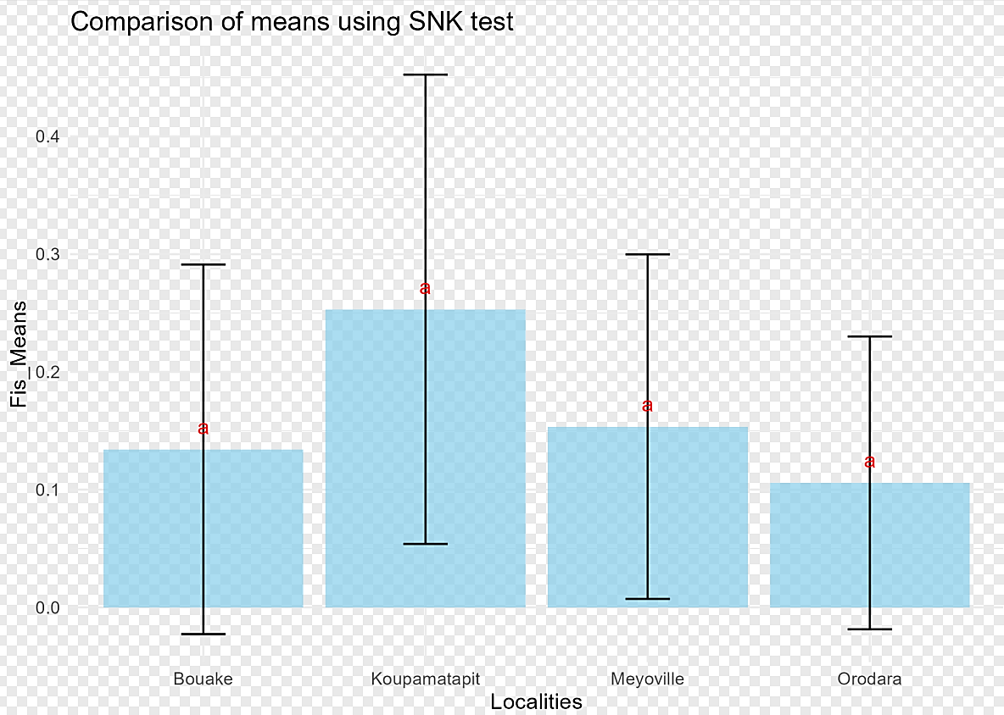

Fig 2 Variance analysis using the SNK test of the inbreeding coefficient of individuals in relation to their sub-population (Measure comparison of the reduction in heterozygosity observed in relation to that expected by locality).
Table 3 Comparison of genetic structuring indices by locality at 5% threshold based on Newman-Keuls post-hoc test
Localities | A | AR | H₀ | H_{E} | F_{IS} ª | r
MeyoVille | 11.38±4.48ª | 9.73±3.41ª | 0.68±0.14ª | 0.80±0.09ª | 0.15±0.14ª | 0.07±0.06ª
Min-Max | 3-15 | 4.61-17.25 | 0.42-0.9 | 0.65-0.92 | -0.10-0.40 | 0-0.18
KoupaMatapit | 9.85±4.79ª | 8.97±4.07ª | 0.56±0.16ª | 0.76±0.16ª | 0.25±0.19ª | 0.11±0.09ª
Min-Max | 3-17 | 2.99-15.51 | 0.28-0.84 | 0.29-0.93 | 0.04-0.63 | 0-0.27
Orodara | 8.38±3.25ª | 8.06±3.02ª | 0.68±0.18ª | 0.73±0.14ª | 0.11±0.12ª | 0.05±0.04ª
Min-Max | 5-22 | 4-14.16 | 0.35-1 | 0.49-0.91 | -0.15-0.29 | 0-0.11
Bouaké | 8.46±3.2ª | 8.46±3.20ª | 0.65±0.15ª | 0.75±0.16ª | 0.13±0.16ª | 0.06±0.05ª
Min-Max | 4-15 | 3-15 | 0.26-0.84 | 0.38-0.94 | -0.19-0.41 | 0-0.18
CV (%) | 41.64 | 39.16 | 24.52 | 18.63 | 98.42 | 90.74
F_{Value} | 1.78 | 0.61 | 1.90 | 0.66 | 2.71 | 2.15
Pr (>F) | 0.162 | 0.61 | 0.14 | 0.58 | 0.09 | 0.11
A= number of alleles, AR= allelic richness, H₀= observed heterozygosity, H_{E=} expected heterozygosity, F_{IS}= inbreeding coefficient or fixation index, r= frequency of null alleles, Min = minimum, Max = maximum. In the same column, values with identical letters are statistically identical at the 5% level. If the value of the probability « Pr(>F) » is less than 0.05(5%) then the individuals compared are different for each evaluated variable (different letter in same column). Otherwise, individuals are statistically identical (same letter in same column).

