Supplementary Materials for

Selective magnetoelectric stimulation antagonizes GABA_{A} receptors subunit in the left prelimbic cortex neurons to alleviate schizophrenia-like behaviors

Yunshan Hu et al.

*Corresponding author. Email: drxrz@hotmail.com

This PDF file includes:

Supplementary Text
Figs. S1 to S4
Tables S1

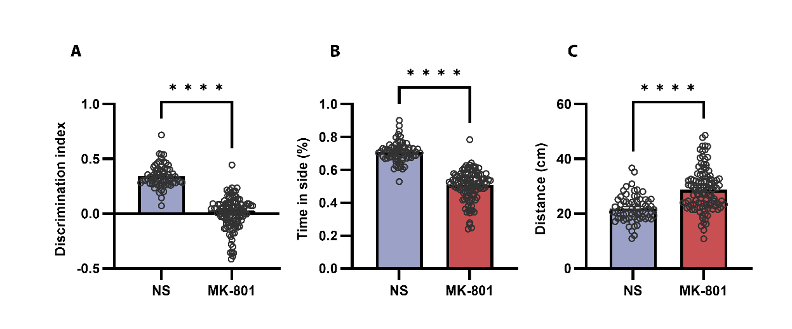

Fig. S1. Establishment and assessment of SCZ-like phenotypes in mice.
(A) Mice have impaired novel object recognition after MK-801 injection. (B) Mice have impaired social behavior after the MK-801 injection. c Mice have increased distance after MK-801 injection. n=28-34 mice of each group; The data were expressed as mean ± SEM; Two-sample t-test. ****p < 0.0001.

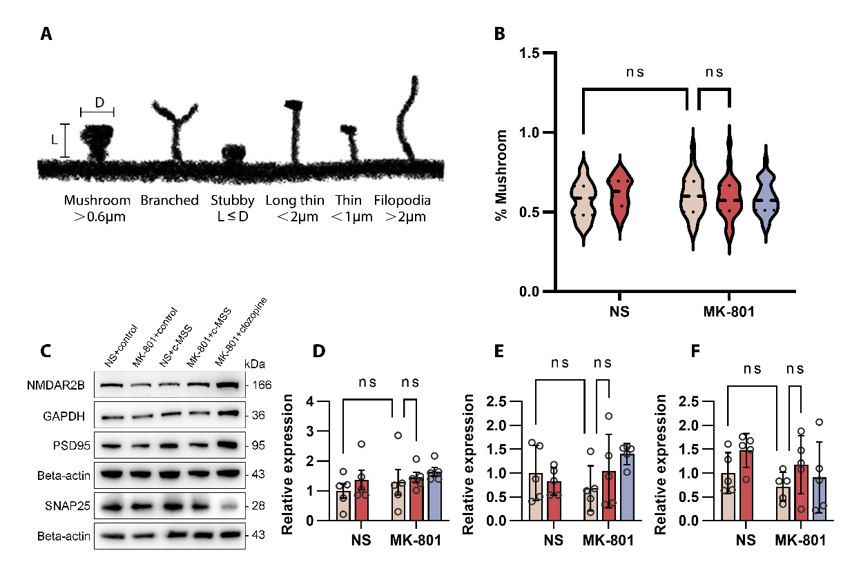

Fig. S2. Relevant synaptic classification and protein detection.
(A)Diagram of dendritic spines with different morphologies. Filopodia spines are more than 2 mm in length; the maximum width of stubby spines is less than its length; long thin spines are 1–2 mm in length; thin spines are less than 1 mm in length; mushroom spines’ head/neck diameter ratios are more than 1. (B) The proportion of mushroom-shaped spines within the total dendritic spine. (C-F) Representative images of proteins reflecting synaptic functional expression (NMDAR2B, PSD95, SANP25) in the PrL using Western blot analysis (n=5 mice per group). The data were expressed as mean ± SEM; one-way ANOVA followed by Tukey post hoc comparison test. *p<0.05, **p<0.01, ***p<0.001, ****p<0.0001. c-MSS, combined magnetic stimulation system; ns, non-significant; clo: clozapine.
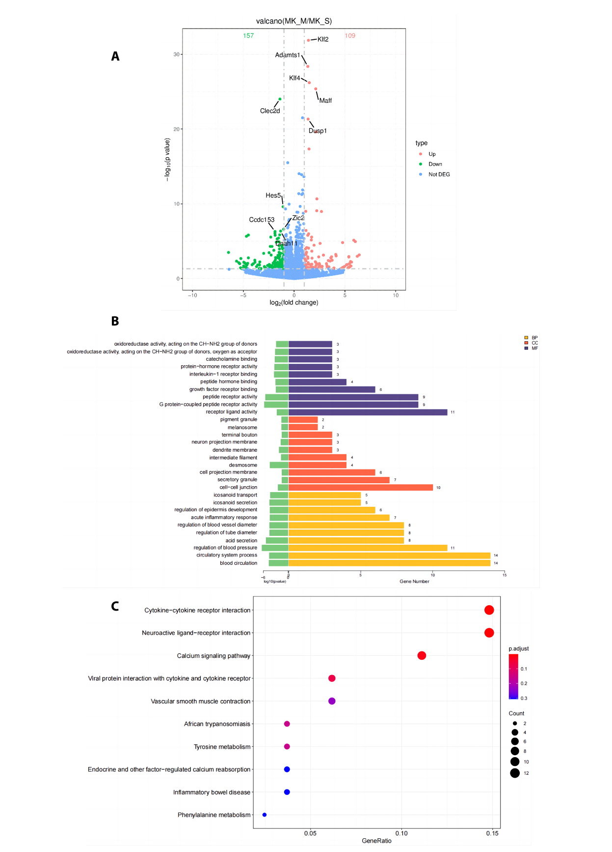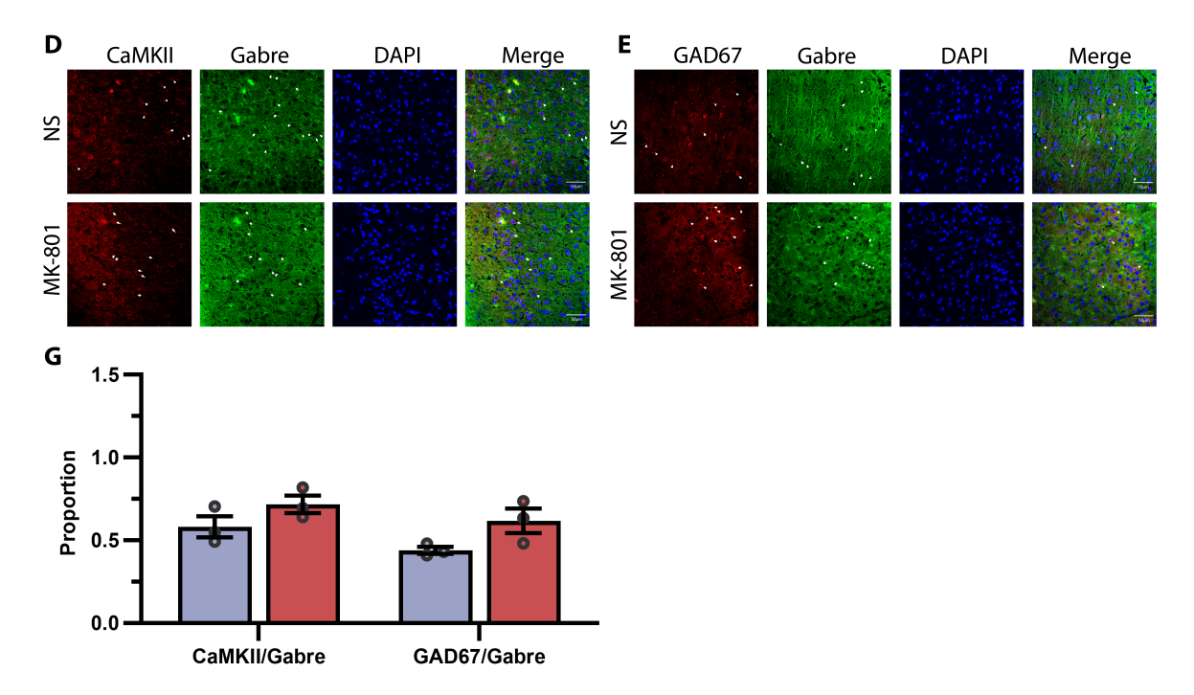

Fig. S3. Transcriptional analysis and cell-type-specific expression of Gabre in the left PrL region of mice.
(A)Schematic representation of transcriptomic sequencing experiments for PrL neurons derived from MK-801+control and NS+control. (B) Transcriptome analysis. GO enrichment analysis. (C) KEGG pathway enrichment analysis. (D, E) Representative fluorescence images of the mouse PrL. Immunofluorescent double labeling for CaMKII (red)/Gabre (green) and GAD67 (red)/Gabre (green). Nuclei were stained blue with DAPI. n=3-4 mice per group. Scale bar=50μm. (F) Colocalization of the two neurocytemarkers with Gabre was quantified in the left PrL of control and MK-801 mice. (n=3-4 mice per group).

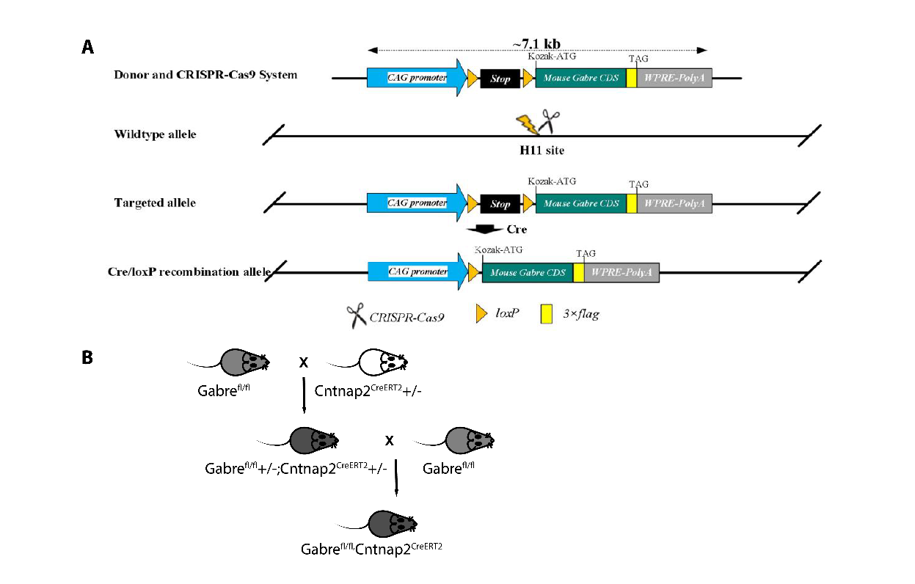

Fig. S4. Gabre knockin in PrL neurons.
(A)Graphical representation of the strategy utilized to generate Gabre knock-in (KI) mice.
(B)The strategy of obtaining Gabre^{flox/flox;} Cntnap2^{CreERT} (CKI) mice.

5’arm | F1 | H11-tF3 | GGGCAGTCTGGTACTTCCAAGCT | WT:0bp  Targeted:335bp
5’arm | R1 | CAG-tR1 | TGGCGTTACTATGGGAACATACGTC | WT:0bp  Targeted:335bp
3’arm | F2 | WPRE-tF1 | TCAATCCAGCGGACCTTCCTT | WT:0bp  Targeted: 475bp
3’arm | R2 | H11-tR3 | ATATCccCTTGTTCCCTTTCTGC | WT:0bp  Targeted: 475bp
WT | F3 | H11-wt-tF1a | AGTCTTTCCCTTGCCTCTGCT | WT:825bp  Targeted:7881bp
WT | R3 | H11-wt-tRla | GGGTCTTCCACCTTTCTTCAG | WT:825bp  Targeted:7881bp

Primer name
H11-seqF1 | TTACTGGCACAATGTTAATCCAGC | 5’，low-GC
H11-seqR1 | CTTTACATTCAATTTATAATACCAG | 5’，low-GC
H11-seqF2 | CTAGAGCAAGGCCAGCCAGA | 3’
H11-seqR2 | TCACATCTTTCCAGTCCCAAATG | 3’

Table S1. PCR primer sequences used for detection by F1 generation mice progeny.

