Supplemental Figures
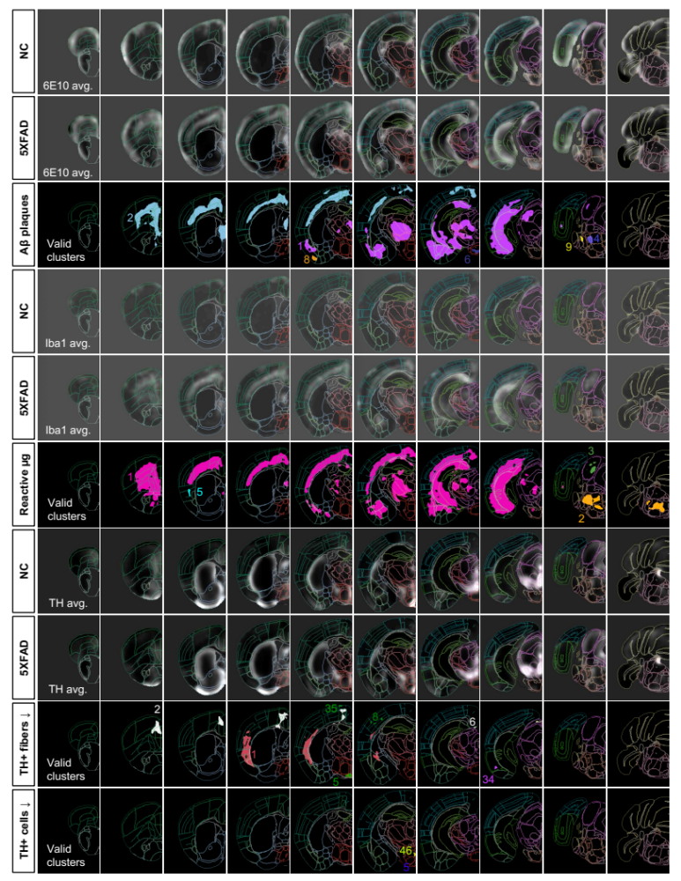

Supplemental Figure S1. Coronal slices showing averaged immunofluorescence and valid clusters. Brains from aged 5XFAD (6.5 months) and non-carrier (NC) control mice were immunostained, cleared, imaged in 3D with LSFM and analyzed with UNRAVEL. Immunofluorescence labeling was preprocessed to minimize autofluorescence and non-specific staining. This involved rolling ball background subtraction (pixel radius of 20) to remove autofluorescence. Non-specific staining from the mouse 6E10 antibody was zeroed out with an Ilastik-based segmentation of capillaries and the brain’s surfaces. Likewise, signal from reactive and aggregated microglia was isolated by segmenting them and zeroing out other voxels. No mask was used for TH labeling. Autofluorescence images were registered with an iDISCO+/LSFM-specific average template brain aligned to the CCFv3 Allen brain atlas. Transformation matrices from this were used to warp the preprocessed immunofluorescence images to atlas space for voxel-wise statistics. Each brain was z-scored and smoothed. Images for each immunolabel and group were averaged (avg.) together. Images were visualized with FSLeyes. The display range was set to -0.3 – 1 for 6E10, -0.3 – 0.8 for reactive microglia, and -0.3 – 2 for TH. Valid clusters were randomly colored and their IDs are shown. Detailed info on each cluster is available in Supplementary Table S10. The images were overlaid with a semi-transparent wireframe version of the Allen brain atlas.

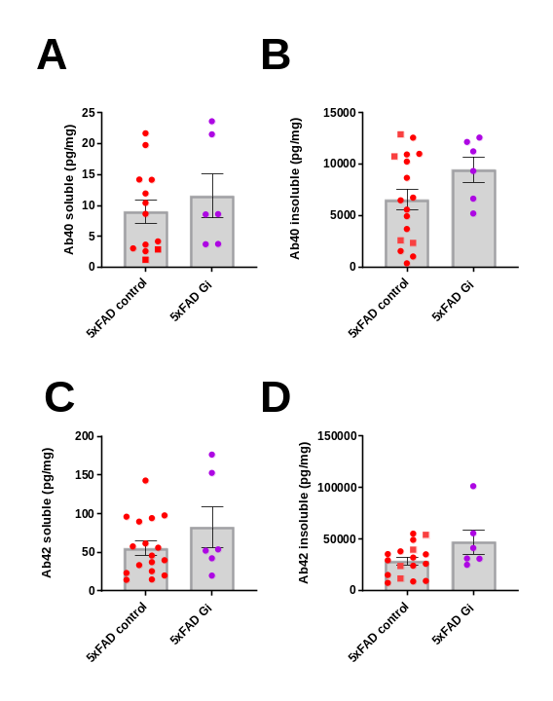

Supplemental Figure S2. No effects of chemogenetic inhibition of locus coeruleus noradrenergic neurons were detected on cortical tissue concentrations of amyloid beta. Bar graphs depict brain concentrations of soluble and insoluble A,B) aβ40 and C,D) aβ42 in female 5XFAD mice.

Supplemental Figure S3. Pharmacological inhibition of beta-adrenergic receptors with propranolol potentiates systemic inflammation and attenuates leptin in the 5XFAD mouse model of amyloidosis. Log2-fold change graphs depict effects of A) 5XFAD (5XFAD-veh/non-carrier (NC)-veh); n=5) in vehicle-treated mice and B) propranolol (5XFAD-prop/5XFAD-veh; n=6) in 5XFAD mice. C) Bar graphs indicate raw data from proteins affected by propranolol, as indicated in panel B. *p < 0.05; Sidak’s post-hoc comparison of means following one-way ANOVA.

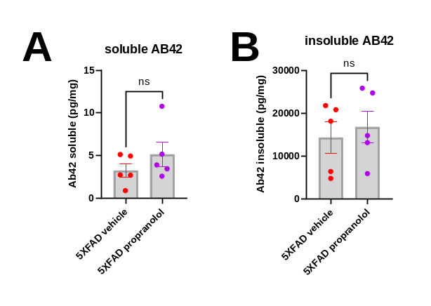
Supplemental Figure S4. No effects of propranolol were detected on frontal cortex concentrations of amyloid beta in 5XFAD mice. Bar graphs depict brain concentrations of A) soluble and B) insoluble aβ42.

Supplemental Figure S5. Propranolol did not affect behavior in the activity chamber (A-D) or Y-maze (E) in 5XFAD mice. A-D) Line graphs depict Vertical Counts, Distance Moved, Vertical Time, and Time in the Center for the Activity Chamber assay. At baseline, 5XFAD mice showed less vertical time than non-carrier controls. E) Bar graphs depict duration in novel versus familiar arms after 7 weeks of dosing with propranolol. ***p < 0.001 for non-carrier-vehicle vs 5XFAD-vehicle Dunnett’s post-hoc following two-way ANOVA.

Supplemental Figure S6. Effects of conditional knockout of adrb1 in microglia in 5XFAD and non-carrier mice. Log2-fold graphs show fold changes across a panel of immune-related markers in response to A) 5XFAD in male mice and B) adrb1 cKO in male 5XFAD mice. Likewise, log2-fold graphs show immune regulation from H) 5XFAD in female mice and I) adrb1 cKO in female 5XFAD mice. For A,C) * indicates the main effects. For B,D) * indicates post-hoc Sidak’s comparison of means following two-way ANOVA (5XFAD x adrb1 cKO). *p < 0.05, **p < 0.01, ***p < 0.001, ****p < 0.0001.

Supplemental Figure S7. No effects of conditional KO of adrb1 were detected on brain tissue concentrations of amyloid beta in 5XFAD mice. Bar graphs depict brain concentrations of soluble and insoluble A,B) aβ40 (cortex) and C,D) aβ42 (thalamus). *p < 0.05; Sidak’s post-hoc comparison of means following two-way ANOVA (sex x adrb1 cKO).

Supplemental Figure S8. Conditional knockdown of adrb1 in mouse microglia did not increase 6E10 or iba1 immunoreactivity (ir) in 5XFAD mice. Bar graphs depict 6E10-ir or iba1-ir in the dentate gyrus (DG), CA3 region of the hippocampus, subiculum (SUB), or retrosplenial cortex (RS). *p < .05, **p < 0.01, ***p < 0.001, ****p < 0.0001; Sidak’s post-hoc comparison of means following two-way ANOVA (5XFAD x adrb1 cKO) for each sex.
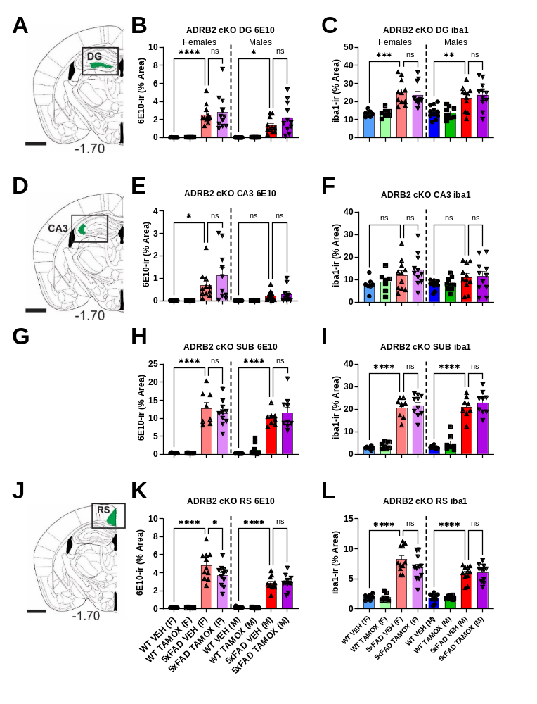
Supplemental Figure S9. Conditional knockdown of adrb2 in mouse microglia did not increase 6E10 or iba1 immunoreactivity (ir) in 5XFAD mice. Bar graphs depict 6E10-ir or iba1-ir in the dentate gyrus (DG), CA3 region of the hippocampus, subiculum (SUB), or retrosplenial cortex (RS). *p < 0.05, **p < 0.01, ***p < 0.001, ****p < 0.0001; Sidak’s post-hoc comparison of means following two-way ANOVA (5XFAD x adrb2 cKO) for each sex.

Supplemental Figure S10. Conditional knockdown of adrb1 in mouse microglia does not alter LC neuronal cell counts. A) Schematic representation of the rostrocaudal extent of locus coeruleus regional cell quantification with atlas plates. Numbers indicate mm from bregma. Line graphs depict the quantification of LC TH-immunoreactive neurons across the rostrocaudal extent of the LC in B) female and C) male mice.

Supplemental Videos

Supplemental Video 1. 3D view of valid clusters (related to Figures 2 and 3). The video shows regions where Aβ aggregates and reactive microglia are more abundant in 5XFAD brains compared to NC brains. Additionally, it highlights clusters where TH expression is downregulated in fibers or somata in 5XFAD brains relative to NC controls. The 3D brain models were created using DSI Studio, with a binarized atlas displayed as a transparent isosurface. Valid cluster maps were loaded as regions, and Allen brain atlas colors were applied using an RGBA value list. Adobe Premiere Pro (2022) was used to export and compile the individual brain videos.

