Supplementary Tables

Supplementary Table S1. Luminex Cytokine Data - ANOVA Table for 5XFAD DREADD – female, brain homogenate.
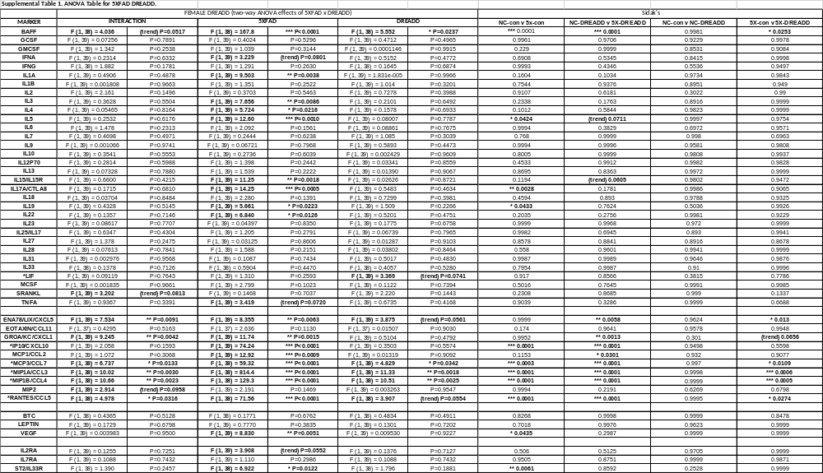

Supplementary Table S2. Luminex Cytokine Data - ANOVA Table for 5XFAD Propranolol – male, brain homogenate.
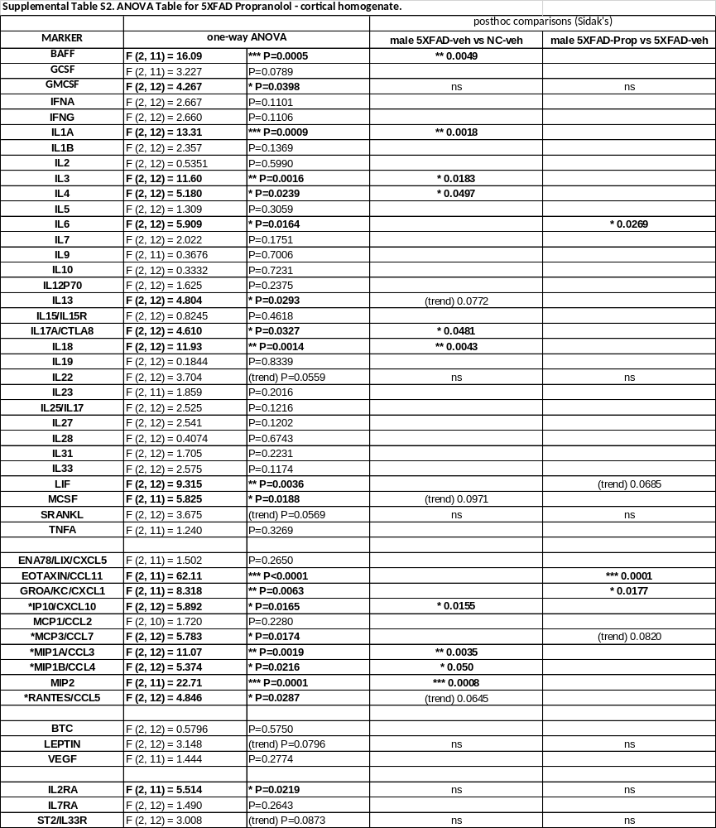

Supplementary Table S3. Luminex Cytokine Data - ANOVA Table for 5XFAD Propranolol – male, plasma.
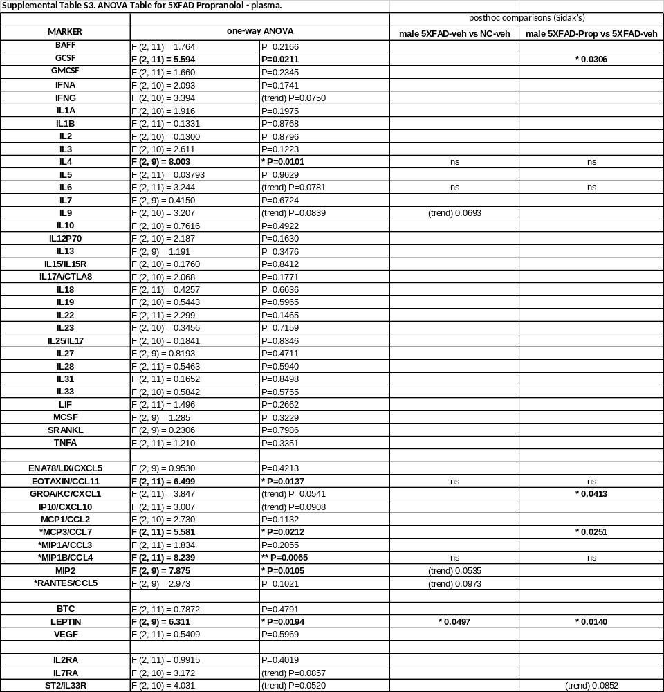

Supplementary Table S4. Luminex Cytokine Data - ANOVA Table for 5XFAD adrb2 cKO – male, brain homogenate.
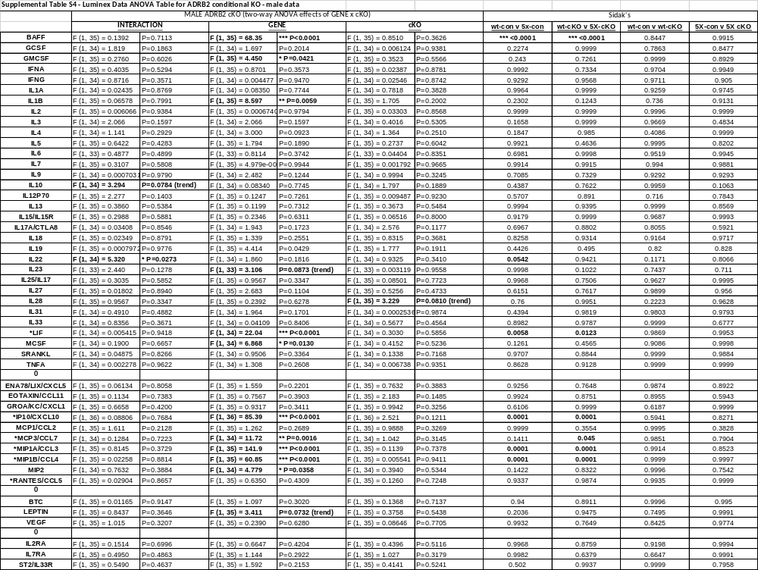

Supplementary Table S5. Luminex Cytokine Data - ANOVA Table for 5XFAD adrb2 cKO – female, brain homogenate.
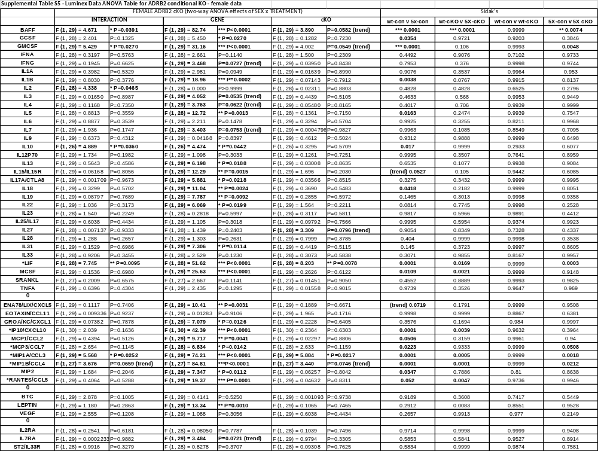

Supplementary Table S6. Luminex Cytokine Data - ANOVA Table for 5XFAD adrb1 cKO – male, brain homogenate.
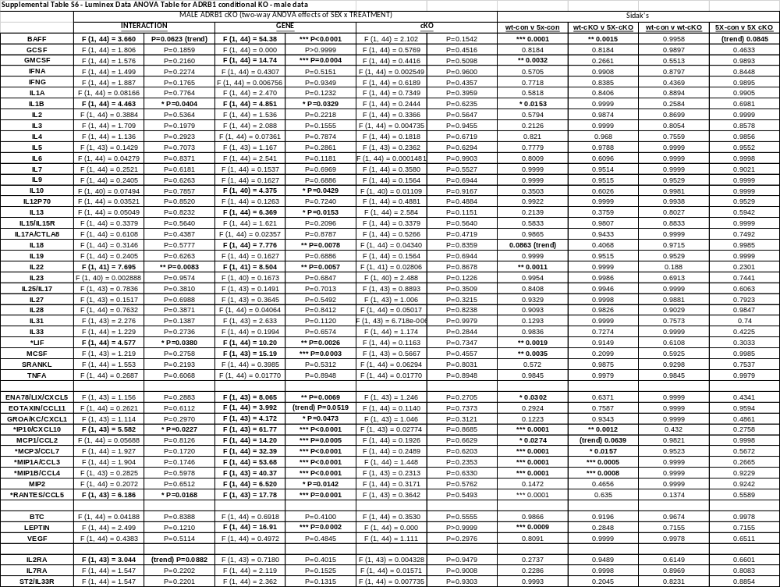
Supplementary Table S7. Luminex Cytokine Data - ANOVA Table for 5XFAD adrb1 cKO – female, brain homogenate.
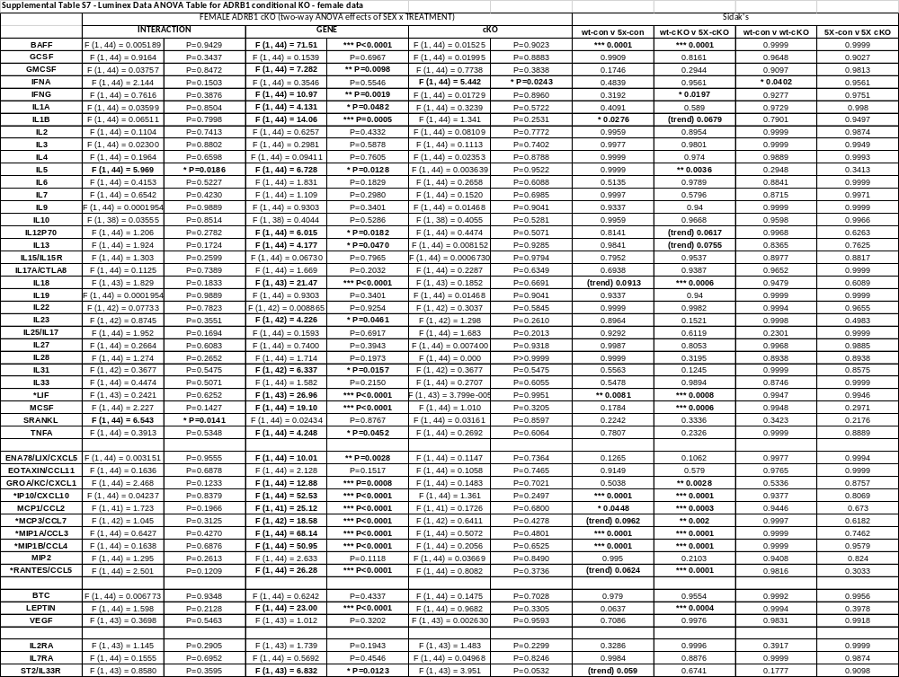

Supplementary Table S8. Luminex Cytokine Data - ANOVA Table for Sex effects in 5XFAD mice (from ADRB2 cKO study).
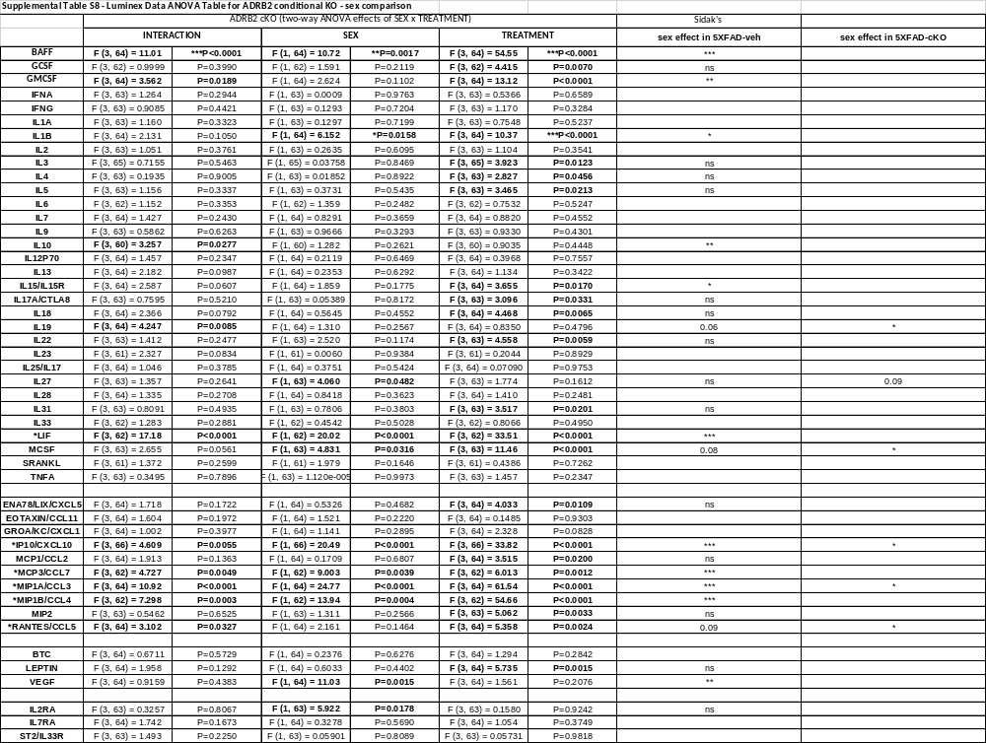

Supplementary Table S9. Definition of region abbreviations used in describing clusters from brain-wide analyses.
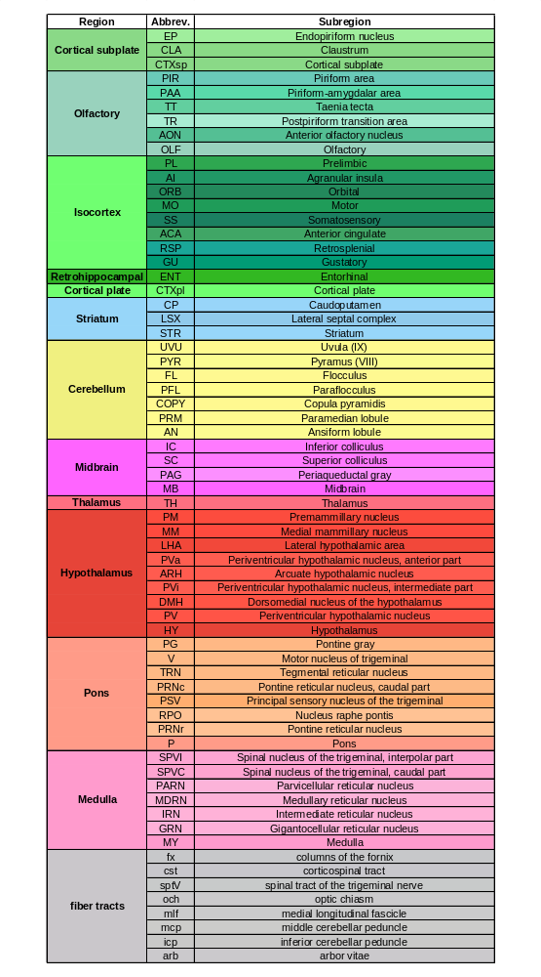

Supplementary Table S10. Information on valid clusters includes the contrast, effect direction, label, FDR q value, and adjusted p-value threshold as well as the cluster ID, volume (in mm³), general region, and top 4 regions (with the percentage of total cluster volume indicated).
